*ID* : 1

# Organizer Portal Sign Up/Log In

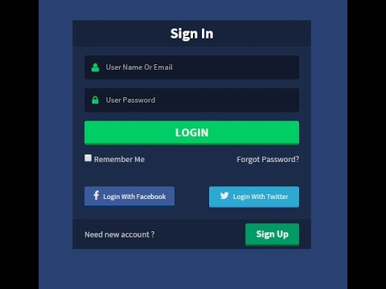

*ID* : 8

## 1.1 There would be a sign up option for organizers who want to make an account.

*ID* : 9

### 1.1.1 The details required for new account are Name (of individual or company), Email Address and password.

*ID* : 13

#### 1.1.1.1 A confirmation mail will be sent to the email provided for authentication and security.

*ID* : 15

#### 1.1.1.2 The person will be required to verify their email address by clicking the link in the email sent to their inbox.

*ID* : 16

## 1.2 There would be a login option for existing organizers.

*ID* : 17

### 1.2.1 The login details are email and password which was made at account creation.

*ID* : 18

#### 1.2.1.1 The user only has 5 tries to login successfully, and is locked for 30 minutes from the platform if not.

*ID* : 19

#### 1.2.1.2 If the user has forgotten password, an option stating "Forgot Password" is present under the Login forms.

*ID* : 20

##### 1.2.1.2.1 A mail will be sent to the email address provided containing instructions for resetting account password.

*ID* : 24

# Organizer Portal Profile

1. 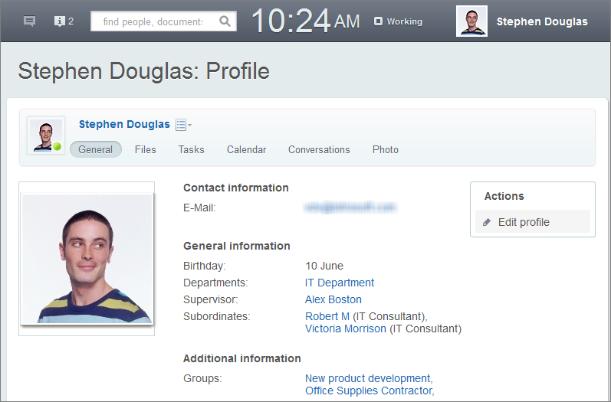

*ID* : 26

## 2.1 User can keep track of their events, see a history of the events organized, favourite suppliers, favourite locations, change password , provide/change their phone number and set default location.

*ID* : 28

### 2.1.1 All currently active events and related information such as order status, venue confirmation, possible delays in item delivery, withdrawal of suppliers or cancellations by customer can be seen here.

*ID* : 29

### 2.1.2 All events ever conducted by the user will be stored and can be sorted by chronological, total pricing, or name in ascending or descending order.

*ID* : 30

### 2.1.3 Favourite suppliers are user preferred suppliers who will be pushed to the top of the user's search lists for subsequent events.

*ID* : 31

### 2.1.4 Favourite locations are user preferred locations and available venues at these places would be shown with priority over others.

*ID* : 32

### 2.1.5 Password can be changed on the platform itself by entering the old one, and new one twice for security and mistaken entry.

*ID* : 33

#### 2.1.5.1 A mail will be sent to the user email notifying a password change and will provide an option to temporarily lock the account and allow user to reset his password.

*ID* : 34

### 2.1.6 User can provide phone number or not, and will be able to choose the visibility to everyone on platform, all suppliers, all users or custom selection.

*ID* : 42

### 2.1.7 Default location can be user defined or auto by allowing access to GPS.

*ID* : 27

# Organizer Portal Event Creation

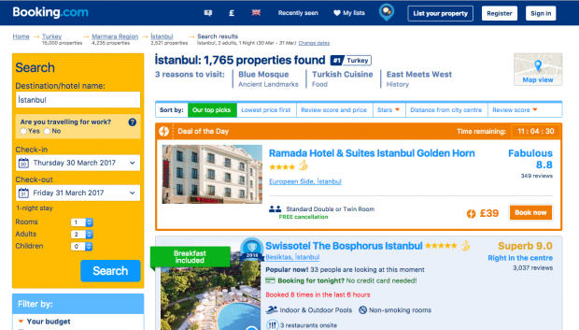

*ID* : 36

## 3.1 The user will have the option to manual create and name a new event, or a template based on user event history,auto-make or co-organize.

*ID* : 52

## 3.2 Creating manual event allows user to customize every aspect.

*ID* : 53

### 3.2.1 The user can state the type, the purpose and description of the event along with an expected number of occupancy and the date and time as well as the budget for this event.

*ID* : 59

#### 3.2.1.1 The about event form can support images, links to external websites alongside normal text.

*ID* : 55

### 3.2.2 The user is then presented with the option to search for a location, venue or browse through popular ones nearby the user.

*ID* : 56

### 3.2.3 The user can now find location filtered vendors specializing in events of the nature or search for specific items, equipment and products.

*ID* : 57

### 3.2.4 The user is able to look for catering services, security, staff, volunteers and even entertainers for the event by either filtering options or find recommended ones.

*ID* : 58

### 3.2.5 Finally the user sets the event visibility to private (with an access code) or public so attenders can find it.

*ID* : 37

## 3.3 Auto-Make allows user to just input type, purpose, description, timings, required services, equipment, looking for co-organizer and select the advertise option.

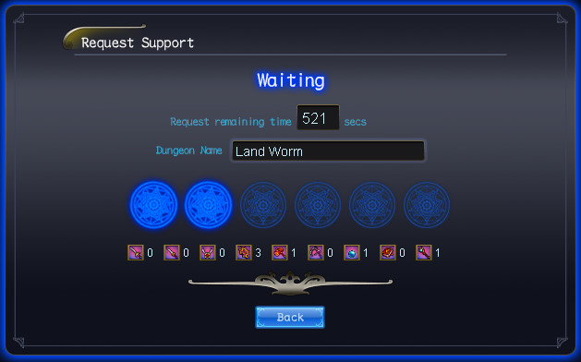

*ID* : 60

### 3.3.1 The advertise option publishes the user's needs onto a general feed where interested suppliers and service providers can "bid" and show interest in the event.

*ID* : 62

## 3.4 Co-organize option allows organizers the potential to increase the scope of their event by teaming up with another organizer setting up a similar event.