Let’s Track

Software Requirements Specification Document

Team-X
American University of Sharjah
College of Engineering
Computer Science and Engineering

Done By,
Brinda KJ (g00056897)
Niha KT (g00057302)
Naili Mustafa (g00058999)
Aranyak ghosh (b00060789)

Version #: SRS-12092017
Table of Content

1 Introduction 3
1.1 System Overview 3
1.2 Operating Environment 3
1.3 Conceptual Model 3
2 Functional Requirements 4
2.1 Product Services 4
2.2 User Interface Specifications 5
2.3 External Interfaces and Database Requirements 14
2.4 Error Handling 14
2.5 Foreseeable Functional Changes and Enhancements 15
3 Non-Functional Requirements 15
3.1 Product Requirements 15
3.2 Error Handling 16
3.3 Development Requirements 16
3.4 Foreseeable Non-Functional Changes 16
4 Remarks and Guidelines for Later Lifecycle Phases 17
5 Glossary and Index 17

Introduction

System Overview
Let’s Track is an Android application that will allow you to keep track of selected family members and friends. The application will connect the user to his/her friends and family and update their location in real-time, allowing the user to see whether they are at predefined labels such as work, home, gym and on vacation . The app can help ensure the safety of the user’s loved ones and know where they are even if they don’t pick up their phones or reply to their messages. Each connected member has an individual hour hand on the app’s clock screen, which points to where the member is currently, allowing the user to keep track easily.

Operating Environment
All Android devices running Android 5.0 (Lollipop) or higher can run the application.
In order for this app to function smoothly, the location services (GPS) as well as an active internet connection is required. This helps to keep track of the locations and update them in real-time.This keeps the user and their connected contacts updated on each-other’s location. It could be intermittently turned on and off, in order to conserve battery.

Conceptual Model
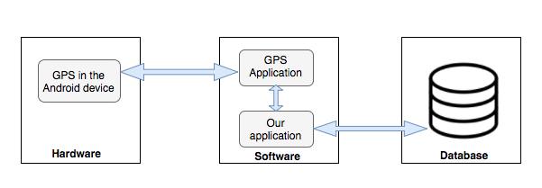
Figure 1: Conceptual Model of the application

Functional Requirements
The following Functional requirements describe the services provided by “Let’s Track” in detail. Functional requirements 1 and 3 describe the registration and setup process. Functional requirement 2 describes the login functionality. Functional requirement 4 allows users to set locations to predefined labels. Functional requirement 5 describes the home screen and setting functionalities.
- The user should be able to register themselves to the app using their email id, user defined password and their contact number.
  - Once a user is registered successfully, a mail should be sent to their account for authentication purposes.
  - Once registered, the user should receive a text message with a verification code to verify their phone number.

- If registered the user should be able to login to the app using their email id and password.
  - The user should be able to reset their password with the ‘Forgot password’ option.
- The user should be able to send requests to track/be tracked by other users who are using the app.
  - The user should be able to add contacts using the contact’s e-mail ID.
  - The user should be able to assign a nickname for the contact.
  - If a contact does not exist in the app database, the user should be able to send an “invite friend” connection request to the contact the user wishes to contact to. This request will have a downloadable link of the app.
  - The user should be allowed to accept or deny connection requests from other users.

- The primary user who is using the app should be able to define his/her locations on map corresponding to predefined labels namely “Work”, “Home” and “Gym”.
- The home screen window should display the current location of each of the contacts that the user is connected to, in addition to which it should have a button to access settings in the app.
  - The settings menu should contain the option of updating/adding contacts, changing the password, changing the location for each tag and logging out.
  - The user should be able to update or add to the connected contacts.
  - The user should be able change his/her password.
  - The user should be able to redefine the labeled locations.
  - The user should be able to log out of the app.

- A user should be able to accept/reject requests that he/she receives from other users who are registered on the app.

Product Services
The various services and computations that the app will provide are as follows:
- The app compares your current location to the locations in the predefined labels and updates the database accordingly.
- The app retrieves the locations of connected users from the database and updates the clock hands accordingly.

User Interface Specifications
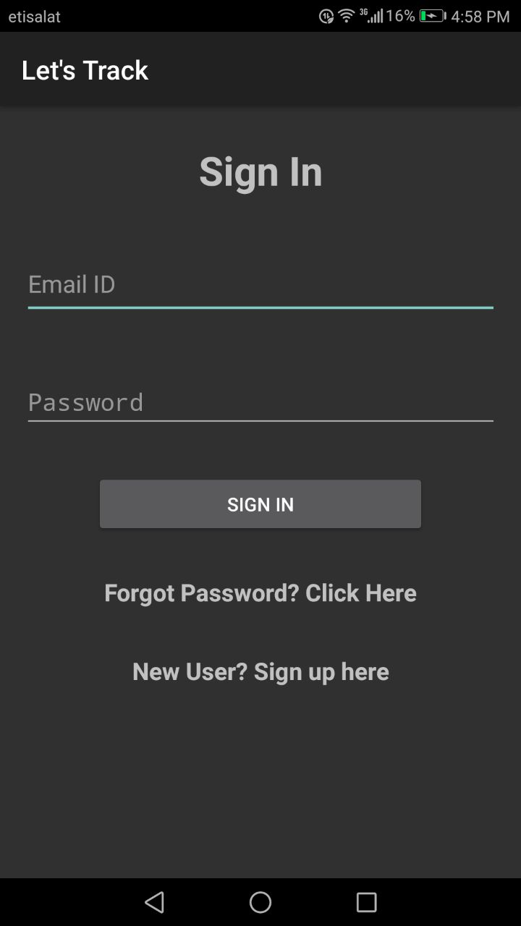
Figure 2: Sign In Page
The app opens up to the login page, as shown in Figure 2, which allows the user to login using their username and password.
If the user has forgotten his/her password, the ‘Forgot Password’ option sends an e-mail with a link which allows the user to reset their password.
A non-registered user can register to the app by clicking on ‘New User? Sign Up here’. This takes the user to a new page on the app.
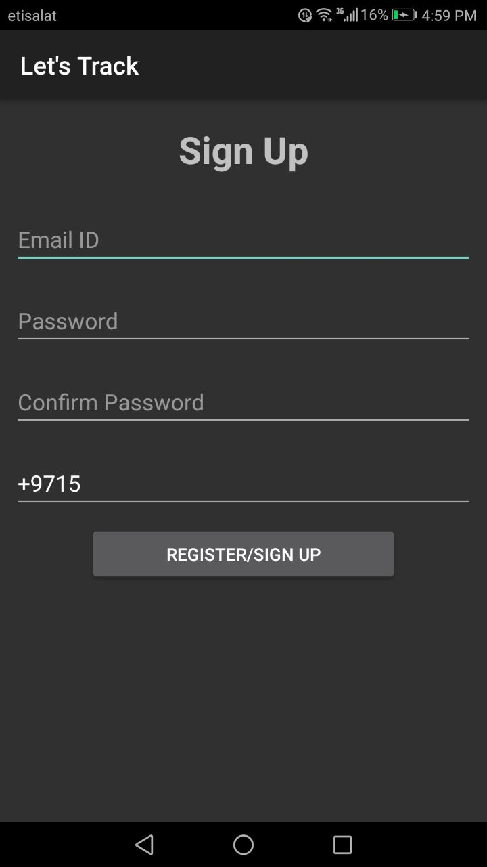
Figure 3: Registration Page
Upon tapping on the “New User? Sign Up here” link, the user is faced with the screen shown in Figure 3 on his/her device.
In order to register, the user has to fill in their E-mail ID, which will also be their username, contact number and a password of their choosing in their respective spaces. In the “Confirm Password” space, the user is required to enter their password they chose again in order to verify their password.
The register/sign up button on the screen adds the user to the user database and allows the user to access the app with the given credentials.
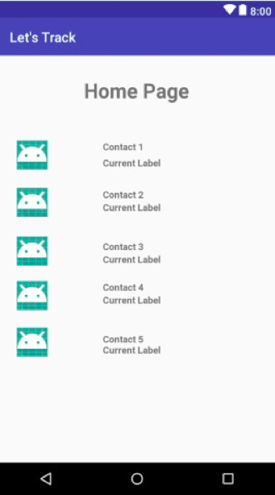
Figure 4: Home Page
After the user completes the registration process or logs on to the app, the user is encountered with the above interface as depicted in Figure 4.
The location of each contact the app user is connected to, can be viewed on the screen.
There is a settings menu on the top left corner of the device screen which leads the user a menu as shown in Figure 6.
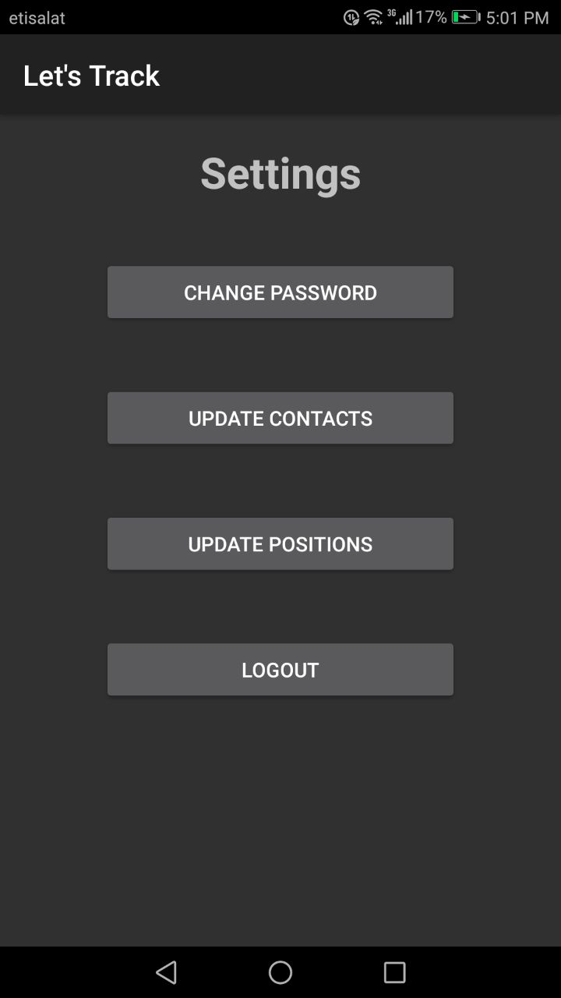
Figure 5: Settings Menu
If the user taps on the “Settings” icon found next to the clock interface (refer to Figure 6), it leads the user to the above screen illustrated in Figure 7. The user is provided with various options on this screen for their convenience.
The “Change Password” button allows the user to change their previously set password.
The “Update Contacts” option lets the user to change their connected contacts if need be.
“Update Positions” button allows the user to change the location that was set earlier under their respective predefined labels to a new one.
Finally, the user is allowed to log out of the app through the “Logout” option.
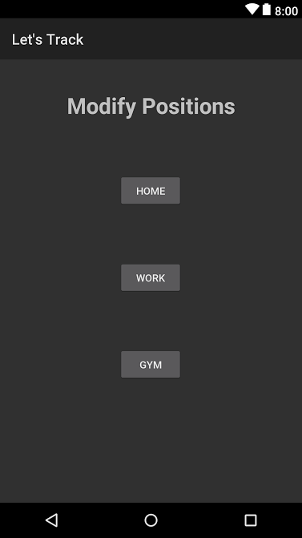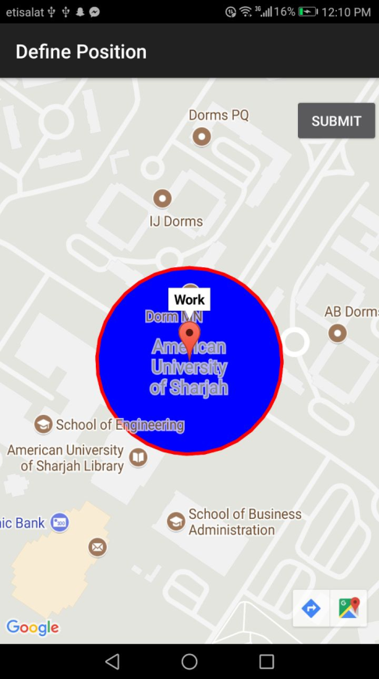
Figure 6: Pin or update locations to Labels
The user can use this option to pin a location for each label and clicking on any of the four options, on the screen shown in Figure 7, which will direct them to the map in the Figure 9, where they can pinpoint the corresponding location for the label on the map.
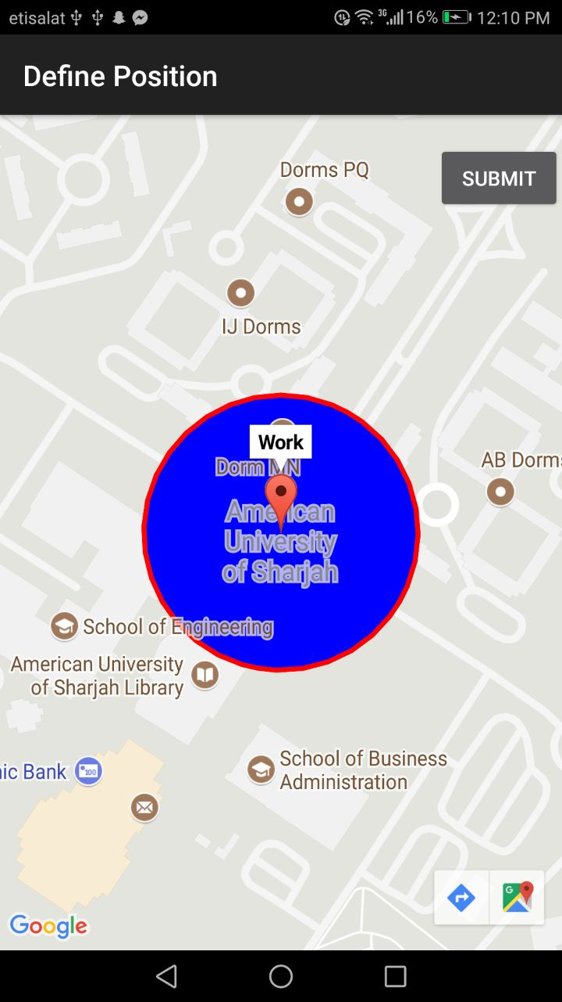
Figure 7: Setting Label Locations
The user will be able to access map services, as shown in Figure 9, from where the user can pin a location for the associated labels.

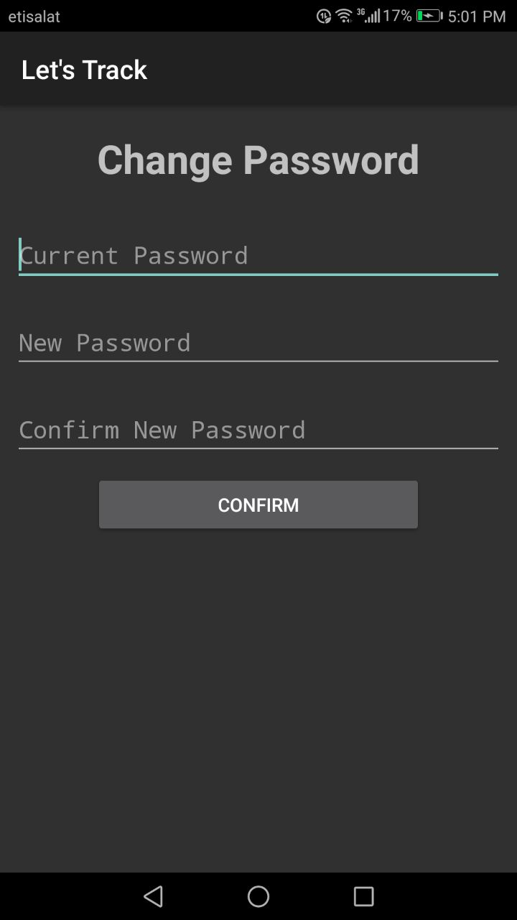
Figure 8: Change Password
The user will be able change password using this GUI by entering the new password and the current password to confirm the user, as shown in Figure 10.

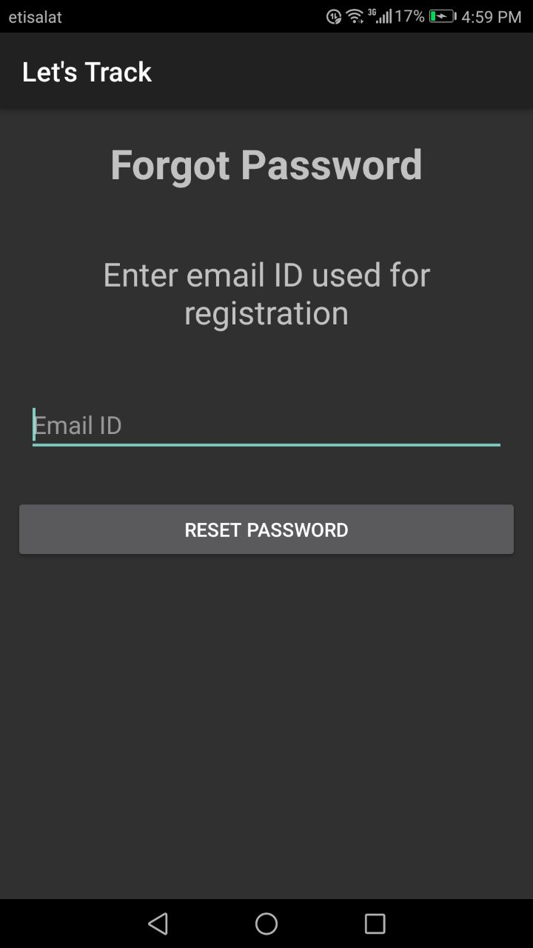
Figure 9: Forgot Password
The user will be able reset his/her password, if the password was forgotten, by entering the e-mail ID the user used to register to the app, as shown in Figure 11. A link to reset the password will be sent to the user’s e-mail ID.
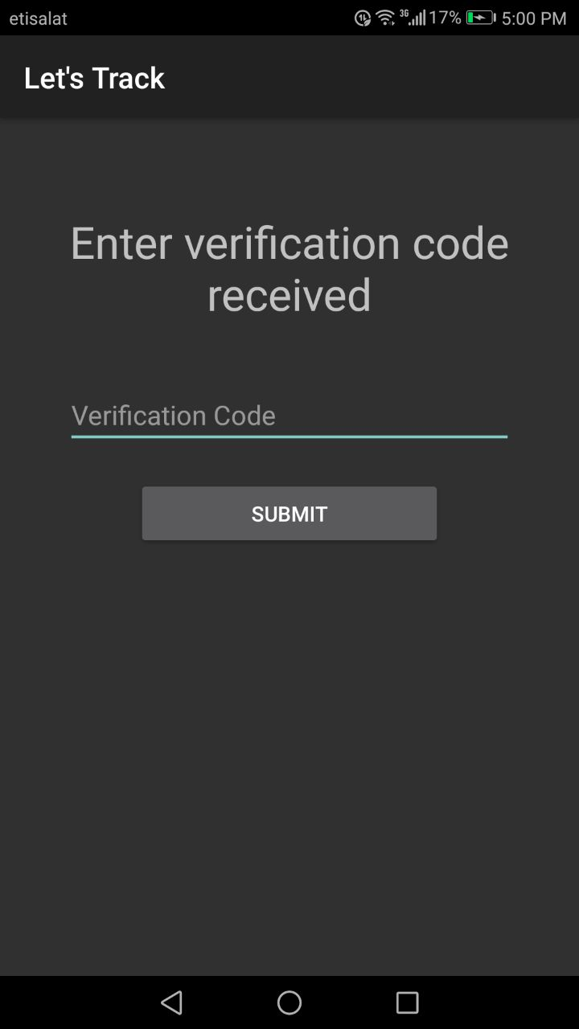
Figure 10: Verification Code
In order to authenticate the account and confirm the mobile number of the user, a confirmation SMS will be sent upon registration which needs to be entered in the GUI as in Figure 12.

External Interfaces and Database Requirements
The external interfaces connected with our app are:
- Google Firebase cloud real-time database.
- Google Firebase authentication service.

The logical organization of the database involves:
The Firebase authentication service consists of a table with the e-mail IDs of the users and their hashed passwords. The Firestore real-time database stores the user details in a ‘document’ which is identified by a unique user ID for querying purposes. This document contains the e-mail ID, contact number, location coordinates for the app’s pre-defined labels (‘Home’, ‘Work’, ‘Gym’) and the connected contacts’ username and e-mail ID.

Error Handling
The following are the errors/ exceptions that will be addressed by the application.
- If the user declines access to location services, the app will prompt the user to switch the location services on or exit the app.
- If the user does not have internet access, the last saved locations in the database are displayed.
- When the contacts that the user is tracking is not at any of the pre-defined labels, the home screen will show the contact to be at the tag “Others”.

Foreseeable Functional Changes and Enhancements
- Develop a desktop widget of the clock so that the user does not have to open the app each time s/he wants to know the locations of their connected contacts.
- Include a feature that allows the user to view the exact location on the map of the connected user upon tapping on their corresponding clock hand.
- Add more labels, for example “Hospital” so that if a connected user is in any hospital in the region, their corresponding clock hand points to the Hospital label.

Non-Functional Requirements
Non-functional requirements are the implicit requirements of the system. Through these we make sure the system is optimized every way possible. The OS required is Android 5.0 (Lollipop). The main constraints include the constant functioning of the location services and Wi-Fi network in the mobile device. The following are some of the major non-functional requirements that need to be fulfilled in order to achieve our objective through this project.
- The app should be simple and straightforward to use. The features made available in the application should be easily visible and accessible.

- Since the app is required to sync the locations of the connected contacts in real-time, the response time of the app is very critical and should be not more than 10^-3 seconds.

- As the app is registered to by providing sensitive information of the user like phone number it is important that this information is properly encrypted and stored.
- The information provided by the app should be accurate, hence, the current location of the user should be classified under the appropriate label with an accuracy of 99%.

- The app is meant to work in near real-time and therefore it is necessary that the location of the users are updated frequently within 10 seconds.

- Location services such as GPS and SMS services should be accessible by the app on the user’s phone.

- The system should be active for 99.9% of the time during a 24-hour period and any maintenance should be done during off-peak hours.

- The database should be able to recover within 5-10 seconds in case of a crash.

Product Requirements
Since the purpose of our application is to track people real-time, it is essential to maintain certain quality factors like:
- Reliability:
To make sure the users are informed precisely of their connected contacts’ locations, the app should be quick to sync the locations and should also correctly depict the location under the appropriate pre-defined labels.
- Security:
In order to register to the app, the user is required to provide sensitive information about oneself. Hence, it is important that this information is well encrypted. In order to achieve this, it is necessary that the user is informed about any change in these details.
- Robustness:
The application should remain stable at all times. It should respond quickly and effectively in case it crashes. If the database crashes, the application should save the last updated location of the connected users. If necessary, the user should be automatically logged out of the app as well.

Error Handling
As the response time is crucial to our application it is important that there is proper error management.
- In the case of a response time delay, the app should notify the connected users of the time the location was last updated.
- Security being another important function of the app, it is important that the user remains informed about any sort of breach that might happen. Taking the case of a password reset, the user has to be notified about such an activity through the registered email.

Development Requirements
N/A

Foreseeable Non-Functional Changes
- Make the app available across other platforms such as iOS App Store.
- In case of a doubt or a concern, the user should be able to contact the right people through a readily available service which should be reachable from the main interface.

Remarks and Guidelines for Later Lifecycle Phases
One of the pitfalls is that they user can track their connected contacts only at the pre-defined labels. More functionality can be added at a later stage by allowing users to add custom labels.
Currently, the app only facilitates connections to a maximum of five contacts which can be expanded upon, in the future.

Glossary and Index
N/A

