Event Horizon

Software Requirements Specification Document

Team 7
American University of Sharjah
College of Engineering
Computer Science and Engineering

Version 0: SRS-02152018

Table of Content

1 Introduction 4
1.1 System Overview 4
1.2 Operating Environment 4
1.3 Conceptual Model 4
2 Functional Requirements 5
2.1 User Interface Specifications 9
2.2 External Interfaces and Database Requirements 12
2.3 Error Handling 12
2.4 Foreseeable Functional Changes and Enhancements 12
3 Non-Functional Requirements 13
3.1 Error Handling 14
3.2 Development Requirements 14
3.3 Foreseeable Non-Functional Changes 14
4 Glossary and Index 14

Introduction

System Overview
EventHorizon is a web-based platform application that is a one-stop destination for everything event related, and aims to provide ease of business in this field and improve social connectedness. The application allows organizers, suppliers and attenders to set up, provide services and go to events respectively. Firstly, for organizers, the application will have a listing of all the locations, vendors, and other necessary factors to host an event, along with each amenities’ pricing. Secondly, suppliers can post their services, equipment’ and products on their profile which is indexed by the search engines available to the organizers filtered by location and type of service. Lastly, attendees simply open the platform and browse available events near them in real time either or filter by their interest.

Operating Environment
Cross browser and cross platform compatibility for browsers supporting and handling HTML5, CSS3.0, JavaScript, mobile and desktop efficiently with fast response times. For desktop browsers, minimum browser version requirements are Chrome 30, Firefox 30, Edge 12, Safari 10.0 running on Windows 7 or higher, MacOSX Lion (10.7). For mobile browsers Samsung 2.0, Firefox Mobile 47 running on iOS 5.0 or higher and Android 4.0 or higher. This application requires internet access and GPS for location services.

Conceptual Model
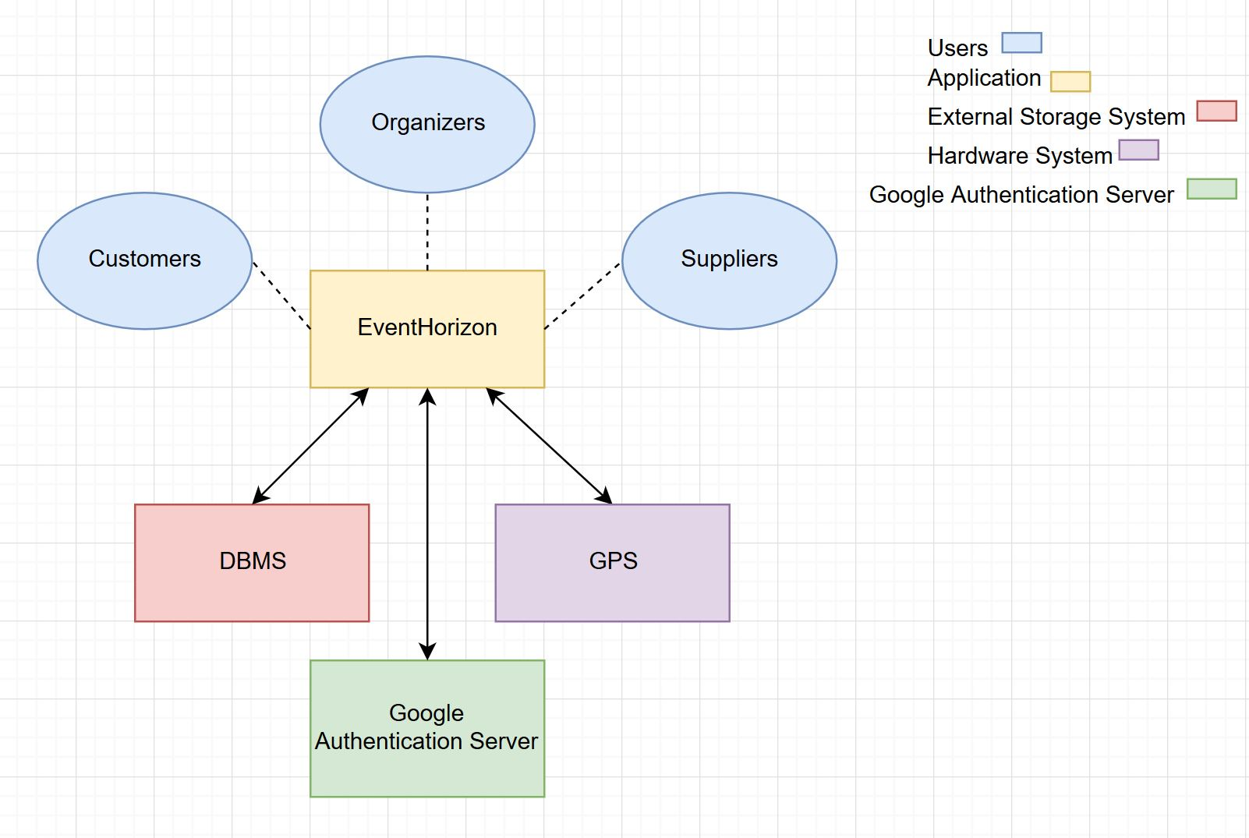

Functional Requirements

- There would be a sign-up option for users who want to make an account.
FR 1.1 Sign up Page: The user should be able to use the sign-up page to create an account. The sign-up page asks for an email, password and the individual or company’s name.

FR 1.1.1 The password field has a text next to it, letting the user know that the password should be 6 to 10 characters long and must be alphanumeric. It must have at least one number and at least one character of the alphabet.
FR 1.1.1.1 If the password does not follow this requirement, the login page displays an error message in red, telling the user which requirement they are missing.
FR 1.1.2 Once the sign up has been done successfully, the website should send a confirmation email to the user and display to the user that this email has been sent. This email contains an activation link.
The user needs to log into their email and click the activation link to activate their account.
FR 1.1.3 Once the user clicks the activation link, the website is opened in a new window.
The page opened will contain a message letting the user know their account has been activated. It will also contain a "log in" link which will bring the user to the log in page to let them start using their account. It will also contain a "home page" link which will bring the user to the home page of the website.
FR 1.2 Log in Page The user should be able to log into their account using the login page, which asks for the email and password.

FR 1.2.1 If the password or email is entered wrong, the login page displays a message letting the user know that their email or password is incorrect.

FR 1.2.2 The login page should have a link titled "forgot password?" in case the user has forgotten their password.

FR 1.2.2.1 The "forgot password?" link opens a new tab, which will ask the user if they want to create a new password and will have a confirmation button.

FR 1.2.2.2 Once the user clicks the confirmation button, the website sends an email to the user containing a new password generated by the website.

- There should be an organizer portal profile.
FR 2.1. User can keep track of their events, see a history of the events organized, favorite suppliers, favorite locations, change password, provide/change their phone number and set default location.
FR 2.1.1. All currently active events and related information such as order status, venue confirmation, possible delays in item delivery, withdrawal of suppliers or cancellations by customer can be seen here.
FR 2.1.2. All events ever conducted by the user will be stored and can be sorted by chronological, total pricing, or name in ascending or descending order.
FR 2.1.3. Favorite suppliers are user preferred suppliers who will be pushed to the top of the user's search lists for subsequent events.
FR 2.1.4. Favorite locations are user preferred locations and available venues at these places would be shown with priority over others.
FR 2.1.5. Password can be changed on the platform itself by entering the old one, and new one twice for security and mistaken entry.
FR 2.1.5.1 A mail will be sent to the user email notifying a password change and will provide an option to temporarily lock the account and allow user to reset his password.
FR 2.1.6. User can provide phone number or not and will be able to choose the visibility to everyone on platform, all suppliers, all users or custom selection.
FR 2.1.7 Default location can be user defined or auto by allowing access to GPS.

- Organizer Portal Event Creation
FR 3.1. The user will have the option to manual create and name a new event, or a template based on user event history, auto-make or co-organize.
FR 3.2. Creating manual event allows user to customize every aspect.
FR 3.2.1 The user can state the type, the purpose and description of the event along with an expected number of occupancy and the date and time as well as the budget for this event.
FR 3.2.1.1 The about event form can support images, links to external websites alongside normal text.
FR 3.2.2 The user is then presented with the option to search for a location, venue or browse through popular ones nearby the user.
FR 3.2.3 presented with the option to search for a location, venue or browse through popular ones nearby the user.
FR 3.2.4 The user is able to look for catering services, security, staff, volunteers and even entertainers for the event by either filtering options or find recommended ones.
FR 3.2.5 Finally the user sets the event visibility to private (with an access code) or public so attenders can find it.
FR 3.3 Auto-Make allows user to just input type, purpose, description, timings, required services, equipment, looking for co-organizer and select the advertise option.
FR 3.3.1 The advertise option publishes the user's needs onto a general feed where interested suppliers and service providers can "bid" and show interest in the event.
FR 3.4 Co-organize option allows organizers the potential to increase the scope of their event by teaming up with another organizer setting up a similar event.

- There should be a Customer Portal
FR 4.1 Customers should be able to search feature for venues, vendors and events
FR 4.1.1 Searches should allow filtering through:
FR 4.2.1.1 Data available
FR 4.2.1.2 Venue Location
FR 4.2.1.3 Minimum / maximum book time
FR 4.2.1.4 Price per unit
FR 4.2.1.5 Service type eg: Hall, flowers, lighting, photo booth, catering, etc.
FR 4.2 Customers should be recommended public events around them
FR 4.2.1 On login or through email
FR 4.2.2 Depending on proximity and tastes specified during sign up
FR 4.3 Customers should be able to view pages with vendor’s or venue’s services
FR 4.3.1 Details listed such as: price, description of venue or service provided, contact details such as website, number, etc., reviews
FR 4.4 Customers should be able to add different services to a cart
FR 4.4.1 Continue shopping while adding
FR 4.4.2 Be displayed a total amount on the cart page
FR 4.4.3 Pay with credit card to confirm booking
FR 4.5 Customers should be sent email notifications after confirmation
FR 4.5.1 With event details such as: duration, arrival time, vendor numbers, vendor setup times
FR 4.6 Customers should be able to view active or completed orders
FR 4.6.1. To post reviews
FR 4.6.2 To open complaints

FR 5. There should be a Supplier Portal: The page dedicated to suppliers.
FR 5.1 Profile Page: The profile page of a supplier is displayed to event organizers who are looking for further information on a specific supplier. The profile page has an "edit" button displayed to the supplier only, which allows the supplier to add or edit information. This page asks for the following information from the supplier:

FR 5.1.1 Company Name

FR 5.1.2 The type of supplies the supplier provides
For example: venue, tables, chairs, plates, food, etc. The supplier must be able to input a list of all the supplies they can provide.

FR 5.1.2.1 If the supplier provides food, extra options appear which ask for the details of their food.

FR 5.1.2.1.1 The supplier should be asked what kind of cuisine they provide.
Options are: fast food, desserts, international, drinks, healthy, any country (e.g. Japanese, Emirati, etc.) The supplier should be able to choose one or more options.

FR 5.1.2.1.2 The supplier should be asked to attach a pdf file of their menu.

FR 5.1.3 A link to the Item Menu will be displayed on the supplier's profile.

FR 5.1.4 A picture of the supplier's logo will be displayed on the profile page.

FR 5.2 Item Menu This page can be accessed by the event provider. It contains a list of all items provided by a certain supplier. A link to this menu is available on the supplier's profile.

FR 5.2.1 Name of Item

FR 5.2.2 Picture of Item

FR 5.2.3 Price of Item: If item is being loaned, price per hour.

FR 5.2.3.1 If Item is a venue:

FR 5.2.3.1.1 The number of guests their venue can accommodate (by ranges)
The ranges are (0-50), (50-100), (100-250), (250-500), (500-1000), (1000-5000), (5000-10000), (10000+)

FR 5.4.3.1.2 The size of the venue in square meters

FR 5.4.3.1.3 The full address of the venue

FR 5.2.3.1.4 The type of events the venue is suited to
Options are: Seminar, Conference, Theme party, Birthday party, Trade show, Wedding, Soirée, Class Reunion, Concert, Theater, Standup. The user can choose one or more of the options.

FR 5.2.4 The amount of time it takes the supplier to provide the item or venue (within ranges)
The ranges include: within a week, one to two weeks, two weeks to a month, one to two months, two to four months, four to six months, more than six months

FR 5.2.5 For suppliers providing food or items, the number of items they can supply (within a range)
The ranges are (0-50), (50-100), (100-250), (250-500), (500-1000), (1000-5000), (5000-10000), (10000+)

FR 5.2.6 Whether they are selling or loaning their supplies

5.4.6.1 If they are loaning, the minimum and maximum number of hours they are willing to loan it for.

FR 5.2.7 Buy Button
Each item has a buy button next to it. The event organizer can click the buy button of an item if they want to buy it.

FR 5.2.7.1 The event organizer will then be asked how many of the item they want to buy.

FR 5.2.7.2 The event organizer can click the "add to cart" button which will add the number of items asked into their cart.

User Interface Specifications
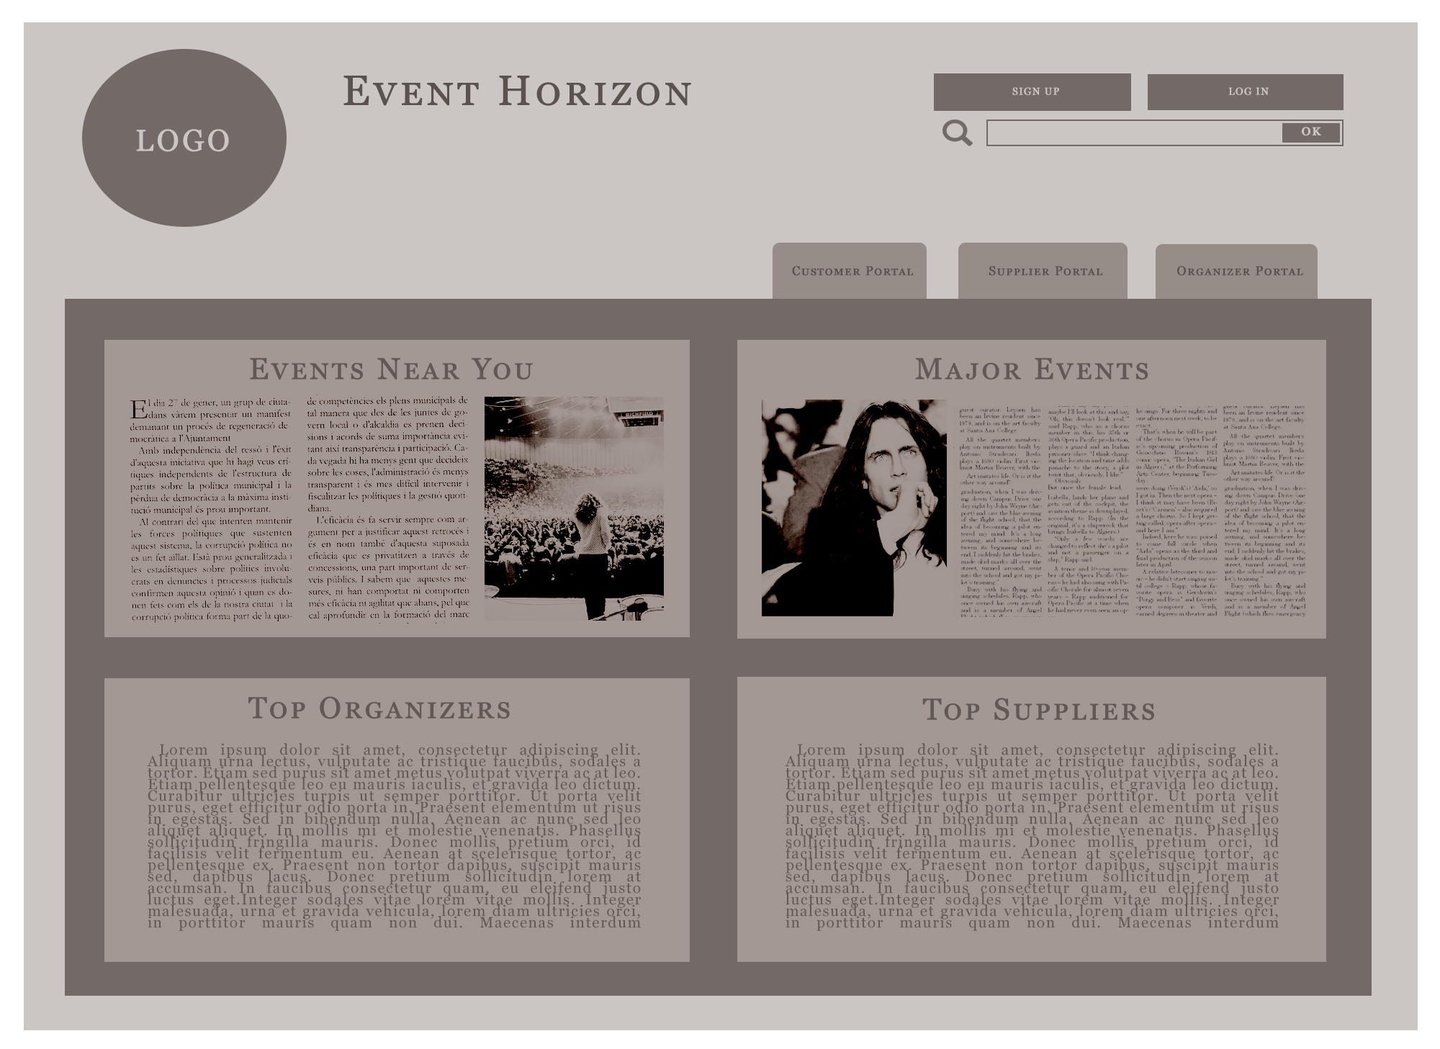
The homepage has the sign up, login and search features on top. The feed that occupies the middle shows nearest events, major events, top suppliers and organizers and the tabs towards the top left show the portals for organizers, suppliers and attendees.

The sign up page allows you to enter username, password, email and select user type.
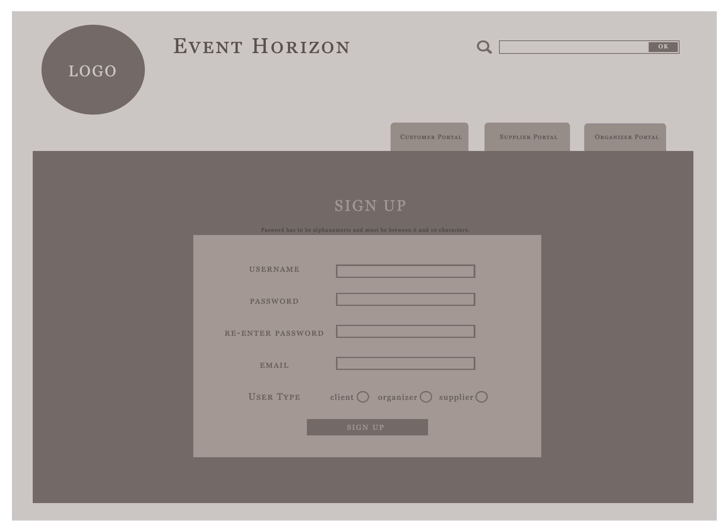
An example page depicting the organizer view of the supplier profile, allowing organizer to access the inventory of the supplier.
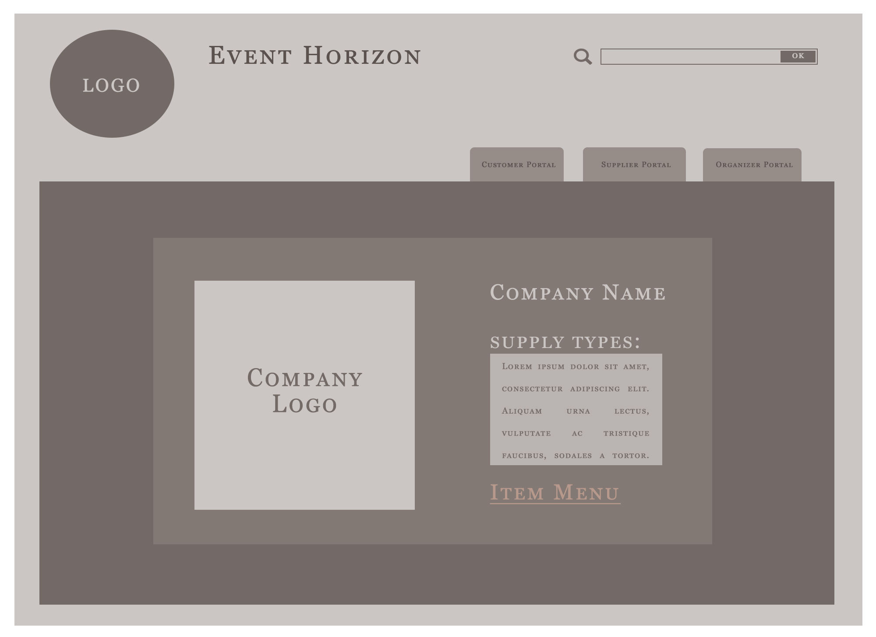

External Interfaces and Database Requirements
The application will require connections to the Oracle SQL Database, which is where the data is stored and to the Google Authentication Server so that users can sign that in with their google account. The GPS in the mobile devices will provide location information on platform, while Google geolocation API’s will be used identify location on desktops.

Error Handling
Plausible error scenarios Event Horizon will encounter and handling approaches as follows:
ERR2.1.1: Failure to establish secure connection for payment during purchase, notify user to try again and terminate connection.
ERR2.1.2: After event creation and total quote is calculated, if vendors update lesser stock or is unavailable, so check all event participants status every 1 hours or right after payment option is selected.

Foreseeable Functional Changes and Enhancements
Subsequent updates would incorporate following features:
- Push notifications informing of real time events.
- Improvements to the Organizer’s ADVERTISE/COORGANIZE feature and make it more streamlined.
- Offer discount program to regular organizers and attenders on bookings after accumulating booking points.
- A new feature to help attendees find other attendees with similar interests for sharing of resources in ways such as carpooling, and social inclusion element where they can go to events in bigger groups.
- A new feature where vendors can “bid” on the Organizers ADVERTISE/COORGANIZE.
- Auto-Page translation based on location.

Non-Functional Requirements
NFR 1. The platform should be user-friendly such that one can understand how to utilize 70% of the features with less than 20 minutes of access.
NFR 1.1. Sign up verification should be within 10 seconds.
NFR 1.2. Search results should load and display within 2 seconds. If no response, time out after 10 seconds.
NFR 1.3. Customer password should be protected with AES-256 protection before transmission.
NFR 1.4. Customers should only be allowed retrial after wrong password 5 times.
NFR 1.5. Database should be protected with alphanumeric password.
NFR 1.6. Server should implement DDoS protection from CloudFlare.
NFR 1.7. Website should be scalable across displays from 3.5’ to desktop sizes.
NFR 1.8. System should respond to an error situation in less than 10 seconds.
NFR 2. The platform should be designed in HTML5, CSS3 and Javascript to allow compatibility across mobile and personal computer systems.
NFR 2.1. Use Oracle SQL database to store data.
NFR 2.2. Use HTML5, CSS for front end formatting and UI.
NFR 2.3. Use JS to code back-end functions.
NFR 2.4. Maximum number of database connections per IP is 2.
NFR 2.5. Maximum number of direct technician access to database is 1.
NFR 2.6. Application web pages should be structured in a hierarchical structure.
NFR 3. The platform must support external systems to provide a seamless integration of multiple services with the base application.
NFR 3.1. Support both Visa and MasterCard online payment.
NFR 3.2. Use Google Maps API to find location of venues, and events users.
NFR 3.3. Use Google Images API to find additional photographs of locations.
NFR 3.4. Allow users to sign up with Google accounts.

Error Handling
ERR 3.1.1. All exception calls should notify system maintainers through email.
ERR 3.1.2. All errors should also show a customized error web page.
ERR 3.1.3. If no response from payment service, time out after 10 seconds.
ERR 3.1.4. If no response from database, time out after 5 seconds.
ERR 3.1.5. If webpage is not found, show a custom 404 page.

Development Requirements
The entire application must be coded according to the stated languages to ensure coordination with the company’s current application portfolio. Abiding by these rules is a must to ensure that staff can troubleshoot, maintain and update the application efficiently.
3.2.1. As mentioned, the entire web application should use HTML5, CSS3 and Oracle SQL. Back end must be in PHP.

Foreseeable Non-Functional Changes
3.3.1. Due to the nature of commercial database management software, using an open source database may be necessary in the future, such as MariaDB or MongoDB.

Glossary and Index
Not Applicable as of now.

