
MINISTRY FOR EDUCATION AND SCIENCE OF RUSSIA
________________________________

SAINT PETERSBURG ELECTROTECHNICAL UNIVERSITY

«LETI»
________________________________

APPROVED

___09.04.2020___
Date, signature

Class organizer application
(COALA)

PROJECT MANAGEMENT PLAN / РАСШИРЕННОЕ ТЕХНИЧЕСКОЕ ЗАДАНИЕ
наименование документа

PMP_1_00.10

Electronic & Paper / Электронный и бумажный
вид носителя данных

10 pages / страниц
объём документа

St. Petersburg / Санкт-Петербург
2020
HISTORY / История версий

Version #/ Версия № | Author / Кто разработал | Data / Дата | Short description / Причина
00.10 | Захра Доросткар | 05.03.20 | Check point 1  The first version of SOW/ Первый вариант детализации содержания проекта
00.20 | Захра Доросткар | 27.03.20 | Check point 2  Detail requirements, gant diagram / Детализация требований, обновлена диаграмма Ганта
00.30 | Захра Доросткар | 10.04.20

Project team / Список исполнителей

№ | Name / ФИО | Group / Группа | Project role / Обязанности | Contact Information / Контактные данные (email/телефон)
1 | Dorostkar Zahra | 5300 | PM, test lead, dev, CM | zahradorostkar@yahoo.com
2
3
4

Teacher / Преподаватель
Filippov Evgeny Vasilyevich / Филиппов Евгений Васильевич e.philippov.leti@mail.ru
Burukin Stanislav / Бурукин Станислав
"Burukin, Stanislav" SBurukin@luxoft.com

AGENDA / содержание
1. BASIS FOR DEVELOPMENT / Основание для разработки 4
2. DEVELOPMENT GOALS / Назначение разработки 4
3. Detail requirements / детальные требования 4
4. high level design / Высокоуровневый дизайн 4
5. work breakdown structure and efforts estimation/ Иерархическая структура работ и оценка трудоемкости 5
6. Key milstones / Стадии и этапы разработки 6
7. Chosen technology and development framework / Описание средств разработки 6
8. configuration and change management / План управления конфигурацией и изменениями 7
9. project specific process, quality plan, metrics / Процесс проекта, План по качеству, метрики 8
10. project risks / проектные риски 9
11. project schedule (gant diagram) / предполагаемый график работ (диаграмма ганта) 9
12. Test plan / план по тестированию 9

BASIS FOR DEVELOPMENT / Основание для разработки
Development is carried out on the basis of the requirements for the course work in the discipline "Software Engineering" / Разработка ведется на основании требований к выполнению курсовой работы по дисциплине «Технологии разработки программного обеспечения».
Full name of the project / Полное наименование проекта
Class Organizer Application Longtime Assisstant
Short name of the program (nick-name, 4-5 characters) / Краткое наименование проекта (4-5 символов)
COALA

DEVELOPMENT GOALS / Назначение разработки
The software product is intended to help students manage their classes throughout their school career. COALA manages all the important aspects of classes, allowing to add classes, remove class, calculate your grades, and easily access information from any class, past or present.

Detail requirements / детальные требования
Numbered list of requirements should be here.

high level design / Высокоуровневый дизайн
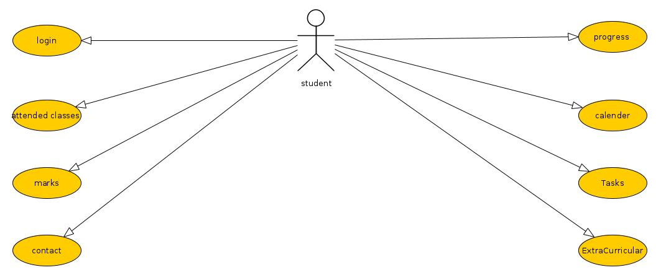

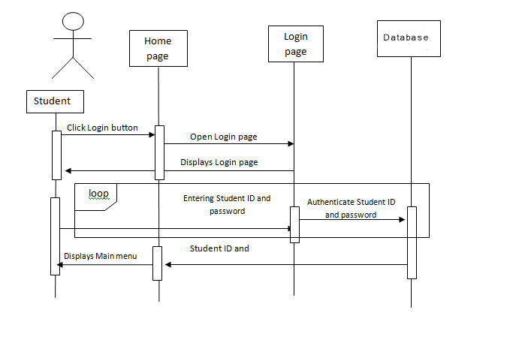

To be completed...

work breakdown structure and efforts estimation/ Иерархическая структура работ и оценка трудоемкости

The WBS Dictionary defines all work packages for the COALA Project. These definitions include all tasks, resources, and deliverables. Every work package in the WBS is defined in the WBS Dictionary and will aid in resource planning, task completion, and ensuring deliverables meet project requirements.

The COALA Project schedule was derived from the WBS and Project Charter with input from all project team members. The schedule was completed, reviewed by the Project Sponsor, and approved and base-lined. If established boundary controls may be exceeded, a change request will be submitted to the Project Manager. The Project Manager and team will determine the impact of the change on the schedule, cost, resources, scope, and risks. If it is determined that the impacts will exceed the boundary conditions then the change will be forwarded to the Project Sponsor for review and approval. The COALA boundary conditions are:

CPI less than 0.8 or greater than 1.2
SPI less than 0.8 or greater than 1.2

If the change is approved by the Project Sponsor then it will be implemented by the Project Manager who will update the schedule and all documentation and communicate the change to all stakeholders in accordance with the Change Control Process.

The Work Breakdown Structure is provided in Appendix A, Project Schedule and Appendix B, Work Breakdown Structure.

To be completed...

Key milstones / Стадии и этапы разработки
Tableb 1. Key milstones / Таблица 1. Ключевые даты
## / № | Start date / Начало | End date / Конец | Description / Описание
1 | 07.02.20 | 28.02.20 | SOW developed, reviewed and signed
2 | 29.02.20 | 13.03.20 | Project planning
3 | 13.03.20 | 10.04.20 | Project development
4 | 10.04.20 | 15.05.20 | Project development
5 | 15.05.20 | 29.05.20 | Course project completed, presentation and final report prepared for defense

Chosen technology and development framework / Описание средств разработки
Used technologies and development framework:
- VisualStudio
- Netframwork
- WPF
- Entityframwork
- CodeFirst
- Sqlite
- Migration

configuration and change management / План управления конфигурацией и изменениями
The following steps comprise TSI’s organization change control process for all projects and will be utilized on the COALA project:

Step 1: Identify the need for a change (Any Stakeholder)
Requester will submit a completed TSI change request form to the project manager
Step 2: Log change in the change request register (Project Manager)
The project manager will maintain a log of all change requests for the duration of the project
Step 3: Conduct an evaluation of the change (Project Manager, Project Team, Requester) The project manager will conduct an evaluation of the impact of the change to cost, risk, schedule, and scope
Step 4: Submit change request to Change Control Board (CCB) (Project Manager)
The project manager will submit the change request and analysis to the CCB for review
Step 5: Change Control Board decision (CCB)
The CCB will discuss the proposed change and decide whether or not it will be approved based on all submitted information
Step 6: Implement change (Project Manager)
If a change is approved by the CCB, the project manager will update and re-baseline project documentation as necessary as well as ensure any changes are communicated to the team and stakeholders

Any team member or stakeholder may submit a change request for the COALA Project. The COALA Project Sponsor will chair the CCB and any changes to project scope, cost, or schedule must meet his approval. All change requests will be logged in the change control register by the Project Manager and tracked through to completion whether approved or not.

project specific process, quality plan, metrics / Процесс проекта, План по качеству, метрики
All members of the COALA project team will play a role in quality management. It is imperative that the team ensures that work is completed at an adequate level of quality from individual work packages to the final project deliverable. The following are the quality roles and responsibilities for the COALA Project:

The Project Sponsor is responsible for approving all quality standards for the COALA Project. The Project Sponsor will review all project tasks and deliverables to ensure compliance with established and approved quality standards. Additionally, the Project Sponsor will sign off on the final acceptance of the project deliverable.
The Project Manager is responsible for quality management throughout the duration of the project. The Project Manager is responsible for implementing the Quality Management Plan and ensuring all tasks, processes, and documentation are compliant with the plan. The Project Manager will work with the project’s quality specialists to establish acceptable quality standards. The Project Manager is also responsible for communicating and tracking all quality standards to the project team and stakeholders.
The Quality Specialists are responsible for working with the Project Manager to develop and implement the Quality Management Plan. Quality Specialists will recommend tools and methodologies for tracking quality and standards to establish acceptable quality levels. The Quality Specialists will create and maintain Quality Control and Assurance Logs throughout the project.

The remaining member of the project team, as well as the stakeholders will be responsible for assisting the Project Manager and Quality Specialists in the establishment of acceptable quality standards. They will also work to ensure that all quality standards are met and communicate any concerns regarding quality to the Project Manager.

Quality control for the COALA Project will utilize tools and methodologies for ensuring that all project deliverables comply with approved quality standards. To meet deliverable requirements and expectations, we must implement a formal process in which quality standards are measured and accepted. The Project Manager will ensure all quality standards and quality control activities are met throughout the project. The Quality Specialists will assist the Project Manager in verifying that all quality standards are met for each deliverable. If any changes are proposed and approved by the Project Sponsor and CCB, the Project Manager is responsible for communicating the changes to the project team and updating all project plans and documentation.

Quality assurance for the COALA Project will ensure that all processes used in the completion of the project meet acceptable quality standards. These process standards are in place to maximize project efficiency and minimize waste. For each process used throughout the project, the Project Manager will track and measure quality against the approved standards with the assistance of the Quality Specialists and ensure all quality standards are met. If any changes are proposed and approved by the Project Sponsor and CCB, the Project Manager is responsible for communicating the changes to the project team and updating all project plans and documentation.

project risks / проектные риски
The approach for managing risks for the COALA Project includes a methodical process by which the project team identifies, scores, and ranks the various risks. Every effort will be made to proactively identify risks ahead of time in order to implement a mitigation strategy from the project’s onset. The most likely and highest impact risks were added to the project schedule to ensure that the assigned risk managers take the necessary steps to implement the mitigation response at the appropriate time during the schedule. Risk managers will provide status updates on their assigned risks in the bi-weekly project team meetings, but only when the meetings include their risk’s planned time-frame.

Upon the completion of the project, during the closing process, the project manager will analyze each risk as well as the risk management process. Based on this analysis, the project manager will identify any improvements that can be made to the risk management process for future projects. These improvements will be captured as part of the lessons learned knowledge base.

project schedule (gant diagram) / предполагаемый график работ (диаграмма ганта)
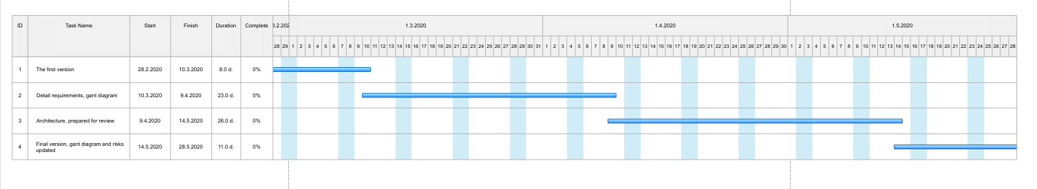

Test plan / план по тестированию
What kind of test types to be used (functional, performance, stress, cross platform, safety, usability, etc.), planned number of test cases for each type

