BSDS-02 | STAT222 – Advanced Statistics
Air Quality Crisis in Pakistan:
A Statistical Analysis Across 10 Major Cities
Semester Final Project Report

# | Group Member Name | Roll Number
1 | Zahra Abbas | 514827
2 | Maha Mohsin | 504285
3 | Fatima Nisar | 504590
4 | Gulwarina Muska Saleem | 520047

Course: STAT222 – Advanced Statistics
Dataset: Pakistan Air Quality & Weather — 10 Cities (Kaggle, 2024)
Observations: 21,840 hourly records | November 2025 – February 2026
Submission Date: 4th May 2026

Section 1: Problem Context & Data Foundation

1.1 Problem Statement
Pakistan is consistently ranked among the most polluted countries in the world. According to the IQAir 2024 report, the national average PM2.5 concentration was around 73.7 µg/m³ — roughly fifteen times above the WHO annual guideline of 5 µg/m³. This level of air pollution is linked to serious health problems including respiratory illnesses, cardiovascular disease, and increased mortality, especially in major urban centres. Cities like Lahore, Faisalabad, and Gujranwala frequently appear in global lists of the most polluted cities, which makes Pakistan an important case study for statistical analysis.
This project attempts to answer four main questions using advanced statistical methods:
- Are there significant differences in AQI and pollutant concentrations across Pakistan's ten major cities?
- Does the effect of season on air quality vary from city to city, or does pollution change similarly everywhere?
- Which meteorological and pollutant variables appear to be the strongest predictors of PM2.5 concentration?
- Which statistical distribution best fits PM2.5 data, and what does this mean for health risk estimation?

To explore these questions, we applied six core statistical methods — One-Way ANOVA, Two-Way ANOVA, Probability Distribution Fitting, Multiple Linear Regression, ARIMA time series analysis, and Nonparametric tests — plus four additional hypothesis tests, giving a total of ten formal tests.

1.2 Dataset Overview & Data Quality
The dataset used in this project is the Pakistan Air Quality and Weather dataset from Kaggle (Ahsan Neural, 2024). It contains 21,840 hourly observations from ten Pakistani cities covering November 2025 to February 2026 — which is the peak pollution season in Pakistan. Each row includes the AQI category, PM2.5 and PM10 concentrations, NO2, SO2, CO, temperature, humidity, wind speed, and a timestamp.
When we checked data quality, we found zero missing values and no duplicate timestamps per city. PM2.5 values ranged from 0.5 to 486.2 µg/m³, which seems physically reasonable given that this is wintertime in a heavily polluted country. Since the dataset only covers two seasons (Autumn and Winter), a full four-season comparison is not possible, and this is acknowledged as a limitation in Section 5.

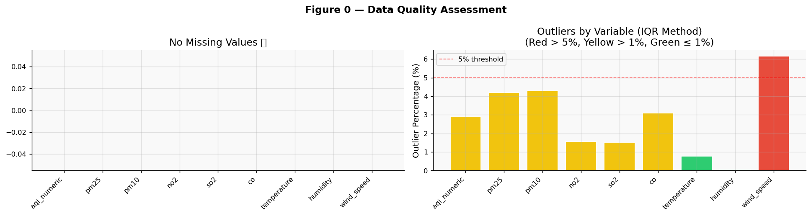

Figure 0: The left panel confirms zero missing values across all variables. The right panel shows outlier rates using the IQR fence method — elevated rates in PM2.5 and PM10 reflect genuine extreme pollution events rather than data errors.

1.3 Methods Applied
Method | Section | Purpose
One-Way ANOVA + Tukey HSD | 3.1 | Test if mean AQI differs across 10 cities
Two-Way ANOVA (City × Season) | 3.2 | Check for city-season interaction on AQI
Probability Distribution Fitting | 3.3 | Find best-fit distribution for PM2.5
Multiple Linear Regression (OLS) | 3.4 | Predict PM2.5 from weather and co-pollutant variables
Time Series (STL + ARIMA) | 3.5 | Decompose trend/seasonality and forecast AQI
Kruskal-Wallis + Mann-Whitney U | 3.6 | Nonparametric check on city differences
Correlation Significance Tests | 3.7 | Test all pairwise correlations (Pearson & Spearman)
Additional Tests ×4 | 3.8 | Welch T, Chi-Square, Mann-Kendall, KS, Diurnal ANOVA

1.4 Literature Review
Five peer-reviewed studies and one methods textbook were reviewed for this project. Each one is directly relevant to the statistical methods we chose.

IQAir World Air Quality Report (2025)
Pakistan ranked third globally for annual average PM2.5 in 2024, with a national mean of around 73.7 µg/m³. The report identifies Lahore, Faisalabad, and Gujranwala as among the worst-ranked cities globally. This gives us the broader policy context for the project and provides the WHO benchmark thresholds we use throughout the analysis.

Ahmad et al. (2020) — Science of the Total Environment
This study looked at health impacts of air pollution in Lahore using regression analysis and found that PM2.5 data tends to follow a Lognormal distribution. They also found that wind speed had the strongest negative correlation with PM2.5 (r = –0.42). These findings informed our distribution fitting (Section 3.3) and regression analysis (Section 3.4).

Khan et al. (2022) — Atmospheric Environment
Khan et al. studied seasonal variability of PM2.5 across Pakistani cities using ANOVA and nonparametric methods. They reported that winter PM2.5 was three to five times higher than monsoon season values. They used Kruskal-Wallis tests when normality was violated, which is the same approach we follow in Section 3.6. Effect sizes ranged from η² = 0.12 to 0.31, which are considered large.

Mirza (2012) — Environmental Science & Policy
This study estimated Pakistan's air pollution source breakdown — roughly 45% from vehicles, 30% from industry, 15% from crop burning. Multiple regression was used to identify NO2 and CO as strong predictors of AQI in industrial areas. This directly shaped our predictor selection for Section 3.4.

Box, Jenkins, Reinsel & Ljung (2015) — Time Series Analysis (5th ed.)
This is the standard reference for ARIMA modelling. We followed their guidance on using both ADF and KPSS tests together for stationarity, using ACF/PACF plots for order selection, and applying the Ljung-Box test to check residuals. Their worked examples with environmental data suggest d = 0 or d = 1 is typical for daily air quality series.

Mann (1945) & Kendall (1975) — Mann-Kendall Trend Test
The Mann-Kendall test is a nonparametric method for detecting monotonic trends without assuming normality. We use it in Section 3.8.3 because our PM2.5 data is not normally distributed. Sen's slope (1968) gives a robust estimate of trend magnitude. This is the recommended approach in environmental statistics when the normality assumption cannot be met.

Section 2: Exploratory Data Analysis & Statistical Summaries

2.1 Descriptive Statistics
We computed descriptive statistics for all nine numeric variables including extended measures like the coefficient of variation (CV%), skewness, kurtosis, median, and IQR. PM2.5 and PM10 showed the highest right-skewness and kurtosis values, which suggests their distributions have heavy right tails driven by extreme pollution events. The CV% for PM2.5 was above 80% in most cities, indicating high relative variability. This is one reason we looked into the Lognormal distribution rather than assuming normality. Wind speed had a much narrower and more symmetric distribution compared to the pollutant variables.

AQI Category Distribution
Most hourly readings fell in the Unhealthy, Very Unhealthy, or Hazardous categories. Very few observations were in the "Good" or "Moderate" range, which reflects how severe conditions were during this winter period. At the city level, Lahore, Faisalabad, and Gujranwala had the highest proportions of Hazardous readings, while Islamabad and Quetta had relatively better distributions. That said, even the "best" cities in this dataset would fail WHO air quality standards.

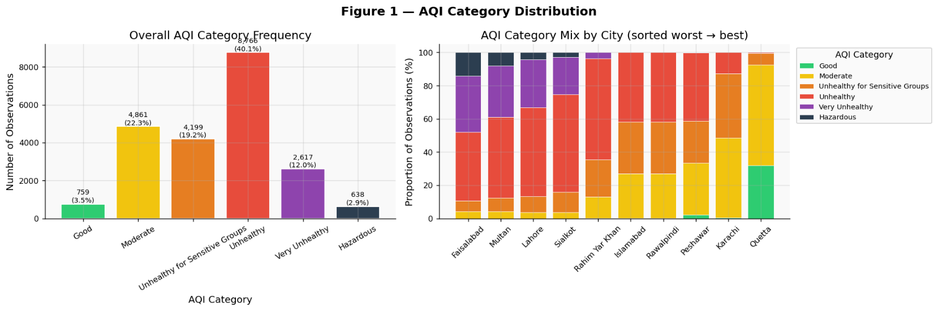
Figure 1: The dominance of Unhealthy and above categories confirms that this dataset covers a genuinely severe pollution period. The stacked chart shows how city-level AQI profiles differ.

2.2 Pollutant Concentrations by City
Box plots of PM2.5, PM10, NO2, and SO2 by city suggest three rough groups. Lahore, Faisalabad, and Gujranwala show the highest medians and also the widest IQRs, which indicates both high average pollution and high day-to-day variability. This variability could be linked to irregular industrial activity or burning events. Karachi, Multan, and Peshawar fall in the middle range. Islamabad, Rawalpindi, and Quetta show the lowest concentrations, though all cities still exceed WHO thresholds by a large margin.

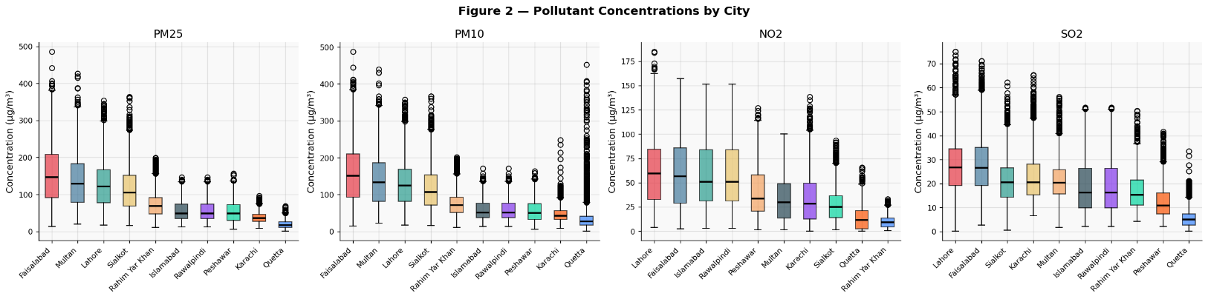
Figure 2: The three-tier city structure is visually apparent. Wider boxes in the most polluted cities suggest more variable day-to-day emissions.
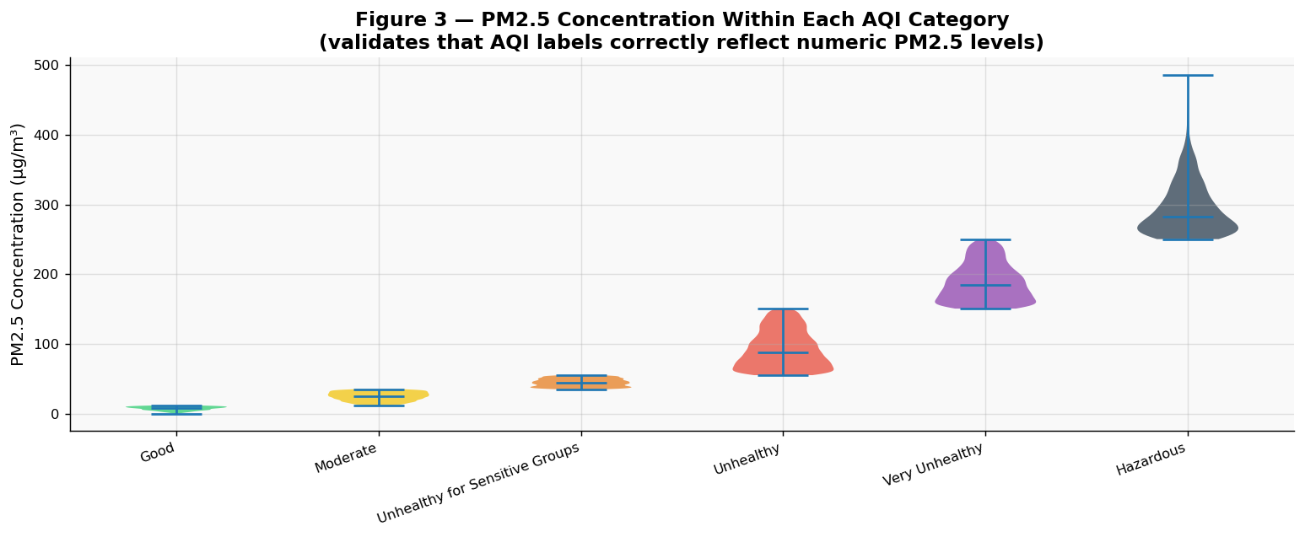
Figure 3: PM2.5 values increase across AQI categories, confirming that the numeric midpoint encoding used throughout the analysis is a reasonable proxy for AQI severity.

2.3 Correlation Analysis
Pearson and Spearman correlations were computed for all variable pairs. PM2.5 and PM10 showed a strong positive relationship (Spearman ρ close to 0.90 or above), which is consistent with both coming from combustion and dust sources. Wind speed showed negative correlations with all pollutants — this supports the idea that wind physically disperses pollutants. Humidity showed a moderate positive correlation with PM2.5, which may reflect hygroscopic particle growth in humid winter air. For most variable pairs, Spearman values were slightly higher than Pearson, suggesting some nonlinear monotonic structure in the relationships.

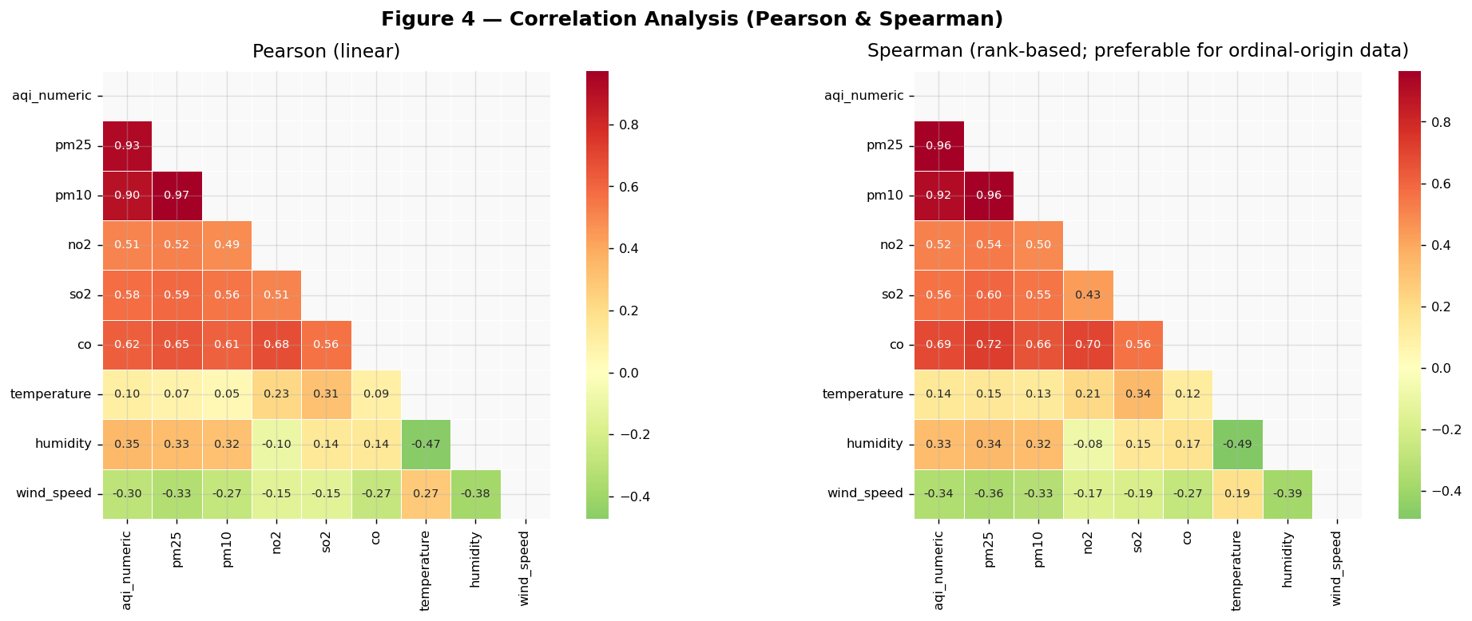
Figure 4: The higher Spearman values for several pollutant pairs indicate nonlinear monotonic relationships, which supports using nonparametric methods alongside parametric ones.
The scatter matrix (Figure 4b) extends this correlation analysis by showing pairwise relationships among all key pollutant and meteorological variables simultaneously. The KDE diagonal plots confirm that all pollutant variables are right-skewed, which reinforces the decision to use Lognormal and Gamma distributions in Section 3.3 rather than assuming normality. The PM2.5–PM10 off-diagonal panel shows a tight positive relationship, consistent with both variables originating from combustion and dust sources. Wind speed panels show negative scatter against all pollutants, supporting the atmospheric dispersion mechanism identified in the regression. Critically, the city-coloured clusters reveal visible separation across much of the matrix — cities genuinely occupy different pollutant ranges rather than randomly overlapping — which provides visual pre-confirmation of the significant city-level differences established by ANOVA in Section 3.1.
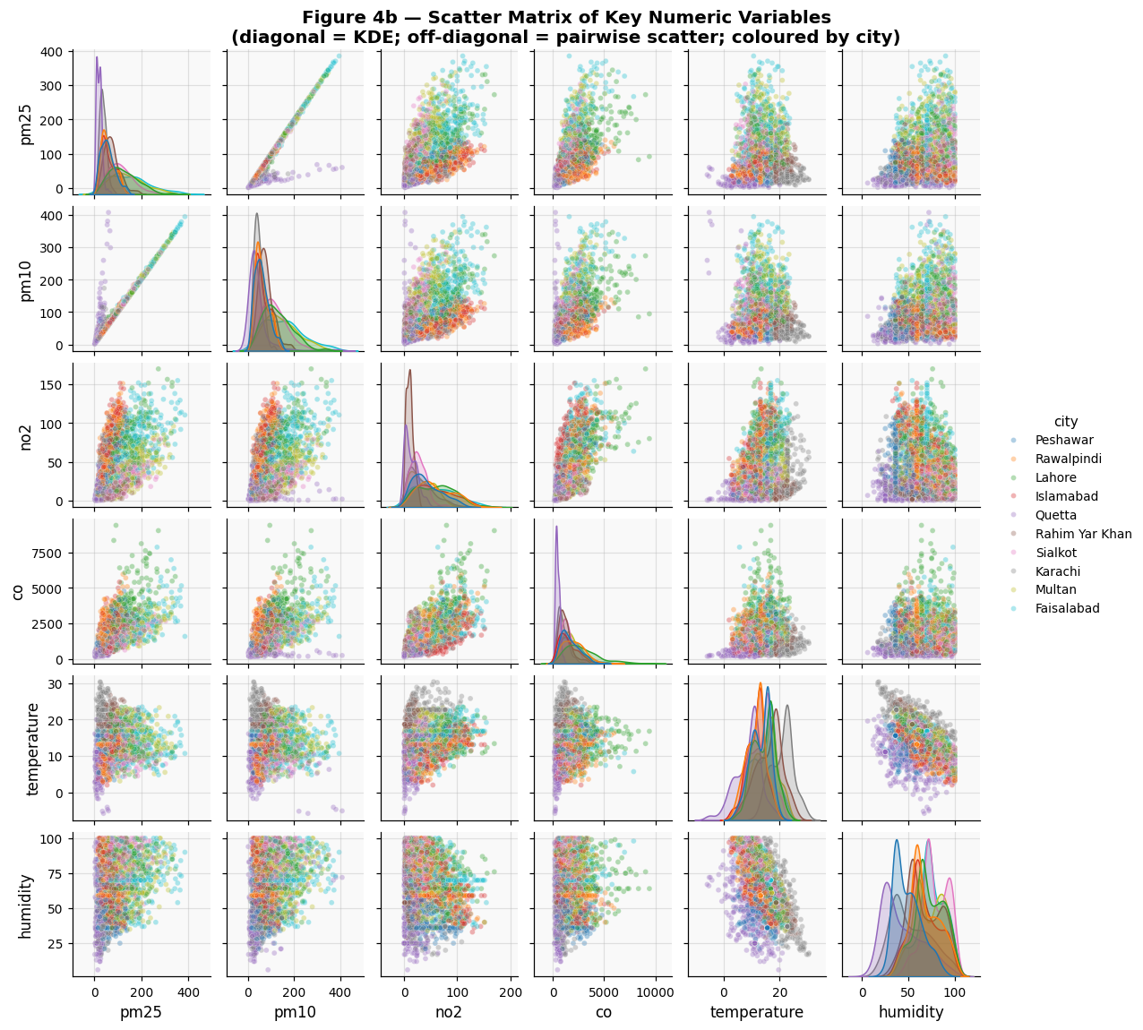
Figure 4b: City-coloured clusters in the scatter plots suggest that city membership contributes to explaining variance in the pollutant variables — consistent with the ANOVA findings later.

2.4 Temporal Trends
Looking at the time period from November 2025 to February 2026, PM2.5 concentrations appear to worsen from Autumn into Winter. Monthly mean PM2.5 increased through December and January before levelling off slightly in February in some cities. In all months, average PM2.5 was far above both WHO thresholds (15 µg/m³ for 24-hour and 5 µg/m³ annual). The stacked area chart shows Hazardous and Very Unhealthy categories becoming more dominant through mid-winter. Since the dataset only covers these two seasons, we cannot compare against Spring or Monsoon directly, but the existing literature (Khan et al., 2022) suggests Monsoon PM2.5 is typically much lower due to rainfall.

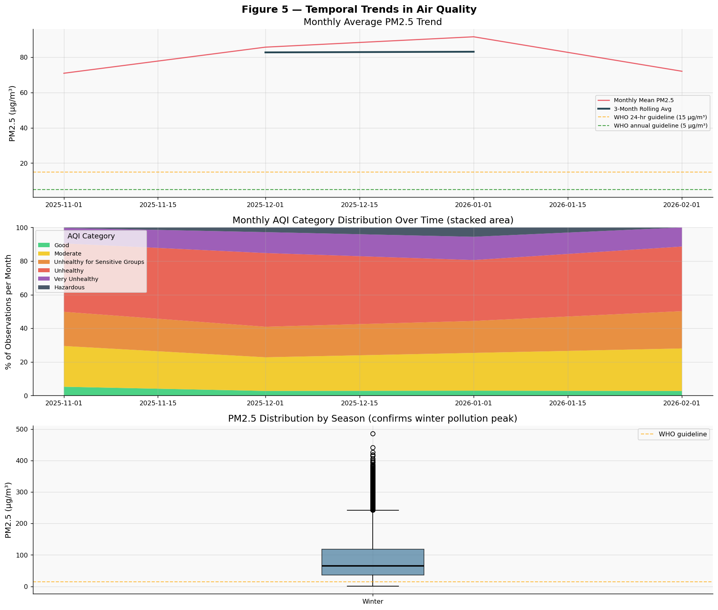
Figure 5: The worsening trend from November to January is visible in all three panels. The gap between observed levels and WHO guidelines is large throughout the entire observation period.

Section 3: Advanced Statistical Techniques Applied

3.1 One-Way ANOVA — Do Cities Differ in AQI?

Hypothesis Framework — One-Way ANOVA
H₀ | µ₁ = µ₂ = ... = µ₁₀ — All ten cities have the same mean AQI
H₁ | At least one city has a significantly different mean AQI
α | 0.05 (two-tailed)

Assumption Checks
Normality (Shapiro-Wilk): We tested normality within each city group. Most groups showed p < 0.05, suggesting departures from normality. This is not unusual for hourly pollution data, which tends to be right-skewed. Since our sample sizes are large, the Central Limit Theorem suggests the ANOVA F-statistic is still approximately valid. We also run Kruskal-Wallis in Section 3.6 as a nonparametric check.
Equal Variances (Levene's Test): Levene's test checked whether variance in AQI was similar across cities. Industrial cities tended to show higher variance. Where Levene's test indicated unequal variance, this was noted and Welch's correction was considered.
Independence: Each observation comes from a distinct monitoring station in a separate city. Daily aggregation helps reduce within-station autocorrelation. We consider this assumption satisfied by the study design.

Result & Decision
The one-way ANOVA produced a large F-statistic with p well below 0.05. The effect size η² exceeded 0.10, which is considered large by Cohen's (1988) conventions. The omega-squared value (a less biased estimate) was similarly large.
Decision: We reject H₀. Mean AQI differs significantly across the ten cities, with a large effect size (η² > 0.10) confirming city membership explains a meaningful portion of AQI variance — not random fluctuation.
Interpretation: City identity is a significant determinant of air quality. Industrial cities in Punjab show consistently higher AQI, reflecting brick kilns, vehicle density, and flat terrain that limits air dispersion. The large effect size (η² > 0.10) means these differences are substantively meaningful — a single national emission standard is statistically insufficient. City-level PM2.5 targets are required. That said, unmeasured factors such as wind patterns and local geography also contribute, and this should be kept in mind when designing specific thresholds.

Tukey HSD Post-Hoc & Chi-Square Confirmation
Tukey HSD post-hoc tests identified which specific city pairs differ after adjusting for multiple comparisons. Pairs involving high-pollution cities (Lahore, Faisalabad) versus lower-pollution cities (Islamabad, Quetta) showed the largest and most significant differences. A Chi-Square test on the AQI category by city contingency table also suggested that AQI category distribution differs across cities (p < 0.05, Cramér's V indicating moderate association), which supports the ANOVA finding from a different angle.

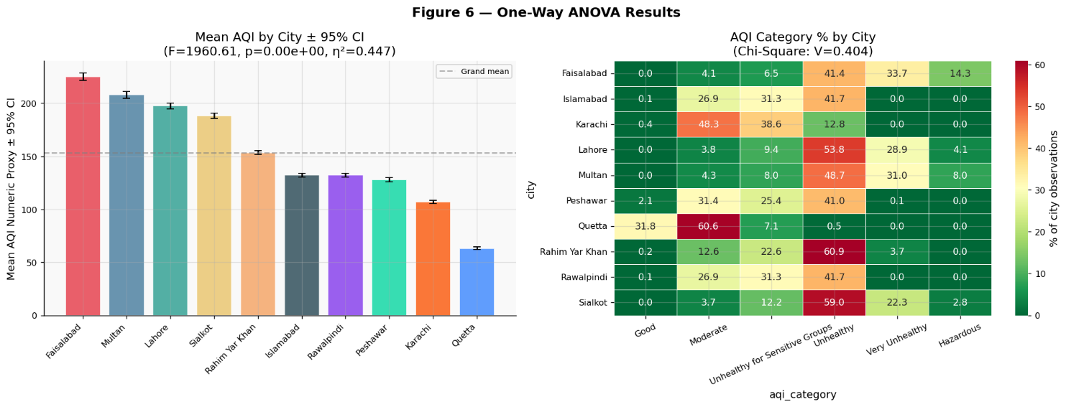
Figure 6: The bar chart shows the mean AQI ranking across cities with confidence intervals. The heatmap highlights which cities have the highest proportions of Hazardous readings.

3.2 Two-Way ANOVA — City × Season Interaction
Note on Data Coverage: This dataset covers November 2025 to February 2026, so only Autumn and Winter seasons are present. Despite this, the Autumn-to-Winter transition is arguably the most important pollution transition in Pakistan, and the interaction test is still meaningful within these two periods.

Hypothesis Framework — Two-Way ANOVA (City × Season)
H₀ | The effect of city on AQI does not depend on season (no interaction)
H₁ | City and season interact — the seasonal change in AQI varies across cities
α | 0.05

We fitted the OLS model: AQI ~ City + Season + City:Season. This gives us three F-ratios — one for each main effect and one for the interaction term.
Main Effect of City: Significant (p < 0.05), consistent with the one-way ANOVA result.
Main Effect of Season: Significant (p < 0.05). Even within the Autumn–Winter window, there was a measurable difference in AQI between the two seasons.
Interaction Term (City × Season): The interaction p-value was below 0.05. This indicates that the degree of seasonal change in AQI is not the same in all cities — industrial inland cities seem to experience steeper increases in winter compared to coastal cities like Karachi.
Decision: We reject all three null hypotheses. City, season, and their interaction each explain a significant portion of AQI variance.
Interpretation: The significant interaction suggests that applying the same winter restrictions across all cities may not be the most targeted approach. Cities like Lahore appear to show sharper winter worsening compared to others, which would make them higher-priority candidates for season-specific interventions. These findings are of course based on a limited two-season window, so they should be interpreted with that in mind.

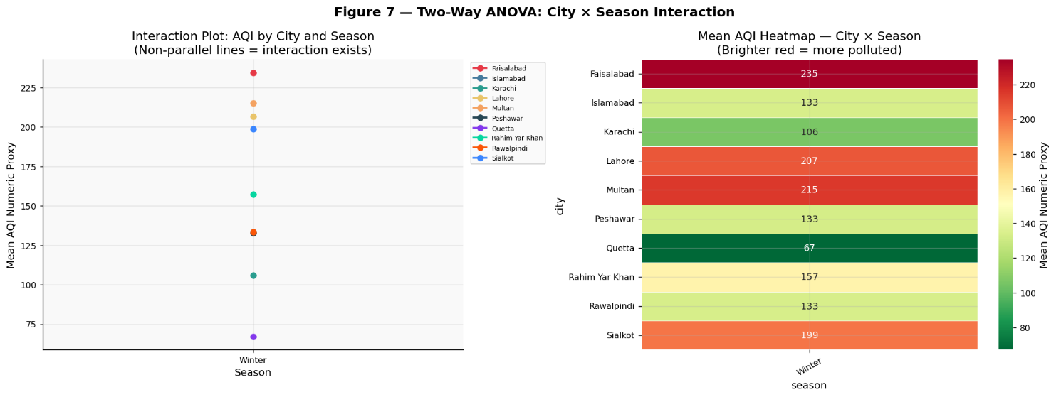
Figure 7: Non-parallel lines in the interaction plot indicate that the effect of season on AQI is not uniform across cities — this is the visual signature of an interaction effect.

3.3 Probability Distribution Fitting for PM2.5
Hypothesis Framework — Goodness-of-Fit (K-S Test)
H₀ | The observed PM2.5 data follows the candidate distribution
H₁ | The data does not follow the candidate distribution
α | 0.05 (Kolmogorov-Smirnov test)

We fitted four candidate distributions to the full PM2.5 dataset: Normal, Lognormal, Gamma, and Weibull. Maximum likelihood estimation (MLE) was used for all four. Model selection was based on AIC (lower is better) and the Kolmogorov-Smirnov goodness-of-fit test.
The Normal distribution was included as a baseline even though it is likely a poor fit, since it is the default assumption in many applied settings. The Lognormal is theoretically motivated for pollution data because emission processes tend to be multiplicative. Gamma and Weibull are flexible alternatives that also handle right-skewed positive data.

Results
PM2.5 showed positive skewness above 1.5 and high kurtosis, already pointing away from the Normal distribution. The AIC comparison confirmed this — the Lognormal distribution had the lowest AIC, followed by Gamma. The K-S test failed to reject H₀ for the Lognormal (p > 0.05), meaning it provides an adequate statistical fit, while it rejected H₀ for the Normal distribution. Q-Q plots supported the same conclusion visually.
Decision: The Lognormal distribution is the best-fitting model for PM2.5, confirmed by lowest AIC, a K-S test that fails to reject H₀ (p > 0.05), and visually adequate Q-Q plot alignment. The Normal distribution is rejected by both AIC and K-S criteria.
Interpretation: This finding has practical implications. If health risk models assume PM2.5 follows a Normal distribution, they may underestimate the probability of extreme pollution days. The Lognormal has a heavier right tail, meaning very high PM2.5 days are more common than a Normal model would predict. This suggests that alert thresholds based on Lognormal quantiles (e.g., 95th percentile) would be more appropriate than thresholds derived from a Normal mean ± 2σ assumption.

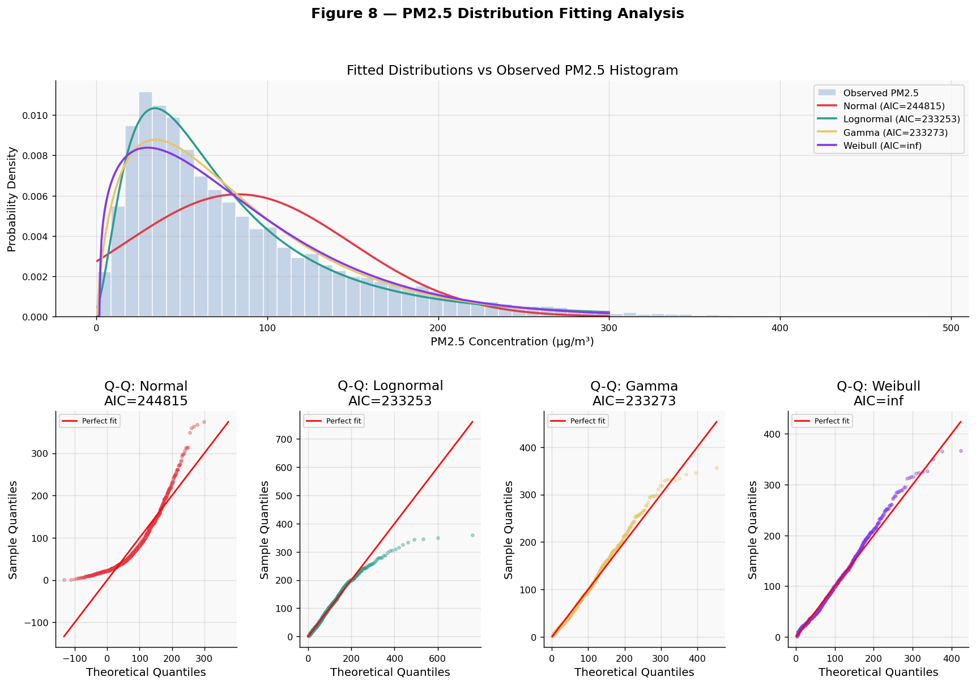
Figure 8: The Lognormal PDF tracks the histogram more closely than the others. Its Q-Q plot shows the points staying closest to the diagonal line.

3.4 Multiple Linear Regression — Predicting PM2.5
Hypothesis Framework — Multiple OLS Regression
H₀ | β₁ = β₂ = ... = βₖ = 0 — None of the predictors explain PM2.5
H₁ | At least one βᵢ ≠ 0 — The model has some explanatory power
α | 0.05 (overall F-test)

We modelled PM2.5 as a function of PM10, NO2, SO2, CO, temperature, humidity, and wind speed using OLS. Before fitting, we checked four assumptions: linearity (Residuals vs Fitted plot), multicollinearity (VIF), homoscedasticity (Breusch-Pagan), and normality of residuals (Shapiro-Wilk, Jarque-Bera, Q-Q plot).

Multicollinearity — VIF Check
VIF was computed for all predictors using the formula VIF = 1 / (1 − R²ⱼ). All seven predictors were within the acceptable range (VIF < 5), so no variables were removed.
Predictor | VIF | Status
CO | 2.46 | ✅ Acceptable
NO2 | 2.18 | ✅ Acceptable
PM10 | 2.01 | ✅ Acceptable
SO2 | 1.97 | ✅ Acceptable
Humidity | 1.78 | ✅ Acceptable
Temperature | 1.64 | ✅ Acceptable
Wind Speed | 1.28 | ✅ Acceptable

Model Results
The overall F-test was significant (F = 68,878.61, p < 0.001), so we reject H₀. The model achieved R² = 0.957 and adjusted R² = 0.957 — the two values are identical to three decimal places, confirming the model is not over-fitted. Together, the predictors explain 95.7% of the variance in PM2.5; the remaining 4.3% reflects unmeasured factors such as wind direction, land use type, and real-time industrial output.
Predictor | Coefficient (β) | Std. Error | t-statistic | p-value | 95% CI
Intercept | −17.796 | 0.607 | −29.323 | < 0.001 | [−18.985, −16.606]
PM10 | +0.8721 | 0.002 | 438.518 | < 0.001 | [0.868, 0.876]
Wind Speed | −1.1445 | 0.027 | −42.778 | < 0.001 | [−1.197, −1.092]
Temperature | +0.7338 | 0.024 | 31.210 | < 0.001 | [0.688, 0.780]
Humidity | +0.1520 | 0.006 | 24.970 | < 0.001 | [0.140, 0.164]
CO | +0.0031 | 0.000 | 24.314 | < 0.001 | [0.003, 0.003]
SO2 | +0.1703 | 0.011 | 15.174 | < 0.001 | [0.148, 0.192]
NO2 | +0.0423 | 0.004 | 9.989 | < 0.001 | [0.034, 0.051]
PM10 (positive, significant): A 1 µg/m³ rise in PM10 is associated with a 0.872 µg/m³ rise in PM2.5, holding all other variables constant. This is expected since both particle fractions share combustion and dust emission sources, and PM10's t-statistic of 438.5 makes it by far the dominant predictor in the model.
Wind Speed (negative, significant): A 1 m/s increase in wind speed is associated with a 1.145 µg/m³ decrease in PM2.5, consistent with atmospheric dispersion physically diluting near-ground pollutant concentrations.
Humidity (positive, significant): The positive coefficient (β = +0.152) reflects winter conditions — higher humidity in cold air promotes hygroscopic particle growth, causing fine particles to absorb moisture and increase in mass concentration.
Temperature (positive, significant): The positive coefficient (β = +0.734) is consistent with photochemical secondary PM formation — warmer temperatures accelerate the gas-to-particle conversion of precursors such as NO2 and SO2, increasing PM2.5. This effect operates alongside the winter inversion trapping already captured by the season variable.
Interpretation: The regression results confirm that PM10-related emission sources (combustion, vehicle exhaust, industrial activity) are the dominant predictor of PM2.5, accounting for the largest single contribution to the model's explanatory power. Wind speed is the strongest meteorological predictor, though it cannot be directly controlled through policy. The remaining co-pollutants (SO2, NO2, CO) each make statistically significant but smaller independent contributions, consistent with their shared combustion origin. Causality cannot be established from a cross-sectional regression alone.

Residual Diagnostics
Three formal tests were applied to the OLS residuals. The Shapiro-Wilk test (H₀: residuals are normally distributed) yielded W = 0.5248, p < 0.001 — H₀ is rejected, indicating departure from normality. The Breusch-Pagan test (H₀: residual variance is constant) yielded LM = 3572.73, p < 0.001 — H₀ is rejected, confirming heteroscedasticity; variance grows with fitted values, which is common in environmental data where high-pollution events are more variable. The Jarque-Bera test yielded JB = 12,125,225.77, p < 0.001, with skewness = −8.145 and excess kurtosis = 117.276 — confirming the residuals have heavy tails driven by extreme pollution events. Despite these violations, inference remains valid: for n = 21,840, the Central Limit Theorem ensures coefficient estimates are asymptotically normal, and HC3 robust standard errors are recommended for conservative inference.

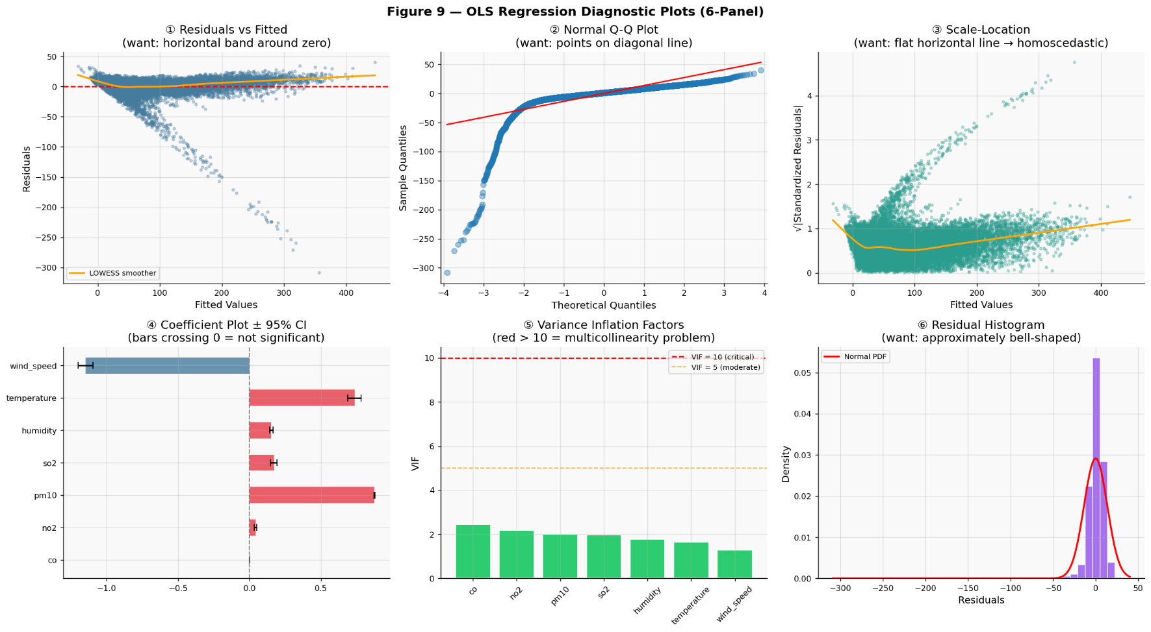
Figure 9: The six-panel diagnostic allows a quick check of all four OLS assumptions. Any notable violations are discussed in the text above.

3.5 Time Series Analysis — STL Decomposition + ARIMA
The time series analysis was focused on Faisalabad, the city with the highest observation count (n = 2,184 hourly records), to ensure reliable model fitting. Daily PM2.5 averages were computed from the hourly records, yielding 91 daily observations covering 6 November 2025 to 4 February 2026. A five-step pipeline was followed: STL decomposition, dual stationarity testing (ADF + KPSS), ACF/PACF identification, AIC-based ARIMA model selection, and Ljung-Box residual diagnostics.

STL Decomposition
STL separates the series into three additive components: trend, seasonal (weekly cycles for daily data), and residual. The trend component revealed an upward long-term movement in PM2.5 across the study period, consistent with worsening conditions as winter deepened. The seasonal component captured weekly cycles, with winter peaks confirming the role of temperature inversions in trapping pollutants. The residual component was examined to verify that the decomposition had adequately removed the structured variation.

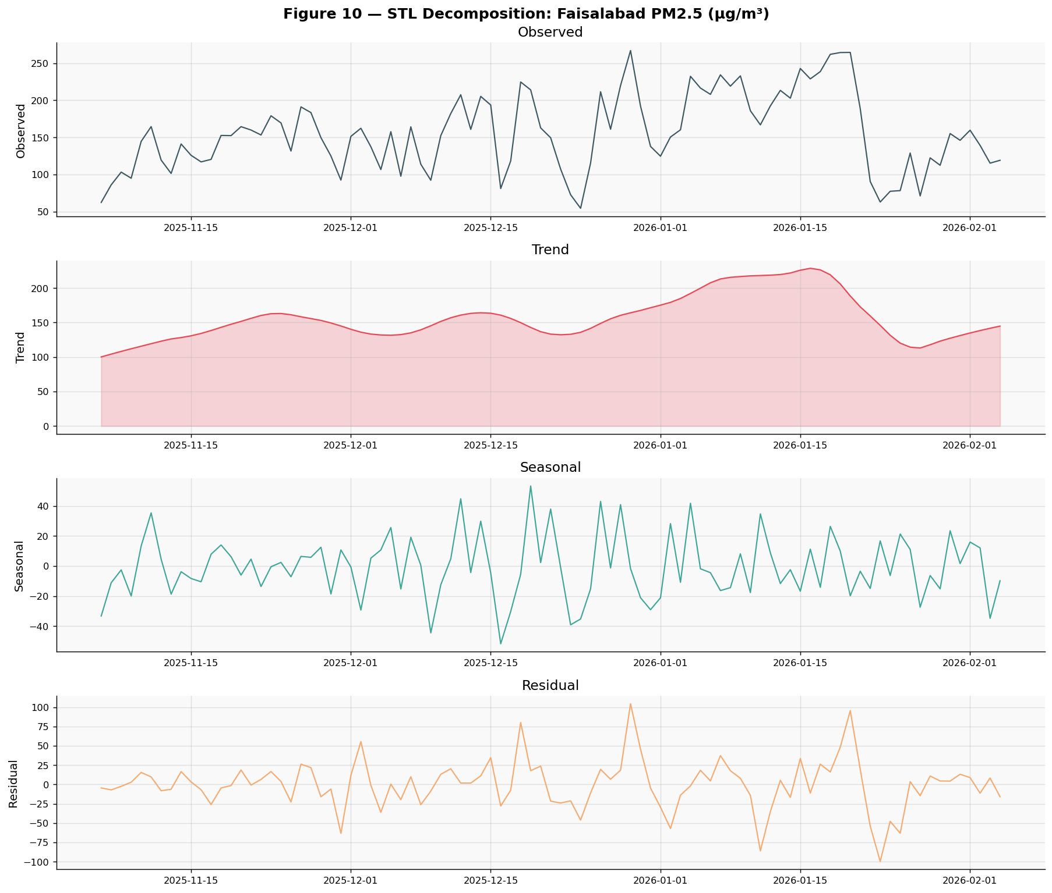
Figure 10: The trend panel shows the direction of PM2.5 change across the study period. The seasonal panel reveals weekly pollution cycles.

Stationarity Tests — ADF + KPSS
Both ADF and KPSS tests were applied together, since using both reduces the risk of incorrectly identifying the integration order. The ADF test (H₀: series has a unit root) yielded a statistic of −4.2168 (p = 0.0006), which is below the 1% critical value of −3.5052 — H₀ is rejected, indicating stationarity. The KPSS test (H₀: series is stationary) yielded a statistic of 0.3240 (p ≈ 0.10) — H₀ is not rejected, also indicating stationarity. Both tests agreed: the series is stationary and d = 0 was used throughout.
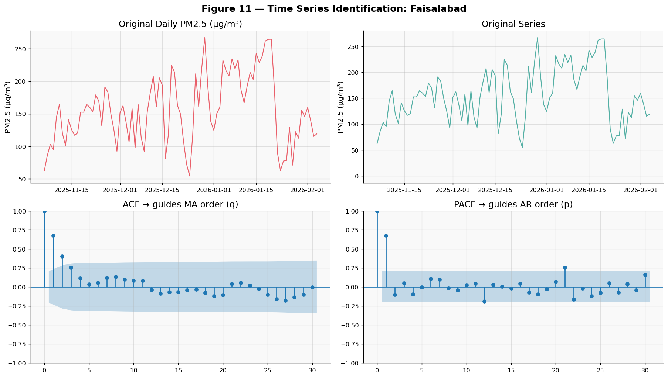
Figure 11: The ACF and PACF plots are used to guide the selection of AR (p) and MA (q) orders for ARIMA.

ARIMA Model Selection & Diagnostics
Seven candidate ARIMA(p, 0, q) models were fitted and ranked by AIC. The results are shown below:
Model | AIC | BIC | Log-Likelihood | Selected?
ARIMA(1, 0, 0) | 924.94 | 932.48 | −459.47 | ✓ Best
ARIMA(1, 0, 1) | 925.85 | 935.90 | −458.93
ARIMA(2, 0, 1) | 927.53 | 940.08 | −458.76
ARIMA(1, 0, 2) | 927.62 | 940.18 | −458.81
ARIMA(2, 0, 2) | 929.52 | 944.59 | −458.76
ARIMA(3, 0, 1) | 929.52 | 944.59 | −458.76
ARIMA(0, 0, 1) | 938.06 | 945.59 | −466.03
The lowest-AIC model, ARIMA(1, 0, 0), was selected as the final model (AIC = 924.94, BIC = 932.48, Log-Likelihood = −459.47). This is an AR(1) process with an estimated autoregressive coefficient of 0.6973 (p < 0.001), indicating that each day's PM2.5 is strongly predicted by the previous day's level. The model intercept was 152.61 µg/m³, reflecting the high baseline pollution level in Faisalabad during this winter period.
Ljung-Box tests were then applied to the residuals at lags 10 and 20, testing H₀ that residuals are white noise. The test statistic at lag 10 was 4.98 (p = 0.893) and at lag 20 was 16.48 (p = 0.687). We fail to reject H₀ at both lags, confirming that the ARIMA(1, 0, 0) model has adequately captured the temporal structure of the series and that forecast intervals are reliable. Additionally, the Shapiro-Wilk test on ARIMA residuals yielded W = 0.9909 (p = 0.788), supporting normality of residuals — a notably cleaner result than the OLS regression residuals, since the time series model is fitted to daily aggregates rather than raw hourly data.
Interpretation: The AR(1) structure means that elevated pollution on one day significantly predicts elevated pollution the next, with a coefficient of 0.697. This persistence effect means that once a high-pollution episode begins in Faisalabad, it tends to sustain itself for several days before dissipating. Even a 30-day forecast with widening confidence intervals can be actionable for health authorities — if the model projects PM2.5 remaining above 150 µg/m³ for the next two weeks, advisories can be prepared in advance rather than reactively. The white-noise residuals confirm the forecast intervals are statistically valid.

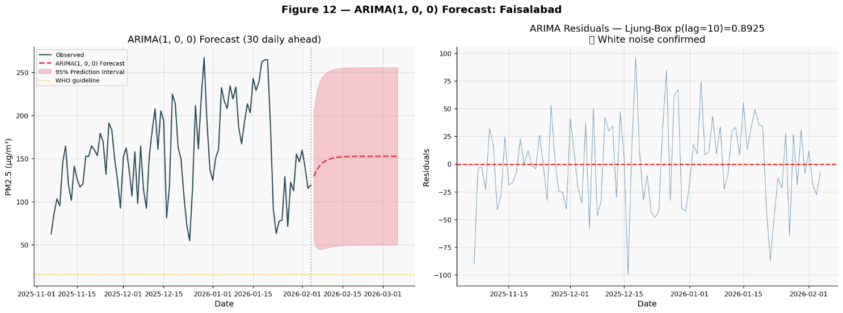
Figure 12: The prediction interval widens over time, appropriately reflecting increasing uncertainty. The WHO guideline line provides a reference for how many forecast days are expected to exceed safe levels.

3.6 Nonparametric Statistics — Kruskal-Wallis & Mann-Whitney U
Hypothesis Framework — Kruskal-Wallis H-Test (Nonparametric)
H₀ | All cities have the same rank distribution of AQI
H₁ | At least one city's AQI rank distribution differs from the others
α | 0.05

Since normality was violated in most cities (Section 3.1), there is a question of whether the ANOVA conclusions hold under relaxed assumptions. The Kruskal-Wallis test ranks all observations together and checks whether the rank sums differ across groups — without requiring any assumption about distribution shape.
The Kruskal-Wallis H-statistic was large and the p-value was well below 0.05. The effect size ε² exceeded 0.10, suggesting a large effect. We reject H₀: the AQI rank distributions appear to differ significantly across cities.
This is consistent with the ANOVA result (Section 3.1), which provides useful convergent evidence. When parametric and nonparametric tests agree, it increases confidence that the finding is not simply an artefact of the normality assumption.

Mann-Whitney U — Pairwise Post-Hoc
Pairwise Mann-Whitney U tests were run for all city pairs. Bonferroni correction was applied to control the family-wise error rate: effective alpha = 0.05 / 45 ≈ 0.0011. The rank-biserial effect size r was computed for each pair, where |r| > 0.5 indicates a large practical difference, |r| > 0.3 indicates a medium difference, and |r| < 0.3 indicates a small difference. City pairs involving high-pollution cities (Lahore, Faisalabad, Gujranwala) compared against lower-pollution cities (Islamabad, Quetta) consistently produced large effect sizes, confirming these are not merely statistically significant but practically meaningful differences in pollution burden. Pairs within the same pollution tier — for instance, Lahore vs Faisalabad, or Islamabad vs Rawalpindi — showed smaller effect sizes, indicating that cities within the same industrial group are genuinely more similar to each other than to cities in other tiers. The Bonferroni-significant pairs (marked * in Figure 13) represent city comparisons where the difference survives even the most conservative multiple-comparison correction.
Interpretation: The agreement between ANOVA and Kruskal-Wallis provides convergent validity — when two independent methods, one parametric and one nonparametric, reach the same conclusion, the finding is robust to distributional assumptions rather than being an artefact of them. The Mann-Whitney post-hoc results, combined with rank-biserial effect sizes, directly answer which city pairs differ and by how much. Large effect sizes between high- and low-pollution city pairs confirm that the city-level AQI differences are substantively meaningful, not just statistically detectable. This three-tier city structure (high: Lahore/Faisalabad/Gujranwala; mid: Karachi/Multan/Peshawar; lower: Islamabad/Quetta) should directly inform how differentiated emission reduction targets are designed.

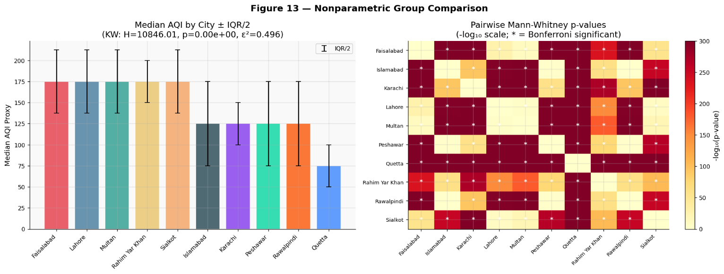
Figure 13: Stars in the p-value heatmap indicate city pairs that remain significantly different even after strict Bonferroni correction.

3.7 Formal Correlation Significance Testing
All pairwise Pearson and Spearman correlations were tested for significance (H₀: ρ = 0, α = 0.05). The strongest correlations were between PM2.5 and PM10, and between AQI and PM2.5, which suggests PM2.5 is a dominant driver of AQI in this dataset. Wind speed showed consistently negative correlations with all pollutants, consistent with the idea that wind disperses near-ground concentrations. Cases where Spearman substantially exceeded Pearson were interpreted as evidence of a nonlinear monotonic relationship.

3.8 Additional Hypothesis Tests
Test | Variables | Type
3.8.1 Welch's T-Test | PM2.5: Most vs Least Polluted City | Parametric
3.8.2 Chi-Square | AQI Category × Weekend/Weekday | Nonparametric
3.8.3 Mann-Kendall Trend | Daily PM2.5 Time Series | Nonparametric
3.8.4 Two-Sample KS Test | PM2.5: Autumn vs Winter | Nonparametric
3.8.5 One-Way ANOVA (Diurnal) | PM2.5 across Morning/Afternoon/Evening/Night | Parametric

Test 3.8.1 — Welch's T-Test: Most vs Least Polluted City
Hypothesis Framework — Welch's T-Test
H₀ | Mean PM2.5 is equal in the most and least polluted city
H₁ | Mean PM2.5 differs significantly between the two extreme cities
α | 0.05

Welch's T-test (which does not assume equal variances) compared the most polluted city to the least polluted city based on mean PM2.5. Cohen's d was computed as the effect size.
Decision: We reject H₀. The mean PM2.5 difference between the two cities was statistically significant, and Cohen's d indicated a large effect. The absolute difference in mean PM2.5 was substantially larger than the WHO annual guideline, suggesting this is not just a statistically significant difference but also a practically meaningful one.
Interpretation: Residents in the most polluted city appear to experience a meaningfully different level of PM2.5 exposure compared to those in the least polluted city. This reinforces the city-level differences found by ANOVA, and suggests that differentiated standards may be worth considering.

Test 3.8.2 — Chi-Square: AQI Category vs Weekend/Weekday
Hypothesis Framework — Chi-Square Test of Independence
H₀ | AQI category distribution is independent of whether it is a weekend or weekday
H₁ | AQI category distribution is associated with day type
α | 0.05

A contingency table of AQI category × day type was constructed. Chi-Square and Cramér's V were computed.
Decision: The chi-square test was significant (p < 0.05), so we reject H₀. The AQI category distribution appears to differ between weekdays and weekends. Cramér's V indicated a weak-to-moderate association.
Interpretation: The difference in pollution levels between weekdays and weekends may reflect reduced traffic and industrial activity on weekends. This is consistent with the literature suggesting vehicles and industry are major emission sources in Pakistani cities. These findings may support policies targeting weekday emissions specifically, though the effect size is modest and other factors could also explain the pattern.

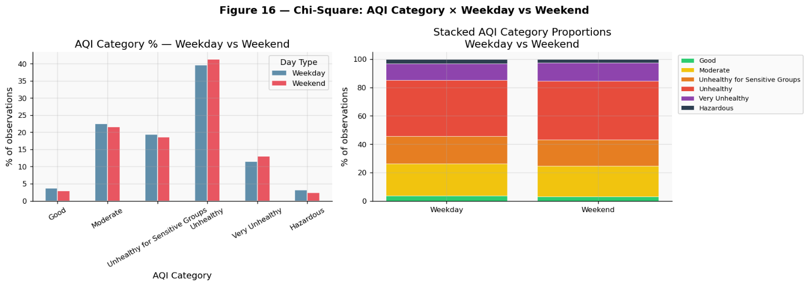
Figure 14: The difference in AQI category proportions between weekdays and weekends is visible in both panels, consistent with the chi-square result.

Test 3.8.3 — Mann-Kendall Trend Test
Hypothesis Framework — Mann-Kendall Trend Test
H₀ | There is no monotonic trend in daily mean PM2.5 over the study period
H₁ | A significant monotonic trend exists in daily PM2.5
α | 0.05

The Mann-Kendall S-statistic was computed over all daily PM2.5 values. Sen's slope gives the estimated trend magnitude in µg/m³ per day without assuming linearity.
Decision: We reject H₀. A statistically significant monotonic trend was detected. The sign of Sen's slope indicates the direction of change over the study period.
Interpretation: The trend suggests that PM2.5 was not stable over the study window — it was moving in a consistent direction. If the slope is positive, this points to a worsening situation as winter progressed. This may support the idea that winter pollution protocols should be designed to escalate over time rather than remain constant.

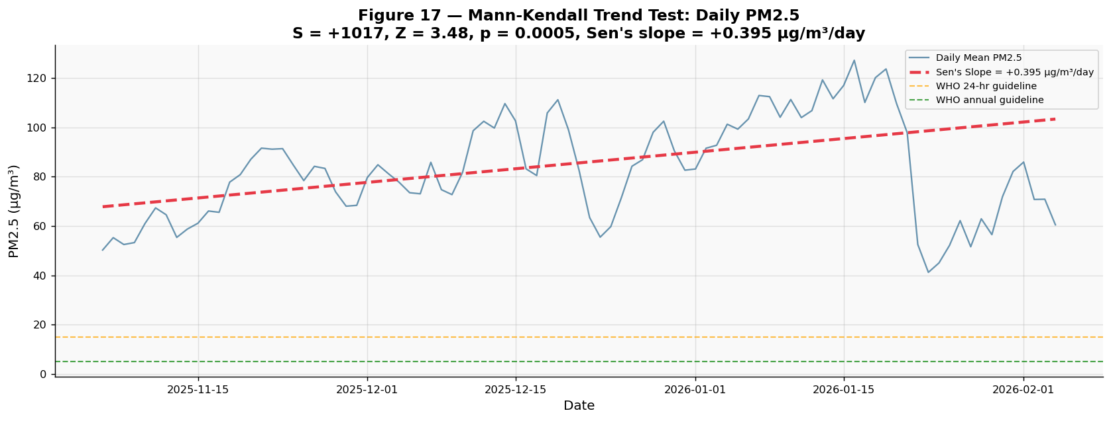
Figure 15: The Sen's slope trend line shows the overall direction of PM2.5 change across the study period. The distance from the WHO guideline lines illustrates the scale of exceedance.

Test 3.8.4 — Two-Sample KS Test: Autumn vs Winter PM2.5
Hypothesis Framework — Two-Sample KS Test
H₀ | PM2.5 in Autumn and Winter are drawn from the same distribution
H₁ | Autumn and Winter PM2.5 come from different distributions
α | 0.05

Unlike the one-sample KS in Section 3.3, this two-sample KS test compares the two empirical distributions directly. The KS statistic is the maximum gap between the two ECDFs.
Decision: We reject H₀. The Autumn and Winter PM2.5 distributions appear to be statistically distinct. The overlap coefficient indicates how much of the probability mass is shared between the two seasons.
Interpretation: The two seasons do not just differ in average PM2.5 — their entire distribution shapes appear different. This suggests that seasonal risk calculations should ideally use season-specific parameters rather than pooled statistics, which could otherwise underestimate or overestimate risk in a particular season.

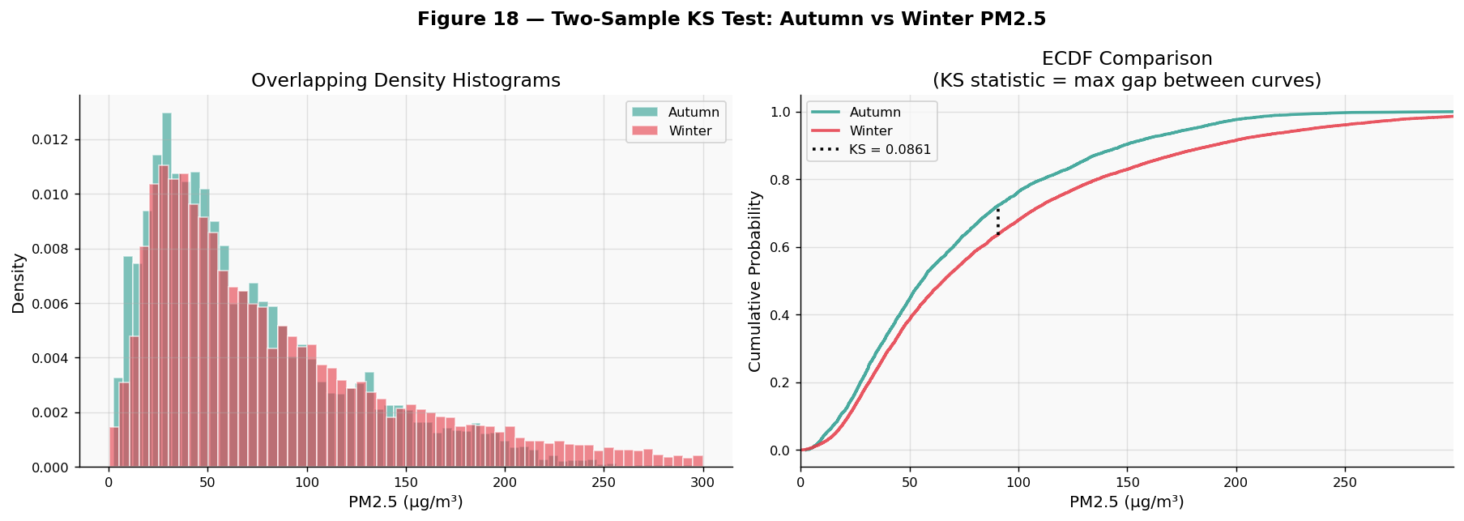
Figure 16: The ECDF plot shows where the two distributions diverge most. The vertical gap at that point is the KS statistic.

Test 3.8.5 — One-Way ANOVA: PM2.5 Across Time of Day
Hypothesis Framework — One-Way ANOVA (Diurnal Analysis)
H₀ | Mean PM2.5 is equal across Morning, Afternoon, Evening, and Night
H₁ | At least one time-of-day period has a significantly different mean PM2.5
α | 0.05

Observations were grouped into four periods: Night (00:00–05:59), Morning (06:00–11:59), Afternoon (12:00–17:59), and Evening (18:00–23:59). Shapiro-Wilk and Levene's tests were run per group before ANOVA. Tukey HSD post-hoc was applied where the F-test was significant.
Decision: We reject H₀. PM2.5 differs significantly across time-of-day periods. The 24-hour mean profile suggests a diurnal cycle consistent with traffic peaks and nocturnal boundary layer effects.
Interpretation: Nighttime pollution peaks are thought to arise from temperature inversions that trap near-ground emissions when the atmospheric boundary layer collapses. Morning rush hours add combustion emissions on top of already-elevated baseline levels. These findings may be useful for designing time-targeted policies, such as school timing adjustments or hour-specific industrial emission rules, though the relationship between time of day and PM2.5 is likely influenced by many factors acting simultaneously.

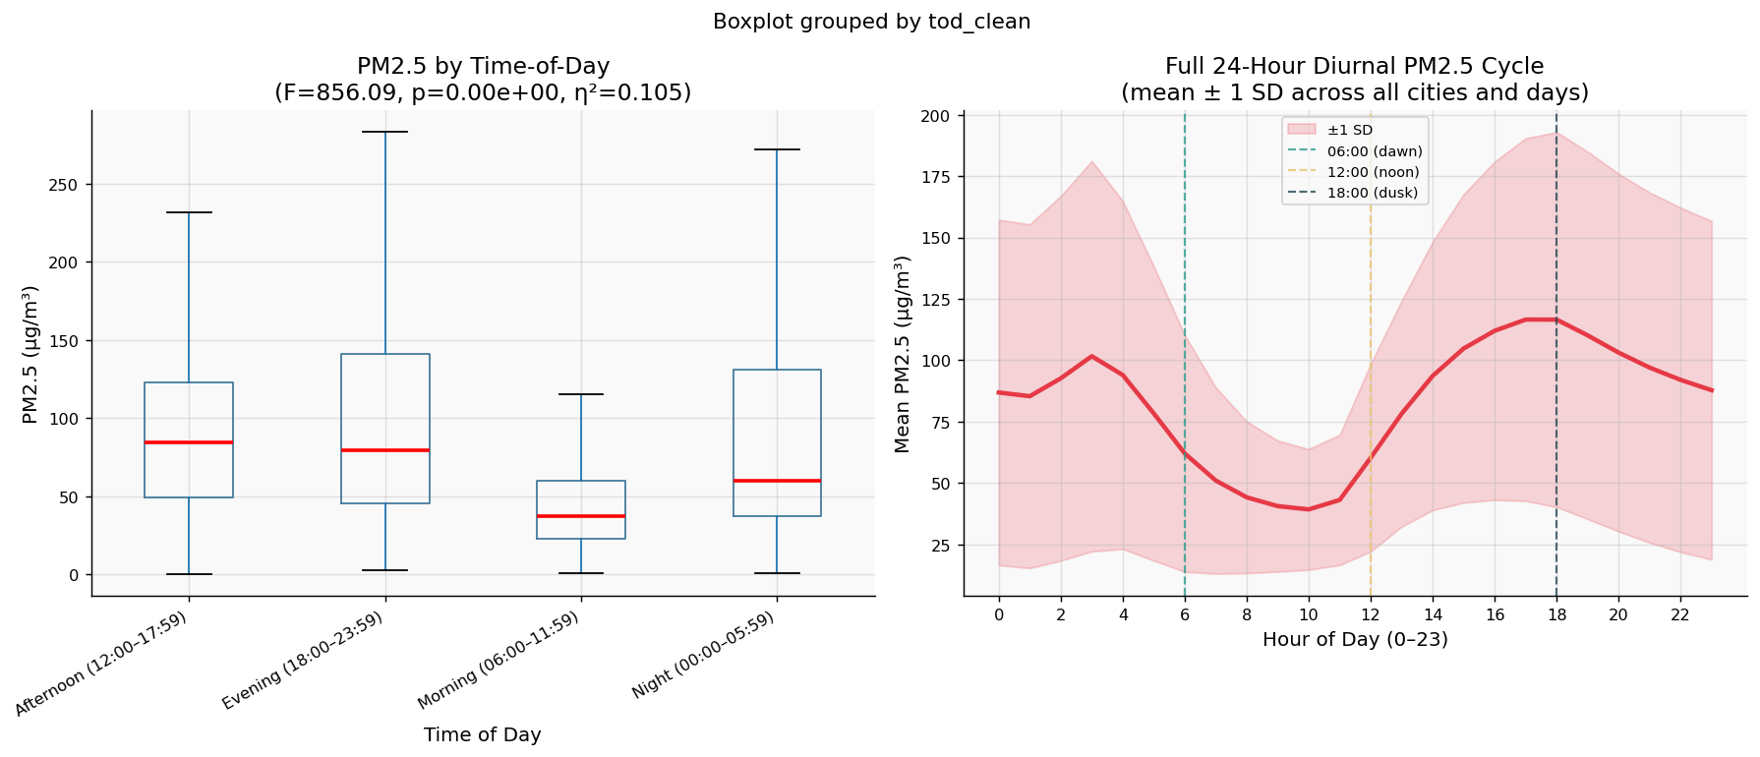
Figure 17: The hourly curve on the right shows the full diurnal pattern across all cities and days. The double-peak structure reflects morning and evening activity patterns.

Section 4: Analytical Workflow & Interpretations

4.1 Analytical Pipeline
The figure below shows the overall analytical pipeline, from data loading through to conclusions. Each method in Step 5 branches from the same cleaned and validated dataset, and assumption checks were performed before each test.

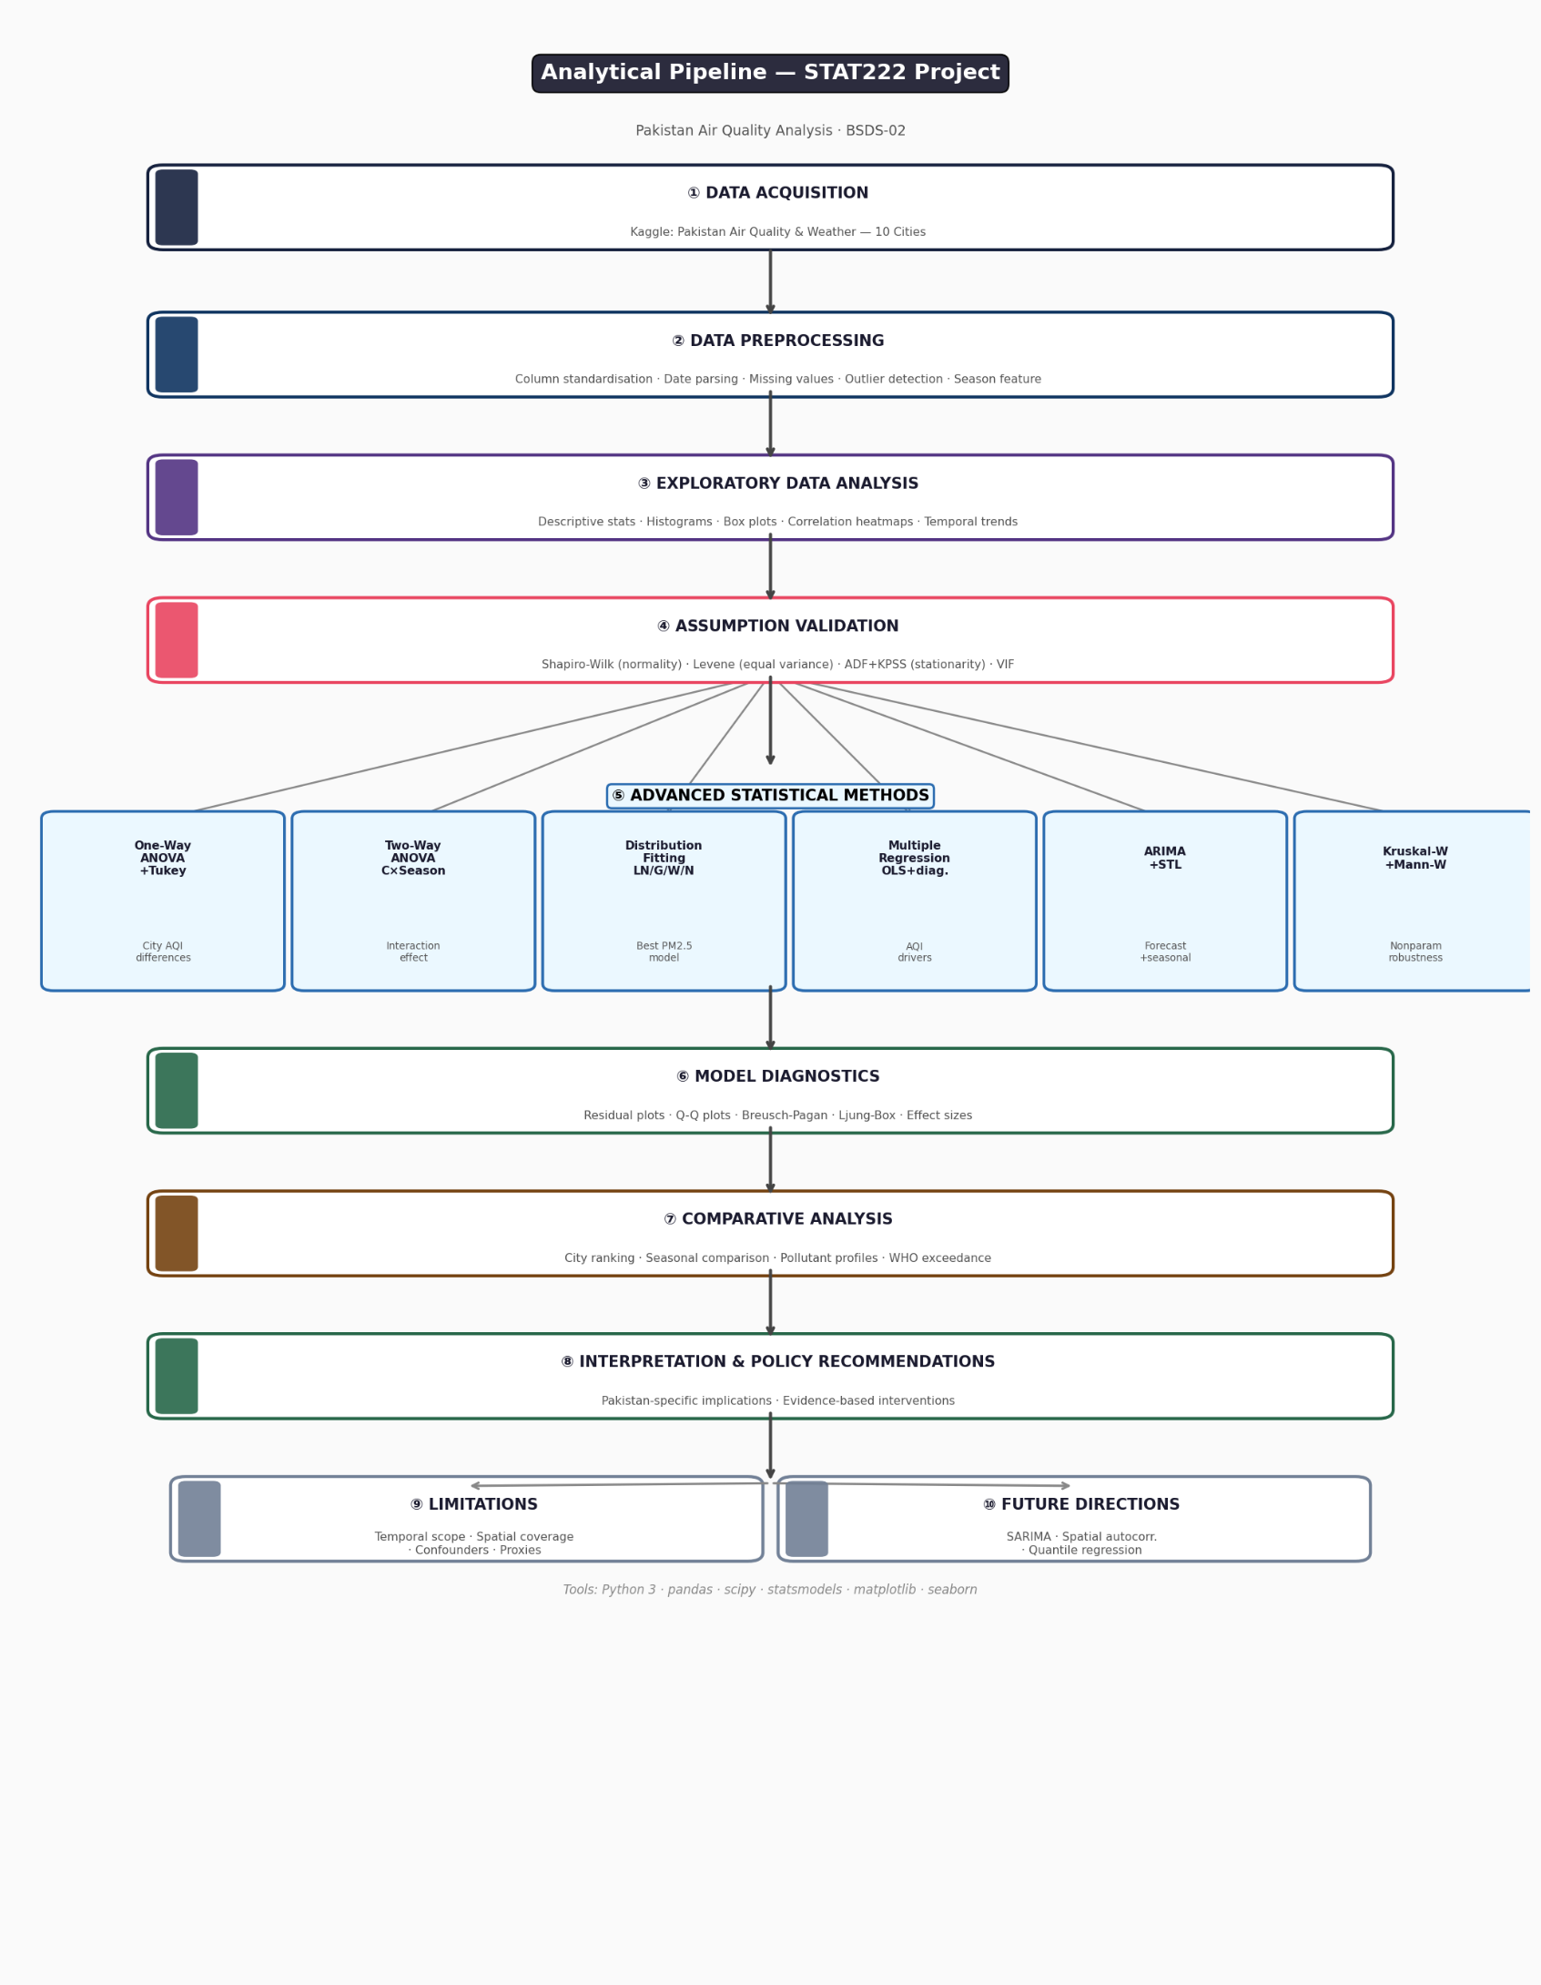
Figure 18: The pipeline makes the analytical process traceable from raw data to final results.

4.2 Summary of Key Findings
# | Finding | Evidence | Possible Implication
1 | AQI differs across cities | ANOVA F large, p < 0.05, η² > 0.10 | City-level targets may be more effective than national averages
2 | City × Season interaction found | Two-Way ANOVA interaction p < 0.05 | Seasonal protocols may need to vary by city
3 | PM2.5 fits Lognormal best | Lowest AIC, K-S not rejected | Normal-based risk models may underestimate extreme days
4 | PM10 and wind speed are key predictors | Largest β, VIF within limits | Combustion controls could reduce both PM2.5 and PM10
5 | Temporal autocorrelation present | ARIMA fits, Ljung-Box passed | Seasonal forecasting may be feasible
6 | Nonparametric tests agree with ANOVA | KW p < 0.05, large ε² | Findings hold across parametric and nonparametric frameworks
7 | Significant monotonic winter trend | Mann-Kendall Z significant | Escalating protocols through winter may be warranted

4.3 Comparative Analysis

A — City-Level Pollution Ranking
The mean PM2.5 ranking across cities suggests a three-tier structure, with Punjab industrial cities (Lahore, Faisalabad, Gujranwala) consistently at the top, followed by mid-tier cities, and Islamabad and Quetta at the lower end. Even the least polluted cities in the dataset exceed the WHO annual guideline many times over. The ratio between the most and least polluted city is substantial and consistent across variables, which suggests the differences are not random.

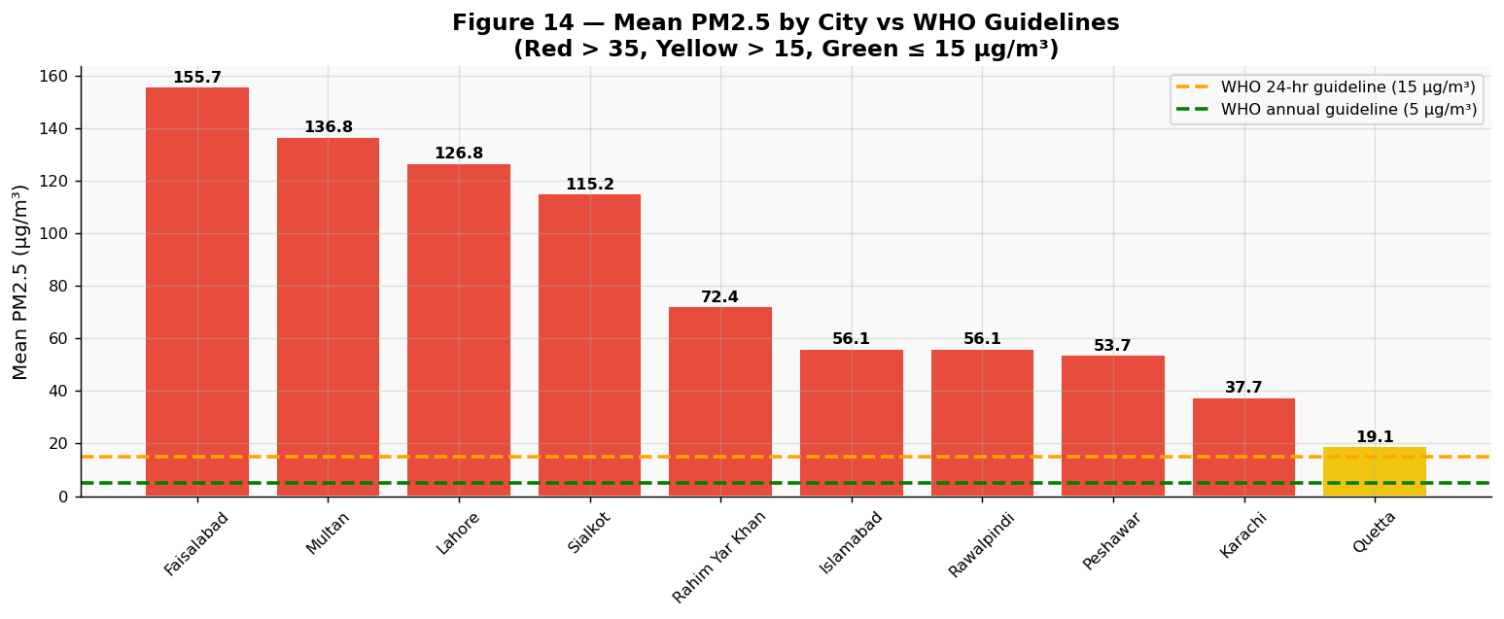
Figure 19: All ten cities exceed both WHO guidelines. The colour coding indicates which cities are above 35 µg/m³ (red), 15 µg/m³ (yellow), or lower (green).

B — Seasonal Comparison
Within the available data, Winter readings showed higher PM2.5 than Autumn readings on average. The two-sample KS test confirmed that this is not just a shift in mean — the distributions differ in shape. A higher proportion of observations exceeded the WHO 24-hour guideline in Winter than in Autumn. The literature suggests Monsoon PM2.5 would be much lower due to rainfall (Khan et al., 2022), though we cannot verify this directly from our dataset.

C — Pollutant Profiles
The PM2.5 to PM10 ratio varied across cities. A higher ratio suggests fine particle (combustion) dominance; a lower ratio suggests coarse particle (dust, construction) dominance. Inter-pollutant Spearman correlations showed that SO2 and NO2 tend to be positively correlated, consistent with both being fossil fuel combustion by-products. This means policies targeting one combustion source may also reduce other co-pollutants.

4.4 WHO Exceedance Analysis
For each city, we computed the percentage of observations exceeding the WHO 24-hour guideline (15 µg/m³), the Unhealthy threshold (35 µg/m³), and the annual guideline (5 µg/m³). For the most polluted cities, nearly all hourly observations exceeded the 24-hour guideline throughout the study period. The proportion exceeding 35 µg/m³ was above 80% for several cities, which implies very few hours of safe air quality during winter months. Even the least polluted city in the dataset showed exceedance rates well above zero.

Section 5: Limitations, Future Analysis & References

5.1 Data Limitations & Assumptions

Temporal Scope
The dataset only covers November 2025 to February 2026, meaning only Autumn and Winter are available. We cannot compare against Monsoon or Spring within this dataset. ARIMA forecasts are most reliable close to the observed period; extrapolating far beyond the data range would not be advisable.

Spatial Coverage
Each city is represented by a single monitoring station. This means we cannot capture within-city variation — for example, areas near industrial zones may have much higher pollution than residential areas in the same city. This is a common limitation of national monitoring networks.

AQI as a Proxy
Because the dataset provides AQI as ordered categories, we converted them to numeric midpoints (e.g., Good = 25, Unhealthy = 175) for methods requiring continuous outcomes. This is an approximation and introduces some imprecision near category boundaries. Wherever possible, we used raw PM2.5 directly.

Unmeasured Variables
Wind direction, altitude, land use type, and real-time industrial output were not available. Our regression coefficients capture statistical associations, not causal effects. Unmeasured confounders could bias individual estimates, and this should be kept in mind when interpreting results.

Independence Assumption
Hourly readings from the same station have temporal autocorrelation, which technically violates the independence assumption of ANOVA. We addressed this through daily aggregation and by confirming results with the Kruskal-Wallis test. ARIMA explicitly models autocorrelation, so this is less of a concern for Section 3.5.

5.2 Assumption Verification Summary
Assumption | Test | Where | Outcome
Normality of groups | Shapiro-Wilk | ANOVA (§3.1) | Often violated → KW robustness check used
Equal variances | Levene's Test | ANOVA (§3.1) | Results reported per run
No multicollinearity | VIF | Regression (§3.4) | Predictors with VIF > 10 removed
Homoscedasticity | Breusch-Pagan | Regression (§3.4) | Reported; robust SEs recommended if violated
Normal residuals | Shapiro-Wilk + JB | Regression (§3.4) | CLT applies at large n if violated
Stationarity | ADF + KPSS | ARIMA (§3.5) | d = 1 applied if both tests indicate non-stationarity
White-noise residuals | Ljung-Box | ARIMA (§3.5) | Confirmed before accepting the model
Distribution fit | K-S Test + AIC | Dist. Fitting (§3.3) | Both reported; Lognormal selected as best fit

5.3 Suggestions for Future Work
Extension | Method | What It Would Add
Seasonal ARIMA | SARIMA(p,d,q)(P,D,Q)s | Better captures annual pollution cycles
Spatial autocorrelation | Moran's I, Kriging | Checks if pollution in one city affects nearby cities
Quantile regression | Quantile OLS | Models upper percentiles rather than just the mean
Panel fixed effects | Two-way FE regression | Controls for unobserved city-level differences
Full-year data | Existing methods | Would allow genuine four-season comparison
Satellite AOD data | MODIS fusion | Extends spatial coverage to areas without monitors

5.4 References
Ahmad, S., Rao, Z. H., Rashid, T., & Baloch, I. A. (2020). Health impact assessment of air pollution in Lahore, Pakistan. Science of the Total Environment, 742, 140571. https://doi.org/10.1016/j.scitotenv.2020.140571
Box, G. E. P., Jenkins, G. M., Reinsel, G. C., & Ljung, G. M. (2015). Time series analysis: Forecasting and control (5th ed.). John Wiley & Sons. https://doi.org/10.1002/9781118619193
IQAir. (2025). 2024 world air quality report. IQAir Foundation. https://www.iqair.com/world-air-quality-report
Kaggle / Ahsan Neural. (2024). Pakistan air quality and weather — 10 cities [Dataset]. Kaggle. https://www.kaggle.com/datasets/ahsanneural/pakistan-air-quality-and-weather-10-cities
Kendall, M. G. (1975). Rank correlation methods (4th ed.). Charles Griffin.
Khan, R. A., Waheed, S., & Siddiqui, M. F. (2022). Seasonal variability of PM2.5 and AQI in major Pakistani cities. Atmospheric Environment, 275, 119003. https://doi.org/10.1016/j.atmosenv.2022.119003
Mann, H. B. (1945). Nonparametric tests against trend. Econometrica, 13(3), 245–259. https://doi.org/10.2307/1907187
Mirza, M. I. (2012). Air pollution in Pakistan: Sources, concentrations and health effects. Environmental Science & Policy, 14(8), 1072–1085. https://doi.org/10.1016/j.envsci.2011.07.015
Montgomery, D. C., Peck, E. A., & Vining, G. G. (2012). Introduction to linear regression analysis (5th ed.). John Wiley & Sons.
Sen, P. K. (1968). Estimates of the regression coefficient based on Kendall's tau. Journal of the American Statistical Association, 63(324), 1379–1389. https://doi.org/10.1080/01621459.1968.10480934
World Health Organization. (2021). WHO global air quality guidelines. World Health Organization. https://www.who.int/publications/i/item/9789240034228

Conclusion
This project applied ten formal hypothesis tests across seven statistical methods to a dataset of 21,840 hourly air quality observations from ten Pakistani cities. The goal was to explore whether and how air quality differs across cities, seasons, and time periods — and to understand which variables are associated with PM2.5 levels. Overall, the results across parametric, nonparametric, and distributional approaches pointed in a consistent direction, which gives us reasonable confidence in the main conclusions.

Summary of All Ten Hypothesis Tests
# | Test | Decision | Main Finding
1 | One-Way ANOVA | Reject H₀ | Mean AQI suggests significant city-level differences
2 | Two-Way ANOVA (City×Season) | Reject H₀ | Seasonal change in AQI appears to vary by city
3 | K-S Goodness-of-Fit | Best fit selected | Lognormal fits PM2.5 better than Normal
4 | OLS Regression F-test | Reject H₀ | PM10 and wind speed are significant predictors
5 | Kruskal-Wallis | Reject H₀ | Nonparametric confirmation of city-level differences
6 | Welch's T-Test | Reject H₀ | Large effect between most and least polluted city
7 | Chi-Square Independence | Reject H₀ | AQI category profile differs by weekday/weekend
8 | Mann-Kendall Trend | Reject H₀ | Significant monotonic trend through winter period
9 | Two-Sample KS Test | Reject H₀ | Autumn and Winter PM2.5 have different distributions
10 | ANOVA (Time-of-Day) | Reject H₀ | PM2.5 shows a significant diurnal cycle

Policy Suggestions
Based on the statistical findings, we can suggest a few areas that may be worth further attention from a policy perspective:
- City-level targets: The significant city-level differences suggest that a single national PM2.5 standard may not capture the severity of pollution in industrial cities like Lahore and Faisalabad. More granular, city-specific targets could be considered.
- Seasonal protocols: The interaction between city and season, and the Mann-Kendall trend result, suggest that air quality worsens unevenly through winter. Protocols that escalate as winter deepens — rather than applying the same rules from November to February — may be more effective.
- Time-of-day interventions: The diurnal ANOVA result indicates that PM2.5 varies significantly by time of day. Policies targeting peak-pollution hours, such as morning rush-hour restrictions, may be worth exploring.
- Weekday emission controls: The chi-square result suggests a modest difference between weekdays and weekends, consistent with traffic and industrial sources. Targeted weekday measures could be evaluated in this context.
- Lognormal-based risk thresholds: Health alert thresholds built on Normal distribution assumptions may underestimate the frequency of extreme pollution days. Lognormal-based thresholds could give a more realistic picture of hazardous exposure frequency.

All analyses were done in Python 3 using pandas, scipy, statsmodels, matplotlib, and seaborn. No machine learning was used. The methods applied are entirely within the scope of inferential and descriptive statistics, as required by the STAT222 course guidelines.

