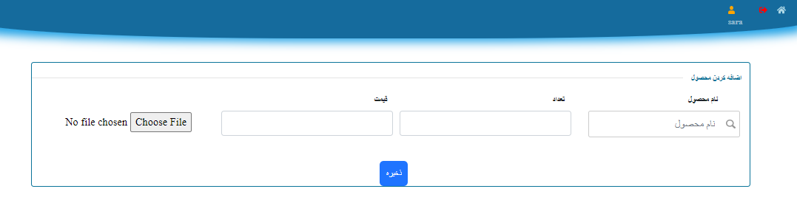admin add product

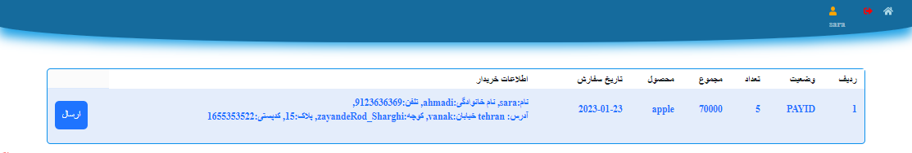

Admin see customer order

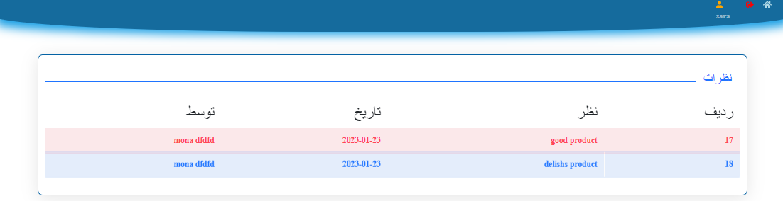

Admin see comments about product

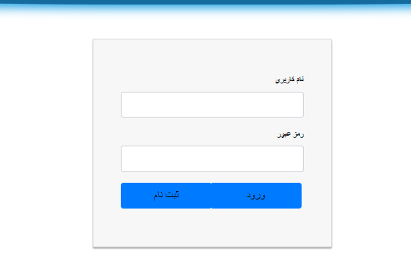

Login page

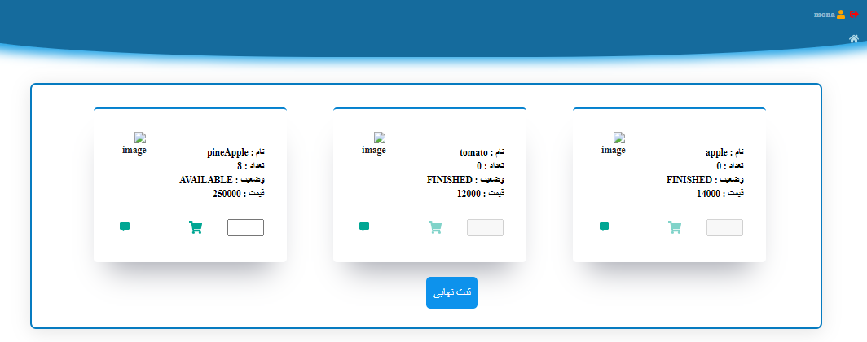

First page customer see product,see other customer idea ,comment about product,can see image of it

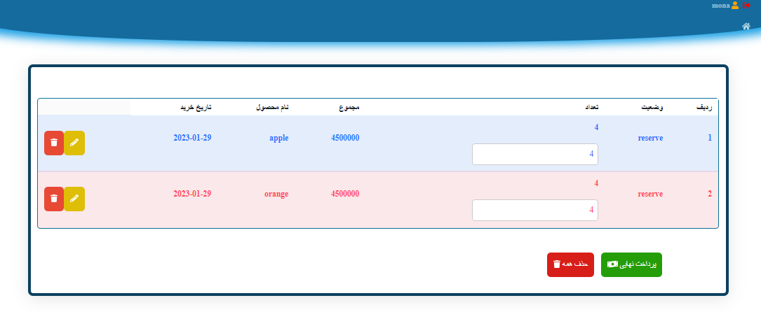

After select them can see to conform or change number of it or edit,cancel

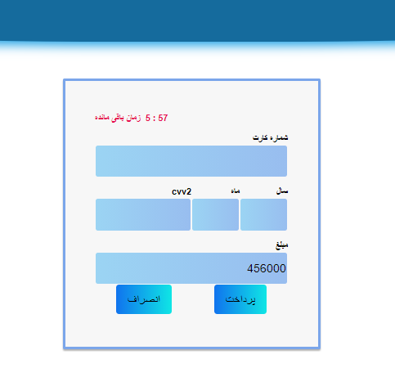

After conform go to pay page

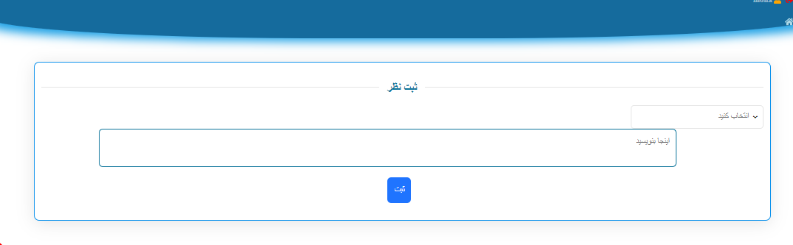

Customer can add comment

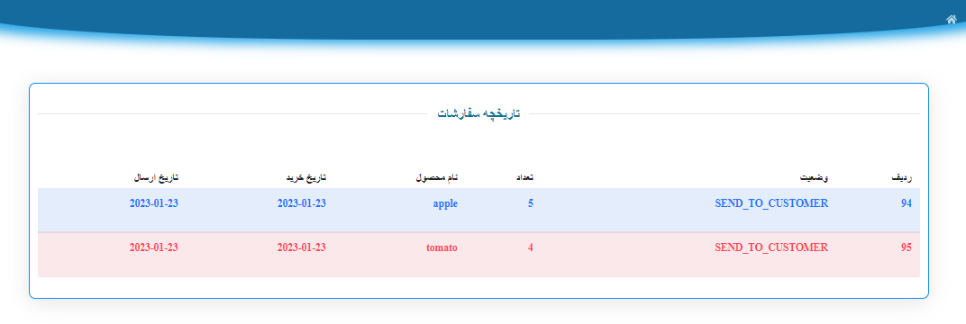

Customer can see order status

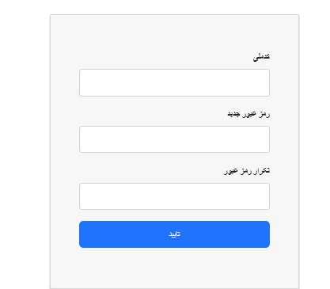

If forgot pass can change it

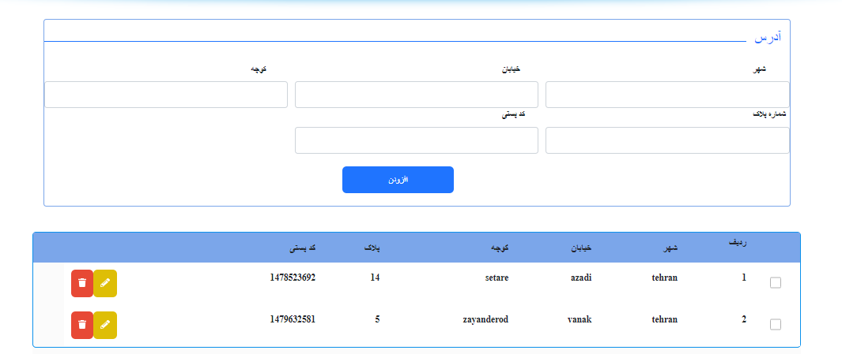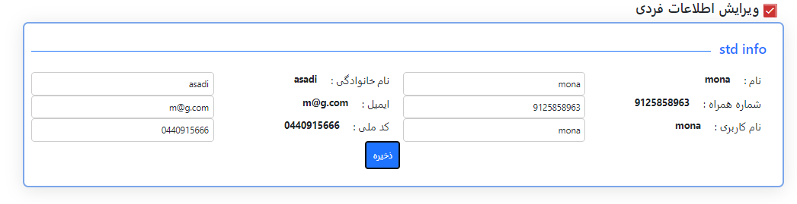Customer can edit info

Customer can add address,select it ,edit it or delete

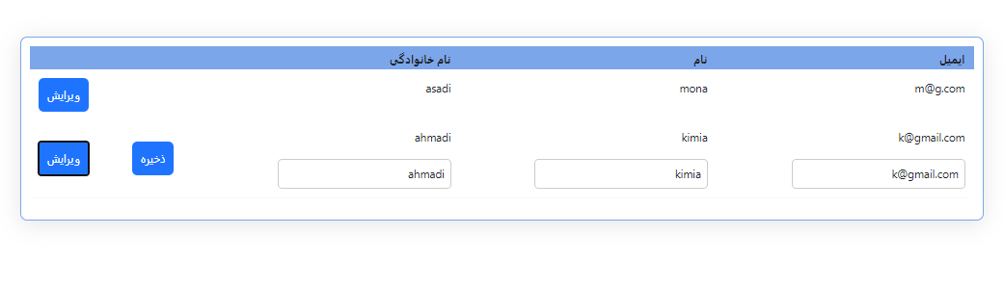nazer can edit customer info