Rehab Exercises Report

Exercise Diagrams
1. Shoulder Flexion:
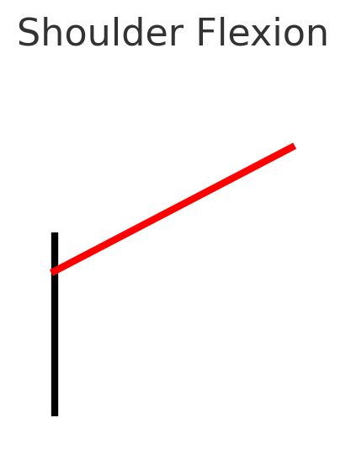
2. Farmer’s Carry:
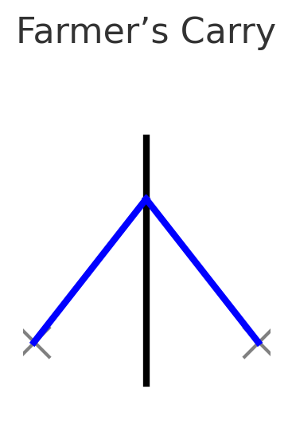
3. Arm Raise and Carry:
