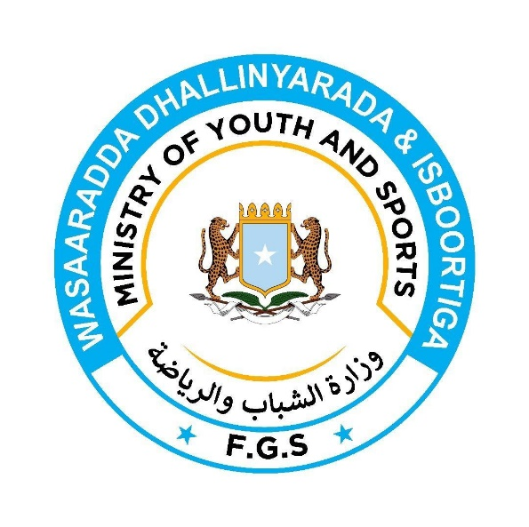

Media List

SNTV Live

Asal Tv Live

Universal Tv : Najiib Faarax Maxamed iyo
Anas Maxamed Soomane.

Dalsan Tv: Maxamed C/raxmaan Xasan iyo
C/salaan Juulle Shaakir

Dawan Tv : Zakariye Hassan Mohamed iyo
Shire Abdi Ahmed.

Kalsan Tv : Feysal Cabdi Faarax iyo
Nuurdiin Xasan Cali.

Juusto Media : Mohamed Bakar Aden

Somali 24 Tv: Asad Tahliil Mohamud iyo Cabdiqadir Macalin Adan

Moys Media shuceyb:
Abdulaahi Carab
Naani kaambo
Nasrokin Hashi Nure
Cabdulaahi Iidaan
Caaisha Faarax

