Intelligent home security threats in the objects layer and ways to deal with it

*Zahra dehghanian -9431039*

*Supervisor : Dr safabakhsh*

*Amirkabir University of technology*

*Autumn 2017*

**

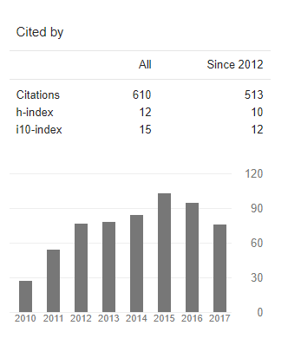

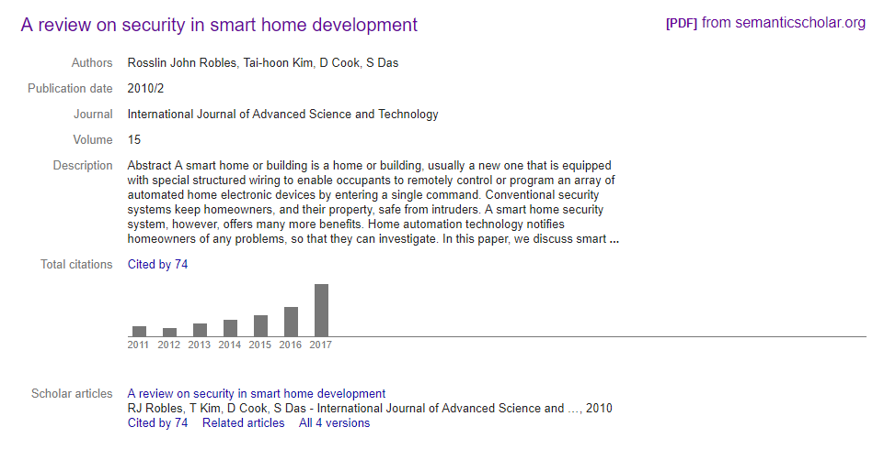

***Abstract***

*Smart Home technology started for more than a decade to introduce the concept of networking devices and equipment in the house. According to the Smart Homes Association the best definition of smart home technology is: the integration of technology and services through home networking for a better quality of living. Many tools that are used in computer systems can also be integrated in Smart Home Systems. In this paper, we present the Technologies and tools that can be integrated or applied in Smart Home systems.*

***Source :*** [*https://pdfs.semanticscholar.org/f07f/d4d666c9fe05e49501884054f6041d554ad5.pdf*](https://pdfs.semanticscholar.org/f07f/d4d666c9fe05e49501884054f6041d554ad5.pdf)

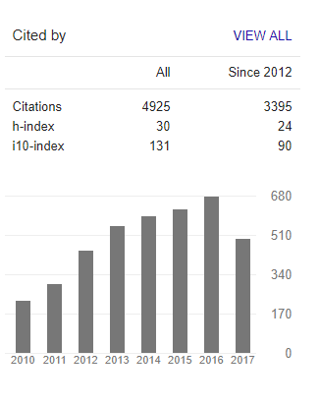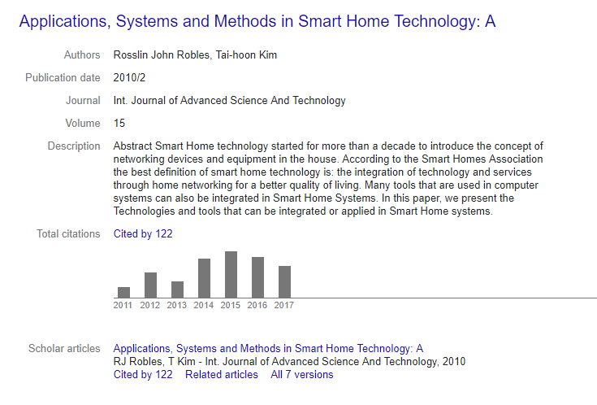

***Abstract***

*Smart Home technology started for more than a decade to introduce the concept of*

*networking devices and equipment in the house. According to the Smart Homes Association*

*the best definition of smart home technology is: the integration of technology and services*

*through home networking for a better quality of living. Many tools that are used in computer*

*systems can also be integrated in Smart Home Systems. In this paper, we present the*

*Technologies and tools that can be integrated or applied in Smart Home systems.*

***Source :***

*https://www.researchgate.net/profile/Rosslin_Robles/publication/242630611_Applications_Systems_and_Methods_in_Smart_Home_Technology_A_Review/links/582c24e908ae138f1bf4cc79/Applications-Systems-and-Methods-in-Smart-Home-Technology-A-Review.pdf*

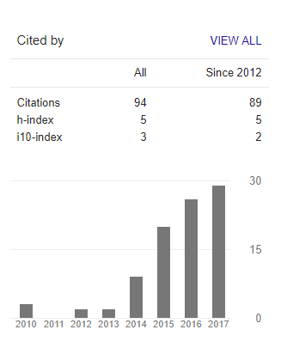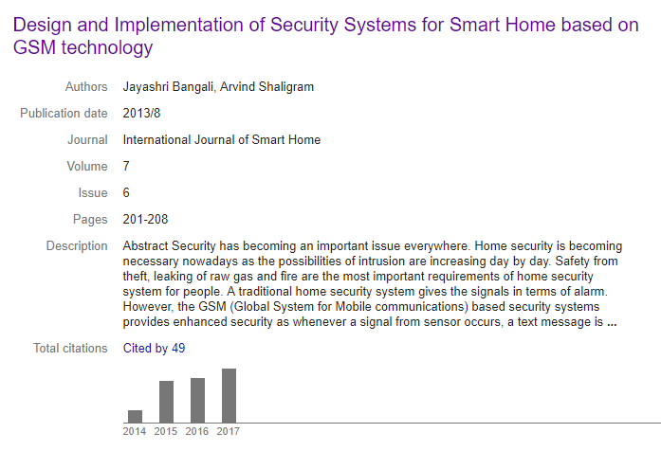

***Abstract***

*Security has becoming an important issue everywhere. Home security is becoming necessary nowadays as the possibilities of intrusion are increasing day by day. Safety from theft, leaking of raw gas and fire are the most important requirements of home security system for people. A traditional home security system gives the signals in terms of alarm. However, the GSM (Global System for Mobile communications) based security systems provides enhanced security as whenever a signal from sensor occurs, a text message is sent to a desired number to take necessary actions.*

*This paper suggests two methods for home security system. The first system uses web camera. Whenever there is a motion in front of the camera, it gives security alert in terms of sound and a mail is delivered to the owner. The second method sends SMS which uses GSM-GPS Module (sim548c) and Atmega644p microcontroller, sensors, relays and buzzers.*

***Source :***[*https://pdfs.semanticscholar.org/684a/74333198998d4889a0a400890a93d65bc214.pdf*](https://pdfs.semanticscholar.org/684a/74333198998d4889a0a400890a93d65bc214.pdf)

**

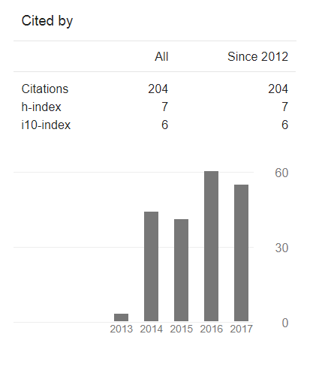

**

***Abstract***

*This paper indicated the differences between Internet of things (IoT) and traditional information system by analyzing the linkage between communication, control, and computation, explained the necessary to put certain “security control” between computation and control, and presented the security model of IoT. It proposed a frame of security technologies in IoT, and guided the research direction about the key technologies of IoT security.*

***Source :*** *http://web.cs.ucla.edu/~miodrag/papers/Xu_ICCAD_2014.pdf*

***Reference***

*Sorted by citations , styled by IEEE standard*

*[1] Rosslin John Robles, and Tai-hoon Kim , Applications, Systems and Methods in Smart Home Technology , 1st ed , International Journal of Advanced Science and Technology*

*Vol. 15, February, 2010*

*[2] Rosslin John Robles , and Tai-hoon Kim , A Review on Security in Smart Home Development , 2nd ed , International Journal of Advanced Science and Technology*

*Vol. 15, February, 2010*

*[3] Teng Xu, James B. Wendt, and Miodrag Potkonjak , Security of IoT Systems:*

*Design Challenges and Opportunities , 1st ed , Computer Science Department University of California, Los Angeles*

*[4] Jayashri Bangali , and Arvind Shaligram , International Journal of Smart Home Vol.7, No.6 , 2013*