**Payamgram Documentation**

**ERD:**

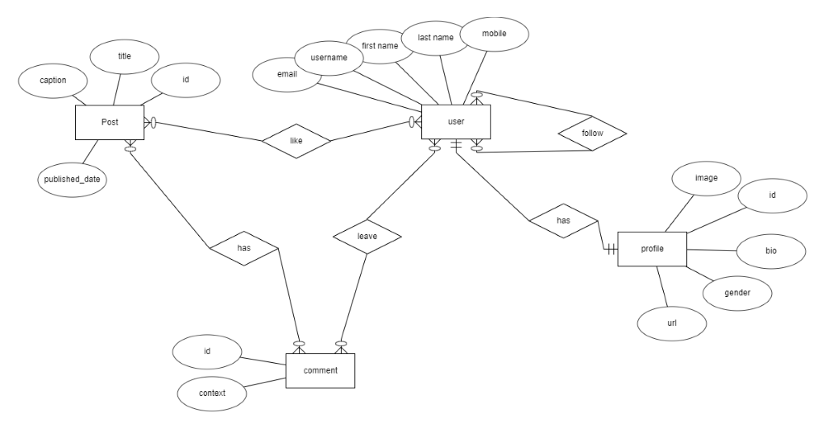

**apps:**

This project includes two applications called Post and User, each post is posted by one person and can be liked by several people (ManyToMany relationship) And each post can have several comments, depending on the implementation of the commenting system, each person can leave several comments for each post, and can only delete his comment, but the person who owns the post can delete all the comments.

In the user application, we also see three models of user, profile and user followings .In this section, the issue of following is discussed that each user can follow several people and be followed by others. With the help of profiles, the user can update information such as bio and gender determination and put a link in his information profile.

The user model, which inherits from the (abstractbaseuser), has fields such as key and email unique to the original model.

The following are some other features and information about the user and the post, like the registration and login system.

**challenges:**

* About the challenge of this project, we can mention user registration and its approval using mobile
* In addition, in some areas, the relationship between the template and the backend was very challenging

**Packages**:

* six: we need this module for generating a token that will be used in email verification
* requests : requests allows you to send HTTP/1.1 requests extremely easily
* ghasedak : for sending sms to user
* django-otp : a package for otp management(generation, verification otp and etc.). We used totp module of this package to generate an one time password that has 6 digits and is valid for 60 seconds. this otp is sent to user’s mobile for verification.