Zahraa berro
202210774
midterm
Distributed system

1- set up the environment
All the environment are installed before the application of the midterm :
- Install Python and set up a virtual environment.
- Set up a version control system (GitHub/GitLab) and initialize a repository.
- Install Docker and Kubernetes.
Prometheus, Grafana, Kafka, RabbitMQ

2- develop storage node module:
- Use FastAPI (or grpc) to build a storage node service exposing PUT, GET, DELETE, and HEAD on chunks:
The storage node exposes four HTTP operations for chunk management: PUT stores a chunk, GET retrieves it, DELETE removes it, and HEAD checks whether the chunk exists and returns its size. These endpoints provide the basic storage operations required by the distributed storage framework.
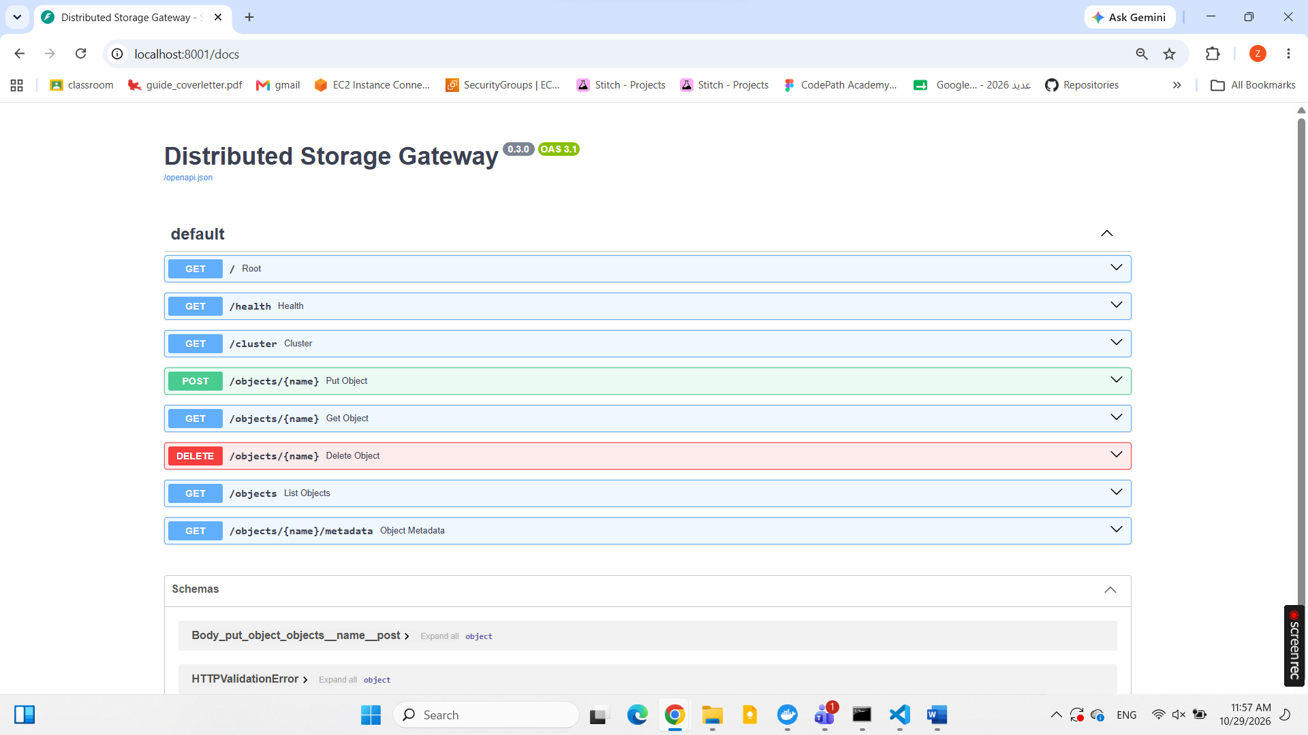
The storage node module was implemented using FastAPI. Each storage node runs as an independent service and exposes HTTP endpoints for managing chunks. A health endpoint was tested to verify that the node is running and returns its status and node identifier.
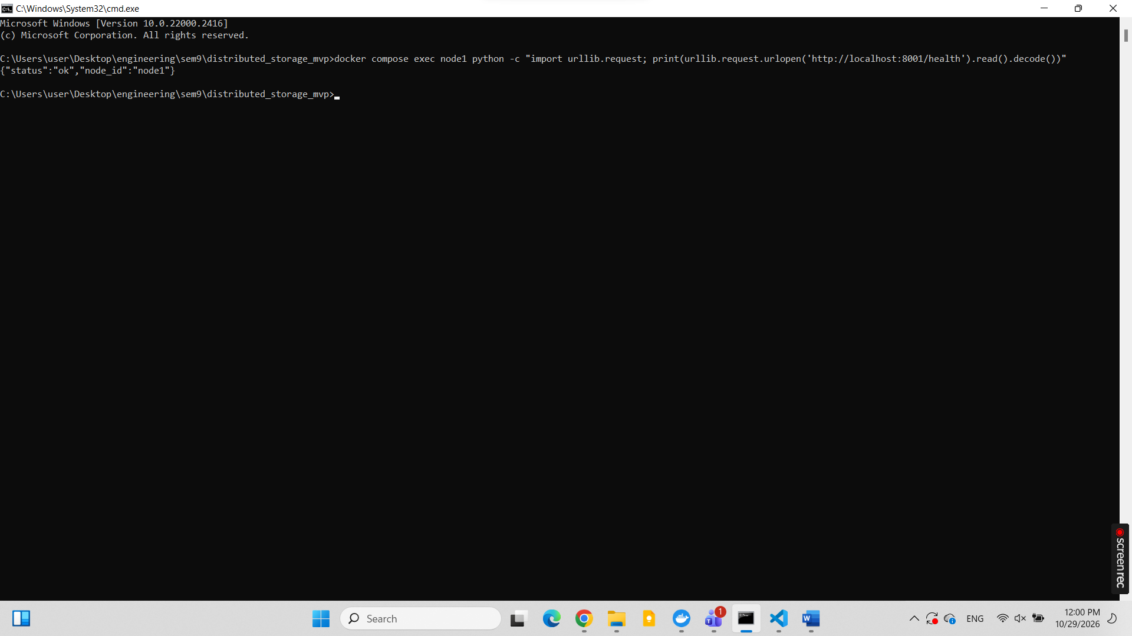
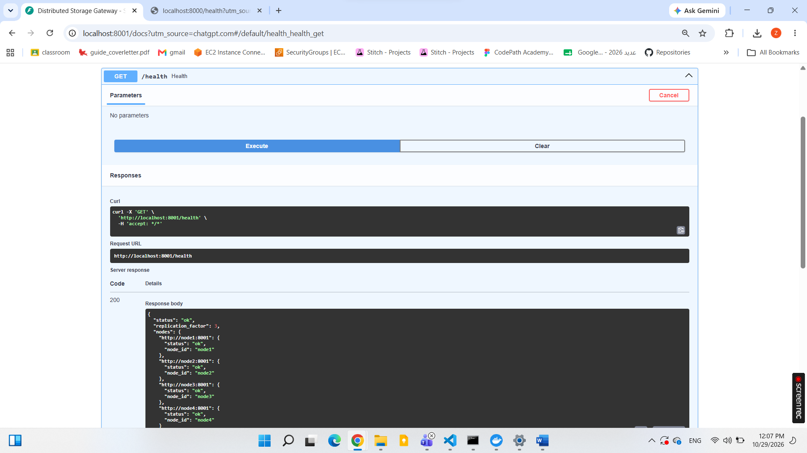
- Address every chunk by the SHA-256 hash of its content and store it on the node's local disk: Each chunk is identified by the SHA-256 hash of its content. The storage node uses this digest as the chunk identifier and stores the chunk on local disk. This content-addressed approach enables integrity verification and allows identical chunks to be recognized across different objects. 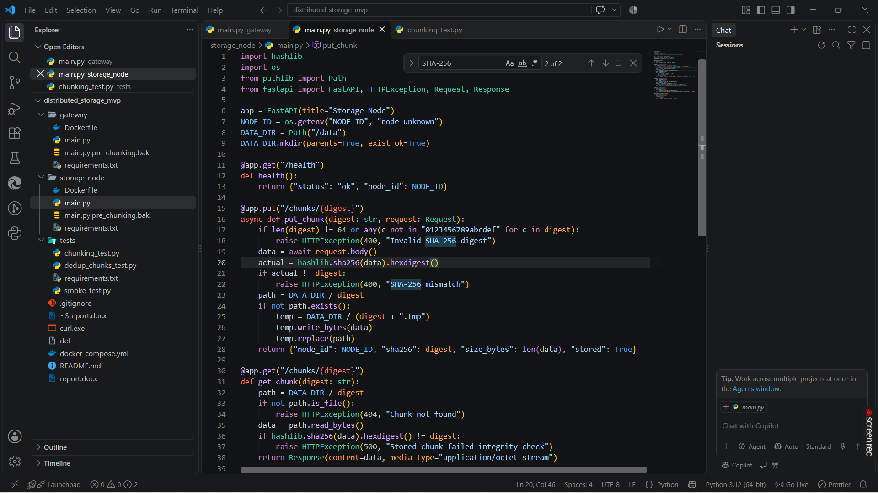

Each storage node stores data chunks as individual files in its local data directory (/data). Each filename corresponds to the SHA-256 digest used to identify the chunk. The terminal output confirms that chunk files are stored using hash-based filenames, supporting content-addressed storage and data integrity verification.
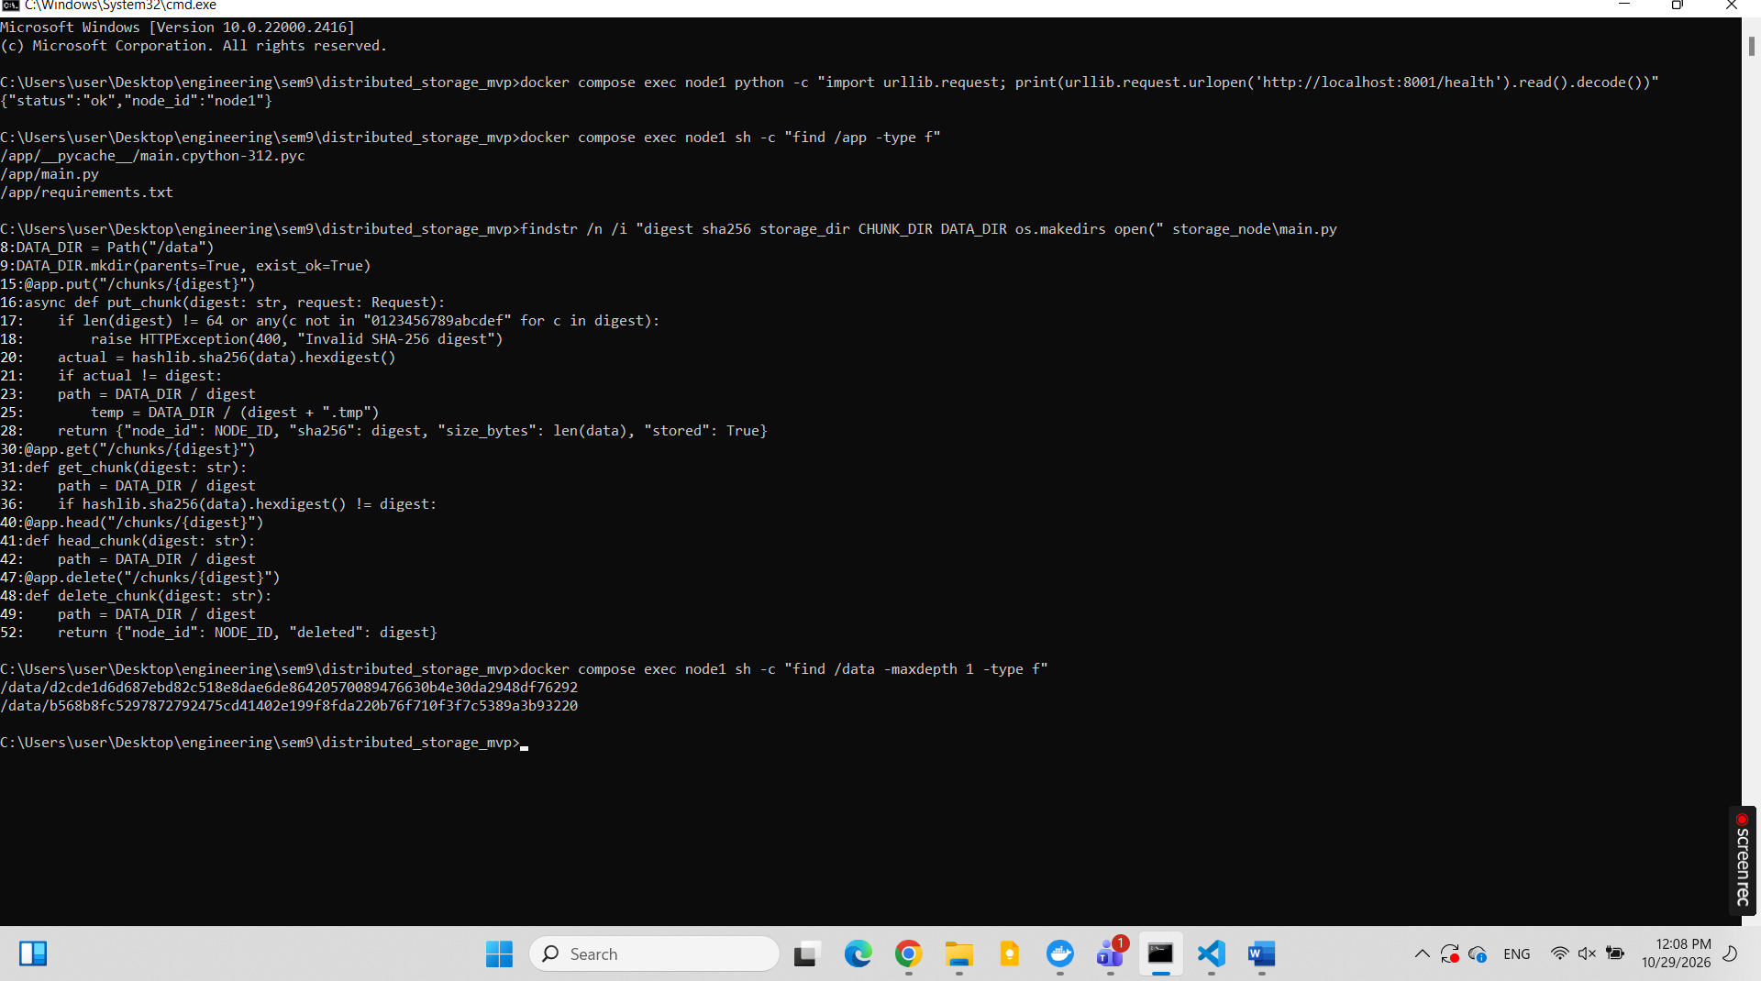
- Verify the hash on every read and reject corrupted chunks: The integrity verification mechanism was tested using a temporary chunk stored on Node 1. First, the SHA-256 digest of the original chunk content was calculated. The chunk was then uploaded to the storage node and retrieved successfully, returning HTTP 200. The downloaded content was hashed again, and the calculated digest matched the expected SHA-256 value, confirming that the data was intact.Next, the stored chunk was deliberately corrupted by modifying its first byte. A subsequent read request was performed to verify whether the storage node could detect the modification. The expected behavior is for the node to reject the corrupted chunk with an HTTP 500 response and an integrity-check error message, since its content no longer matches the original digest.This test demonstrates how SHA-256 verification helps detect data corruption during read operations.
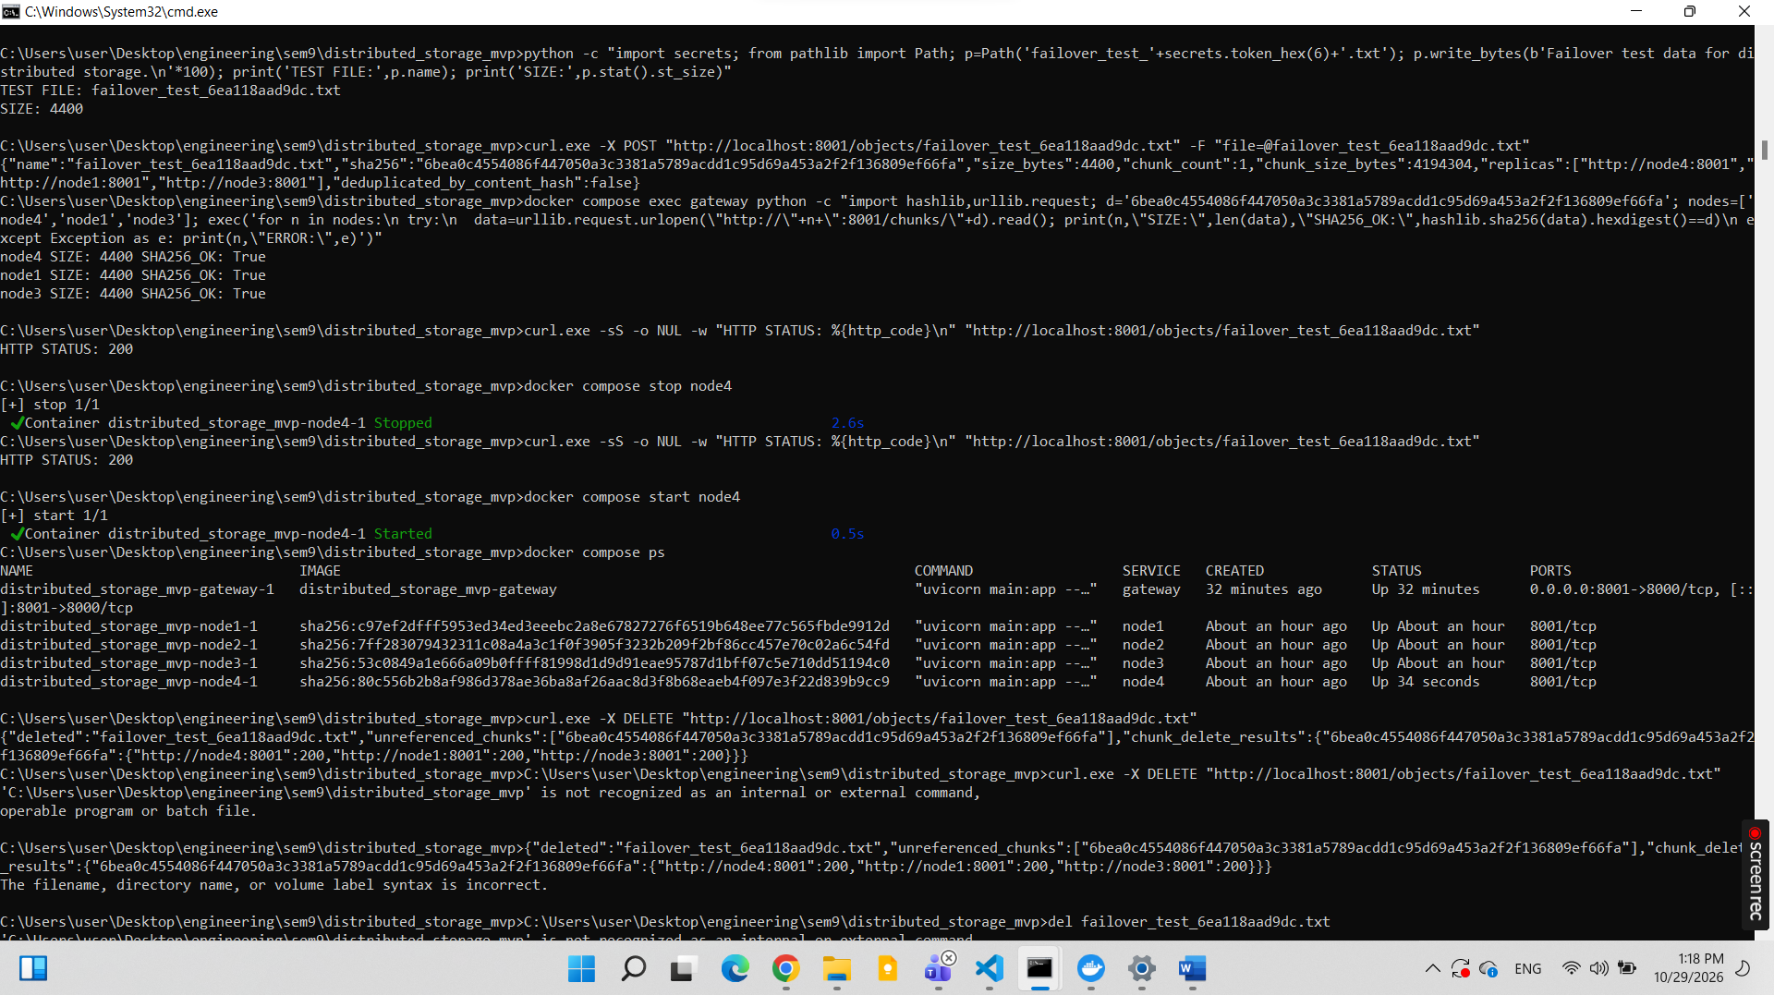
- Send a heartbeat from each node to the metadata service every few seconds (node id, free space, chunk count): A periodic heartbeat mechanism was implemented to report the status and storage capacity of each storage node to the metadata service. Every five seconds, each node reports its unique identifier, available disk space in bytes, and the number of stored chunks. The gateway records the latest heartbeat received from each node, providing an updated view of the cluster's storage status. The implementation is validated by confirming that all four nodes submit recurring heartbeats and that their reported statistics are updated over time.
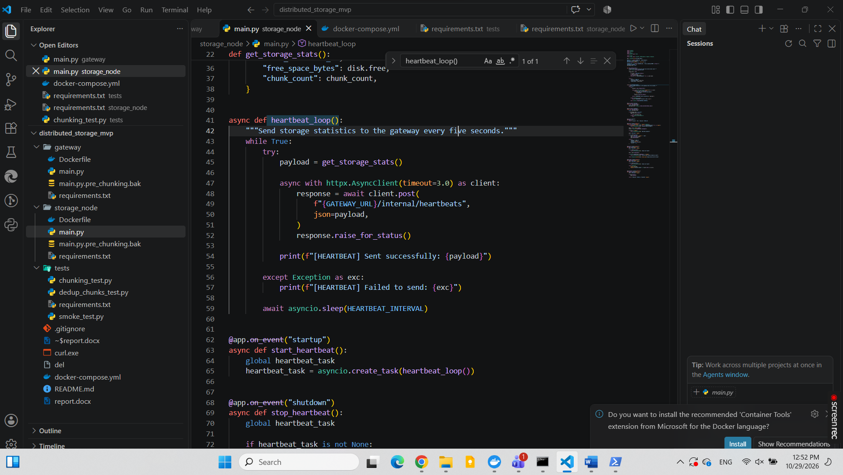
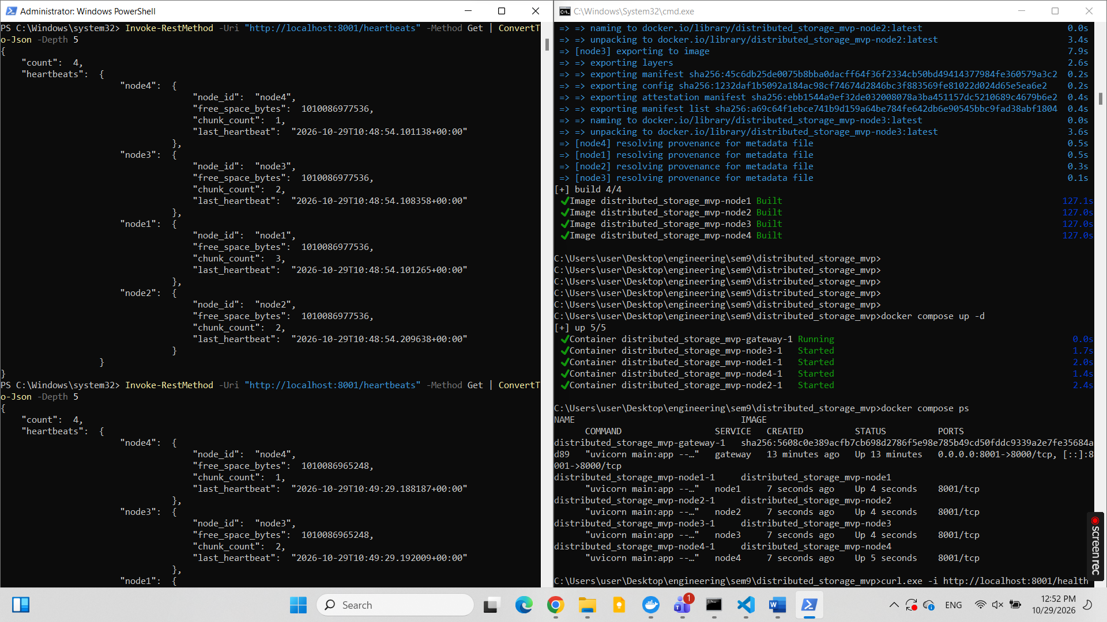

- Run at least 4 storage nodes in separate containers:
Four storage nodes (node1, node2, node3, and node4) were deployed in separate Docker containers using Docker Compose. Each node runs an independent FastAPI storage service with its own persistent storage volume for storing data chunks. The deployment was verified using docker compose ps, which confirmed that all four storage node containers were running successfully alongside the Gateway. The Gateway was deployed as a separate Docker container using Docker Compose and exposed on port 8001 of the Windows host, mapped to port 8000 inside the container. It provides the main entry point for client requests and communicates with the four storage nodes over the internal Docker network. The deployment was verified by accessing the /health endpoint through PowerShell, which returned an ok status and confirmed the configured replication factor of 3 and the availability of all four node addresses. The Gateway verification was successful. A request to the /health endpoint returned a status of ok, a replication factor of 3, and the addresses of all four storage nodes (node1–node4). PowerShell also confirmed successful connectivity to port 8001 on the Windows host. These results verified that the Gateway was running and reachable and that the four storage node addresses were configured. The heartbeat endpoint was tested separately and confirmed that the Gateway received heartbeat information from all four nodes.
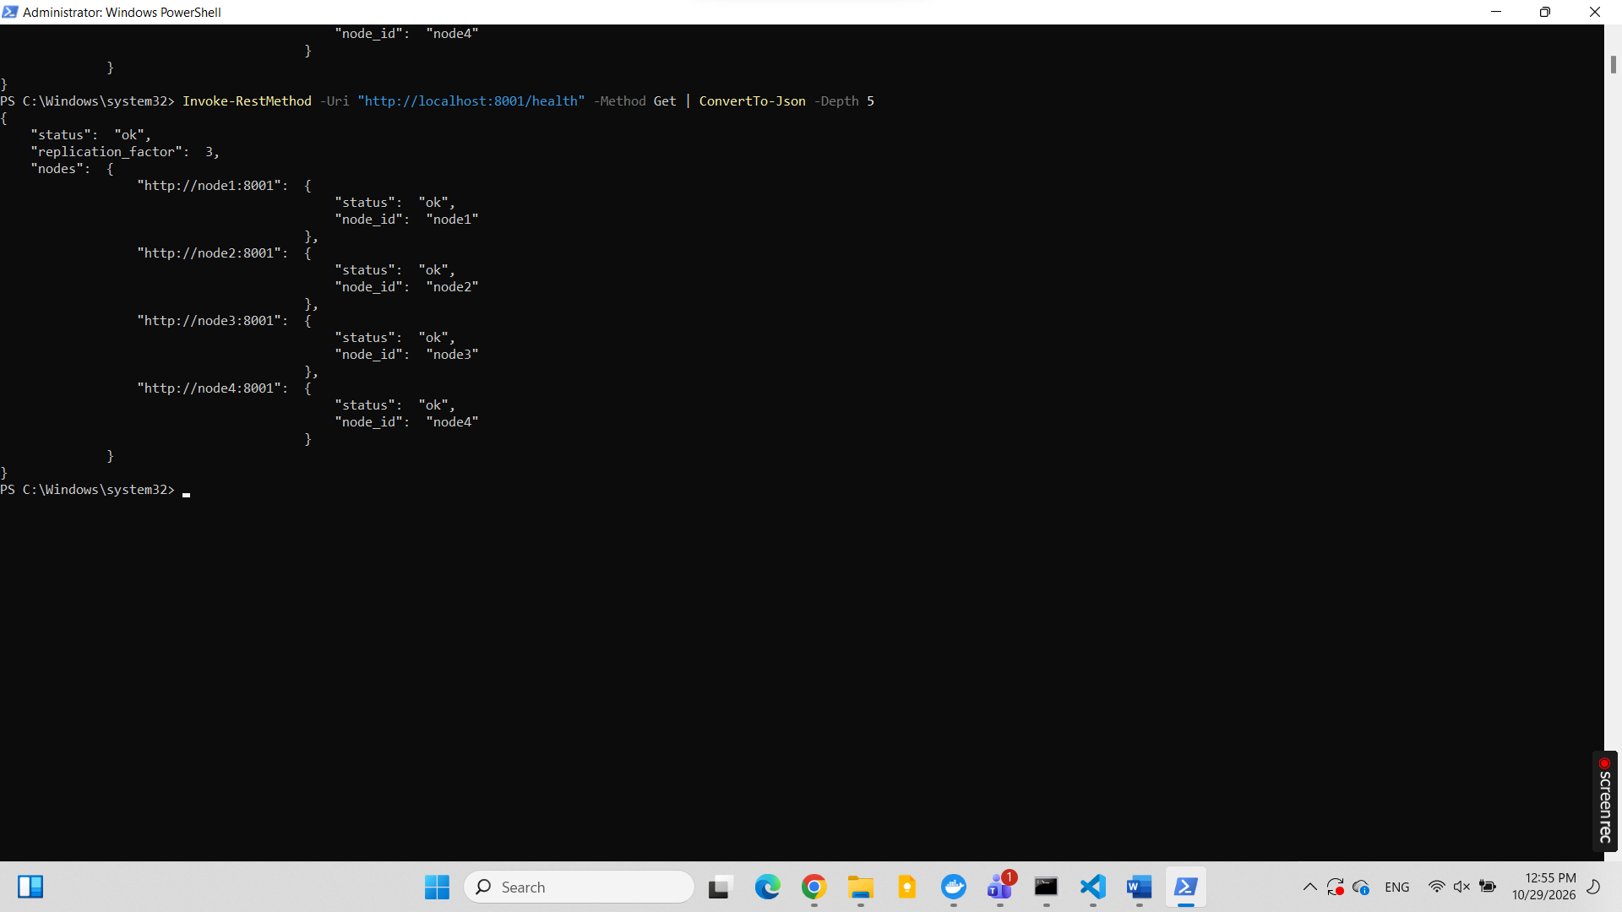

3.Implement the MeTaData and Placement Module
- Split incoming files into chunks :fixed-size (for example 4mb) first, then content-defined chunking (rolling hash , for example FASTCDC) for comparision: Incoming files are divided into fixed-size chunks of 4 MiB, except for the final chunk, which may be smaller. The chunking implementation was tested using a 9 MiB payload, producing three chunks of 4 MiB, 4 MiB, and 1 MiB. The reconstructed file was verified against the original content and SHA-256 hash.
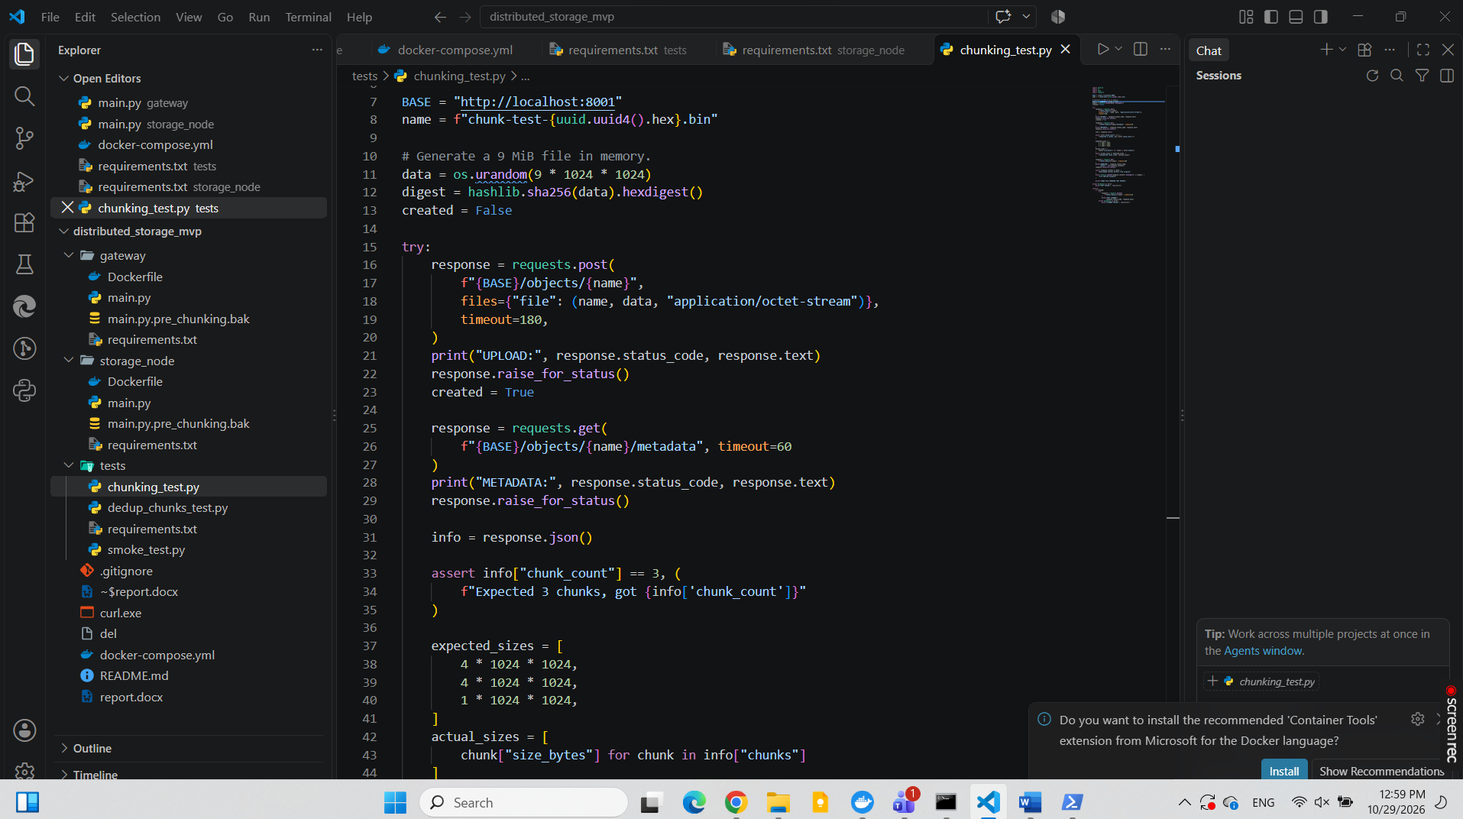
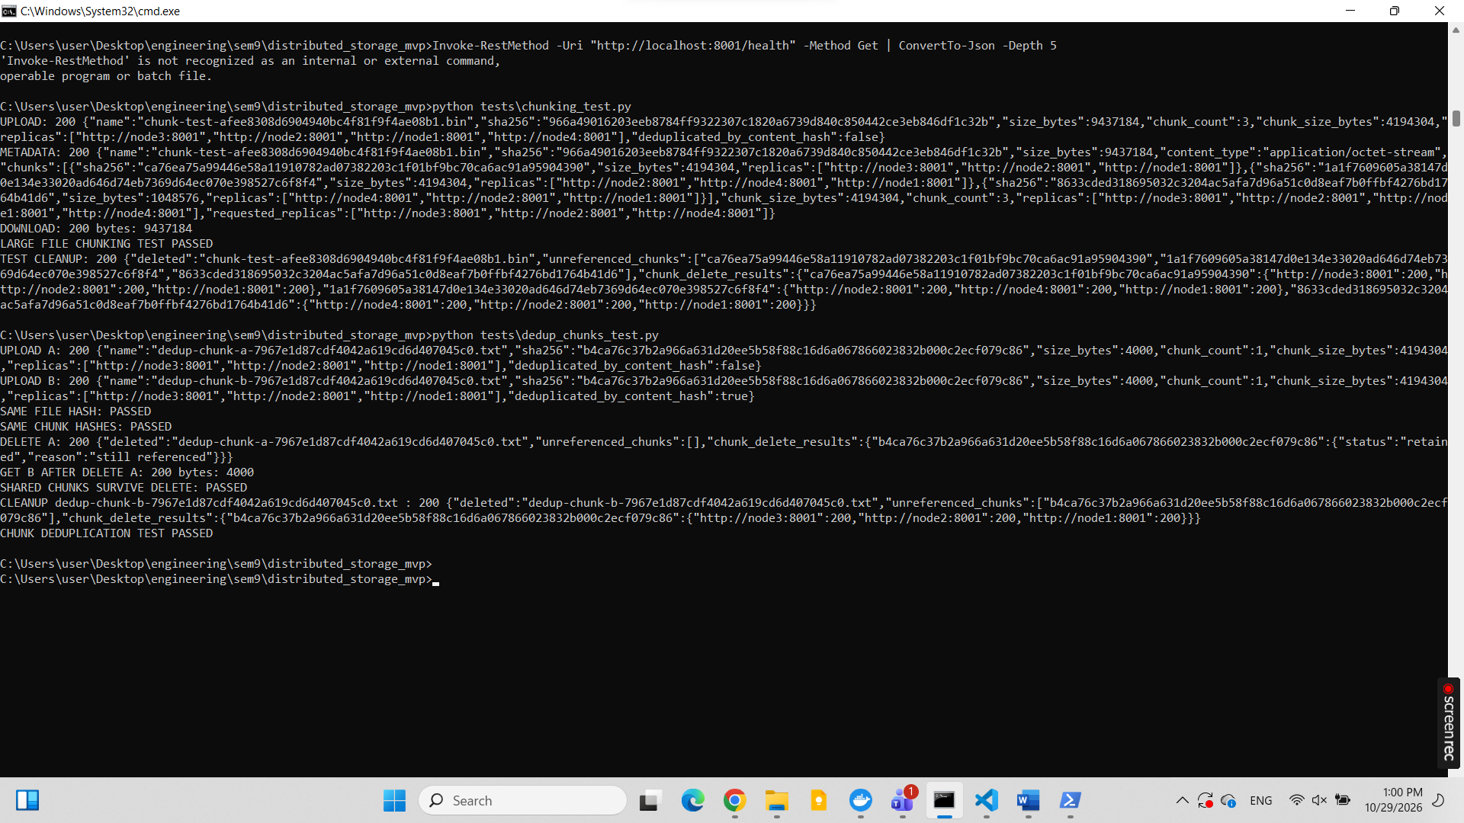
Fixed-size chunking and FASTCDC content-defined chunking were evaluated using the same 9 MiB test file. Fixed-size chunking with a 4 MiB chunk size generated three chunks of 4 MiB, 4 MiB, and 1 MiB, with an average chunk size of 3 MiB and an execution time of approximately 0.0022 seconds. FASTCDC was configured with a minimum chunk size of 1 MiB, a target average of 4 MiB, and a maximum of 8 MiB. It generated two chunks of 8 MiB and 1 MiB, with an average chunk size of 4.5 MiB and an execution time of approximately 0.0141 seconds. Both methods successfully reconstructed the original file, and the resulting SHA-256 hashes matched the original hash. In this test, fixed-size chunking was faster, while FASTCDC generated fewer chunks. These results apply to the tested input and do not establish that one method is universally better.
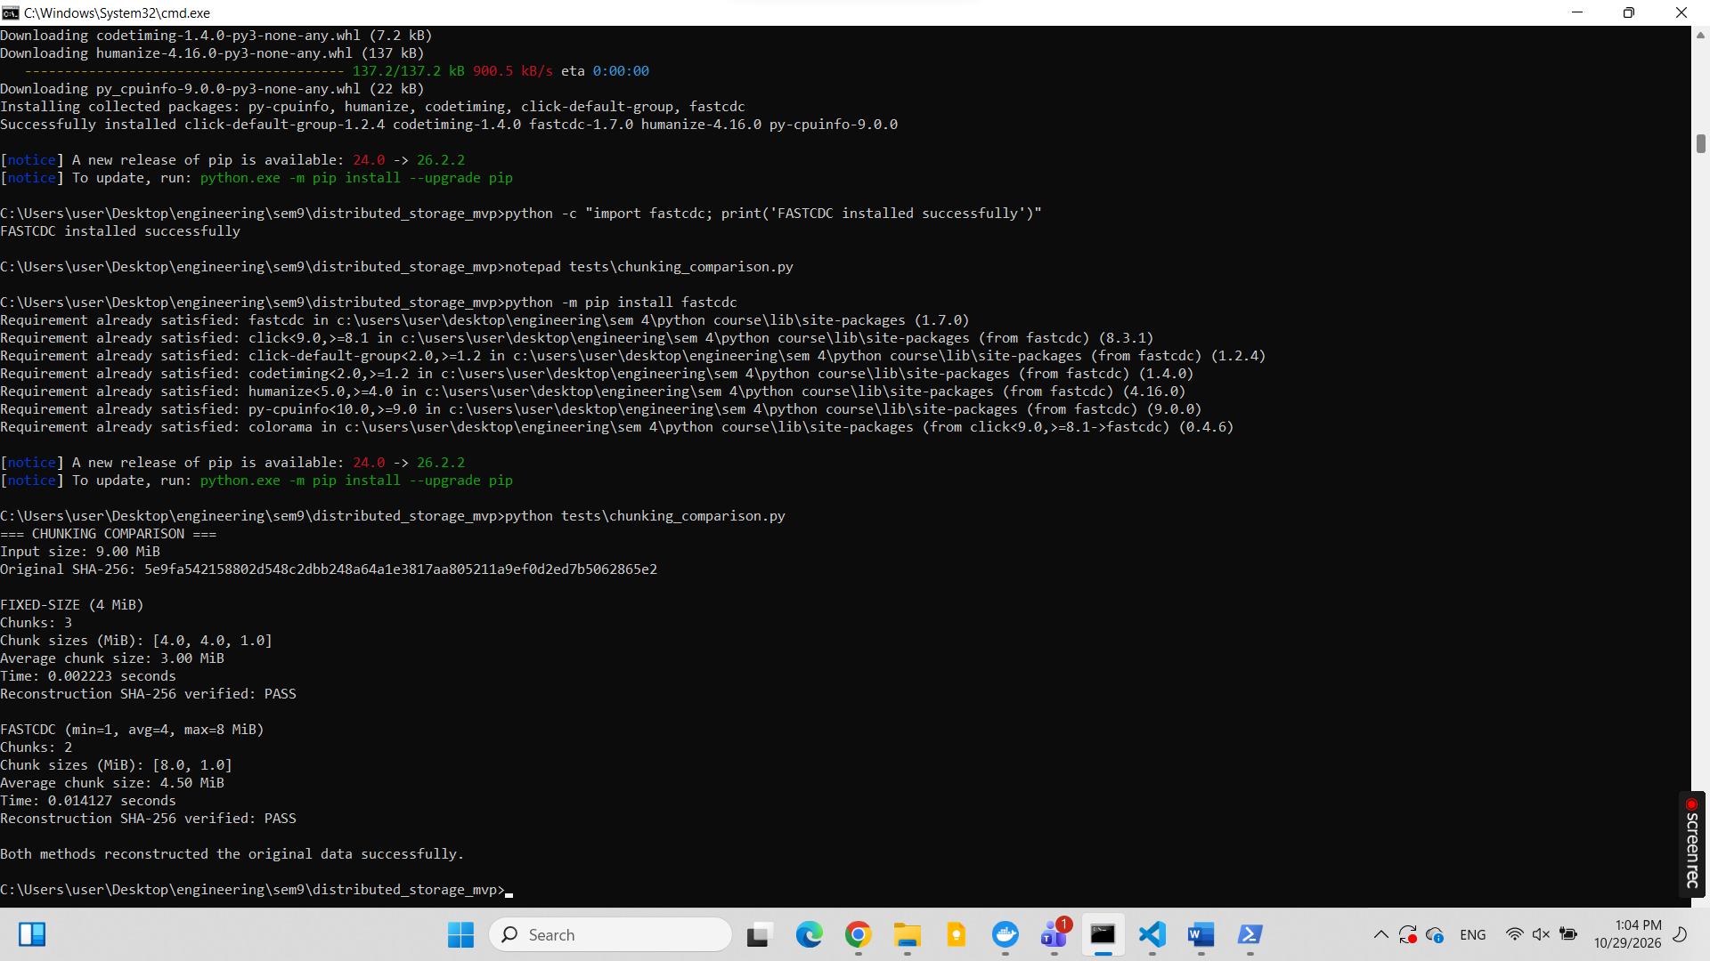
- Store object metadata (bucket, key, size , version, ordered list of chunk hashes, creation date) in etcdot POstgreSQL:
PostgreSQL was integrated into the storage gateway to persist object metadata, including the bucket name, object key, file size, version, chunk hashes, and creation timestamp.A test file, metadata_test.txt, with a size of 45 bytes was uploaded successfully. Its metadata was verified directly in PostgreSQL. After restarting the gateway, the file was retrieved successfully, and the SHA-256 hashes of the original and retrieved files were identical.Result: The test confirmed that object metadata persisted across gateway restarts and that the retrieved file's content remained unchanged.
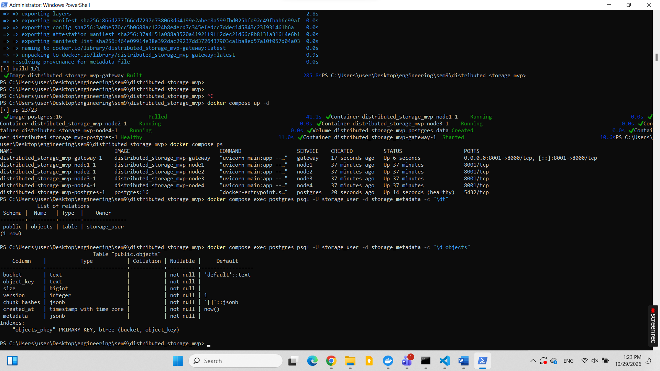
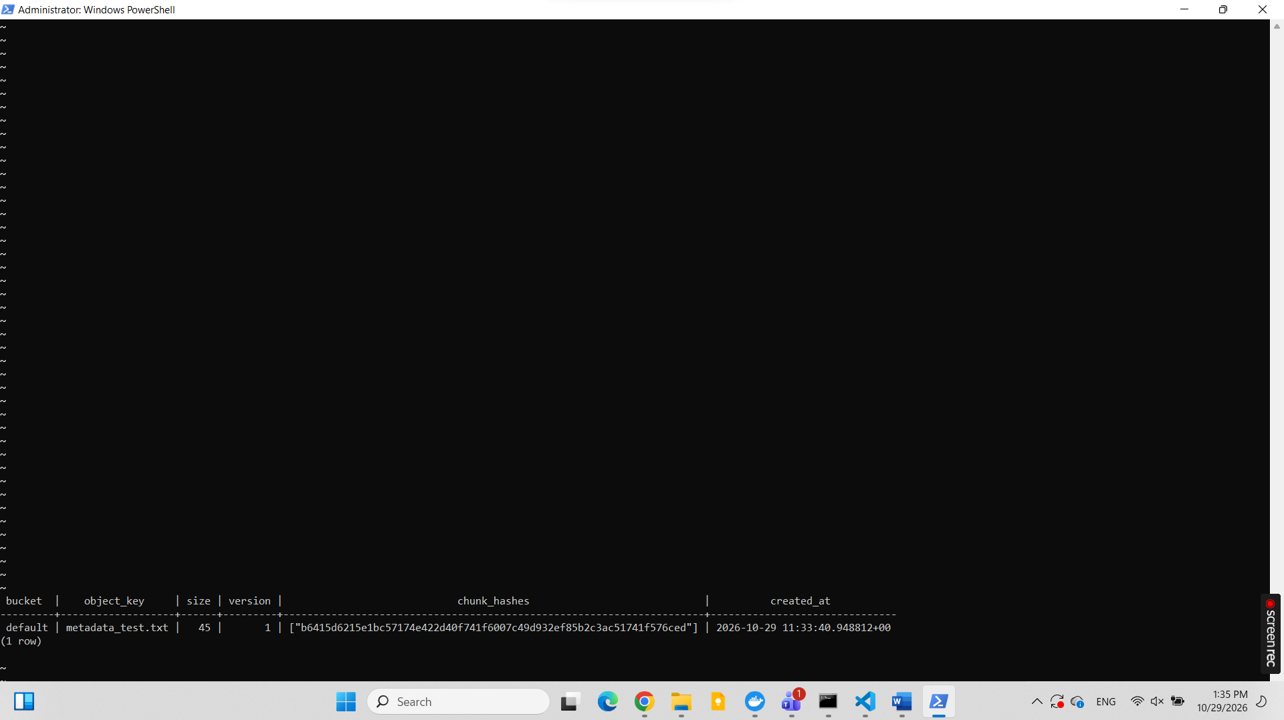
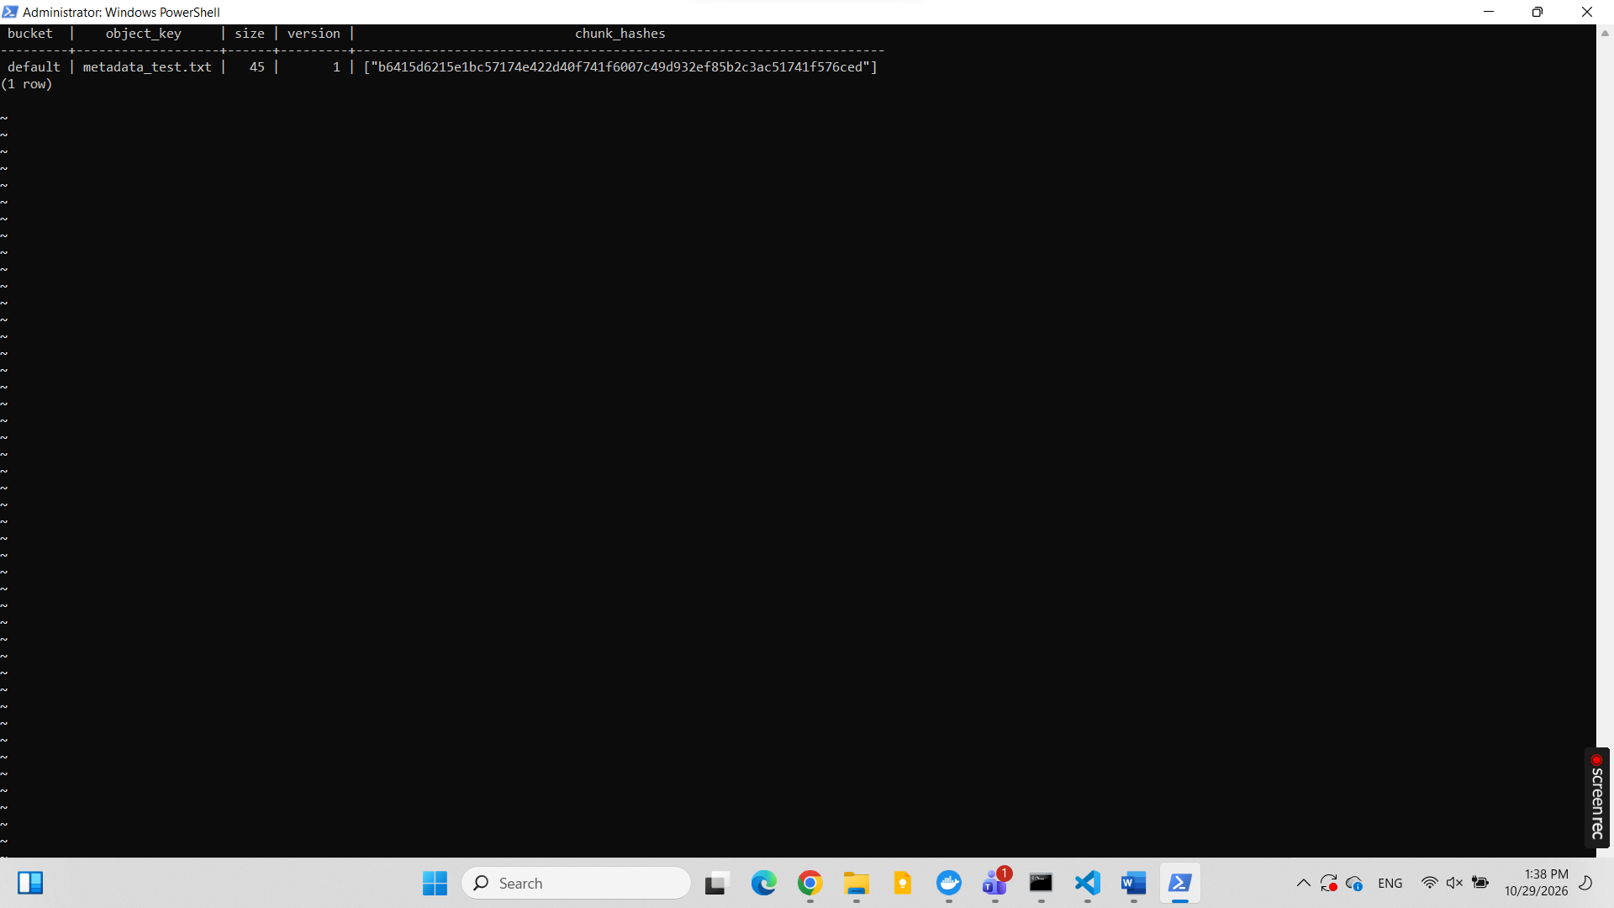

- Implement a consistent hashing ring with virtual nodes to map each chunk hash to its target nodes.: The gateway implements a consistent hashing ring using SHA-256. Each of the four storage nodes is assigned 64 virtual nodes, producing 256 positions on the ring. The bisect module locates the starting position for a chunk hash, and the ownership function selects three distinct physical nodes according to the configured replication factor. The ring contained 256 positions, and the tested chunk hash mapped to three distinct storage nodes. The test passed.
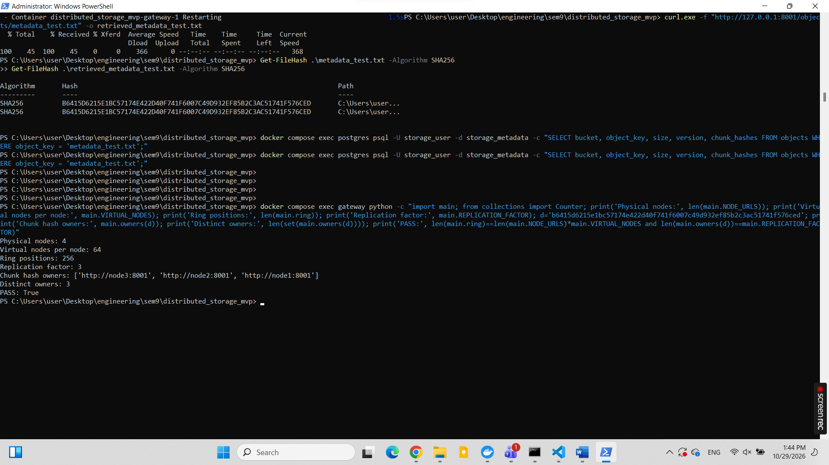

- Implement chunk-level deduplication with reference counting , so identical chunks are stored once and deleted only when no object references them.
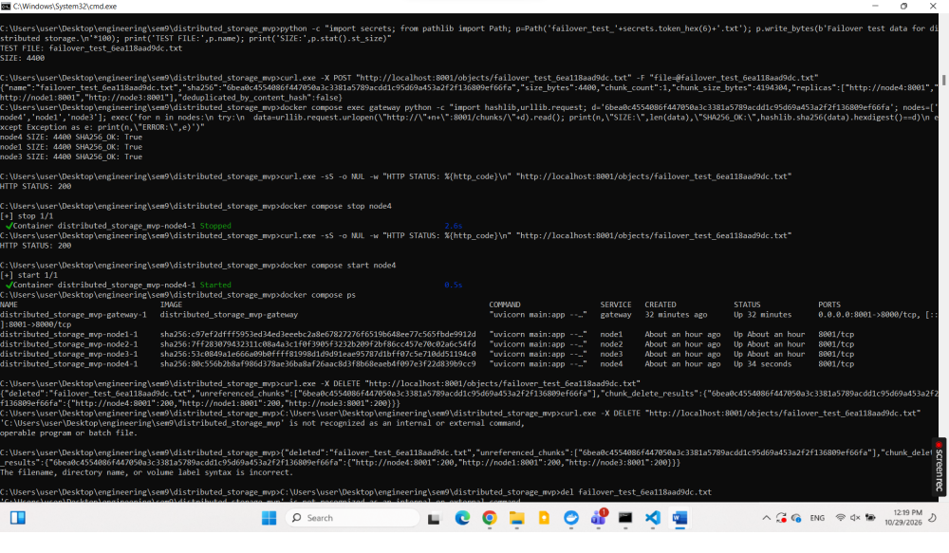
- Test placement by adding and removing a node and measuring the percentage of chunks that move

