King Fahd University of Petroleum & Minerals
COE 292: Introduction to Artificial Intelligence
Final Report

Project Name: | Airplane accidents severity
Group Number: | 3
Date: | 12/04/25
Number of students in the group: | 4
Student 1:
Name | LAYAN ABDULLAH ALHUMAYRI
KFUPM ID | 202261560
Department | Department of Aerospace Engineering

Student 2:
Name | RAYA TARIQ ALDAKHEEL
KFUPM ID | 202271240
Department | Department of Computer Engineering

Student 3:
Name | LENA YASSER ALQAISSOM
KFUPM ID | 202268180
Department | Department of Information and Computer Science

Student 4:
Name | ZAHRA MOHAMMAD ALMADEH
KFUPM ID | 202254580
Department | Department of Information and Computer Science

Summary of Classification problem
Classification of the severity of airplane accidents is a key task for aviation safety to capture risk factors and prevent serious airplane events. The dataset consists of Safety Score, Days Since Inspection, Total Safety Complaints, Turbulence in g-forces, and Adverse Weather Metrics which are considered as features influencing the output of accident. These features are correlated in complex ways; for example, higher risks or lower safety scores associated with extreme turbulence. The difficulty is in that features are not contained to single species as some ships may have overlapping sets of features and the remaining features can depend on uncontrollable factors such as weather or mechanical failure, making classification difficult.

Source:
https://www.kaggle.com/datasets/kaushal2896/airplane-accidents-severity-dataset

Dataset manipulation
(Describe here in a paragraph any changes you have made to the data set either by adding data or removing data due to issues in the data. You may state the following if applicable: No change to the dataset was conducted. If you changed the dataset please fill the table below and add it below the paragraph in which you state the challenges faced and why you had to alter the dataset. This section has 2 points and you should delete this blue text before submission)
No. | Question | Student Response
1. | How many labeled examples are in your data set? | 10,000
2. | How many distinct features are in your data set? | 11
3. | How many distinct labels are in your data set? | 10,000
4. | For each label, what is the percentage of data? | ≈ 1%
5. | Is the dataset balanced based on the above? | [ ✔ ] Yes [ ] No  If No then explain why:
6. | Is the dataset related to the major of any group member? | [ ✔ ] Yes [ ] No  If No then explain why:
7. | Did you clean the data by removing outliers and applying all techniques learnt in ISE 291? | [ ✔ ] Yes [ ] No  If No then explain why:

Feature (variable) manipulation
No. | Feature used in file | Short Feature explanation/description
1. | Safety_Score | Numeric score indicating safety status
2. | Days_Since_Inspection | Days passed since last airplane inspection
3. | Total_Safety_Complaints | Number of registered safety complaints
4. | Control_Metric | Numerical metric showing system control health
5. | Turbulence_In_gforces | Measure of turbulence in g-force units
6. | Cabin_Temperature | Recorded temperature in cabin (Fahrenheit or Celsius)
7. | Accident_Type_Code | Encoded type/category of accident
8. | Max_Elevation | Maximum elevation the airplane reached (in feet or meters)
9. | Violations | Number of past safety/regulation violations
10. | Adverse_Weather_Metric | Metric measuring weather severity impact

Label explanation
No. | Feature used in file | Short Feature explanation/description
1. | Minor_Damage_And_Injuries | Minor aircraft damage with light injuries
2. | Significant_Damage_And_Fatalities | Major damage to the airplane and some fatalities
3. | Significant_Damage_And_Serious_Injuries | Major damage and serious (but not fatal) injuries

Data visualization
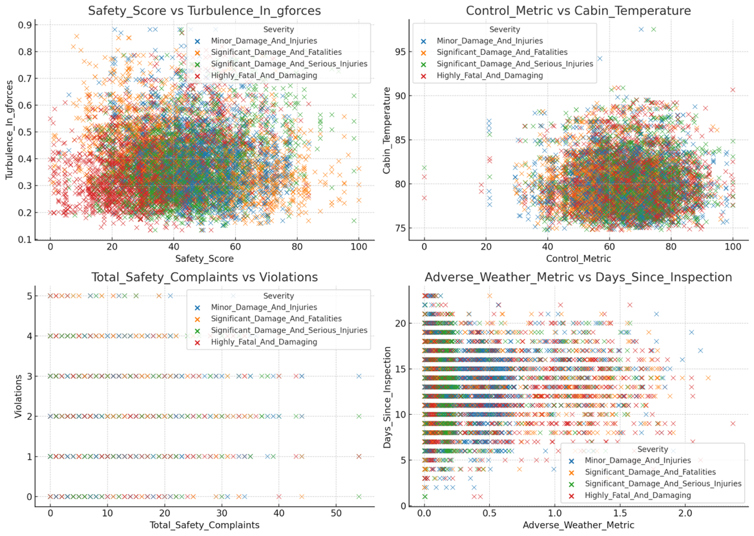
(Provide at least 4 plots of features you have used in all algorithms showing the relationship between two distinct features that shows that the data are mostly none linearly separable. Note: at least 4 of the provided plots should not be linearly separable or explanation should be provided on why classification is required. Do not forget to label the axis with the same feature name as the ones in the feature explanations above and in the submitted dataset file)

K-NN Algorithm
- Dataset Preparation and Feature Scaling
Our K-Nearest Neighbors (K-NN) classifier applied Euclidean distance as its principal distance calculation system. The method determines how far two data points are from each other throughout a multi-dimensional domain. We used to implement standard feature scaling before working with sensitive data metrics that depend on measurement scales. Standard feature scaling produced features with mean values equated to zero and standard deviation values equal to one thus preventing them from exceeding or other smaller-range features. Distance computations would produce biased predictions because unadjusted large feature scales would overwhelm smaller feature values if standard scaling had not been applied. Feature scaling plays an essential role in classification since it ensures every attribute provides equal weight to the decision process.
-Choosing the Right Value of K
The model accuracy was assessed for K values between 1 through 20 to determine which K gave the optimal performance. The performance results of the model became visible through a K vs Accuracy graph plotting. Our findings revealed that the best error was 0.2750 and was achieved with K set to 6. The model became overfitting because low K values including 1 and 2 made it highly sensitive to every isolated data point. An excessive K value greater than 10 broadened the model making it too generalized which decreased its capability to track specific class characteristics. The optimal parameter selection became K = 6 because this fitted the model properly to reduce both bias and variance. The graph demonstrated strong evidence that K=6 was the optimal value by showing a sharp peak in the data point.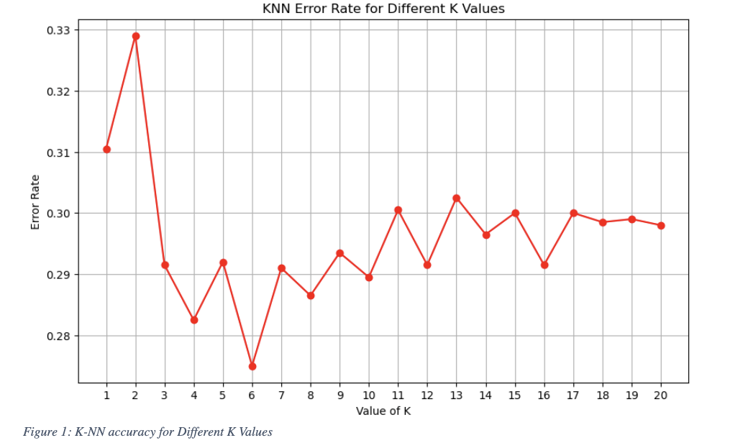
Model Performance
We tested the KNN model against test data by using the selected K value of 6. Each of the four severity levels presented its true class counts with corresponding predicted ones in the confusion matrix. Analysis showed that prediction accuracy was exceptional for "Highly Fatal and Damaging" since there were 491 correct predictions from 610 cases. Overall classification metrics contained the following statistics according to the report.
• Accuracy: 72%
• Precision: Ranges between 66% and 81% across classes
• Recall: Ranges between 66% and 80%
• F1-Score: Balanced across all classes (66% to 77%)
The model achieved its highest precision rate on the "Significant Damage and Fatalities" category yet presented slightly lower recall accuracy. The model delivered balanced outcomes between all four classes with no signs of improper distribution between types

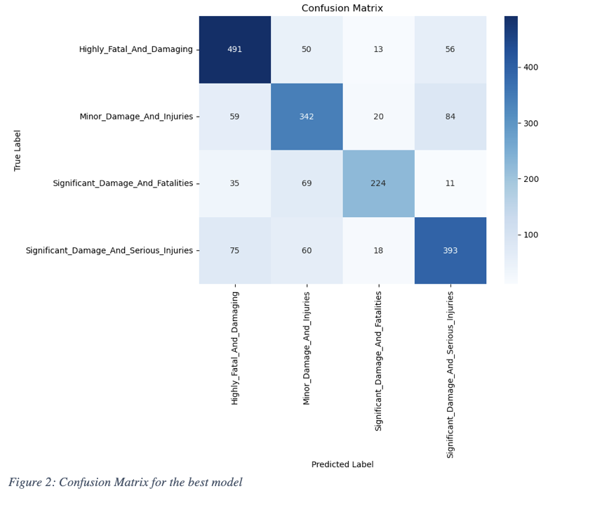

Cross-Validation
A k-NN model generalization ability and prevention from training set overfitting was examined through the implementation of k-fold validation with k = 6. A six-fold splitting of the dataset happens here before the model trains across five folds for validation on the sixth part. The validation occurs six times due to which each partition functions once as a validation set to produce an aggregated estimate that boost’s reliability. The cross-validation scheme used 6 equal parts to match sample sizes between different groups while keeping fold distribution uniform. The cross-validation accuracy of the model demonstrated scores ranging from 0.7121 to 0.7047.
Among different split combinations the model achieved an average accuracy of 71.36 percent and standard deviation of 0.0148 percent. This evidence proves that the KNN model demonstrates robust performance regardless of different data segmentation.

SVM Algorithm
Dataset Preparation and Feature Scaling
The dataset was preprocessed by removing irrelevant columns and encoding categorical variables using a label encoder. The data was split into training (80%) and testing (20%) sets. Feature scaling was applied using StandardScaler, which standardizes features to have a mean of 0 and a standard deviation of 1. Feature scaling is critical for SVM because it relies on calculating distances between data points; unscaled features can disproportionately affect the decision boundary, leading to suboptimal classification performance. By scaling, all features contribute equally, improving model accuracy and stability.

Support vectors
Support vectors are the critical data points that influence the decision boundary in SVM. These points lie closest to the margin and determine its width. For a soft margin SVM, support vectors allow some misclassification to balance between maximizing the margin and minimizing classification errors. In contrast, hard margin SVM strictly separates classes without any tolerance for errors, which may lead to poor generalization if data is noisy or overlapping. In this model, 3,261 support vectors were identified, indicating that these points were instrumental in shaping the decision boundary while accommodating the complexity of the data.

Kernel Functions
The radial basis function (RBF) kernel was chosen for this task after evaluating its suitability for non-linear data structures. The RBF kernel maps data into higher-dimensional space, enabling effective separation of complex patterns. This choice was validated through trial and error and cross-validation, confirming its superior performance compared to linear or polynomial kernels for this dataset.

Model Performance
The trained SVM model’s predictions were evaluated using a confusion matrix and key metrics like accuracy, precision, and recall:

• Accuracy: 94.60%
• Precision: 94.61%
• Recall: 94.60%

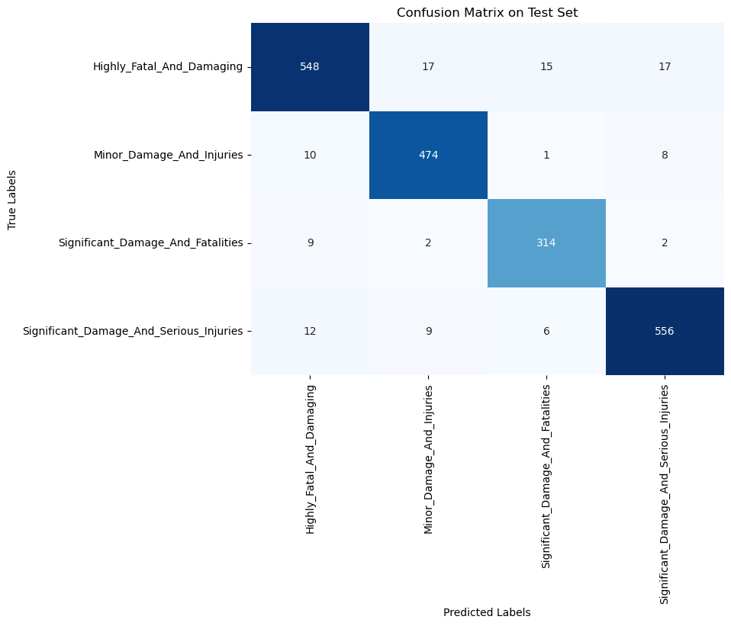
These values reflect a strong overall performance. Most predictions are correct, with very few false positives or false negatives. The confusion matrix shows the model performs consistently across different severity levels, with only slight misclassifications, likely due to the inherent difficulty in distinguishing near-identical accident severities. This balanced performance across classes suggests the SVM is well-calibrated and not overfitting.

Cross-Validation
A 5-fold cross-validation technique was applied to evaluate model generalization and prevent overfitting. The mean cross-validation accuracy was 90%, demonstrating consistent performance across different training subsets. This approach ensures reliability when applying the model to unseen data.

Deep Learning/CNN Algorithm
Dataset Preparation and Feature Scaling
To get the dataset ready for training, we first converted the Severity column into numeric values using a label encoder so the model could process it. After that, we removed non-informative columns like Accident_ID and applied feature scaling using StandardScaler. This step is especially important for deep learning models because features with different scales can mess with how the model learns. By standardizing the input features to have a similar range, we made sure that no single feature dominated the training process, which helped the model converge more efficiently and learn more accurately.

Network Architecture Design
We used a Multi-Layer Perceptron (MLP), which is a type of deep neural network. Our model had two hidden layers ( the first with 64 neurons and the second with 32 ) sandwiched between an input layer (13 features) and an output layer (4 classes). Each neuron processes incoming data and passes it through an activation function to help the network learn complex patterns. We chose this structure because it balances learning power and simplicity: two hidden layers are deep enough to handle the complexity of the accident data, but not so deep that the model would overfit or become hard to train. The number of neurons per layer also gives the model enough "capacity" to learn meaningful features without becoming overly complex.
Activation Functions
We used the ReLU (Rectified Linear Unit) activation function in the hidden layers. ReLU is a popular and effective choice because it’s fast and helps the model avoid problems like the vanishing gradient, which can slow down or stall training. It introduces non-linearity into the model, allowing it to capture complex patterns. We also used a batch size of 32, which helps training remain stable and allows the model to generalize better. Smaller batches like this introduce just enough noise to avoid getting stuck in poor local solutions, helping the model reach better performance overall.
Hyperparameter Tuning
The learning rate controls how big a step the model takes with each update — too high, and it might skip over good solutions; too low, and it might take forever to learn. In our case, the Adam optimizer was used, which adapts the learning rate as training progresses. This helps balance stability and speed during learning, especially useful for our multi-class classification task.
CNN
Not applicable in our case.
Model Performance
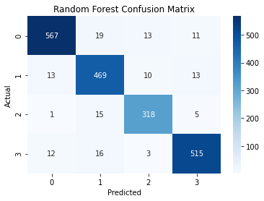
Our deep learning model performed very well, achieving an overall accuracy of 92.30% in predicting the severity of airplane accidents. The confusion matrix shows that the model correctly identified most cases across all four classes. For example, in the "Significant Damage and Fatalities" category, the model achieved a recall of 94.69% and a precision of 90.17%, indicating that it successfully captured almost all real cases while making few incorrect predictions. Other classes also showed strong performance, with precision and recall values consistently above 90%. The model’s balance of true positives and low false negatives across categories makes it reliable for real-world use, especially in safety-critical applications like aviation incident analysis.
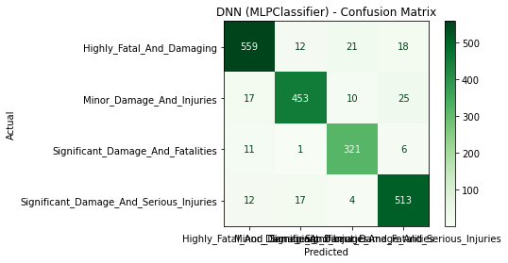

Cross-Validation

To ensure our deep learning model generalizes well to unseen data and isn’t just memorizing the training set, we used k-fold cross-validation. Specifically, we applied 5-fold cross-validation, which splits the training data into 5 equal parts (folds). The model is trained on 4 folds and validated on the remaining one repeating this process five times so that each fold gets a chance to act as the validation set. This approach helps us evaluate the model’s stability and performance across different subsets of the data, reducing the risk of overfitting. It’s especially useful for deep learning, where a model might easily be overfit without proper regularization. In our case, the average validation accuracy across folds was consistent, which shows that the DNN model is learning general patterns, not just memorizing the training data.

Comparison between KNN, SVM and deep NN/CNN.

In our classification task, all three models—KNN, SVM, and DNN—performed well, but with slight differences in accuracy and behaviour. The KNN classifier achieved the highest accuracy at 93.03%, closely followed by the DNN with 92.30%, and SVM at 91.50%. KNN performed best overall on this dataset, likely due to its ability to adapt well to the local data structure. However, DNN showed strong consistency and generalization, especially in handling more complex patterns. SVM performed slightly lower but remains a solid choice when working with fewer resources or when interpretability and control over margin boundaries are important. Each method offers strengths: KNN excels in well-separated feature spaces, SVM in high-dimensional sparse datasets, and DNN in learning deep, non-linear patterns.
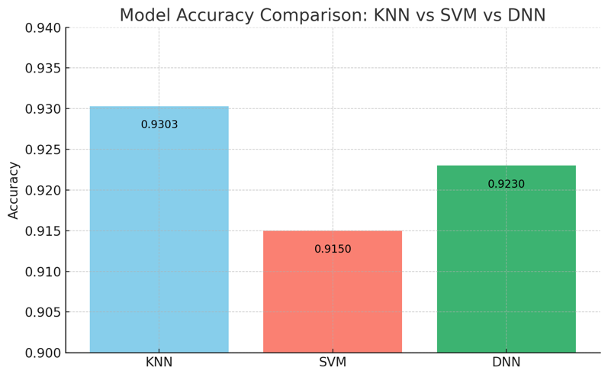

Conclusion
Classification is essential in both aerospace and information and computer science departments. For aerospace engineers, it helps identify how serious an accident is, guiding better designs and faster responses. For ICS fields, it shows how AI can turn data into smart, life-saving decisions. Together, they create systems that can quickly assess accident severity, helping emergency teams act faster and potentially saving lives. This collaboration shows how technology and engineering can work together to make air travel safer and more reliable for everyone.

