Pre questionnaire:
supsi collaboration questionary
3. Have you ever worked with a robot before?
8. Is the robot’s presence pleasant to you?

General Self-Efficacy Scale: 1-4: Measures belief in one’s own ability to succeed in tasks.
    - I can always manage to solve difficult problems if I try hard enough.
    - If someone opposes me, I can find the means and ways to get what I want.
    - It is easy for me to stick to my aims and accomplish my goals.
    - I am confident that I could deal efficiently with unexpected events.
    - Thanks to my resourcefulness, I know how to handle unforeseen situations.
    - I can solve most problems if I invest the necessary effort.
    - I can remain calm when facing difficulties because I can rely on my coping abilities.
    - When I am confronted with a problem, I can usually find several solutions.
    - If I am in trouble, I can usually think of a solution.
    - I can usually handle whatever comes my way.

general attitude toward robots
🟩 Personal-Level Positive (P⁺) — Comfort & Enjoyment
- I can trust persons and organizations related to development of robots
- Persons and organizations related to development of robots will consider the needs, thoughts and feelings of their users
- I can trust a robot
- I would feel relaxed talking with a robot
- If robots had emotions, I would be able to befriend them

🟥 Personal-Level Negative (P⁻) — Unease & Anxiety
- I would feel uneasy if I was given a job where I had to use robots
- I fear that a robot would not understand my commands
- Robots scare me
- I would feel very nervous just being around a robot
- I don’t want a robot to touch me

🟦 Societal-Level Positive (S⁺) — Rational Hopes
- Robots are necessary because they can do jobs that are too hard or too dangerous for people
- Robots can make life easier
- Assigning routine tasks to robots lets people do more meaningful tasks
- Dangerous tasks should primarily be given to robots
- Robots are a good thing for society, because they help people

🟨 Societal-Level Negative (S⁻) — Rational Worries
- Robots may make us even lazier
- Widespread use of robots is going to take away jobs from people
- I am afraid that robots will encourage less interaction between humans
- Robotics is one of the areas of technology that needs to be closely monitored
- Unregulated use of robotics can lead to societal upheavals

Each item is rated on a Likert scale (typically 1 = strongly disagree to 5 or 7 = strongly agree).

Experiment questionnaire:
I. Describe the workload you experienced while completing the tasks, by circling the mark:
Mental Demand: How much thinking, deciding, or calculating was required to perform the tasks?
Low |  |  |  |  |  |  |  |  |  |  |  |  |  |  |  |  |  |  |  | High
Physical Demand: How much physical activity was required to perform the tasks?
Low |  |  |  |  |  |  |  |  |  |  |  |  |  |  |  |  |  |  |  | High
Temporal Demand: How hurried or rushed was the pace of the tasks?
Low |  |  |  |  |  |  |  |  |  |  |  |  |  |  |  |  |  |  |  | High
Performance: How successful were you in accomplishing what you were asked to do?
Perfect |  |  |  |  |  |  |  |  |  |  |  |  |  |  |  |  |  |  |  | Failure
Effort: How hard did you have to work to accomplish and maintain your level of performance?
Low |  |  |  |  |  |  |  |  |  |  |  |  |  |  |  |  |  |  |  | High
Frustration: How insecure, discouraged, irritated, stressed, and annoyed were you?
Low |  |  |  |  |  |  |  |  |  |  |  |  |  |  |  |  |  |  |  | High

I felt more capable than the robot for this task.
I was satisfied with the outcome of the collaboration.

Post Questionnaire:
Supsi : 10. Are you ready to collaborate with this robot on more important tasks?
→ See how perception of the robot may have changed after interaction.
→ Custom scale: Ask participants to rate the fairness, efficiency, and satisfaction with their allocation decisions.

Interview questions:
How did you decide whether to assign a task to yourself or the robot?
What were your thoughts about the robot’s capabilities?
Did you feel the robot was better at any tasks than you?
Did the collaboration feel balanced?
Do you think if the robot was more capable you would allocate more tasks to it?
Did you consider yourself and the robot as a team? Or did you feel you are the lead of it?
What qualities of the robot influenced your allocation decisions?
Did your opinion of the robot change during the task?
If you could reallocate the tasks after this experience, what would you change and why?

List of questionare:
supsi collaboration questionary
1. Have you ever watched videos or played games that included robots?
2. Have you ever been close or in the same space with a robot before?
3. Have you ever worked with a robot before?
4. How do you feel about the environment, and what do you think about the workload?
5. Is the operation consistent and predictable?
6. Do you understand thoroughly the task requirements?
7. Do you think your skills are sufficient and helpful for the tasks?
8. Is the robot’s presence pleasant to you?
9. Are you happy with your performance?
10. Are you ready to collaborate with this robot on more important tasks?

Nasa-TLX
Date (yy/mm/dd): 2023 /____ / ____ Shift: ________ Participant ID: ________
I. Describe the workload you experienced while completing the tasks, by circling the mark:
Mental Demand: How much thinking, deciding, or calculating was required to perform the tasks?
Low |  |  |  |  |  |  |  |  |  |  |  |  |  |  |  |  |  |  |  | High
Physical Demand: How much physical activity was required to perform the tasks?
Low |  |  |  |  |  |  |  |  |  |  |  |  |  |  |  |  |  |  |  | High
Temporal Demand: How hurried or rushed was the pace of the tasks?
Low |  |  |  |  |  |  |  |  |  |  |  |  |  |  |  |  |  |  |  | High
Performance: How successful were you in accomplishing what you were asked to do?
Perfect |  |  |  |  |  |  |  |  |  |  |  |  |  |  |  |  |  |  |  | Failure
Effort: How hard did you have to work to accomplish and maintain your level of performance?
Low |  |  |  |  |  |  |  |  |  |  |  |  |  |  |  |  |  |  |  | High
Frustration: How insecure, discouraged, irritated, stressed, and annoyed were you?
Low |  |  |  |  |  |  |  |  |  |  |  |  |  |  |  |  |  |  |  | High
SUS
System Usability Scale (SUS)

This is a standard questionnaire that measures the overall usability of a system. Please select the answer that best expresses how you feel about each statement after using the website today.

 | Strongly Disagree | Somewhat Disagree | Neutral | Somewhat Agree | Strongly Agree
- I think I would like to use this tool frequently. | ❍ | ❍ | ❍ | ❍ | ❍
- I found the tool unnecessarily complex. | ❍ | ❍ | ❍ | ❍ | ❍
- I thought the tool was easy to use. | ❍ | ❍ | ❍ | ❍ | ❍
- I think that I would need the support of a technical person to be able to use this system. | ❍ | ❍ | ❍ | ❍ | ❍
- I found the various functions in this tool were well integrated. | ❍ | ❍ | ❍ | ❍ | ❍
- I thought there was too much inconsistency in this tool. | ❍ | ❍ | ❍ | ❍ | ❍
- I would imagine that most people would learn to use this tool very quickly. | ❍ | ❍ | ❍ | ❍ | ❍
- I found the tool very cumbersome to use. | ❍ | ❍ | ❍ | ❍ | ❍
- I felt very confident using the tool. | ❍ | ❍ | ❍ | ❍ | ❍
- I needed to learn a lot of things before I could get going with this tool. | ❍ | ❍ | ❍ | ❍ | ❍

How likely are you to recommend this website to others? (please circle your answer)
Not at all likely 0 1 2 3 4 5 6 7 8 9 10 Extremely likely

Nars: Negative attitude toward robots
- S1 (Interaction Situations; 6 items)
- S2 (Social Influence; 5 items)
- S3 (Emotional Interaction; 3 items) link.springer.com+15rikou.ryukoku.ac.jp+15imperial.ac.uk+15rins.st.ryukoku.ac.jp+1journals.sagepub.com+1
Many items are reverse-scored. Here's a representative list from public sources :
S1 – Interaction Situations
- I would feel uneasy if I was given a job where I had to use robots.
- The word “robot” means nothing to me. (reverse-scored)
- I would feel nervous operating a robot in front of other people.
- I would hate the idea that robots or artificial intelligences were making judgments about things.
- I would feel very nervous just standing in front of a robot.
- I would feel paranoid talking with a robot.
S2 – Social Influence
7. I would feel uneasy if robots really had emotions.
8. Something bad might happen if robots developed into living beings.
9. I am concerned that robots would be a bad influence on children.
10. I feel that in the future society will be dominated by robots.
11. I feel that if I depend on robots too much, something bad might happen.
S3 – Emotional Interaction
12. I would feel relaxed talking with robots. (reverse-scored)
13. If robots had emotions, I would be able to make friends with them. (reverse-scored)
14. I feel comforted being with robots that have emotions. (reverse-scored)

general attitude toward robots
🟩 Personal-Level Positive (P⁺) — Comfort & Enjoyment
- I can trust persons and organizations related to development of robots
- Persons and organizations related to development of robots will consider the needs, thoughts and feelings of their users
- I can trust a robot
- I would feel relaxed talking with a robot
- If robots had emotions, I would be able to befriend them

🟥 Personal-Level Negative (P⁻) — Unease & Anxiety
- I would feel uneasy if I was given a job where I had to use robots
- I fear that a robot would not understand my commands
- Robots scare me
- I would feel very nervous just being around a robot
- I don’t want a robot to touch me

🟦 Societal-Level Positive (S⁺) — Rational Hopes
- Robots are necessary because they can do jobs that are too hard or too dangerous for people
- Robots can make life easier
- Assigning routine tasks to robots lets people do more meaningful tasks
- Dangerous tasks should primarily be given to robots
- Robots are a good thing for society, because they help people

🟨 Societal-Level Negative (S⁻) — Rational Worries
- Robots may make us even lazier
- Widespread use of robots is going to take away jobs from people
- I am afraid that robots will encourage less interaction between humans
- Robotics is one of the areas of technology that needs to be closely monitored
- Unregulated use of robotics can lead to societal upheavals

Each item is rated on a Likert scale (typically 1 = strongly disagree to 5 or 7 = strongly agree).

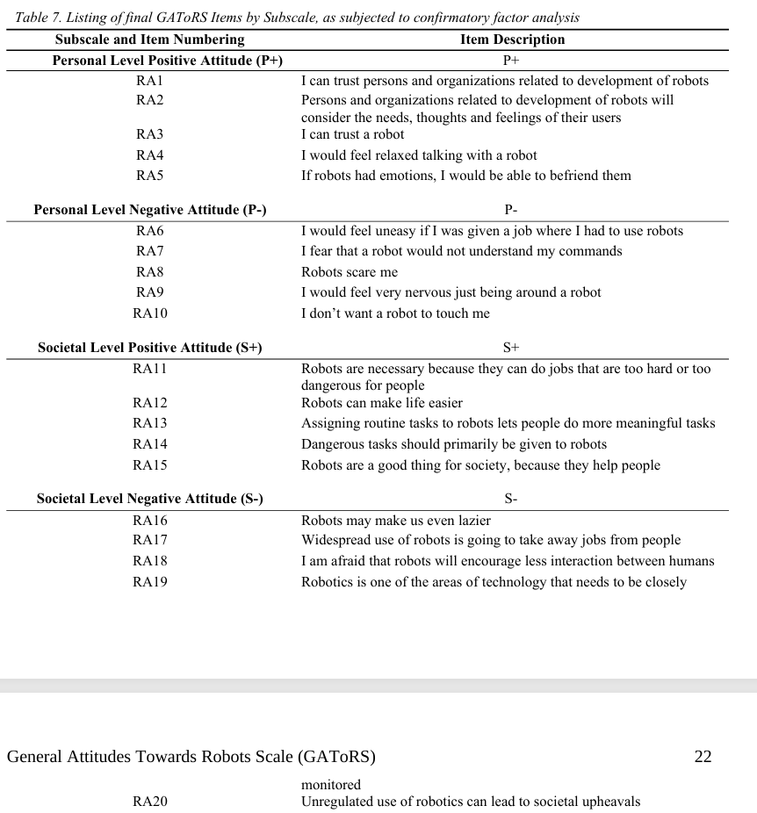
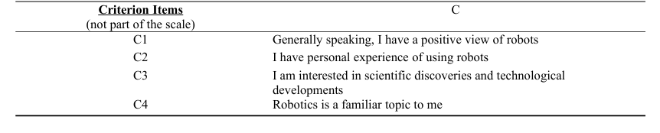

Post experimental:

Munka utasítás rossz darabbal
Instructions:
Please rate your experience during the last task on a scale from 1 (Not at all) to 10 (Very much).

Performance Self-Esteem:
  - "I felt rattled about my performance when I saw the inconsistency between the instruction and the next step."
  - "I felt confident that I understand the task well." (reverse scored)
Recognition of Contradiction:
- "When I received the instruction to place the piece, I had doubts about whether it was correct."
- "I was surprised by the instruction to place the piece in that position."
Interest:
  - "The mismatch between the instruction and the puzzle piece motivated me to figure out the problem."
  - "I wanted to understand the source of the inconsistency."
  - „The mismatch attracts my attention.”
Confusion:
  - "The mismatch confused me."
  - "The mismatch caused me to feel mentally strained."
Cognitive Reappraisal:
  - "I tried to find a reason why the piece did not fit as instructed."
  - "I re-examined the pieces to confirm their placement."
Frustration:
- "I felt frustrated because I couldn’t figure out the correct solution."
- "I felt frustrated because the instruction was impossible to follow."
Intrinsic Load:
  - "The task of assembling the puzzle was complex."
  - "The instructions for placing the pieces were difficult to follow."
Extraneous Load:
  - "The instructions during the task were very unclear. "
  - " The instructions were, in terms of the task, very ineffective. "
Germane Load:
  - "Resolving the conflict deepen my understanding of the puzzle"
  - "I had to develop new strategies to meet the challenge."

Instructions:
Please rate your experience during the last task on a scale from 1 (Not at all) to 10 (Very much).

Pre:
PRE-TASK QUESTIONNAIRE
Instructions. This questionnaire is concerned with your feelings and thoughts at the moment. Please answer every question, even if you find it difficult. Answer, as honestly as you can, what is true of you. Please do not choose a reply just because it seems like the 'right thing to say'. Your answers will be kept entirely confidential. Also, be sure to answer according to how you feel AT THE MOMENT. Don't just put down how you usually feel. You should try and work quite quickly: there is no need to think very hard about the answers. The first answer you think of is usually the best. Before you start, please provide some general information about yourself.
Age............. (years) Sex. M F (Circle one)
Occupation..................... If student, state your major..............
Date today..................... Time of day now..............
For each statement, circle an answer from 1 to 5, so as to indicate how accurately it describes your feelings AT THE MOMENT.
Definitely false = 1, Somewhat false = 2, Neither true nor false = 3, Somewhat true = 4, Definitely true = 5
1 | I feel concerned about the impression I am making. | 1 | 2 | 3 | 4 | 5
2 | I feel relaxed. | 1 | 2 | 3 | 4 | 5
3 | The content of the task will be dull. | 1 | 2 | 3 | 4 | 5
4 | I am thinking about how other people might judge my performance. | 1 | 2 | 3 | 4 | 5
5 | I am determined to succeed on the task. | 1 | 2 | 3 | 4 | 5
6 | I feel tense. | 1 | 2 | 3 | 4 | 5
7 | I am worried about what other people think of me. | 1 | 2 | 3 | 4 | 5
8 | I am thinking about how I would feel if I were told how I performed | 1 | 2 | 3 | 4 | 5
9 | Generally, I feel in control of things. | 1 | 2 | 3 | 4 | 5
10 | I am reflecting about myself. | 1 | 2 | 3 | 4 | 5
11 | My attention will be directed towards the task. | 1 | 2 | 3 | 4 | 5
12 | I am thinking deeply about myself. | 1 | 2 | 3 | 4 | 5
13 | I feel energetic. | 1 | 2 | 3 | 4 | 5
14 | I am thinking about things that happened to me in the past | 1 | 2 | 3 | 4 | 5
15 | I am thinking about how other people might perform on this task | 1 | 2 | 3 | 4 | 5
16 | I am thinking about something that happened earlier today. | 1 | 2 | 3 | 4 | 5
17 | I expect that the task will be too difficult for me. | 1 | 2 | 3 | 4 | 5
18 | I will find it hard to keep my concentration on the task. | 1 | 2 | 3 | 4 | 5
19 | I am thinking about personal concerns and interests. | 1 | 2 | 3 | 4 | 5
20 | I feel confident about my performance. | 1 | 2 | 3 | 4 | 5
21 | I am examining my motives. | 1 | 2 | 3 | 4 | 5
22 | I can handle any difficulties I may encounter | 1 | 2 | 3 | 4 | 5
23 | I am thinking about how I have dealt with similar tasks in the past | 1 | 2 | 3 | 4 | 5
24 | I am reflecting on my reasons for doing the task | 1 | 2 | 3 | 4 | 5
25 | I am motivated to try hard at the task. | 1 | 2 | 3 | 4 | 5
26 | I am thinking about things important to me. | 1 | 2 | 3 | 4 | 5
27 | I feel uneasy. | 1 | 2 | 3 | 4 | 5
28 | I feel tired. | 1 | 2 | 3 | 4 | 5
29 | I feel that I cannot deal with the situation effectively. | 1 | 2 | 3 | 4 | 5
30 | I feel bored. | 1 | 2 | 3 | 4 | 5

Post:
Appendix B
POST-TASK QUESTIONNAIRE
Instructions. This questionnaire is concerned with your feelings and thoughts while you were performing the task. Please answer every question, even if you find it difficult. Answer, as honestly as you can, what is true of you. Please do not choose a reply just because it seems like the 'right thing to say'. Your answers will be kept entirely confidential. Also, be sure to answer according to how you felt WHILE PERFORMING THE TASK. Don't just put down how you usually feel. You should try and work quite quickly: there is no need to think very hard about the answers. The first answer you think of is usually the best.
For each statement, circle an answer from 0 to 4, so as to indicate how accurately it describes your
feelings WHILE PERFORMING THE TASK.
Definitely false = 1, Somewhat false = 2, Neither true nor false = 3, Somewhat true = 4, Definitely true = 5,

1 | I felt concerned about the impression I am making. | 1 | 2 | 3 | 4 | 5
2 | I felt relaxed. | 1 | 2 | 3 | 4 | 5
3 | The content of the task was dull. | 1 | 2 | 3 | 4 | 5
4 | I thought about how other people might judge my performance | 1 | 2 | 3 | 4 | 5
5 | I was determined to succeed on the task. | 1 | 2 | 3 | 4 | 5
6 | I felt tense. | 1 | 2 | 3 | 4 | 5
7 | I was worried about what other people think of me. | 1 | 2 | 3 | 4 | 5
8 | I thought about how I would felt if I were told how I performed | 1 | 2 | 3 | 4 | 5
9 | Generally, I felt in control of things. | 1 | 2 | 3 | 4 | 5
10 | I reflected about myself. | 1 | 2 | 3 | 4 | 5
11 | My attention was directed towards the task. | 1 | 2 | 3 | 4 | 5
12 | I thought deeply about myself. | 1 | 2 | 3 | 4 | 5
13 | I felt energetic. | 1 | 2 | 3 | 4 | 5
14 | I thought about things that happened to me in the past | 1 | 2 | 3 | 4 | 5
15 | I thought about how other people might perform on this task | 1 | 2 | 3 | 4 | 5
16 | I thought about something that happened earlier today. | 1 | 2 | 3 | 4 | 5
17 | I found the task was too difficult for me. | 1 | 2 | 3 | 4 | 5
18 | I found it hard to keep my concentration on the task. | 1 | 2 | 3 | 4 | 5
19 | I thought about personal concerns and interests. | 1 | 2 | 3 | 4 | 5
20 | I felt confident about my performance. | 1 | 2 | 3 | 4 | 5
21 | I examined my motives. | 1 | 2 | 3 | 4 | 5
22 | I felt like I could handle any difficulties I encountered | 1 | 2 | 3 | 4 | 5
23 | I thought about how I have dealt with similar tasks in the past | 1 | 2 | 3 | 4 | 5
24 | I reflected on my reasons for doing the task | 1 | 2 | 3 | 4 | 5
25 | I was motivated to try hard at the task. | 1 | 2 | 3 | 4 | 5
26 | I thought about things important to me. | 1 | 2 | 3 | 4 | 5
27 | I felt uneasy. | 1 | 2 | 3 | 4 | 5
28 | I felt tired. | 1 | 2 | 3 | 4 | 5
29 | I felt that I could not deal with the situation effectively. | 1 | 2 | 3 | 4 | 5
30 | I felt bored. | 1 | 2 | 3 | 4 | 5

DSSQ
1. I felt concerned about the impression I am making. 0 1 2 3 4
2. I felt relaxed. 0 1 2 3 4
3. The content of the task was dull. 0 1 2 3 4
4. I thought about how other people might judge my performance 0 1 2 3 4
5. I was determined to succeed on the task. 0 1 2 3 4
6. I felt tense. 0 1 2 3 4
7. I was worried about what other people think of me. 0 1 2 3 4
8. I thought about how I would felt if I were told how I performed 0 1 2 3 4
9. Generally, I felt in control of things. 0 1 2 3 4
10. I reflected about myself. 0 1 2 3 4
11. My attention was directed towards the task. 0 1 2 3 4
12. I thought deeply about myself. 0 1 2 3 4
13. I felt energetic. 0 1 2 3 4
14. I thought about things that happened to me in the past 0 1 2 3 4
15. I thought about how other people might perform on this task 0 1 2 3 4
16. I thought about something that happened earlier today. 0 1 2 3 4
17. I found the task was too difficult for me. 0 1 2 3 4
18. I found it hard to keep my concentration on the task. 0 1 2 3 4
19. I thought about personal concerns and interests. 0 1 2 3 4
20. I felt confident about my performance. 0 1 2 3 4
21. I examined my motives. 0 1 2 3 4
22. I felt like I could handle any difficulties I encountered 0 1 2 3 4
23. I thought about how I have dealt with similar tasks in the past 0 1 2 3 4
24. I reflected on my reasons for doing the task 0 1 2 3 4
25. I was motivated to try hard at the task. 0 1 2 3 4
26. I thought about things important to me. 0 1 2 3 4
27. I felt uneasy. 0 1 2 3 4
28. I felt tired. 0 1 2 3 4
29. I felt that I could not deal with the situation effectively. 0 1 2 3 4
30. I felt bored. 0 1 2 3 4

SCORING:
Engagement = d5 + d11 + d13 + d25 - d3 - d18 - d28 - d30 + 16.
Distress = d6 + d17 + d27 + d29 - d2 - d9 - d20 - d22 + 16.
Worry = d1+d7+d10 + d12 + d16 + d19 + d21 + d26.
Range of scores. Scores will range from 0-32.
Remaining items are candidate items for an improved worry scale.

General Self-Efficacy Scale: 1-4
    - I can always manage to solve difficult problems if I try hard enough.
    - If someone opposes me, I can find the means and ways to get what I want.
    - It is easy for me to stick to my aims and accomplish my goals.
    - I am confident that I could deal efficiently with unexpected events.
    - Thanks to my resourcefulness, I know how to handle unforeseen situations.
    - I can solve most problems if I invest the necessary effort.
    - I can remain calm when facing difficulties because I can rely on my coping abilities.
    - When I am confronted with a problem, I can usually find several solutions.
    - If I am in trouble, I can usually think of a solution.
    - I can usually handle whatever comes my way.

