Self assessment: (0-40 better perception of self)

General attitude toward robots:

Time:

Nasa_TLX:

Mental Load:
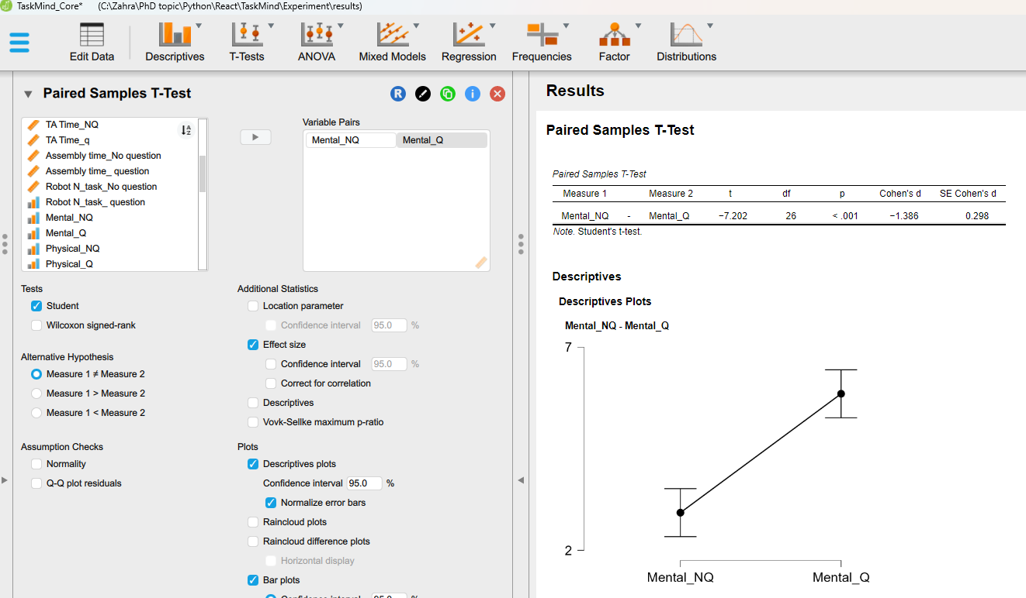

Temporal load:

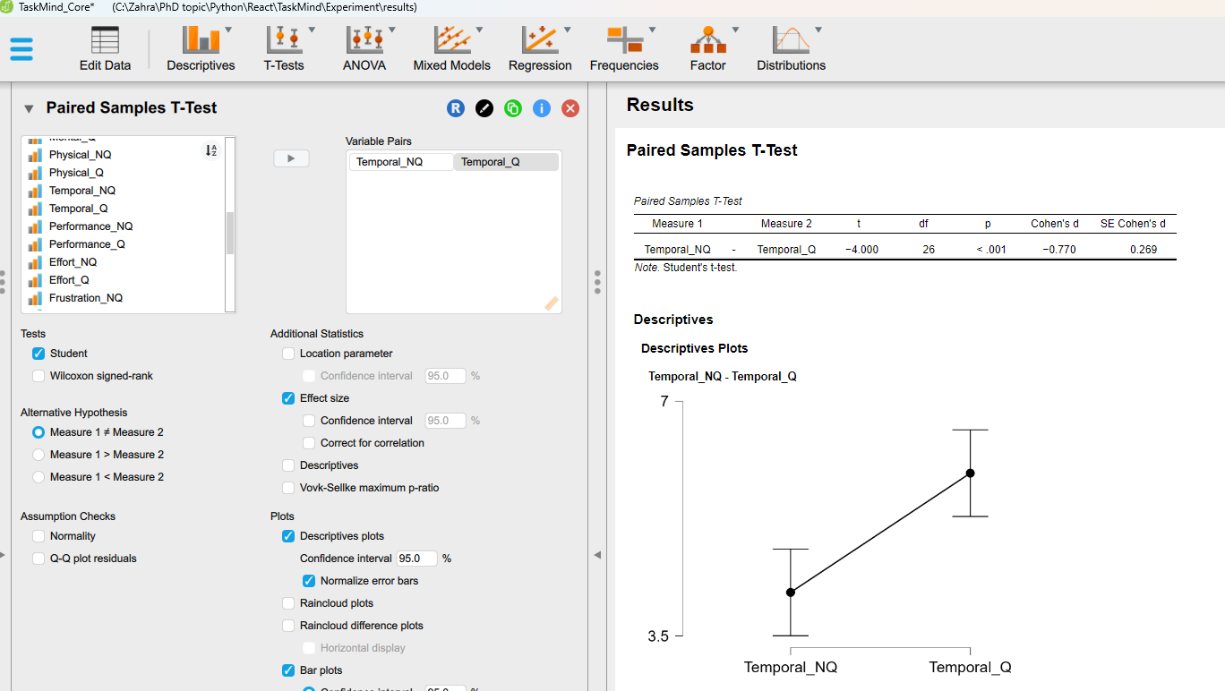
Effort:
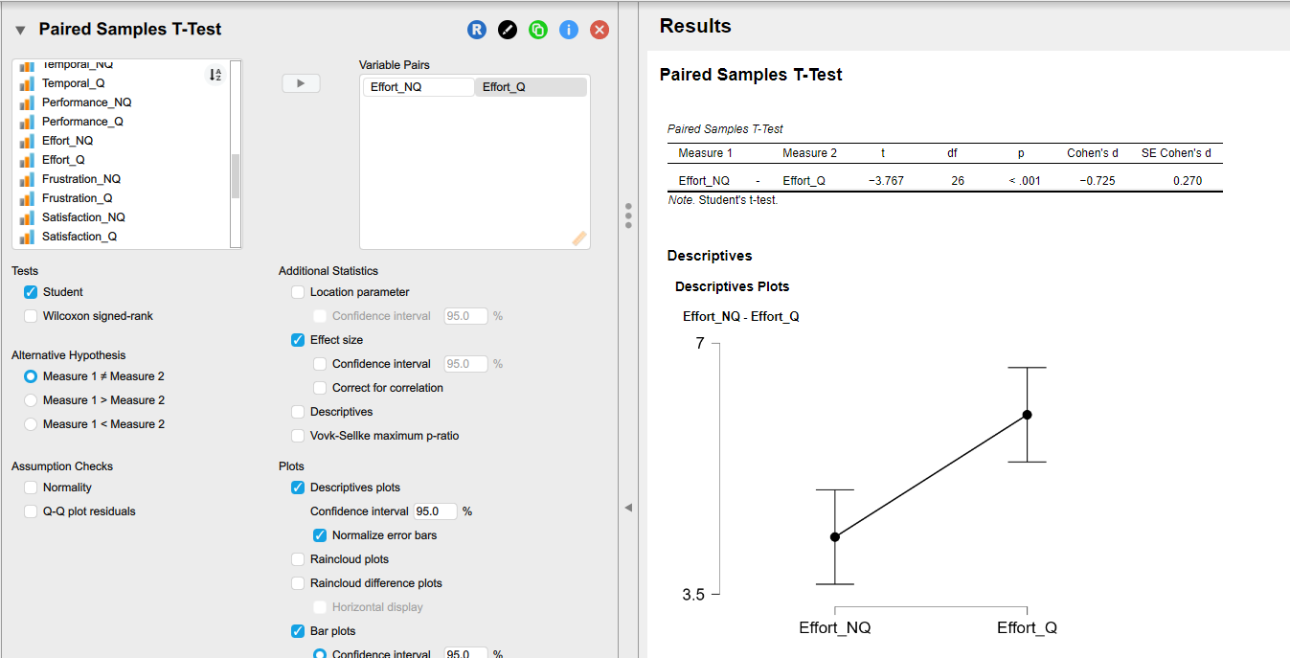
Frustration:
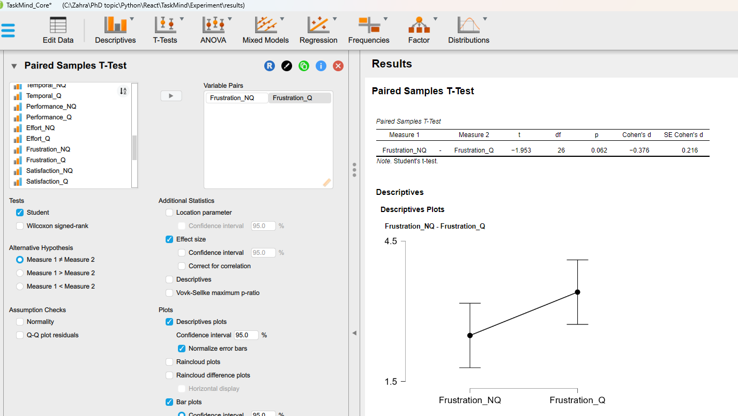

TA difficulty:
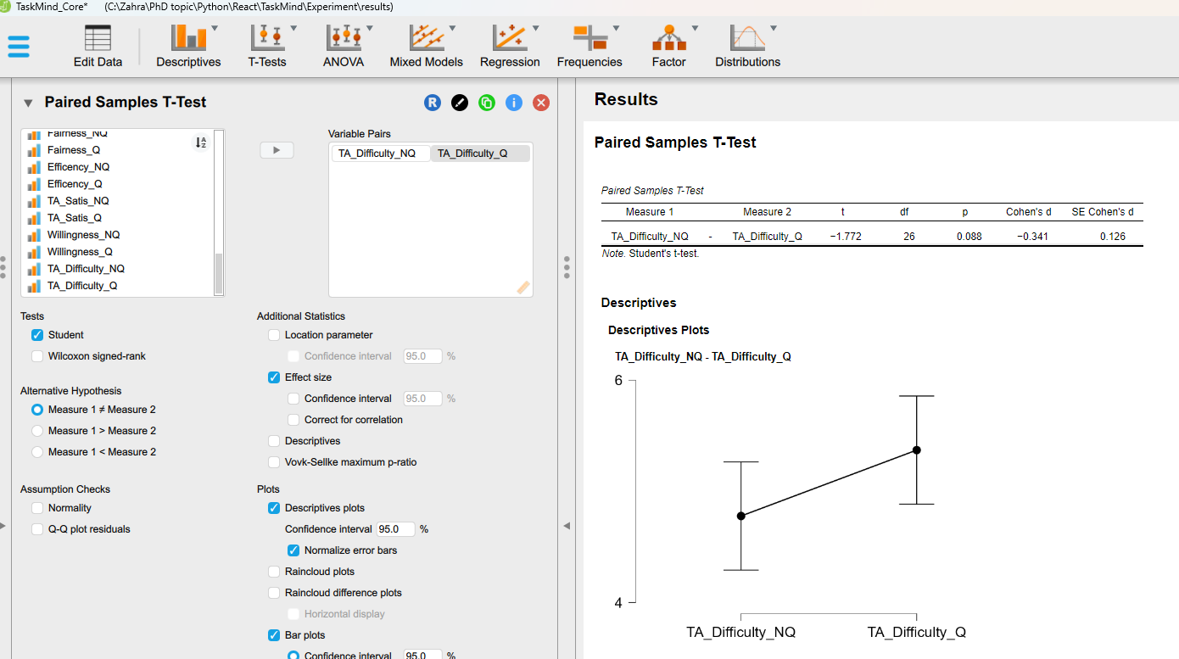

No statistical significance: Physical load, Successful, Satisfaction, Fairness, TA_efficiency , TA_Satisfaction, Willingness

No effect of Self assessment, attitude toward robot on time of completion of Number of TA

Factors for TA:
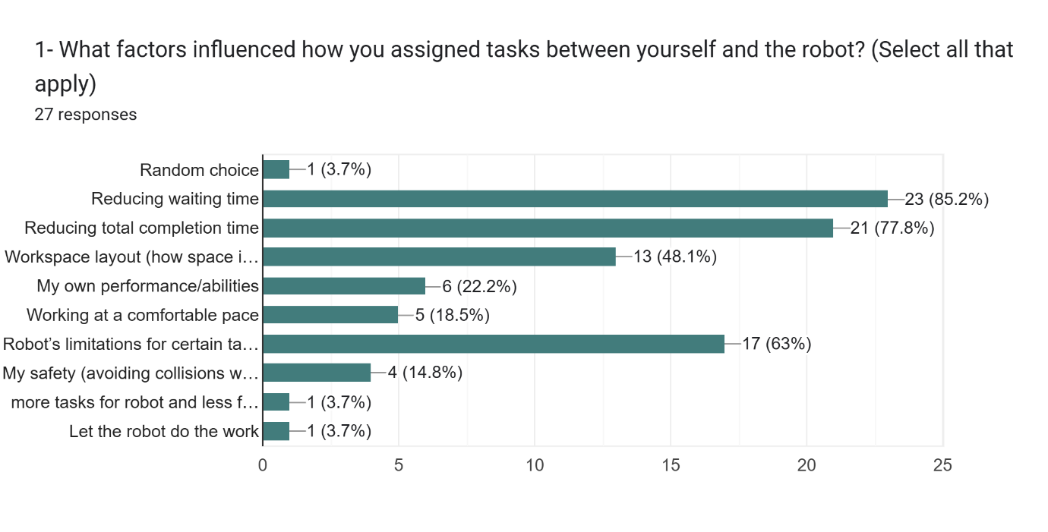

Correlation:
Time and Frustration:
