FAST-NUCES | Karachi Campus
Department of Computer Science
Operating Systems — CS-3004
Project Report
Multithreaded Producer-Consumer Problem
Restaurant Order Simulation with GTK3 GUI
Group No. | 6
Members | Muhammad Waleed — 24K-0772  Zaid Bin Tariq — 24K-0789  Muhammad Subhan — 24K-0784
Submitted To | Course Instructor
Session | Spring 2025

1. Introduction
The Producer-Consumer Problem is one of the fundamental synchronization challenges in Operating Systems. It describes a scenario where one or more producer threads generate data items and place them into a shared, bounded buffer, while one or more consumer threads retrieve and process those items. The core difficulty is ensuring that producers do not overflow the buffer and consumers do not attempt to read from an empty buffer — all while multiple threads operate concurrently without corrupting shared data.

This project implements the Producer-Consumer Problem in C using POSIX threads (pthreads), semaphores, and mutexes. To make the simulation tangible and visually engaging, the problem is mapped onto a real-world restaurant scenario: waiters (producers) place customer orders onto a shared order table (the bounded buffer), while chefs (consumers) pick up and serve those orders. A fully interactive GTK3 graphical user interface allows the user to observe the synchronization in real time, control thread behaviour, and review a live activity log — all without touching the terminal.

Problem Type: Classic Concurrency / Synchronization Problem
Language: C (POSIX standard)
Threads: POSIX pthreads (pthread_create, pthread_join)
Synchronization: Semaphores (sem_t) + Mutex (pthread_mutex_t)
GUI Toolkit: GTK3 (Gimp Toolkit, version 3)
Real-world Mapping: Restaurant Order Processing System

2. Problem Statement
The bounded-buffer (Producer-Consumer) problem requires a solution to the following three constraints, all of which must hold simultaneously at runtime:

- Mutual Exclusion — Only one thread may access the buffer at any given moment. Without this, two threads could simultaneously read or modify the same buffer slot, leading to data corruption or race conditions.
- Buffer Overflow Prevention — A producer thread must not insert an item if the buffer is already full. It must block and wait until a consumer frees a slot.
- Buffer Underflow Prevention — A consumer thread must not remove an item if the buffer is empty. It must block and wait until a producer inserts an item.

Without proper synchronization, concurrent access to the shared buffer leads to race conditions, deadlocks, or incorrect program behaviour. This project demonstrates a correct, complete solution to all three constraints using industry-standard POSIX synchronization primitives.

3. System Design and Architecture

3.1 Modular File Structure
The project is organized into clearly separated modules, each responsible for a single concern. This separation of concerns makes the code easier to understand, test, and extend.

File | Responsibility
buffer.c / buffer.h | Shared bounded buffer — insert(), removeItem(), init(), destroy()
producer.c / producer.h | Producer thread logic — places orders, records timing statistics
consumer.c / consumer.h | Consumer thread logic — serves orders, records timing statistics
logger.c / logger.h | File-based activity logger — writes timestamped events to activity_log.txt
main.c | GTK3 GUI — startup dialog, simulation window, thread lifecycle control

3.2 Buffer Design
The shared buffer is a dynamically allocated circular array of integers. Its size is configurable at runtime (5 to 50 slots) via the startup configuration dialog. The buffer maintains three integer indices:

- in — the next position where a producer will write
- out — the next position from which a consumer will read
- count — the current number of occupied slots

This circular (ring-buffer) design ensures that slots are reused efficiently and that no item is ever overwritten before being consumed, provided the synchronization primitives are correctly applied.

3.3 Synchronization Mechanism
Three synchronization primitives work together to guarantee correctness:

sem_t empty — counts available empty slots. Initialized to buffer_size. Producers call sem_wait(&empty) before inserting. Consumers call sem_post(&empty) after removing.
sem_t full — counts filled slots. Initialized to 0. Consumers call sem_wait(&full) before removing. Producers call sem_post(&full) after inserting.
pthread_mutex_t lock — protects the critical section (buffer read/write + index update). Held only for the duration of the actual buffer access.

/* Producer — critical section */
sem_wait(&empty); // wait for a free slot
pthread_mutex_lock(&lock); // enter critical section
buffer[in] = item; // write item
in = (in + 1) % size; // advance circular index
count++;
pthread_mutex_unlock(&lock); // leave critical section
sem_post(&full); // signal: one more item available

4. Features Added to the Project
Beyond the bare-minimum synchronization logic, the group implemented a comprehensive set of features that elevate this submission from a console program to a fully interactive OS simulation tool. Each feature is described below.

4.1 GTK3 Graphical User Interface
A professional dark-themed graphical interface was built using the GTK3 toolkit. The GUI consists of two screens:

- Startup Configuration Dialog — before the simulation begins, the user can set the buffer size (5–50), number of producer threads (1–10), number of consumer threads (1–10), and the number of items each thread should process (1–50). This makes the simulation fully configurable without recompilation.
- Main Simulation Dashboard — displays the buffer visualization, live thread status badges, real-time statistical counters, a scrollable live log panel, and all control buttons in a single organized window (1200 × 800 pixels).

4.2 Real-Time Buffer Visualization
The bounded buffer is displayed as a row of coloured squares on screen. Each square represents one buffer slot. Occupied slots are shown in green; empty slots appear as dark outlines. The display refreshes every 400 milliseconds using GTK's g_timeout_add() mechanism, giving a live view of how items flow through the buffer as producers insert and consumers remove.

4.3 Live Log Panel (GUI — Not Terminal)
All thread activity — order placements, order servings, pause/resume events, and thread completion messages — is displayed inside a scrollable text panel within the GUI window itself. Each log entry is timestamped (HH:MM:SS). The logging system uses GTK's g_idle_add() to safely pass messages from background threads to the GUI's main thread, ensuring thread-safe updates without crashing. Simultaneously, events are written to activity_log.txt on disk for post-run review.

4.4 Thread Statistics and Counters
A sidebar of four live-updating statistic cards shows:

- Total Produced — cumulative number of orders placed across all producer threads
- Total Consumed — cumulative number of orders served across all consumer threads
- In Buffer — current number of items occupying the shared buffer
- Average Wait Time — the mean time (in seconds) that producers spent blocked on the semaphore waiting for a free slot. This value is non-zero because the consumer threads run slightly slower than producers, causing the buffer to fill and forcing producers to wait.

4.5 Start, Pause/Resume, Stop, and End Controls
Four control buttons give full lifecycle management of the simulation:

- Start — creates all producer and consumer threads with the configured parameters. Disabled after the simulation begins.
- Pause / Resume — sets a shared volatile int pause_flag that all producer and consumer threads poll continuously (every 50 ms). When paused, threads do not insert or remove items; they spin-wait until resumed. The button label toggles between Pause and Resume accordingly.
- Stop — sets stop_flag = 1, causing all threads to exit their loops cleanly. A background joiner thread waits for all threads to finish before re-enabling the Start button. This prevents the UI from freezing.
- End — immediately sets stop_flag = 1 and calls gtk_main_quit(), terminating the entire application. Useful for an instant clean exit at any point.

4.6 Speed / Delay Control
A horizontal slider in the top bar allows the user to adjust the sleep delay of all threads during a running simulation (1–6 seconds). Increasing the delay slows thread activity, making individual insert and remove operations easier to observe. Decreasing it speeds up the simulation for throughput testing. The change takes effect immediately without restarting the threads.

4.7 Per-Thread Status Badges
Each producer and consumer thread has a dedicated row in the GUI showing its name, a coloured status badge, and an order counter (items done / total limit). The badge updates every 400 ms and shows one of four states: idle (grey), running (green), paused (amber), or done (grey/dim). This gives an immediate visual sense of which threads are active at any moment.

4.8 Timing and Average Wait Time Measurement
Each producer and consumer thread measures, for every individual operation, the wall-clock time it spent blocked on its semaphore using clock_gettime(CLOCK_MONOTONIC). This elapsed time is accumulated and divided by the number of operations completed to produce a running average wait time, shown both in the live log and in the GUI stat card. A meaningful non-zero average wait time is guaranteed because the consumer sleep delay is set one second longer than the producer delay, causing the buffer to fill and producers to block.

5. Real-World Mapping — Restaurant Simulation
To make the abstract OS concept concrete, the producer-consumer system is modelled as a restaurant kitchen workflow. The mapping is as follows:

OS Concept | Restaurant Equivalent
Producer thread | Waiter — takes a customer order and places it on the order table
Consumer thread | Chef — picks up an order from the table and prepares/serves it
Bounded buffer | Order table — has a fixed number of slots for pending orders
sem_t empty | Available table slots — waiter waits if table is full
sem_t full | Pending orders — chef waits if table has no orders
pthread_mutex_t lock | Kitchen access lock — only one person reads/writes the table at a time
stop_flag | End of shift — all staff stop working when the flag is raised
pause_flag | Break time — all staff pause activity until the break ends

6. How to Compile and Run
The project requires WSL (Windows Subsystem for Linux) with Ubuntu, GTK3 development libraries, and the GCC compiler with pthread support.

6.1 Install Dependencies (once only)
sudo apt update
sudo apt install build-essential libgtk-3-dev pkg-config

6.2 Navigate to Project Folder
cd /mnt/c/Users/<YourName>/PRODUCER_CONSUMER_GUI

6.3 Compile
gcc main.c producer.c consumer.c buffer.c logger.c \
`pkg-config --cflags --libs gtk+-3.0` -lpthread -o app

6.4 Run
./app

After running the command, the Startup Configuration Dialog will appear. Set your desired parameters and click Launch Simulation. The main dashboard will open. Press Start to begin the simulation.

7. Program Output and Screenshots
The following section provides visual evidence of the simulation running correctly. Each screenshot is labelled and annotated to explain what is happening at that moment in the simulation.

7.1 Startup Configuration Dialog
When the program is launched, a configuration dialog appears before the simulation begins. The user sets the buffer size, number of producer and consumer threads, and the number of items each thread should process. Default values are pre-filled for convenience.

Screenshot 1 — Startup Configuration Dialog
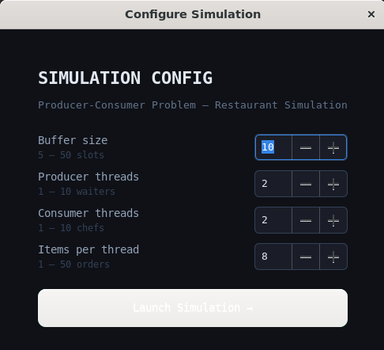
[ Paste or insert your screenshot here ]

Figure 1: Startup dialog showing configurable simulation parameters.

7.2 Main Simulation Dashboard — Running State
After clicking Launch and then Start, the main dashboard shows the buffer slots filling with green squares as waiters (producers) place orders. The Live Log panel on the left displays timestamped messages for each operation. The stat cards on the right update in real time showing total produced, total consumed, items currently in the buffer, and average wait time.

Screenshot 2 — Main Dashboard (Simulation Running)
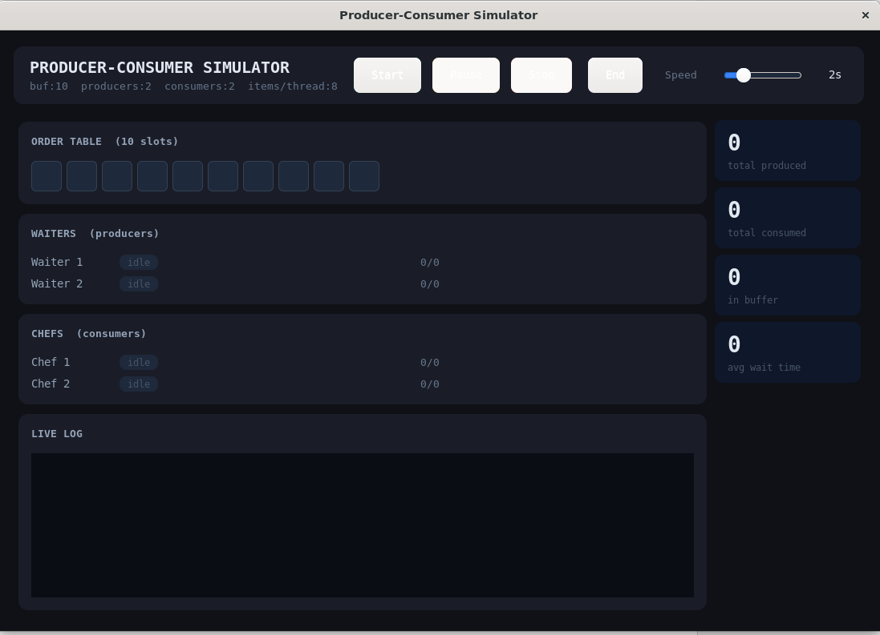
[ Paste or insert your screenshot here ]

Figure 2: Main dashboard showing buffer filling, live log messages, and running thread badges.

7.3 Paused State
When the Pause button is pressed, all threads detect the pause_flag and suspend their operations. The thread status badges change from green (running) to amber (paused). No new log entries are added. The buffer state remains frozen. Pressing Resume restores normal operation immediately.

Screenshot 3 — Simulation Paused (amber badges visible)
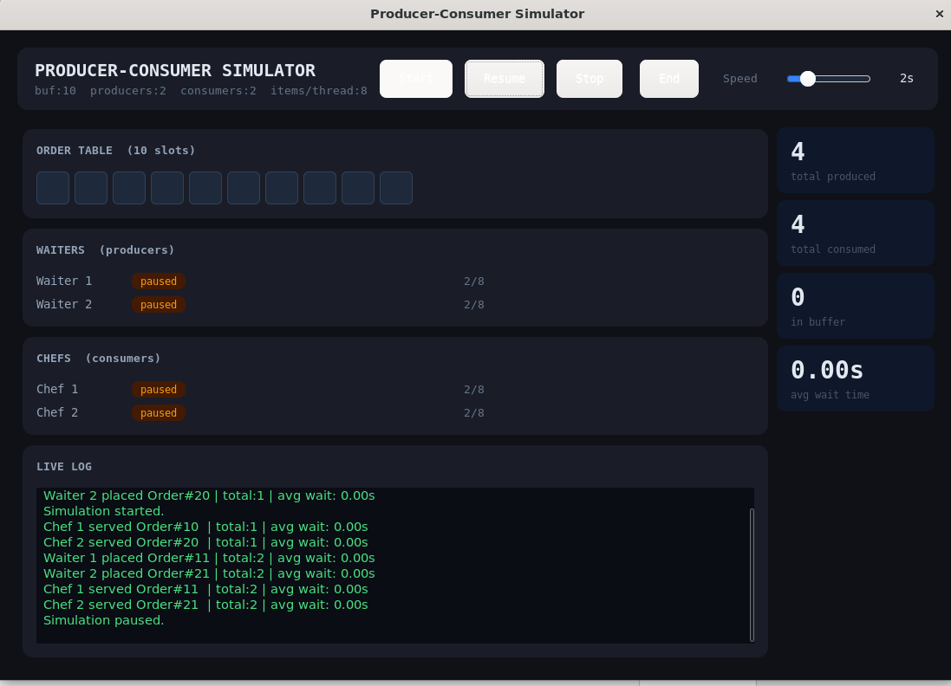
[ Paste or insert your screenshot here ]

Figure 3: Paused state — all thread badges show amber 'paused' label; buffer unchanged.

7.4 Live Log Output
The live log panel shows a continuous stream of timestamped events generated by producer and consumer threads. Each line reports the thread identity, the order number processed, the running count of operations completed, and the average time that thread spent waiting on its semaphore. This directly demonstrates that synchronization is working correctly and that threads are experiencing measurable wait times when the buffer fills up.

Screenshot 4 — Live Log Panel (close-up)
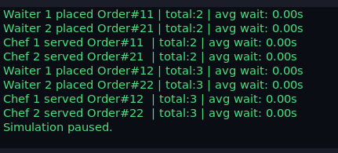
[ Paste or insert your screenshot here ]

Figure 4: Live log showing per-thread timestamped events and average wait times.

7.5 Terminal Output (activity_log.txt)
In addition to the GUI log, all events are written to a file named activity_log.txt in the project directory. This file can be opened after the simulation ends to review the complete history of operations. A sample of this file content is shown below.

Screenshot 5 — activity_log.txt file content (optional)
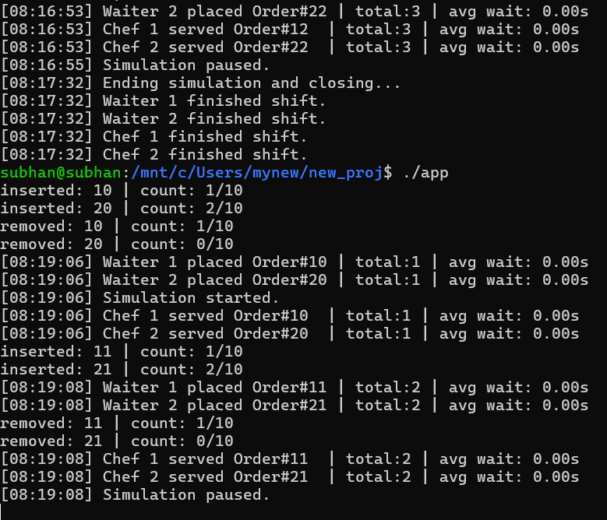
[ Paste or insert your screenshot here ]

Figure 5: Contents of activity_log.txt showing file-based event logging.

8. Work Distribution
All three group members collaborated on the full project, including design, implementation, testing, and documentation. The primary areas of focus for each member were:

Member | Primary Focus Area
Muhammad Waleed 24K-0772 | Buffer module (buffer.c/h) — circular array, semaphore initialization, insert() and removeItem() logic. Producer thread implementation and timing measurement.
Zaid Bin Tariq 24K-0789 | Consumer thread implementation. Logger module (logger.c/h) — file-based timestamped logging. Thread statistics struct design and graceful shutdown logic.
Muhammad Subhan 24K-0784 | GTK3 GUI design and implementation (main.c) — startup dialog, simulation dashboard, live log panel, stat cards, button callbacks, refresh timer, and final integration of all modules.

Integration testing and debugging were performed jointly by all members. Each member has a full understanding of all parts of the code and can explain any section during the viva examination.

9. Conclusion
This project successfully implements the classic Producer-Consumer synchronization problem using POSIX threads, semaphores, and mutexes in C. The solution correctly prevents buffer overflow, buffer underflow, and race conditions through the combined use of two counting semaphores (empty and full) and one mutual exclusion lock.

The addition of a GTK3 graphical interface transforms the simulation from an invisible console program into a transparent, interactive demonstration of operating system synchronization concepts. The real-time buffer visualization, live log panel, per-thread status badges, average wait time measurement, and full thread lifecycle controls (start, pause, resume, stop, end) make the underlying OS mechanisms visible and understandable.

The restaurant analogy (waiters as producers, chefs as consumers, order table as the bounded buffer) provides an intuitive real-world frame for a concept that can otherwise seem abstract. This mapping was reflected in the variable naming, log messages, and GUI labels throughout the implementation.

Key OS concepts demonstrated in this project:

1. Mutual exclusion using pthread_mutex_t
2. Synchronization using counting semaphores (sem_t)
3. Thread creation and lifecycle management (pthread_create, pthread_join)
4. Volatile shared variables for inter-thread signalling (stop_flag, pause_flag)
5. Thread-safe GUI updates using GTK main loop (g_idle_add)
6. Wall-clock timing with clock_gettime(CLOCK_MONOTONIC)

— End of Report —

