Gain insight into your supply chain ecosystem
Continuously track and secure all elements of your supply chain, including software components, dependencies, third-party services and fourth party vendors.

Get complete supply chain visibility: Monitor all components in your supply chain, including vendor software, plugins, dependencies, and third-party libraries.

Deep and Continuous Scanning: Regularly scan and map your supply chain to identify vulnerabilities and ensure compliance with security standards.

Detailed Vulnerability Analysis: Conduct in-depth analyses of software components and dependencies to detect potential security issues.

Address supply chain vulnerabilities
Implement proactive measures to detect, assess, and prioritize risks in your supply chain and software components, ensuring robust security

Continuous Risk Assessment: Regularly evaluate the security posture of your vendors and software components to identify and mitigate risks

Automated Risk Assessment: Utilize advanced automation to assess, categorize, and remediate vendor related risks

Prioritized Risk Alerts: Receive alerts that prioritize third-party risks based on their potential impact and severity, enabling efficient risk management

How It Works
Discover: Inventory and profile all vendors and suppliers across business units.

Analyze: Evaluate risk posture using threat intelligence, behavioral analytics, and risk scoring.
Evaluate: Prioritize high-risk vendors and escalate remediation tasks.
Act: Initiate automated workflows, enforce policies, and monitor vendor compliance.
Review: Continuously monitor risk changes and generate audit-ready reports.

Features that Mesmerises

Monitor Mass Assets
By continuously scanning and assessing your mass assets, proactively detect any vulnerabilities or suspicious activities, ensuring the better security

Easy Crawling and Prioritisation
Crawling and prioritizing assets becomes a seamless and effortless process. Easily navigate through your organization's digital ecosystem, gathering comprehensive information about each asset.

Key Features

Vendor risk scoring

Continuous monitoring

Compliance tracking

Risk alerts

Automated reports

Manage your team with reports
Measure what matters with Sentinelware's easy-to-use reports. You can filter, export, and drilldown on the data in a couple clicks.

Dashboard
- Attack Surface Status: Critical
- Attack Assets: Last 1 Days
- Active Data Leaks: Last 7 Days
- Active Security Risk: Last 7 Days
- Overall Rating
- Issue name
- Ratings
- Assets
- Security Ratings
- Security Issues
- External Assets
- Brand Threat
- Data Breach
- Darkweb
- Social Media Monitoring
- Fake Ads
- Score Increase
- New Issues
- Issues Solved
- Total Issues
- Total Assets

Network Security
- Overall Score
- Issue name
- Ratings
- Assets
- Total Issues
- Score Increase
- New Issues
- Issues Solved
- Total Issues
- Total Assets

CVE Detection

WebApp Security

DNS Security

IP Reputation

API Security

Cloud Security

Email Security

Endpoint Security

Information Leak

Digital Reputation

Darkweb

3rd Party Co. List Page
Give Option For Super Admin & Admin To Create 3rd Party Companies.
Total 3rd Party Companies
Total Service Providers
Total Prospecting Companies
Total Subsidiaries
Add Organizations

- Company Name
- Risk Score
- Type
- Company Domain
- Inherent Risk
- Scan Frequency
- External Assets
- Status
- Industry
- Action

Attack Surface Timeline.
- Asset Count
- Issue Count
Top Asset Type Discovery
- Assets & count
- Subdomain = 4
- Associated IP = 3
- Social Media = 4
- AWS = 7
Exposure Severity Disclosure
Activity

Connect the tools you already use
Explore 100+ integrations that make your day-to-day workflow more efficient and familiar. Plus, our extensive developer tools.

Security Rating
- Overall Ratings
- issue name
- Ratting
- Assets

- If Scored Increased. New Issues Found. Issues Solved. Total Issues. Total Assets
- Insights from last scan

- Active Vendors
- Continue Assessment Vendors
- Poor
- Average
- Good
- One-time Assessment Vendors
- Poor
- Average
- Good
- Digital Exposure Risk Coverage
- Credential Leaks
- Docs Expose
- Brand Name Mentioned On Hacker Discussion Forums
- Employee & Executives Data Exposed
- Credential Listed on Dark forums
- Infrastructure Initial Attack Vector Coverage
- Misconfigured Cloud Services & Storage Buckets
- Secrets & Vulnerabilities effected mobile application
- Misconfigured & Vulnerabilities DNS Server & DNS Records
- Improper SSL Implementation
- Exposed Services
- Vendor Risk Summery
- Vendor Name
- Rating
- Assessment Type: One Time or Continuous
- Incidents
- Status Break-up
- View
- Digital Assets Count of your organization
Assets
- Domains
- Subdomain
- IP Address
- Mobile Apps
- Web Apps
Counts

Add Assets
- Total Third Party Companies
- Total Service Providers
- Total Prospecting Companies
- Type: TPRM, Sister Concern
- Company Name
- Inheritance Risk: Positive, High, Medium, Low
- Scan Frequence: Daily, Manual, Monthly
- External Assets
- Status: Pending, Solved, False Positive
- Source: OSINT, Manual
- Industry: Retail
- Action: Delete.

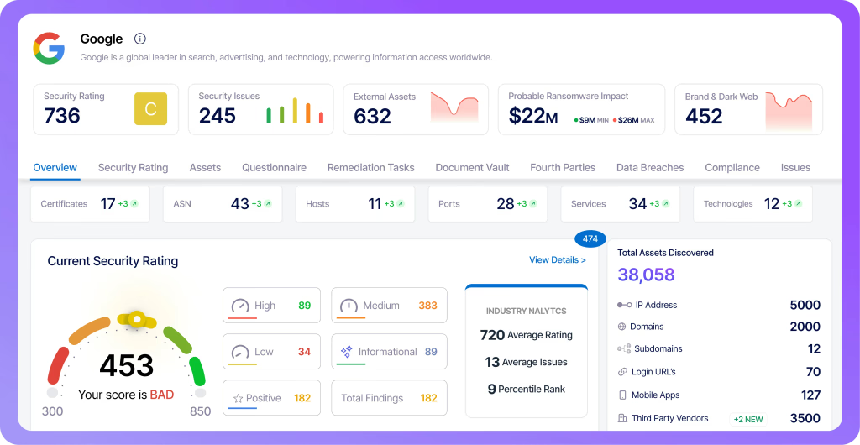
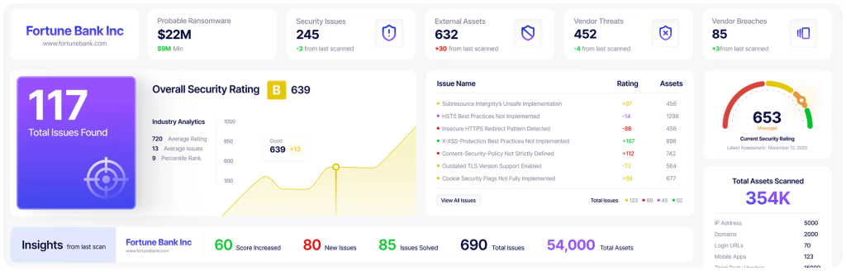

Supply Chain
- Add Supplier
- Company Name Dropdown (google, octa, etc.
(Enter a company name or its main domain (example.com):)
- If Supplier Not in the list give option to create new supplies
- Create New Company
Company Name & Domain
Check It New Company Already Exist or not, if existing company
The primary domain you’ve entered is an additional primary domain associated with a company using a different name:
It looks like you're trying to create this company:
Company Name
Is this the company you want to add? Yes Use This Company (Button). Show Internet Software & Services & Total Employee for the asset
If Not Existing Continue with co creation
Add more supplier options
Supplier Overview Page
- RISK RATING BREAKDOWN
- RISK BY BUSINESS IMPACT
- Cyber Posture
- Avg. rating
- Suppliers - With critical findings

Suppliers Page
- Company Name
- Status
- Business Impact
- Evaluation Type
- Cyber Posture
- Risk Rating
- Date added
Supplier Details Page
- Cyber Posture Rating
- Business Impact
- Risk Rating
- Business Snapshot
- (per public data)
Company Details
Industry
Internet Software & Services
Location
San Francisco, CA, United States of America
Founded
2009
Company Size
5001-10000 employees
Market Cap
—
Company Type
Public Company
Company Websiteokta.com

- Remediation Tasks
- Assets
- Rating History
- Dark Web Mentions
- Posture By Categories
- Network and IT
Asset Reputation
Cloud
DNS
Endpoint
Mailserver
TLS
Webserver
  - Application
Application security
Domain attack
Exposed services
Technologies
- Human
Employee ASM
Security team
Social posture
- Findings
- Assets
IPs Distribution
Geolocation
- Remediation & Tasks

