Threat Intelligence
Stay ahead of cyber threats with real-time, industry-tailored intelligence. Detect vulnerabilities, monitor emerging risks, and receive actionable alerts empowering you to prevent attacks before they happen.

Unified threat intelligence enriched with WHOIS, TLS, DNS, and paste data, mapped to MITRE ATT&CK to pinpoint threats across your external attack surface.
continuously discovers new C2 servers, global threat campaigns, and early signals before they escalate.

Real-time attacker intelligence

Zero-day indicators missed by others

Threat actor behavior tracking

Context-rich intelligence for all

Dashboard:
- Infrastructure Overview

Tactical Summary
1. C2 Server Count
2. Countries
3. CVEs Exploitation
4. Zero Day C2 Server
5. Predictive Lead Time
6. AI-Based C2 Channels
7. Top TTPs
- C2 Servers Geography (Globe With Pins As Per Country)
- Impact Possible Sectors at Risk
- Impact Possible Platforms Affected
- Impact Potential Organizations at Risk
- Threat Intel Dashboard ASN Count
- Threat Intel Dashboard Top Country

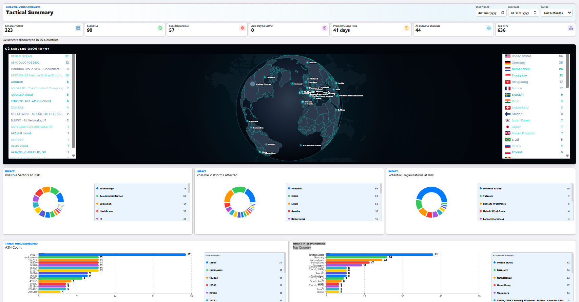

Threat Intelligence Analytics
CISO Security Posture Overview
Risk, infrastructure concentration, detection confidence, and adversary tooling.

- TOTAL INDICATORS

- Total Indicators
- Countries
- Cloud Providers
- C2 Attributions
- Tooling Matches

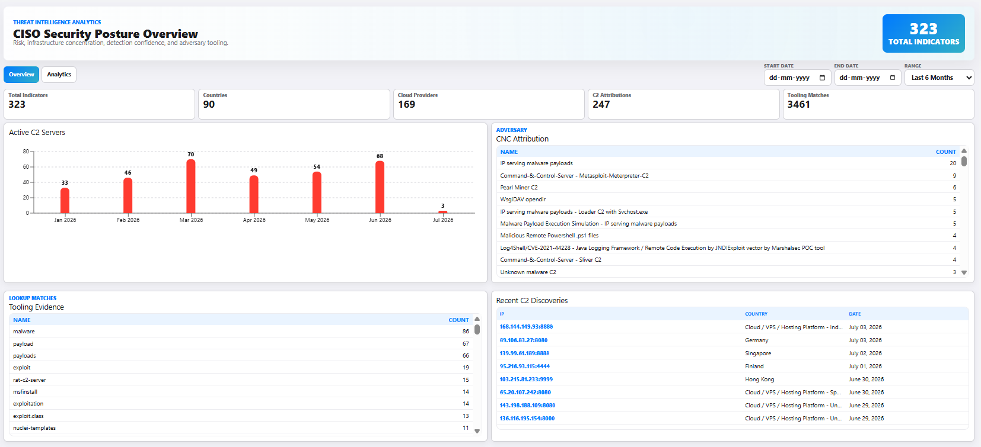

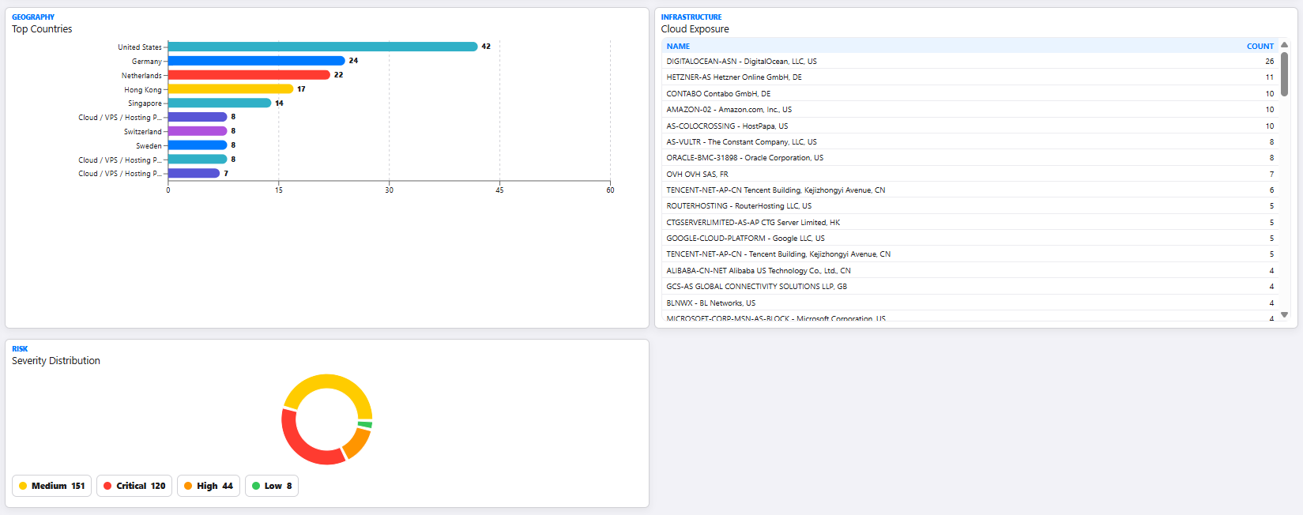

ImpactTechnology
- IP Address
- C2 Discovered Date
- Country
- Possible Platforms Affected
- Potential Sectors at Risk
- Potential Organizations at Risk
- ASN

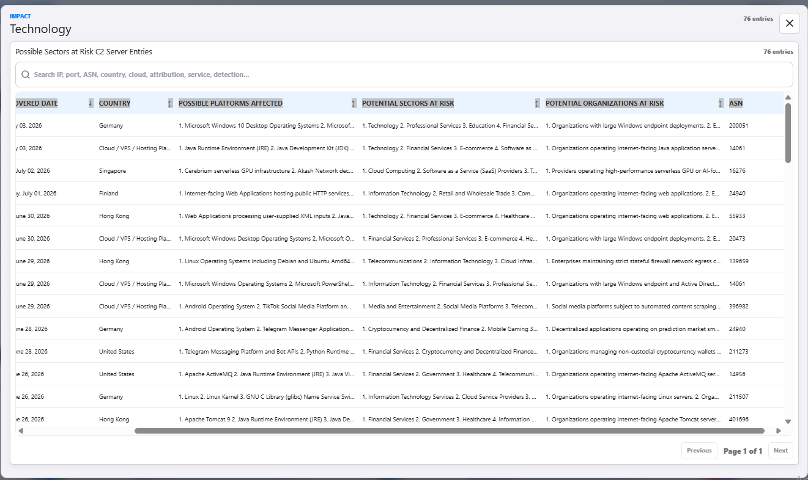

C2 Server Profile IP:PORT
- Discovered On0
- Port
- Country
- ASN

Location & Hosting
ASN & Network
Service Category
Sectors at Risk
Platforms at Risk
Organisations at Risk
Threat Intelligence and File Summary
Reputation & Risk
Detection Summary

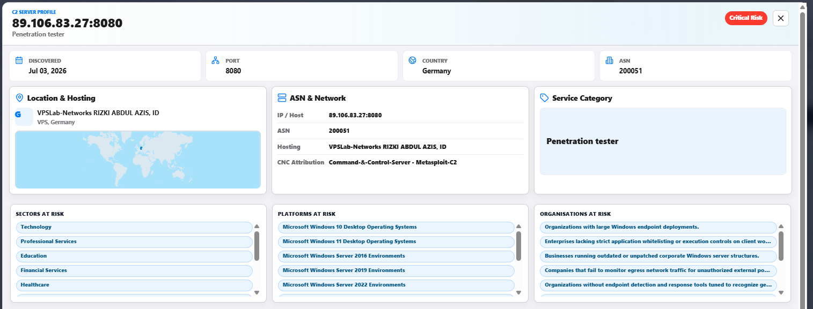

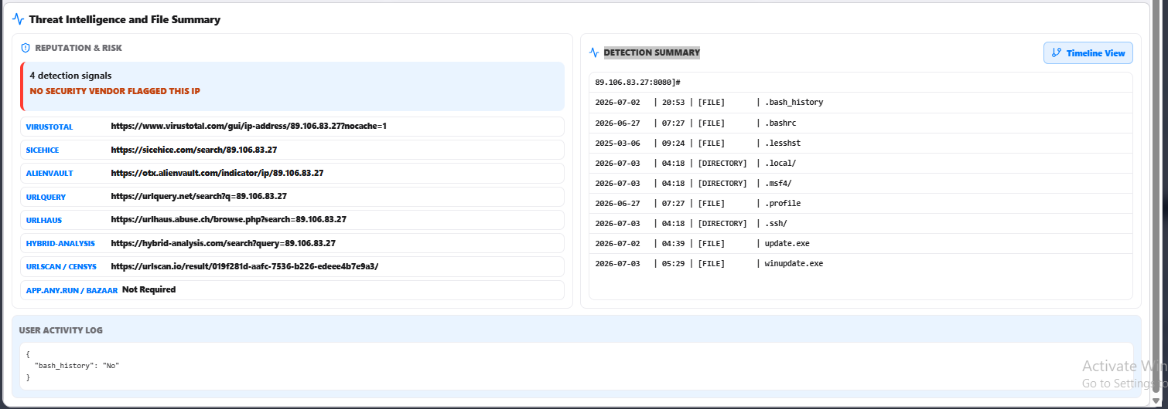

Active C2 Servers - Month to Month Graph

Lookup Matches - Tooling Evidence
Adversary - CNC Attribution
Recent C2 Discoveries
Geography - Top Countries
Infrastructure Cloud Exposure
Risk Severity Distribution

Zero-Day Infrastructure

CVEs Exploitation Intelligence

Adversary Behaviour Profiling

Overview
Feed Added in last 7 days (Map) - Hacktivism, Ransomware, Dark Web
Live Threat Feeds
Top Initial Attack Vector
Top 5 threat actor
Top 15 key exploited vulnerbility

Access insights from open sources, dark web monitoring, ransomware tracking, and more, all within a single dashboard.

Comprehensive Threat Actor Tracking: Monitor a rapidly growing database of over 30K threat actors, their tactics, and evolving attack methods to stay ahead of emerging threats

Exploited CVEs and Attack Surface Insights: Keep track of actively exploited CVEs and live Initial Attack Vectors (IAVs) to mitigate risks before they escalate

All-in-One Intelligence Hub: Gain visibility into cyber threats across multiple vectors, ensuring a proactive approach to security

Correlate Patterns and Preempt Security
Go beyond basic alerts, uncover hidden connections between global cyber incidents and threats targeting your organization with advanced AI correlation.

Advanced Threat Correlation: Detect patterns across vast threat landscapes by linking your security incidents to global attack trends for deeper context

Real-Time Risk Mapping: Gain a clear, actionable perspective on emerging threats and their potential impact on your assets, brand, and industry

Smarter Threat Intelligence: AI bridges the gap between raw data and meaningful insights, helping you prioritise and respond to threats proactively

Turn Industry-Specific Intelligence into Tactical Advantage
Stay ahead of cyber threats with early detection of planned attacks, emerging CVE exploits, and evolving attack trends tailored to your industry.

Sector-Specific Threat Anticipation: Identify threats targeting your industry before they materialize, giving you a proactive security edge

Predictive Defense & Future-Proofing: Leverage AI-driven intelligence to strengthen your defenses against evolving attack vectors and future incidents
Bridge the gap between threat intelligence and your attack surface with AI, highlighting attacker intent, IoC relevance, and potential breaches.

Identify Active Adversary Behavior & Malicious Kits
Intel AI continuously tracks malicious IPs, botnets, scanners, and exploit kits to curate attacker profiles actively probing vulnerabilities across your industry.

Map Prioritized IoCs to External Attack Surface
Surface high-confidence indicators linked to active exploitation, command-and-control infrastructure, and known attacker clusters so your team can act decisively.

Spot Potential Perimeter Breaches before Exploitation
Track early signals of compromise by identifying malicious IP scanning ports, probing services, or testing credentials, allowing SOC teams to investigate threats before they become incidents.

Receive Live IoC & Exposure Updates
Stay ahead of cyber adversaries by identifying critical threats based on active exploitation patterns and Indicators of Compromise (IoC) impacting your environment.
IOC
TYPE
SUBTYPE
SOURCE
TLP
Adversary Attribution
Agentic AI links threats to attacker groups, tools, and malware, clarifying intent, strategy, and likely actions.
Threat Actor Name
Overview
IOC
Techniques
Tactics
Software
Campaigne
Top 5 Malware

Contextual Threat Validation
Intel AI helps teams determine whether a threat is part of broad, opportunistic scanning or a focused attempt against your assets by analyzing trends.

Block Malicious Scanners
Block malicious IPs probing for vulnerabilities autonomously, reducing the risk of mass scanning or unauthorized access attempts across your systems.

Alerts for CVEs & Exploitation
Receive instantaneous alerts when any known CVE is actively exploited, enabling faster patching or mitigation to prevent breaches and contain impact before escalation.

Request cyber threat intelligence on threats, exposures, and adversary behavior, helping analysts move from questions to answers in seconds.
- Retrieve CVE insight on active exploitation patterns and attacker interest
- Uncover exposure risks tied to active attacker behavior
- Request detailed profiles of threat groups shaping current campaigns

Threat Actor Directory
Know Your Adversaries
Access comprehensive profiles of known threat actors, including APT groups and cybercriminal collectives. Gain a strategic advantage by understanding threat actors, their tactics, past activities, and potential nation-state affiliations.

Adversary Intelligence
Know Your Enemy Before They Strike
‍Gain deep insights into attack methodologies, and malicious infrastructures. Our system blends exclusive intelligence from HUMINT, OSINT, and incident RFIs to help you anticipate and neutralise adversaries.

Vulnerability Intelligence
Prioritise Threats, Patch Smarter
‍Track and prioritise vulnerabilities that are actively exploited in the wild. We identifies and alerts you to the most pressing CVEs, helping you patch smarter and reduce exposure to costly breaches.

Malware Intelligence
Detect Malware Threats Faster
Stay ahead of malware campaigns with intelligence from malware logs and deep/dark web investigations. Get critical incident reports and actionable insights on malware threats that may impact your business.

Cyber News Feeds
Stay Updated with AI-Driven Insights
‍Quickly digest the critical information by filtering through the noise with AI-curated summaries from credible sources, highlighting key threats and trends relevant to your industry, region or any other area of interest.

Dark Web Feeds
See Threats Others Miss
‍Gain visibility into hidden cybercriminal activity on the dark web. Identify stolen credentials, illegal marketplaces, hacking tool sales and other criminal operations before they surface on mainstream platforms.

CVE Feeds
Monitor Emerging Vulnerabilities
Be the first one to know of emerging and actively exploited vulnerabilities. We provides timelines, exploitation trends, and dark web insights, ensuring ready to act before threat actors exploit them.

Ransomware Feeds
Proactive Defence Against Ransomware
Monitor global ransomware activity with live alerts and impact assessments. Identify targeted sectors and vulnerabilities to strengthen your defenses against one of the most disruptive cyber threats.

Hacktivism Feeds
Monitor Ideologically Driven Threats
‍Track hacktivist campaigns, their targets, and their methods. Real-time activity alerts and in-depth analysis of tactics (TTPs) and motivations help you prepare for ideologically motivated cyber attacks.

OBJECTIVE
Build an Enterprise Threat Intelligence Module.

This module continuously collects intelligence from hundreds of sources.

Normalize intelligence.

Enrich intelligence.

Correlate intelligence.

Score intelligence.

Relate intelligence with existing ASM findings.

Predict attacks.

Provide AI recommendations.

Everything should integrate with existing ASM assets.

CORE PURPOSE
The Threat Intelligence Module must become the central intelligence correlation engine.

Every finding already discovered by ASM should automatically be enriched using Threat Intelligence.

This module must answer:

Is this finding currently being exploited?

Which Threat Actor is using it?

Which malware uses it?

Which campaign uses it?

Has it been seen recently?

Is it being discussed on Dark Web?

Which industries are targeted?

What is the likelihood this client will be attacked?

Should Risk Score increase?

Should AI recommend immediate remediation?

MODULE ARCHITECTURE
build these internal services.

Threat Feed Engine

IOC Intelligence Engine

Threat Actor Engine

Campaign Intelligence Engine

Malware Intelligence Engine

Infrastructure Intelligence Engine

Threat Correlation Engine

Threat Graph Engine

Threat Scoring Engine

AI Intelligence Engine

Threat Report Engine

Threat Search Engine

Threat API Layer

THREAT FEED ENGINE
Support ingestion from:
AlienVault OTX

AbuseIPDB

GreyNoise

ThreatFox

MalwareBazaar

URLHaus

VirusTotal

PhishTank

CISA KEV

MITRE ATT&CK

NVD

CVE

CWE

CAPEC

MISP

OpenCTI

STIX/TAXII

Open Source RSS

Dark Web

Telegram

Discord

GitHub

Pastebin

Ransomware Blogs

OSINT feeds

Commercial Feed Connectors

Everything must normalize into one common schema.

THREAT ACTOR INTELLIGENCE
Every Threat Actor should contain:
- Overview
- Aliases
- Country
- Motivation
- Target Industries
- Target Countries
- Campaigns
- Malware
- Infrastructure
- C2 Servers
- Domains
- IPs
- Emails
- Wallets
- File Hashes
- MITRE ATT&CK
- ATT&CK Navigator
- Kill Chain
- Diamond Model
- Timeline
- Recent Activity
- Confidence Score
- Risk Score
- References
- Detection Rules
- Mitigation
- Executive Summary

IOC DATABASE
Support:
- IP
- Domain
- URL
- Email
- Hash
- JA3
- JA4
- TLS Fingerprint
- SSL Certificate
- ASN
- CIDR
- Wallet
- Telegram
- Discord
- GitHub
- Filename
- Mutex
- Registry
- Service
- User-Agent
- DNS
- URI
- Cookie
- HTTP Header
Everything searchable.

CORRELATION ENGINE
This is the most important part.
Whenever ASM discovers something, automatically correlate.
Example
ASM discovers

Apache 2.4.54

↓

Threat Intelligence

↓

Known CVE

↓

Known Threat Actor

↓

Known Campaign

↓

Known Malware

↓

Known Exploit

↓

Known IOC

↓

Recently Exploited

↓

Targeting Healthcare

↓

Client belongs Healthcare

↓

Increase Risk Score

↓

Generate Alert

↓

AI Summary

↓

Executive Dashboard

Everything must correlate automatically.

KNOWLEDGE GRAPH
Build a graph database using Neo4j.
Example relationships:
Threat Actor

↓

USES

↓

Malware

↓

USES

↓

C2

↓

HOSTED ON

↓

Cloud Provider

↓

TARGETS

↓

Industry

↓

TARGETS

↓

Organization

↓

OWNS

↓

Asset

↓

HAS

↓

Technology

↓

HAS

↓

CVE

↓

MATCHES

↓

Campaign

Everything should be clickable.

THREAT SCORING
Every IOC must calculate:
Source Reliability
Confidence
Severity
Popularity
Freshness
Threat Actor Reputation
Malware Reputation
Industry Relevance
Country Relevance
Exploitation Status
Customer Relevance
Historical Activity
Current Campaign
AI Confidence
Overall Threat Score

AI CORRELATION
Instead of simple alerts.
Generate explanations.
Example:
This exposed Fortinet VPN matches IOC intelligence associated with Volt Typhoon. The campaign has actively targeted government and telecom organizations over the last 14 days. Your organization operates within a targeted industry. This increases the exploitation likelihood to High. Immediate patching and VPN log review are recommended.

LIVE CORRELATION
Whenever ANY module finds:
New Asset
New Domain
New IP
New Certificate
New Vulnerability
New Email
New DNS Record
New Cloud Instance
New Brand Mention
New Credential Leak
New Port
New Technology
Automatically perform Threat Intelligence lookup.

DASHBOARDS
Global Threat Intelligence Dashboard
Threat Actor Dashboard
Campaign Dashboard
Malware Dashboard
IOC Dashboard
Infrastructure Dashboard
Correlation Dashboard
Industry Threat Dashboard
Executive Threat Dashboard
SOC Dashboard
Threat Timeline
MITRE ATT&CK View
Attack Graph
Global Threat Globe
Campaign Timeline
Threat Heatmaps

