**Cloud Project And Video Explainer**

**Project Name: NexGenGamer blog site**

**Name: Mohammed Zaid Zaheer Mistry**

**Student id: 35488112**

**Unit: ICT1711**

**IP address:** 172.164.225.6

**DNS:**

**Introduction**

The proposed cloud project is a gaming blog, designed to provide gaming enthusiasts with news, reviews, and community discussions. The blog will cover a wide range of gaming topics, including industry updates, game releases, strategies, and gaming hardware reviews. The primary goal is to create an engaging platform where gamers can stay informed and share their thoughts on various gaming-related topics.

**Design of my Microsoft server.**

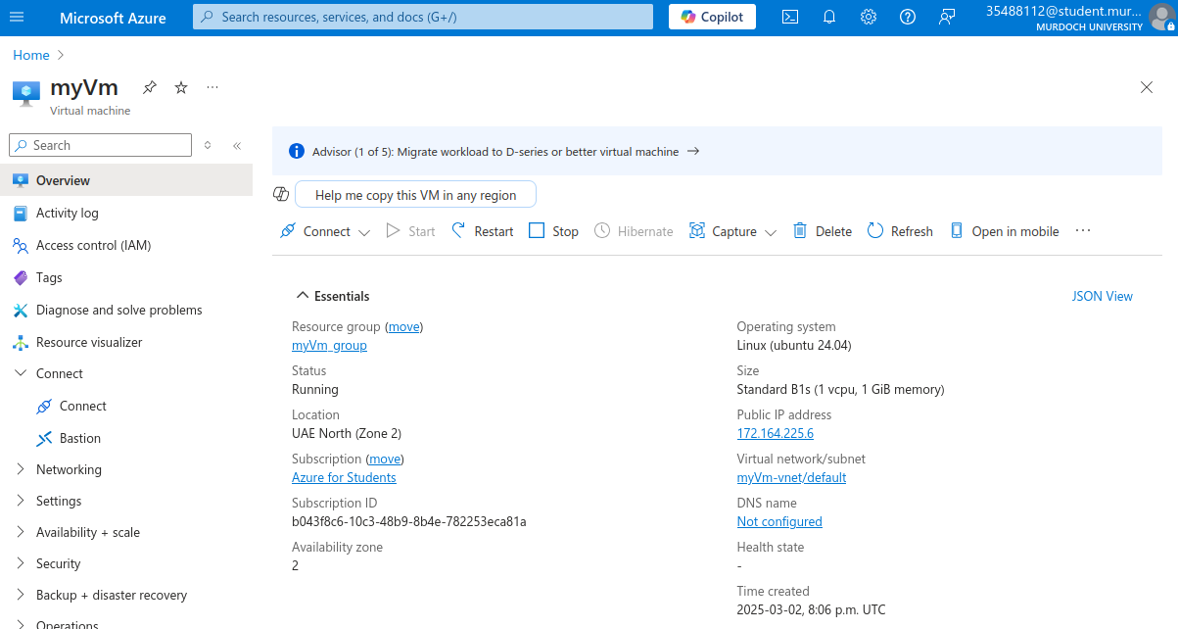

**Installing apache**



**Upgrading apache**



**Now connecting to Ubuntu**

**2.**



**3. Type private key**

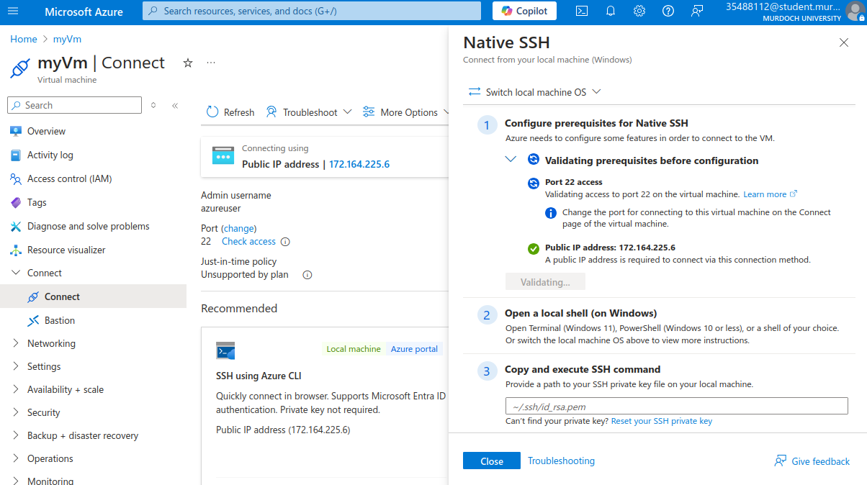

**4. Run this command**

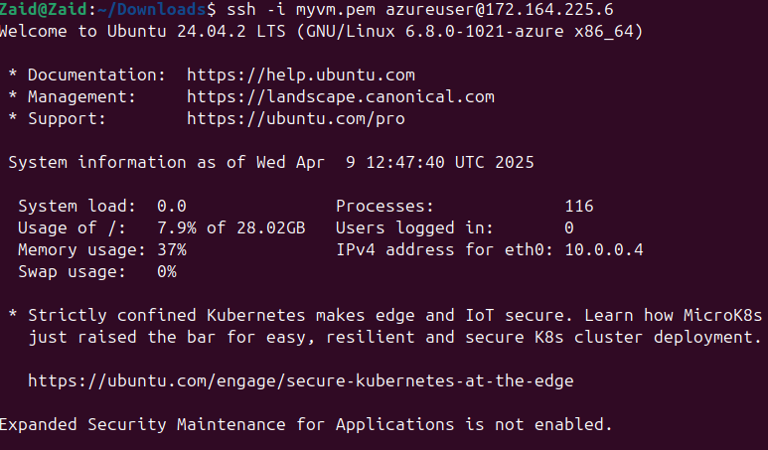

**DOMAIN**

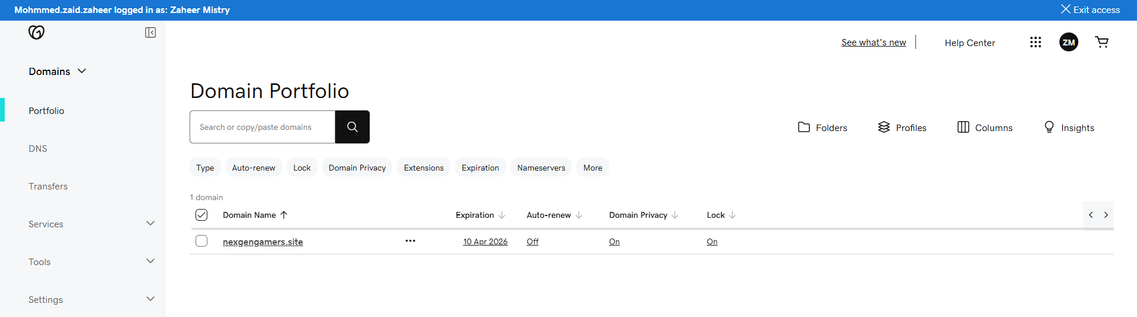

**Now install**