MOTS Supplier Portal
A walk through the whole system, in 96 screens
Every screenshot in this document was taken while driving the real application against a database that started empty. Nothing was seeded by a script: each supplier, tender, clarification, proposal and award below came into existence through the interface, in the order a real procurement would produce them.
It is written to be presented from. Each step carries the screenshot, who is signed in, what has just happened, the next click, and one line to say out loud.
Reference: walkthrough/GUIDE.md and walkthrough/screenshots/ in the repository. Reproduce the whole run with ./walkthrough/run.sh — roughly twelve minutes, most of it waiting for the five-minute job that opens the submission window.

Contents
Right-click and choose “Update field” to fill in page numbers after opening.

The personas, and what each one does
Eight roles appear in this walk. Every one of them is a real account created during it.
Persona | What they do in this walk
system_admin | Creates the buying body and invites every member of staff. Owns reference data, interface text, email wording, the audit log and the operations screens. The only role for which two-factor authentication is compulsory.
supplier_admin | Registers the company, completes onboarding, uploads documents, lists an offering, asks a clarification, prices and submits the bid, and sees the outcome.
onboarding_reviewer | Claims the submitted application, checks each document against the profile, and approves it with a written reason. Sees applications, never tenders.
procurement_officer | Authors the tender, invites suppliers, answers clarifications, closes submissions, opens and consolidates the evaluation, and recommends a winner. Cannot approve their own recommendation.
procurement_manager | Owns the scoring template, approves and publishes the tender, assigns evaluators, finalizes the evaluation, and issues the award.
procurement_manager (second) | Exists only because the manager who recommends may not approve. Approves the award.
evaluator | Declares any conflict of interest, then scores the bids with the bidders anonymous and the prices sealed until technical qualification.
ministry_viewer | Reads cross-organization totals. Deliberately holds no permission that reaches an individual tender.

Credentials
These are the accounts this walk created. They are regenerated on every run of walkthrough/run.sh, and are printed into walkthrough/GUIDE.md each time.
Persona | Email | Password
system_admin (bootstrap) | admin@mots.local | motsadmin2026 + TOTP
procurement_officer | officer@mots.local | Walkthrough2026!
procurement_manager | manager@mots.local | Walkthrough2026!
procurement_manager (approver) | manager2@mots.local | Walkthrough2026!
evaluator | evaluator@mots.local | Walkthrough2026!
onboarding_reviewer | reviewer@mots.local | Walkthrough2026!
ministry_viewer | ministry@mots.local | Walkthrough2026!
supplier_admin | supplier@gulfcatering.example | Walkthrough2026!
The administrator’s six-digit code comes from an authenticator app enrolled at first sign-in. Its secret is generated once, on the run that creates the account — so it changes every time the database is reset.

Act 1 — The public surface, and the only account that exists
The system starts with nothing in it but reference data and one administrator. These four screens are what a visitor sees, and how the one account that exists signs in.

01. Landing page
Persona anonymous
Screen Landing page (/)
What just happened The portal answers with a live health check and the currencies the system booted with. This is a clean database: reference data only.
What to do next Click Sign in, or About in the footer to see which build is deployed.
What to say “This is a completely empty system — no suppliers, no tenders, no staff except one administrator. Everything you are about to see gets created in front of you.”
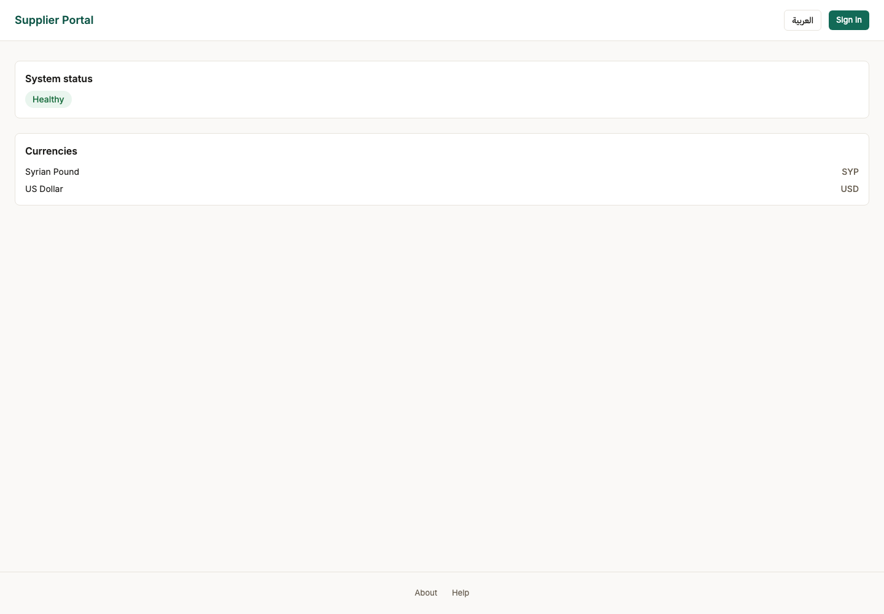

02. About
Persona anonymous
Screen About (/about)
What just happened Reached by clicking the footer, not by typing the address — this screen had no link to it until batch 12. It names the version and the exact commit deployed.
What to do next Quote the build reference when reporting a problem. Go back and sign in.
What to say “Every deployment tells you exactly which build it is, and this page is reachable without signing in — which matters when the thing you are reporting is that you cannot sign in.”
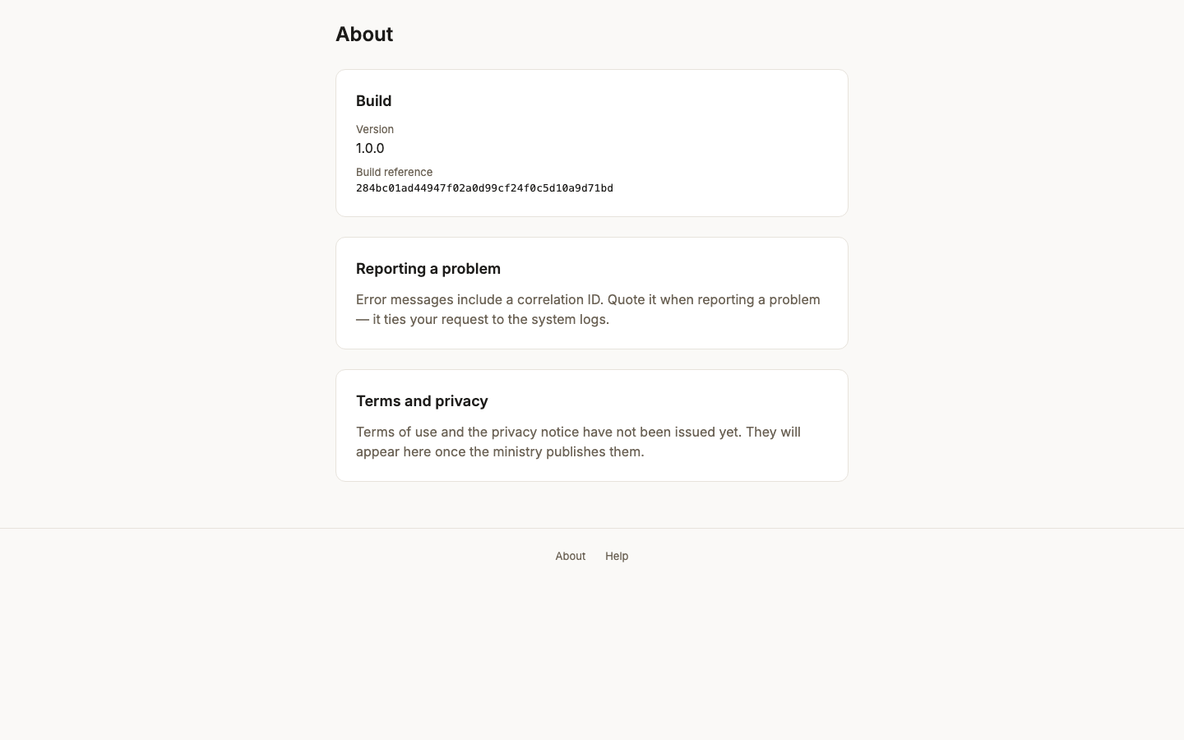

03. Choose your language
Persona system_admin
Screen Choose your language (/evaluation)
What just happened SCR-010, asked once and only of someone who has not answered it. The product ships Arabic-first, so this is the first thing a new account sees, in both languages at once — a language chooser written only in the language you cannot read is no use.
What to do next Pick a language. The choice is stored against the account, so it is not asked again on any device.
What to say “The product is Arabic-first. It asks once, in both languages, because a language chooser written only in the language you cannot read is no use to anybody.”
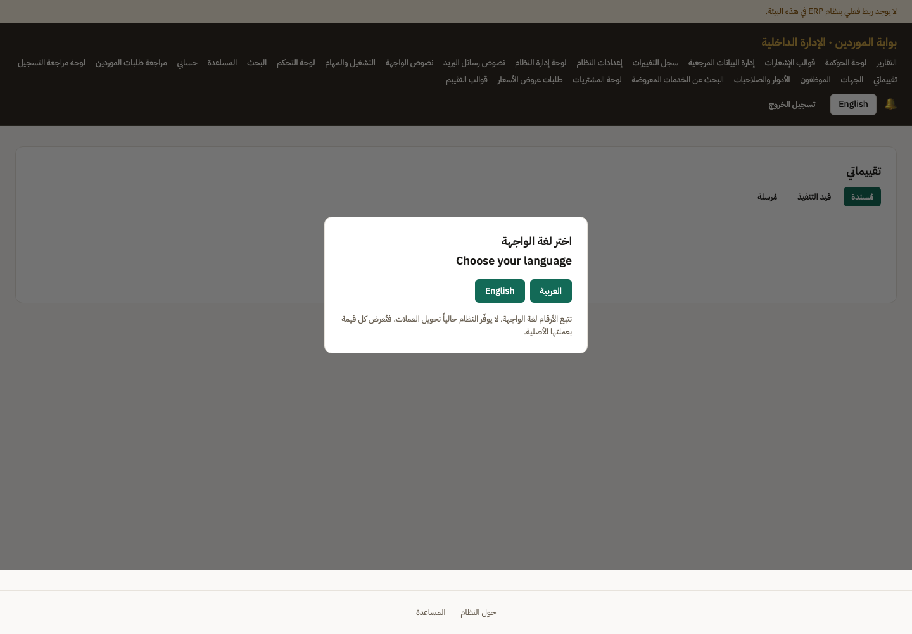

04. Back-office landing
Persona system_admin
Screen Back-office landing (/evaluation)
What just happened Signed in as the bootstrap administrator — the only account that exists on a fresh database. It required a six-digit authenticator code: system_admin is the one role for which MFA is mandatory.
What to do next Open Staff to create the people who actually run a tender.
What to say “The administrator is the only account that exists on a fresh install, and it is the only role for which two-factor authentication is compulsory.”
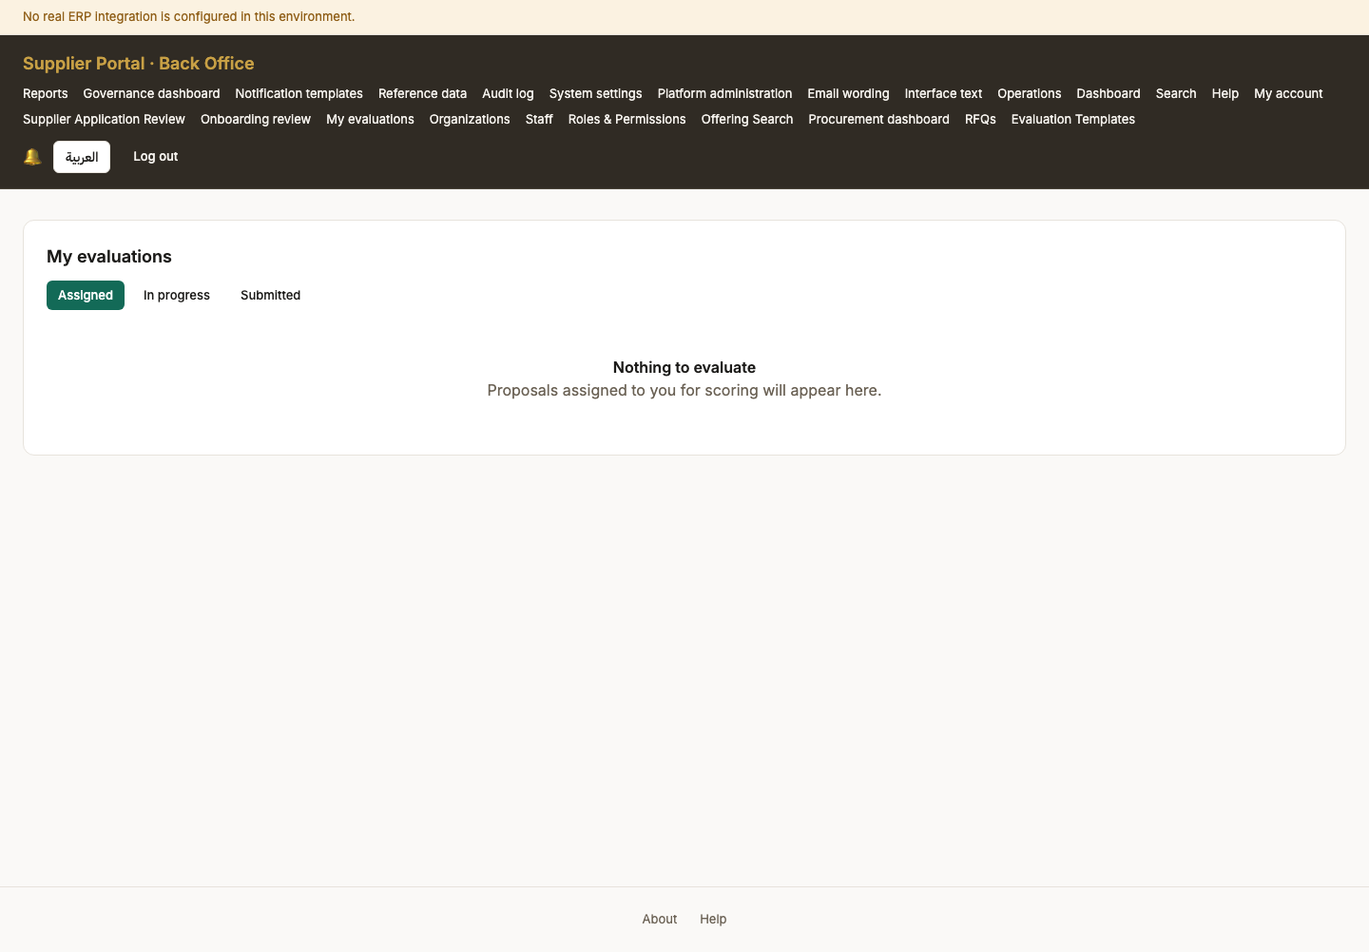

Act 2 — A buying body, and the people who will run the tender
An organization is the unit a tender belongs to and the boundary every query is scoped by, so it comes first. Six members of staff are then invited by name — there is no self-service route to a ministry account.

05. Organizations (empty)
Persona system_admin
Screen Organizations (empty) (/back-office/organizations)
What just happened No buying bodies yet. An organization is the unit a tender belongs to and the boundary every query is scoped by, so nothing procurement-shaped can exist before one does.
What to do next Create the directorate that will run this tender.
What to say “Nothing procurement-shaped can exist before a buying body does — an organization is the boundary every tender query is scoped by.”
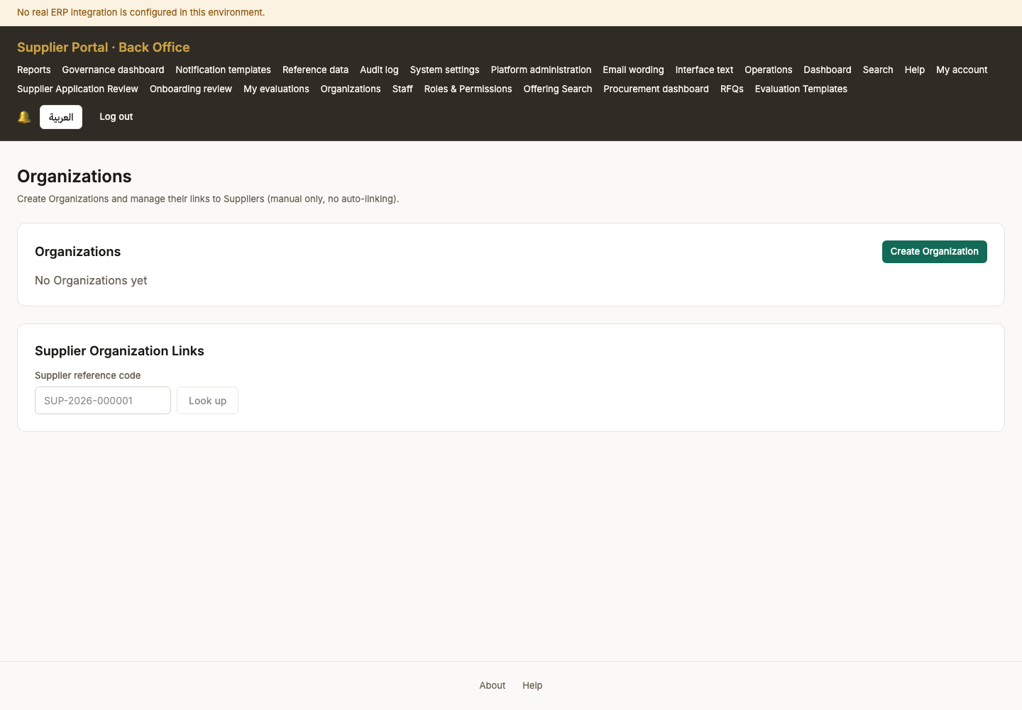

06. Buying body created
Persona system_admin
Screen Buying body created (/back-office/organizations)
What just happened The directorate exists. Staff invited into it inherit its scope, and a tender they raise belongs to it.
What to do next Invite the people who will run the procurement.
What to say “One directorate, created in about ten seconds. Staff invited into it inherit its scope automatically.”
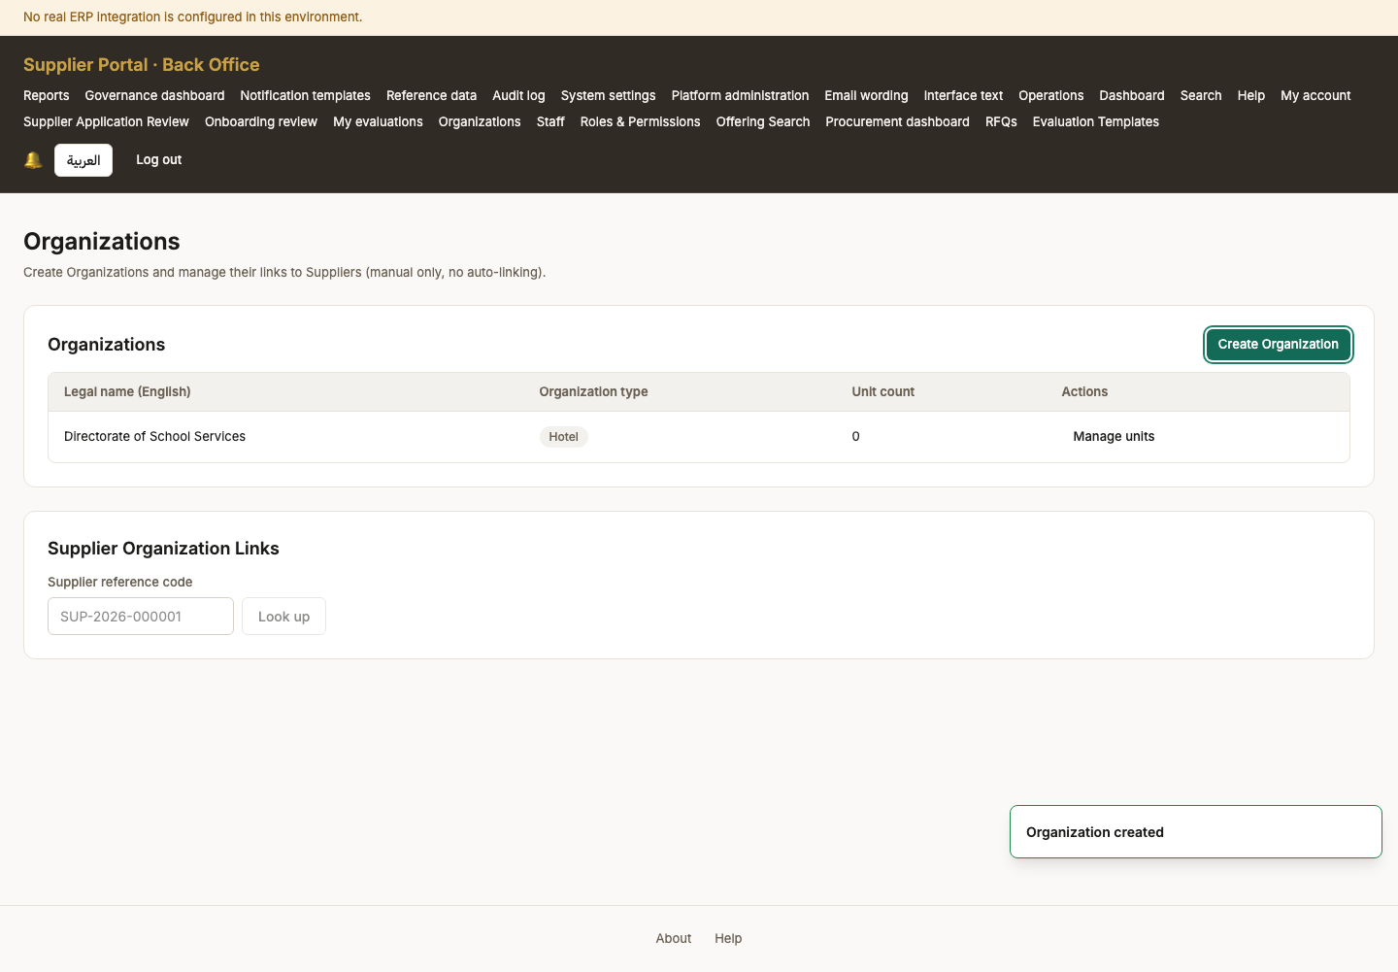

07. Staff
Persona system_admin
Screen Staff (/back-office/staff)
What just happened The staff list, empty apart from the administrator. There is no other way in: registration only ever creates a supplier, so ministry accounts must be invited from here.
What to do next Invite each role the procurement needs — officer, manager, evaluator, reviewer and the Ministry viewer.
What to say “There is no self-service route to a ministry account. Registration only ever creates a supplier, so every member of staff here is invited by name.”
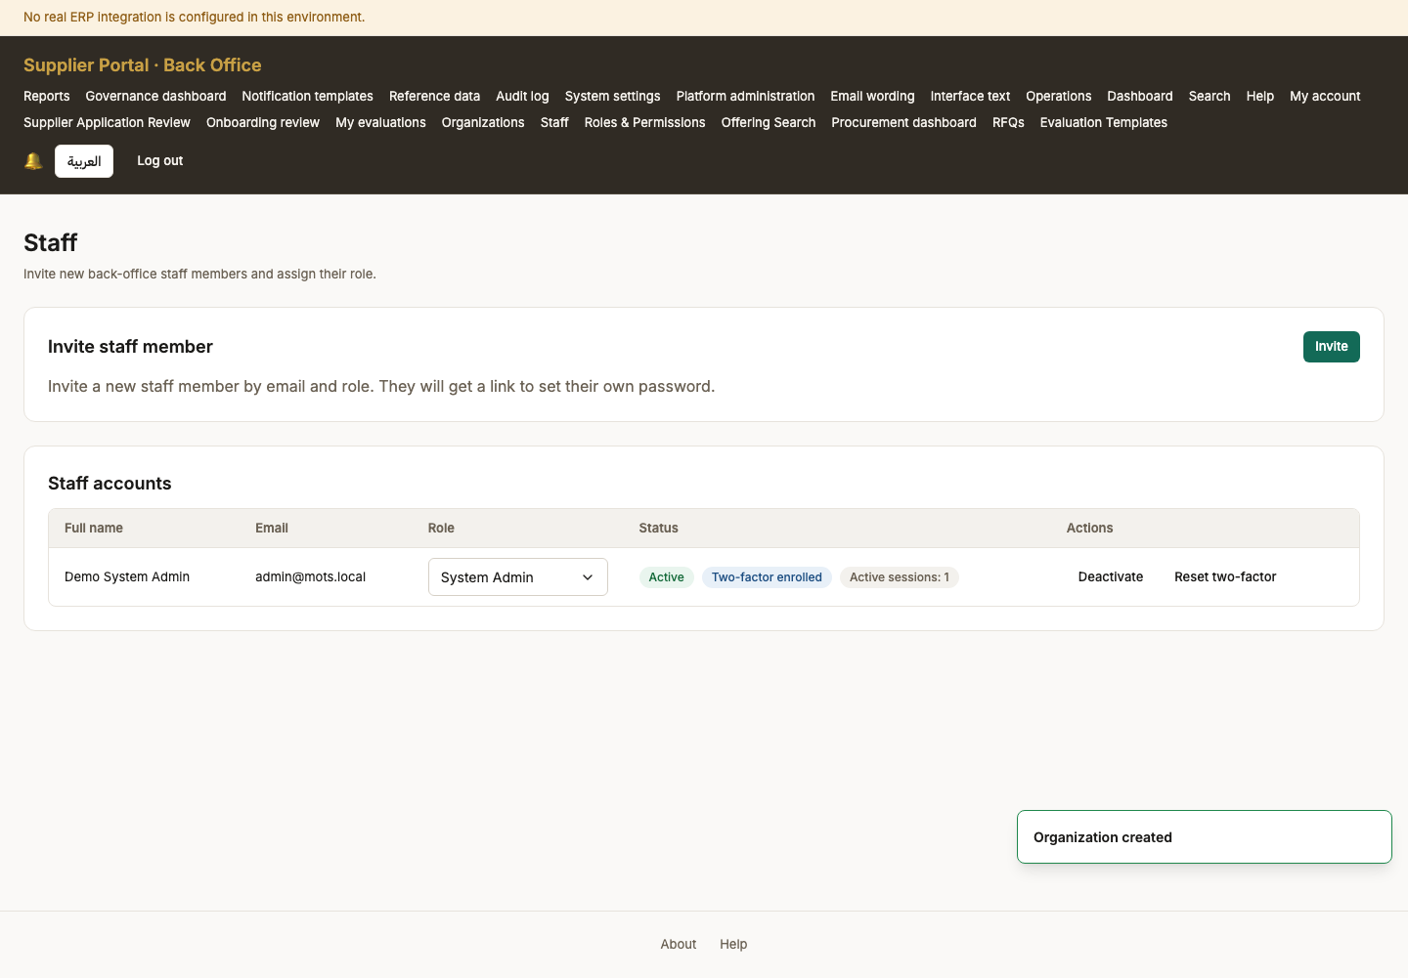

08. Staff after invitations
Persona system_admin
Screen Staff after invitations (/back-office/staff)
What just happened Six invitations sent. Each recipient gets an email with a single-use link; nobody has a password until they set one, so an unaccepted invitation is not a live account.
What to do next Each person opens their invitation and sets a password.
What to say “Six invitations, one email each with a single-use link. Until someone accepts and sets a password, that invitation is not a live account.”
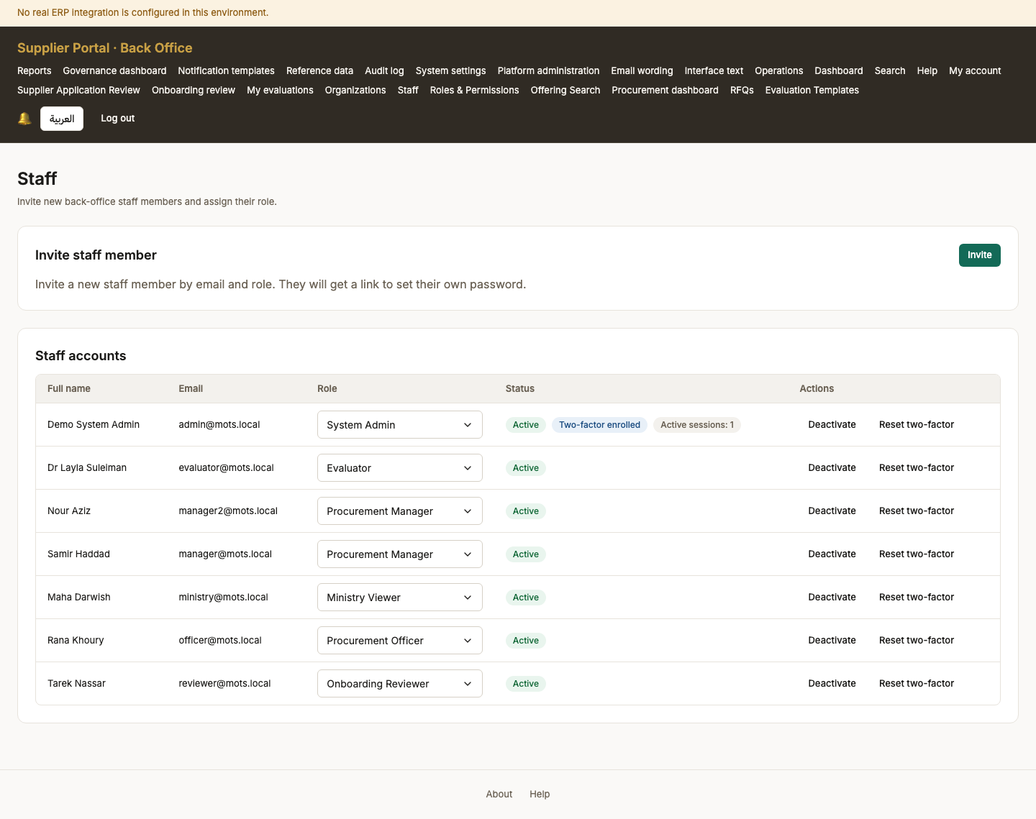

Act 3 — A supplier registers
The only self-service sign-up in the product, and it always produces a supplier. Registration alone proves nothing: the account cannot sign in until the address is verified.

09. Register
Persona anonymous
Screen Register (/register)
What just happened The only self-service account creation in the product, and it always produces a supplier. Ministry staff cannot register; they are invited.
What to do next Fill in the company name in both languages and an email, then submit.
What to say “Now we switch sides. This is the supplier's first contact with the ministry — and the only self-service sign-up in the product.”
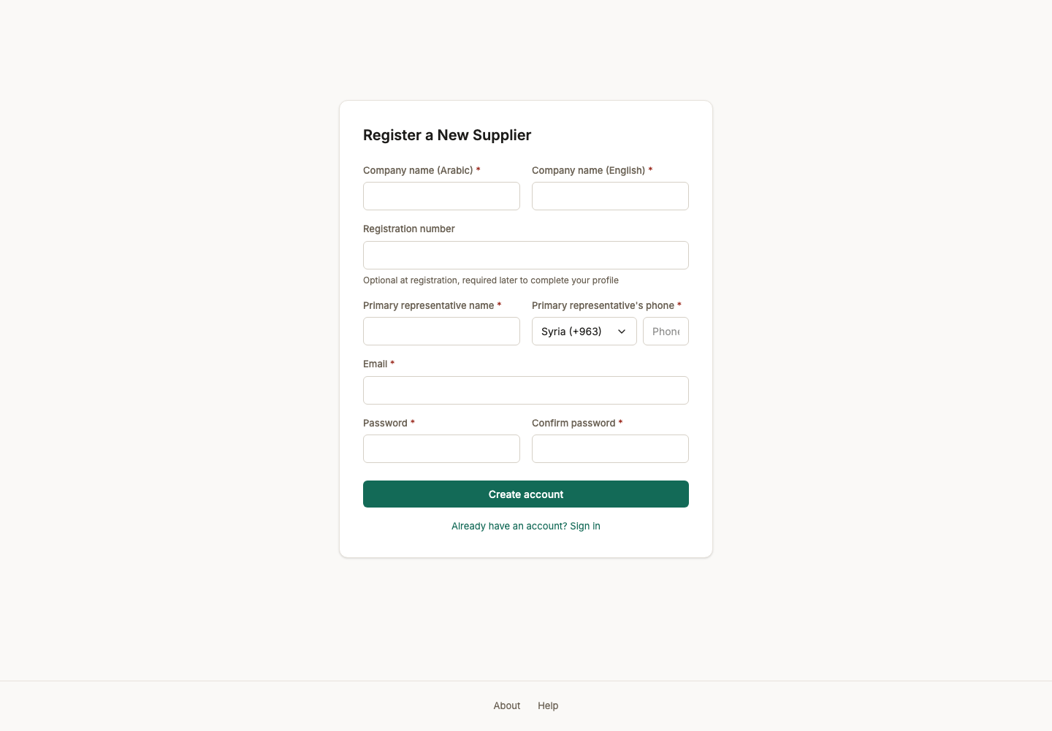

10. Register — filled in
Persona anonymous
Screen Register — filled in (/register)
What just happened Every required field answered. The company name is asked in both languages because the tender record it will appear on is bilingual.
What to do next Submit. Nothing is trusted until the email address is proven.
What to say “The company name is asked in both Arabic and English because it will appear on a tender record that has to read correctly in either.”
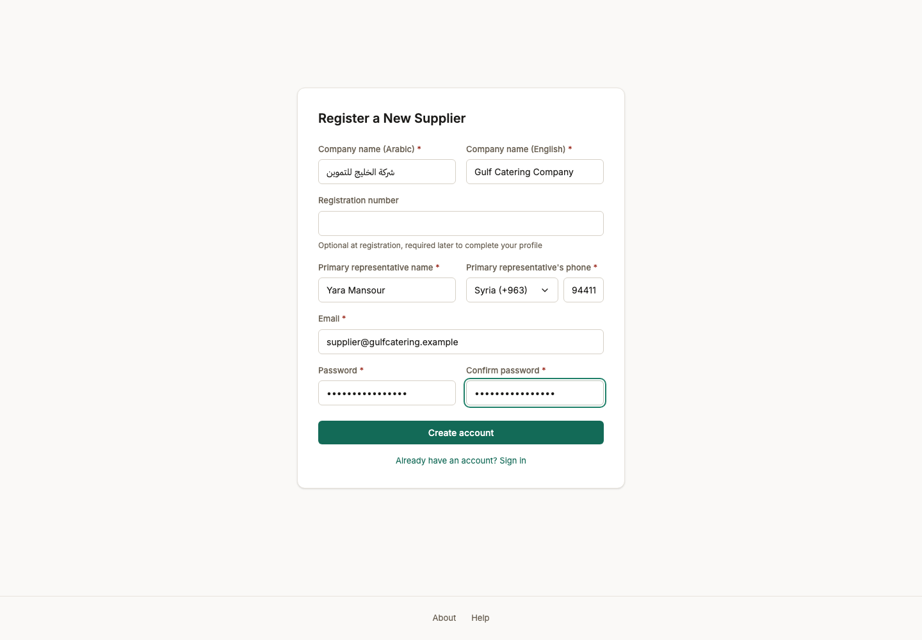

11. Registered — check your email
Persona supplier_admin
Screen Registered — check your email (/register)
What just happened The account exists but cannot sign in yet. Nothing is trusted until the address is proven.
What to do next Open the verification email and follow its link.
What to say “The account exists but cannot sign in yet. Nothing is trusted until the address is proven.”
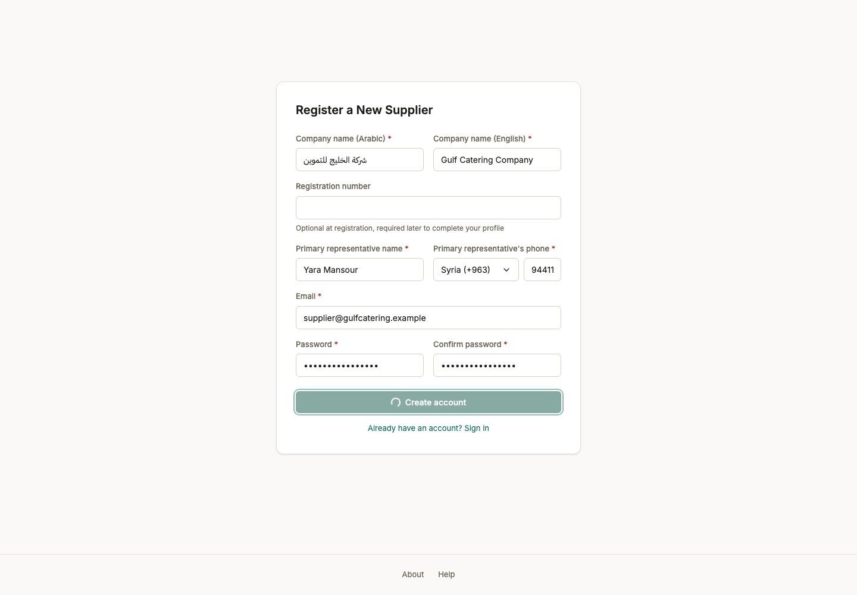

12. Email verified
Persona supplier_admin
Screen Email verified (/verify-email?token=iA7TpbFcsDpT8hDb11yvRZ4_cpXTIXfTBnMxUcohjM4)
What just happened The address is proven and the account is live. The supplier is in Draft: registered, not yet allowed to bid.
What to do next Sign in and complete the company profile.
What to say “Verified. The supplier is now in Draft — registered, but not yet allowed anywhere near a tender.”
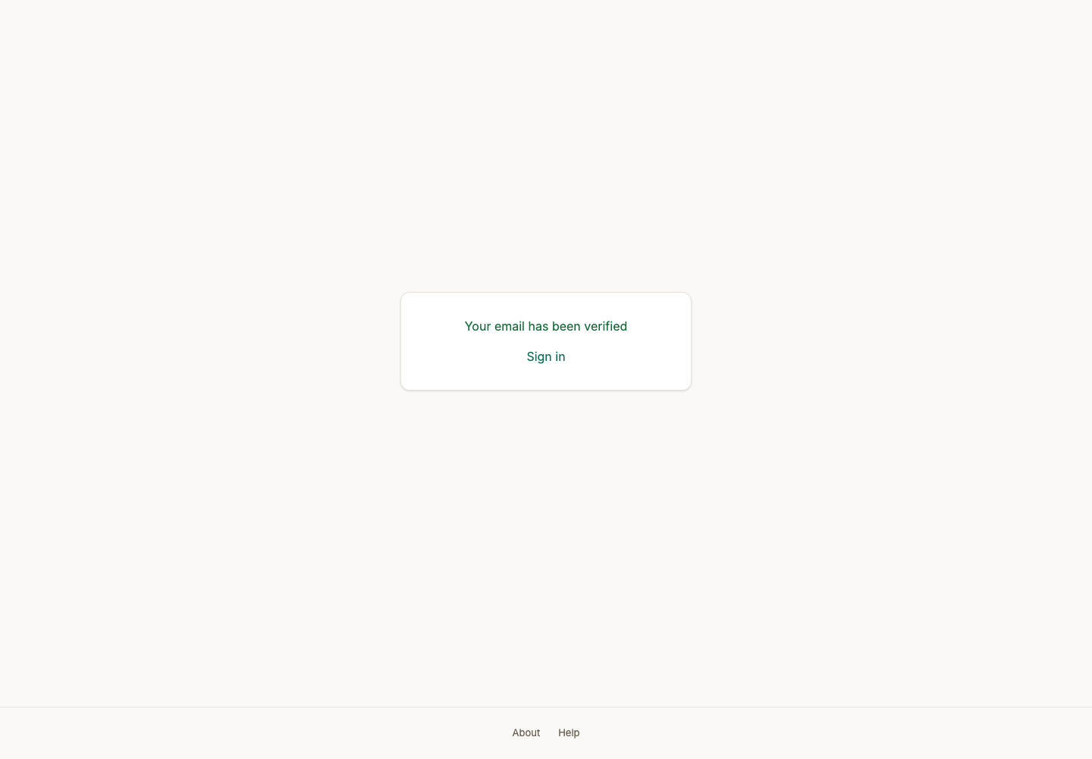

Act 4 — Onboarding: who this company is
A checklist the server enforces, filled in one section at a time: legal identity, company profile, a named contact, an address, a bank account, and what the company supplies.

13. Supplier dashboard (new account)
Persona supplier_admin
Screen Supplier dashboard (new account) (/dashboard)
What just happened The supplier can sign in now. There is no tender activity yet and the screen says so rather than showing empty widgets: what it offers instead is the completeness of the profile that stands between this account and bidding.
What to do next Open Onboarding and fill in the company record.
What to say “An honest empty state. It tells the supplier what to do next rather than showing them a dashboard of zeroes.”
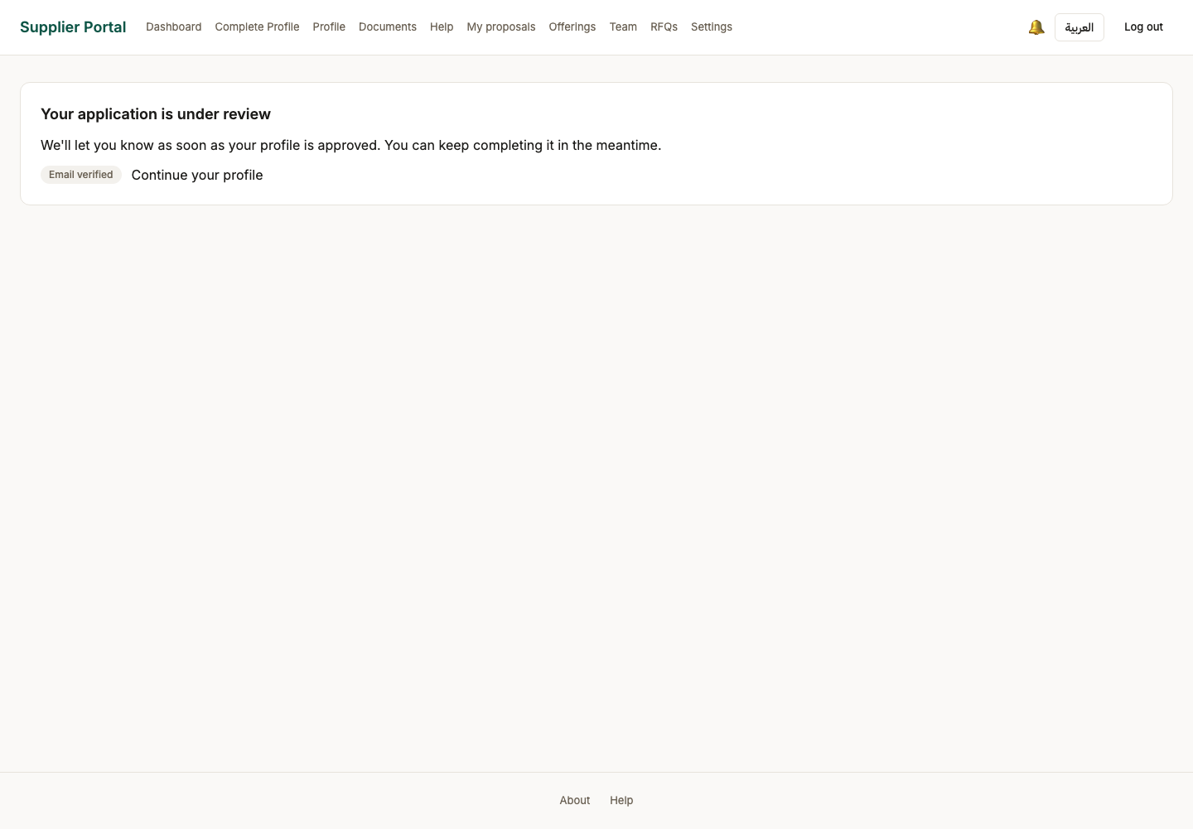

14. Onboarding — checklist
Persona supplier_admin
Screen Onboarding — checklist (/onboarding)
What just happened The checklist is the gate. Each item is a condition the server enforces on submission, so this screen and the refusal cannot disagree.
What to do next Fill in the legal information first.
What to say “This checklist is the gate. Every item on it is a condition the server enforces at submission — the screen and the rule cannot drift apart.”
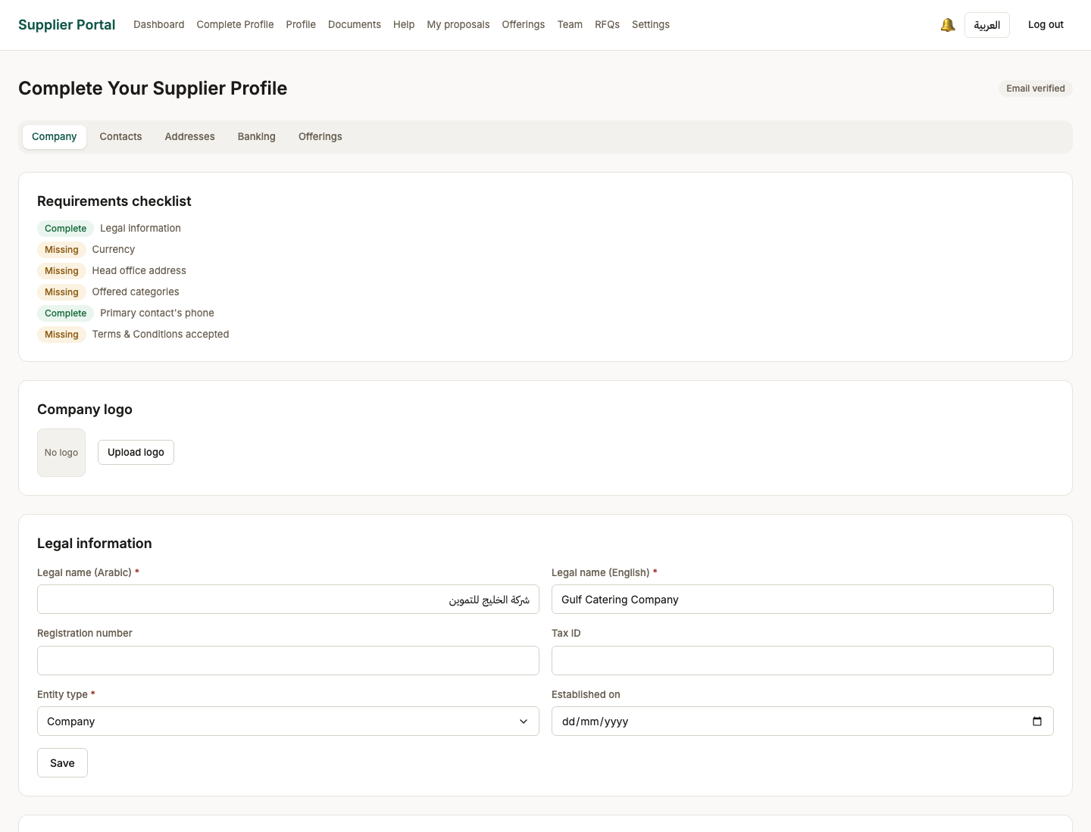
Screen 14, part 1 of 2 — top of the page

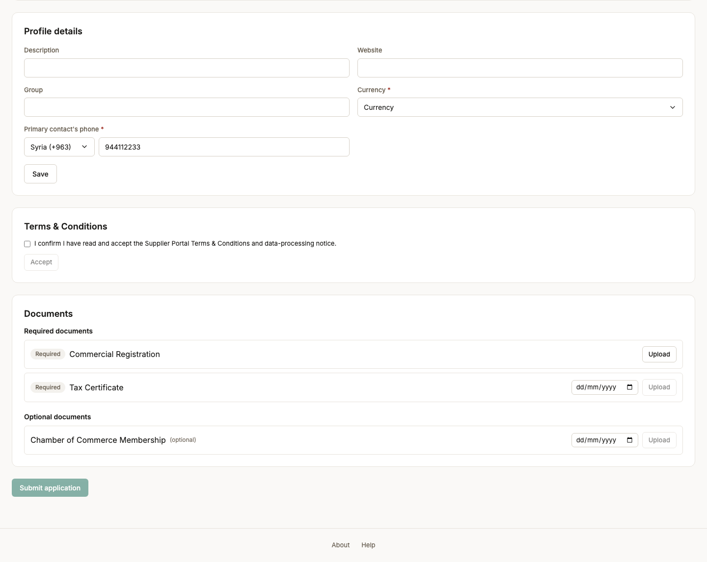
Screen 14, part 2 of 2 — bottom of the page

15. Onboarding — legal information saved
Persona supplier_admin
Screen Onboarding — legal information saved (/onboarding)
What just happened The legal identity is recorded. This is the block a reviewer checks against the registration certificate.
What to do next Fill in the company profile below it — currency and the contact phone are both required.
What to say “The legal identity — this is the block a reviewer will check against the registration certificate.”
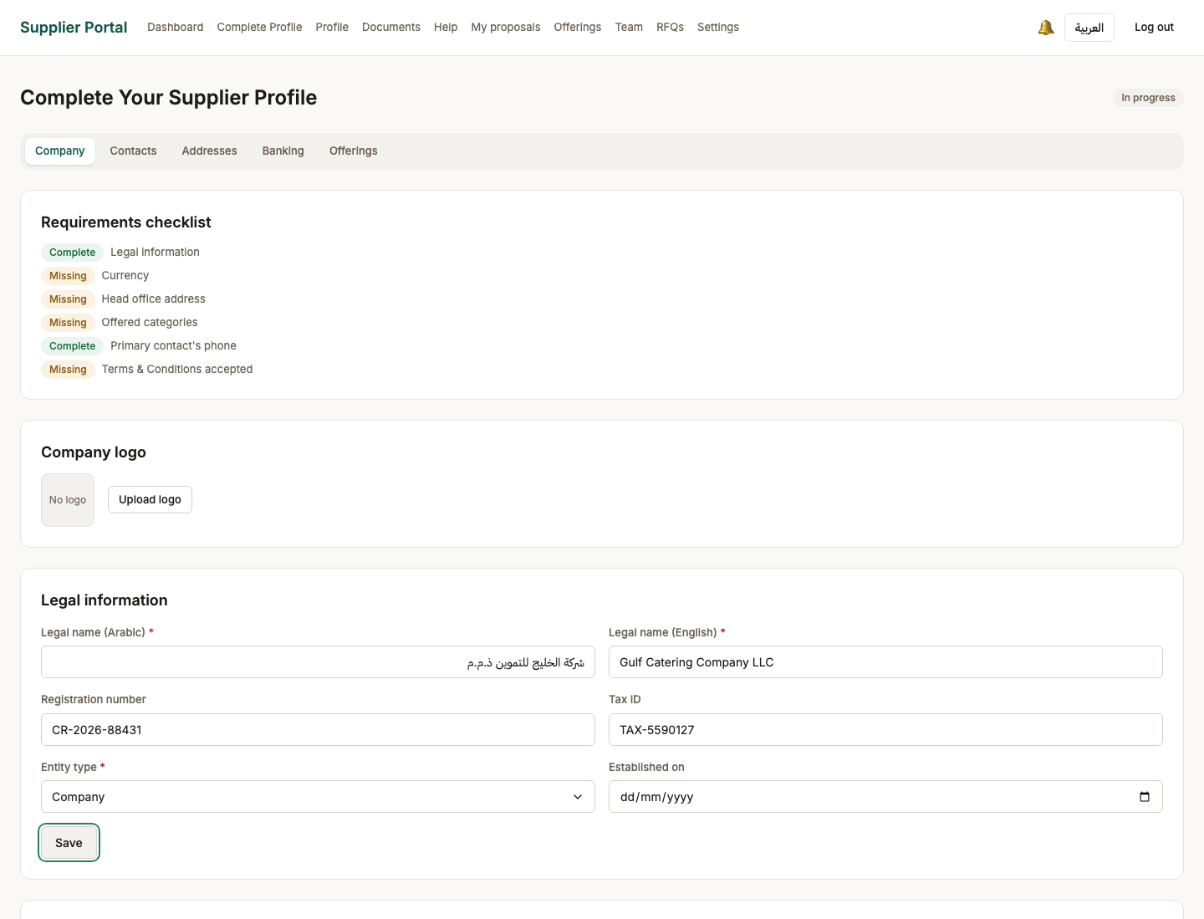
Screen 15, part 1 of 2 — top of the page

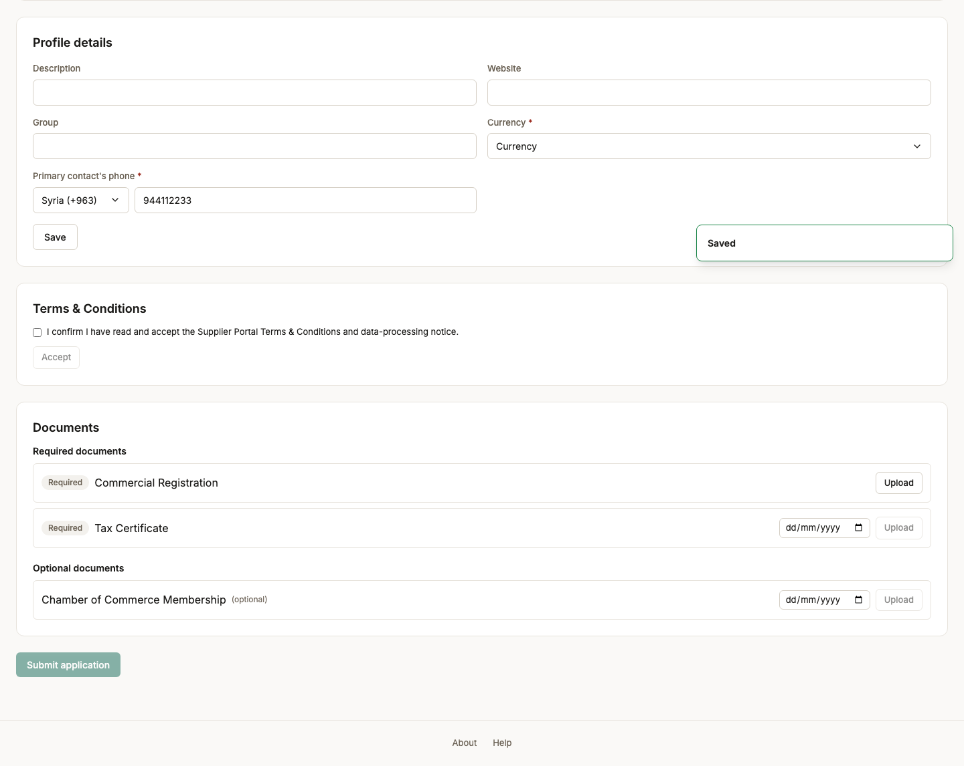
Screen 15, part 2 of 2 — bottom of the page

16. Onboarding — company profile saved
Persona supplier_admin
Screen Onboarding — company profile saved (/onboarding)
What just happened Currency and a reachable contact are recorded. The currency matters later: a proposal is priced in it, and the comparison matrix refuses to convert between currencies it was never told the rate for.
What to do next Add a head-office address, a bank account, and the categories this company supplies.
What to say “The default currency matters later: a bid is priced in it, and the award is issued in it.”
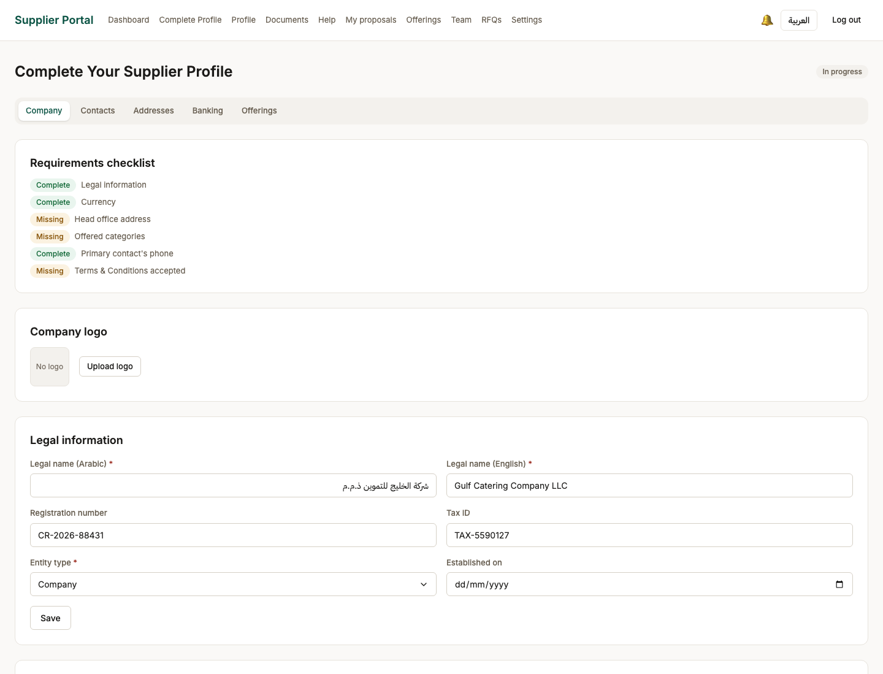
Screen 16, part 1 of 2 — top of the page

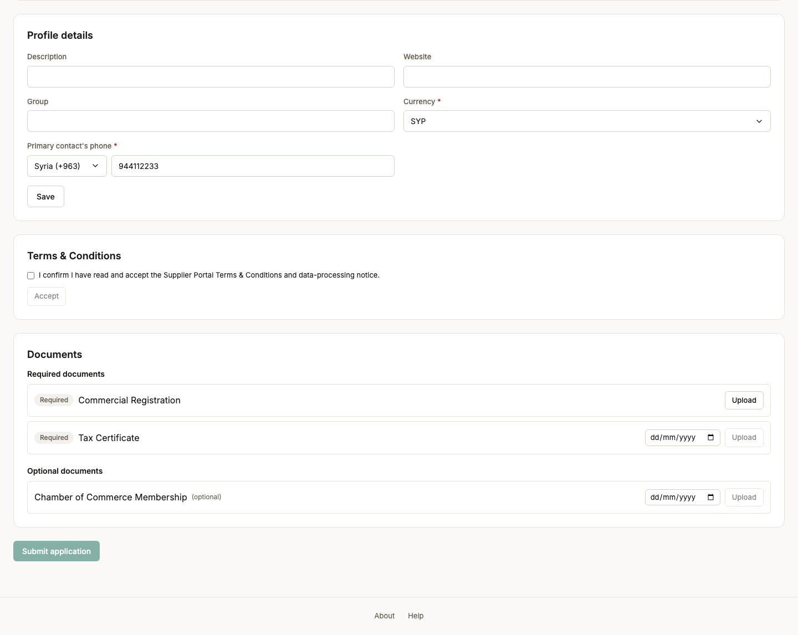
Screen 16, part 2 of 2 — bottom of the page

17. Onboarding — contacts
Persona supplier_admin
Screen Onboarding — contacts (/onboarding/contacts)
What just happened A primary representative is recorded. This is the person a buyer addresses a clarification to, and the completeness rule requires their phone number specifically — a supplier nobody can reach mid-tender is one a buyer cannot include.
What to do next Add the head-office address.
What to say “A named representative. This is the person a buyer addresses a clarification to.”
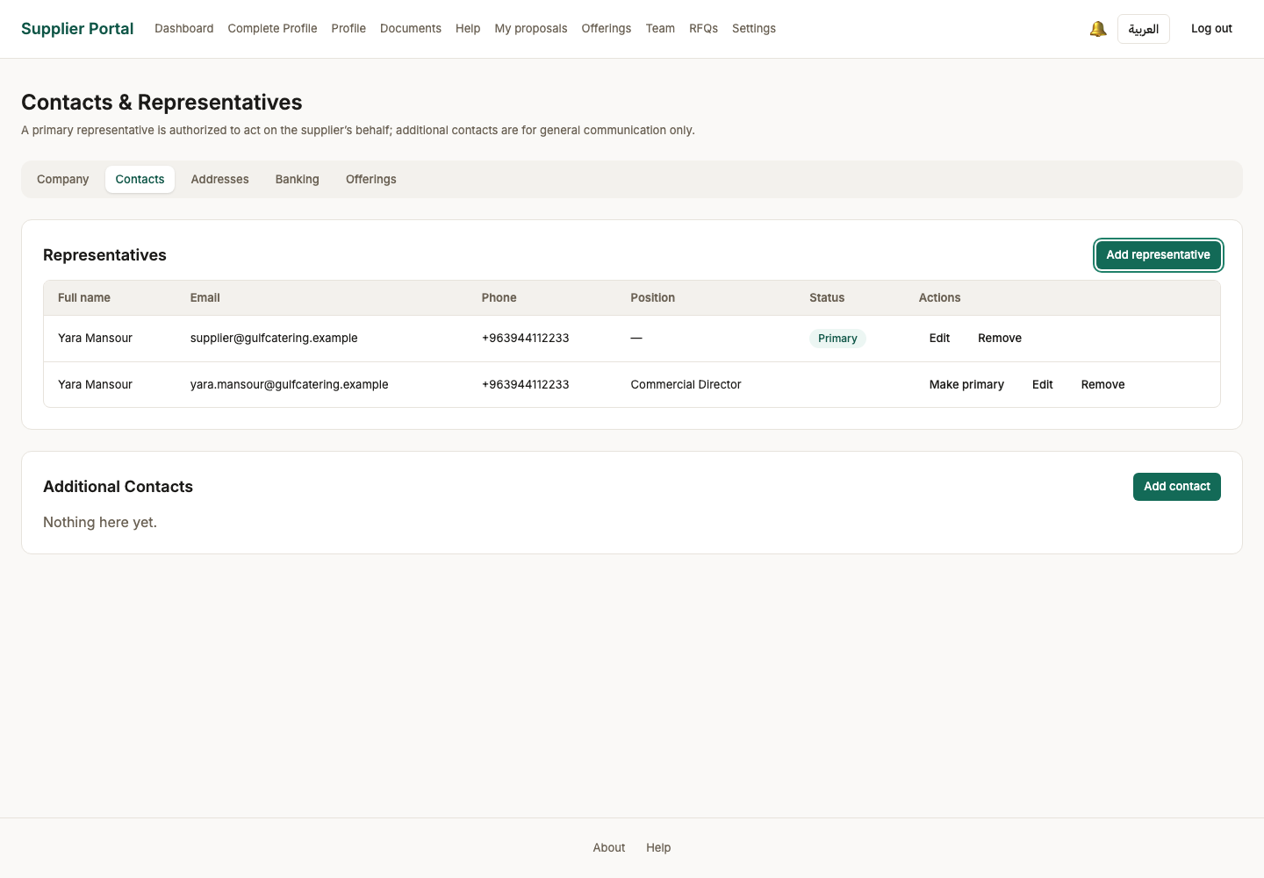

18. Onboarding — addresses
Persona supplier_admin
Screen Onboarding — addresses (/onboarding/addresses)
What just happened A head-office address, which is one of the completeness conditions: an approved supplier with no registered address is one nobody can serve notice on.
What to do next Add the bank account an award would be paid into.
What to say “An approved supplier with no registered address is not something a ministry should be able to create, so the address is a completeness condition.”
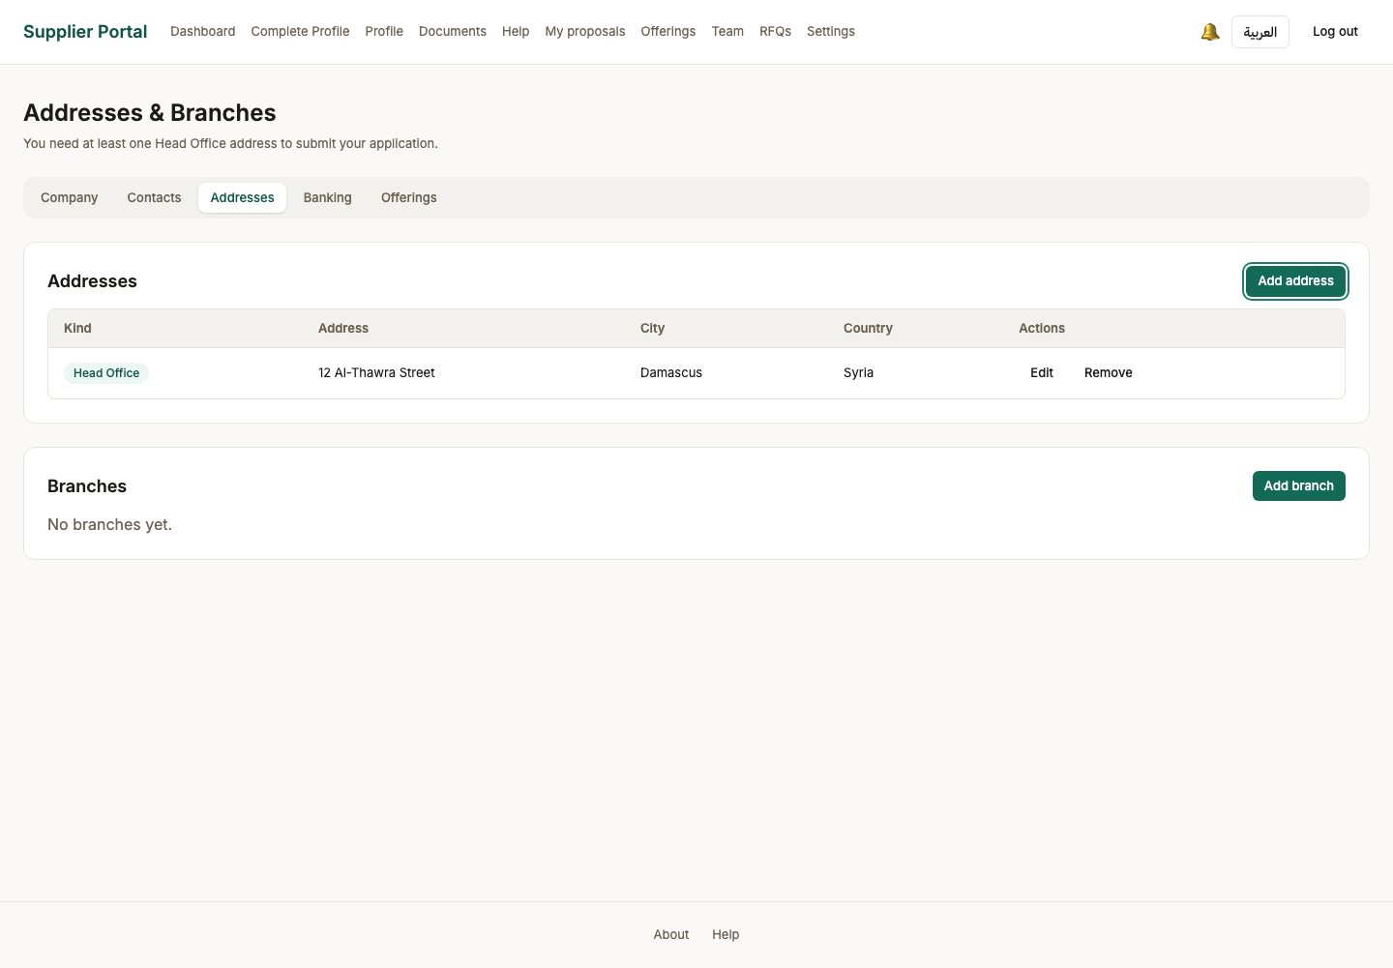

19. Onboarding — banking
Persona supplier_admin
Screen Onboarding — banking (/onboarding/banking)
What just happened Where an award would be paid. The account number is masked everywhere it is shown again, including on the reviewer's screen.
What to do next Choose the categories this company supplies.
What to say “Where an award would actually be paid. The account number is masked everywhere it is shown again — including on the reviewer's screen.”
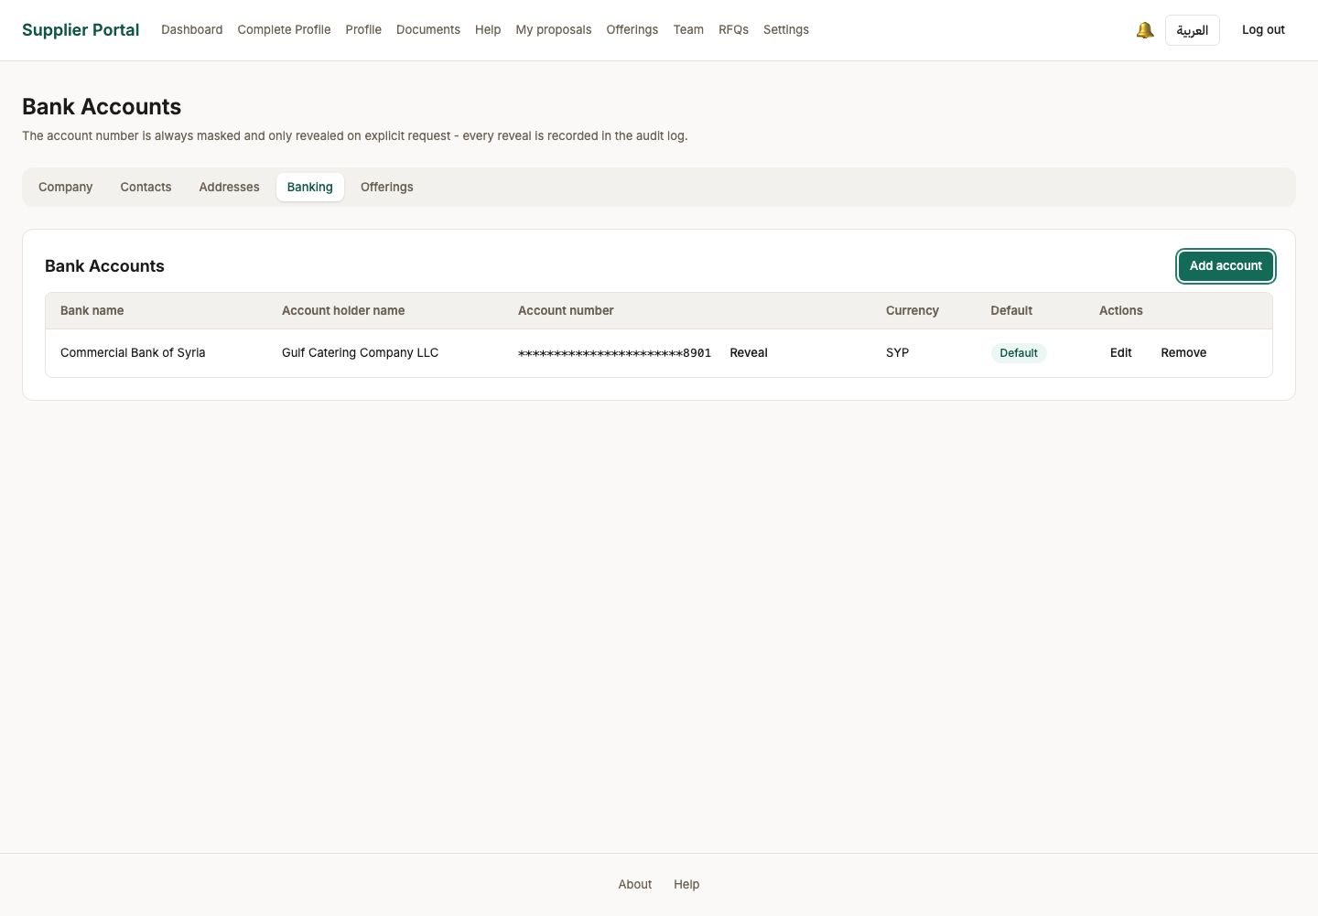

20. Onboarding — categories
Persona supplier_admin
Screen Onboarding — categories (/onboarding/offerings)
What just happened What this company supplies, chosen from the ministry-maintained category list rather than typed. Invitations are matched against these.
What to do next Tick at least one category — a supplier with none cannot be matched to any tender.
What to say “Categories are chosen from the ministry's own list, not typed. That is what makes invitations targetable later.”
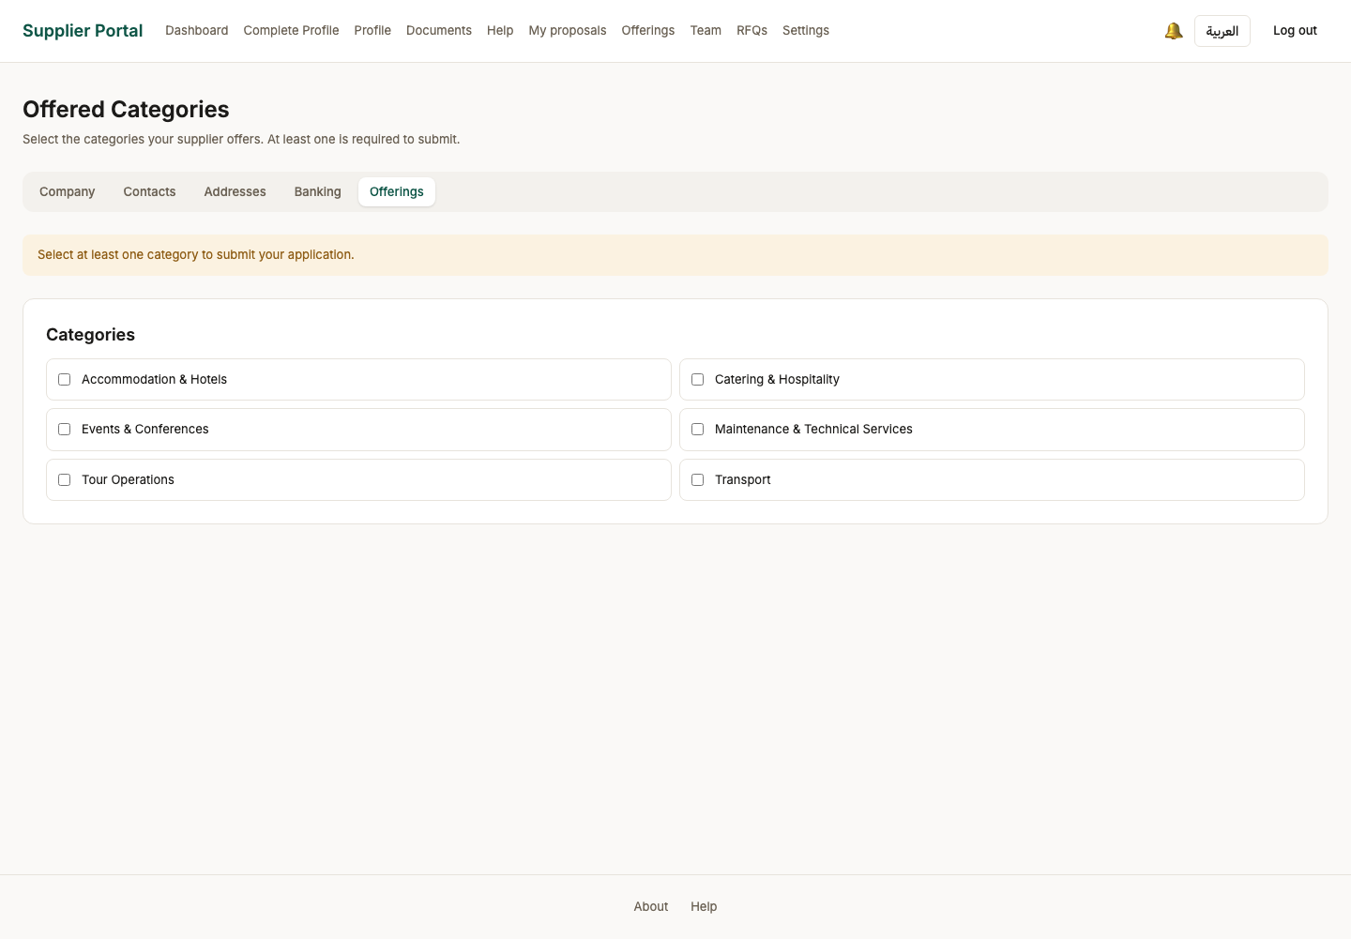

21. Onboarding — category chosen
Persona supplier_admin
Screen Onboarding — category chosen (/onboarding/offerings)
What just happened The category link is recorded and the completeness checklist drops one item.
What to do next Upload the documents the ministry requires before an application can be submitted.
What to say “One item off the checklist. Notice the completeness figure moving as we go.”
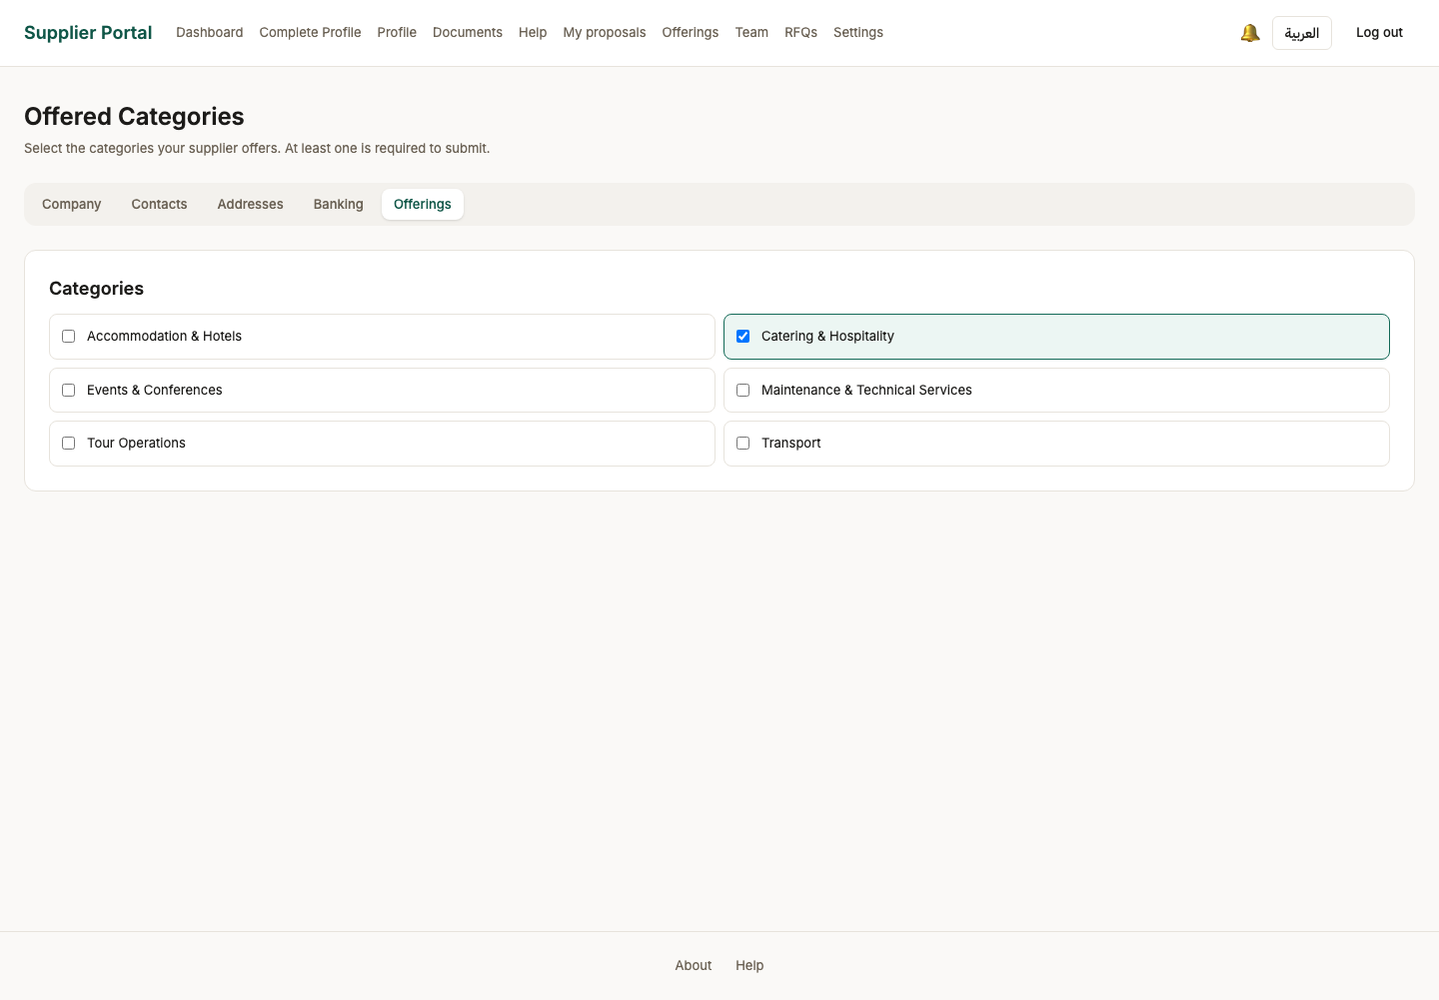

Act 5 — Documents, and submitting the application
Each required document is uploaded with its own expiry date and virus-scanned before it is accepted. Only when the checklist is complete does the application become submittable.

22. Onboarding — document uploaded
Persona supplier_admin
Screen Onboarding — document uploaded (/onboarding)
What just happened The file went to object storage and ClamAV scanned it before it was accepted. That scan is fail-closed by design: with clamd stopped the upload is REFUSED rather than stored unscanned, so a portal that cannot scan does not quietly accept attachments.
What to do next Upload the remaining required documents, giving an expiry date where the type tracks one.
What to say “The file went to object storage and was virus-scanned before it was accepted. If the scanner is down, the upload is refused — I will come back to that at the end.”
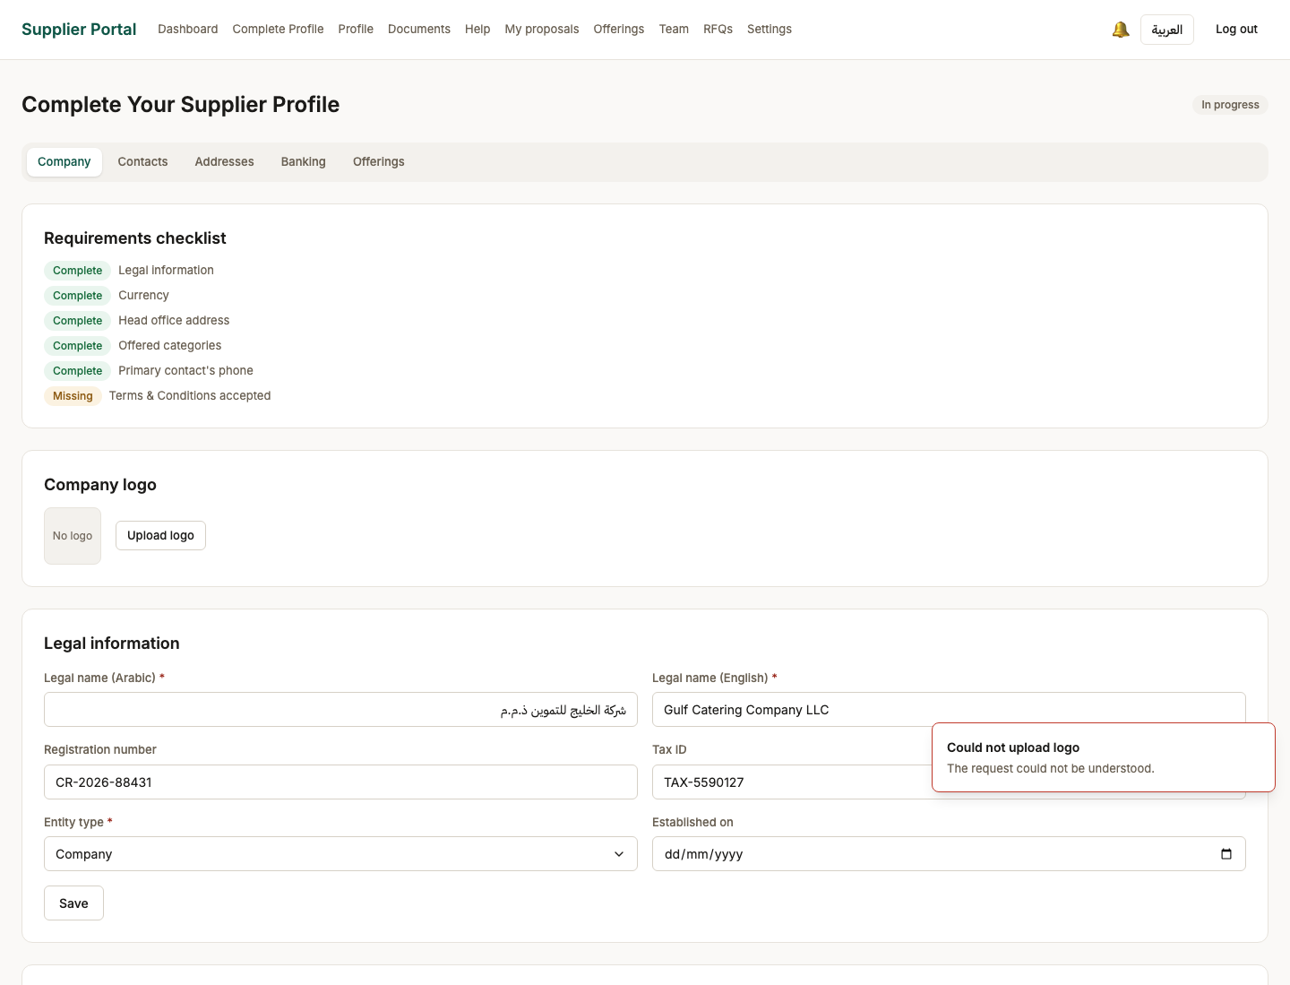
Screen 22, part 1 of 2 — top of the page


Screen 22, part 2 of 2 — bottom of the page

23. Onboarding — terms accepted
Persona supplier_admin
Screen Onboarding — terms accepted (/onboarding)
What just happened The terms are accepted, recorded against a named version and a timestamp. The tick alone was not the acceptance: a separate button is, so that what is stored is an action somebody took rather than a box that happened to be ticked.
What to do next Every condition is now met. Submit the application.
What to say “Accepting the terms is recorded against a named version and a timestamp. The tick on screen is not the acceptance; the record is.”
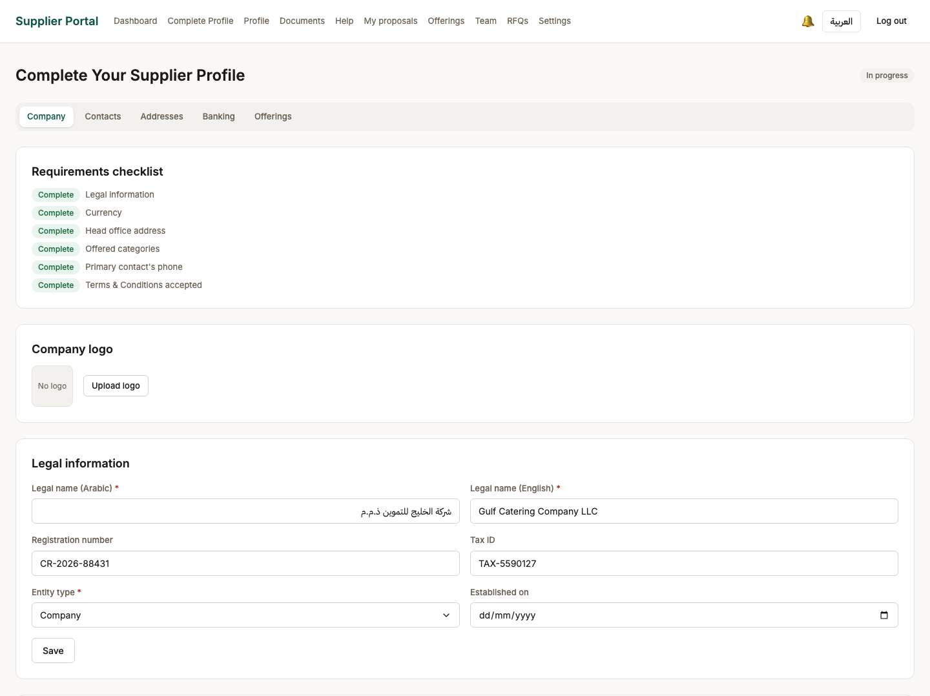
Screen 23, part 1 of 2 — top of the page

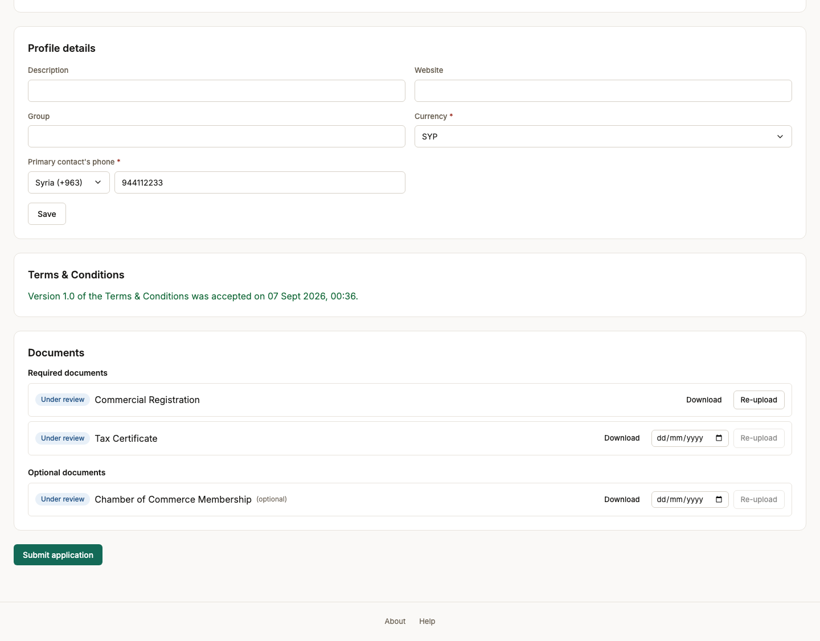
Screen 23, part 2 of 2 — bottom of the page

24. Onboarding — ready to submit
Persona supplier_admin
Screen Onboarding — ready to submit (/onboarding)
What just happened Every required document is uploaded and scanned. The submit button is offered only now: the server enforces the same list, so a submission that looks possible here is one that will be accepted.
What to do next Submit the application for review.
What to say “Only now does Submit appear. The server enforces the same condition, so this is not the button being polite.”

Screen 24, part 1 of 2 — top of the page


Screen 24, part 2 of 2 — bottom of the page

25. Application submitted
Persona supplier_admin
Screen Application submitted (/onboarding)
What just happened The profile is now read-only and sits in the reviewer queue. The supplier cannot edit what is being judged while it is being judged.
What to do next Wait for the ministry reviewer. Sign in as the reviewer to see the other side.
What to say “Submitted. The profile is read-only from here — the supplier cannot edit what is being judged while it is being judged.”
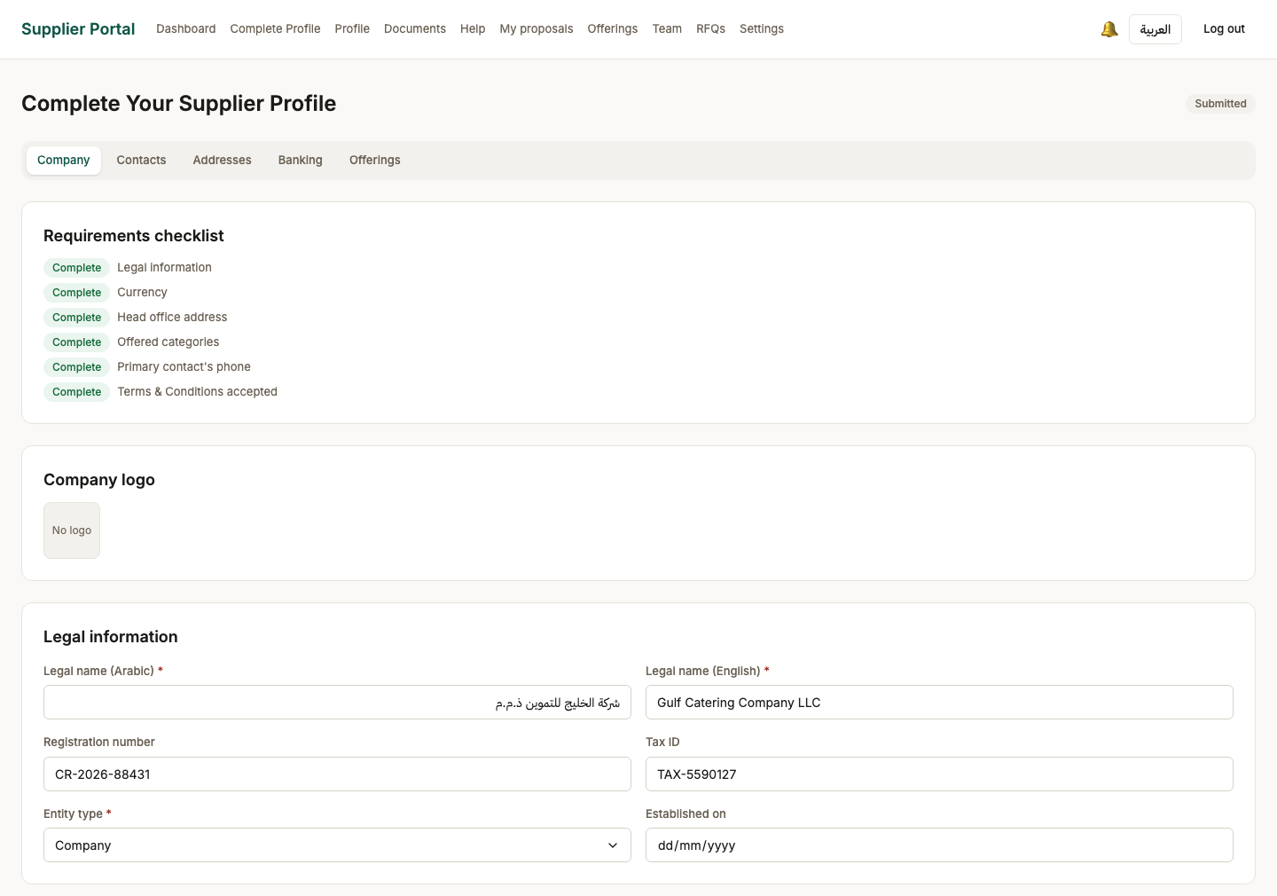
Screen 25, part 1 of 2 — top of the page

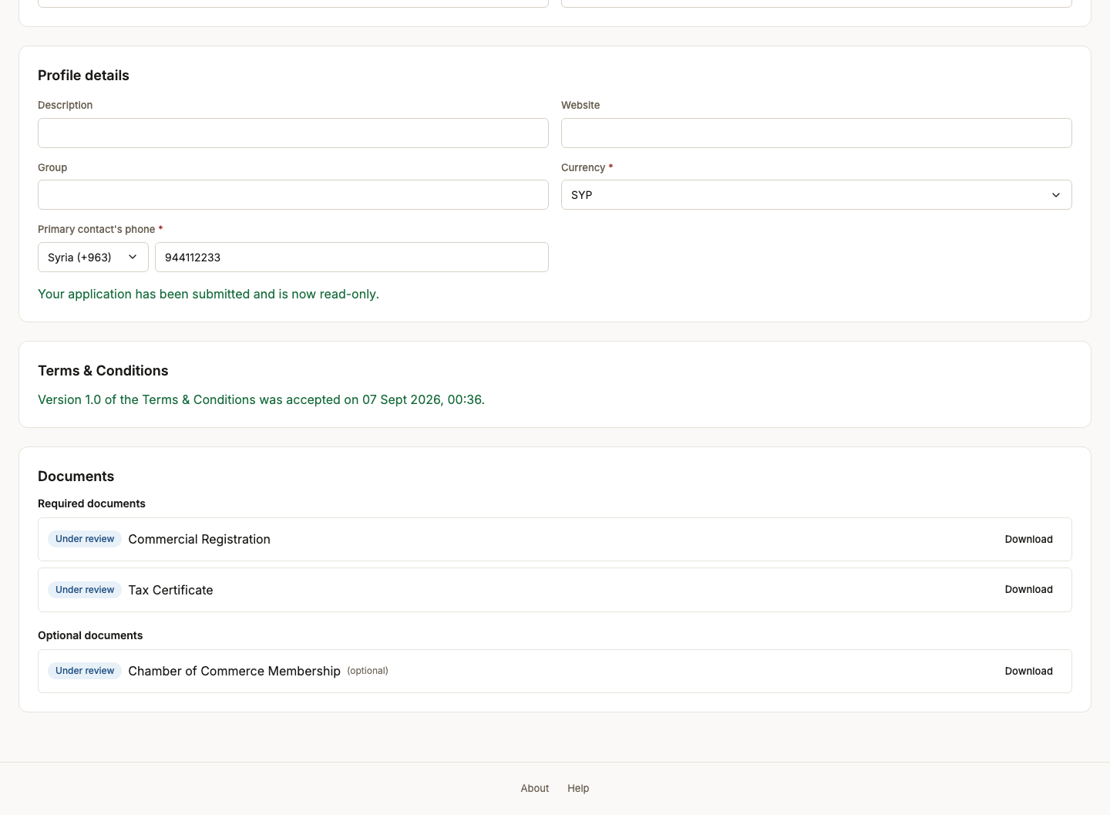
Screen 25, part 2 of 2 — bottom of the page

Act 6 — The reviewer decides
A different person, a different set of screens, and a decision recorded with a written reason. The reviewer claims the case before the decision controls appear.

26. Reviewer landing
Persona onboarding_reviewer
Screen Reviewer landing (/back-office/dashboard)
What just happened The onboarding reviewer signs in. Their navigation carries exactly two working links — the review queue and its dashboard — because supplier.review is the only permission this role holds.
What to do next Open the reviewer dashboard.
What to say “Now the reviewer. Notice how little this persona can reach: two links, both about reviewing suppliers.”
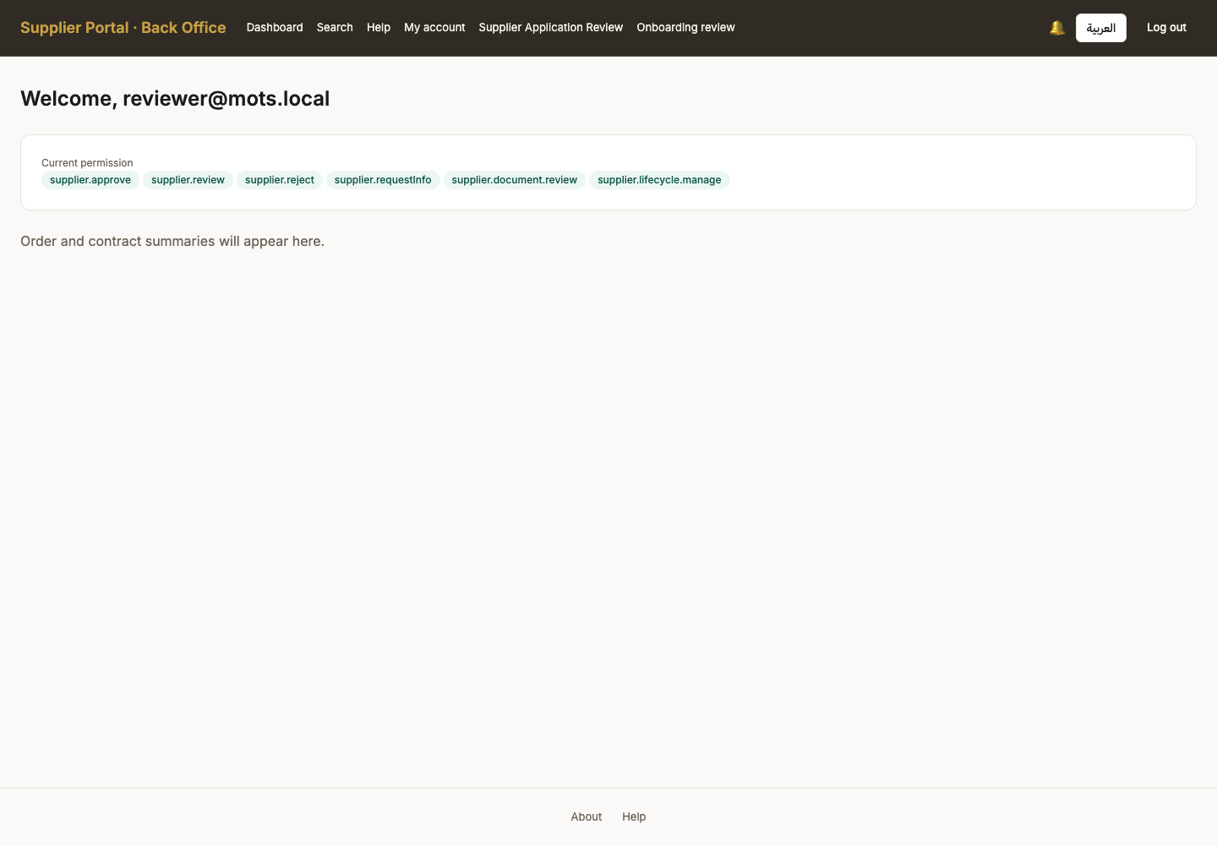

27. Reviewer dashboard
Persona onboarding_reviewer
Screen Reviewer dashboard (/back-office/review-dashboard)
What just happened SCR-300, and until batch 12 nothing in the app linked to it. It reports the oldest waiting case and the queue age, which is the question a reviewer actually opens the product to answer.
What to do next Open the review queue and take the waiting application.
What to say “This dashboard existed for two batches and nothing in the application linked to it. Nobody could reach it without typing the address.”
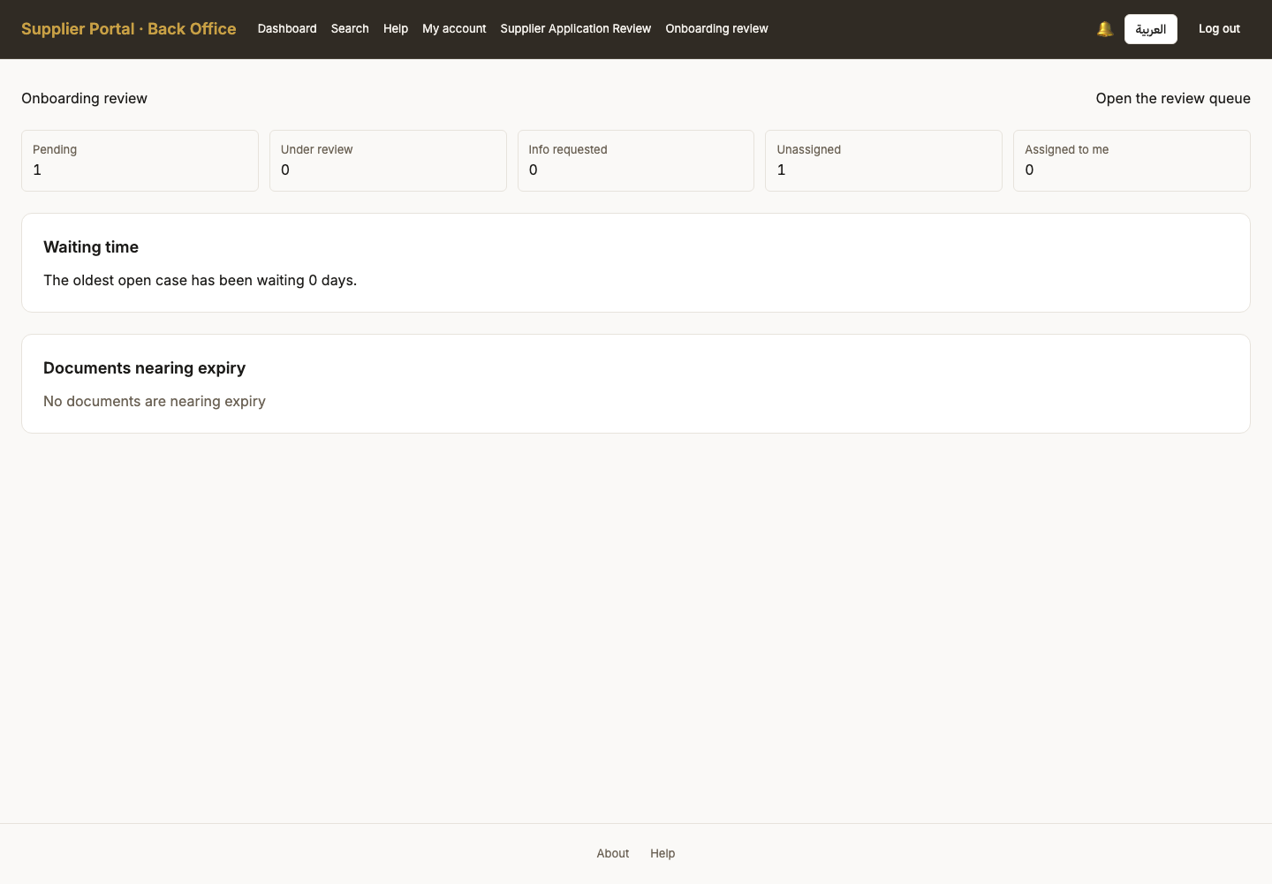

28. Review queue
Persona onboarding_reviewer
Screen Review queue (/back-office/review)
What just happened One application waiting — the one created in act 3. The queue is row-scoped: a reviewer sees applications, never tender data.
What to do next Open the application and check it against its documents.
What to say “One application waiting — the one we created five minutes ago. The queue is scoped: a reviewer sees applications, never tenders.”
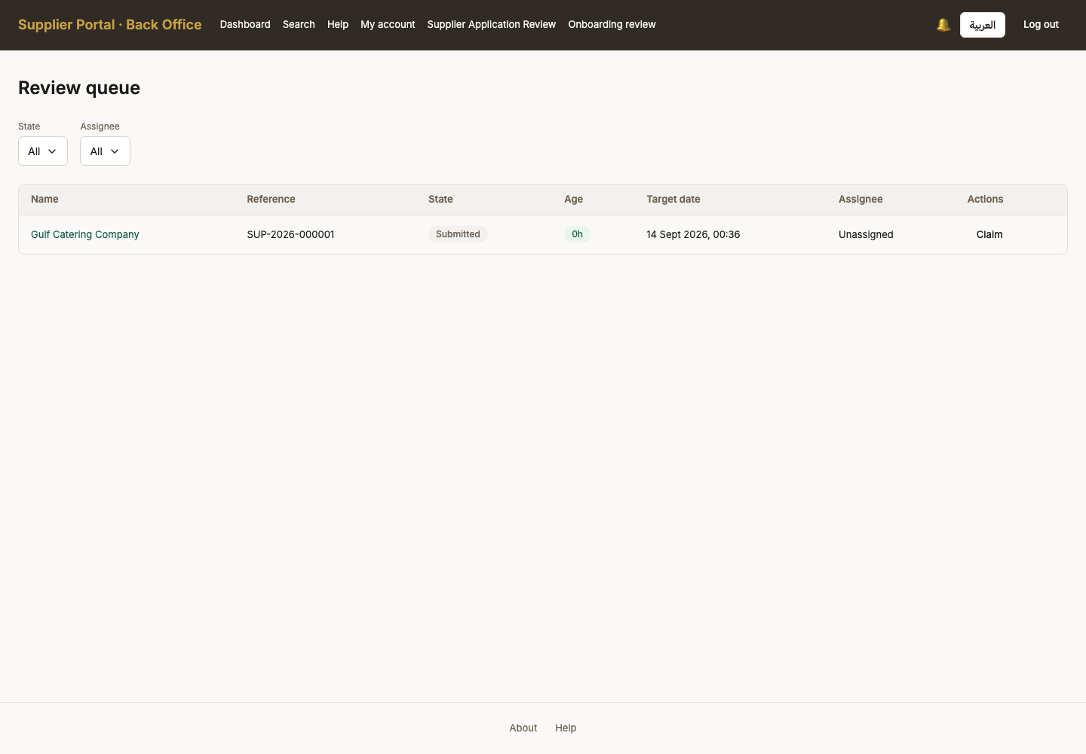

29. Application detail
Persona onboarding_reviewer
Screen Application detail (/back-office/review/SUP-2026-000001)
What just happened The whole submitted profile in one place, with every uploaded document downloadable. This is the screen the completeness rules exist to make answerable.
What to do next Approve, reject, or request more information. Each one demands a written reason.
What to say “The entire submitted profile in one place, with every document downloadable. This is the screen the compliance decision is actually made on.”
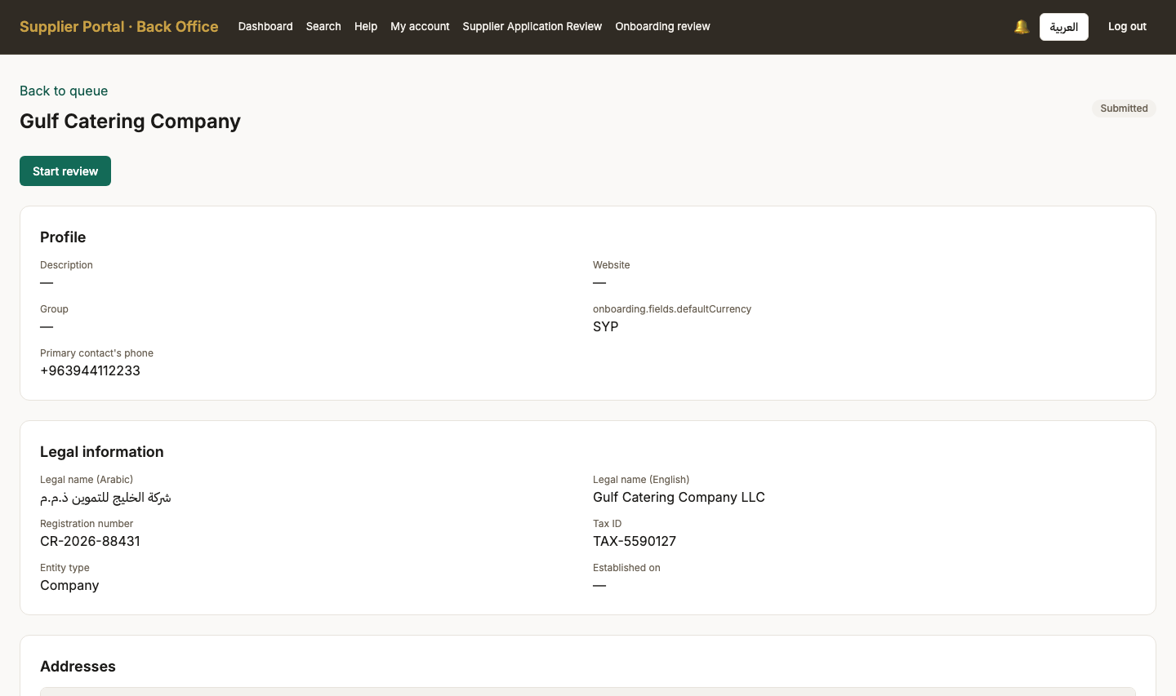
Screen 29, part 1 of 2 — top of the page

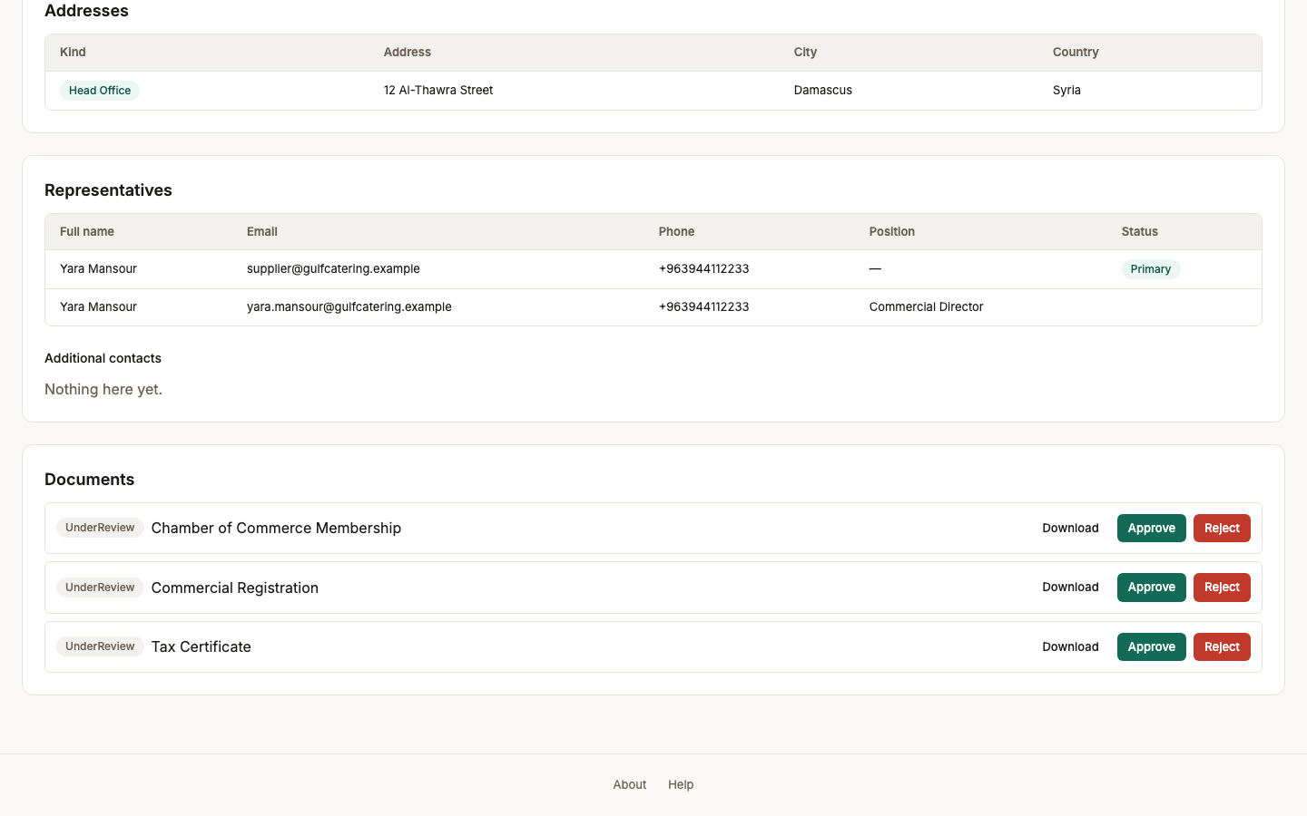
Screen 29, part 2 of 2 — bottom of the page

30. Review started
Persona onboarding_reviewer
Screen Review started (/back-office/review/SUP-2026-000001)
What just happened Claimed. The decision controls appear only now, and the queue records who took it - which is what stops two reviewers working the same application without knowing.
What to do next Check the documents, then approve, reject, or ask for more information.
What to say “Claimed. The decision controls appear only after the reviewer takes the case, which is what stops two reviewers working on the same application.”
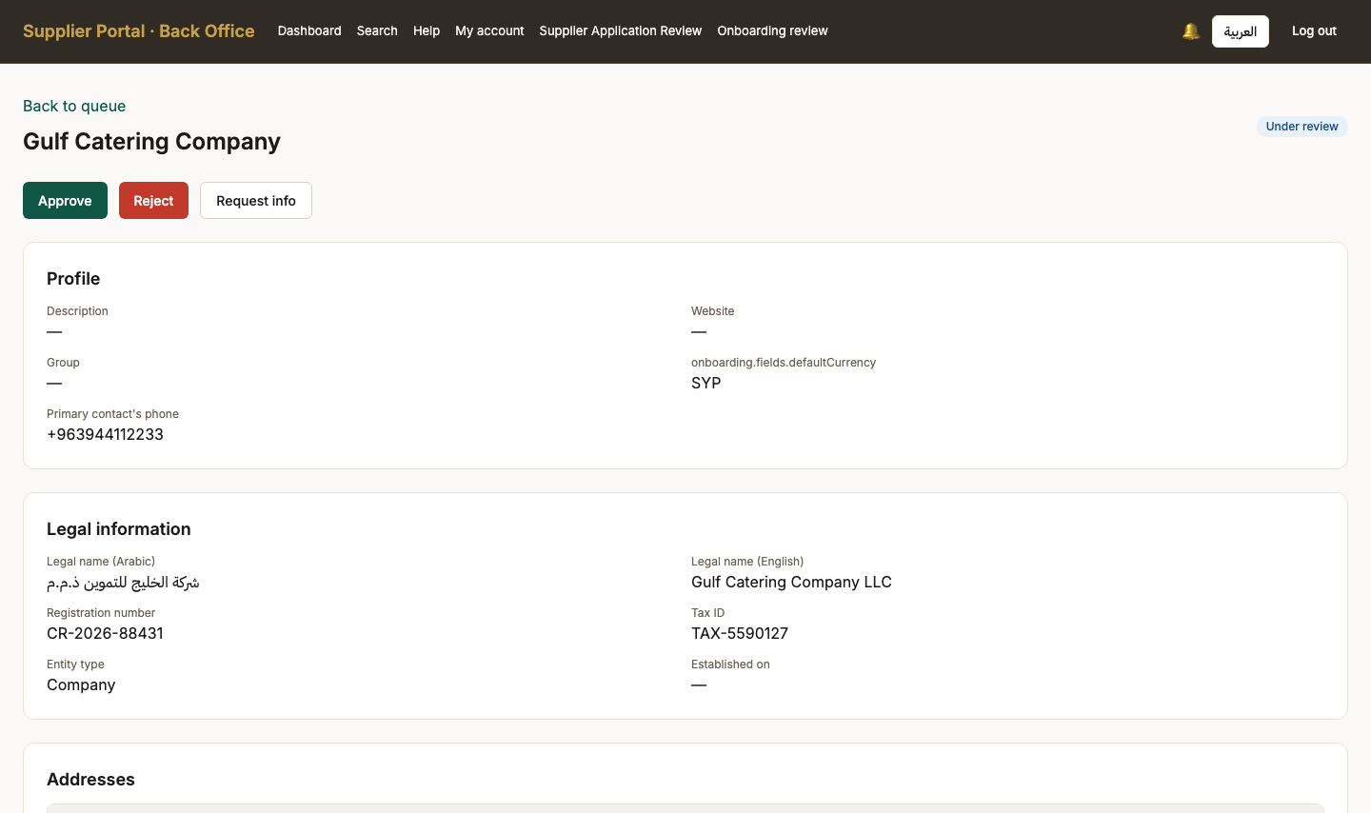
Screen 30, part 1 of 2 — top of the page

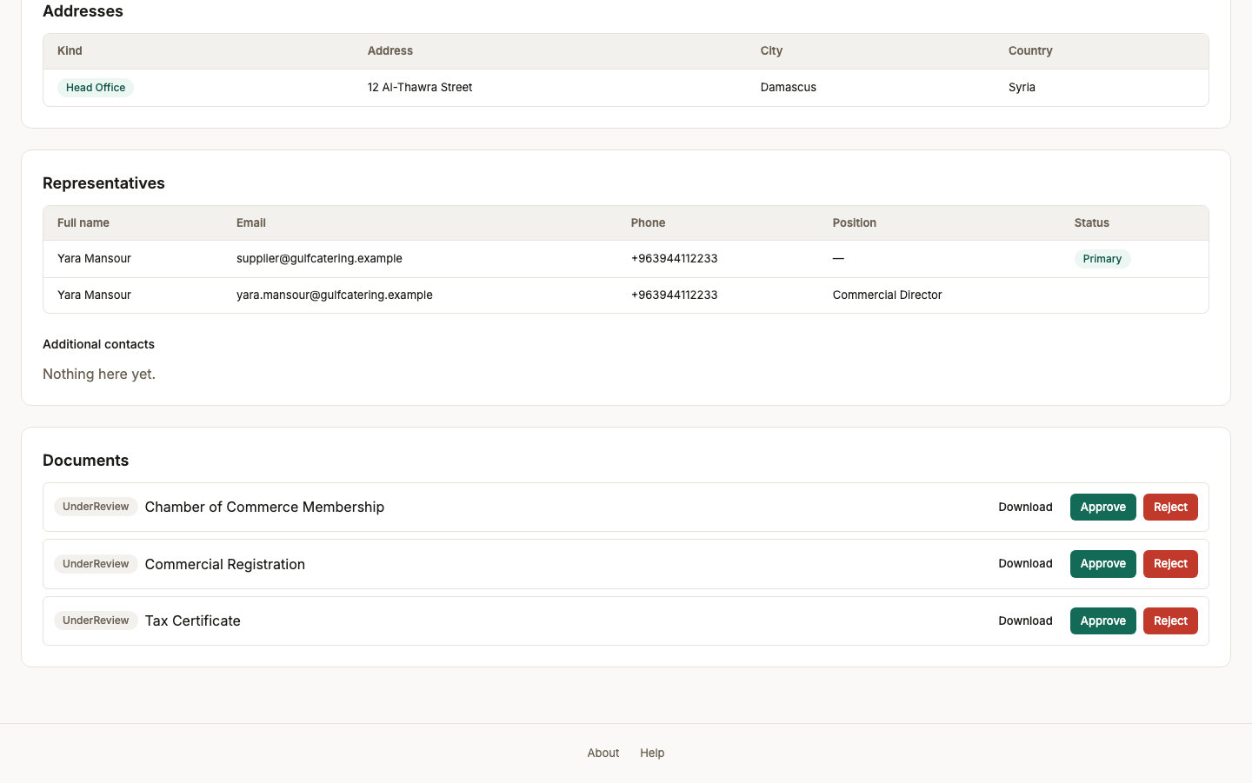
Screen 30, part 2 of 2 — bottom of the page

31. Application approved
Persona onboarding_reviewer
Screen Application approved (/back-office/review/SUP-2026-000001)
What just happened Approved, with a written reason recorded against the decision. The reason is not decoration: an approval nobody can account for later is the thing an audit trail exists to prevent.
What to do next The supplier is now Active and can be invited to tenders. Sign in as the procurement officer.
What to say “Approved, with a written reason recorded against the decision. An approval nobody can account for later is not much of an approval.”
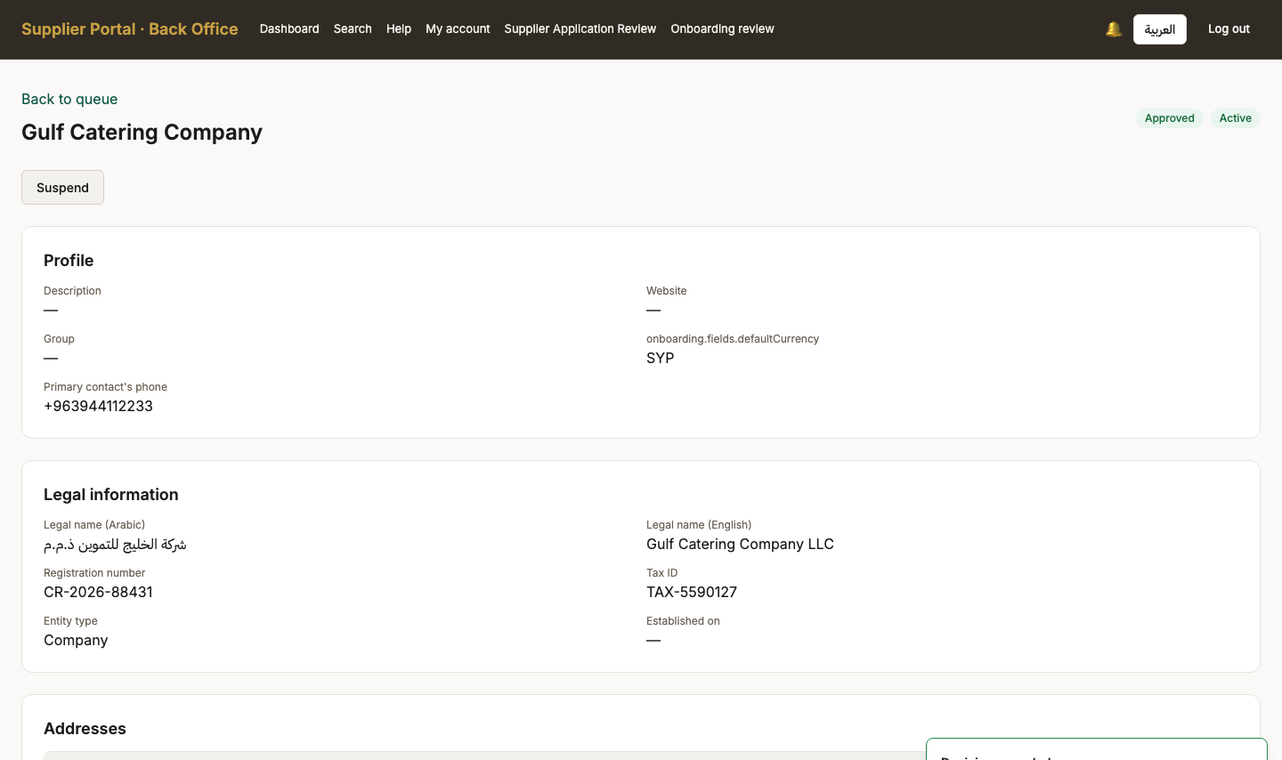
Screen 31, part 1 of 2 — top of the page

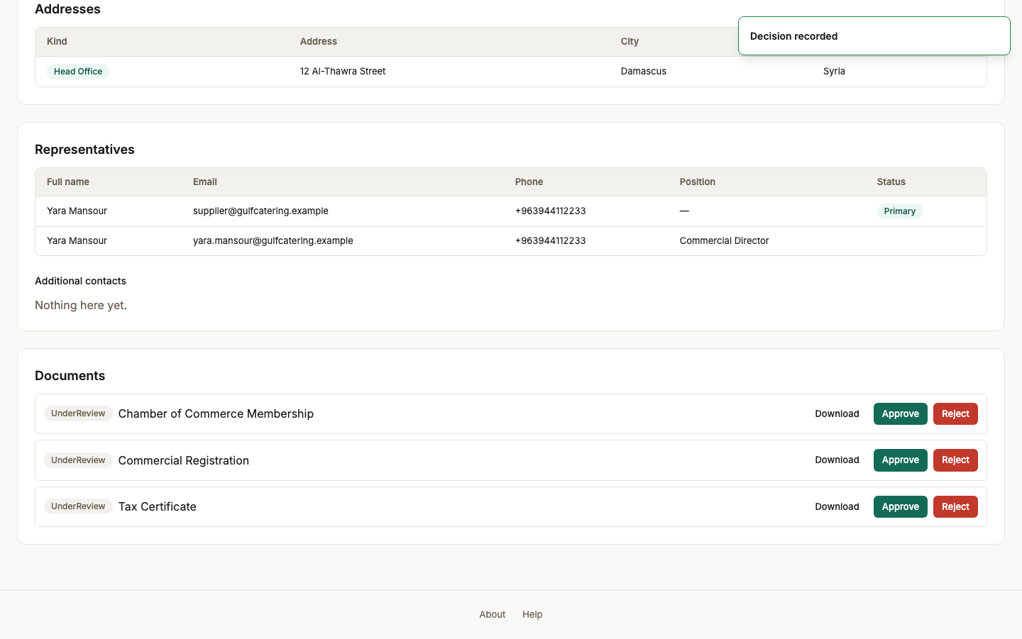
Screen 31, part 2 of 2 — bottom of the page

Act 7 — An offering, which is what makes a supplier findable
Approval alone does not make a company visible to buyers. Ticking a category says what it does in principle; an offering is the concrete thing it sells, and it is what invitations are drawn from.

32. Offerings (empty)
Persona supplier_admin
Screen Offerings (empty) (/offerings)
What just happened Ticking a category during onboarding said what this company does in principle. An offering is the concrete thing it sells, and this is the list a buyer is matched against - the invitation suggestions on a tender are built from OFFERINGS, not from the categories chosen at sign-up.
What to do next Add an offering in the catering category.
What to say “Ticking a category said what this company does in principle. An offering is the concrete thing it sells — and it is what actually makes them findable.”
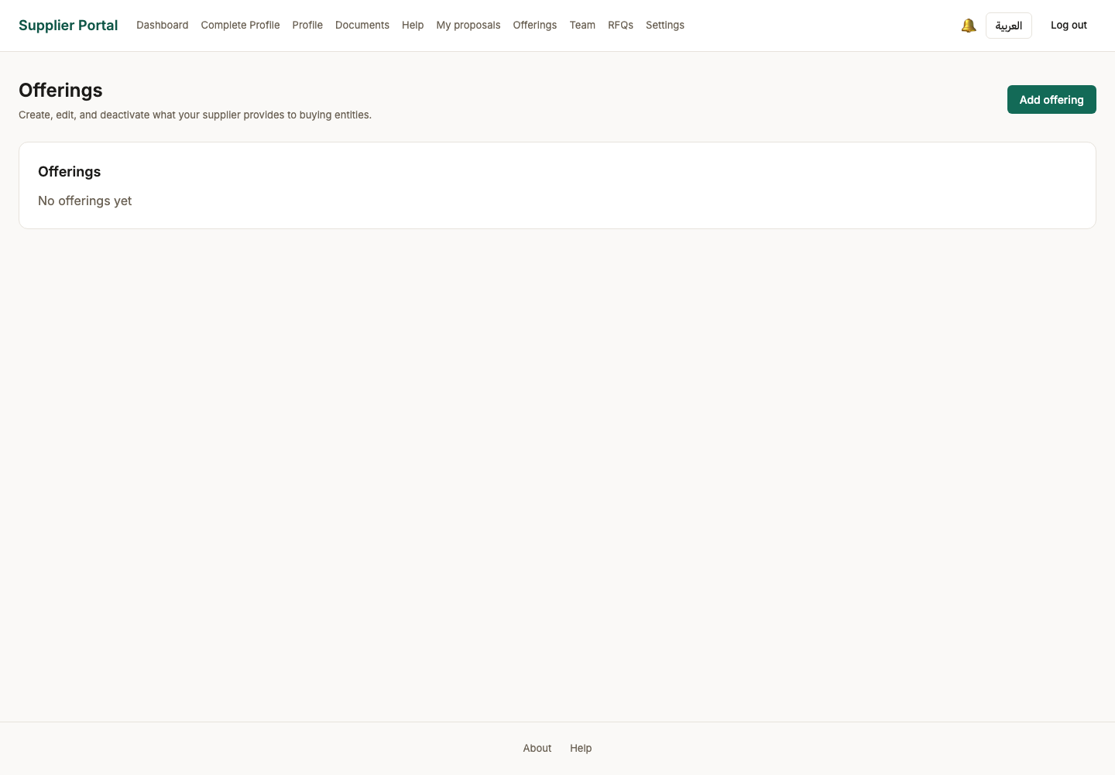

33. Offering listed
Persona supplier_admin
Screen Offering listed (/offerings)
What just happened The company is now findable. A tender whose line items carry this category will suggest this supplier to the officer writing it — which is the whole mechanism by which a buyer discovers who can bid.
What to do next Back to the officer, who writes the tender.
What to say “The company is now visible to buyers. A tender carrying this category will suggest this supplier to the officer writing it.”
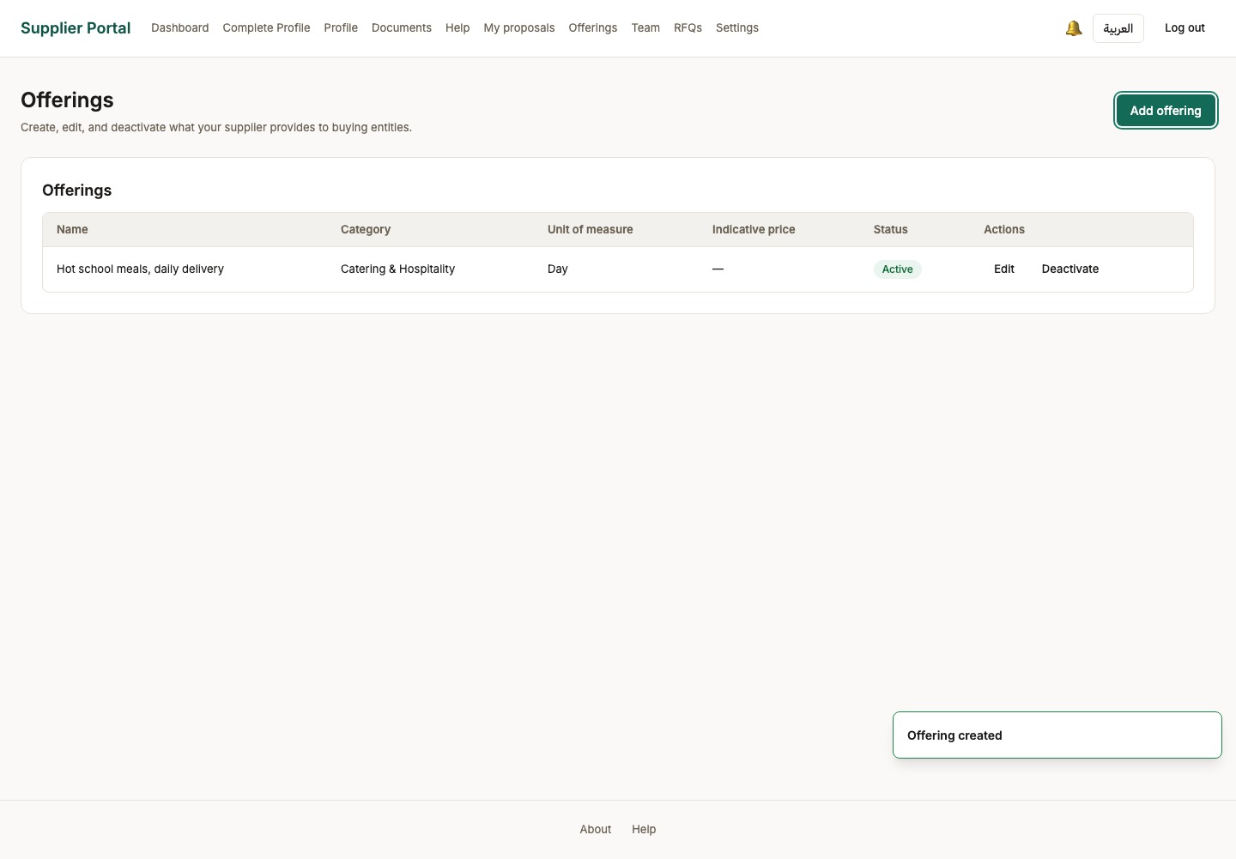

Act 8 — How the bids will be scored, decided before any bid exists
The scoring template belongs to the manager, not to the officer who writes the tender. It must total one hundred and be activated before anything can bind it.

34. Evaluation templates (empty)
Persona procurement_manager
Screen Evaluation templates (empty) (/back-office/evaluation-templates)
What just happened How bids get scored is decided before any bid exists, and by the manager rather than the officer who writes the tender. A template is reusable and versioned: activating one freezes it, and changing it later forks a new version rather than editing history.
What to do next Create the template this tender will be judged against.
What to say “How bids will be scored is decided before any bid exists, and by the manager — not by the officer who writes the tender.”
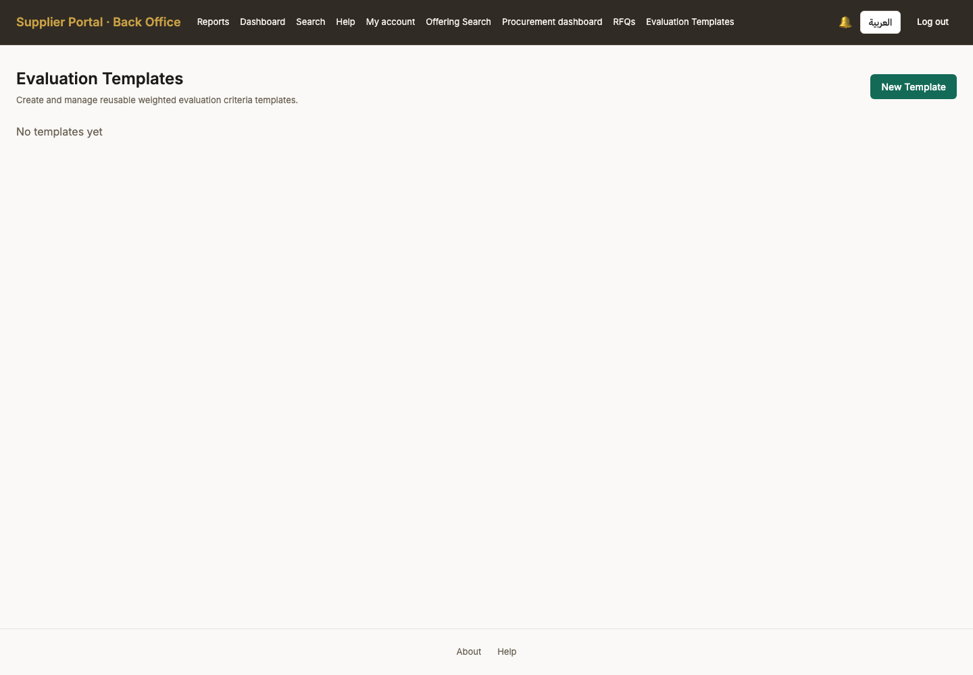

35. Template created (Draft)
Persona procurement_manager
Screen Template created (Draft) (/back-office/evaluation-templates)
What just happened The template exists in draft. It scores nothing yet: criteria carry the weights, and the weights have to total 100 before it can be activated.
What to do next Add the criteria bids will be scored on.
What to say “A draft template scores nothing. The weights have to total one hundred before it can be used.”
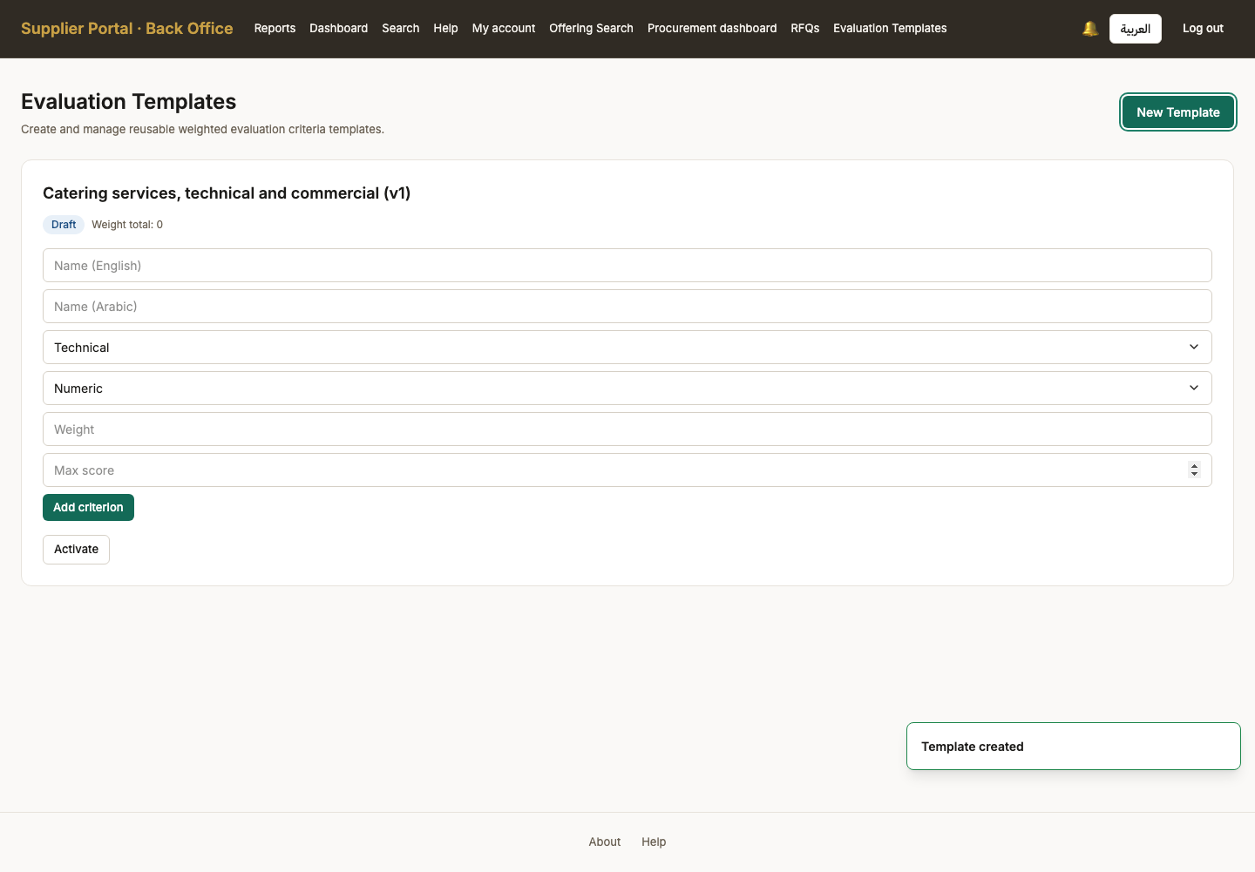

36. Criteria added, weights total 100
Persona procurement_manager
Screen Criteria added, weights total 100 (/back-office/evaluation-templates)
What just happened Two criteria across two of the four dimensions the product offers - Technical, Commercial, Compliance and Delivery. The weight total is shown because activation refuses anything but 100 — a template that does not add up would produce rankings nobody could defend.
What to do next Activate it so a tender can bind it.
What to say “Two criteria, across two of the four dimensions the product offers: technical, commercial, compliance and delivery.”
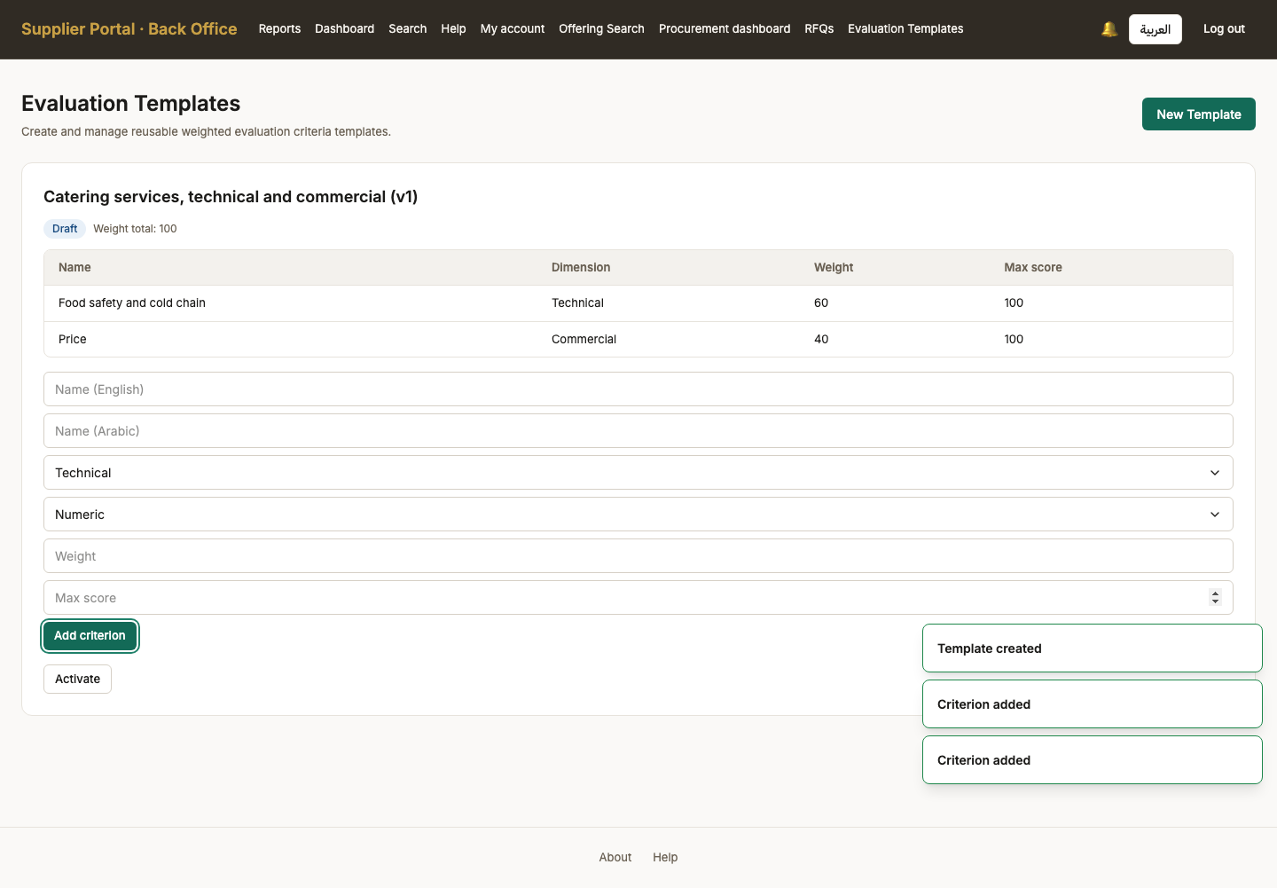

37. Template activated
Persona procurement_manager
Screen Template activated (/back-office/evaluation-templates)
What just happened Activated and now bindable. From here it is frozen: a tender that binds it keeps this exact set of criteria and weights even if a later version is created.
What to do next Hand back to the officer to write the tender.
What to say “Activated, and frozen from here. A tender that binds this template keeps this exact set of criteria even if somebody edits the template tomorrow.”
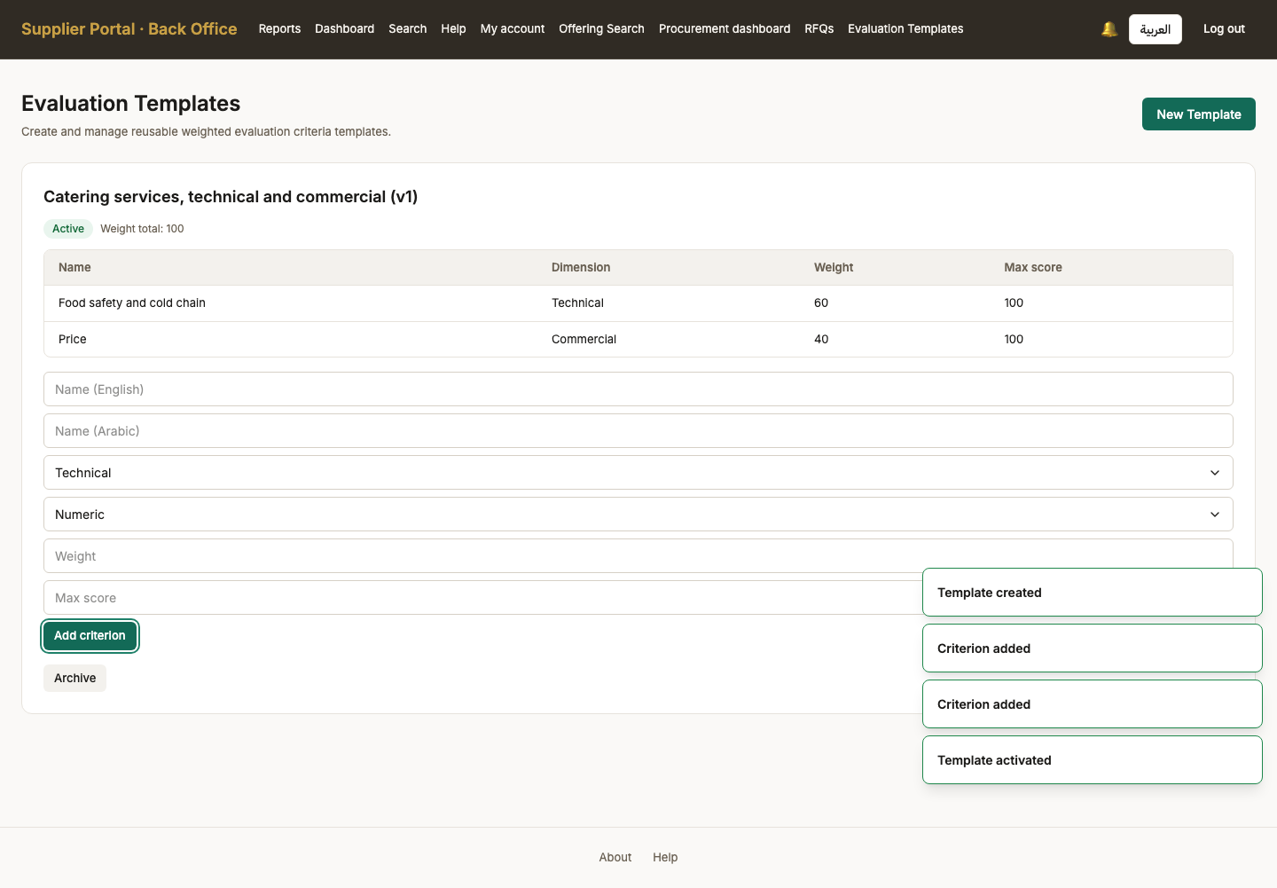

Act 9 — Authoring the tender
The longest act: a tender from an empty draft to something ready for review — line items, a scored requirement, the specification, the scoring template, and an invited supplier.

38. Officer landing
Persona procurement_officer
Screen Officer landing (/back-office/dashboard)
What just happened The procurement officer signs in. Their navigation carries the procurement dashboard, the tender list, the offering catalogue and search — the RFQ-facing half of the back office.
What to do next Open the procurement dashboard, which is this role's home screen.
What to say “The procurement officer. This is the persona that does the day-to-day work of running a tender.”
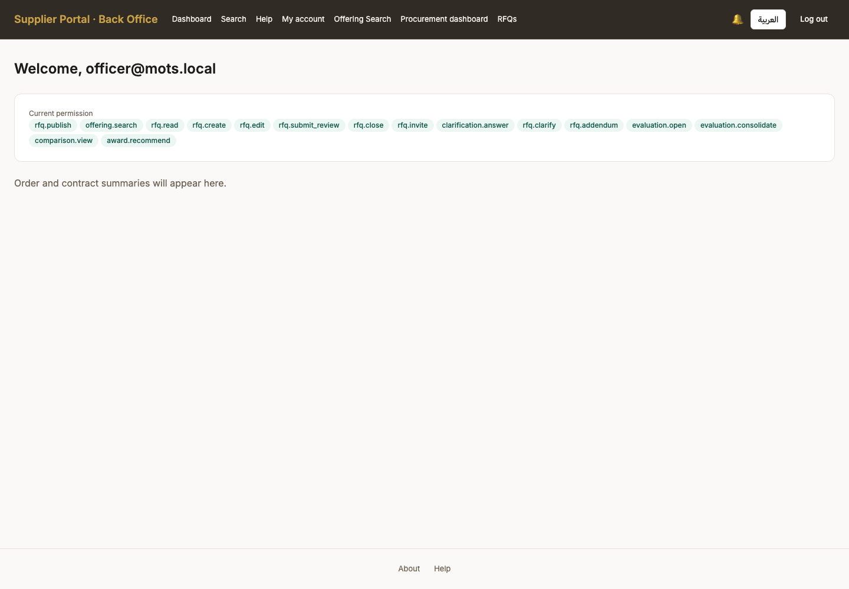

39. Procurement dashboard
Persona procurement_officer
Screen Procurement dashboard (/back-office/procurement)
What just happened SCR-400, and until batch 12 nothing in the app linked to it. Tenders by state, approvals waiting, deadlines — the officer's actual home screen, reachable at last by clicking.
What to do next Open the tender list and create one.
What to say “Another screen that was built, permissioned and unreachable until batch twelve. It is the officer's home page.”
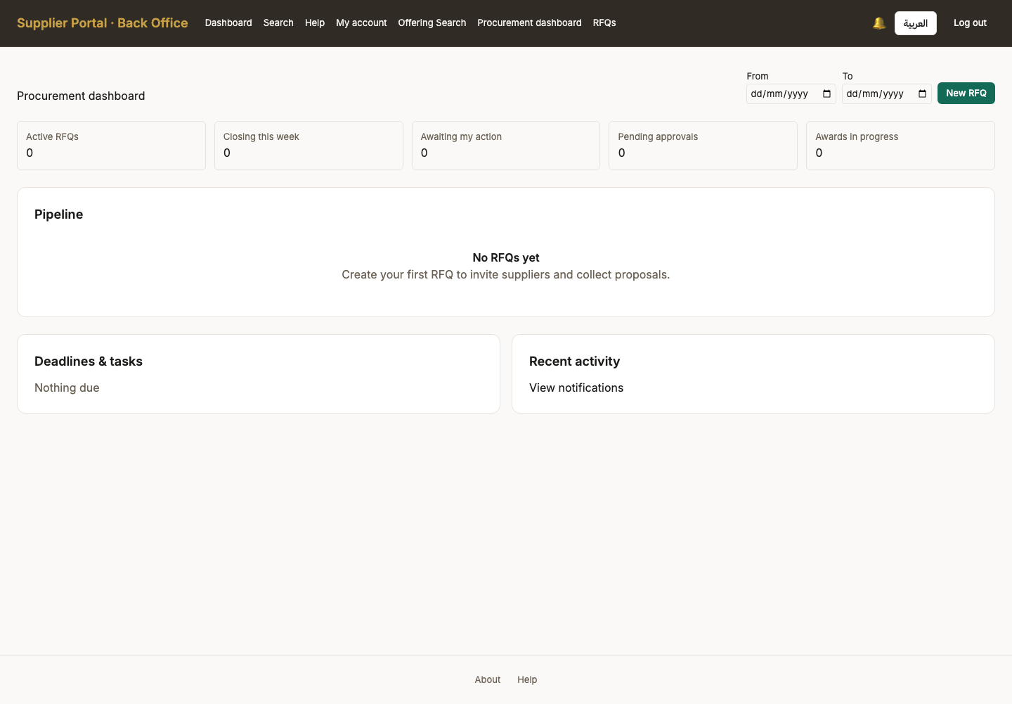

40. Tender list (empty)
Persona procurement_officer
Screen Tender list (empty) (/back-office/rfqs)
What just happened No tenders exist yet: this database started empty and everything in it so far was created through these screens.
What to do next Create the first RFQ.
What to say “No tenders exist. Everything you have seen so far was created through these screens, in this order.”
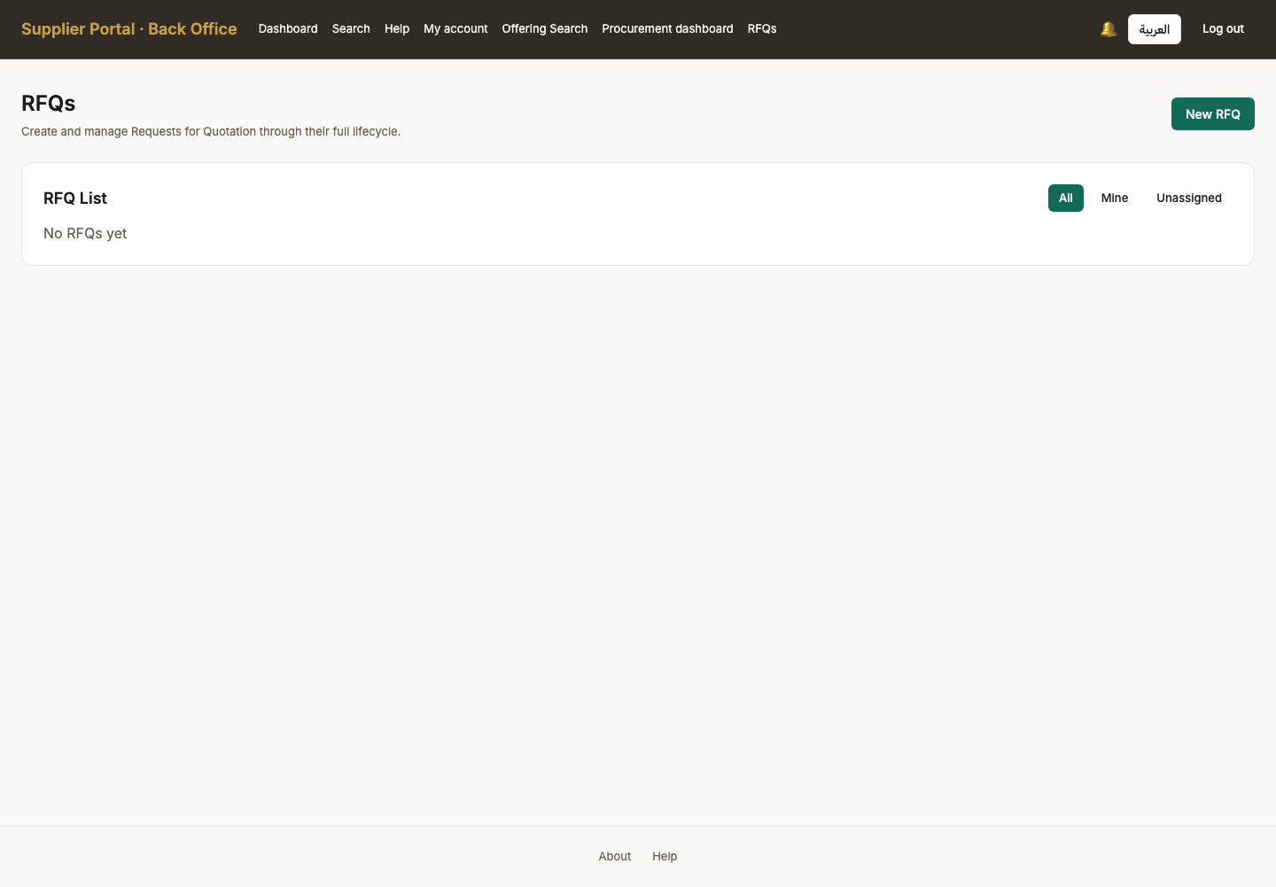

41. Tender created (Draft)
Persona procurement_officer
Screen Tender created (Draft) (/back-office/rfqs)
What just happened The tender exists in Draft, with a reference code allocated by the server. Everything on it is editable while it stays in Draft and nothing is visible to a supplier yet.
What to do next Add the line items being bought, and the requirements bidders must answer.
What to say “The reference code is allocated by the server, not typed. It is the code that appears in every email and every export from here on.”
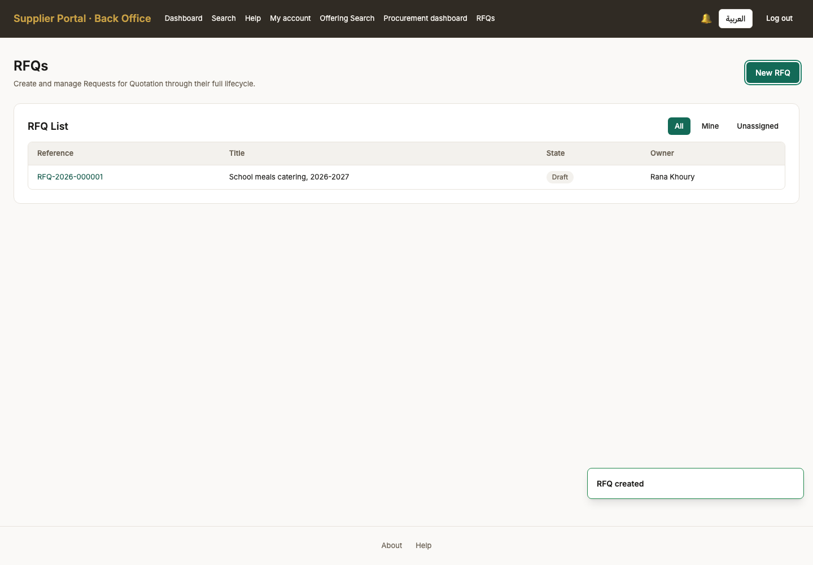

42. Tender detail (Draft)
Persona procurement_officer
Screen Tender detail (Draft) (/back-office/rfqs/RFQ-2026-000001)
What just happened The tender in Draft. Items, requirements, attachments and the evaluation template are all editable here and nowhere else: once it leaves Draft the editing controls disappear rather than failing on use.
What to do next Add the line item being bought.
What to say “In Draft, everything is editable and nobody outside this office can see any of it.”
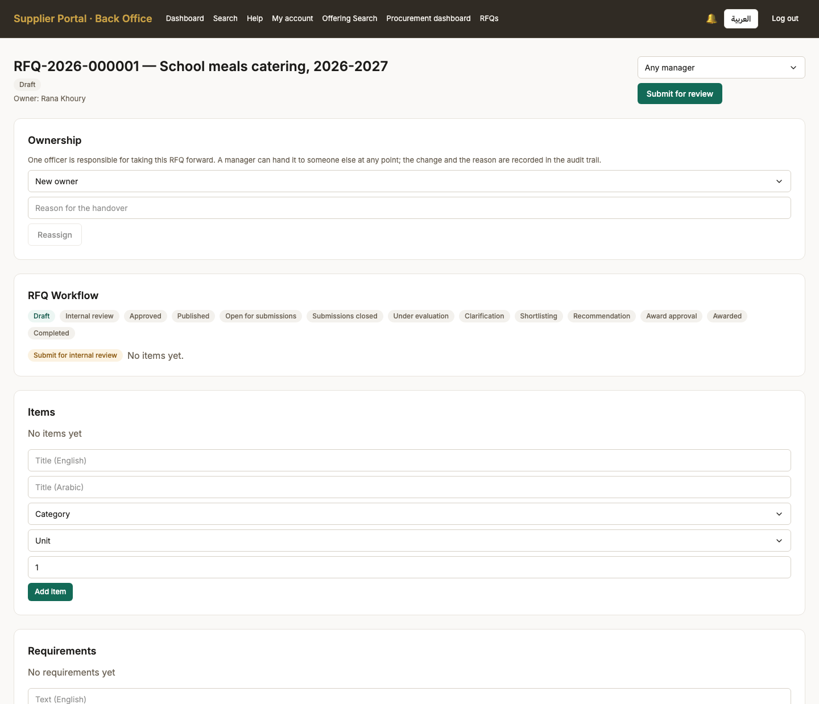
Screen 42, part 1 of 2 — top of the page

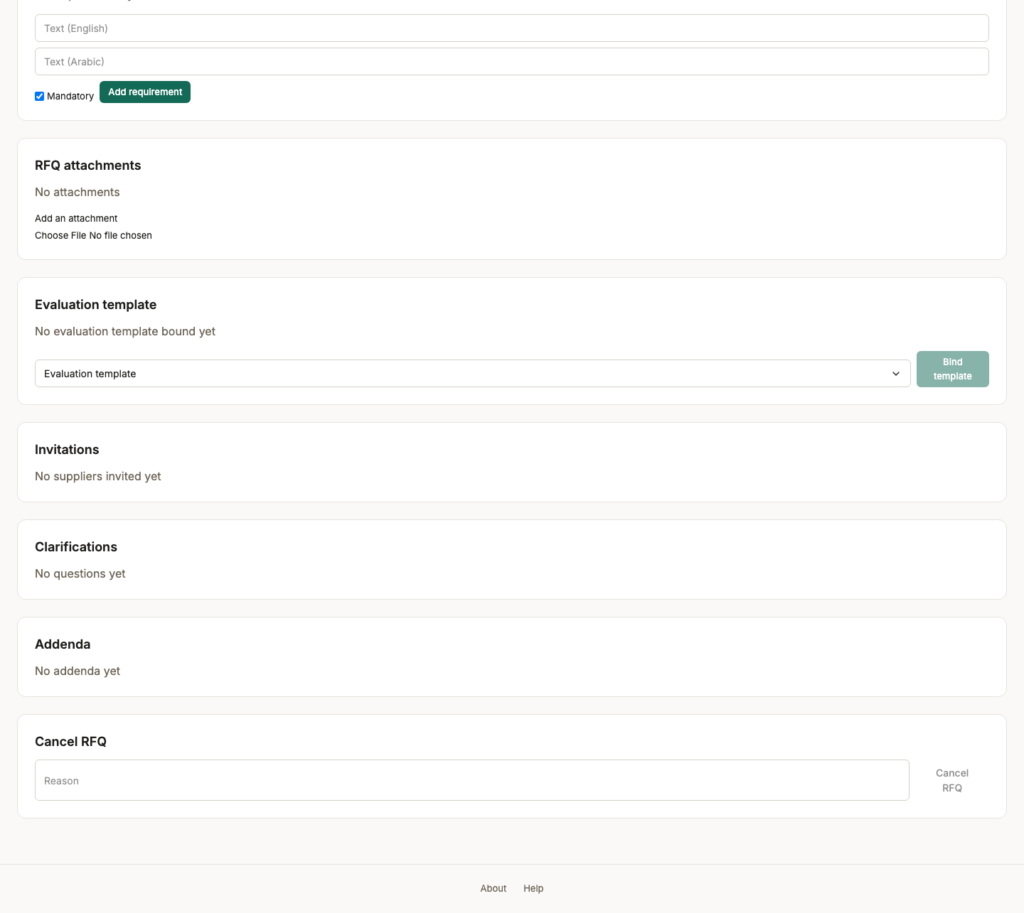
Screen 42, part 2 of 2 — bottom of the page

43. Line item added
Persona procurement_officer
Screen Line item added (/back-office/rfqs/RFQ-2026-000001)
What just happened One line, priced per pupil per day, with a quantity for the school year. A bid is priced against these lines, so the comparison matrix later compares like with like.
What to do next Add a requirement bidders must answer in words.
What to say “One line, priced per pupil per day, with a quantity for the school year. Bids are priced against these lines.”
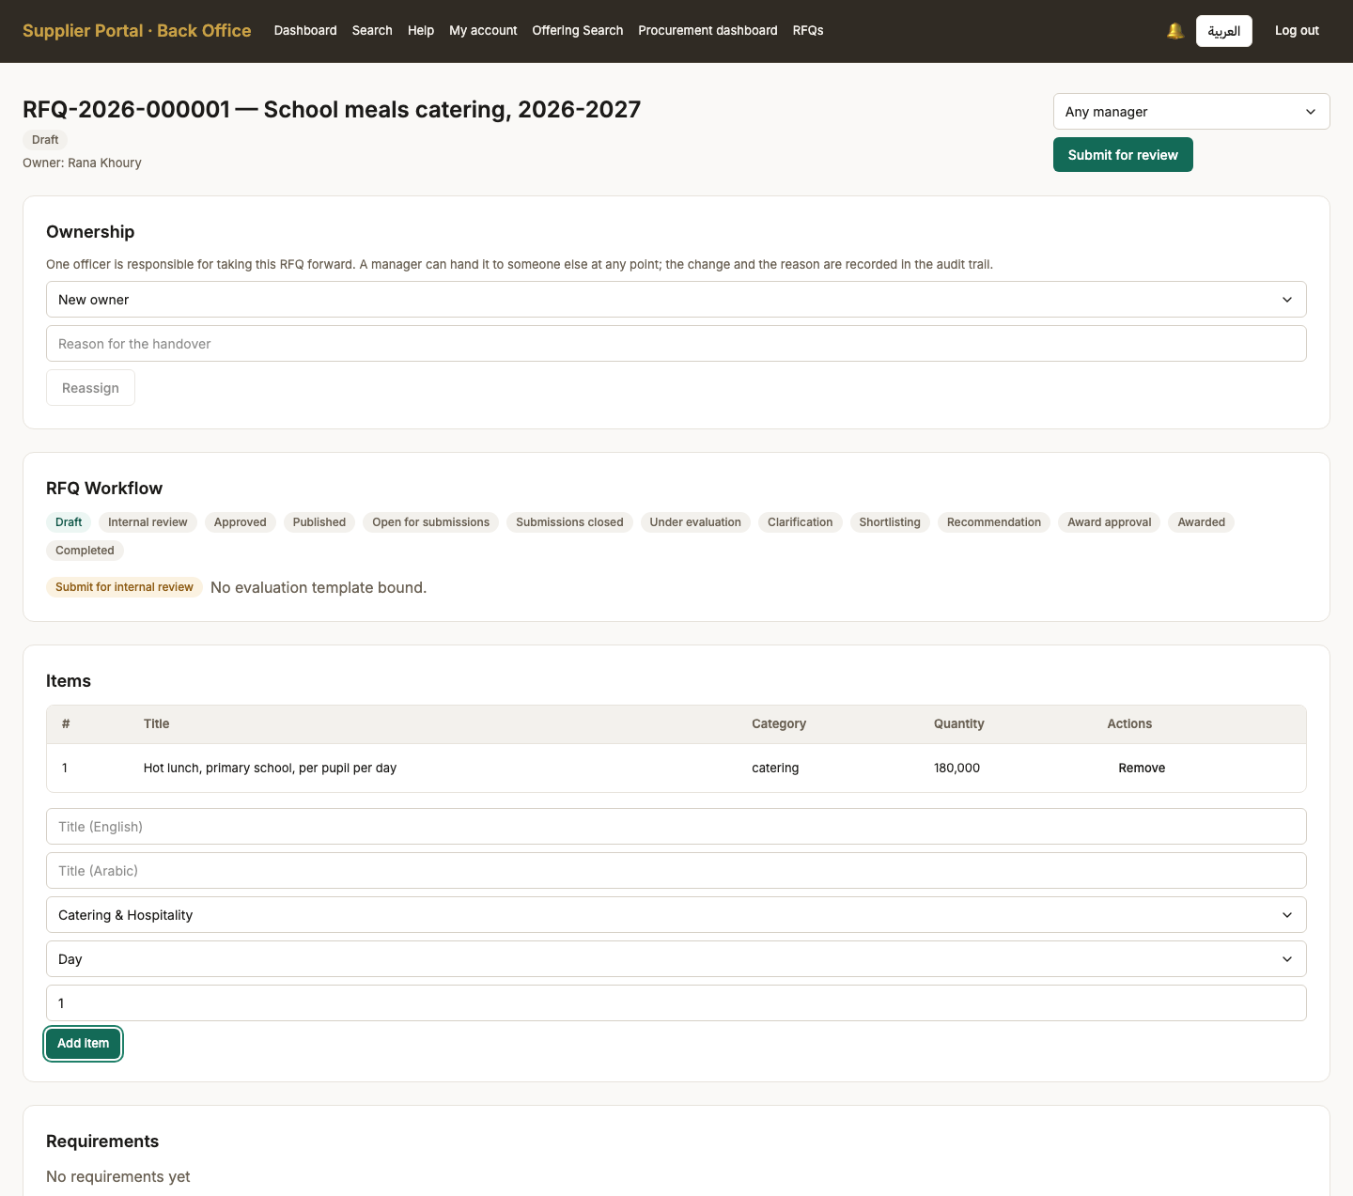
Screen 43, part 1 of 2 — top of the page

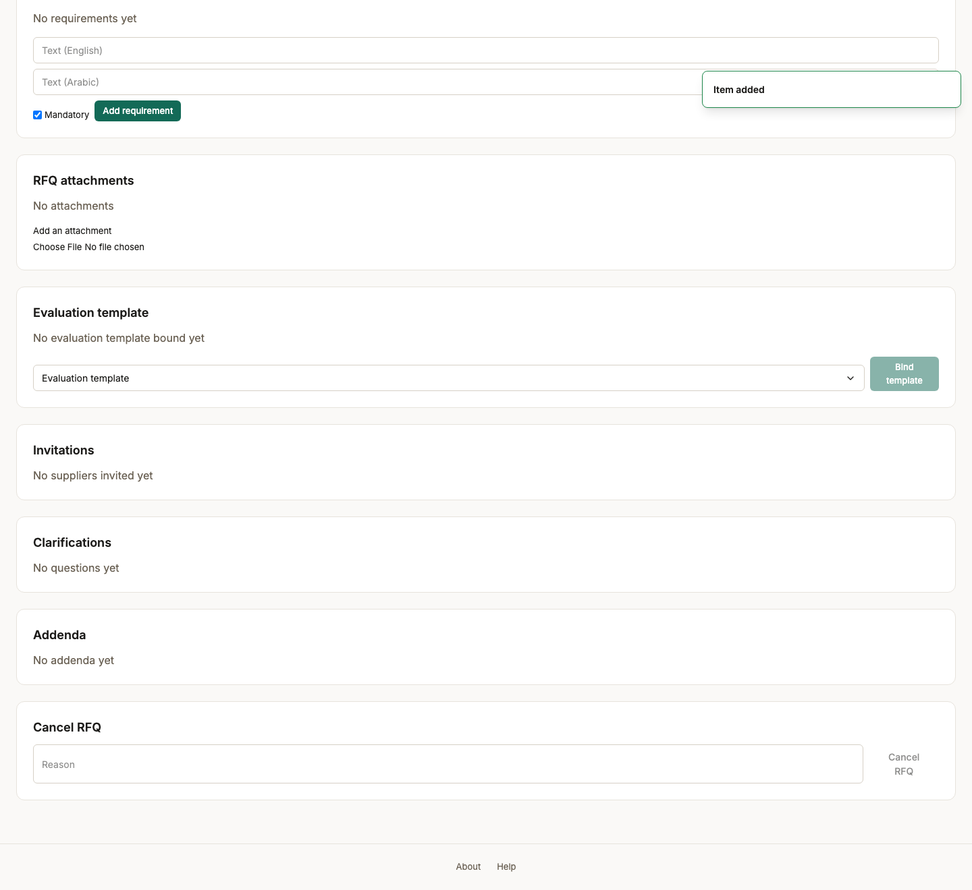
Screen 43, part 2 of 2 — bottom of the page

44. Requirement added
Persona procurement_officer
Screen Requirement added (/back-office/rfqs/RFQ-2026-000001)
What just happened A requirement is answered in prose and scored by an evaluator, which is what separates it from a line item. The two halves of a bid — the technical answer and the price — are sealed from each other until consolidation.
What to do next Attach the tender documents suppliers need to read.
What to say “A requirement is answered in prose and scored by an evaluator — that is what makes it different from a line item.”
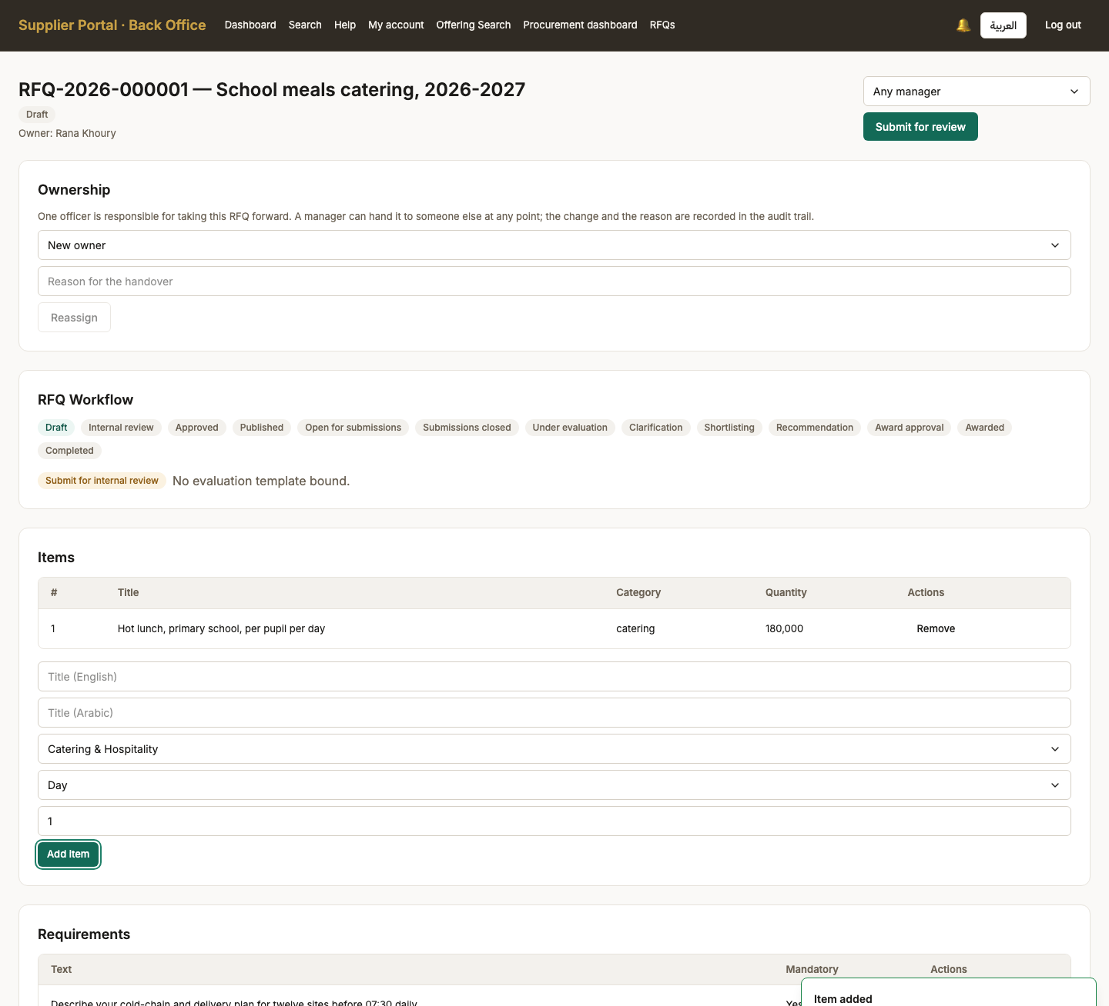
Screen 44, part 1 of 2 — top of the page

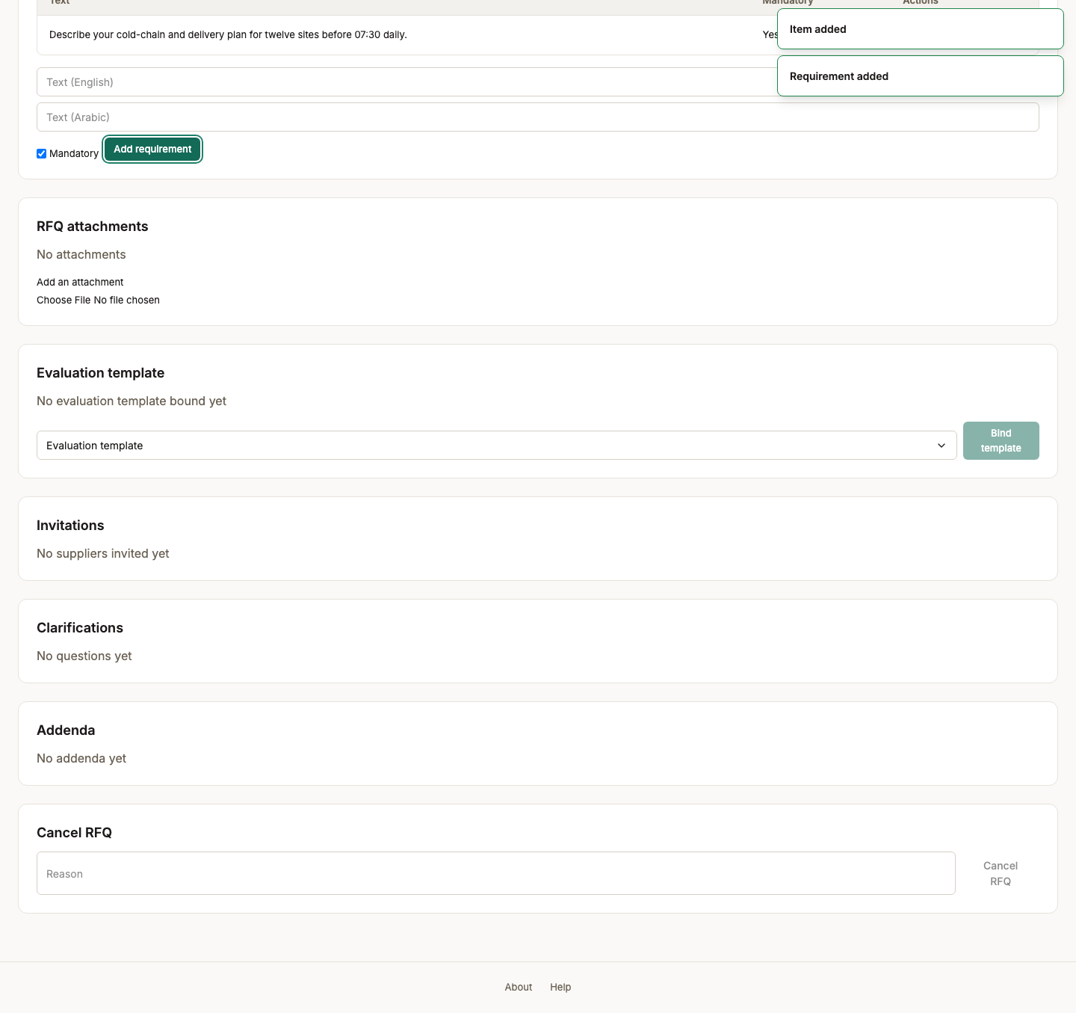
Screen 44, part 2 of 2 — bottom of the page

45. Tender document attached
Persona procurement_officer
Screen Tender document attached (/back-office/rfqs/RFQ-2026-000001)
What just happened The specification suppliers will bid against. It is scanned on upload like every other file here, and it becomes readable to a supplier only once the tender is published to them.
What to do next Submit the tender for internal review.
What to say “The specification suppliers will bid against. Scanned on upload like every other file, and it becomes part of the published tender.”
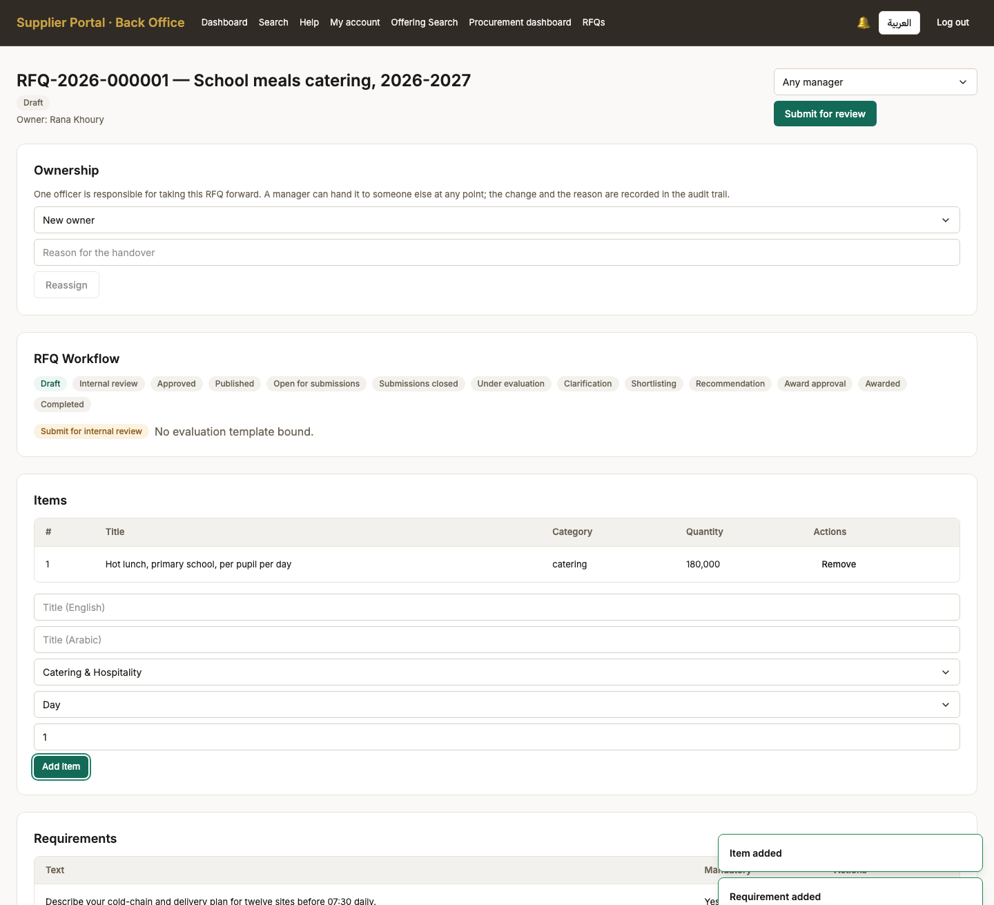
Screen 45, part 1 of 2 — top of the page

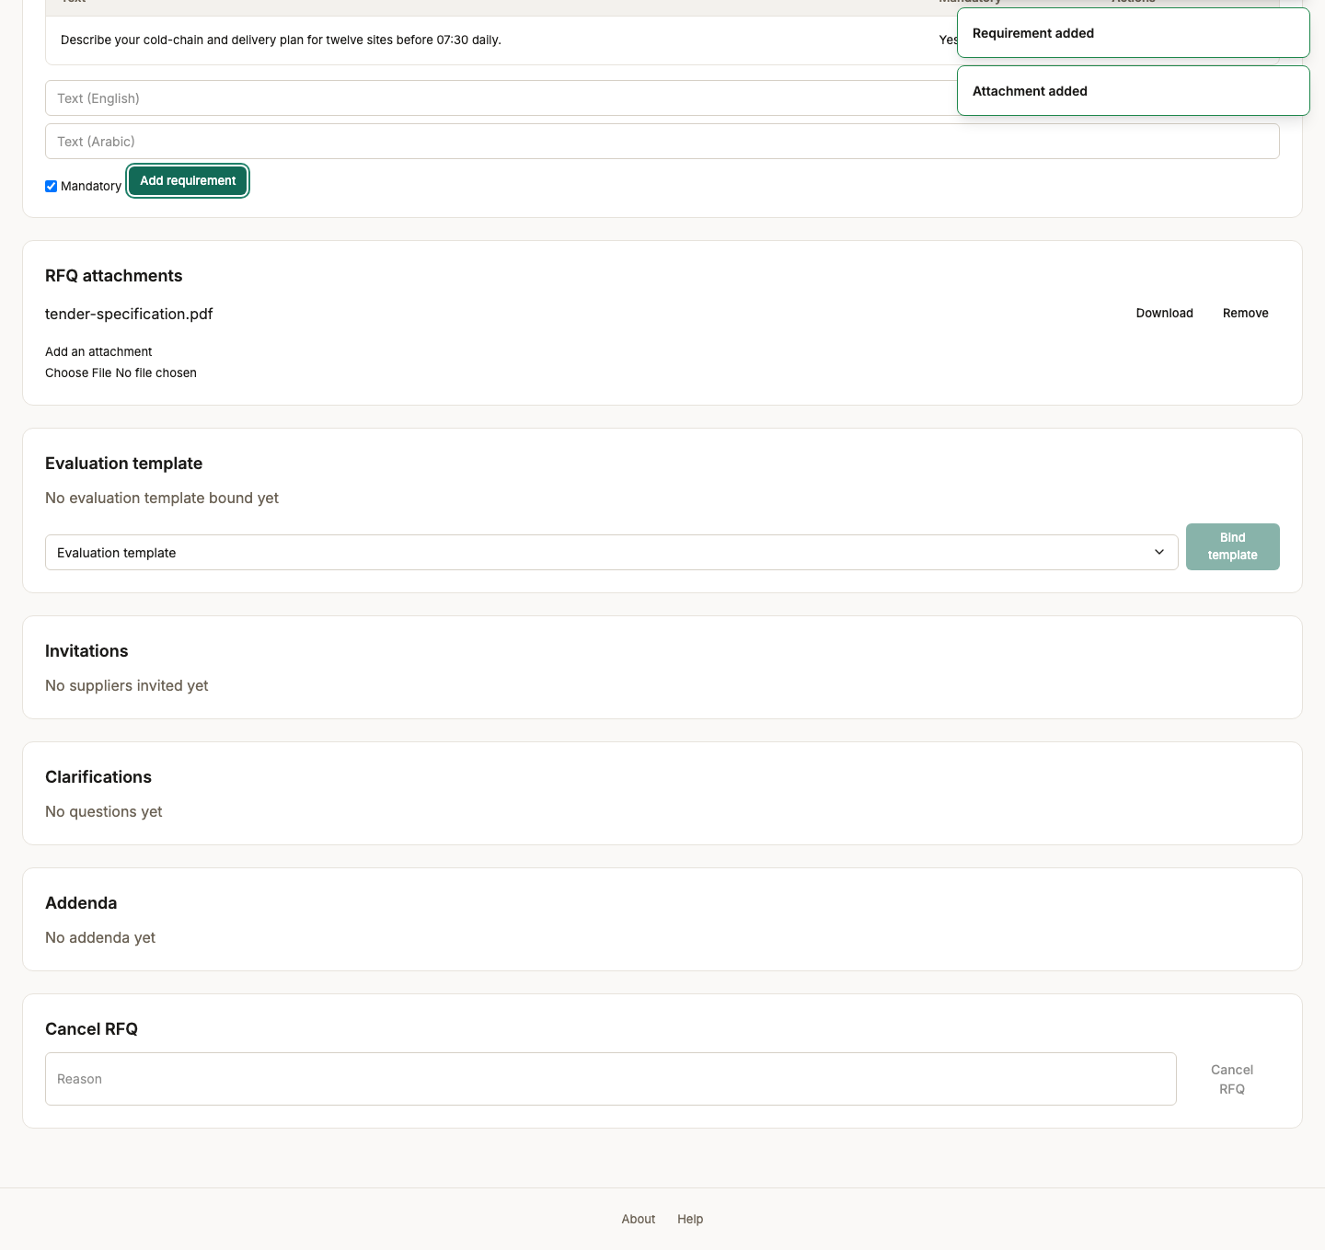
Screen 45, part 2 of 2 — bottom of the page

46. Evaluation template bound
Persona procurement_officer
Screen Evaluation template bound (/back-office/rfqs/RFQ-2026-000001)
What just happened The tender now carries the criteria it will be judged by, frozen at the version bound. Bidders can see what they are being scored on before they bid, which is the point of binding it this early.
What to do next Submit the tender for internal review.
What to say “The tender now carries the criteria it will be judged by. Bidders can see them, which is deliberate — nobody is scored against a rule they were not told.”
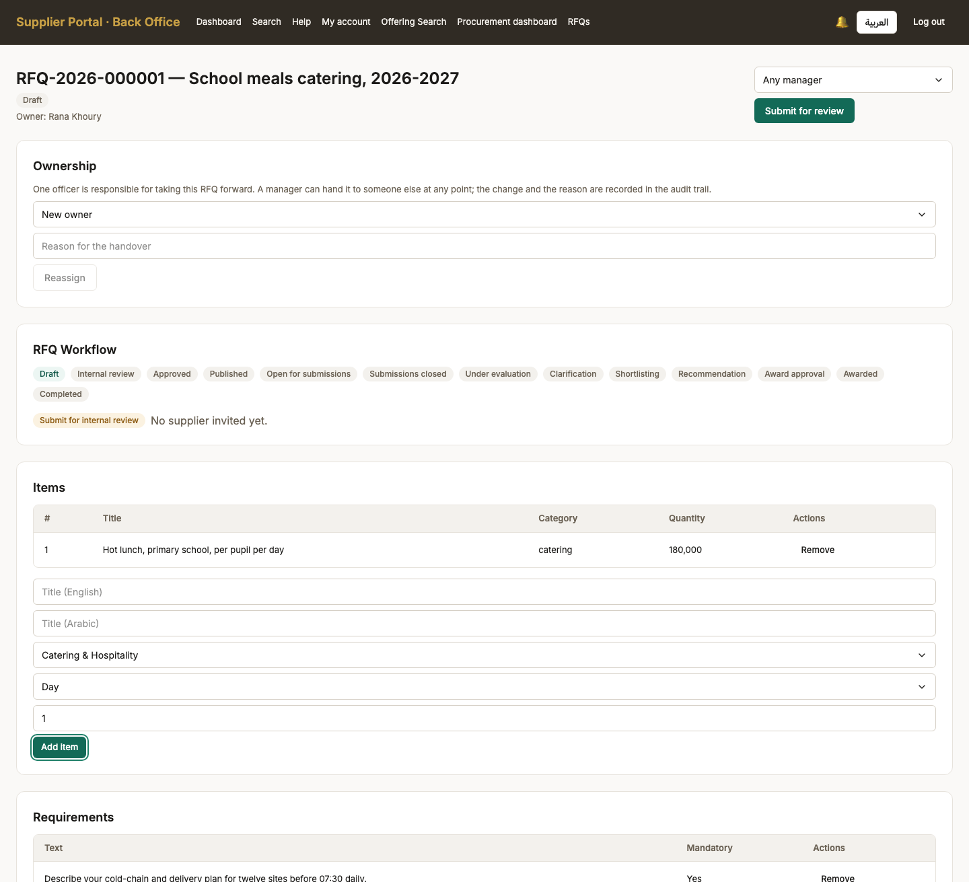
Screen 46, part 1 of 2 — top of the page

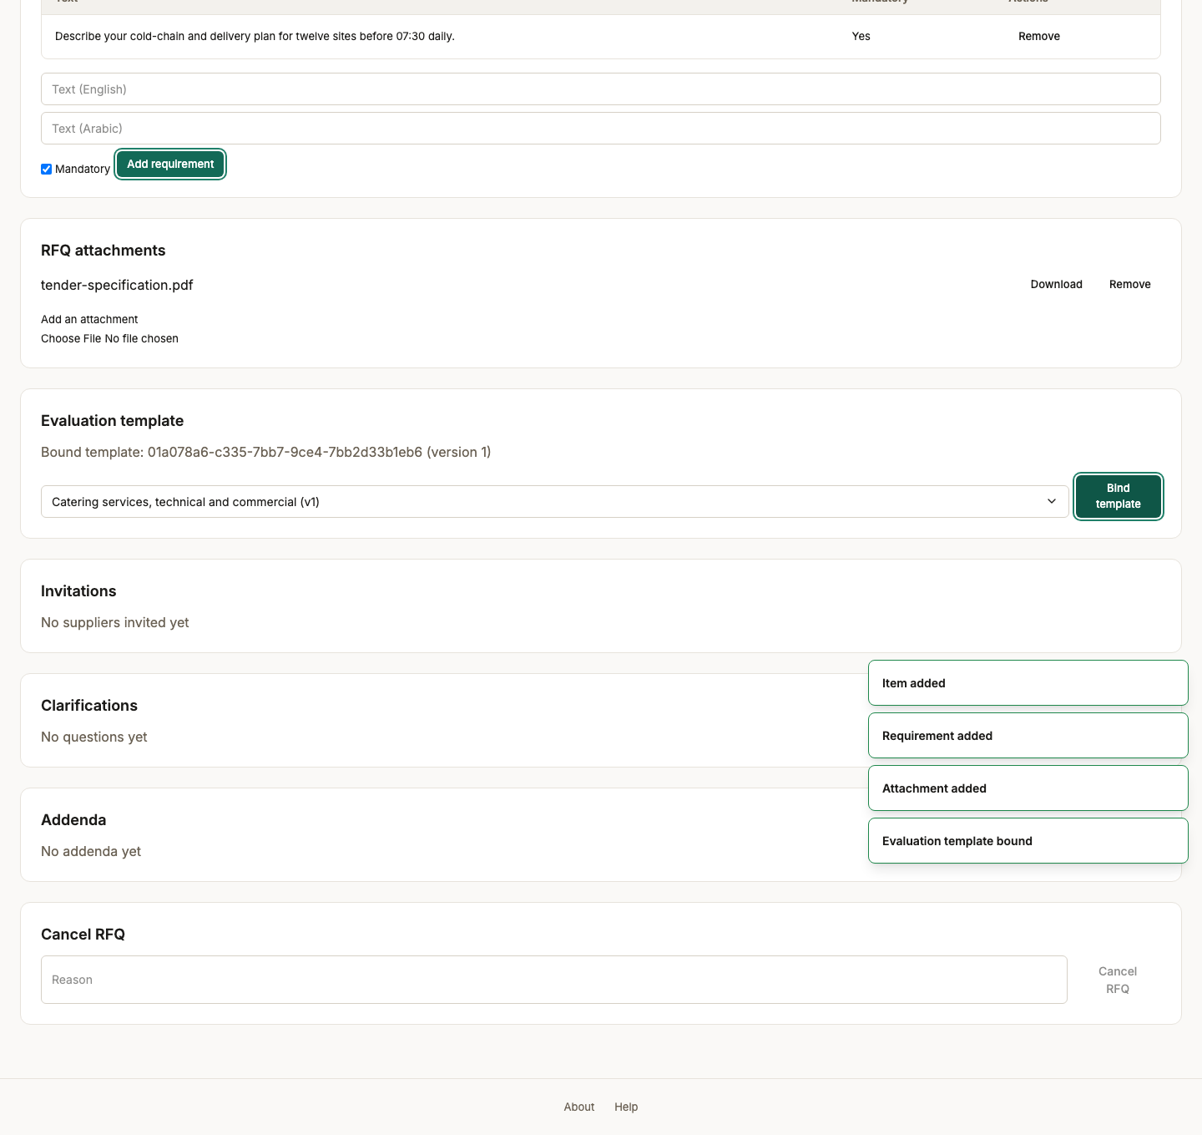
Screen 46, part 2 of 2 — bottom of the page

47. Supplier invited
Persona procurement_officer
Screen Supplier invited (/back-office/rfqs/RFQ-2026-000001)
What just happened Invited by name from the approved list — a tender cannot be sent to a company that has not been through onboarding. The invitation is also a precondition of review: an approver is shown who the tender is going to.
What to do next Submit the tender for internal review.
What to say “Invited by name from the approved list. A tender cannot be sent to a company that has not been through onboarding.”
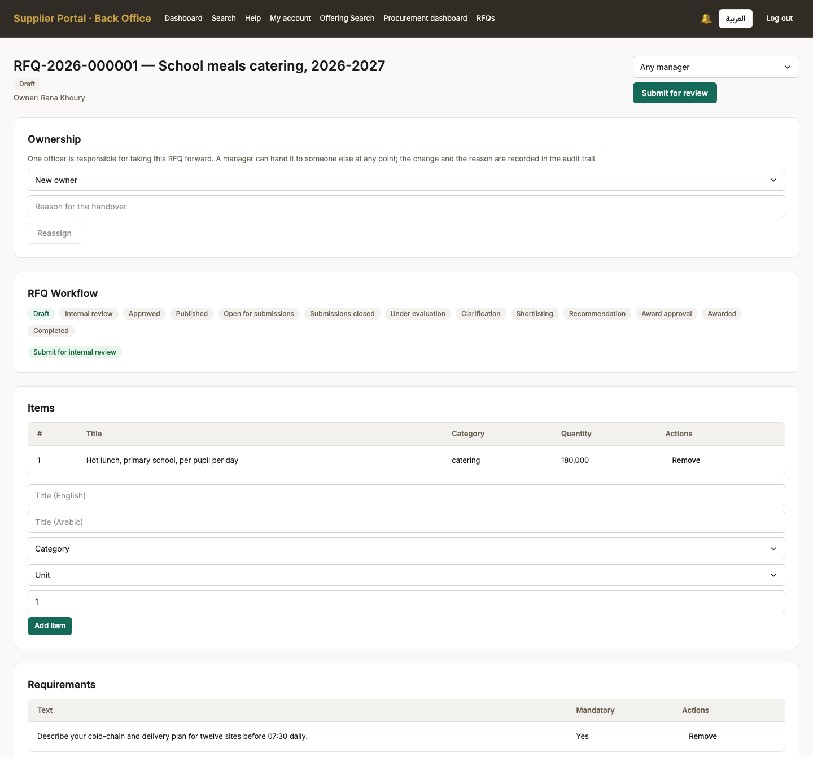
Screen 47, part 1 of 2 — top of the page

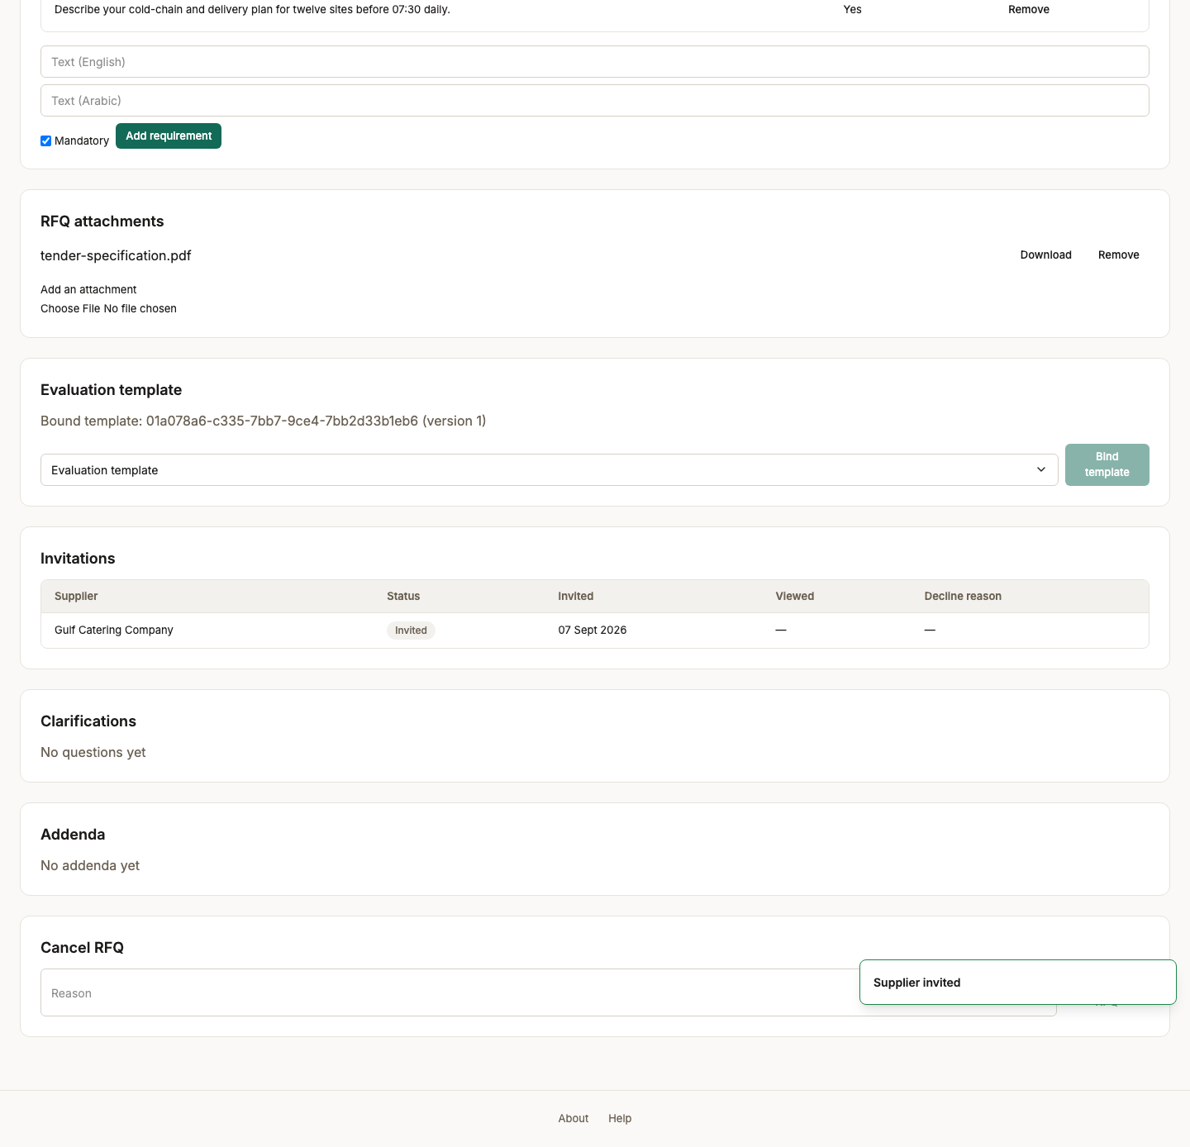
Screen 47, part 2 of 2 — bottom of the page

48. Submitted for internal review
Persona procurement_officer
Screen Submitted for internal review (/back-office/rfqs/RFQ-2026-000001)
What just happened The tender moves to InternalReview and the officer can no longer edit it. Authorship and approval are separated deliberately: the person who wrote the tender is not the person who lets it out.
What to do next Sign in as the procurement manager to approve it.
What to say “Submitted for review, and the officer can no longer edit it. Authorship and approval are separate jobs.”
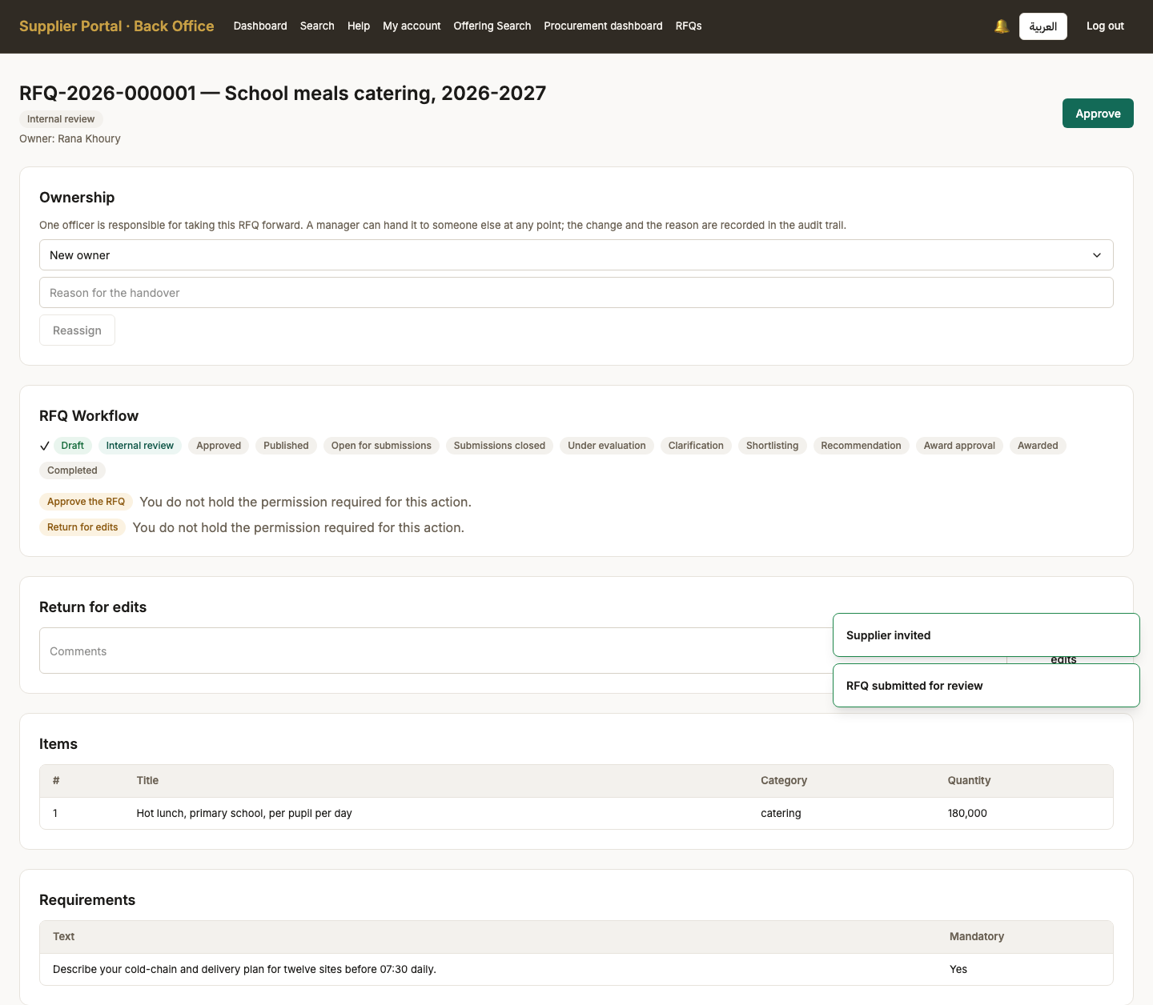
Screen 48, part 1 of 2 — top of the page

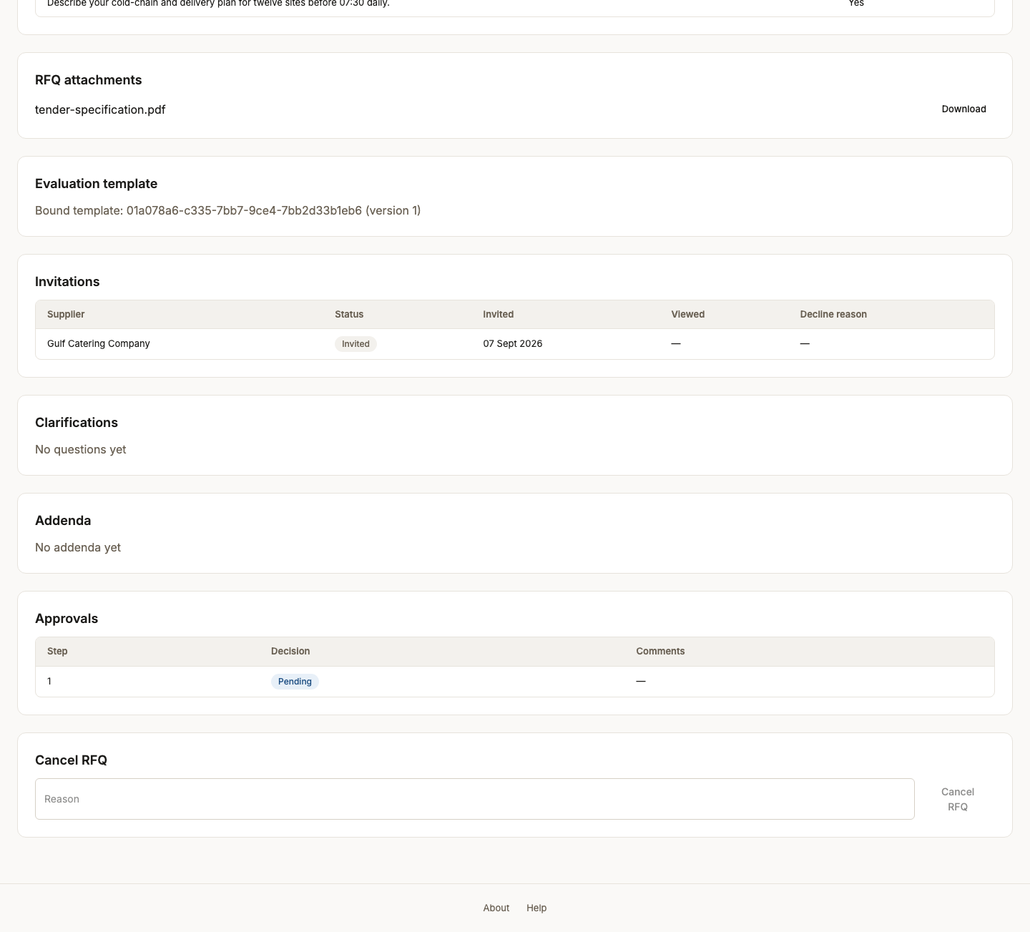
Screen 48, part 2 of 2 — bottom of the page

Act 10 — Approval, publication, and a window that opens itself
Authorship and approval are separate jobs, and approval and publication are separate steps. The submission window then opens on a schedule rather than when somebody presses something.

49. Tender awaiting approval
Persona procurement_manager
Screen Tender awaiting approval (/back-office/rfqs/RFQ-2026-000001)
What just happened The manager sees the same tender with a different set of controls: approve or return for edits, and no way to alter its contents. Reviewing something you can silently change is not a review.
What to do next Approve it.
What to say “The manager sees the same tender with different controls: approve, or send back for edits.”
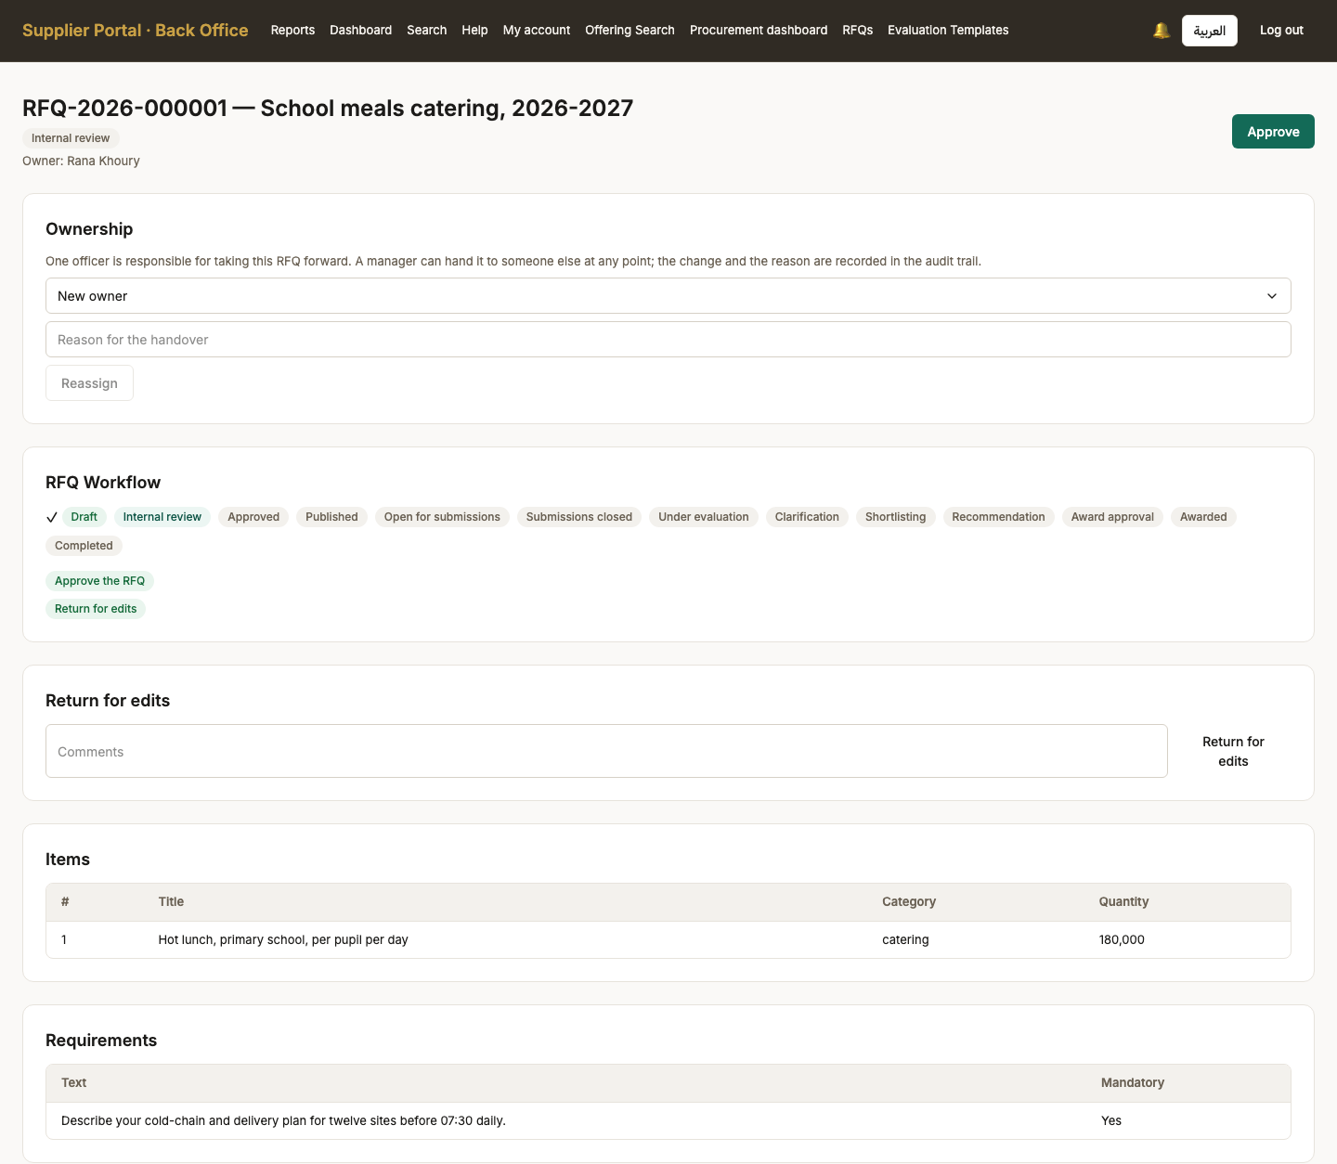
Screen 49, part 1 of 2 — top of the page

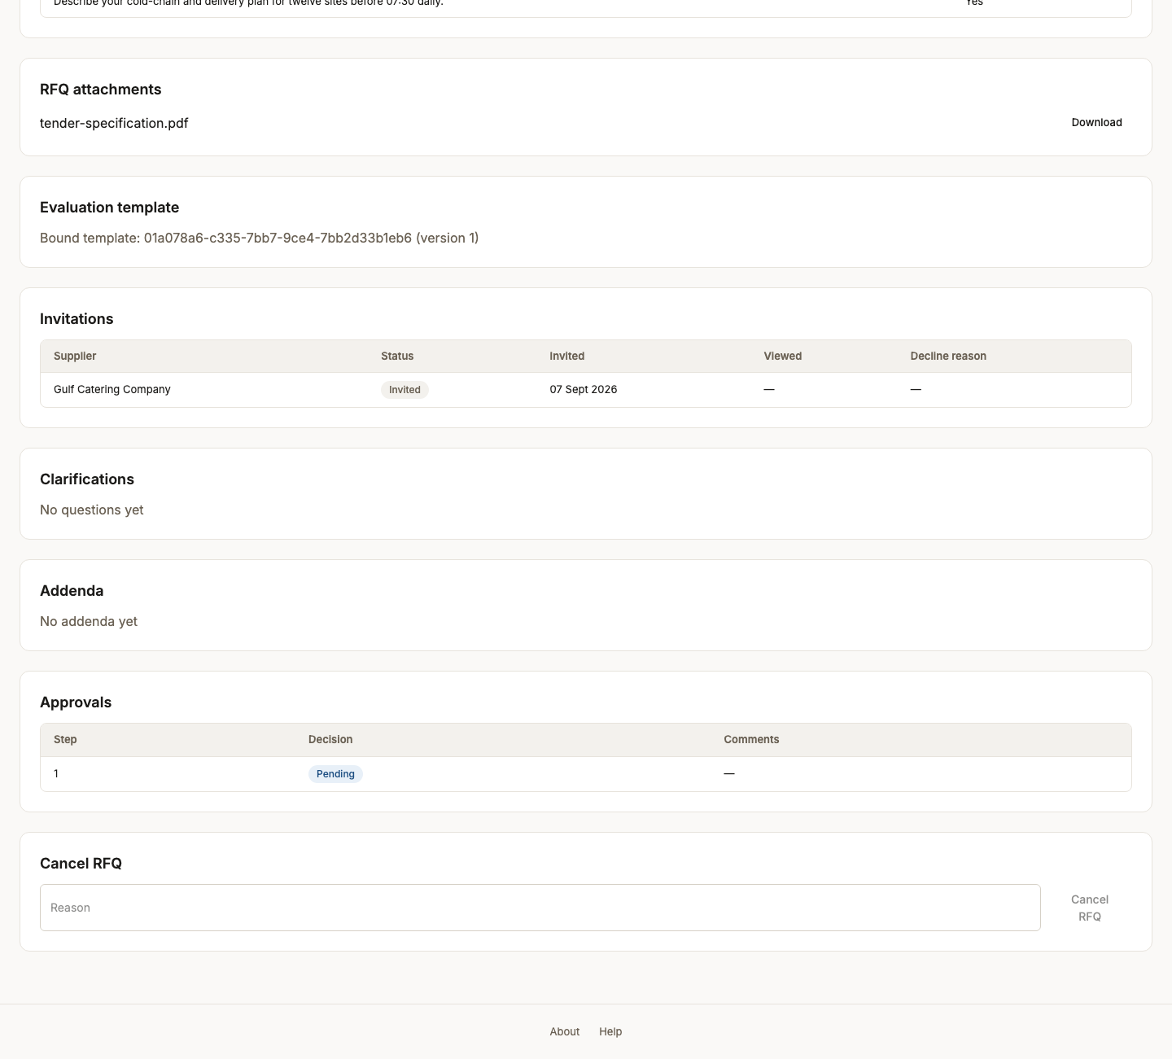
Screen 49, part 2 of 2 — bottom of the page

50. Tender approved
Persona procurement_manager
Screen Tender approved (/back-office/rfqs/RFQ-2026-000001)
What just happened Approved. It is not yet visible to any supplier: approval and publication are separate steps, so a tender can be signed off and released on a chosen date.
What to do next Hand back to the officer to publish and invite.
What to say “Approved — but not yet visible to any supplier. Approval and publication are two steps on purpose.”
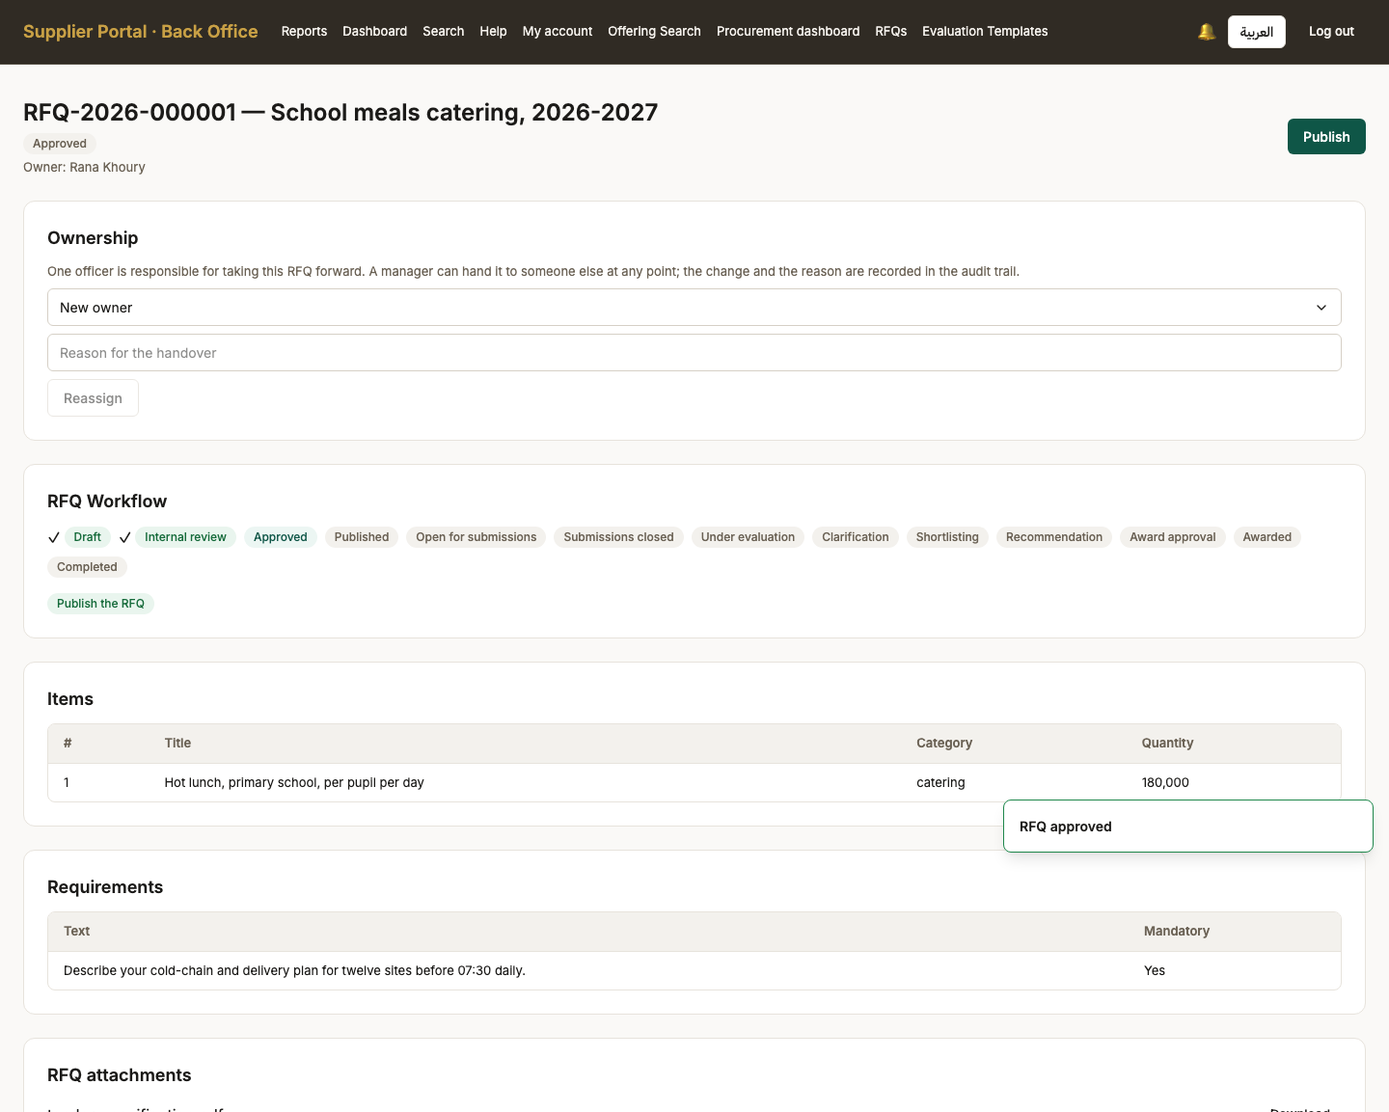
Screen 50, part 1 of 2 — top of the page

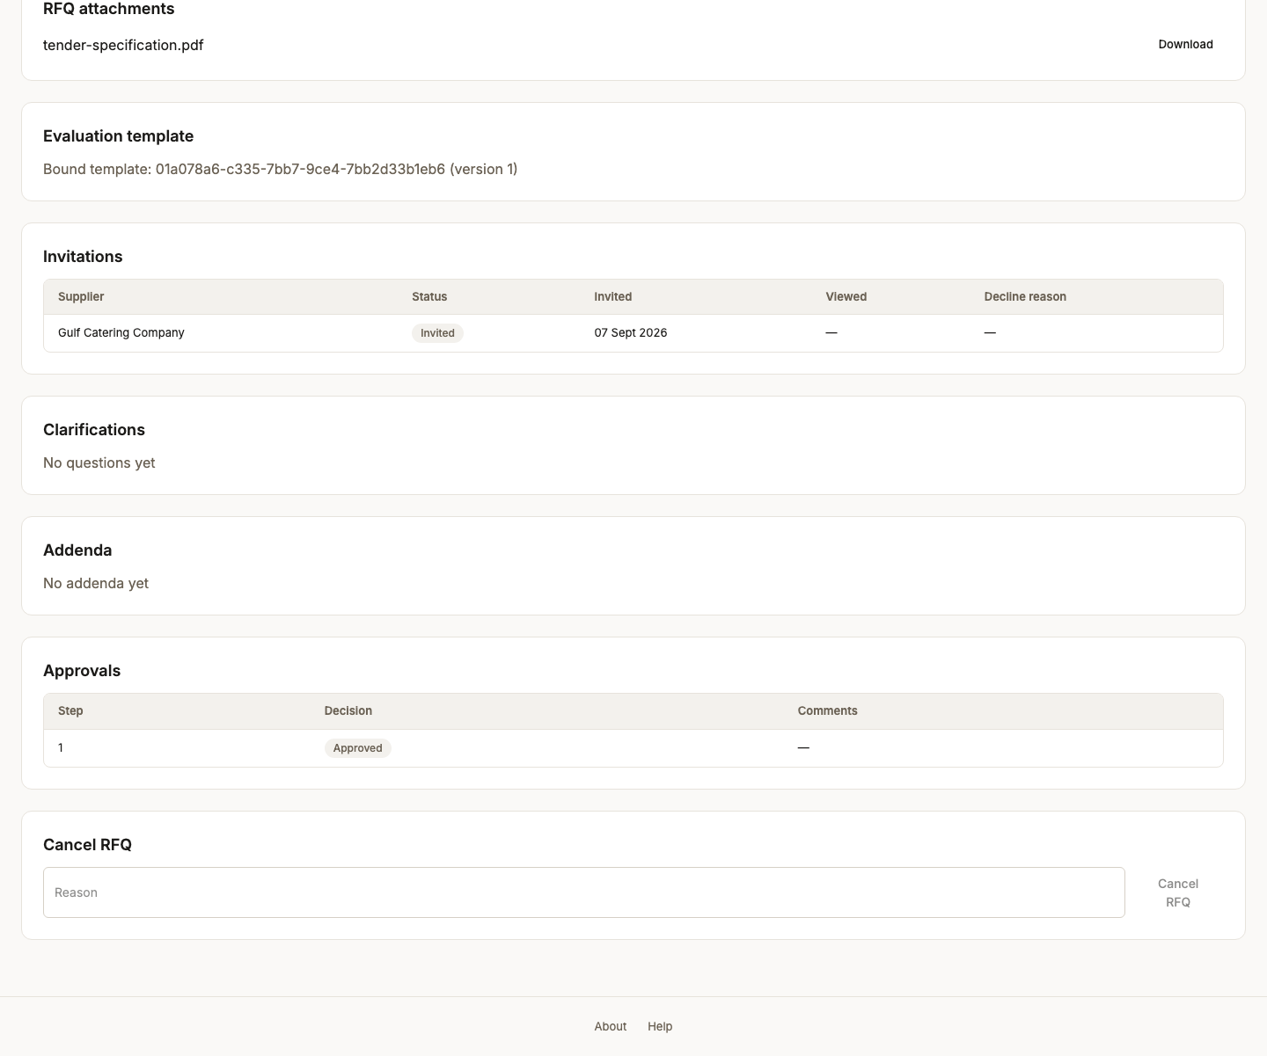
Screen 50, part 2 of 2 — bottom of the page

51. Tender published
Persona procurement_officer
Screen Tender published (/back-office/rfqs/RFQ-2026-000001)
What just happened Published. The submission window opens on its own when the start time passes - a scheduled job moves it, not a person - so the tender becomes biddable without anyone having to be at a desk.
What to do next Wait for the window to open, then bid as the supplier.
What to say “Published. The submission window opens on its own when the start time passes; a scheduled job moves it, not a person.”
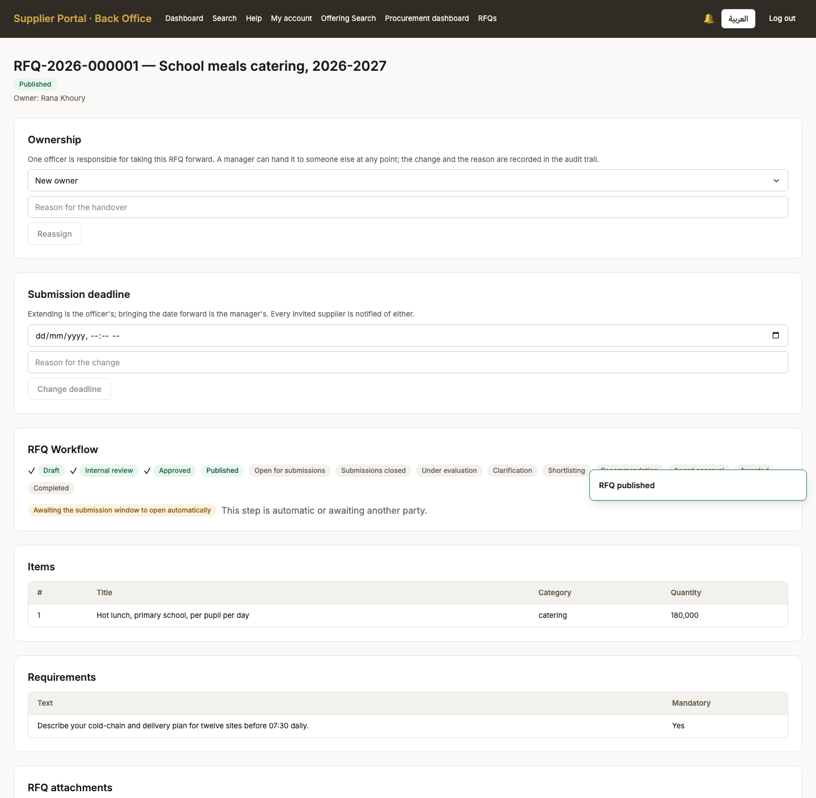
Screen 51, part 1 of 2 — top of the page

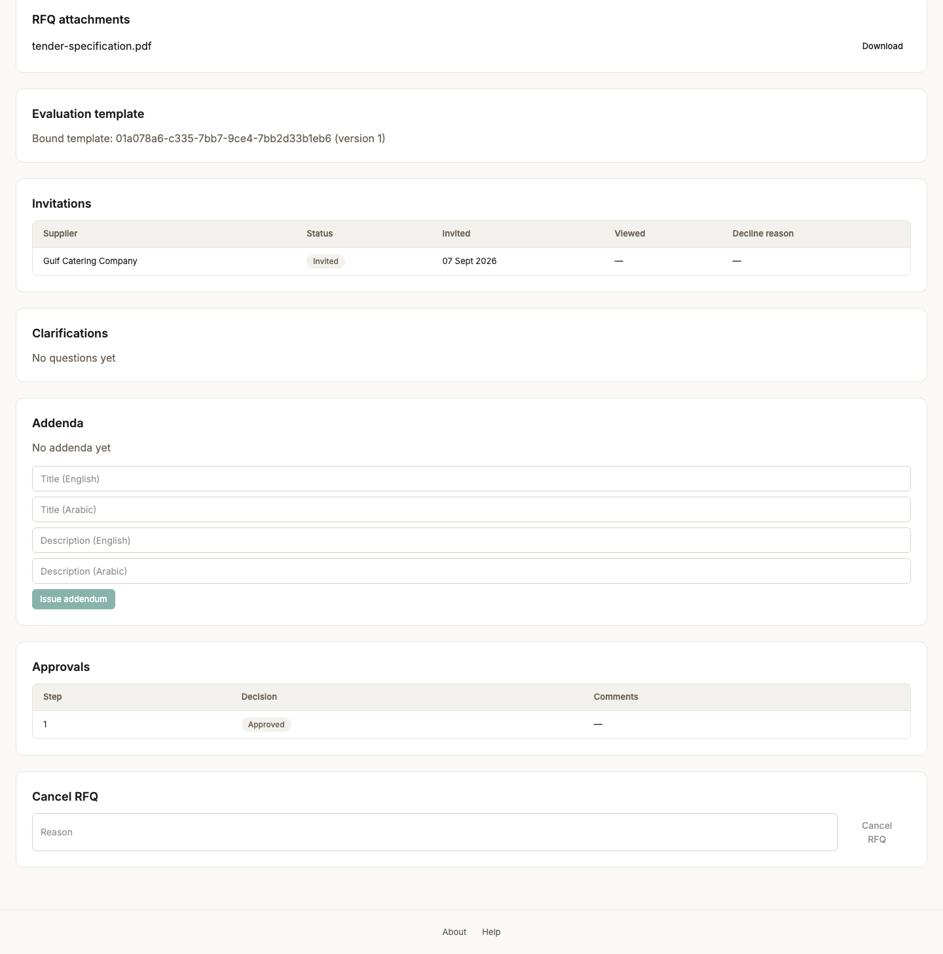
Screen 51, part 2 of 2 — bottom of the page

52. Submission window open
Persona procurement_officer
Screen Submission window open (/back-office/rfqs)
What just happened The window opened on its own. A scheduled job moves the tender from Approved to SubmissionOpen when the start time passes - nobody has to be at a desk for bidding to begin.
What to do next Sign in as the invited supplier.
What to say “There it is — the job ran and the window is open. That is the system's clock, not ours.”
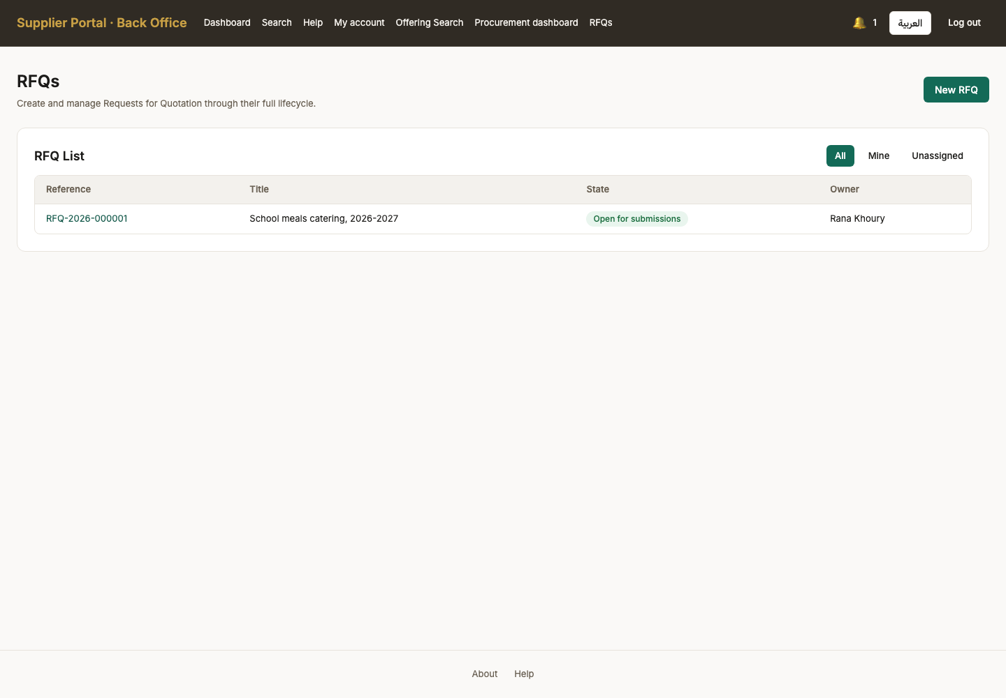

Act 11 — A question, and an answer everybody gets
The fairness mechanism of the whole tender: one supplier asks, and every invited supplier receives the answer at the same moment, with the asker anonymised.

53. Invited tenders
Persona supplier_admin
Screen Invited tenders (/rfqs)
What just happened The supplier sees the tender because they were invited to it. This list is scoped to invitations: a supplier cannot browse tenders they were not asked to bid on.
What to do next Open it and read what is being bought.
What to say “Back to the supplier. They see this tender because they were invited to it; an uninvited company sees nothing at all.”
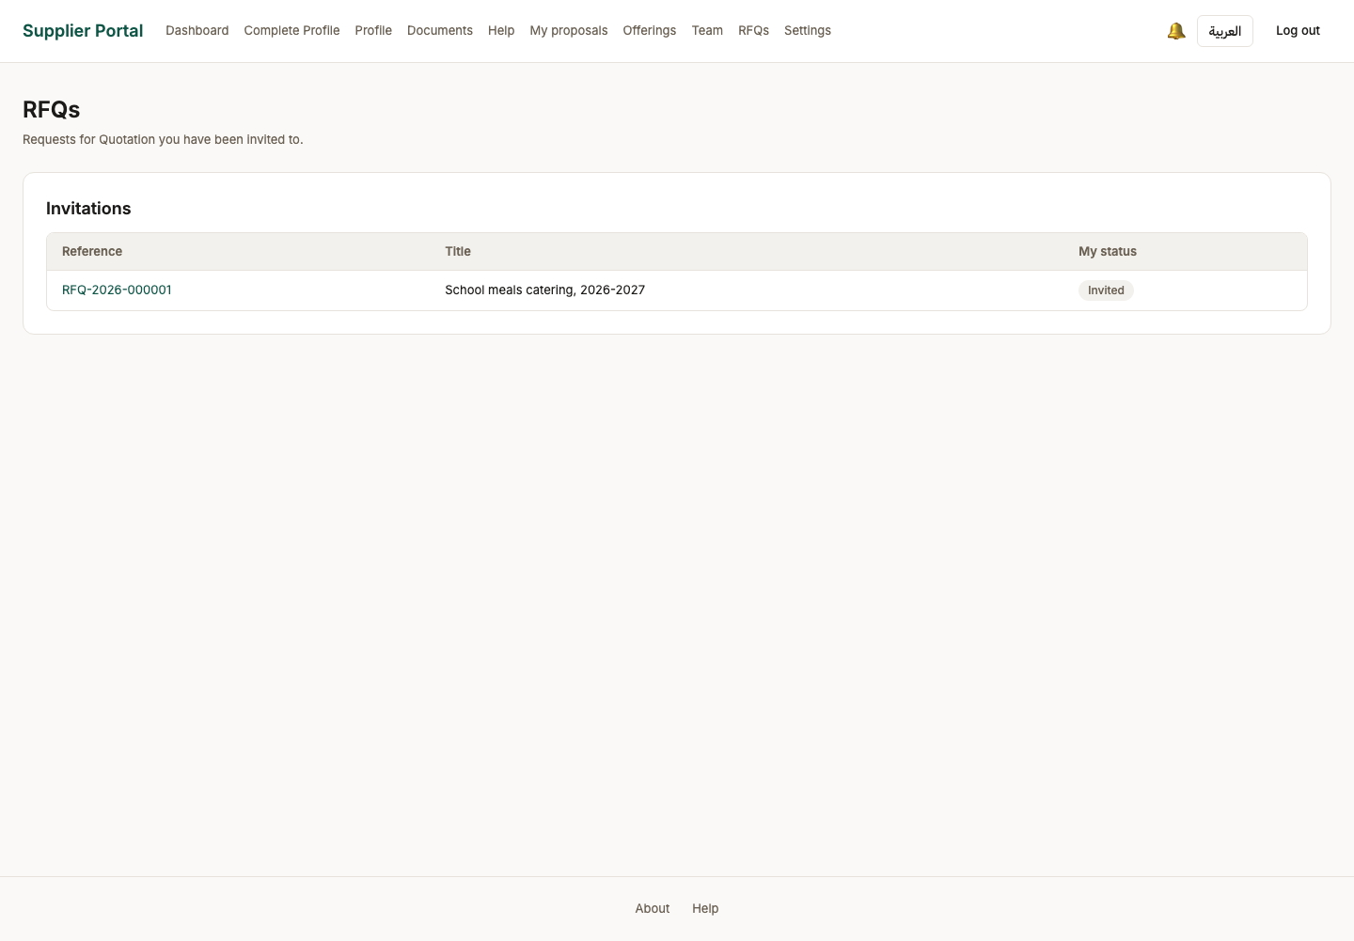

54. Tender as the supplier sees it
Persona supplier_admin
Screen Tender as the supplier sees it (/rfqs/RFQ-2026-000001)
What just happened The same tender from the other side: the line items, the requirements to answer, the deadline, and the attached specification to download. The evaluation criteria are visible too, so a bidder knows what they are being scored on before they bid.
What to do next Ask a clarification question.
What to say “The same tender from the other side: the lines to price, the requirements to answer, the deadline, and the specification to download.”
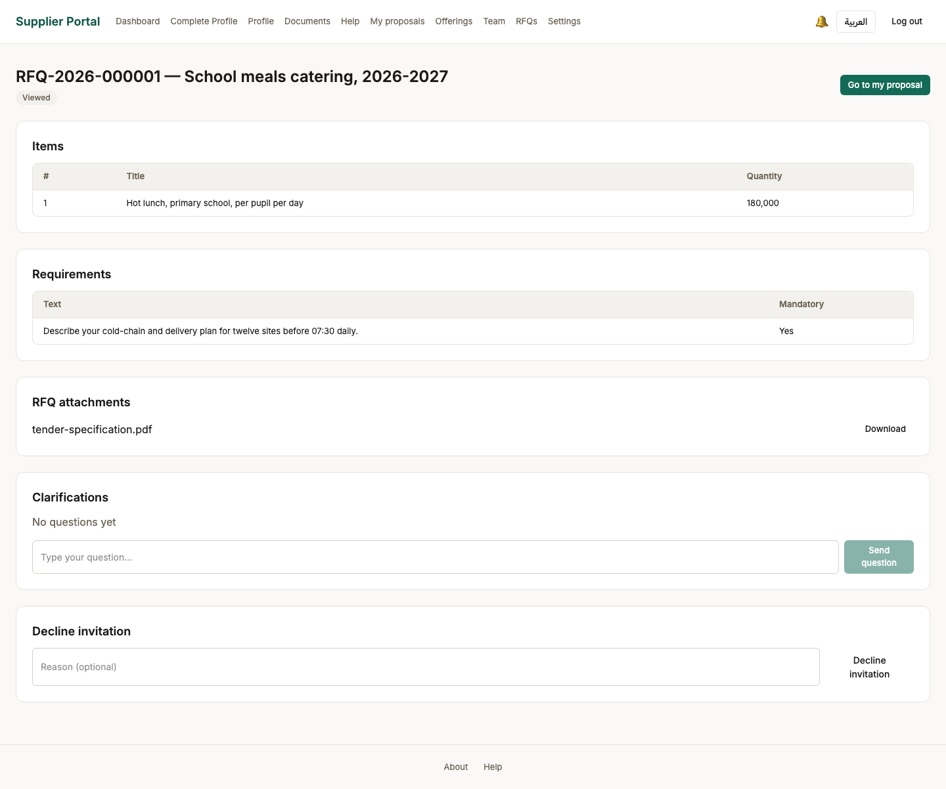

55. Question sent
Persona supplier_admin
Screen Question sent (/rfqs/RFQ-2026-000001)
What just happened The question is recorded against the tender and waits for the buyer. The supplier cannot see other bidders' questions until an answer is published to everyone.
What to do next The officer answers it.
What to say “A question, recorded against the tender. The supplier cannot see other bidders' questions until an answer is published.”
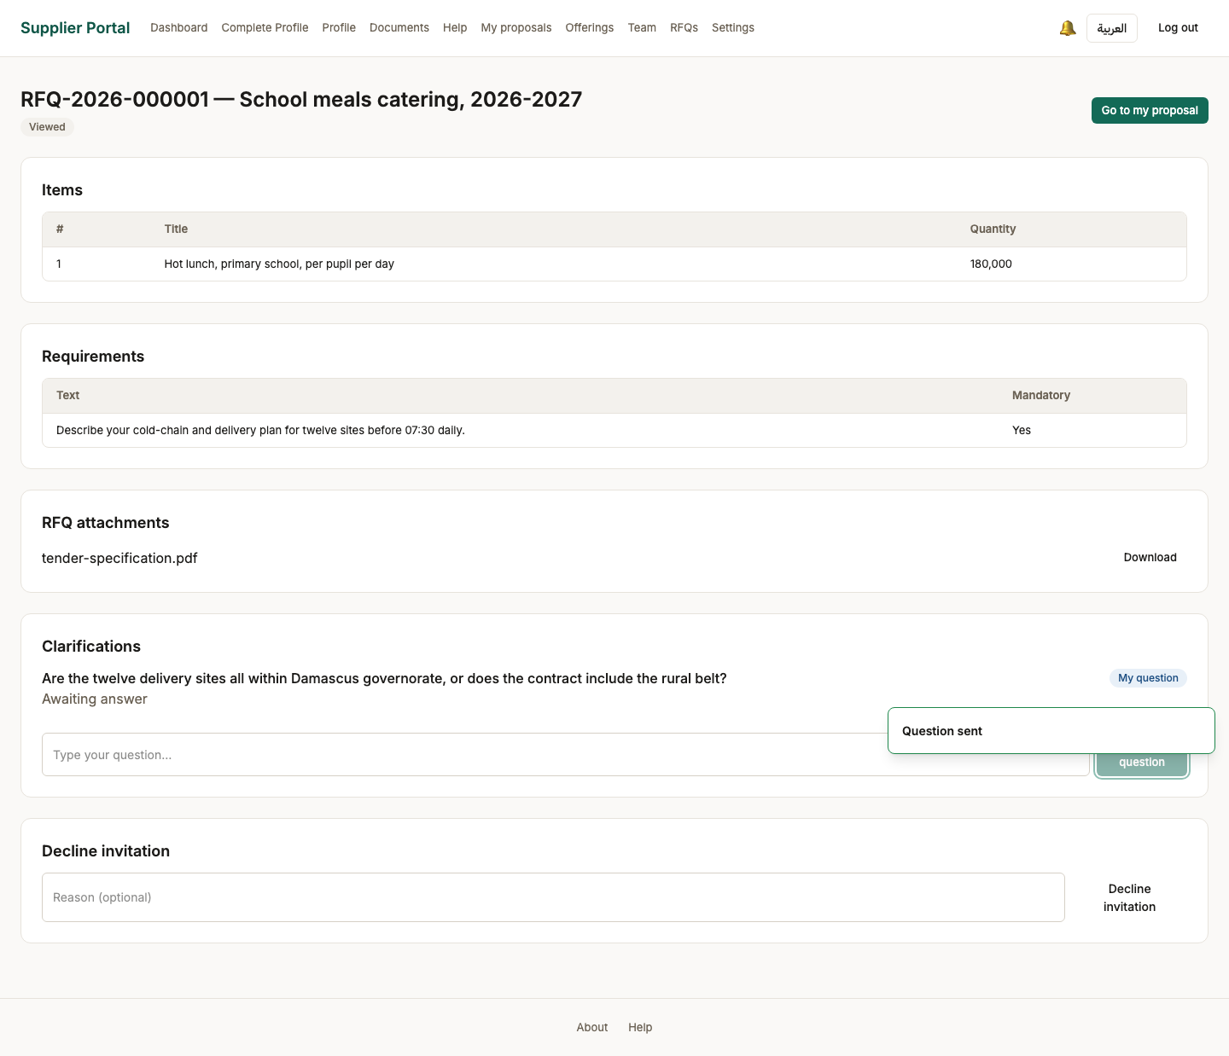

56. Clarification waiting
Persona procurement_officer
Screen Clarification waiting (/back-office/rfqs/RFQ-2026-000001)
What just happened The buyer sees the question. Who asked it is deliberately not the point: an answer goes to every invited supplier, so a question cannot be used to work out who else is bidding.
What to do next Write an answer and publish it to all invitees.
What to say “The buyer sees the question. Who asked it is deliberately not shown — and here is why that matters.”
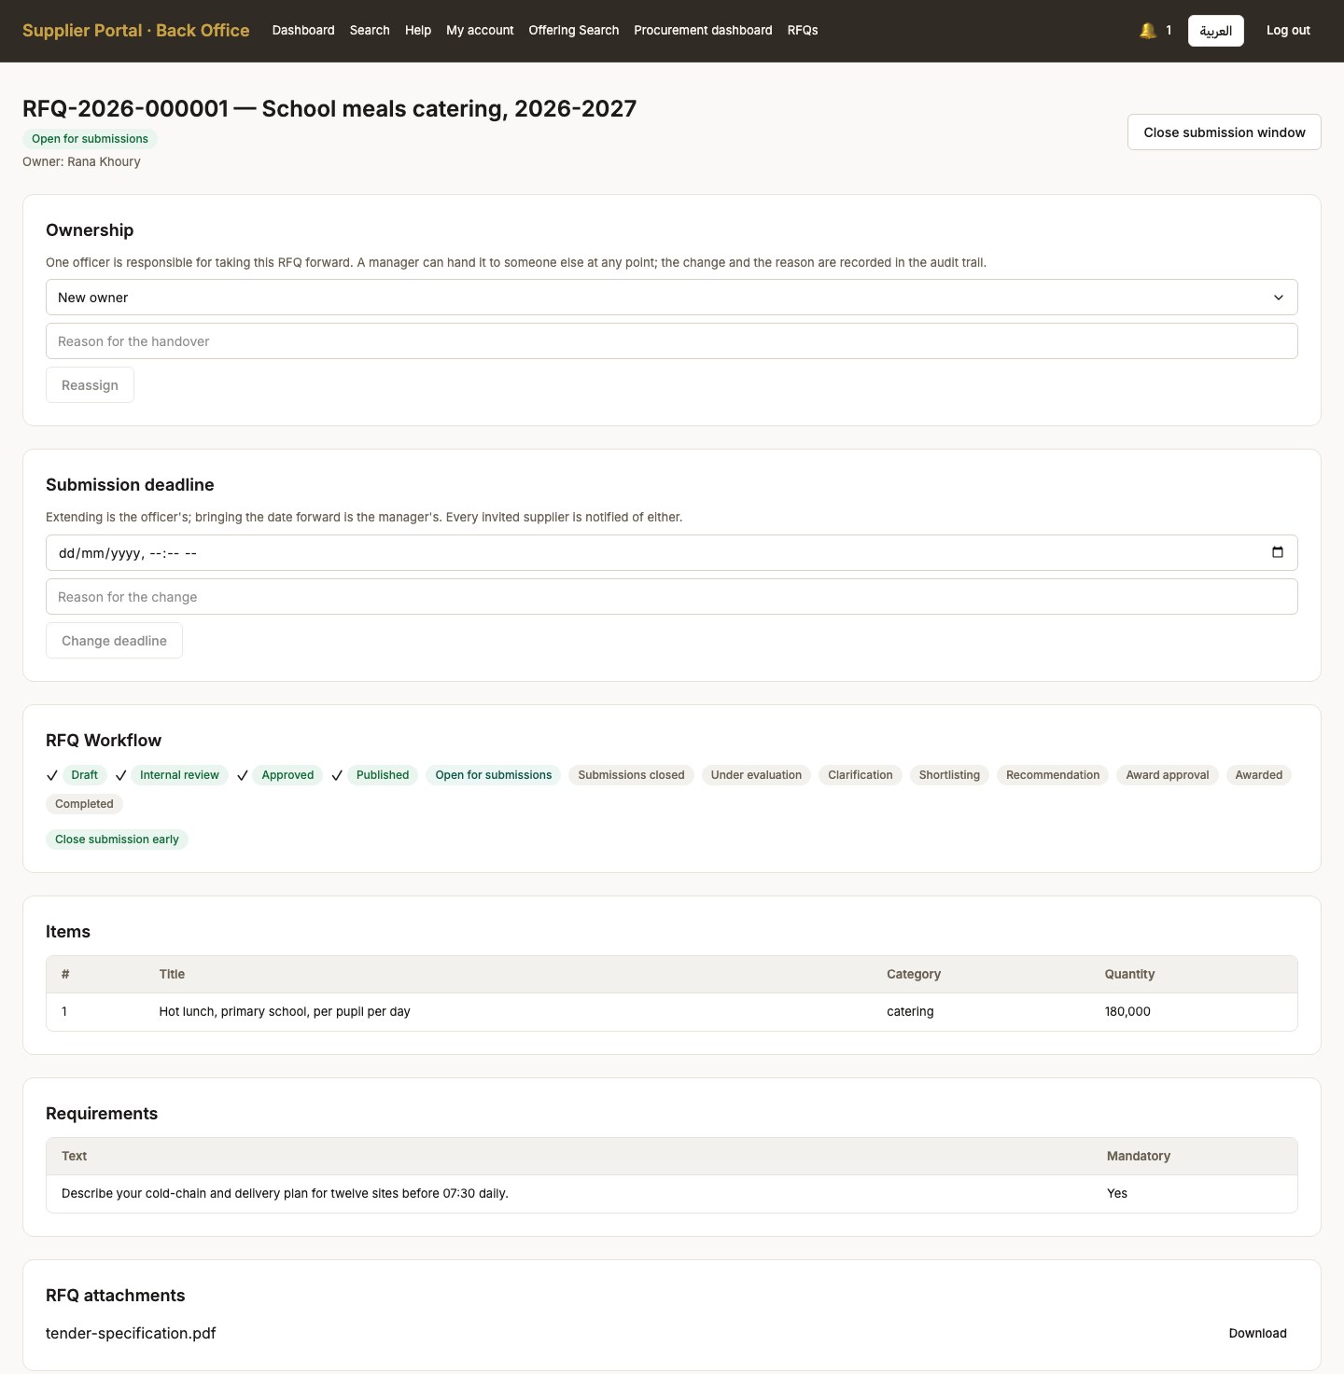
Screen 56, part 1 of 2 — top of the page

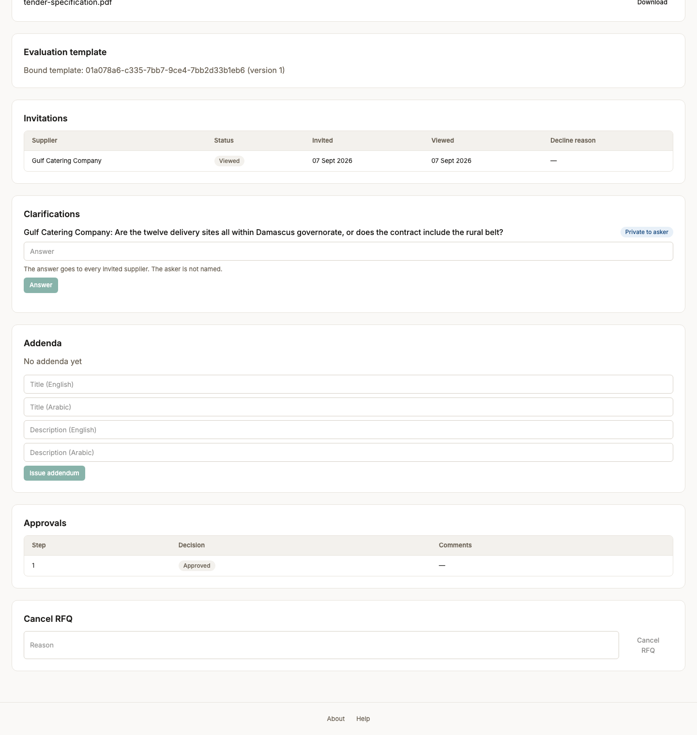
Screen 56, part 2 of 2 — bottom of the page

57. Answer published to all invitees
Persona procurement_officer
Screen Answer published to all invitees (/back-office/rfqs/RFQ-2026-000001)
What just happened Published to every invited supplier at once, with the asker anonymised. That is the rule this screen exists to enforce: one bidder's question must not tell the others who is in the room, and no bidder may receive information the rest do not.
What to do next Back to the supplier to price the bid.
What to say “One answer, published to every invited supplier at once, with the asker anonymised. Nobody gets an advantage by asking, and nobody is discouraged from asking.”
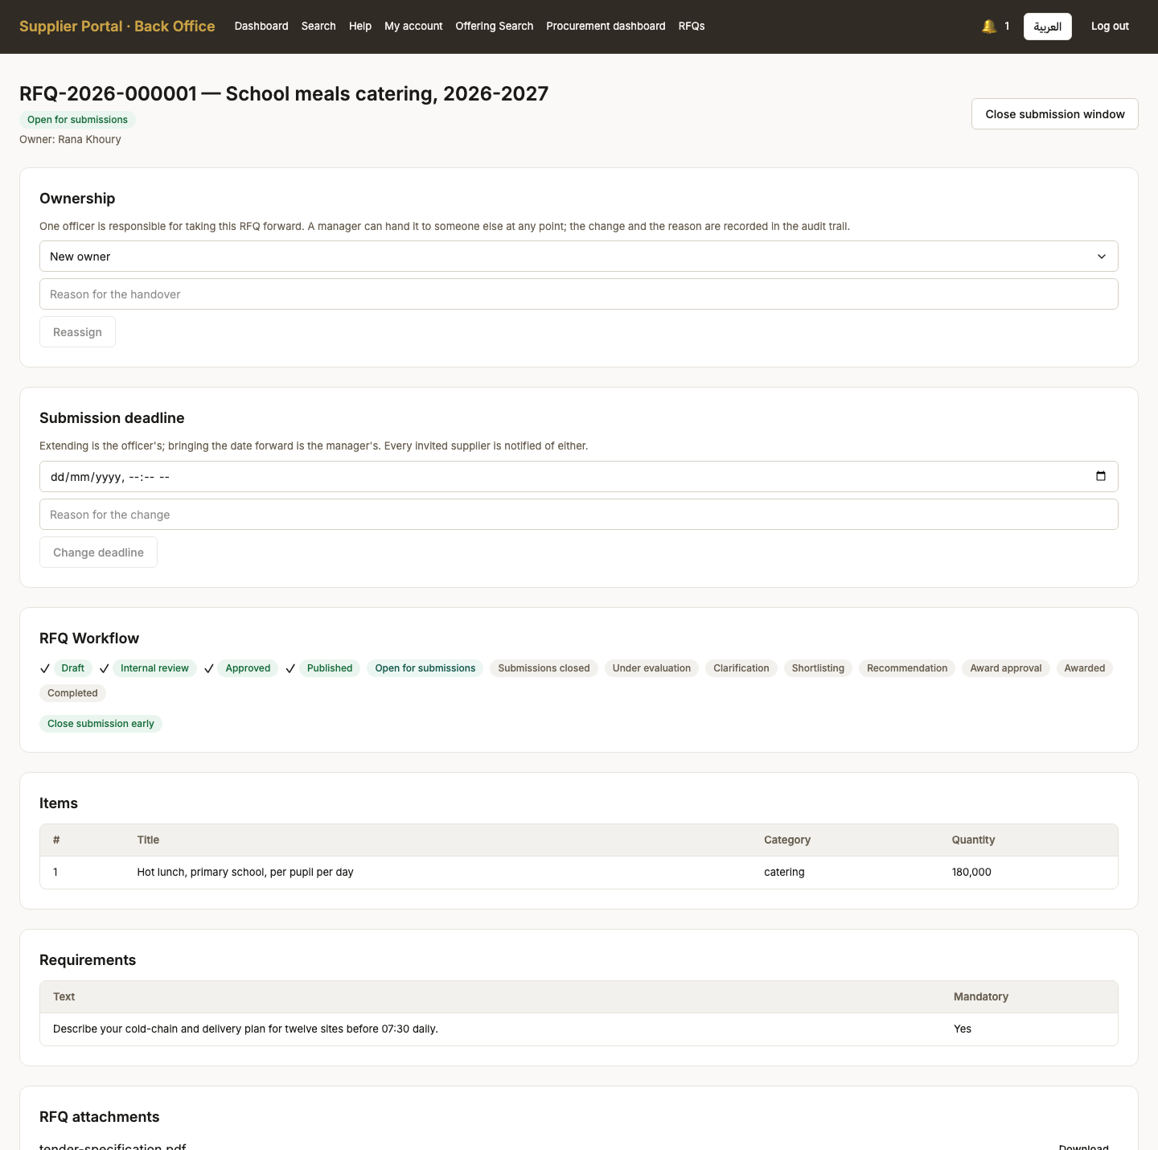
Screen 57, part 1 of 2 — top of the page

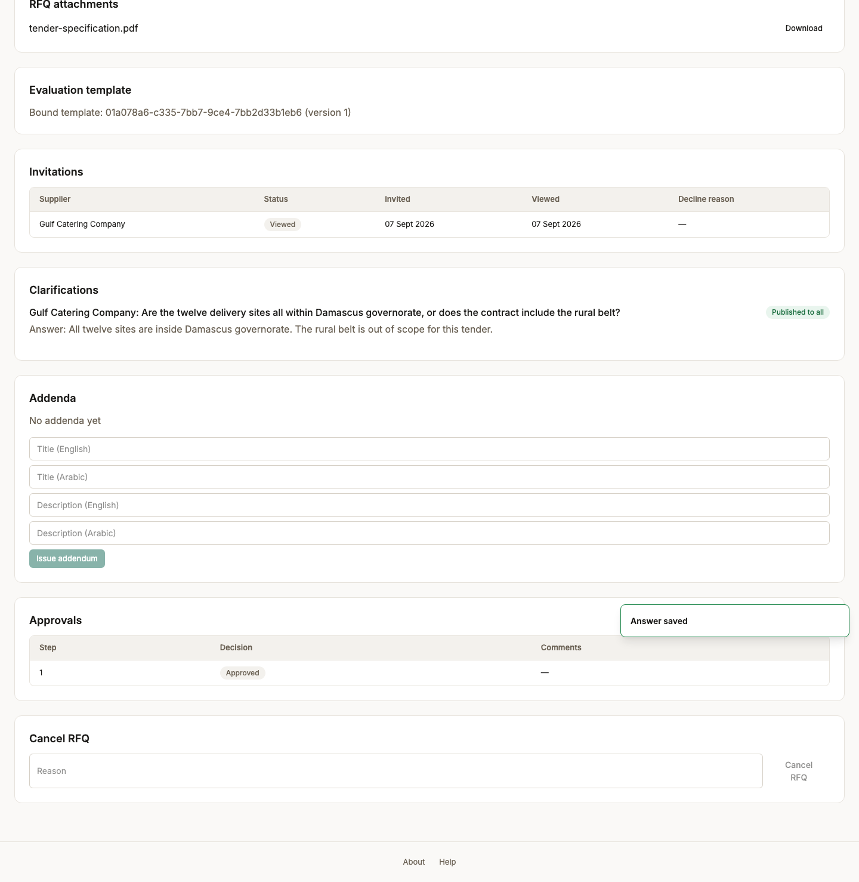
Screen 57, part 2 of 2 — bottom of the page

58. The published answer, seen by the bidder
Persona supplier_admin
Screen The published answer, seen by the bidder (/rfqs/RFQ-2026-000001)
What just happened The answer is here, attributed to the buyer and not to whoever asked. Every invited supplier sees the same text at the same time, which is what keeps a clarification from becoming an advantage.
What to do next Start a proposal.
What to say “And here is that answer arriving on the supplier's side, attributed to the buyer rather than to whoever asked.”
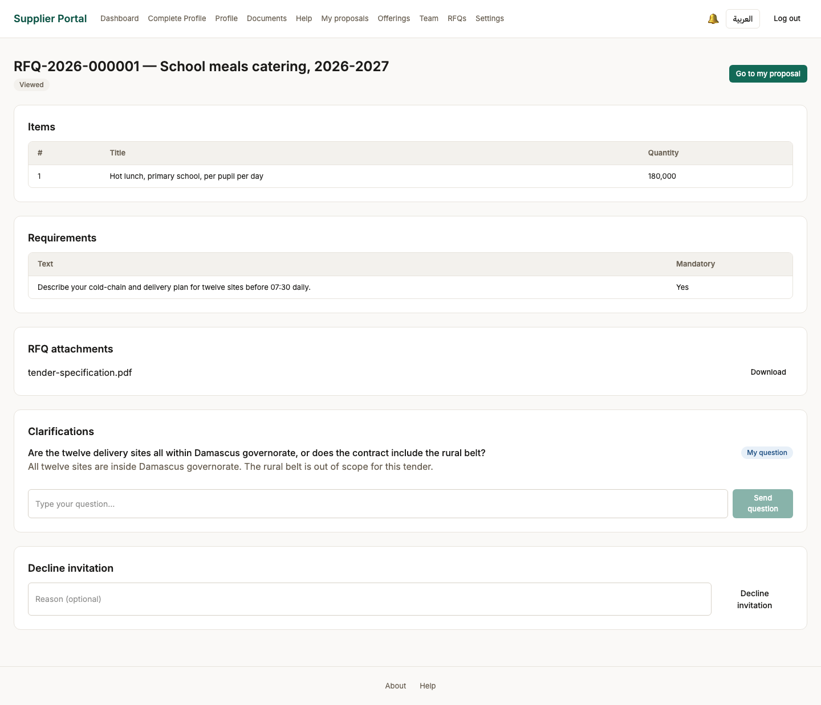

Act 12 — The bid
Two envelopes in one form. The supplier prices the buyer’s lines, answers the requirement in both languages, sets terms, attaches a certificate and submits.

59. Proposal started (Draft)
Persona supplier_admin
Screen Proposal started (Draft) (/rfqs/RFQ-2026-000001/proposal)
What just happened A draft proposal, private to this supplier. The two envelopes are visible as separate sections: the technical answers and the commercial figures are stored apart because the buyer is allowed to see them at different times.
What to do next Price the line items.
What to say “A draft bid, private to this supplier. Notice the two envelopes as separate sections — technical and commercial.”
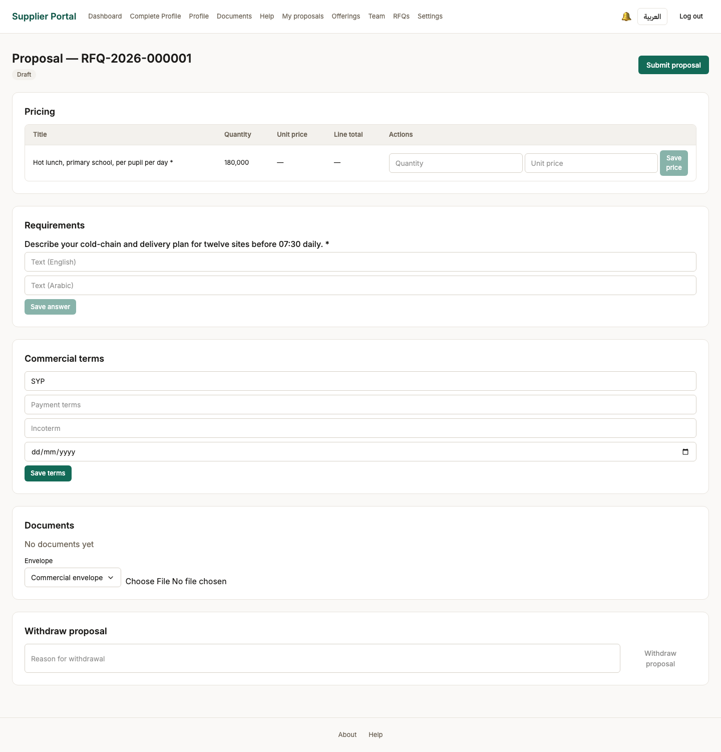

60. Line item priced
Persona supplier_admin
Screen Line item priced (/rfqs/RFQ-2026-000001/proposal)
What just happened A unit price against the line the buyer specified. The total is derived from the quantity on the tender rather than typed, so the two cannot disagree.
What to do next Answer the requirement.
What to say “A unit price against the buyer's line. The total is derived from the quantity on the tender, not typed by the bidder.”
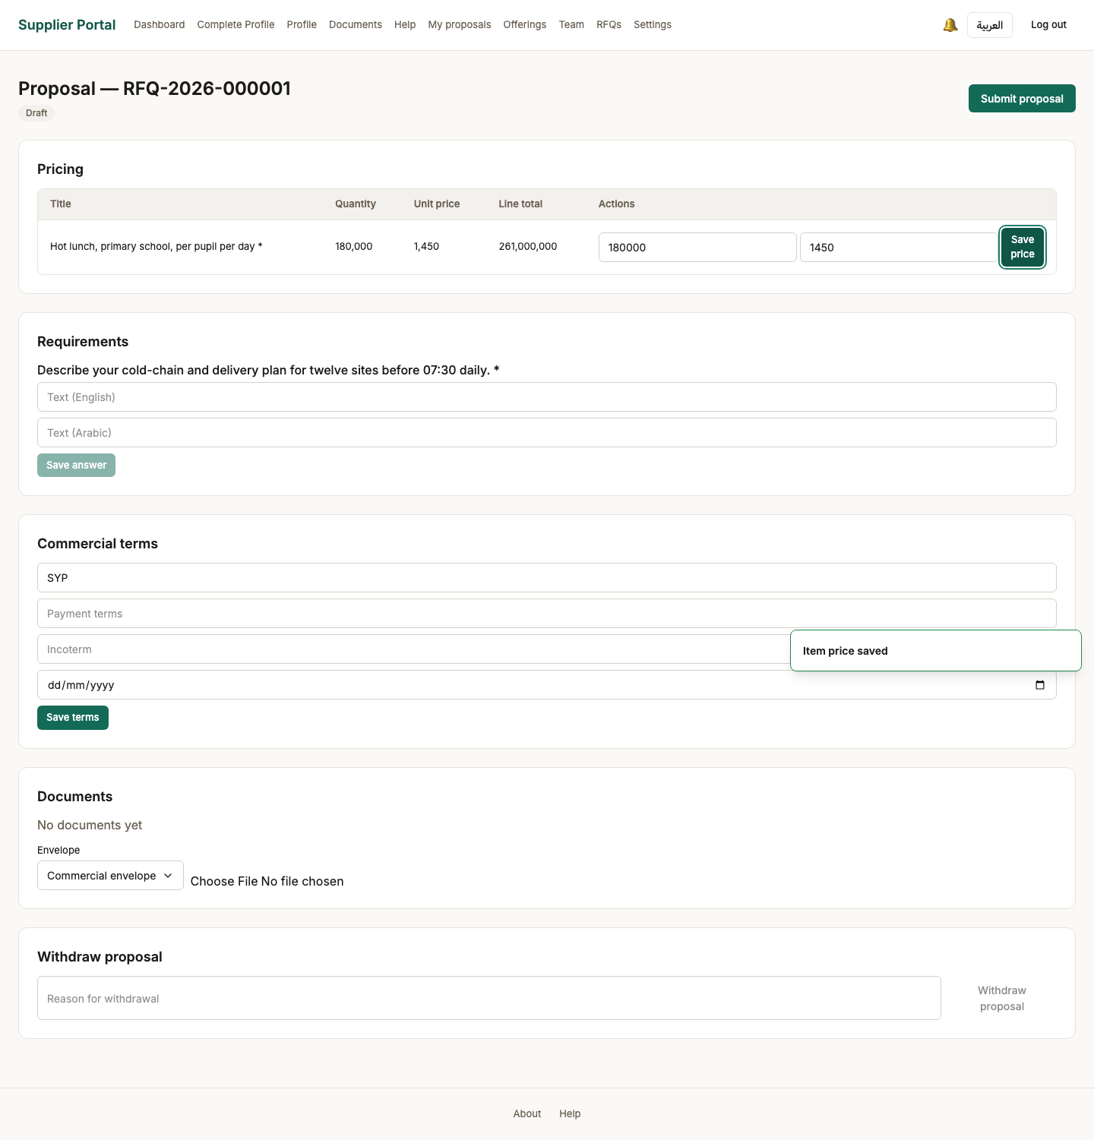

61. Requirement answered
Persona supplier_admin
Screen Requirement answered (/rfqs/RFQ-2026-000001/proposal)
What just happened The technical half of the bid. This is what an evaluator scores, and it is sealed from the price until the buyer consolidates.
What to do next Set the commercial terms and attach a document.
What to say “The technical half of the bid. This is what an evaluator scores, and it stays sealed from the price until the technical stage is passed.”
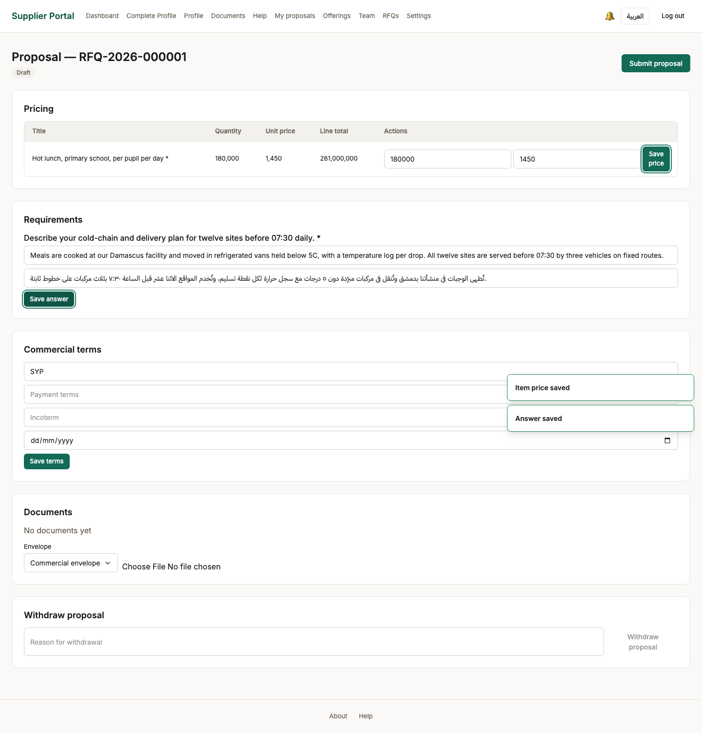

62. Terms set and document attached
Persona supplier_admin
Screen Terms set and document attached (/rfqs/RFQ-2026-000001/proposal)
What just happened Payment terms and a supporting document. Everything a bid consists of is now on the record and still editable, because nothing has been submitted yet.
What to do next Submit the bid.
What to say “Payment terms and a supporting certificate. Everything a bid consists of is now on the record — and still editable.”
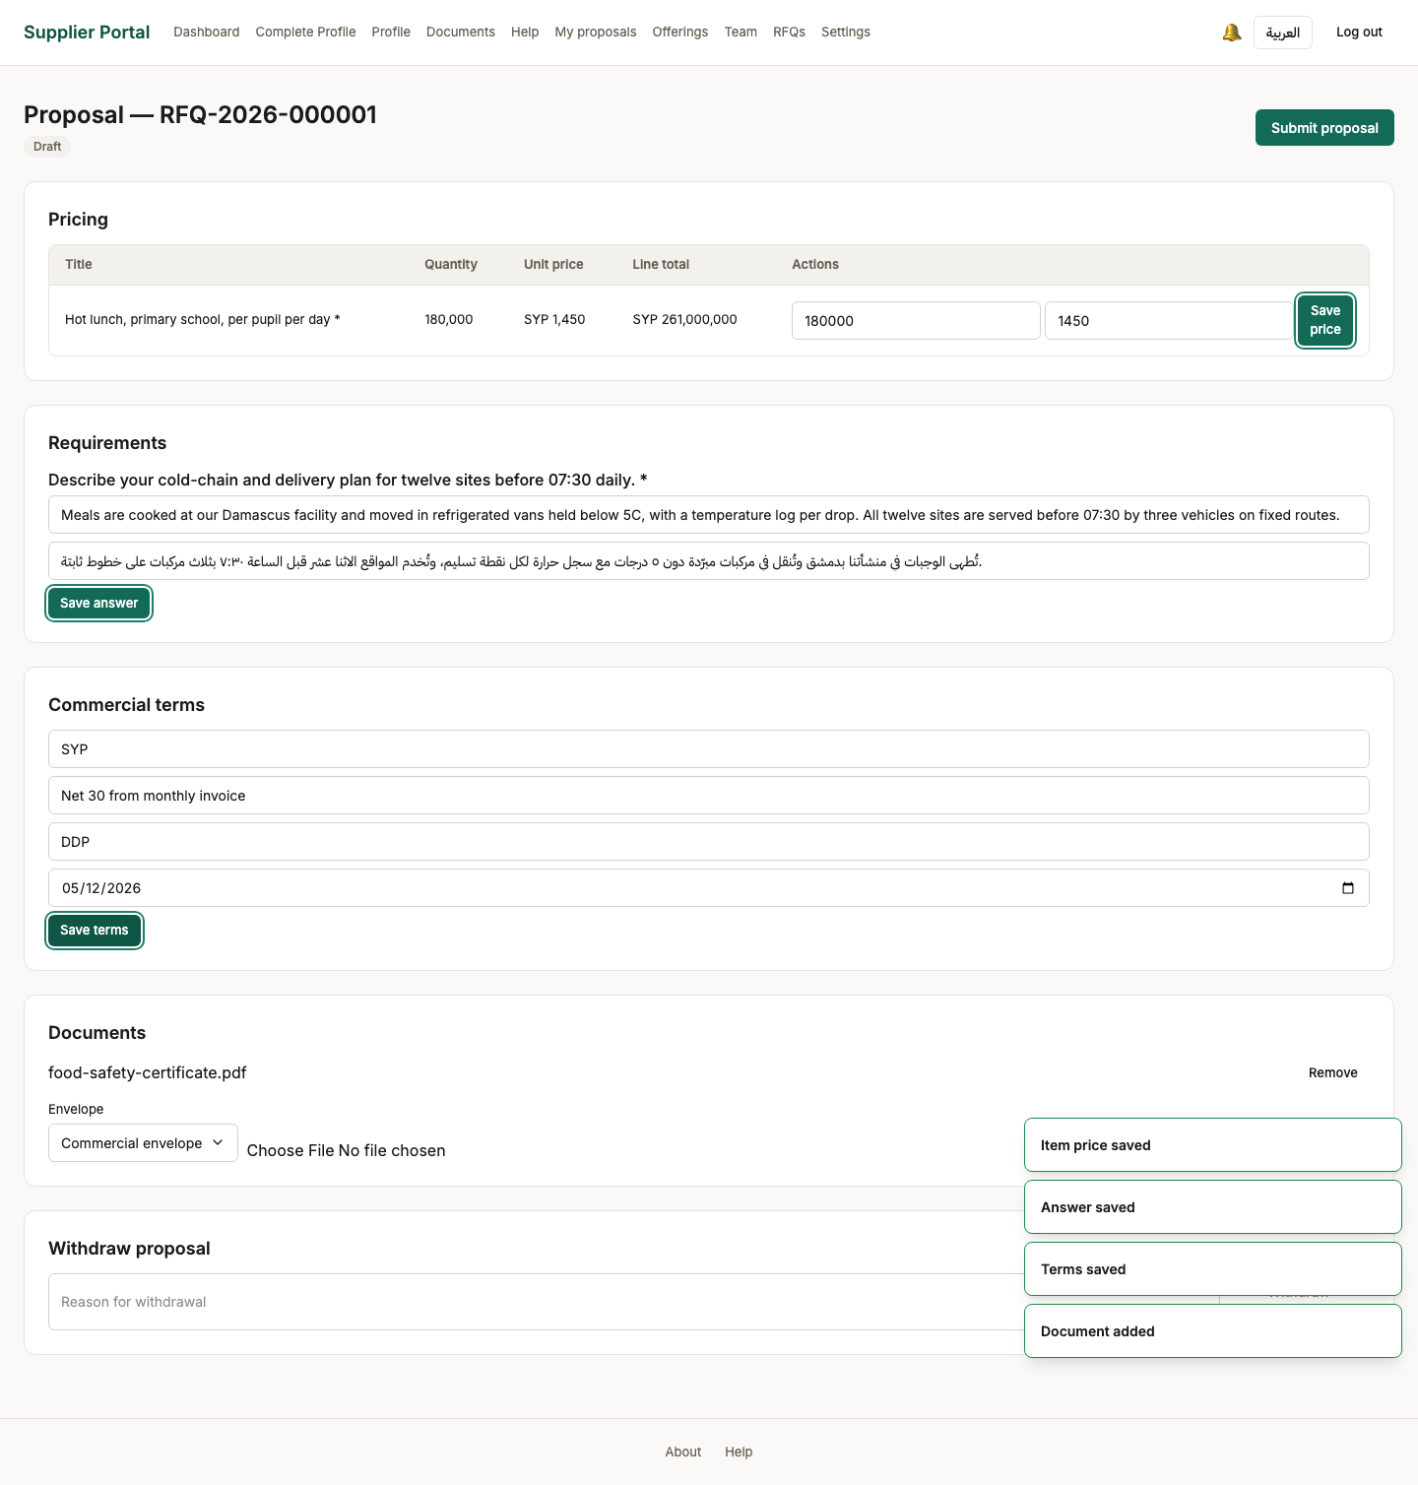

63. Bid submitted
Persona supplier_admin
Screen Bid submitted (/rfqs/RFQ-2026-000001/proposal)
What just happened Submitted, and now read-only to the supplier. From here the buyer cannot see the commercial half until the submission window closes and the evaluation is consolidated - that is the two-envelope seal, and it is enforced on the server rather than by hiding a column.
What to do next The officer closes the window and opens evaluation.
What to say “Submitted, and read-only from here. This is the moment the bid becomes evidence rather than a draft.”
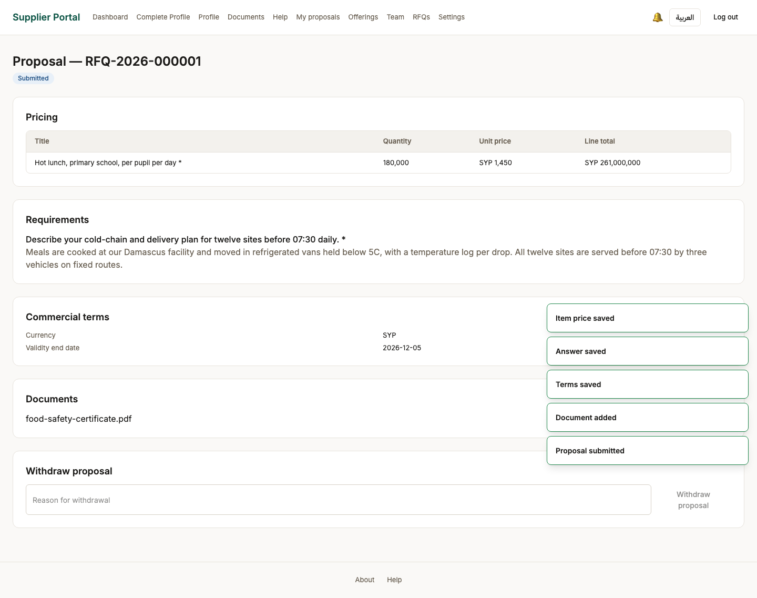

Act 13 — Closing submissions and opening the evaluation
Bids are fixed at close. The evaluation is created from the criteria frozen when the template was bound, and an evaluator is assigned by name.

64. Submissions closed
Persona procurement_officer
Screen Submissions closed (/back-office/rfqs/RFQ-2026-000001)
What just happened Closed early by the officer rather than waiting for the deadline. Bids are now fixed: nothing further can be submitted, withdrawn or repriced, which is the precondition for looking at any of them.
What to do next Open the evaluation.
What to say “Closed early by the officer rather than waiting out the clock. Bids are fixed now; nothing further can arrive.”
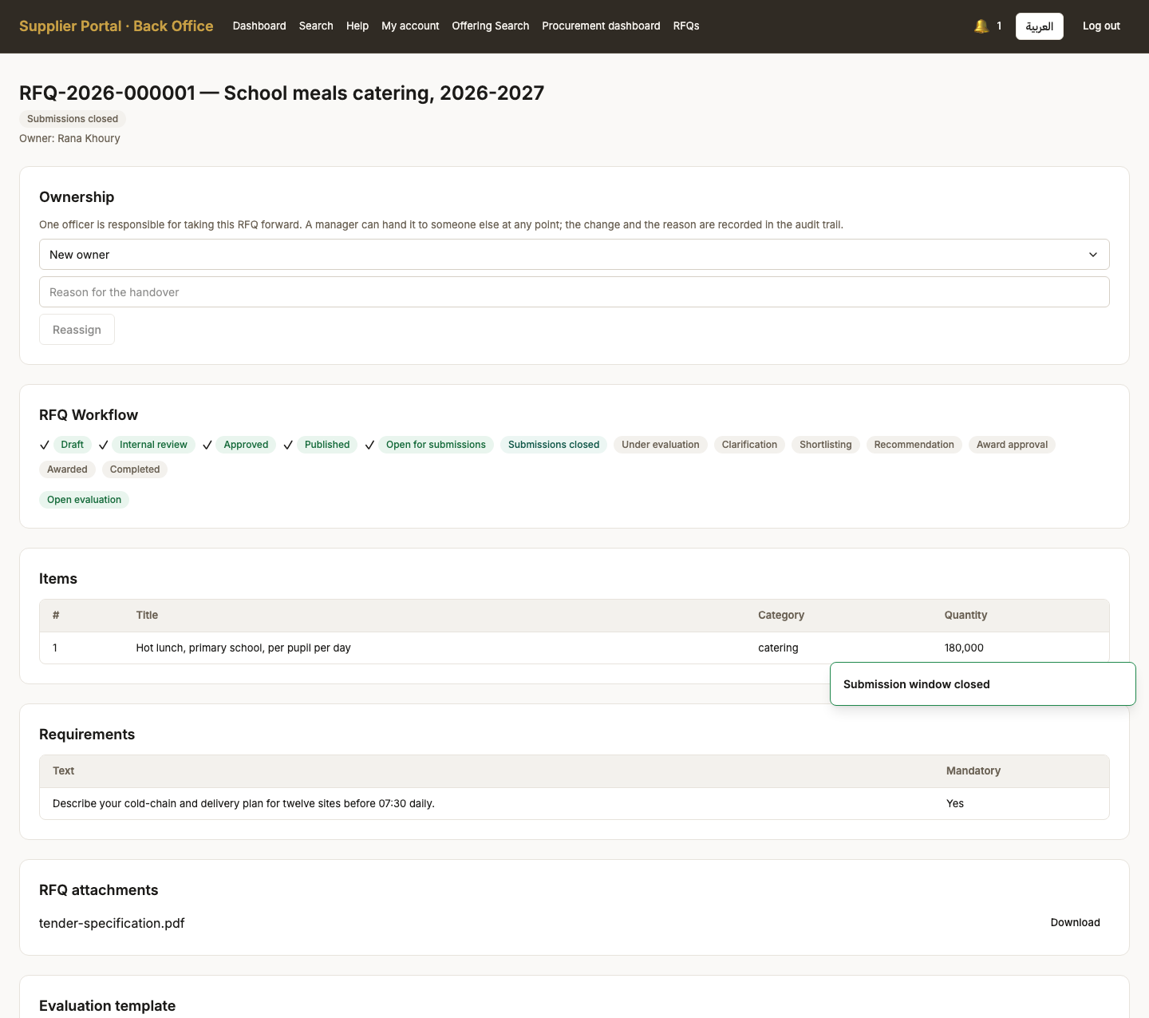
Screen 64, part 1 of 2 — top of the page

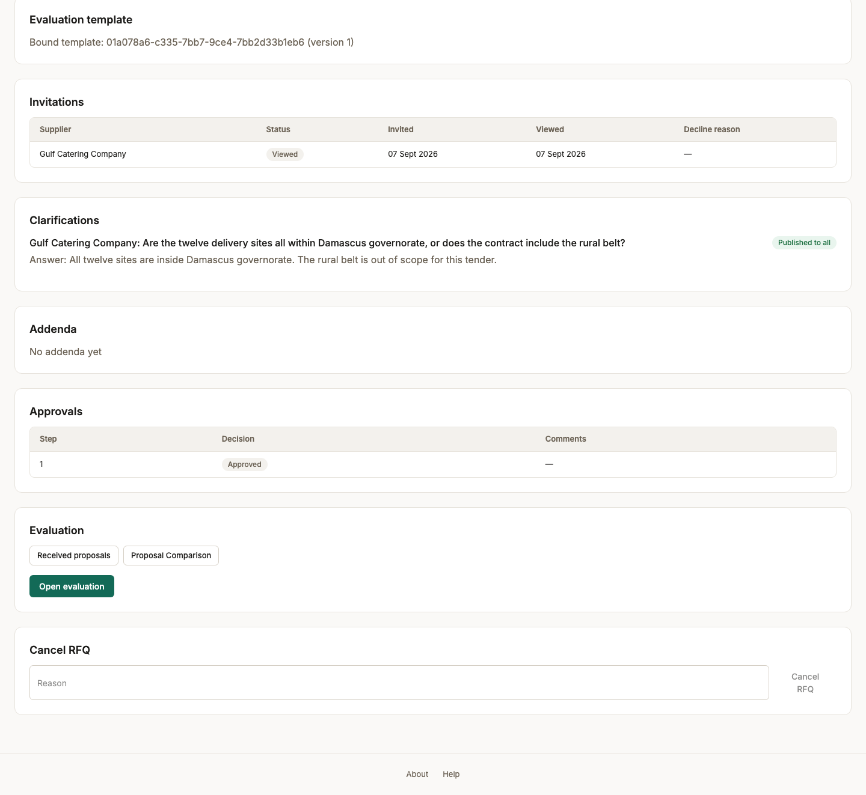
Screen 64, part 2 of 2 — bottom of the page

65. Evaluation opened
Persona procurement_officer
Screen Evaluation opened (/back-office/rfqs/RFQ-2026-000001)
What just happened The evaluation exists, carrying the criteria frozen when the template was bound. No score exists yet and the commercial envelope stays sealed.
What to do next The manager assigns an evaluator.
What to say “The evaluation exists, carrying the criteria frozen when the template was bound. No scores yet.”
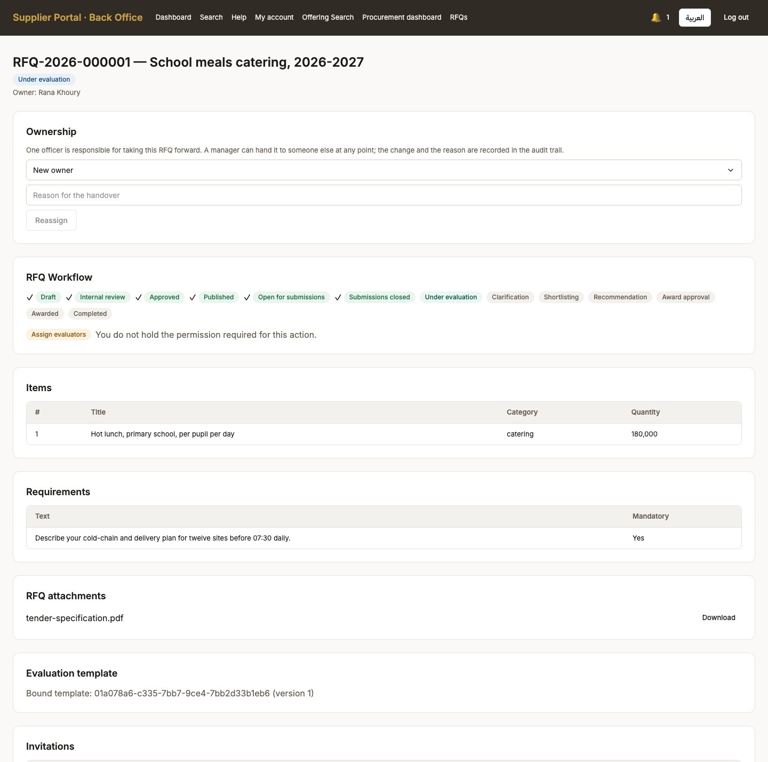
Screen 65, part 1 of 2 — top of the page

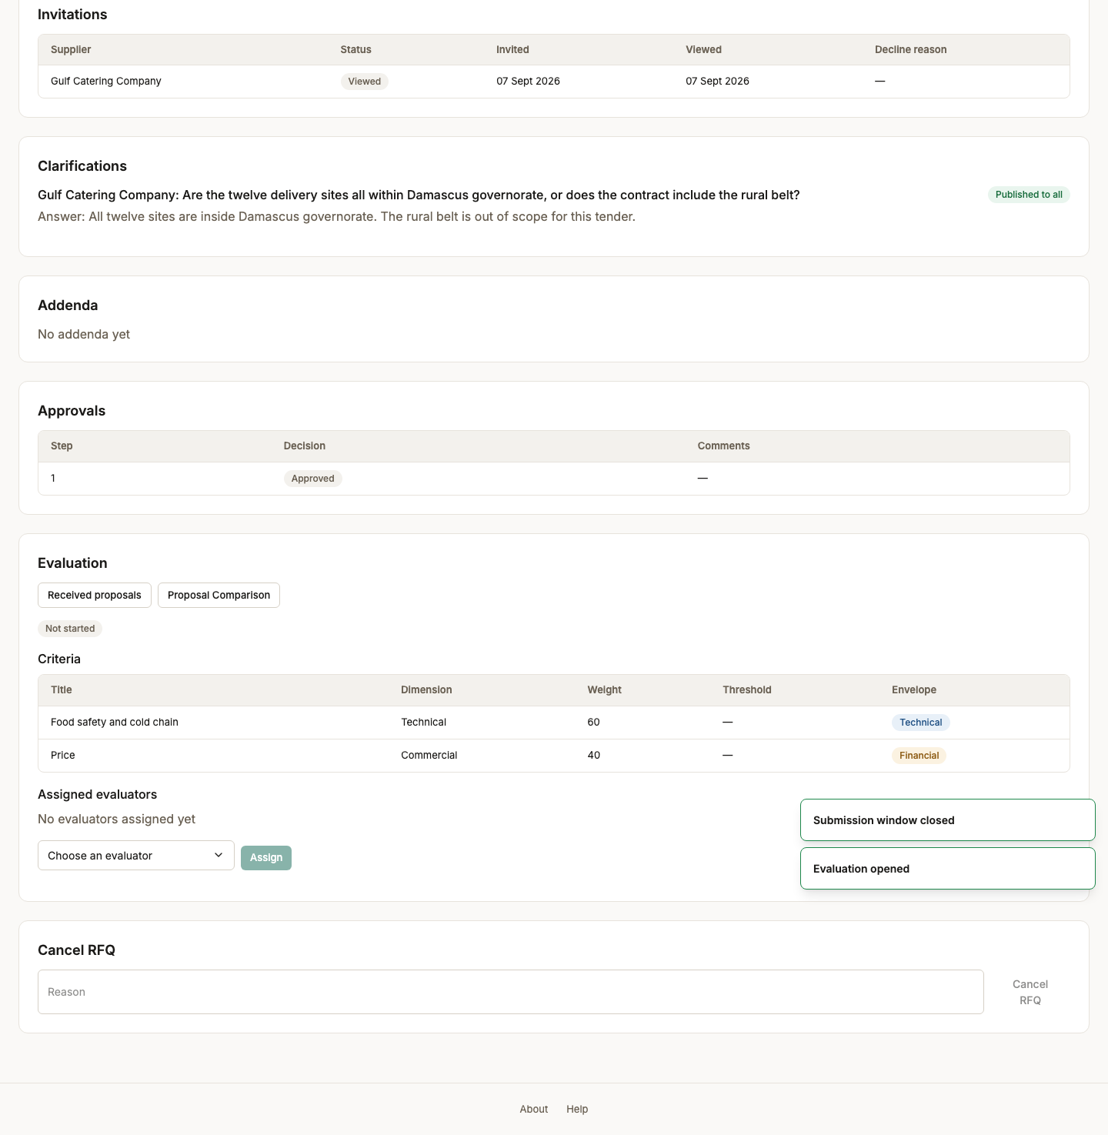
Screen 65, part 2 of 2 — bottom of the page

66. Evaluator assigned
Persona procurement_manager
Screen Evaluator assigned (/back-office/rfqs/RFQ-2026-000001)
What just happened Assigned by name, from the staff who actually hold the scoring permission in this buying body. The picker lists people rather than asking for an identifier, and anyone already assigned is absent from it.
What to do next The evaluator scores the bids.
What to say “Assigned by name, and only from staff who actually hold the scoring permission in this buying body.”
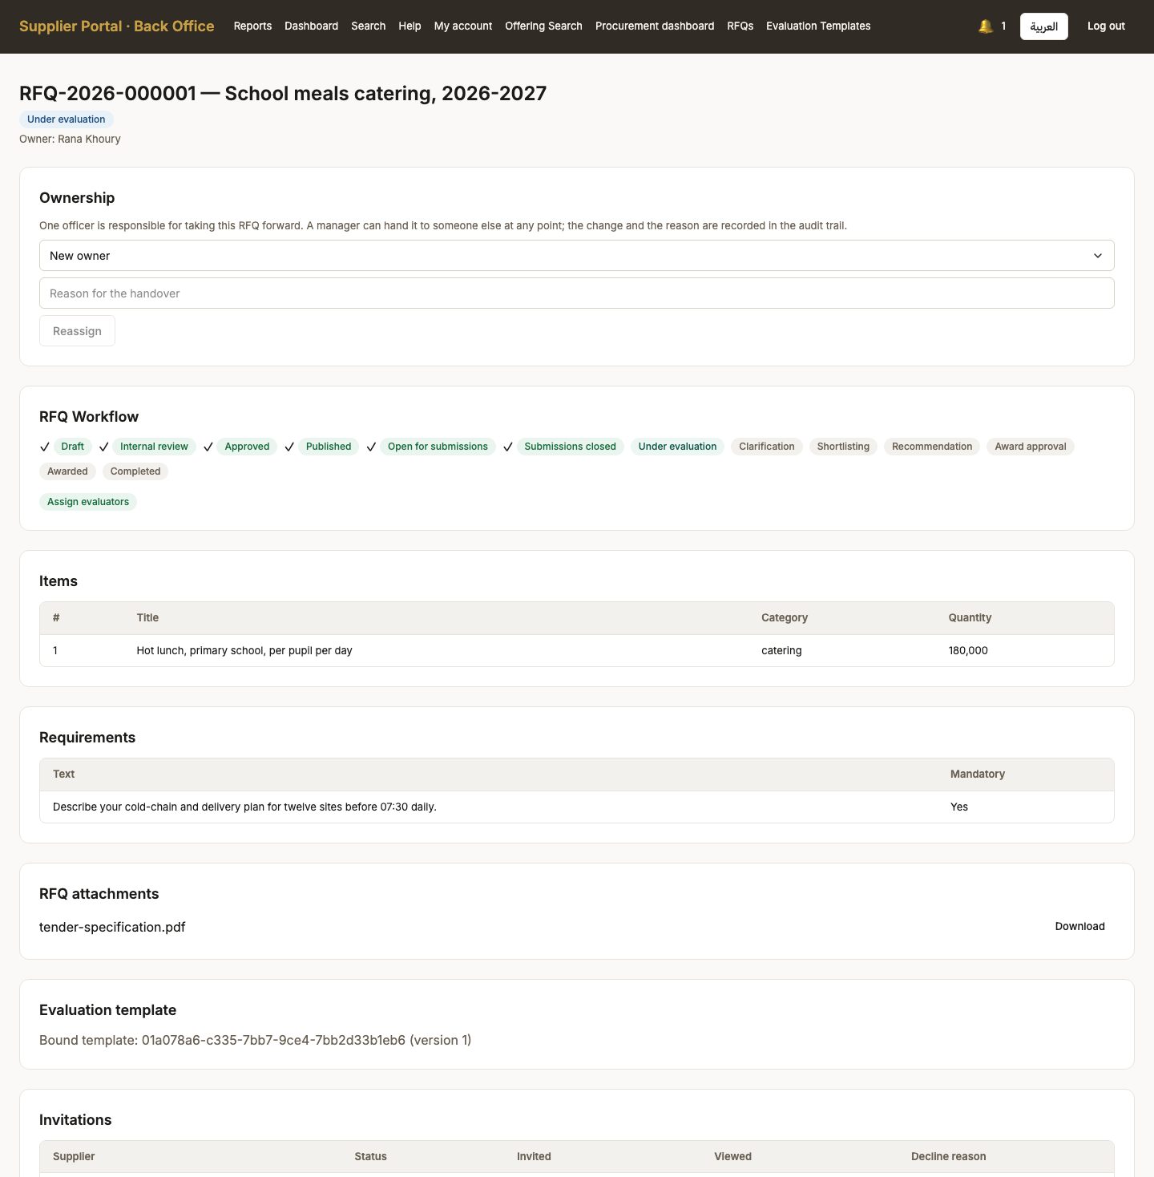
Screen 66, part 1 of 2 — top of the page

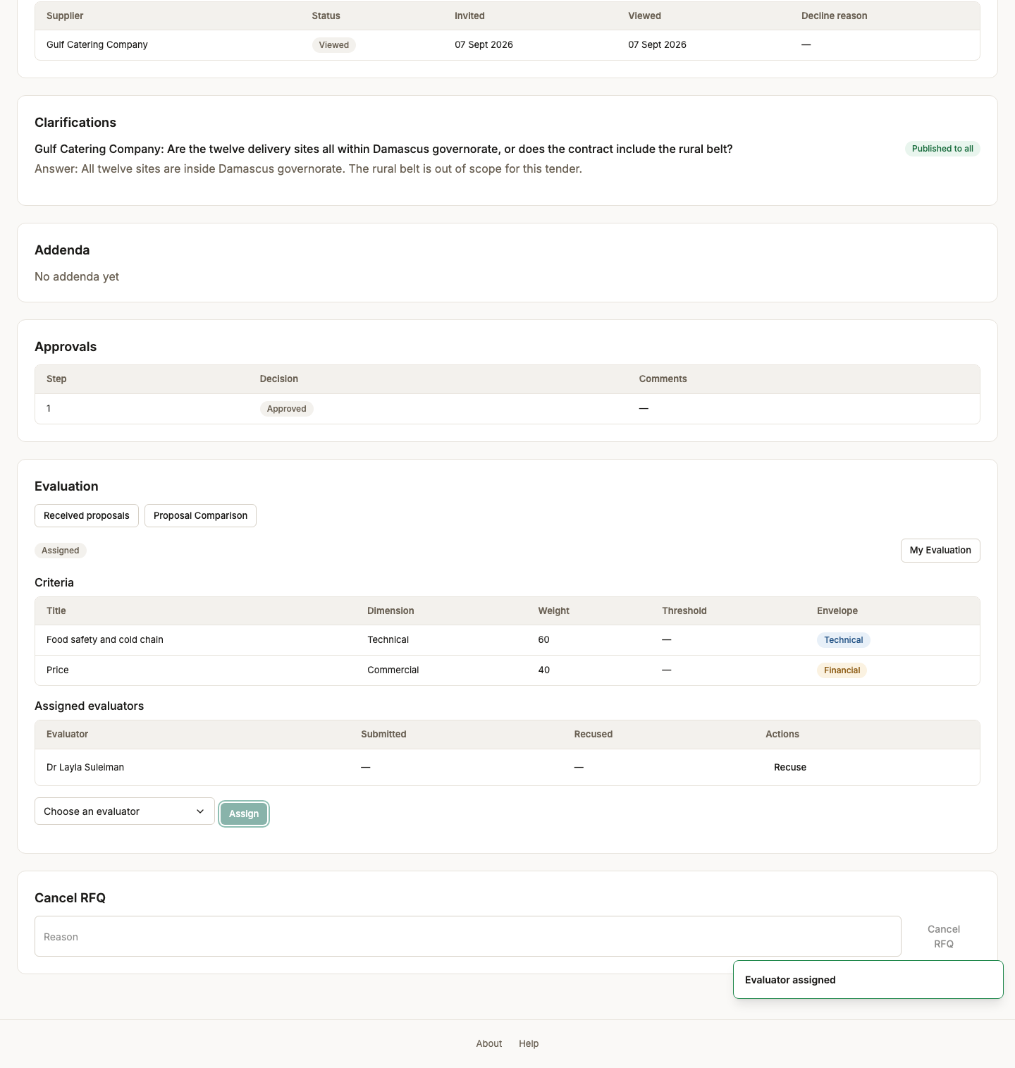
Screen 66, part 2 of 2 — bottom of the page

Act 14 — Scoring, with the bidders anonymous
A conflict declaration before any bid is visible, then scoring against a technical criterion with the price still sealed. The financial envelope unlocks only on technical qualification.

67. Evaluator dashboard
Persona evaluator
Screen Evaluator dashboard (/evaluation)
What just happened The evaluator signs in to a dashboard of their own assignments and almost nothing else: this role holds evaluation.score, evaluation.submit and rfq.clarify, so there is no tender list and no supplier data to browse.
What to do next Open the assignment.
What to say “The evaluator's world is deliberately small: their assignments, and almost nothing else.”
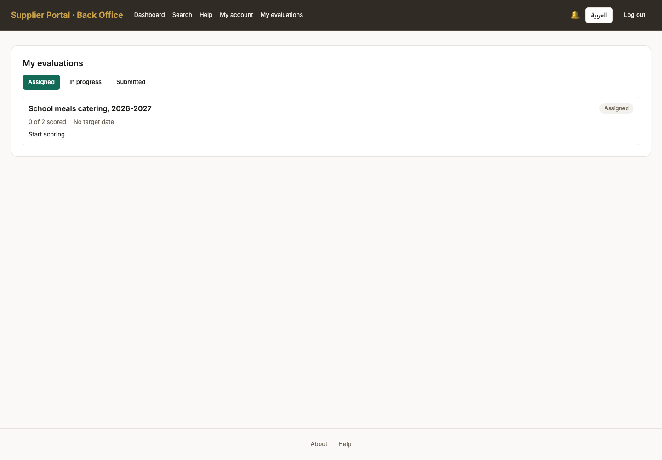

68. Conflict of interest declaration
Persona evaluator
Screen Conflict of interest declaration (/back-office/rfqs/RFQ-2026-000001/my-evaluation)
What just happened Asked before a single bid is visible, and it names the suppliers taking part precisely because that is the one thing an evaluator must see in order to answer honestly. Declaring a conflict here recuses them instead of letting them score and hope nobody checks.
What to do next Declare no conflict and continue.
What to say “The conflict declaration comes before a single bid is visible, and it names the bidders — because that is the information somebody needs in order to declare a conflict.”
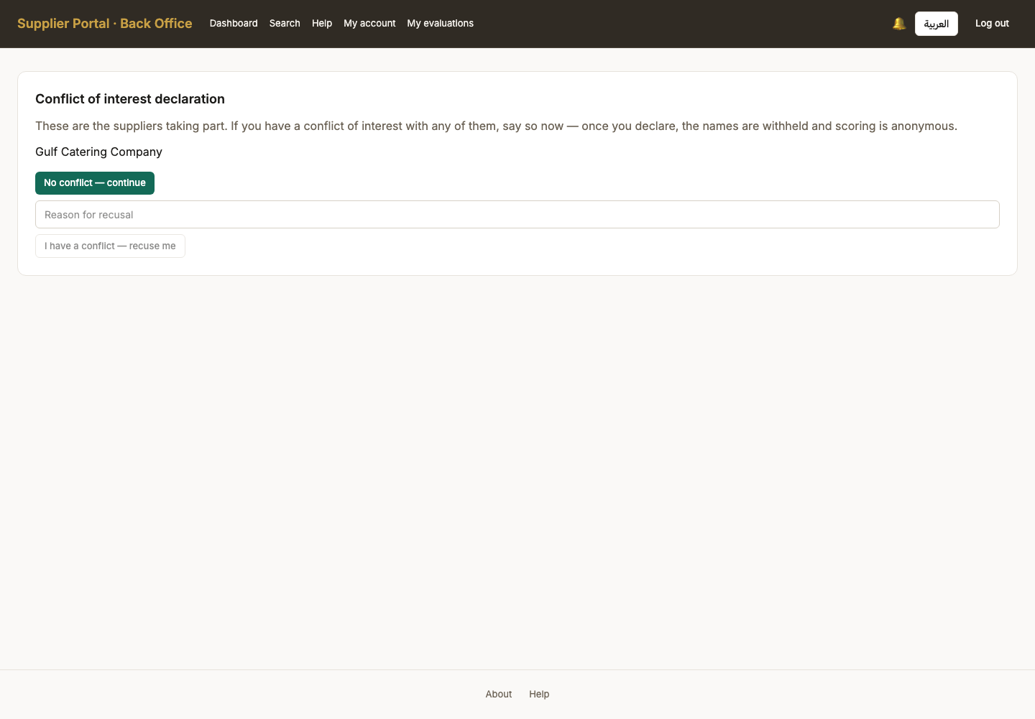

69. Scoring screen — bidders anonymous
Persona evaluator
Screen Scoring screen — bidders anonymous (/back-office/rfqs/RFQ-2026-000001/my-evaluation)
What just happened The bids, with the bidder identity withheld and the financial envelope locked. An evaluator scores the technical answer without knowing whose it is or what it costs, which is the two-envelope seal doing its actual job rather than a label on a screen.
What to do next Score each criterion.
What to say “Bidders anonymous, price locked. The evaluator is judging the answer, not the company and not the number.”
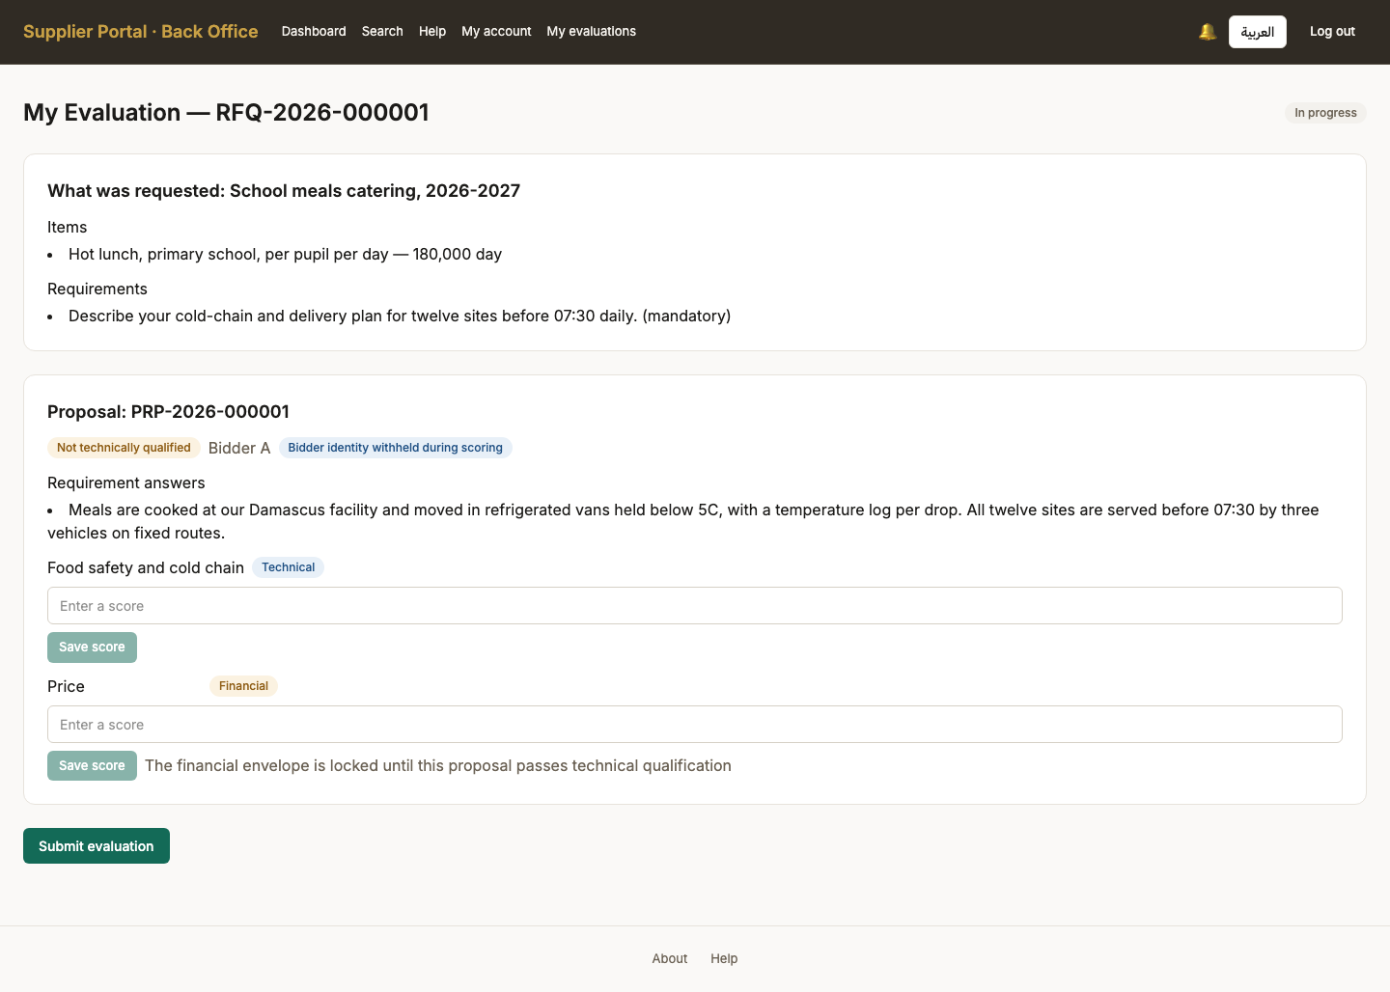

70. Technical criterion scored, price still locked
Persona evaluator
Screen Technical criterion scored, price still locked (/back-office/rfqs/RFQ-2026-000001/my-evaluation)
What just happened The technical score is recorded and the price is still sealed. An evaluator judges the answer before knowing what it costs, which is the entire purpose of separating the envelopes.
What to do next Saving a passing technical score qualifies the bid and unlocks the financial criterion.
What to say “The technical score is in, and the price is still sealed.”
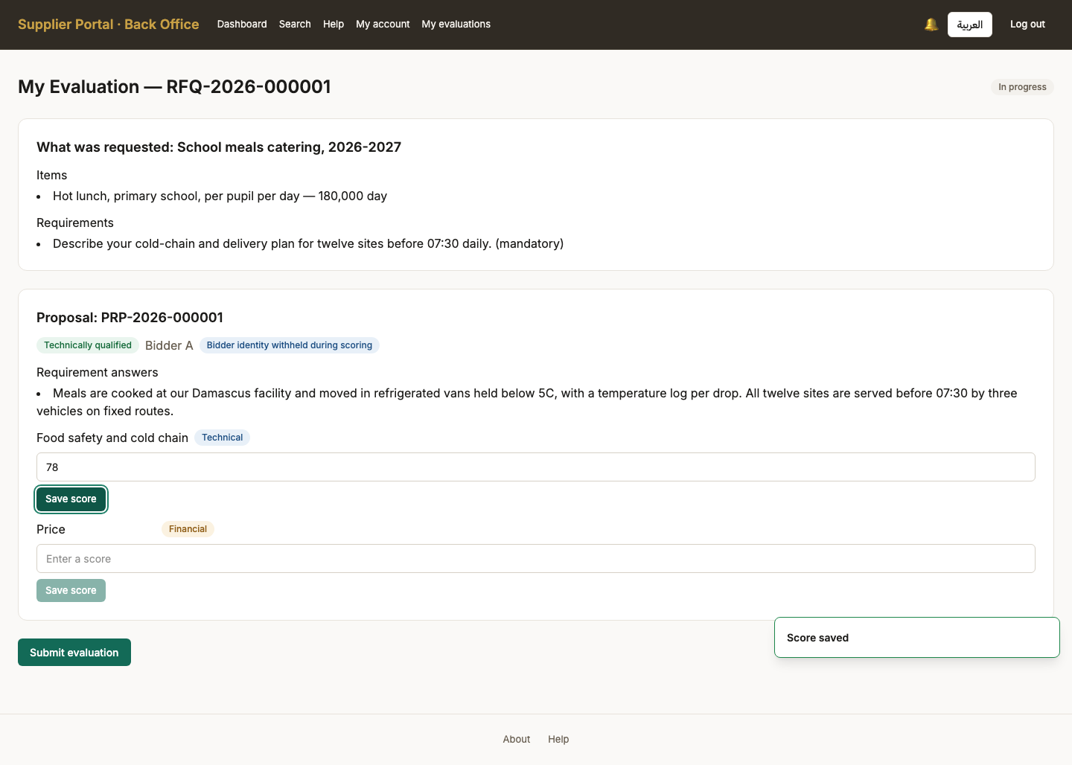

71. All criteria scored
Persona evaluator
Screen All criteria scored (/back-office/rfqs/RFQ-2026-000001/my-evaluation)
What just happened Both criteria now carry a score. The financial one unlocked only once the bid passed technically, and the evaluation cannot be submitted until every unlocked criterion is answered.
What to do next Submit the evaluation.
What to say “The financial criterion unlocked only because this bid passed technically. That order is enforced, not conventional.”
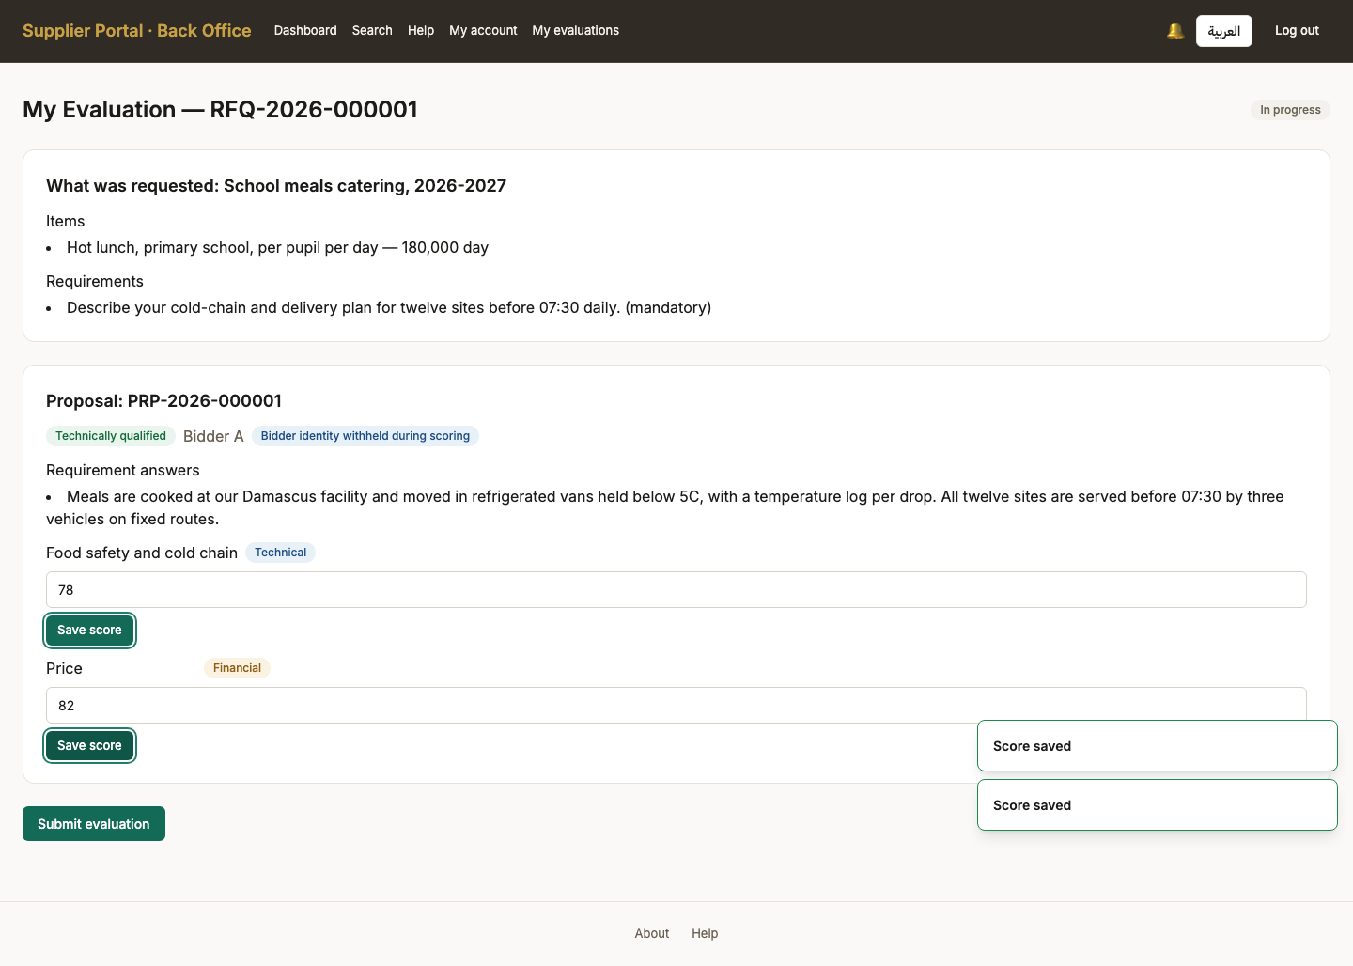

72. Evaluation submitted
Persona evaluator
Screen Evaluation submitted (/back-office/rfqs/RFQ-2026-000001/my-evaluation)
What just happened Submitted and now read-only to this evaluator. Scores cannot be revised after submission without a manager reopening the evaluation, which is recorded.
What to do next The officer consolidates the results.
What to say “Submitted. Scores cannot be revised after this without a manager reopening the evaluation, and that reopening is recorded.”
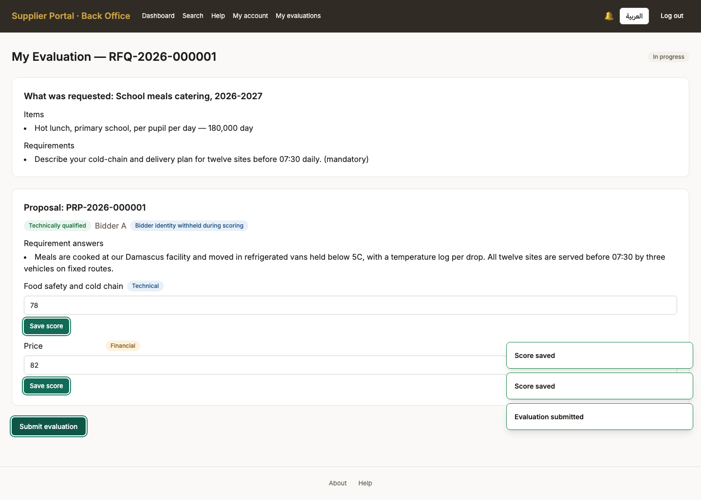

Act 15 — From scores to an issued award
Consolidation, the comparison matrix, a finalized ranking, a recommendation with its justification, a self-approval refused, an approval by somebody else, and the award issued.

73. Results consolidated
Persona procurement_officer
Screen Results consolidated (/back-office/rfqs/RFQ-2026-000001)
What just happened Consolidation is the moment the two envelopes are put together: technical scores and prices are weighted into one ranking. Until now nobody on the buying side had seen both halves of a bid at once.
What to do next Open the comparison matrix.
What to say “Consolidation is the moment the two envelopes are put together — technical scores and prices weighted into one ranking.”
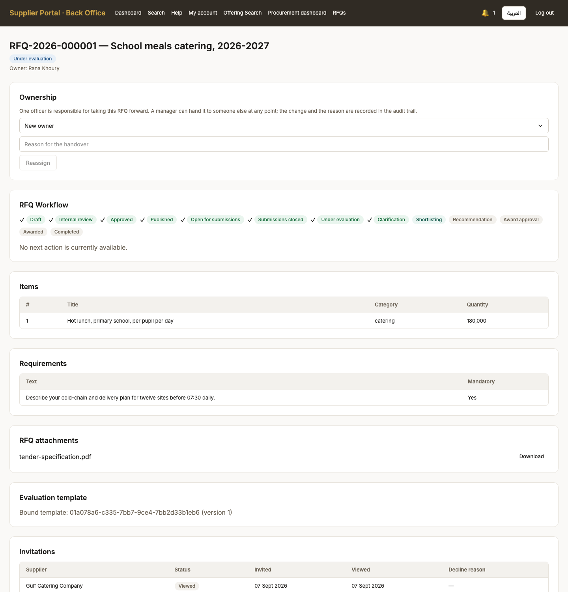
Screen 73, part 1 of 2 — top of the page

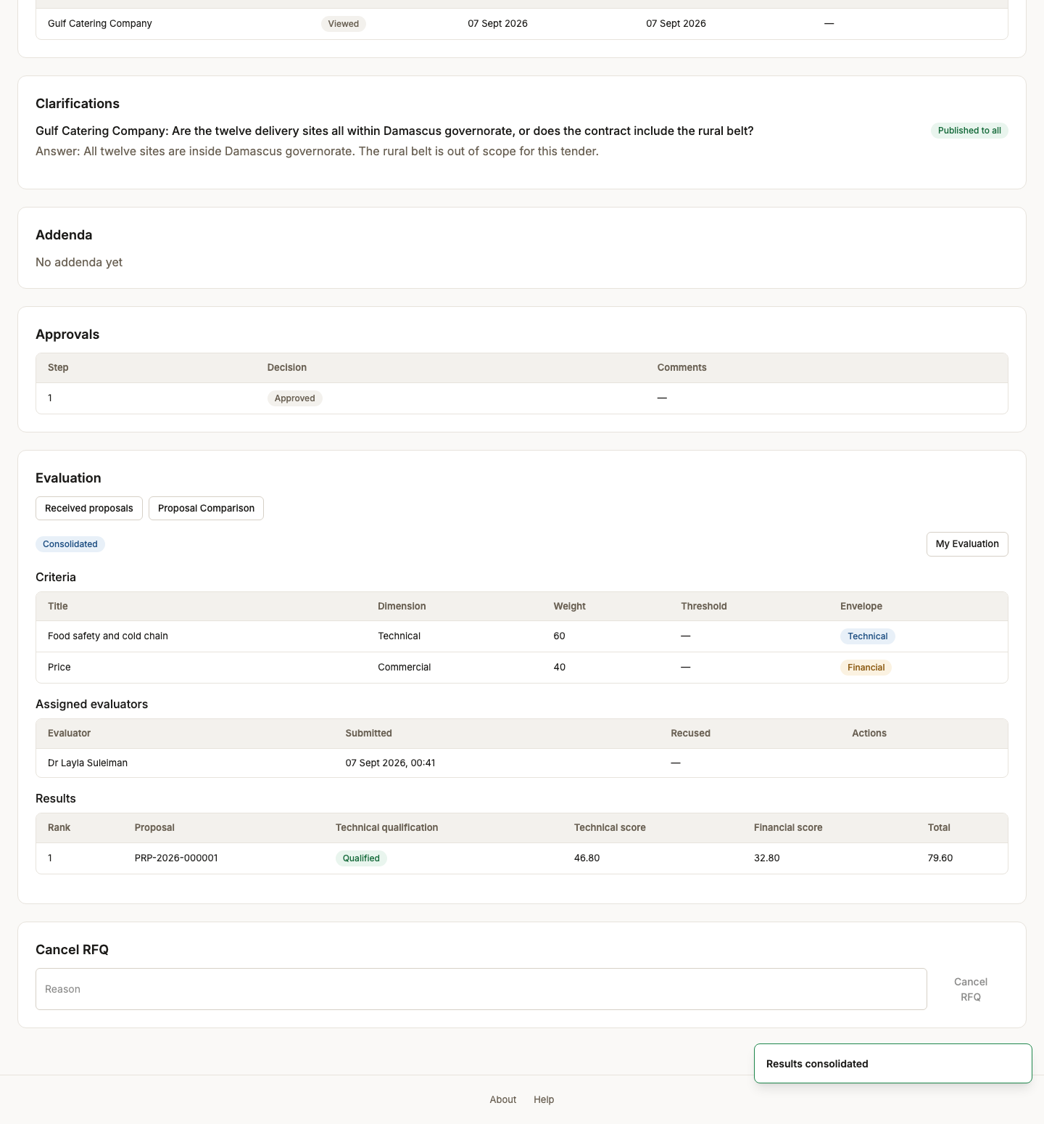
Screen 73, part 2 of 2 — bottom of the page

74. Comparison matrix
Persona procurement_officer
Screen Comparison matrix (/back-office/rfqs/RFQ-2026-000001/comparison)
What just happened Bids side by side, each identified by its PROPOSAL REFERENCE CODE rather than an internal id — this is the screen on which a tender is decided, and it used to print GUIDs. Technical, financial and weighted totals with a rank.
What to do next Open the award screen and recommend a winner.
What to say “Bids side by side, identified by proposal reference rather than company name. This is the screen a procurement decision is defended from.”
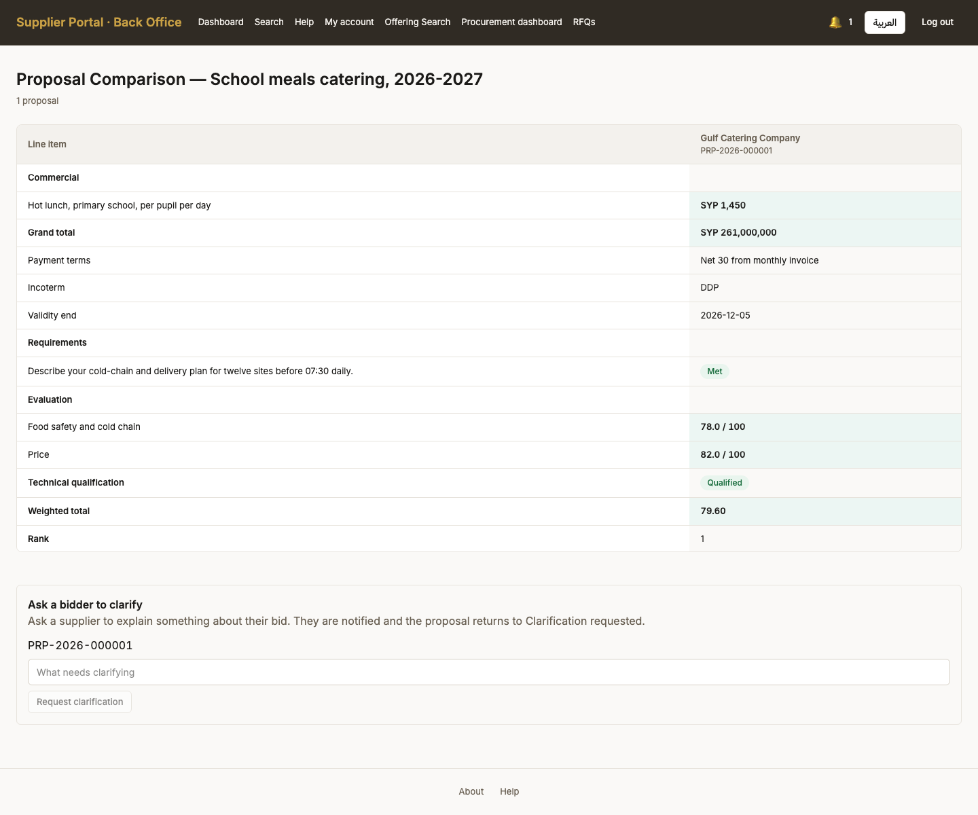

75. Evaluation finalized
Persona procurement_manager
Screen Evaluation finalized (/back-office/rfqs/RFQ-2026-000001)
What just happened The shortlist is closed and the ranking fixed, by the manager rather than the officer who ran the evaluation. Reopening after this undoes a decision rather than correcting a score, which is why it carries its own permission.
What to do next Back to the officer, who recommends a winner.
What to say “The manager closes the shortlist and fixes the ranking — not the officer who ran the evaluation.”
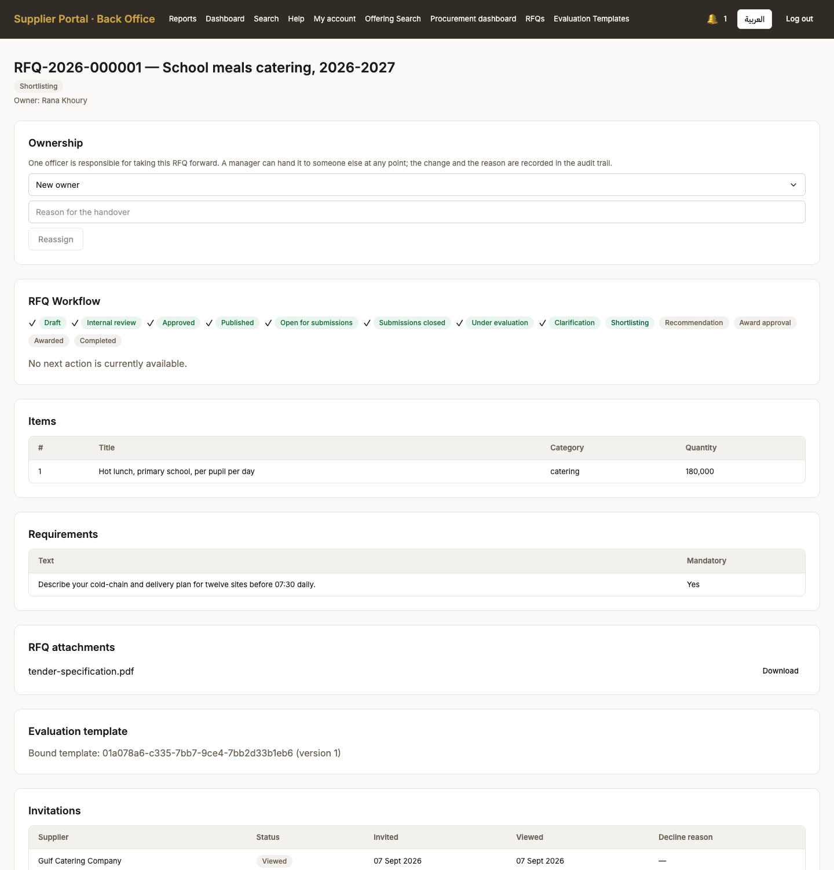
Screen 75, part 1 of 2 — top of the page

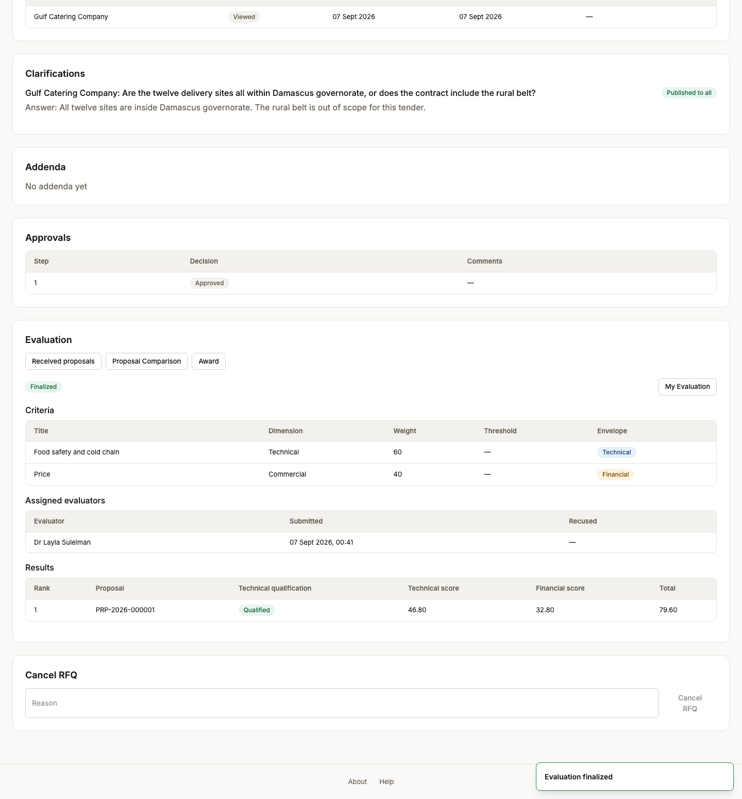
Screen 75, part 2 of 2 — bottom of the page

76. Award — nobody recommended yet
Persona procurement_officer
Screen Award — nobody recommended yet (/back-office/rfqs/RFQ-2026-000001/award)
What just happened The award screen before any decision. A winner is recommended by the officer and approved by somebody else, and the screen carries both halves so the separation is visible rather than implied.
What to do next Recommend the winning bid with a justification.
What to say “The award screen before any decision has been taken. Nobody is recommended yet.”
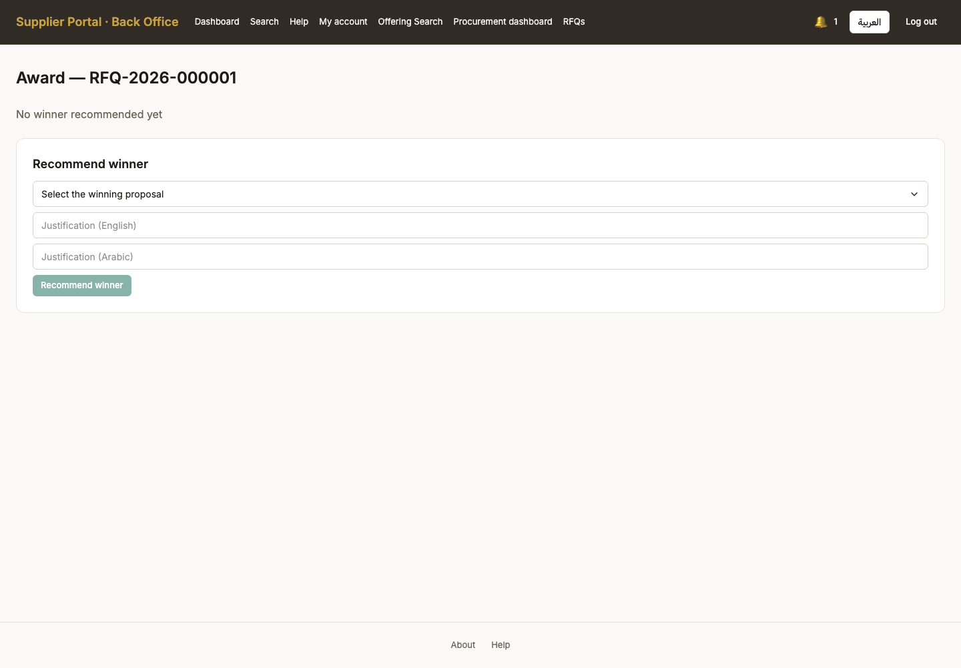

77. Winner recommended
Persona procurement_officer
Screen Winner recommended (/back-office/rfqs/RFQ-2026-000001/award)
What just happened A recommendation, with a written justification, naming the bid rather than the company - and it decides nothing on its own. It waits for a manager.
What to do next Route it for approval.
What to say “A recommendation, with a written justification, naming the bid. It decides nothing on its own.”
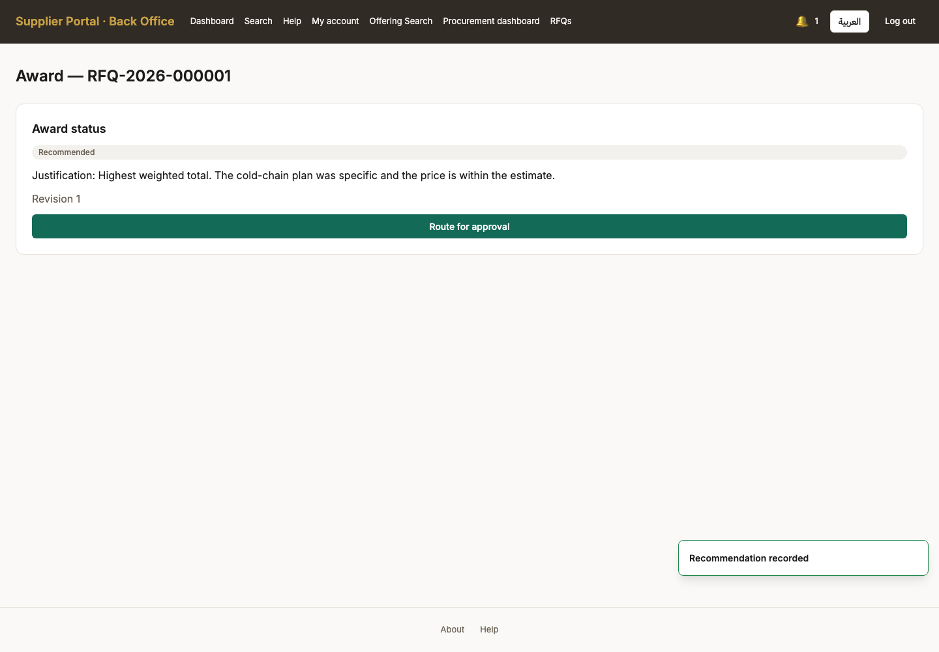

78. Routed for approval
Persona procurement_officer
Screen Routed for approval (/back-office/rfqs/RFQ-2026-000001/award)
What just happened Handed on. The recommender has done all they can do: approving their own recommendation is the one thing the system will not let them attempt.
What to do next The manager who approved the tender tries to approve the award.
What to say “Handed on. The recommender has now done everything they are allowed to do.”
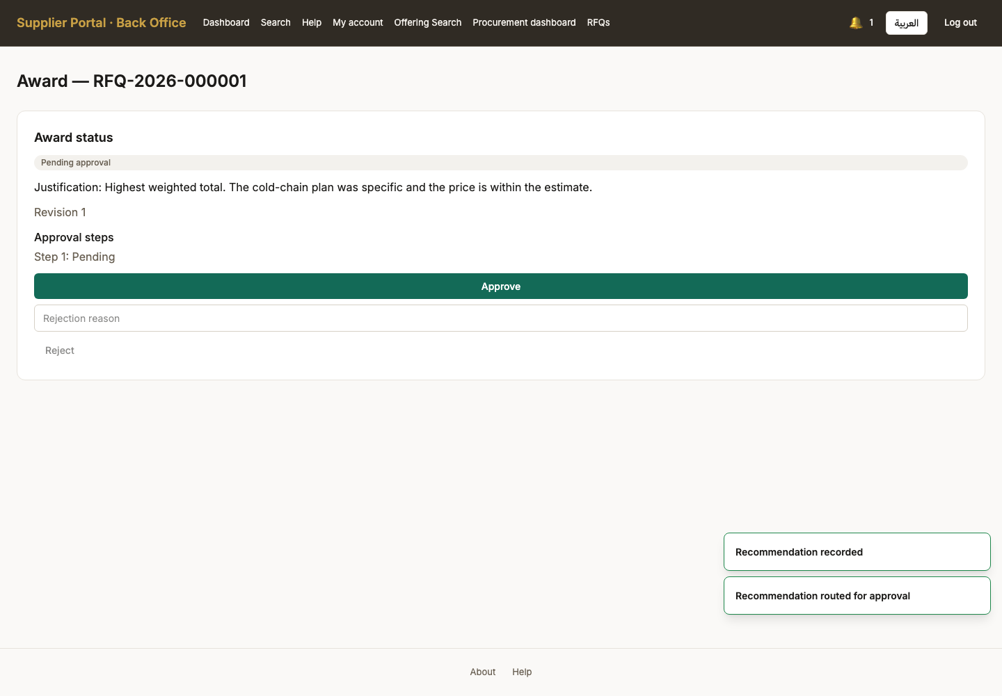

79. Self-approval refused
Persona procurement_officer
Screen Self-approval refused (/back-office/rfqs/RFQ-2026-000001/award)
What just happened Refused, and this is the product working: §6.1 requires the approver to differ from the recommender. The server said so explicitly. It is the most confusing dead end here, which is exactly why it is worth seeing once.
What to do next A second manager approves it.
What to say “This refusal is the product working, not a fault. Segregation of duties: the person who recommends may not approve.”
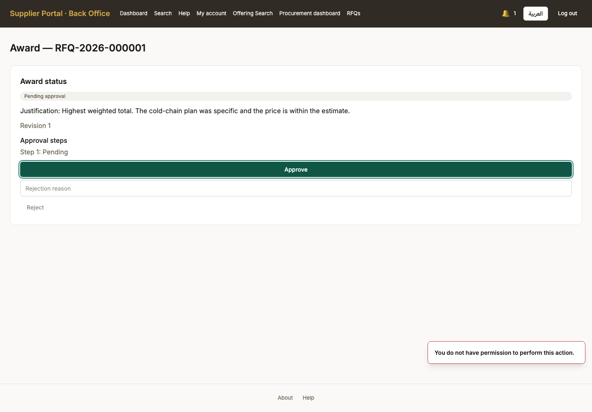

80. Award awaiting a second pair of eyes
Persona procurement_manager
Screen Award awaiting a second pair of eyes (/back-office/rfqs/RFQ-2026-000001/award)
What just happened The second manager sees the recommendation, the justification, and the bid it names. They did not write it and did not recommend it, which is the whole point of them being the one to approve it.
What to do next Approve the award.
What to say “A second manager, who did not write the recommendation, sees the recommendation, the justification and the bid it names.”
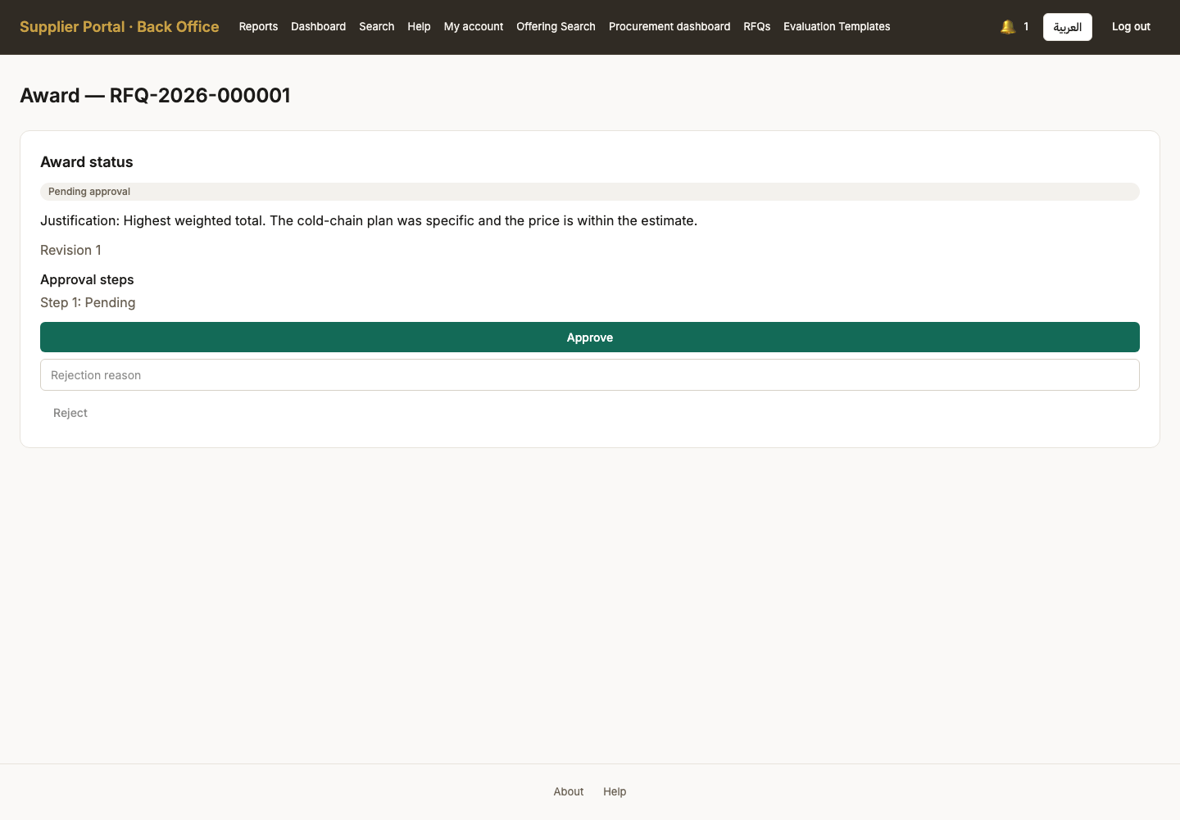

81. Award approved
Persona procurement_manager
Screen Award approved (/back-office/rfqs/RFQ-2026-000001/award)
What just happened Approved by somebody other than the recommender. The tender now has a winner, and the supplier is about to be told.
What to do next The officer issues it, which is what notifies the supplier and starts the ERP sync.
What to say “Approved by somebody other than the recommender. The tender has a winner.”
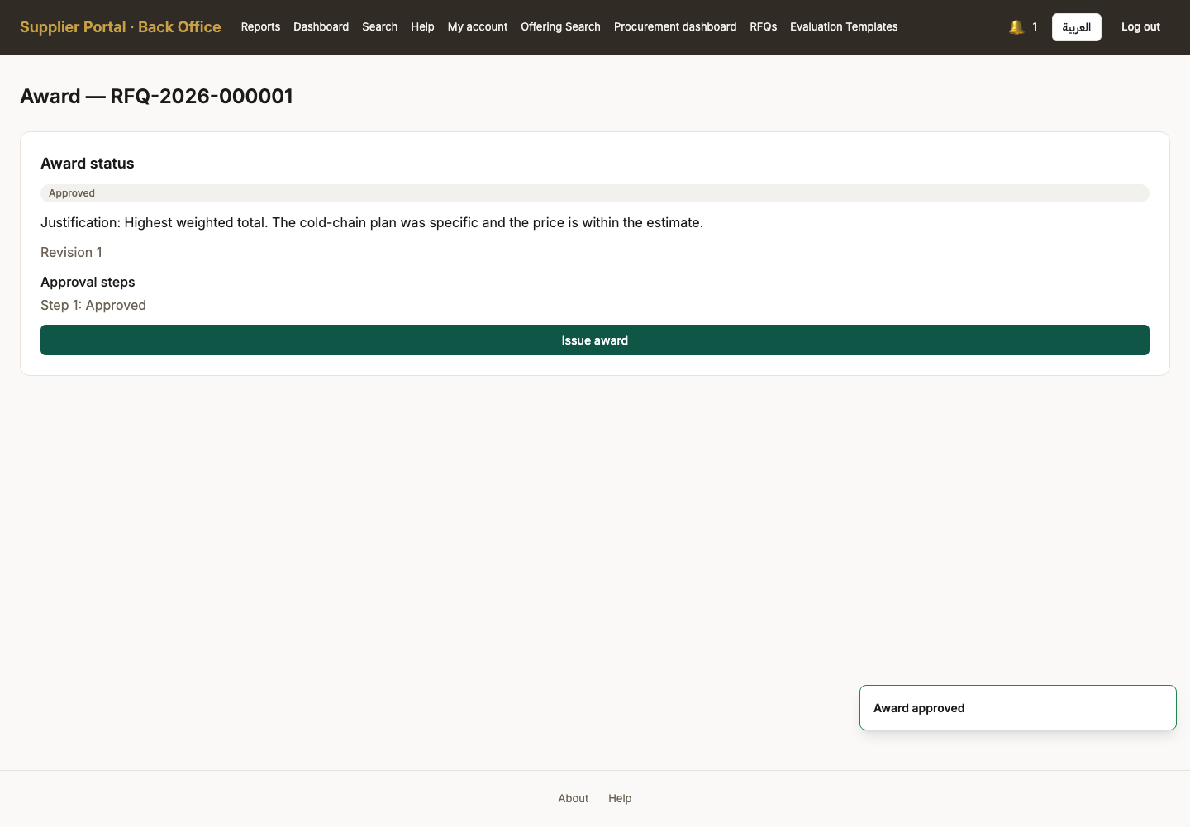

82. Award issued
Persona procurement_manager
Screen Award issued (/back-office/rfqs/RFQ-2026-000001/award)
What just happened Issued. This is the point at which the outcome leaves the building: the winning supplier is notified, and an integration message is queued for the ERP so a purchase order can be raised against it.
What to do next Check the ERP sync, then look at the outcome as the supplier.
What to say “Issued. This is the point at which the outcome leaves the building — the winner is notified and the integration message is queued.”
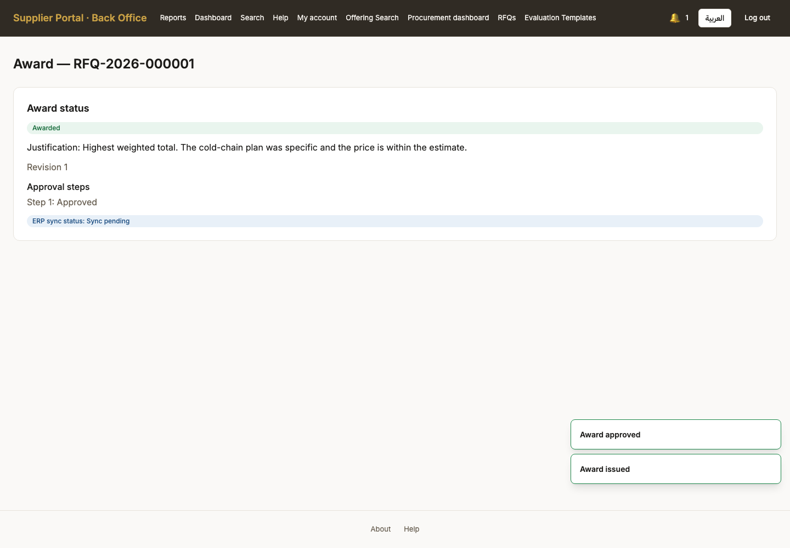

Act 16 — The outcome, and the ERP seam
What the winning supplier sees, and what happened to the integration message the award queued.

83. The supplier sees the outcome
Persona supplier_admin
Screen The supplier sees the outcome (/proposals)
What just happened The bid the supplier submitted now shows its result. Their own price is visible to them at every state - the two-envelope seal governs what the BUYER may see, and hiding a bid from the company that wrote it would be a bug wearing the costume of a security feature.
What to do next Check the ERP sync as the administrator.
What to say “The supplier sees the result of the bid they submitted. Their own price was visible to them throughout; the buyer's view of it was not.”
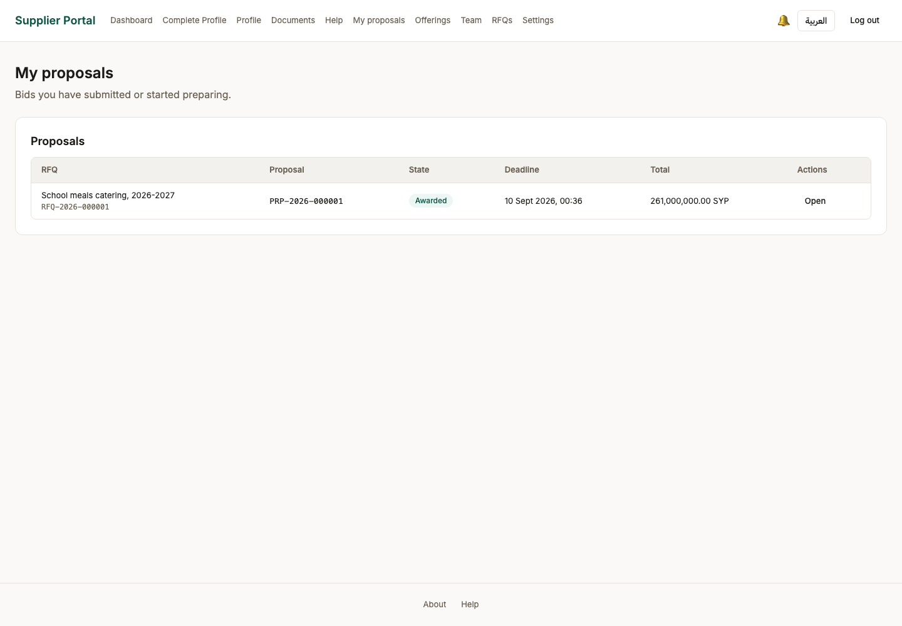

84. Operations — jobs, outbox and ERP
Persona system_admin
Screen Operations — jobs, outbox and ERP (/back-office/operations)
What just happened The issued award queued an integration message. This card is honest about what happens to it: NO REAL ERP TRANSPORT IS CONFIGURED in this environment, and the screen says so rather than showing a column of Synced produced by a logging stand-in that accepts everything and sends nothing.
What to do next Look at the rest of the administrator surface.
What to say “The award queued an integration message, and this screen is honest about what happens to it: there is no real ERP connected yet, and it says so rather than showing a green tick.”
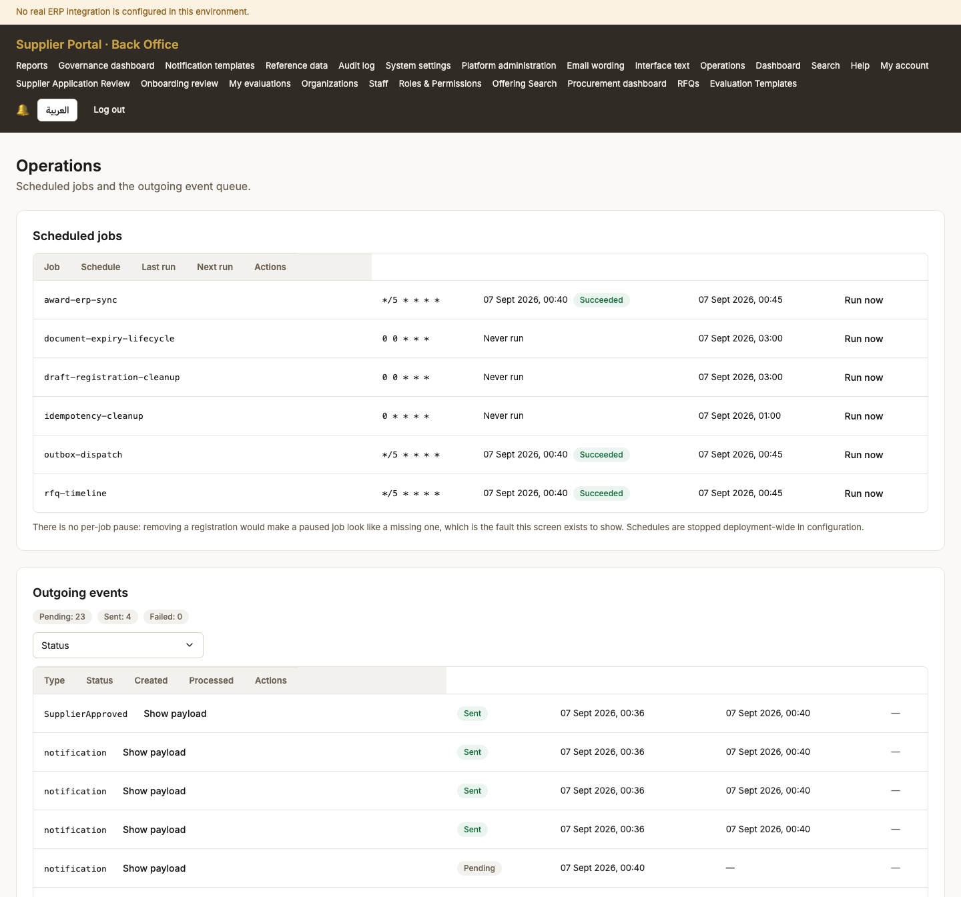
Screen 84, part 1 of 3 — top of the page

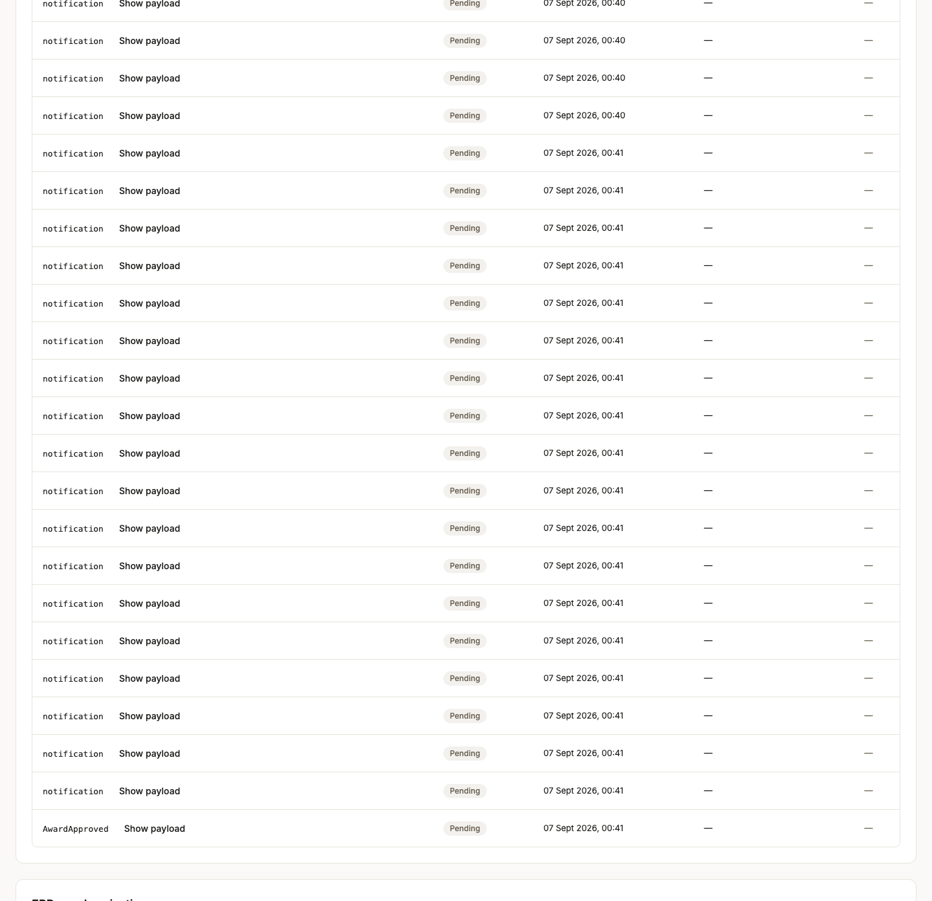
Screen 84, part 2 of 3 — continued

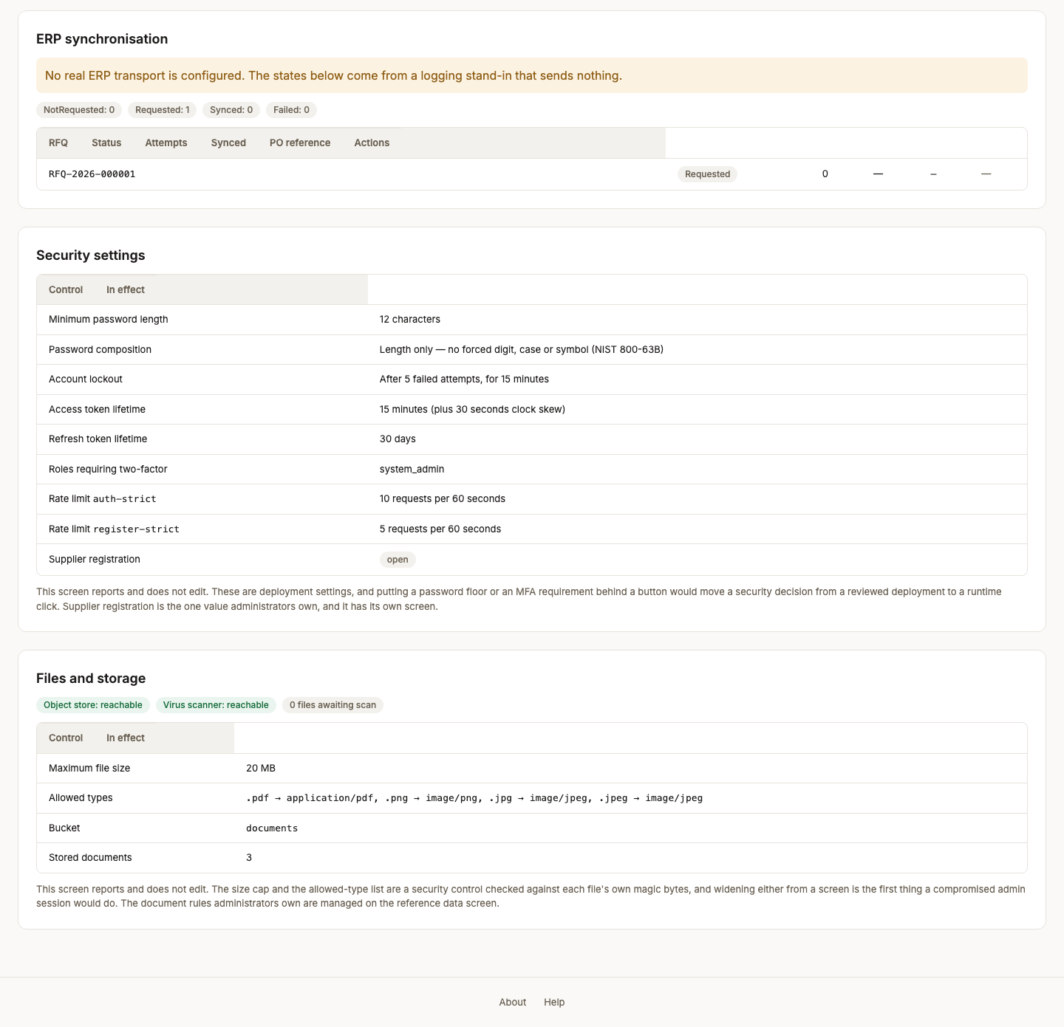
Screen 84, part 3 of 3 — bottom of the page

Act 17 — Each persona’s own screens
The screens that belong to a persona rather than to the tender: the administrator’s platform tools, the Ministry’s overview, and the supplier’s own account.

85. Platform administration
Persona system_admin
Screen Platform administration (/back-office/admin)
What just happened The administrator overview: counts, health and the state of the integrations.
What to do next Continue through the administrator screens.
What to say “The rest of the walk is each persona's own screens. This is the administrator's overview: counts, health, integrations.”
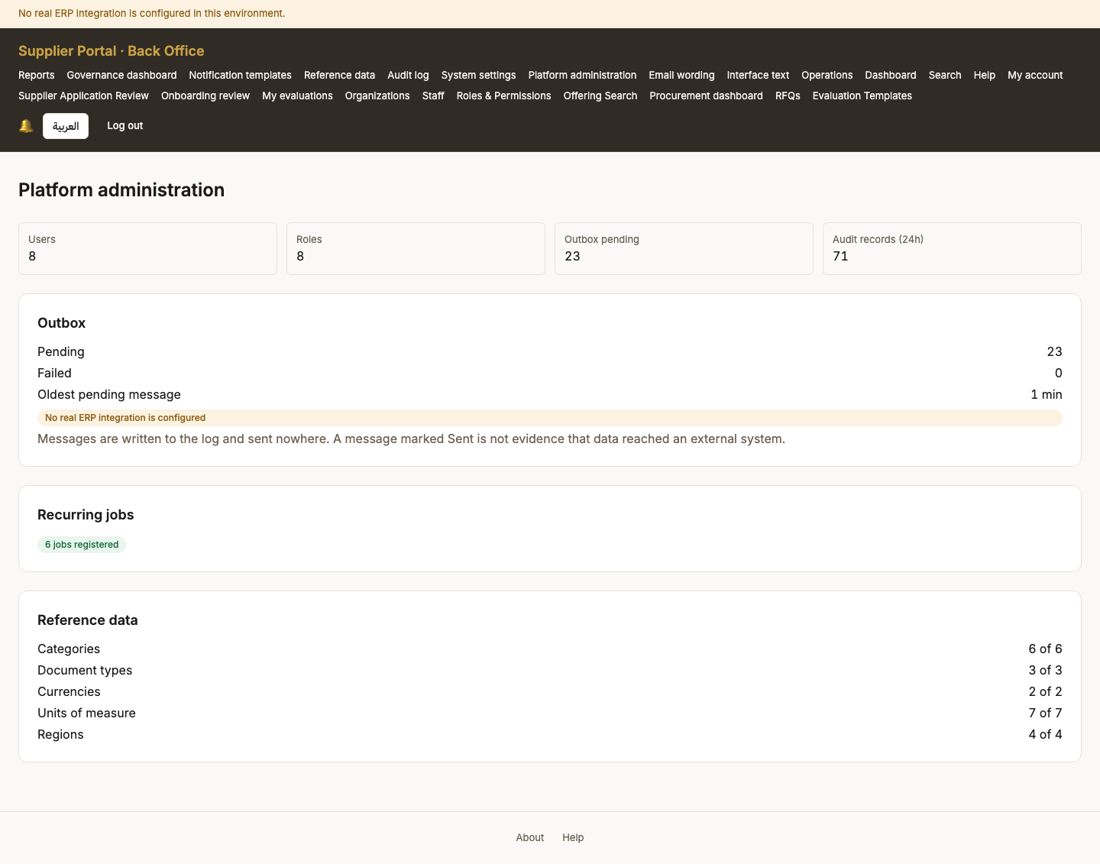

86. Reference data
Persona system_admin
Screen Reference data (/back-office/reference)
What just happened The code lists everything else is built from - categories, document types, currencies, units, regions. Codes are deactivated, never deleted, because they are foreign keys in live rows.
What to do next Continue through the administrator screens.
What to say “The code lists everything else is built from — categories, document types, currencies, units, regions.”
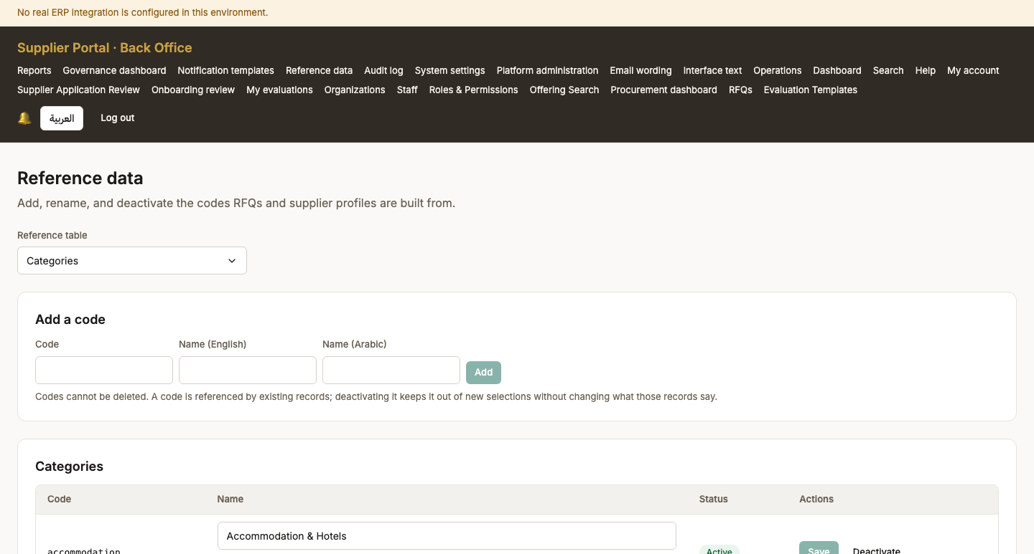
Screen 86, part 1 of 2 — top of the page

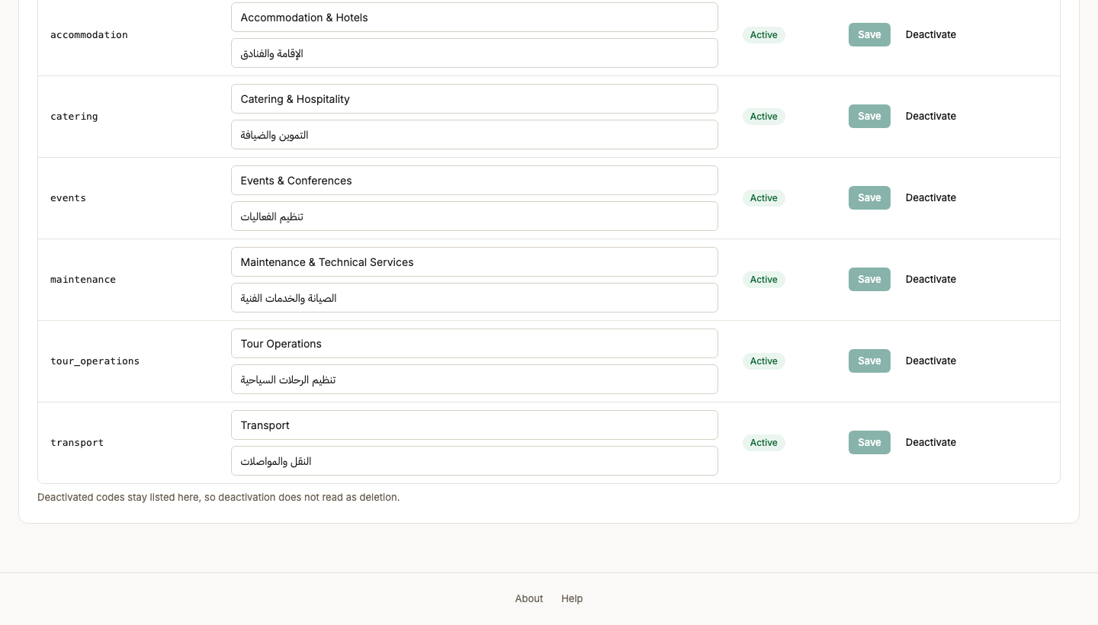
Screen 86, part 2 of 2 — bottom of the page

87. Interface text
Persona system_admin
Screen Interface text (/back-office/ui-strings)
What just happened Any string in the product can be reworded here without a release. The people who own the wording are not the people who own deployments.
What to do next Continue through the administrator screens.
What to say “Any string in the product can be reworded here without a release, because the people who own the wording are not the people who deploy.”
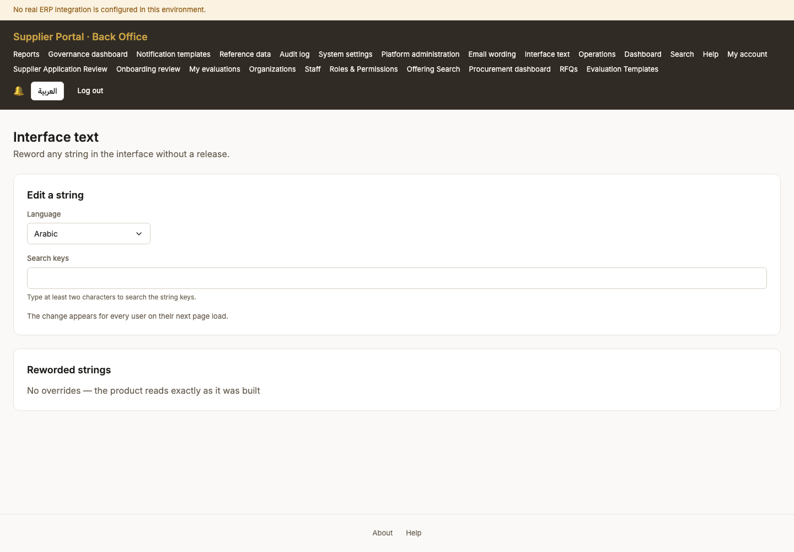

88. Email wording
Persona system_admin
Screen Email wording (/back-office/email-templates)
What just happened The transactional emails, with their required tokens shown. A save that drops {verifyUrl} is refused, because an email that loses it locks the recipient out of the account they are creating.
What to do next Continue through the administrator screens.
What to say “The transactional emails, with their required tokens shown. A save that drops the verification link is refused.”
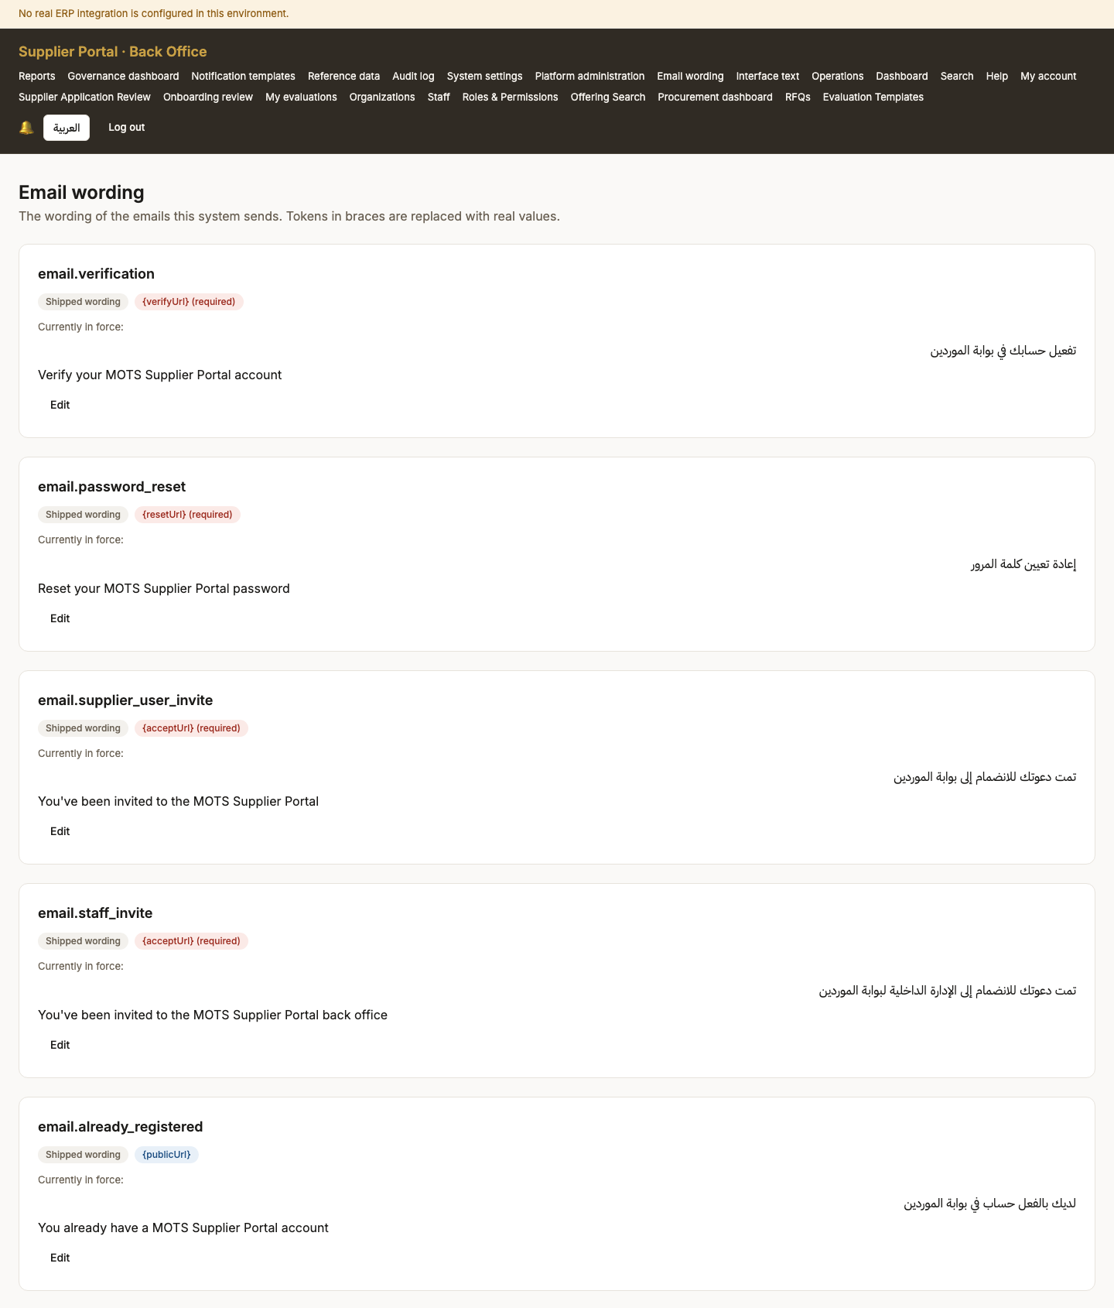
Screen 88, part 1 of 4 — top of the page

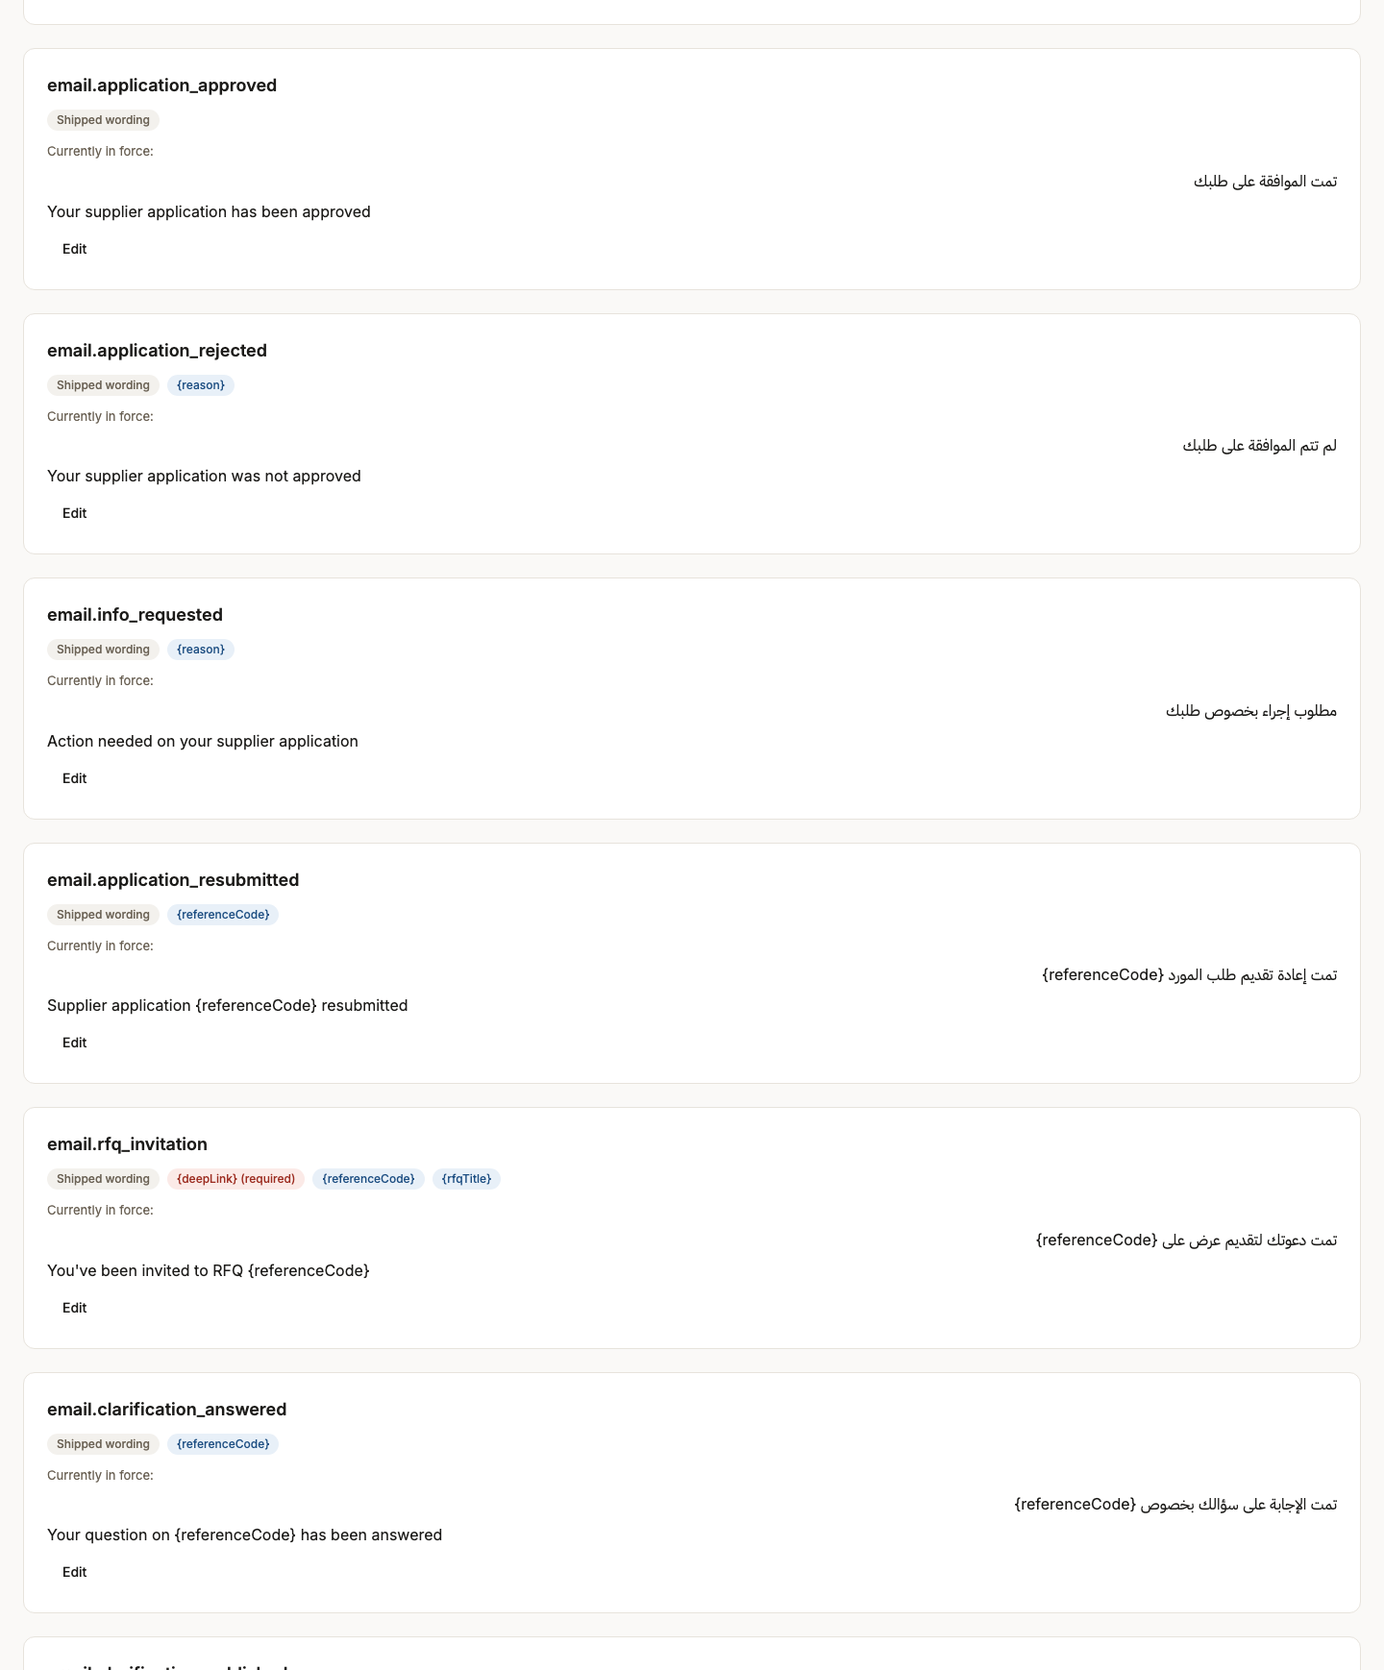
Screen 88, part 2 of 4 — continued

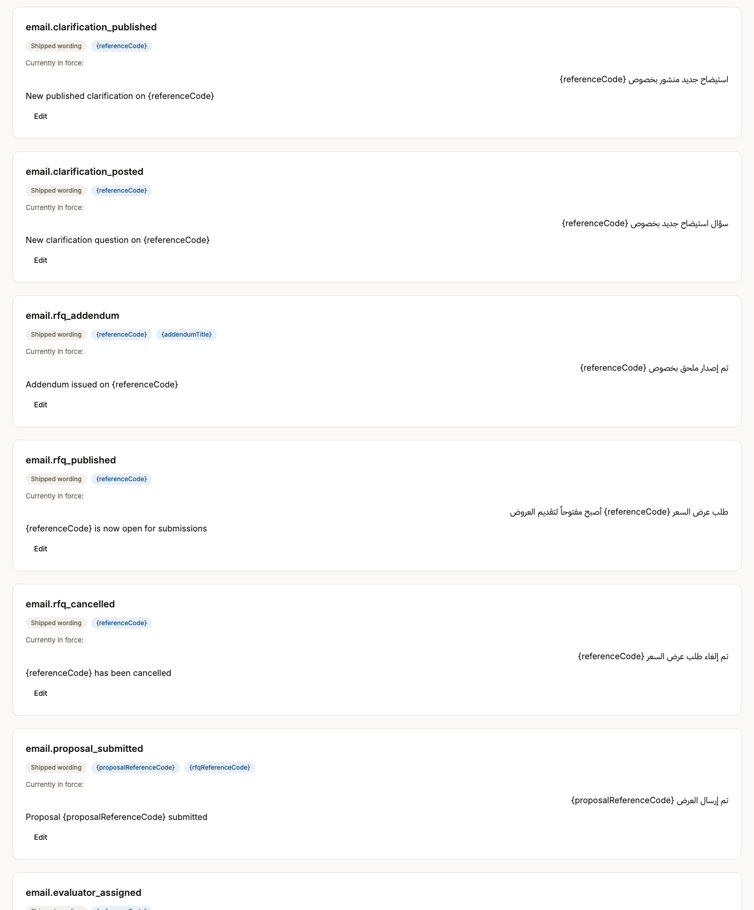
Screen 88, part 3 of 4 — continued

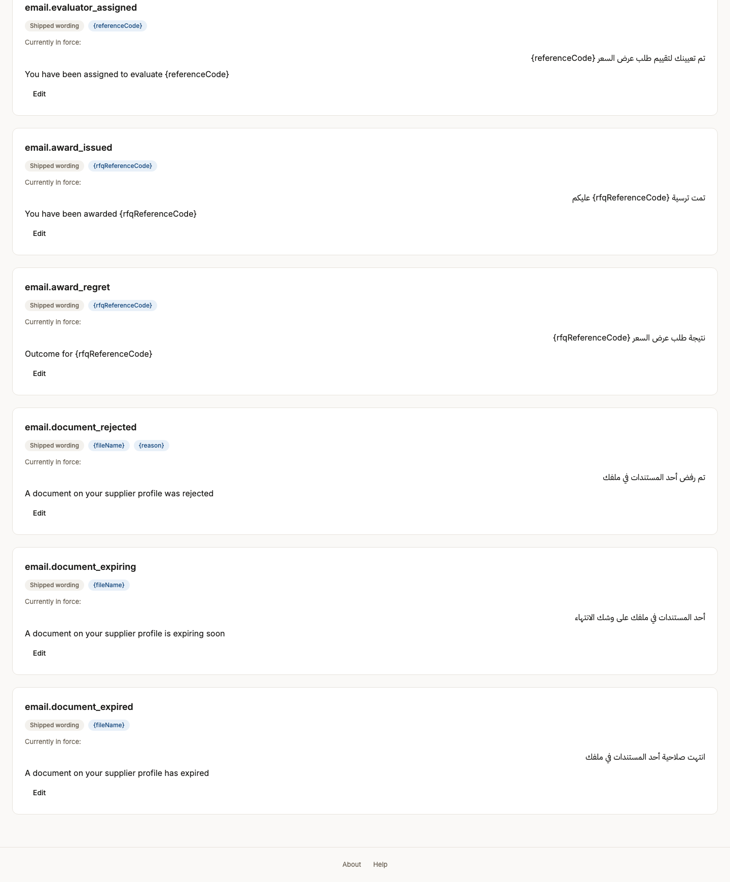
Screen 88, part 4 of 4 — bottom of the page

89. Audit log
Persona system_admin
Screen Audit log (/back-office/audit)
What just happened Every state change, with an actor and a correlation id. Append-only: this is the record that makes an approval accountable months later.
What to do next Continue through the administrator screens.
What to say “Every state change, with an actor and a correlation id, append-only. This is the record that makes an approval defensible a year later.”
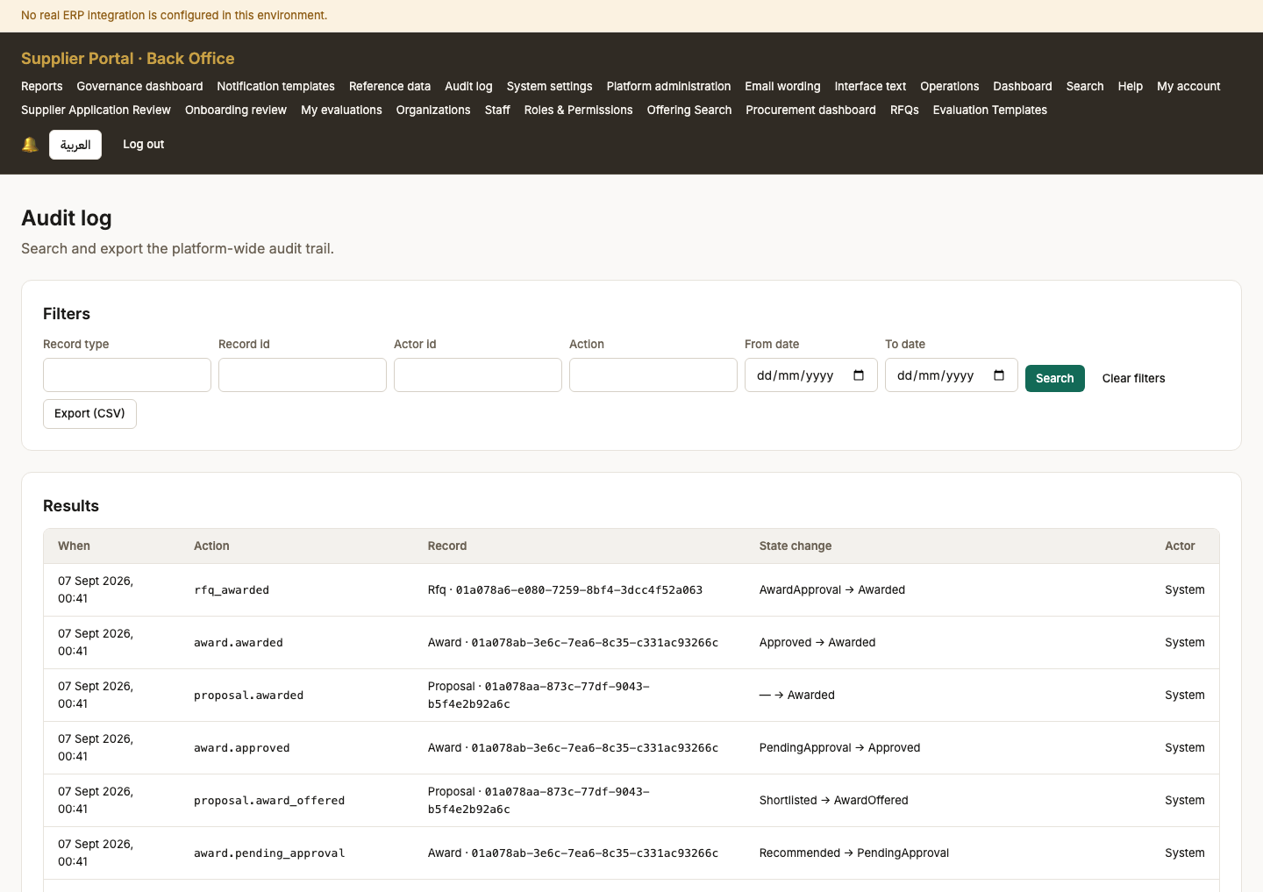
Screen 89, part 1 of 2 — top of the page

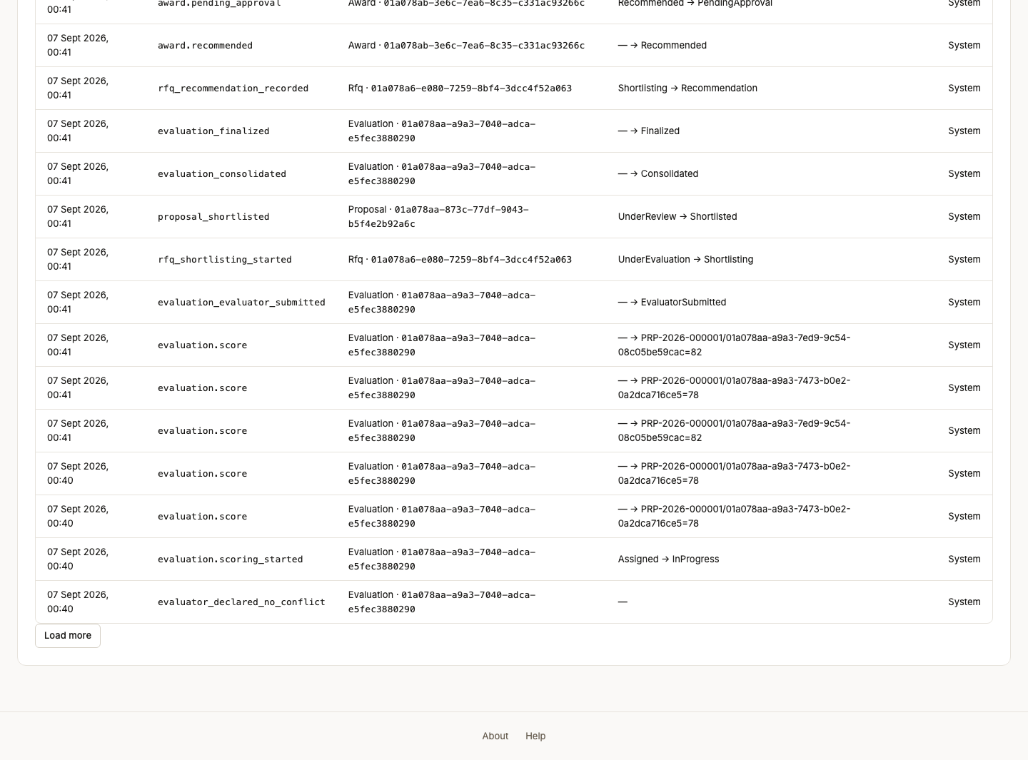
Screen 89, part 2 of 2 — bottom of the page

90. Organizations
Persona system_admin
Screen Organizations (/back-office/organizations)
What just happened The buying bodies, and the boundary every tender query is scoped by.
What to do next Continue through the administrator screens.
What to say “The buying bodies — the boundary every tender query is scoped by.”
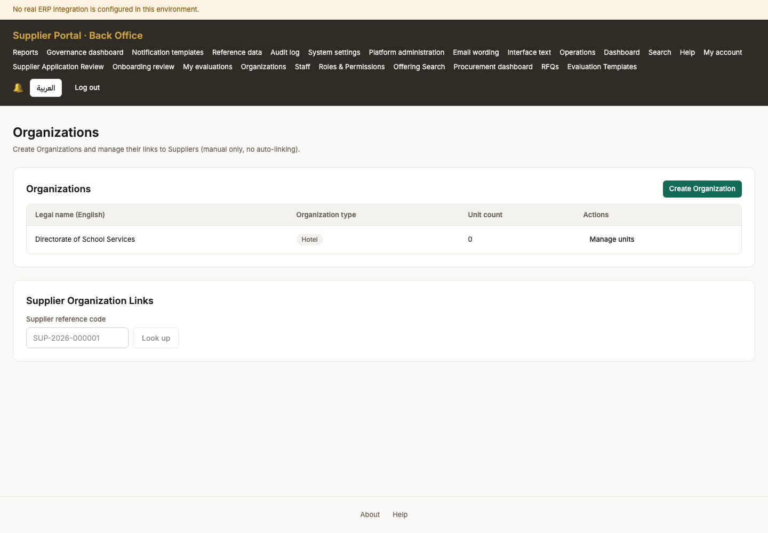

91. Ministry overview
Persona ministry_viewer
Screen Ministry overview (/back-office/ministry)
What just happened Cross-organization totals and nothing else. NO COMMERCIAL FIGURES APPEAR HERE, and that is a decision rather than an omission: it is held pending an answer from MOT Legal, and until then BRULE-086 grants aggregate access only, with BRULE-087 defaulting to aggregate-only wherever visibility is undecided. There is no drill-down to a named supplier or tender by design.
What to do next The Ministry viewer has no other working screen, which is the grant working as written.
What to say “The Ministry's view: cross-organization totals and no commercial figures at all. That is a decision, and I will explain it at the end.”
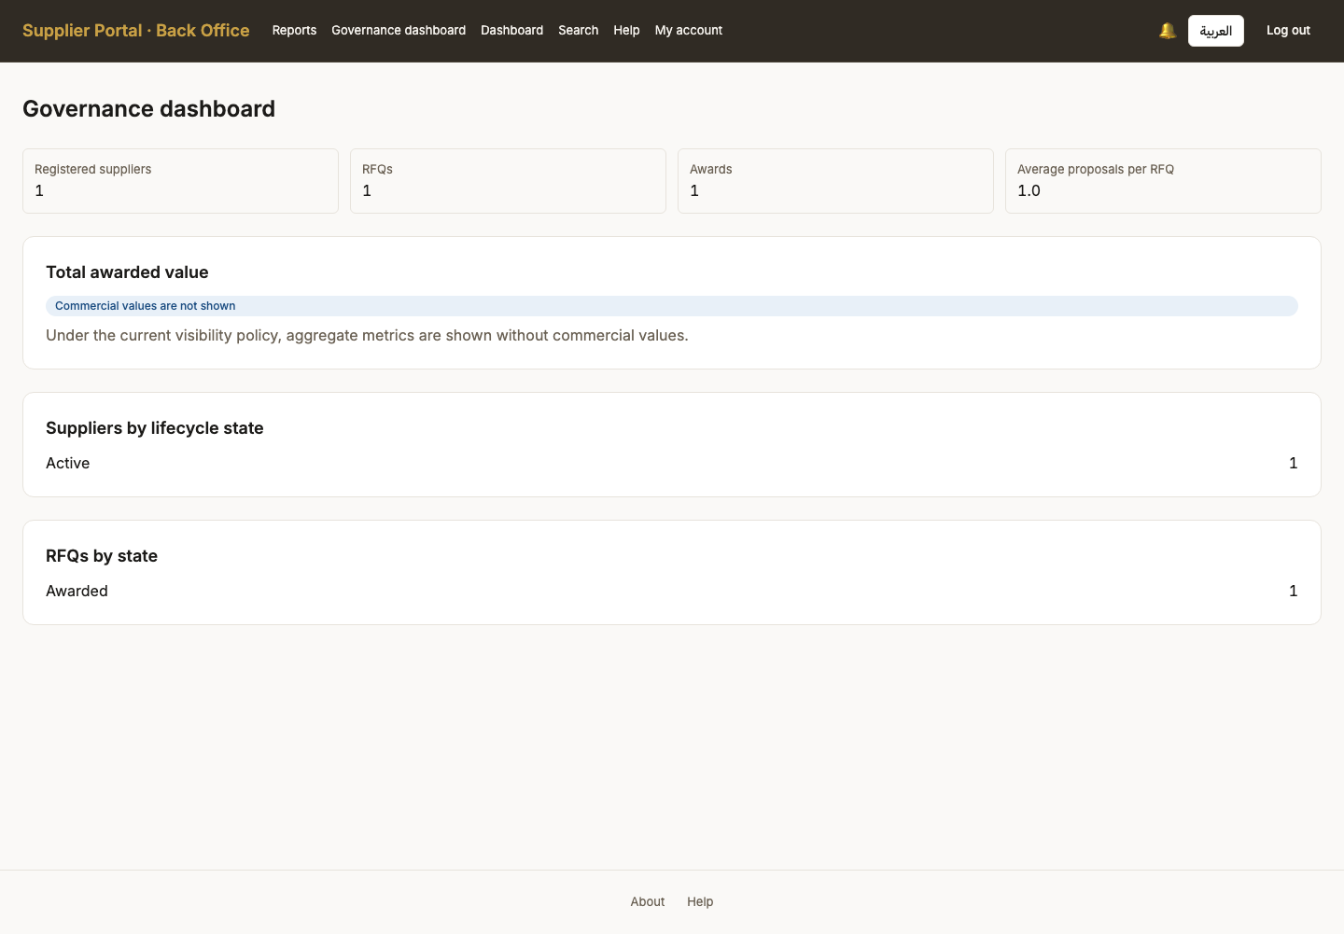

92. Supplier dashboard
Persona supplier_admin
Screen Supplier dashboard (/dashboard)
What just happened The supplier home once there is real activity: completeness, invitations, proposals and documents needing attention.
What to do next Continue through the supplier screens.
What to say “Back to the supplier, now with real activity: completeness, invitations, proposals, and documents needing attention.”
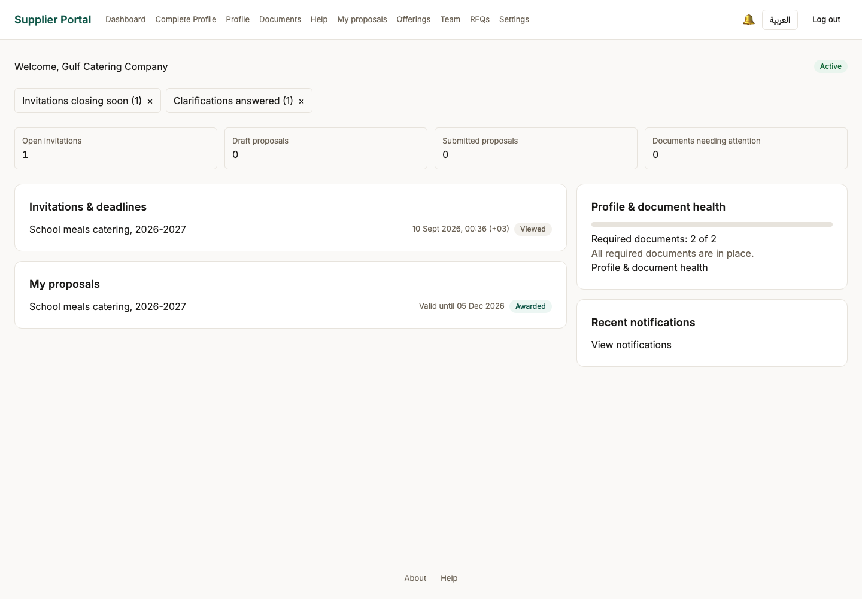

93. Supplier profile
Persona supplier_admin
Screen Supplier profile (/profile)
What just happened The company record as its own staff see it, each section linking to the editor rather than duplicating it.
What to do next Continue through the supplier screens.
What to say “The company record as its own staff see it, each section linking to the editor rather than duplicating it.”
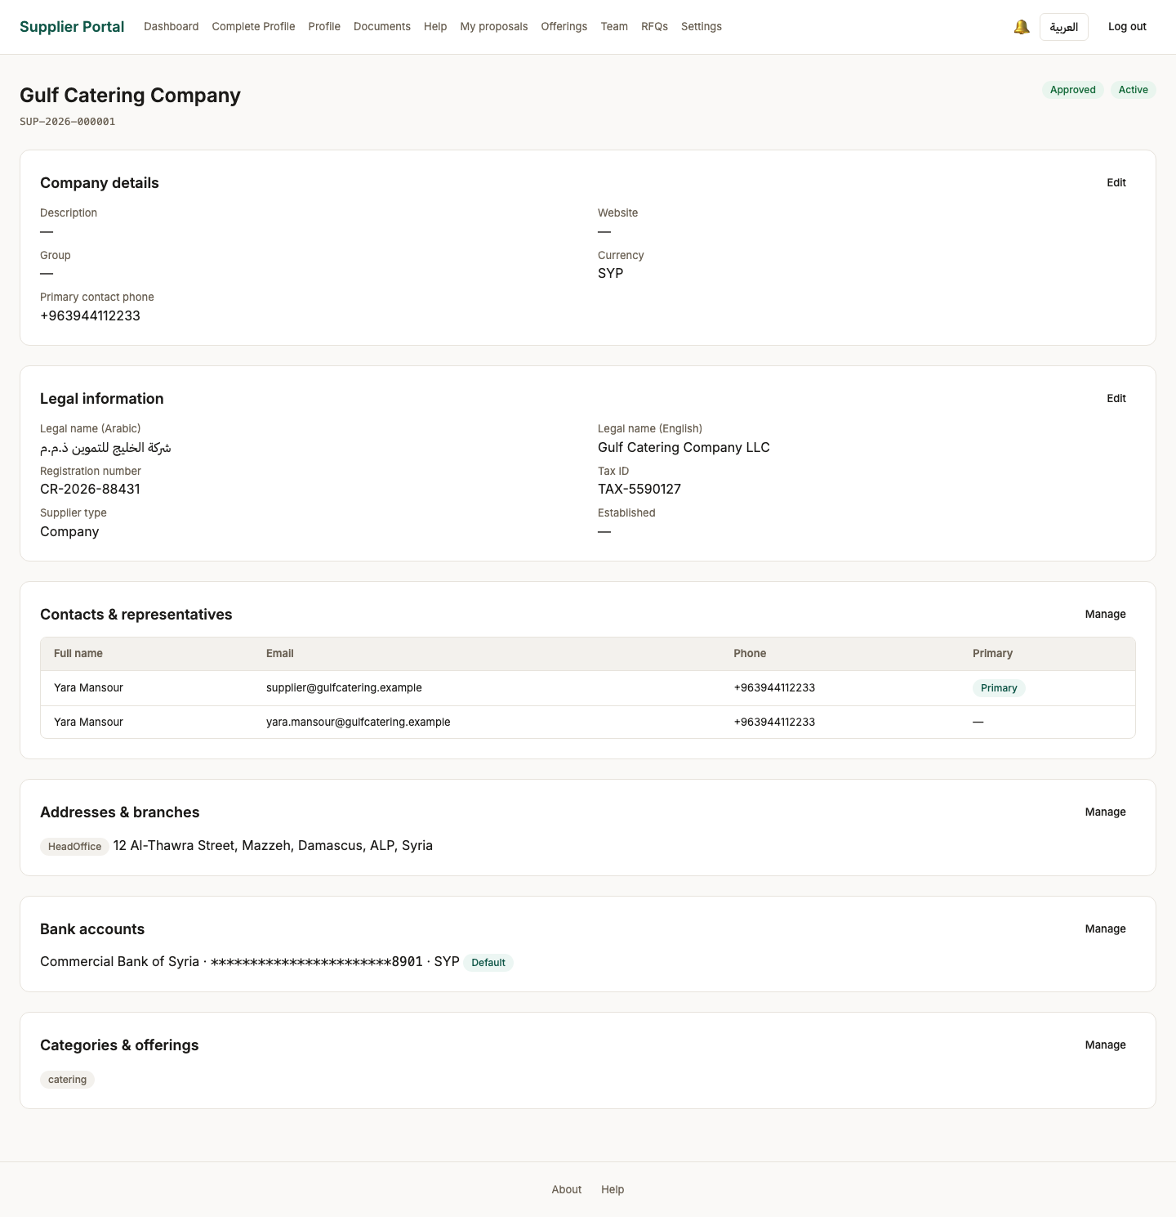

94. Documents centre
Persona supplier_admin
Screen Documents centre (/documents)
What just happened Every document type with its state and expiry, and a filter for the ones needing attention. Expiry is the state a daily job maintains, so this screen and the job cannot disagree.
What to do next Continue through the supplier screens.
What to say “Every document with its state and expiry, and a filter for the ones needing attention. Expiry is the thing that quietly disqualifies a supplier.”
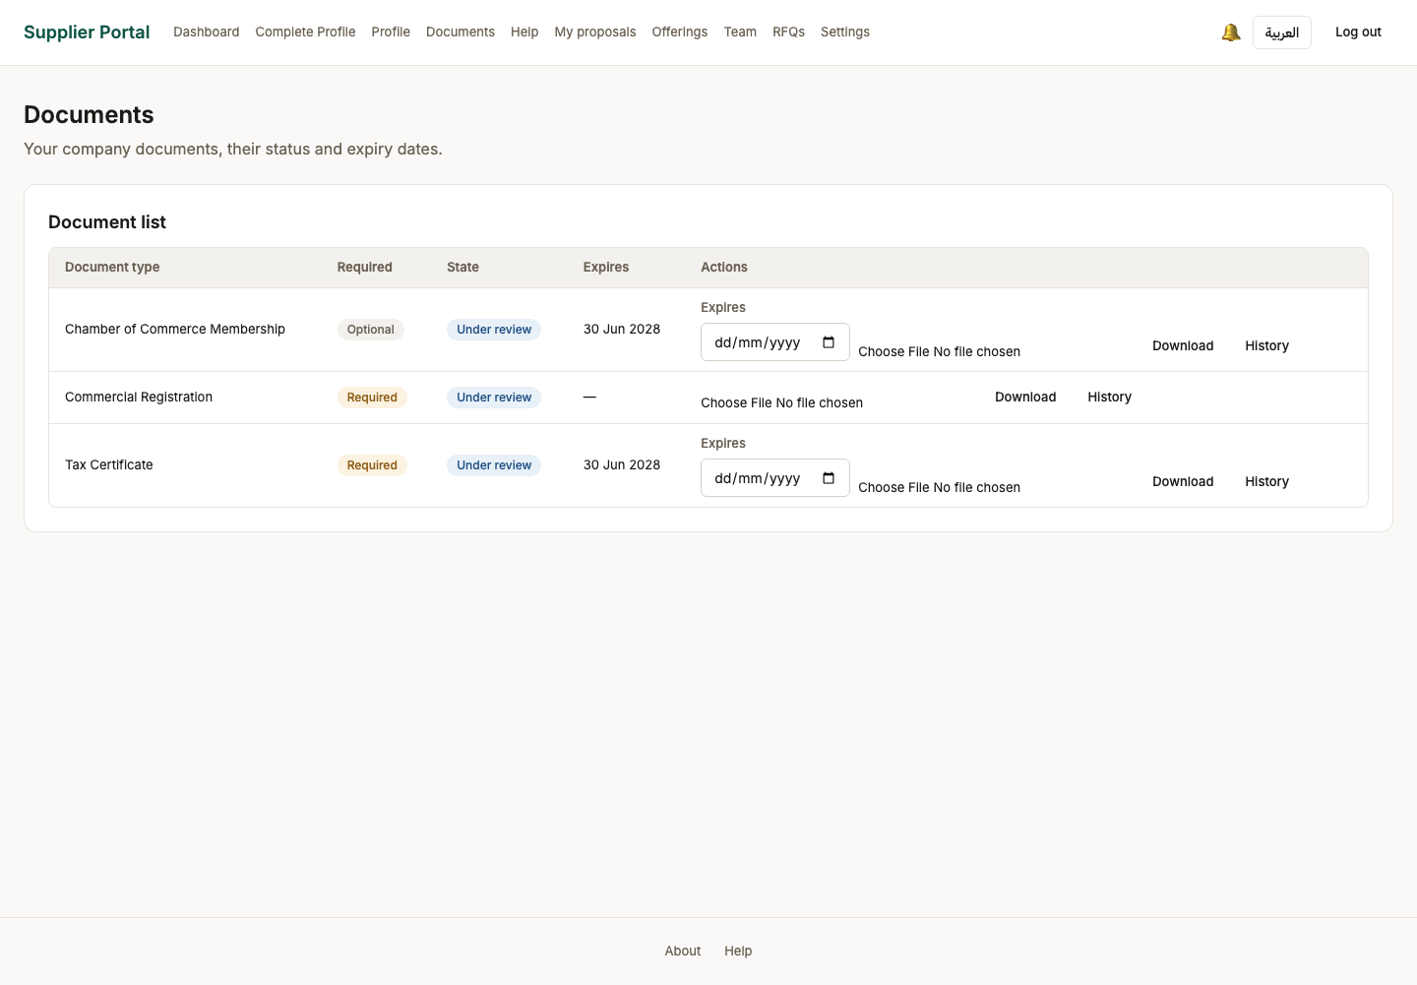

95. Team
Persona supplier_admin
Screen Team (/team)
What just happened The supplier invites its own colleagues. A supplier_user can prepare a bid; only a supplier_admin can submit one.
What to do next Continue through the supplier screens.
What to say “The supplier invites its own colleagues. A supplier user can prepare a bid; only a supplier admin can submit one.”
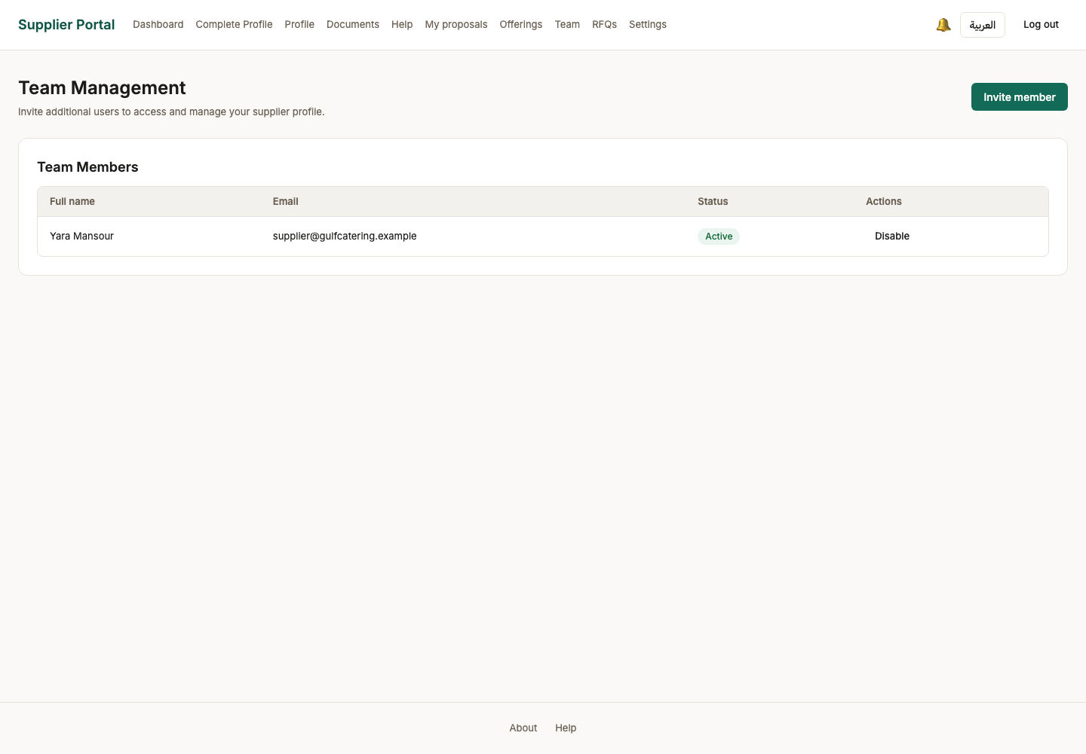

96. Settings
Persona supplier_admin
Screen Settings (/settings)
What just happened Account, language, password and active sessions.
What to do next Continue through the supplier screens.
What to say “Account, language, password and active sessions — and that is the whole system, from an empty database to an issued award.”
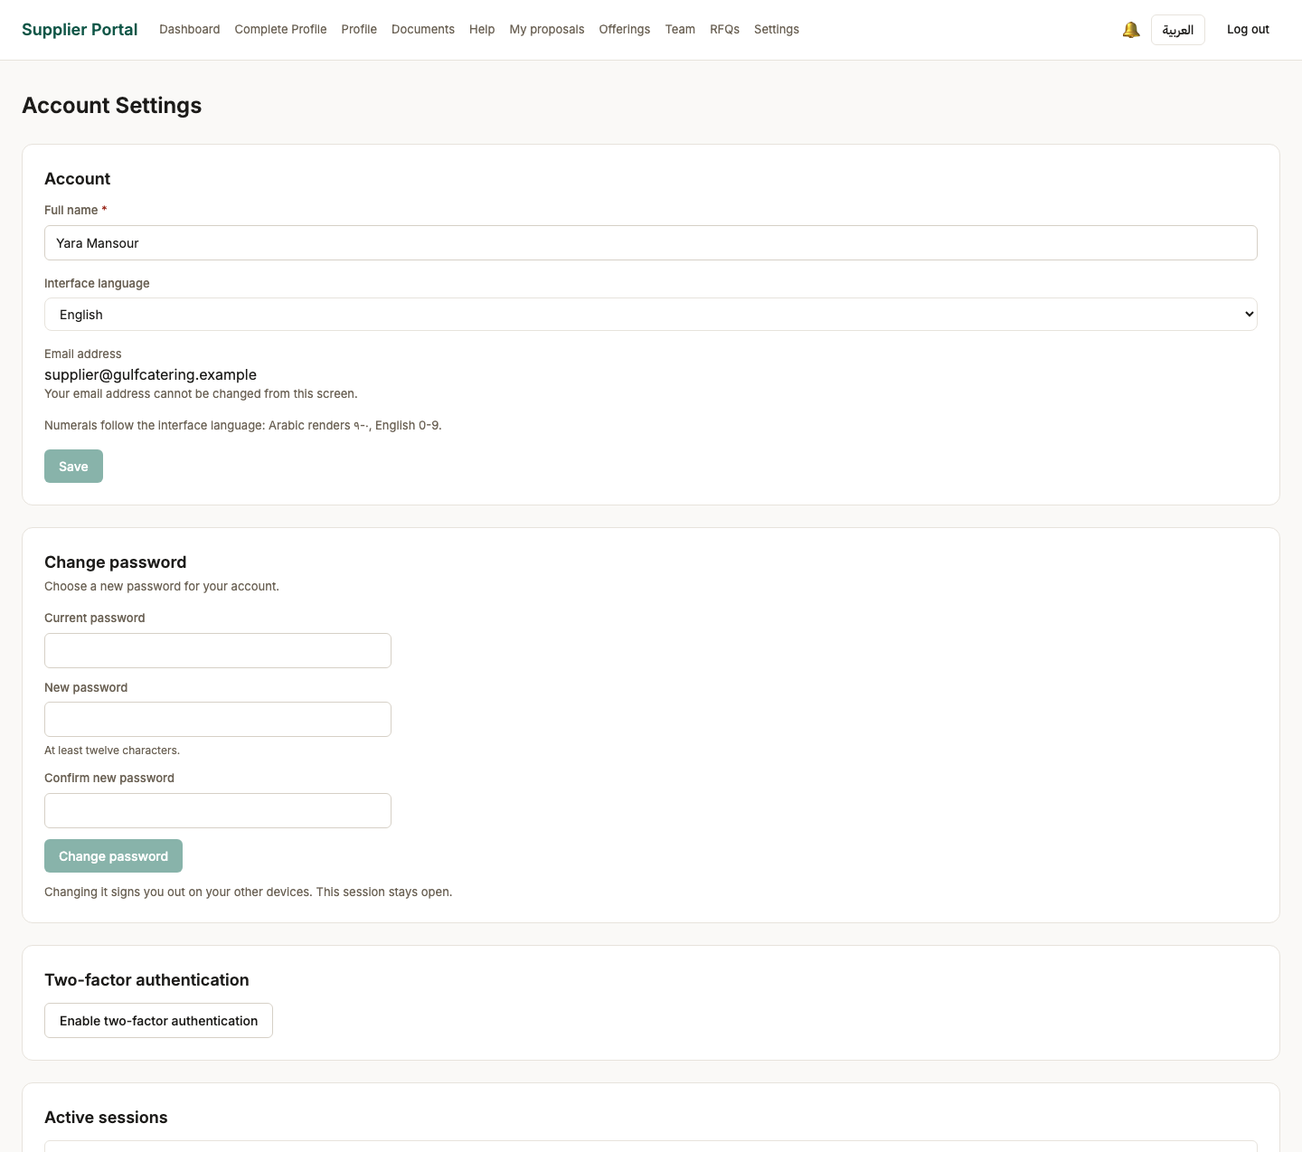
Screen 96, part 1 of 2 — top of the page

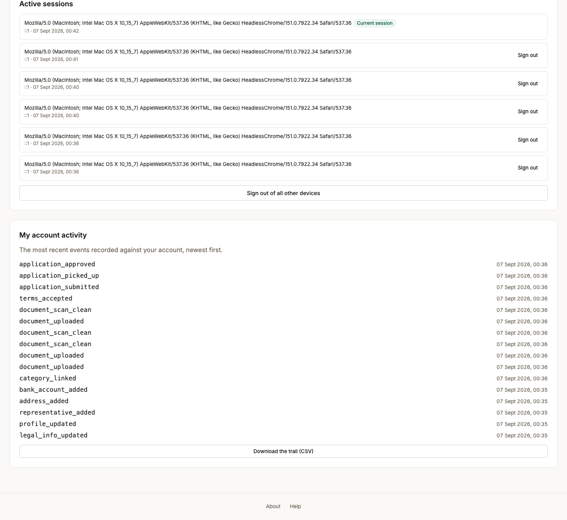
Screen 96, part 2 of 2 — bottom of the page

Things that look wrong and are not
Three answers worth having ready. Each one is a decision or an enforced rule, and each one looks like a defect the first time somebody meets it.

The Ministry dashboard shows no commercial figures
This is a deliberate hold, not missing work. What the Ministry may see has been referred to MOT Legal and has not been answered. BRULE-086 grants the Ministry aggregate, cross-organization access; BRULE-087 says that wherever visibility is undecided, the default is aggregate-only. So the overview carries counts and states and no bid values, no supplier names against those values, and no drill-down into an individual tender.
If asked what happens when the answer comes back: the screen gains figures, and the permission that reaches them is one row in the seed. Nothing has to be rebuilt.

Uploads are refused when the virus scanner is down
The scanner is fail-closed by design: any failure — including the scanner being unavailable — is folded into “infected” rather than letting an unscanned file through. With clamd stopped, onboarding cannot be completed, and that is correct behaviour, not an outage in the portal.
If a demonstration machine starts refusing every upload, start the scanner before filing a bug.

The orderings the product enforces, and why
Each of these was found by being refused during the walk. They are rules, not accidents, and any of them will look like a bug to somebody trying to skip a step.
The rule | Why it exists
Invitations come before approval, not after publication | A tender cannot be sent for internal review without at least one invited candidate — and it cannot be sent with a submission window that has already started. Approval is a judgement about a complete tender, and who it is going to is part of it.
A supplier is only invitable once approved AND listing an offering | The categories ticked at sign-up say what a company does in principle. The offering is the concrete thing it sells, and it is what a buyer is actually inviting a bid on.
A scoring template must be activated before a tender can bind it, and binding comes before review | A template in draft can still change. Binding freezes the criteria against the tender, so bidders and evaluators are working from the same fixed scheme — and the reviewer approving the tender can see what it will be judged by.
The submission window opens on a schedule, not on publication | Publication and opening are separate so a tender can be published in advance of the date bidding starts. A job moves it when the start time passes; no person presses anything.
The financial envelope stays locked until technical qualification | Two-envelope evaluation. An evaluator judges the answer before knowing the price, so the price cannot colour the technical score. The financial criterion is visible but disabled until the bid passes technically.
The officer who recommends may not approve | Segregation of duties, §6.1. The recommender is offered no Approve control at all, and the endpoint refuses it as well — hiding the affordance is a courtesy, the refusal is the control.

If something goes wrong during the demonstration
Symptom | Most likely cause
Every document upload is refused | clamd is not running. Fail-closed, as above.
“Invalid email or password” on a password you know is right | The sign-in rate limit answers before the password is checked. Wait a minute. The message now says so explicitly, but an older build does not.
A tender will not move to internal review | It needs an invited candidate, a bound template, and a submission window that has not already started.
The submission window has not opened | The job runs every five minutes. Wait for it rather than looking for a button.
A screen shows no data at all | Check which persona is signed in. Almost every list here is scoped to an organization or to an invitation.

