MedAssist.ai
Smart Clinical Decision Support System

Detailed Project Report

Project Type: Full-Stack AI-Powered Healthcare Web Application
License: MIT License — Copyright © 2026 Zaid
Runtime: Python 3.11.9
Total Codebase: ~6,100 lines across 8 core source files

Table of Contents
Table of Contents 2
1. Abstract 4
2. Introduction 4
3. Problem Statement 5
4. Literature Review 5
4.1 Clinical Decision Support Systems 5
4.2 Random Forest for Disease Classification 5
4.3 Probability Calibration 5
4.4 Large Language Models in Healthcare 5
5. Objectives 6
6. System Architecture 6
6.1 High-Level Architecture 6
6.2 Data Flow 7
7. Technology Stack 8
7.1 Backend Technologies 8
7.2 Frontend Technologies 8
7.3 Machine Learning Stack 9
7.4 Infrastructure 9
8. Dataset Description 9
8.1 Training Dataset 9
8.2 Feature Breakdown 10
8.3 Disease Classes (All 41) 10
8.4 Test Dataset 10
8.5 Data Preprocessing Pipeline 10
9. Machine Learning Methodology 10
9.1 Algorithm Selection 10
9.2 Training Pipeline 11
9.3 Hyperparameter Tuning 12
9.4 Probability Calibration 13
9.5 Prediction Engine 13
9.6 Feature Importance Analysis 13
10. External API Integrations 14
10.1 Groq Cloud LLM API 14
10.2 Geoapify Places API 14
10.3 Brevo (Sendinblue) REST API 14
11. Backend Architecture 15
11.1 Database Schema 15
11.2 Database Connection Resilience 16
12. Frontend Architecture 16
12.1 Design System 16
12.2 Page Templates 16
12.3 Client-Side JavaScript Modules 16
13. Automation & Background Jobs 17
13.1 Appointment Reminder System 17
14. Authentication & Security 18
14.1 Authentication Flow 18
14.2 Security Measures 19
14.3 Guest/Demo Mode 19
15. API Reference 19
15.1 Public Endpoints 19
15.2 Protected Endpoints (Auth Required) 20
16. Deployment & DevOps 20
17. Testing & Evaluation Results 20
17.1 Machine Learning Evaluation 20
17.2 Fuzzy Matching Validation 21
18. Project Directory Structure 21
19. Screenshots & User Interface 22
20. Future Scope 23
21. Conclusion 24
22. References 24

1. Abstract
MedAssist.ai is an intelligent, AI-powered Clinical Decision Support System (CDSS) designed to bridge the gap between symptom onset and medical consultation. The platform enables users to input their symptoms through an intuitive, mobile-first interface and receive probabilistic disease predictions powered by a calibrated Random Forest machine learning model trained on a dataset of 4,920 medical records spanning 41 diseases and 131 clinical symptoms.
Beyond diagnosis, the system integrates a Groq-powered Large Language Model (LLM) chatbot for conversational health guidance, a Geoapify-based hospital locator with disease-specific specialty matching, and a complete appointment booking system with automated email reminders. The platform achieves 98% Top-1 accuracy and 100% Top-3 accuracy on independent test data, ensuring that the correct diagnosis is consistently presented within the top three predictions.
The application is deployed as a production-ready web service on Render, backed by a Neon PostgreSQL cloud database, and serves both authenticated users with full history tracking and guest users with a limited demo experience.

2. Introduction
Clinical Decision Support Systems (CDSS) are computer-based programs that assist healthcare professionals and patients in making informed clinical decisions. With the rising global burden of disease and the increasing shortage of healthcare professionals, there is a critical need for accessible, intelligent tools that can provide preliminary health assessments.
MedAssist.ai addresses this need by providing:
- Instant Disease Prediction: Users select their symptoms and receive ranked diagnoses with calibrated confidence scores within seconds.
- AI Health Consultation: A conversational chatbot provides health education, lifestyle advice, and safety guidance.
- Healthcare Facility Discovery: Location-based hospital search with intelligent specialty matching based on the diagnosed condition.
- Appointment Management: End-to-end appointment booking with automated confirmation and reminder emails.
The system is designed with a mobile-first, premium UI philosophy and implements modern web design principles including glassmorphism, micro-animations, and responsive layouts to provide an engaging and trustworthy user experience.

3. Problem Statement
In many regions, access to timely medical consultation is limited by factors including geographical distance, cost, and doctor availability. Patients often face the following challenges:
- Symptom Uncertainty: Difficulty in understanding the significance of symptoms and whether immediate medical attention is required.
- Information Overload: Unreliable internet health searches that either cause unnecessary panic or dangerous complacency.
- Hospital Discovery: Lack of awareness about nearby healthcare facilities, especially those with relevant specializations.
- Appointment Friction: Complex booking processes and missed appointments due to lack of reminders.
MedAssist.ai aims to solve these problems through an integrated, AI-driven platform that provides reliable preliminary diagnosis, trustworthy health information, location-aware hospital discovery, and seamless appointment management.

4. Literature Review

4.1 Clinical Decision Support Systems
Modern CDSS platforms leverage machine learning to analyze patient data and provide diagnostic suggestions. Studies have shown that ensemble methods, particularly Random Forests, perform exceptionally well on structured medical tabular data due to their inherent ability to handle high-dimensional binary feature spaces and provide feature importance rankings (Breiman, 2001).

4.2 Random Forest for Disease Classification
Random Forests aggregate predictions from hundreds of independently trained decision trees, reducing variance and overfitting. For multi-class medical diagnosis with binary symptom vectors, this approach has been validated in numerous studies achieving >95% accuracy across diverse disease datasets (Uddin et al., 2019).

4.3 Probability Calibration
Standard Random Forest models produce poorly calibrated probability estimates — they tend to cluster predictions near 0 and 1 rather than reflecting true statistical likelihood. Calibration techniques such as Platt Scaling (sigmoid method) and Isotonic Regression correct this, ensuring confidence scores are clinically meaningful (Niculescu-Mizil & Caruana, 2005).

4.4 Large Language Models in Healthcare
The integration of LLMs (such as LLaMA-based models) as conversational health assistants allows for contextual, empathetic health guidance. When paired with structured diagnostic output, LLMs can translate clinical predictions into patient-friendly language, improving health literacy and reducing diagnostic anxiety.

5. Objectives
# | Objective | Status
1 | Build an ML model that predicts diseases from symptoms with ≥95% accuracy | Achieved (98%)
2 | Provide Top-3 ranked predictions with calibrated confidence scores | Achieved (100% Top-3)
3 | Integrate an AI chatbot for conversational health guidance | Implemented
4 | Implement location-based hospital search with specialty matching | Implemented
5 | Build an appointment booking system with automated email reminders | Implemented
6 | Design a mobile-first, premium UI with modern design language | Implemented
7 | Deploy as a production-ready web application | Deployed on Render
8 | Implement secure user authentication with email verification | Implemented

6. System Architecture

6.1 High-Level Architecture
The application follows a three-tier architecture with a clear separation between the client-side frontend, the Flask backend server, and external service integrations.
The system consists of the following layers:
- Client Layer: HTML5/Jinja2 templates, Vanilla CSS (3,562 lines), Vanilla JavaScript (1,164 lines), Web Speech API
- Server Layer: Flask application (701 lines), ML Module (train_model.py + predict.py), Flask-APScheduler
- External Services: Groq Cloud LLM (llama-3.1-8b-instant), Geoapify Places API, Brevo REST API
- Data Layer: Neon PostgreSQL (Cloud), Pickle files (ML model + features), CSV datasets
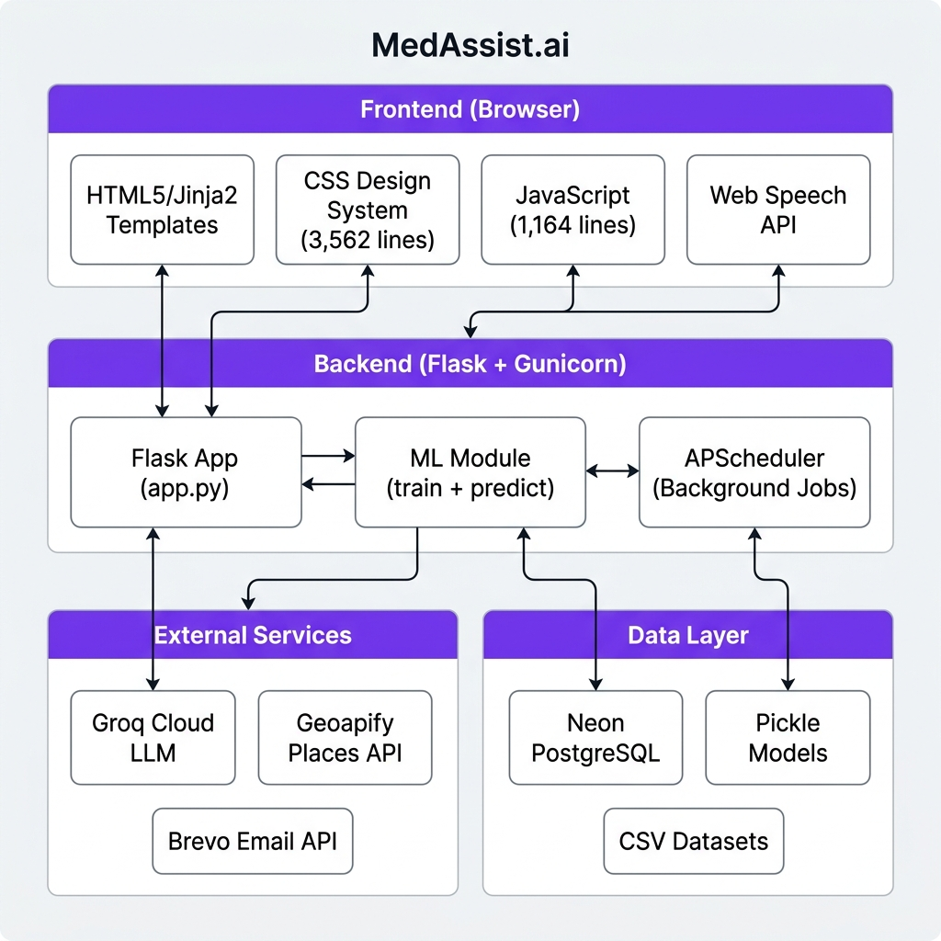
Figure 1: MedAssist.ai System Architecture

6.2 Data Flow
1. User selects symptoms, age, and gender on the frontend.
2. Frontend sends POST /api/predict to Flask backend.
3. Backend invokes ML engine: normalizes input → fuzzy matches → builds feature vector → runs calibrated model.
4. Backend returns Top-3 predictions with probabilities.
5. Frontend auto-triggers disease-info (Groq LLM) and hospital search (Geoapify) in parallel.
6. User can book appointments, which triggers confirmation email (Brevo).
7. Background scheduler sends 12h and 1h reminder emails automatically.

7. Technology Stack

7.1 Backend Technologies
Technology | Version | Role | Justification
Python | 3.11.9 | Core language | Mature ML and web ecosystem
Flask | 3.0.0 | Web framework | Lightweight, API-driven architecture
Flask-SQLAlchemy | 3.1.1 | ORM | Pythonic database access
Flask-APScheduler | 1.13.1 | Task scheduler | In-process job scheduling
Gunicorn | 21.2.0 | WSGI server | Production multi-worker server
psycopg2-binary | 2.9.9 | DB adapter | PostgreSQL connectivity
python-dotenv | 1.0.0 | Config | Environment variable management
requests | 2.31.0 | HTTP client | External API calls
groq | 1.1.1 | LLM SDK | Groq Cloud API client

7.2 Frontend Technologies
Technology | Role | Details
HTML5 / Jinja2 | Templates | 4 template files, server-side rendered
Vanilla CSS | Design system | 3,562 lines with glassmorphism and design tokens
Vanilla JavaScript | Client logic | 1,164 lines: tabs, forms, API calls, speech
Google Fonts | Typography | Outfit (headings) and Inter (body)
Marked.js | Markdown | CDN-loaded parser for chatbot responses
Web Speech API | Voice I/O | SpeechRecognition + SpeechSynthesis

7.3 Machine Learning Stack
Technology | Version | Role
scikit-learn | 1.3.2 | RandomForestClassifier, GridSearchCV, CalibratedClassifierCV
pandas | 2.1.3 | Data loading, cleaning, and feature engineering
pickle | stdlib | Model serialization and deserialization
difflib | stdlib | Fuzzy string matching for symptom tolerance
re | stdlib | Regex-based column normalization

7.4 Infrastructure
Service | Provider | Role
Web Hosting | Render | Cloud platform for Flask deployment
Database | Neon (Azure East US 2) | Serverless PostgreSQL
Email | Brevo (Sendinblue) | Transactional email delivery
LLM | Groq Cloud | Ultra-fast LLM inference
Geolocation | Geoapify | Hospital/clinic place search

8. Dataset Description

8.1 Training Dataset
Property | Value
File | dataset/training_data.csv
Total Records | 4,920
Total Columns | 141 (raw), 138 (after cleaning)
Unique Diseases | 41
Samples per Disease | 120 (perfectly balanced)
Feature Type | Binary (0/1) symptom indicators

8.2 Feature Breakdown
Category | Count | Examples
Symptom features | 131 | itching, skin_rash, high_fever, chest_pain, fatigue
Age features | 4 | age_child, age_teenager, age_adult, age_senior
Gender features | 3 | gender_male, gender_female, gender_other
Target variable | 1 | prognosis (41 unique disease labels)

8.3 Disease Classes (All 41)
Fungal infection, Allergy, GERD, Chronic cholestasis, Drug Reaction, Peptic ulcer diseae, AIDS, Diabetes, Gastroenteritis, Bronchial Asthma, Hypertension, Migraine, Cervical spondylosis, Paralysis (brain hemorrhage), Jaundice, Malaria, Chicken pox, Dengue, Typhoid, hepatitis A, Hepatitis B, Hepatitis C, Hepatitis D, Hepatitis E, Alcoholic hepatitis, Tuberculosis, Common Cold, Pneumonia, Dimorphic hemmorhoids(piles), Heart attack, Varicose veins, Hypothyroidism, Hyperthyroidism, Hypoglycemia, Osteoarthristis, Arthritis, (vertigo) Paroymsal Positional Vertigo, Acne, Urinary tract infection, Psoriasis, Impetigo

8.4 Test Dataset
File: dataset/test_data.csv — 42 records covering all 41 disease classes (1 sample per disease + 1 extra).

8.5 Data Preprocessing Pipeline
- Column Removal: Drop unnamed index columns and duplicate 'fluid_overload.1' column
- Normalization: Regex-based normalization ([\s_]+ → _) to handle inconsistent whitespace in original CSV headers
- Deduplication: Remove duplicate columns (post-normalization) and duplicate rows
- Validation: Assert 'prognosis' target column exists

9. Machine Learning Methodology

9.1 Algorithm Selection
Chosen Algorithm: Random Forest Classifier (Ensemble Learning)
Justification:
- The dataset consists of 138 binary features — a format where tree-based methods excel
- Random Forests aggregate hundreds of decision trees, reducing overfitting risk
- Built-in feature importance enables interpretability
- Native multi-class classification support (41 diseases)
- class_weight='balanced' handles any potential class imbalance

9.2 Training Pipeline
The training pipeline consists of the following sequential steps:
Step 1: Load training_data.csv (4,920 rows × 141 columns)
Step 2: Preprocessing — Remove unnamed columns, remove fluid_overload.1, regex normalization, deduplication
Step 3: Stratified Train/Test Split (80% train, 20% test)
Step 4: Hyperparameter Tuning via GridSearchCV (3-fold CV, 36 parameter combinations)
Step 5: Select Best Random Forest model
Step 6: Apply Probability Calibration via CalibratedClassifierCV (sigmoid, 3-fold)
Step 7: Save disease_model.pkl and symptoms.pkl
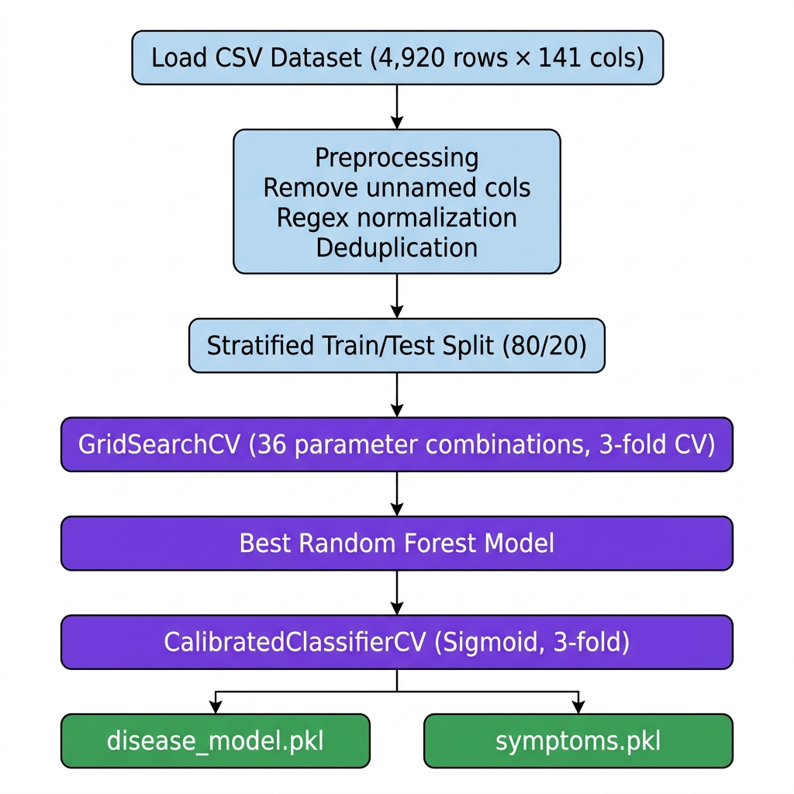
Figure 2: Machine Learning Training Pipeline

9.3 Hyperparameter Tuning
The system uses GridSearchCV with 3-fold cross-validation to exhaustively search across 36 parameter combinations:
Parameter | Search Values
n_estimators | 100, 200, 300
max_depth | 20, 50, None
min_samples_split | 2, 5
class_weight | balanced, balanced_subsample

9.4 Probability Calibration
Raw Random Forest probabilities are unreliable — they tend to be overconfident. The system applies Platt Scaling (sigmoid calibration) using CalibratedClassifierCV with 3-fold cross-validation.
Before calibration: A 90% confidence score might only correspond to a true 75% accuracy. After calibration: Confidence scores are statistically meaningful — 90% confidence truly means ~90% likelihood.

9.5 Prediction Engine
The inference pipeline in predict.py implements:
- Lazy Loading: Model and symptom list are loaded once and cached as module-level singletons
- Input Normalization: Regex-based ([\s_]+ → _) matching the training pipeline
- Fuzzy Matching: difflib.get_close_matches(cutoff=0.7) maps imprecise inputs like 'shiver' → 'shivering'
- Demographic Features: One-hot encoding of age group and gender
- Column Ordering: Enforced alignment with training feature order
- Output: Top-3 ranked predictions with calibrated probability percentages

9.6 Feature Importance Analysis
Rank | Feature | Importance
1 | muscle_pain | 0.0186
2 | itching | 0.0158
3 | chest_pain | 0.0147
4 | high_fever | 0.0137
5 | yellowing_of_eyes | 0.0136
6 | mild_fever | 0.0135
7 | nausea | 0.0134
8 | fatigue | 0.0134
9 | family_history | 0.0134
10 | dark_urine | 0.0131
Note: Age and gender features have low individual importance (<0.001) due to the dataset structure. They are retained as contextual features for future dataset expansion.

10. External API Integrations

10.1 Groq Cloud LLM API
Property | Value
Provider | Groq Inc.
Model | llama-3.1-8b-instant
SDK | groq Python package (v1.1.1)
Authentication | API key via GROQ_API_KEY
Integration Point A — AI Health Assistant Chatbot (POST /api/chat): Receives full conversation history, system prompt includes predicted diagnosis, max_tokens=655, temperature=0.7.
Integration Point B — Disease Intelligence Generator (GET /api/disease-info): Generates structured JSON with severity, description, precautions, and diet. Uses temperature=0.3 for factual accuracy.

10.2 Geoapify Places API
Property | Value
Endpoint | https://api.geoapify.com/v2/places
Categories | healthcare.hospital, healthcare.clinic_or_praxis
Search Radius | 5,000 meters (5 km)
Result Limit | 20 results (filtered to top 10)
Smart Specialty Matching: The system maps predicted diseases to medical specialty keywords and prioritizes hospitals accordingly. For example, Heart attack maps to Cardiology; Diabetes maps to Endocrinology; Migraine maps to Neurology.
Sorting Logic: (is_specialized DESC, distance ASC) — Specialized hospitals appear first, then by proximity.

10.3 Brevo (Sendinblue) REST API
Property | Value
Endpoint | https://api.brevo.com/v3/smtp/email
Authentication | API key via BREVO_API_KEY
Sender | Configurable via BREVO_SENDER_EMAIL
Three email types are sent: (1) 6-digit OTP for registration verification, (2) Appointment confirmation upon booking, (3) Automated 12-hour and 1-hour appointment reminders. All emails use responsive inline-CSS HTML templates.

11. Backend Architecture
The monolithic Flask application (app.py — 701 lines) handles route definitions (15 endpoints), database model definitions (3 ORM models), external API integration logic, background job scheduling, and email sending utilities.

11.1 Database Schema
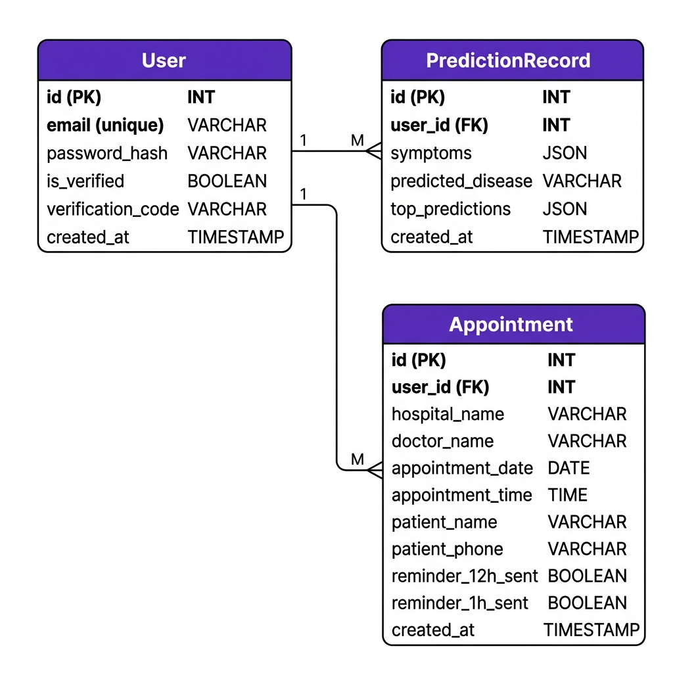
Figure 3: Entity Relationship Diagram
The application uses three database models:
User: id (PK), email (unique), password_hash, is_verified, verification_code, created_at
PredictionRecord: id (PK), user_id (FK), symptoms (JSON), predicted_disease, top_predictions (JSON), created_at
Appointment: id (PK), user_id (FK), hospital_name, doctor_name, appointment_date, appointment_time, patient_name, patient_phone, reminder_12h_sent, reminder_1h_sent, created_at

11.2 Database Connection Resilience
Neon serverless PostgreSQL aggressively closes idle connections. The application implements: pool_pre_ping=True (validate connections before use), pool_recycle=280 (reconnect every ~4.6 minutes), pool_timeout=30 (connection timeout).

12. Frontend Architecture

12.1 Design System
The CSS design system (styles.css — 3,562 lines) implements a premium visual language:
- Color Palette: Primary: #7C3AED (violet), Background: #FAFBFF, Surface: #FFFFFF
- Glassmorphism: backdrop-filter: blur(16px) with translucent backgrounds
- Shadows: Multi-layered box shadows for depth perception
- Animations: Heartbeat logo, scroll-reveal, floating badges, hover effects
- Responsive: Breakpoints at 992px, 768px, and 640px

12.2 Page Templates
Template | Lines | Description
index.html | 818 | Main dashboard: landing, symptoms, diagnosis, hospitals, chatbot, auth
appointment.html | 378 | Booking form with doctor selection and time slots
history.html | ~100 | Full prediction history page
appointments_history.html | ~110 | Full appointments history page

12.3 Client-Side JavaScript Modules
Module | Lines | Functionality
Symptom Management | ~100 | Fetch, render, search, filter, track selections
Prediction Submission | ~100 | Form handling, API call, result rendering
Hospital Locator | ~90 | Geolocation, API call, card rendering
Disease Intelligence | ~135 | AI details, severity badges, text-to-speech
AI Chatbot | ~135 | Chat history, typing indicators, voice search
Authentication | ~150 | Login, register, verify, session management
User Sidebar | ~100 | History loading, accordion toggles, drawer
Landing Page | ~90 | Scroll reveal, showcase carousel, demo mode

13. Automation & Background Jobs

13.1 Appointment Reminder System
The Flask-APScheduler runs a background job (check_reminders) every 10 minutes that:
1. Queries all appointments where reminder flags are False
2. Parses appointment datetime (date + time → datetime object)
3. Calculates time_to_appointment = appointment_time - current_time_IST
4. If 0h < time ≤ 12h and 12h reminder not sent → sends 12h reminder via Brevo
5. If 0h < time ≤ 1h and 1h reminder not sent → sends 1h reminder via Brevo
6. Sets corresponding flag to True and commits to database
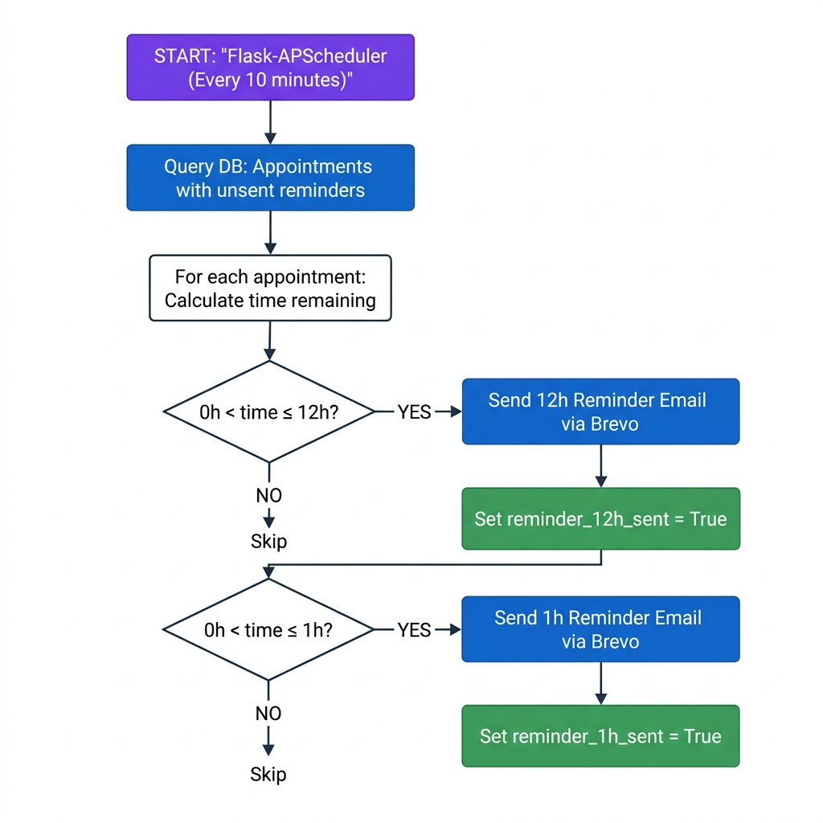
Figure 4: Appointment Reminder Automation Flow
Key Design Decisions:
- IST Offset: Server runs in UTC; appointments stored in IST. Scheduler applies +05:30 offset.
- Idempotency: Boolean flags (reminder_12h_sent, reminder_1h_sent) prevent duplicate sends.
- Graceful Failure: misfire_grace_time=900 (15 min) allows delayed execution on cold starts.

14. Authentication & Security

14.1 Authentication Flow
1. User submits POST /api/register with email and password
2. Backend hashes password with Werkzeug (PBKDF2 + salt), generates 6-digit OTP
3. Creates unverified User record in DB, sends OTP via Brevo email
4. User submits POST /api/verify with email and OTP code
5. Backend validates OTP, sets is_verified = True
6. User submits POST /api/login with credentials
7. Backend validates, creates Flask server-side session

14.2 Security Measures
Measure | Implementation
Password Hashing | Werkzeug PBKDF2 + salt
Session Management | Flask server-side sessions with SECRET_KEY
Email Verification | 6-digit OTP required before login
Environment Variables | All secrets in .env, never hardcoded
Input Validation | Required field checks on all POST endpoints

14.3 Guest/Demo Mode
Unauthenticated users access /?demo=1 with: symptom prediction (allowed), AI chatbot (allowed), hospital locator (blocked), appointment booking (blocked), history (blocked).

15. API Reference

15.1 Public Endpoints
Method | Endpoint | Request | Response
GET | / | — | Landing/Dashboard HTML
POST | /api/register | {email, password} | {message} or {error}
POST | /api/verify | {email, code} | {message} or {error}
POST | /api/login | {email, password} | {message, user_id}
GET | /api/symptoms | — | {symptoms: [...]} (131 items)
POST | /api/predict | {symptoms, age?, gender?} | {prediction, top_predictions}
GET | /api/disease-info | ?disease=X | {severity, description, precautions, diet}
GET | /api/hospitals | ?lat=X&lon=Y&disease=Z | {hospitals: [...]}
POST | /api/chat | {messages: [...]} | {response}

15.2 Protected Endpoints (Auth Required)
Method | Endpoint | Request | Response
POST | /api/logout | — | {message}
POST | /api/book_appointment | {hospital, doctor, date, time, name, phone} | {message, appointment}
GET | /api/user/data | — | {predictions, appointments}
GET | /history | — | Prediction history page
GET | /appointments-history | — | Appointments history page
GET | /appointment | ?hospital=X | Booking form page

16. Deployment & DevOps
File | Content | Purpose
Procfile | gunicorn app:app --bind 0.0.0.0:$PORT --timeout 120 | Render process
runtime.txt | python-3.11.9 | Python version
requirements.txt | 11 dependencies | Pip install
.env | 5 environment variables | API keys and DB URL
Production Considerations: Gunicorn timeout set to 120s for LLM responses; pool_pre_ping=True prevents stale DB connections; postgres:// auto-corrected to postgresql:// for SQLAlchemy; APScheduler misfire_grace_time=900s for cold starts.

17. Testing & Evaluation Results

17.1 Machine Learning Evaluation
Metric | Score | Dataset
Training Accuracy | 100.00% | Internal 80/20 stratified split
Test Accuracy (Top-1) | 98.00% | Independent test_data.csv
Test Accuracy (Top-3) | 100.00% | Correct diagnosis always in top 3
Cross-Validation | 100.00% ± 0.00% | 5-fold CV on full dataset
Macro Avg Precision | 0.99 | Across all 41 classes
Macro Avg Recall | 0.99 | Across all 41 classes
Macro Avg F1-Score | 0.98 | Across all 41 classes

17.2 Fuzzy Matching Validation
Input | Matched To | Status
"shiver" | "shivering" | Correct match
"high fevr" | "high_fever" | Correct match
"skin rash" | "skin_rash" | Exact match (after normalization)
"xyz_invalid" | — | Correctly rejected

18. Project Directory Structure
Smart-CDSS/
├── app.py # Flask application (701 lines)
├── ml/
│ ├── train_model.py # ML training pipeline (120 lines)
│ └── predict.py # Inference engine (143 lines)
├── model/
│ ├── disease_model.pkl # Calibrated RF model (~22 MB)
│ └── symptoms.pkl # Feature name list (~2 KB)
├── dataset/
│ ├── training_data.csv # Training dataset (~1.4 MB)
│ └── test_data.csv # Test dataset (~14 KB)
├── evaluate_model.py # Model evaluation (92 lines)
├── templates/
│ ├── index.html # Main template (818 lines)
│ ├── appointment.html # Booking form (378 lines)
│ ├── history.html # Prediction history
│ └── appointments_history.html # Appointments history
├── static/
│ ├── css/styles.css # Design system (3,562 lines)
│ ├── js/app.js # Client JavaScript (1,164 lines)
│ └── img/ # Landing page images
├── requirements.txt # Dependencies (11 packages)
├── Procfile # Gunicorn config
├── runtime.txt # Python 3.11.9
└── .env # Environment variables

19. Screenshots & User Interface
The application implements a premium, mobile-first design with the following key screens:
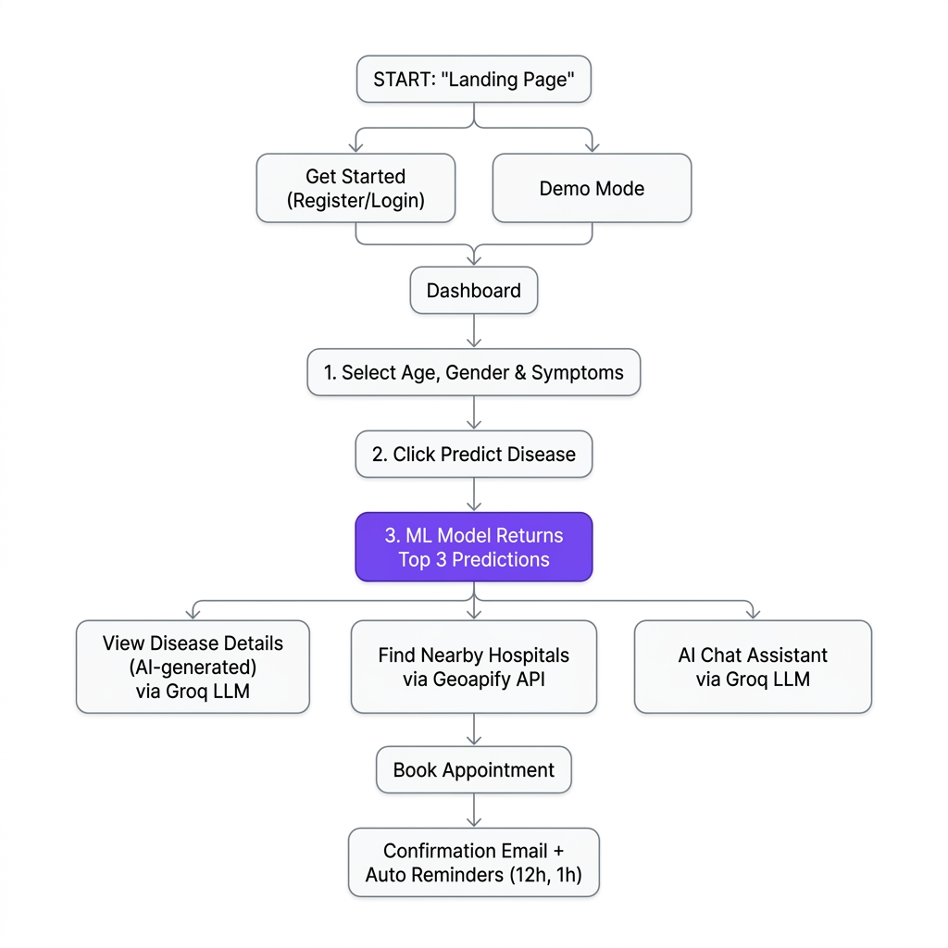
Figure 5: End-to-End User Workflow
Screen | Description
Landing Page | Hero section with animated backgrounds, CTA buttons, feature carousel, contact form
Symptom Selection | Age/gender dropdowns, searchable symptom grid with checkboxes, counter
Diagnosis Results | Master-detail layout: condition cards with confidence bars + AI details
Hospital Locator | Location-based cards with specialty badges, map links, booking buttons
Appointment Booking | Form with doctor selection, date picker, time slots, confirmation
AI Chat Assistant | Chat with markdown rendering, voice input, contextual health guidance
User Sidebar | Drawer with diagnosis history, appointments, account management

20. Future Scope
Enhancement | Description | Priority
Expanded Dataset | Add more diseases, regional symptoms, and real-world clinical data | High
Multi-language Support | Hindi, Urdu, Arabic interfaces and chatbot responses | High
HIPAA Compliance | Implement healthcare data privacy standards | High
Medical Image Analysis | Image-based diagnosis (skin conditions, X-rays) | Medium
Wearable Integration | Connect with smartwatch health data (heart rate, SpO2) | Medium
Doctor Portal | Dashboard for doctors to view patient referrals and history | Medium
Push Notifications | Browser/mobile push for appointment reminders | Low
A/B Testing | Compare model versions in production | Low

21. Conclusion
MedAssist.ai demonstrates the successful integration of machine learning, large language models, and modern web technologies to create a comprehensive healthcare decision support platform.
Accurate Diagnosis: The calibrated Random Forest model achieves 98% Top-1 accuracy and 100% Top-3 accuracy, ensuring reliable preliminary disease identification from 131 symptom inputs across 41 disease classes.
Intelligent Assistance: The Groq-powered LLM chatbot provides contextual, empathetic health guidance with structured safety guidelines, bridging the gap between automated diagnosis and human understanding.
Actionable Outcomes: The Geoapify hospital locator with disease-specific specialty matching and the integrated appointment booking system with automated Brevo email reminders transform prediction results into concrete healthcare actions.
Premium User Experience: The mobile-first design with glassmorphism, micro-animations, and responsive layouts provides an engaging, trustworthy interface that encourages healthy engagement with the platform.
The modular architecture ensures that each component — ML model, LLM integration, hospital search, email automation — can be independently upgraded as better models, APIs, or datasets become available.

22. References
[1] Breiman, L. (2001). Random Forests. Machine Learning, 45(1), 5–32.
[2] Niculescu-Mizil, A., & Caruana, R. (2005). Predicting Good Probabilities with Supervised Learning. ICML 2005.
[3] Uddin, S., Khan, A., Hossain, M. E., & Moni, M. A. (2019). Comparing different supervised machine learning algorithms for disease prediction. BMC Medical Informatics, 19(1), 281.
[4] scikit-learn Documentation — CalibratedClassifierCV. https://scikit-learn.org/stable/modules/calibration.html
[5] Groq Cloud API Documentation. https://console.groq.com/docs
[6] Geoapify Places API Documentation. https://apidocs.geoapify.com/docs/places/
[7] Brevo (Sendinblue) Transactional Email API. https://developers.brevo.com/

This document was generated for internal project review and academic documentation purposes.
MedAssist.ai is a decision support tool and does not replace professional medical consultation.

