YouTube Retrofit Comments
NMF Topic Modeling and Standalone Analysis Report
Frozen inclusive TF-IDF NMF solution, k = 16
Standalone unsupervised analysis completed before any comparison with the predefined rule-based framework.
Analysis status: model selection, validation, interpretation, contextual analysis and robustness complete
Report prepared from locked project outputs through Stage 08d.

Executive summary
This report documents the complete unsupervised Non-negative Matrix Factorization (NMF) analysis of substantive YouTube comments about practical energy retrofit. It covers corpus preparation, TF-IDF design, candidate-model selection, interpretability review, subsampling stability, preprocessing sensitivity, final topic locking, standalone topic prevalence, video-level context, engagement associations and equal-comment robustness. The predefined rule-based comment analysis is deliberately excluded from this report so that the unsupervised findings remain analytically independent before later comparison.
- The modeling corpus contains 42,443 comments from 1,158 videos after 44 zero-vector comments were removed from the 42,487-comment substantive corpus.
- Six candidate topic counts were evaluated (k = 8, 10, 12, 14, 16 and 20). Quantitative screening advanced k = 12, 16 and 20; human interpretability review retained k = 12 and k = 16; stability and preprocessing-sensitivity evidence favoured k = 16.
- The final solution contains 16 retained components: 7 technical subjects, 7 knowledge-sharing behaviours, 1 social-interaction topic and 1 mixed/contextual topic.
- The solution is intrinsically multi-topic. At comment level, the median dominant relative weight is 0.473 and the median effective topic count is 3.81. At video level, the median effective topic count rises to 8.81.
- Technical subjects are often concentrated in specific video clusters, while interactional behaviours are more widely distributed across the corpus. Spray-foam discussion is the most concentrated technical component.
- Engagement relationships are observational and compositional. Equal-comment resampling showed that 74 of 128 topic-metadata associations had empirical intervals excluding zero under both 10- and 20-comments-per-video conditions.
- The NMF model and its interpretation are now frozen. The next analytical phase should compare this independent solution with the predefined rule-based framework; that comparison is outside the scope of this report.
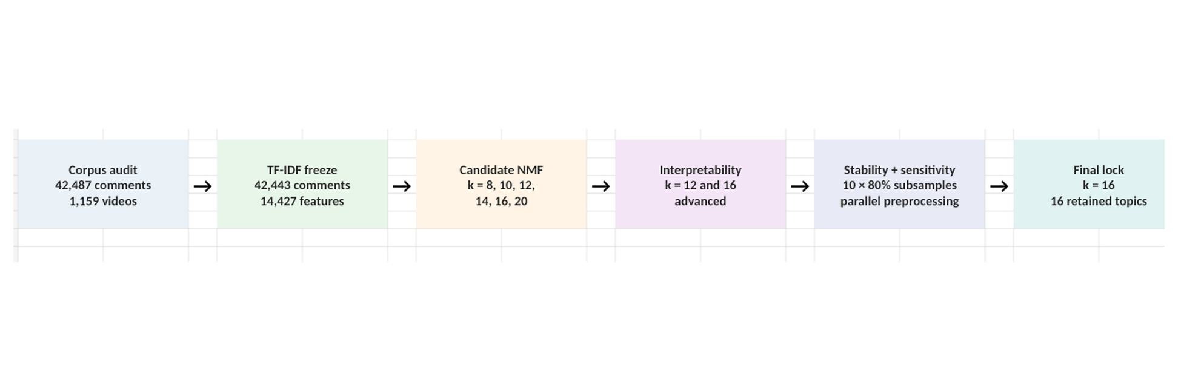
Figure 1. NMF model-selection and validation funnel. The final model was locked only after quantitative screening, interpretability review, repeated corpus perturbation and preprocessing sensitivity testing.
The report proceeds from corpus construction and model selection through validation, locked-topic interpretation, standalone results, contextual analysis, engagement analysis and robustness, followed by methodological limitations and reproducibility appendices.

1. Research purpose and analytical scope
The aim of this NMF analysis is to discover latent structures in substantive retrofit-related YouTube comments without requiring comments to conform to the project’s existing predefined theme system. The model is therefore used as an independent unsupervised analytical pathway. Its value lies not in producing a single “correct” classification, but in revealing recurring technical subjects, question forms, troubleshooting behaviours, social interaction and contextual patterns that emerge from the comment text itself.
The report treats NMF weights as continuous component loadings. Row-normalised weights are used descriptively to compare relative topic composition within a comment or video; they are not posterior probabilities. Dominant-topic assignments are used only for interpretable summaries and never as a claim that comments belong to mutually exclusive categories.

2. Corpus and TF-IDF representation
The starting substantive corpus contained 42,487 comments from 1,159 videos. Conservative text preparation used comment_text_no_urls, HTML unescaping, Unicode NFKC normalisation, lowercase conversion, contraction expansion, URL removal and whitespace normalisation. Stemming and lemmatisation were not used. English stop words were applied conservatively while preserving negation, questioning and comparison terms relevant to troubleshooting discourse.
Element | Frozen value
Substantive corpus before TF-IDF | 42,487 comments / 1,159 videos
Primary NMF corpus | 42,443 comments / 1,158 videos
Zero-vector removals | 44 comments; one video entirely removed
Primary TF-IDF vocabulary | 14,427 features
Unigrams / bigrams | 6,433 / 7,994
Primary matrix non-zero entries | 1,013,411
Content-focused sensitivity corpus | 42,424 comments
Content-focused vocabulary | 14,084 features

Two representations were frozen. The inclusive representation was designated primary because praise and gratitude are substantively relevant to trust and social endorsement. A content-focused representation removed platform terms, generic gratitude/strong praise and web residue to test whether substantive technical topics survived preprocessing changes. Ambiguous words such as “good”, “love”, “liked”, “like” and “just” were retained in the sensitivity representation rather than being removed automatically.

3. Candidate NMF model selection
Candidate NMF models were fit at k = 8, 10, 12, 14, 16 and 20 using NNDSVDa initialisation, coordinate descent, Frobenius loss, tolerance 1e-4, maximum 500 iterations and a fixed random state. Model selection was intentionally multi-criterion: reconstruction error alone was not treated as decisive because it predictably improves as topic count increases.
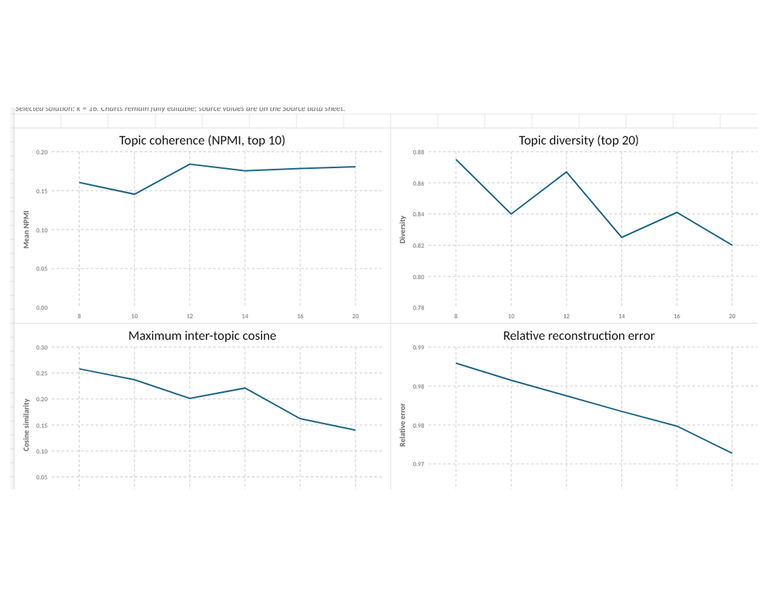
Figure 2. Candidate-model diagnostics. Lower reconstruction error and inter-topic similarity favour larger models, while coherence and diversity show a less monotonic pattern. The selected k=16 solution reflects the combined evidence rather than a single metric.
k | Relative error | NPMI | Diversity | Max topic cosine | Iterations
8 | 0.98292 | 0.1605 | 0.875 | 0.258 | 239
10 | 0.98074 | 0.1454 | 0.840 | 0.237 | 201
12 | 0.97874 | 0.1839 | 0.867 | 0.201 | 149
14 | 0.97674 | 0.1755 | 0.825 | 0.221 | 487
16 | 0.97485 | 0.1783 | 0.841 | 0.162 | 62
20 | 0.97137 | 0.1805 | 0.820 | 0.140 | 282

Quantitative screening advanced k = 12, 16 and 20. Human interpretability review found k = 12 coherent but relatively compact, k = 16 better separated key technical subjects, and k = 20 increasingly fragmented and noisy. The interpretability stage therefore retained k = 12 and k = 16 for formal stability testing.

4. Stability and preprocessing sensitivity
Because NNDSVDa is largely deterministic on an unchanged matrix, stability was assessed through corpus perturbation rather than merely changing random seeds. For k = 12 and k = 16, ten independent runs were fit to 80% subsamples of the corpus. Topics were aligned to the full-corpus reference solution using Hungarian matching on cosine similarity; top-20-term Jaccard overlap and prevalence differences were also recorded.
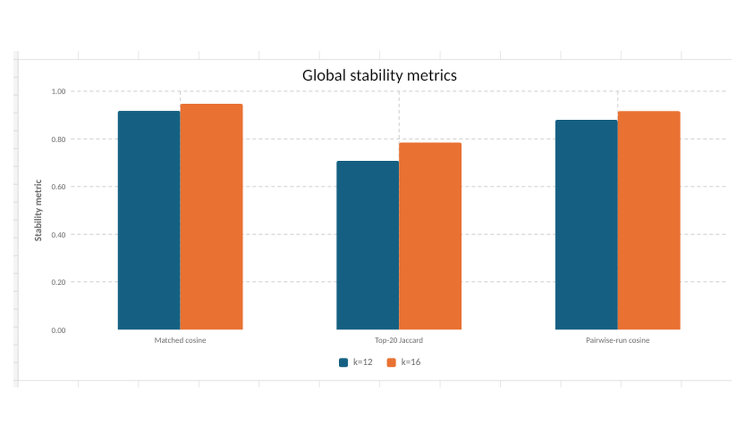
Figure 3. Global subsampling stability. k=16 outperformed k=12 on matched cosine similarity, top-term overlap and pairwise run stability, with lower mean absolute prevalence difference and no convergence-warning runs.
For k=16, mean matched cosine similarity was 0.947, median 0.998, and 93.8% of matched topics were at least 0.90 similar to their reference topic. Mean top-20 Jaccard overlap was 0.784 and pairwise run cosine was 0.917. The corresponding k=12 values were 0.918, 0.995, 81.7%, 0.708 and 0.880. k=16 also had a smaller mean absolute prevalence difference (0.89 percentage points versus 1.28) and no convergence warnings.
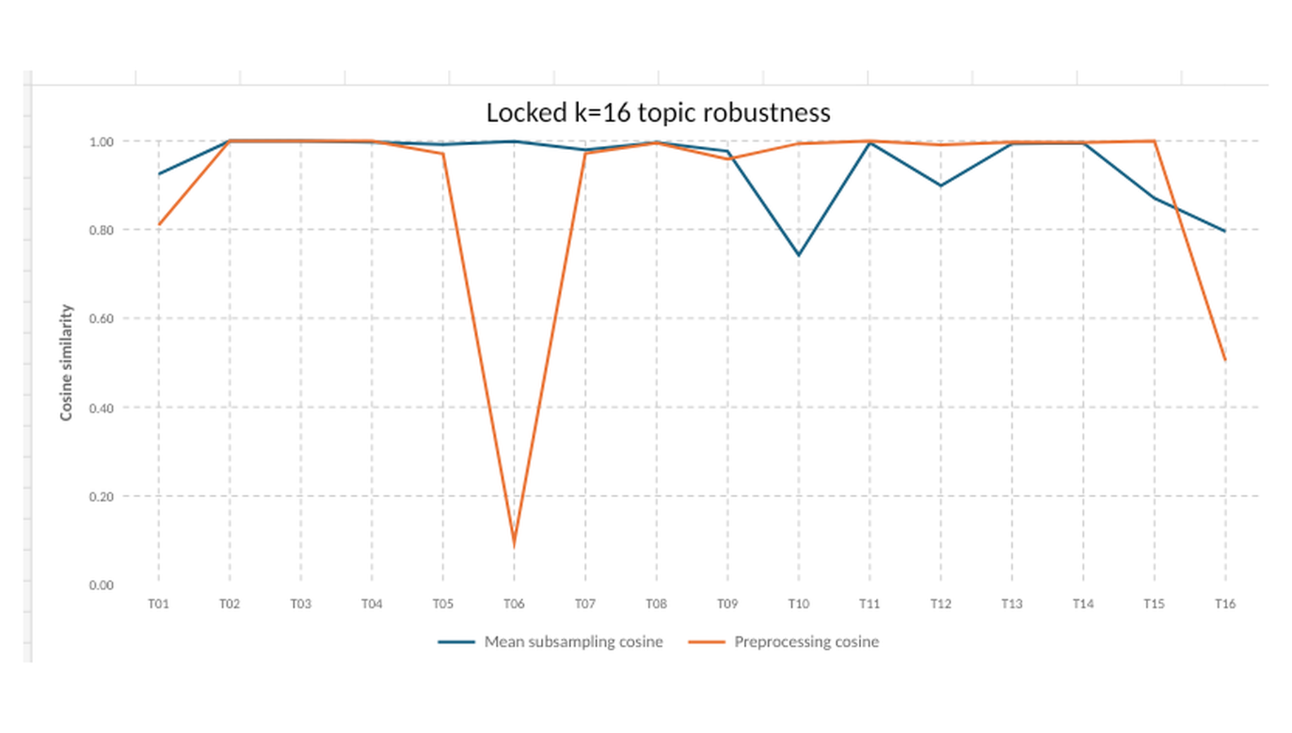
Figure 4. Topic-level stability and preprocessing sensitivity for the final k=16 solution. Most technical topics are extremely stable. Topic 6 changes sharply when praise vocabulary is deliberately removed, while Topic 16 is more diffuse and preprocessing-sensitive.
The content-focused preprocessing sensitivity model was fit at k=16 and aligned to the inclusive primary model. The mean matched cosine similarity was 0.893, median 0.994, with 81.2% of topics at or above 0.90 similarity and 87.5% at or above 0.80. Technical topics were highly preserved. Topic 6 (praise, gratitude and social endorsement) largely disappeared, as expected because the sensitivity representation removed its defining vocabulary. Topic 16 was also comparatively sensitive, supporting its lower-confidence cross-cutting interpretation rather than invalidating the overall solution.

5. Locked k=16 topic solution
After stability and sensitivity testing, the inclusive k=16 solution was locked. All 16 topics were retained. The final structure contains seven technical subjects, seven knowledge-sharing behaviours, one social-interaction component and one mixed/contextual component. Confidence scores were 5/5 for eight topics, 4/5 for six topics and 3/5 for two cross-cutting discourse topics (Topics 10 and 16).
Topic | Locked label | Type | Conf. | Dominant | Soft
T01 | Situated household retrofit experience and building context | mixed | 4 | 12.0% | 14.0%
T02 | Spray foam and foam insulation | technical subject | 5 | 3.9% | 3.4%
T03 | Clarification and specification questions | knowledge sharing behaviour | 4 | 6.6% | 6.6%
T04 | Implementation, cost and how-to questions | knowledge sharing behaviour | 4 | 5.6% | 5.4%
T05 | Heat pumps and heating systems | technical subject | 5 | 7.0% | 6.2%
T06 | Praise, gratitude and social endorsement | social interaction | 5 | 8.8% | 8.2%
T07 | Alternative methods, challenges and "why" questions | knowledge sharing behaviour | 4 | 4.1% | 4.8%
T08 | Solar PV, batteries and power systems | technical subject | 5 | 8.0% | 7.3%
T09 | Performance checking and troubleshooting | knowledge sharing behaviour | 4 | 5.7% | 5.8%
T10 | Implementation follow-up, outcomes and retrospective questions | knowledge sharing behaviour | 3 | 4.0% | 3.7%
T11 | Product sourcing, access and location questions | knowledge sharing behaviour | 4 | 2.5% | 2.6%
T12 | Roof and attic ventilation and airflow | technical subject | 5 | 9.6% | 8.6%
T13 | Wall, cavity and floor insulation | technical subject | 5 | 7.7% | 7.7%
T14 | Thermostat wiring and smart heating controls | technical subject | 5 | 4.3% | 4.8%
T15 | Vapour barriers and moisture control | technical subject | 5 | 3.8% | 3.9%
T16 | Prospective choices, recommendations and alternatives | knowledge sharing behaviour | 3 | 6.3% | 6.8%

Interpretive caution: the locked labels describe the dominant semantic meaning of latent components; they are not manually assigned ground-truth classes. Topic 6 captures social endorsement rather than technical correctness. Topics 12 and 15 were retained despite isolated unstable subsamples because their median stability, substantive coherence and preprocessing robustness were strong.

6. Standalone comment-level topic structure
The final NMF solution is strongly multi-topic. Across 42,443 modelled comments, the median dominant relative weight is 0.473, the median secondary relative weight is 0.223, and the median dominant-secondary margin is 0.201. The median effective topic count is 3.81 (IQR 2.67-5.11). These values show that most comments carry meaningful weight on several components rather than mapping cleanly to one exclusive topic.
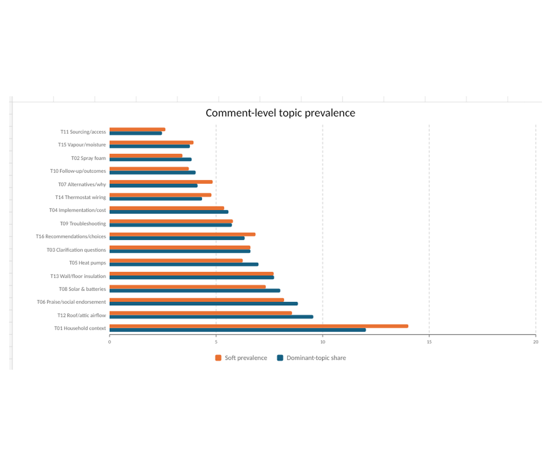
Figure 5. Comment-level topic prevalence. Dominant-topic share gives an interpretable hard summary, while soft prevalence preserves the continuous NMF structure. Both should be reported together.
Topic 1, situated household retrofit experience and building context, is the largest component: 12.03% of comments by dominant assignment and 14.02% by soft prevalence. It is also the most common secondary topic for 14 of the other 15 dominant topics, suggesting that house-specific context, prior interventions, climate, occupancy and personal experience form a broad layer across many technical discussions. The main exception is vapour barriers/moisture control (Topic 15), whose most common secondary topic is wall/cavity/floor insulation (Topic 13).
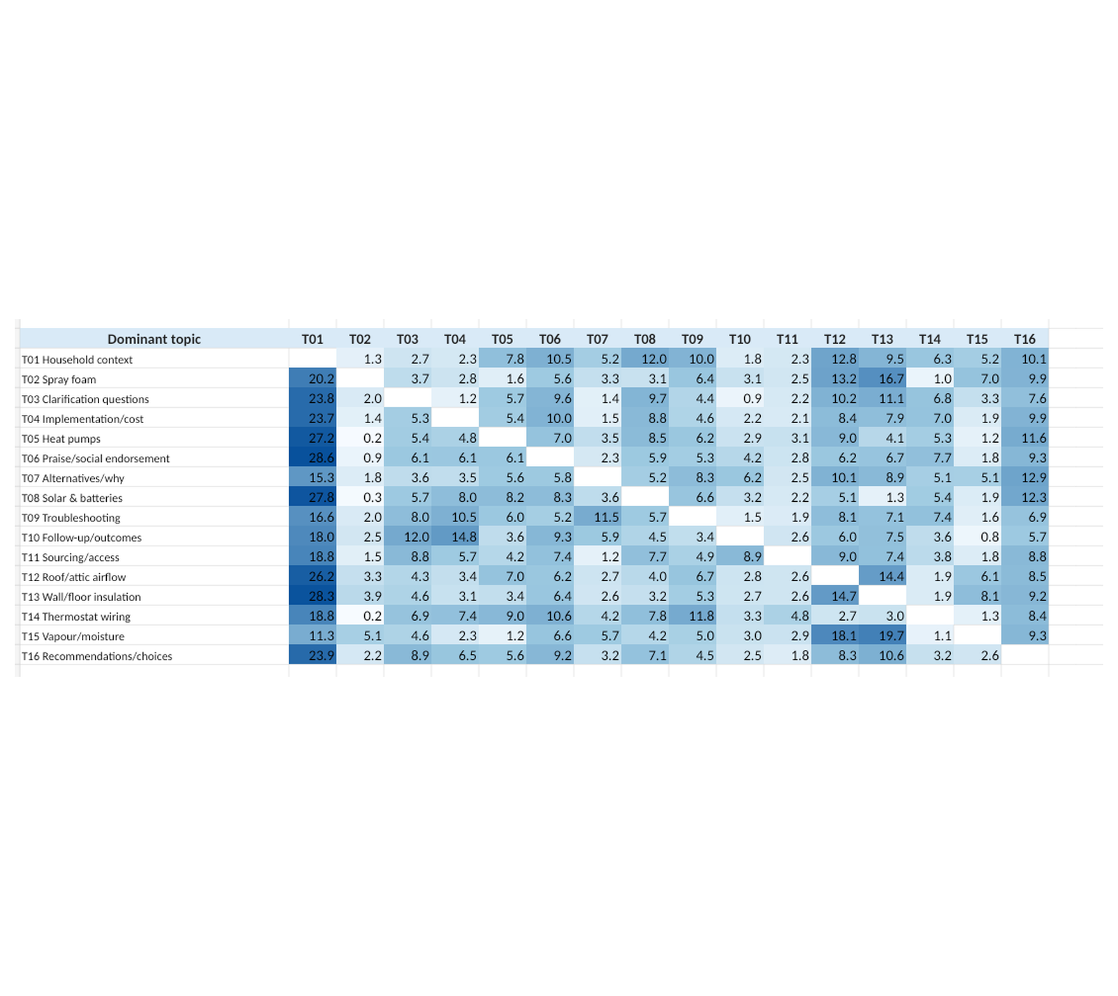
Figure 6. Dominant-secondary topic pairing. Darker cells indicate that a secondary topic is especially common within comments dominated by the row topic. Topic 1 acts as a broad contextual companion across the model.
Topic distinctiveness varies. Clarification/specification questions (Topic 3) and spray foam (Topic 2) have comparatively large median dominance margins, while follow-up/outcomes (Topic 10), sourcing/access (Topic 11), prospective recommendations (Topic 16) and troubleshooting (Topic 9) are more intertwined with other components. This supports interpreting several discourse topics as cross-cutting knowledge-sharing behaviours rather than bounded technical subjects.

7. Video-level context and temporal distribution
Aggregating comment-level weights by video produces substantially broader mixtures. The 1,158 NMF videos have a median of 10 modelled comments per video (IQR 3-39). Median video-level dominant topic weight is 0.275, median secondary weight 0.161, median dominance margin 0.090 and median effective topic count 8.81. A video comment section therefore typically spans many of the 16 components.
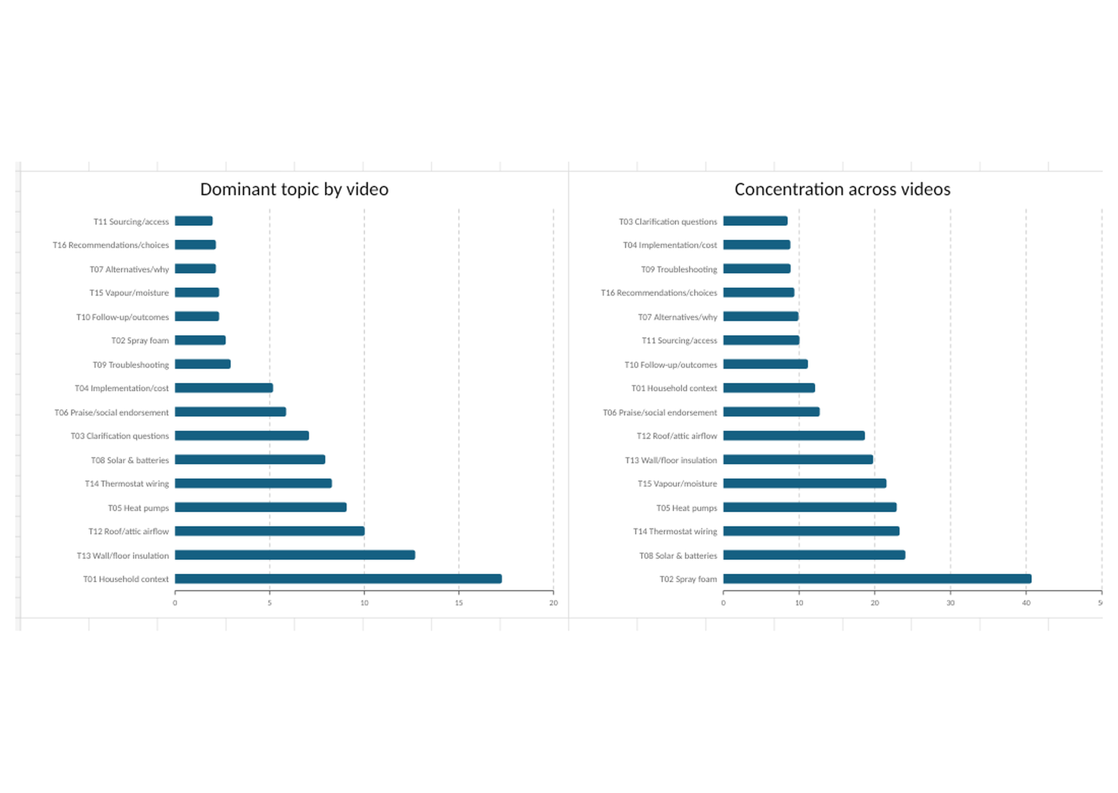
Figure 7. Video-level prevalence and concentration. Technical subjects such as spray foam, solar, thermostat wiring and heat pumps are more concentrated in particular videos; interactional topics are generally more diffuse across the corpus.
Spray foam is the most concentrated topic: its top 10 contributing videos account for 40.72% of total topic weight. Solar, thermostat wiring, heat pumps, vapour/moisture control, wall/floor insulation and roof/attic airflow also show noticeable concentration. By contrast, clarification, how-to questions, troubleshooting, recommendations and other discourse components are spread more broadly across videos.
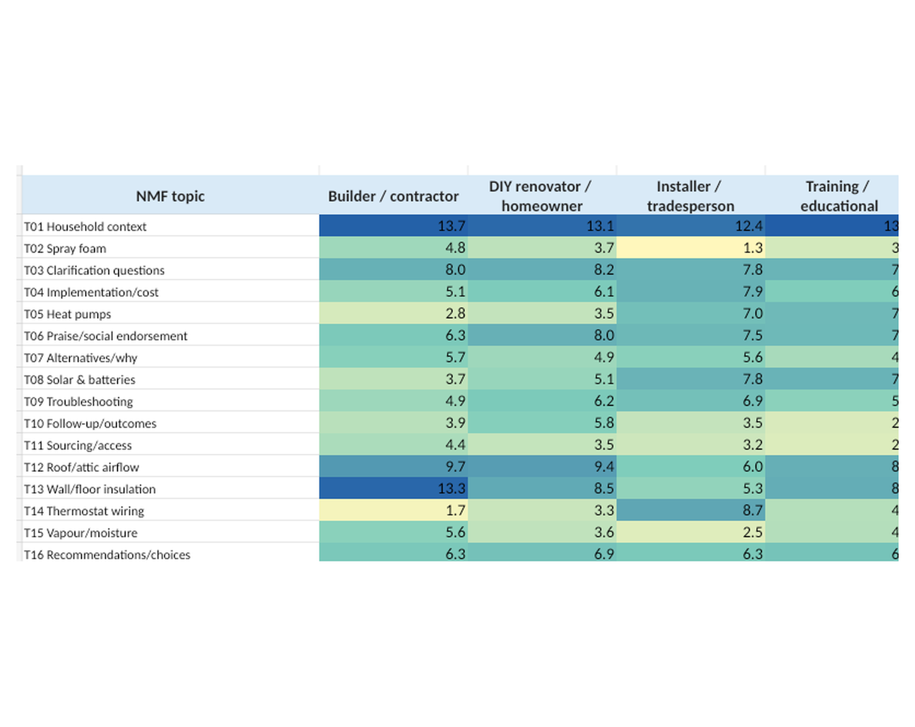
Figure 8. Mean video-level NMF topic weight by creator type. These are descriptive contextual associations, not causal effects or quality judgements.
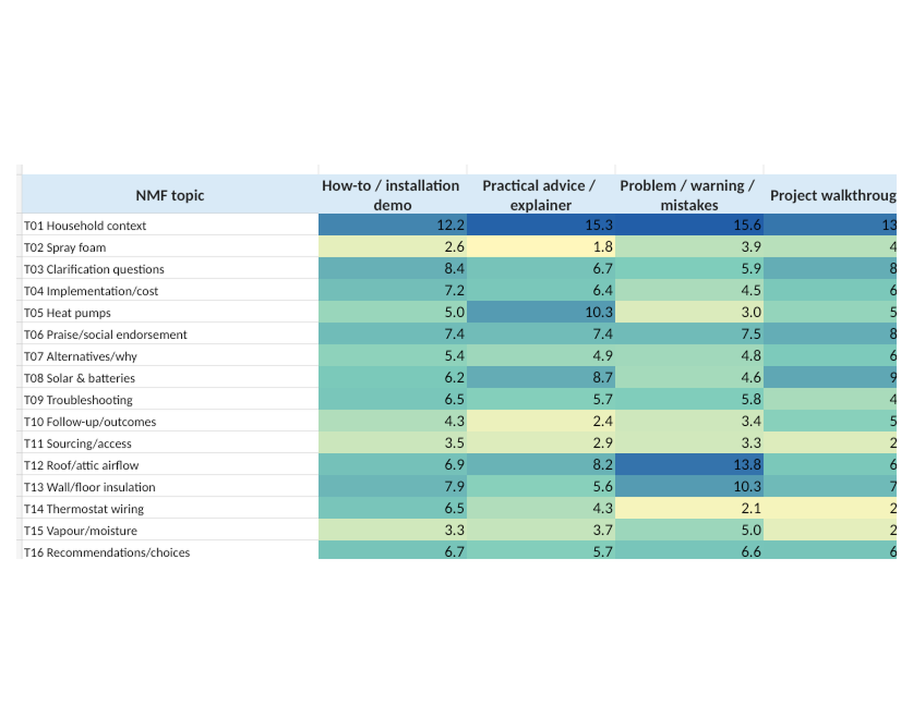
Figure 9. Mean video-level NMF topic weight by video type. Problem/warning videos lean toward roof/airflow, contextual building problems and fabric-risk topics; practical explainers lean more toward heat pumps and solar; installation demos show comparatively more thermostat-wiring and procedural/specification discussion.
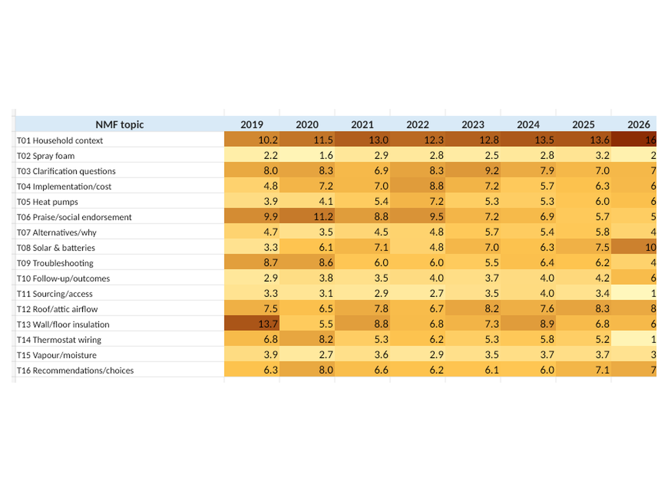
Figure 10. Mean topic weight by publication year. Annual values describe the composition of observed discussion; they do not measure absolute topic volume. 2026 is a partial year and should not be used to claim a completed-year trend.
Across the fuller 2020-2025 period, situated household context, roof/attic airflow, heat-pump discussion, spray foam and alternative/challenge questions generally become more prominent in relative discussion composition, while praise/social endorsement declines. These patterns should remain descriptive because annual video counts differ and the data represent the project sample rather than a census of YouTube.

8. Metadata and engagement associations
The frozen NMF video profiles were linked to neutral video metadata for the same 1,158 videos. Measures included duration, raw views, likes, API comment count, likes per 1,000 views, API comments per 1,000 views, views per day and API comments per day. Spearman rank correlations were used because engagement measures are strongly right-skewed. Age-normalised measures remain provisional because the original metadata snapshot date was not retained.
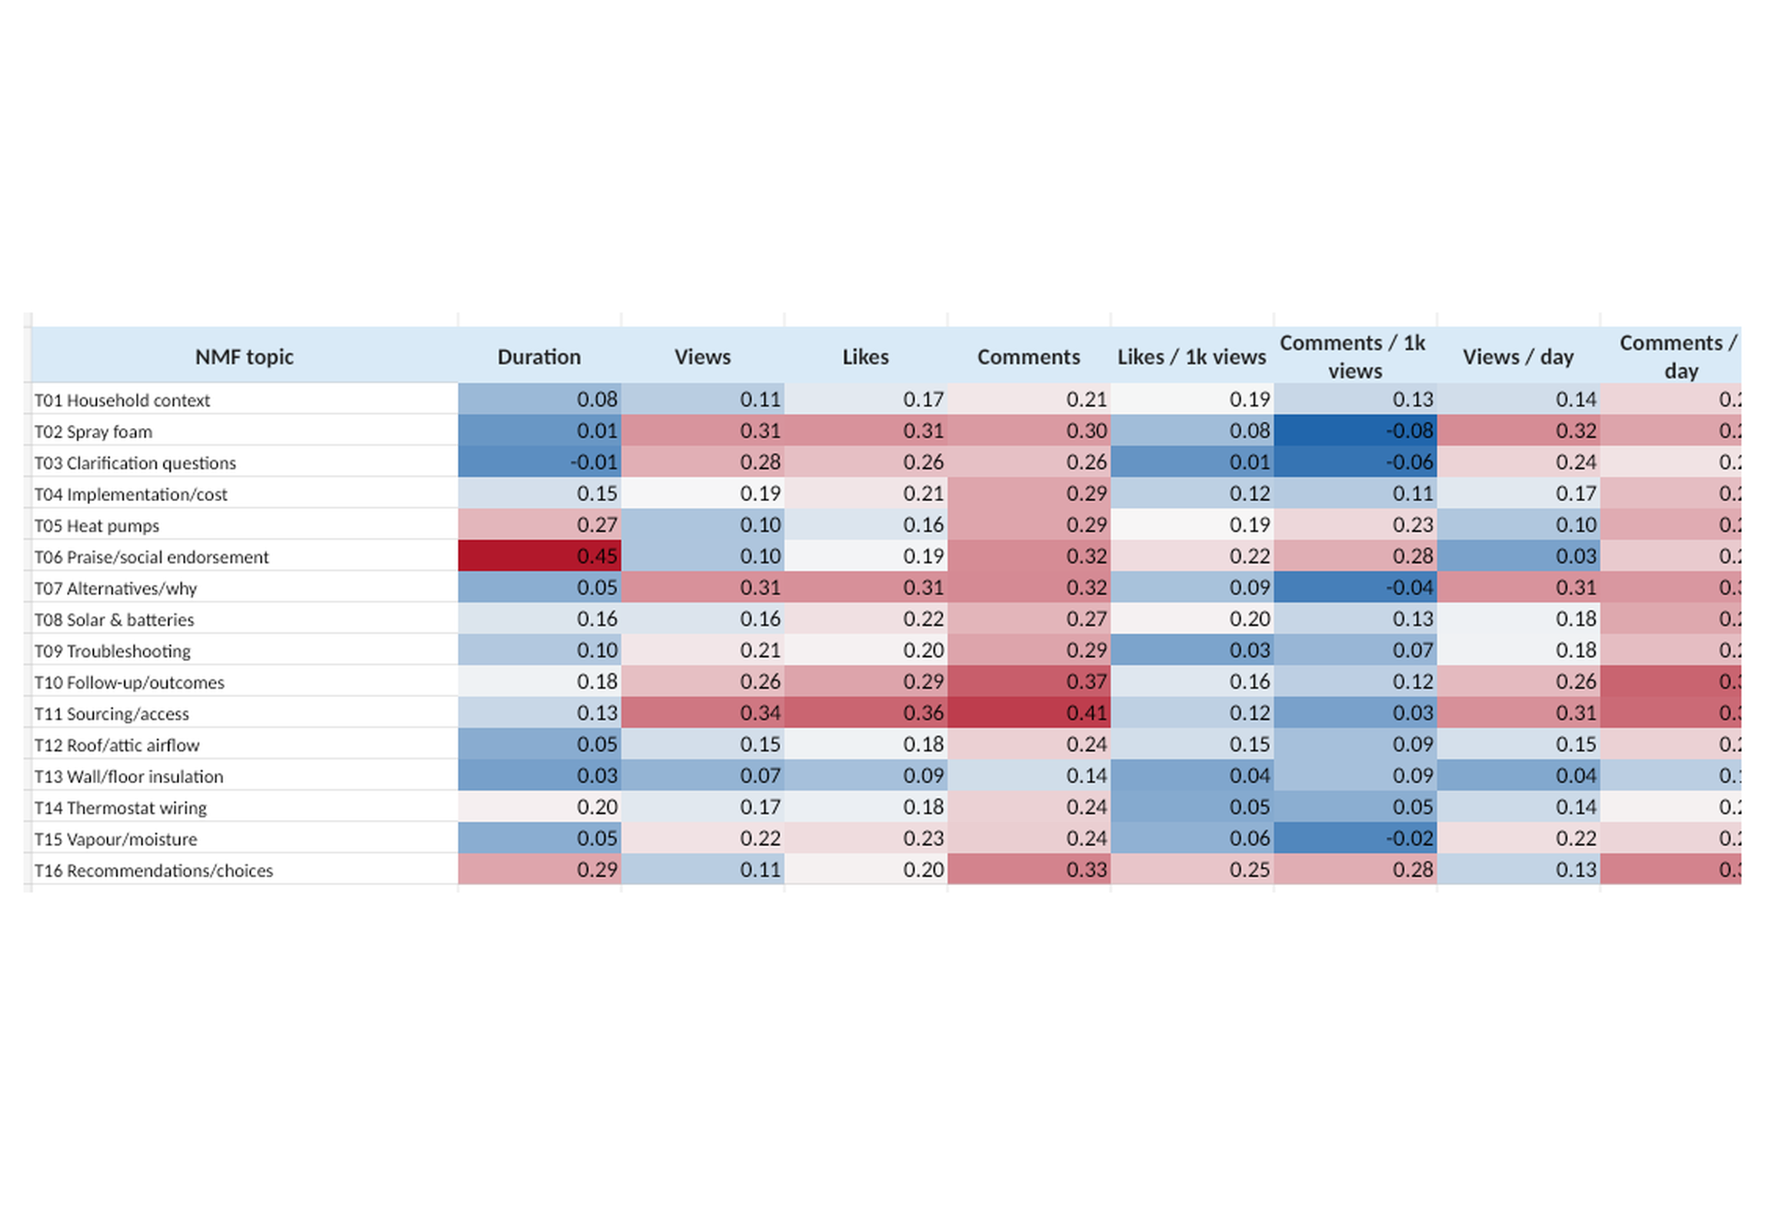
Figure 11. Full-sample Spearman correlations between video-level NMF topic weight and metadata/engagement. Because the 16 topic weights are compositional and low-comment videos have less stable mixture estimates, this figure is exploratory and must be interpreted with the robustness analysis below.
Dominant-topic groups differ across all eight metadata measures in Kruskal-Wallis tests, with the largest effect sizes for API comment count (epsilon-squared = 0.126), API comments per day (0.123) and duration (0.114). These tests compare rank distributions rather than proving topic-specific causal effects. Engagement is also not a proxy for technical quality.
A critical diagnostic showed that the number of modelled comments per video is strongly related to apparent mixture breadth: effective topic count correlates 0.781 with modelled-comment count, while dominant-topic weight correlates -0.513. This means unrestricted video-level topic profiles partly reflect how many comments were available, motivating the equal-comment robustness analysis.

9. Equal-comment robustness
To control the unequal number of comments contributing to each video-level profile, exactly 10 comments were sampled from each of 591 eligible videos and exactly 20 comments from each of 433 eligible videos. Sampling was without replacement and repeated 100 times per condition. For each replicate, mean NMF weights were recomputed and topic-metadata Spearman correlations recalculated.
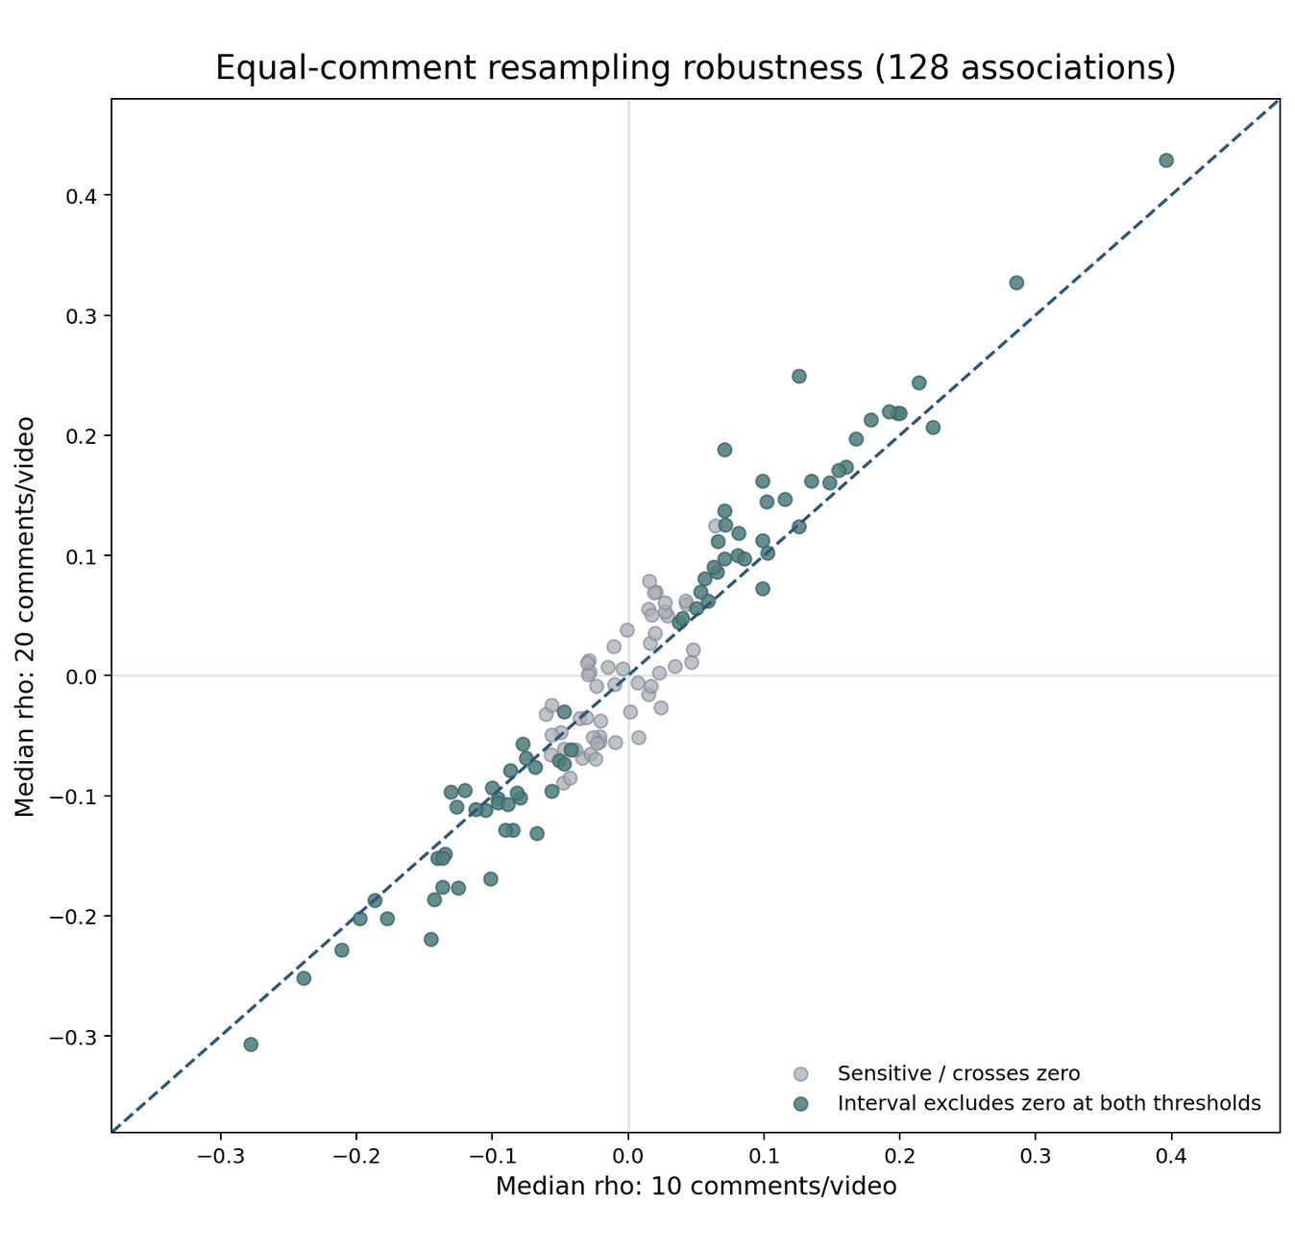
Figure 12. Equal-comment resampling robustness. Each point is one of the 128 topic-metadata associations. Points near the 45-degree line are stable across 10- and 20-comment conditions; highlighted points have empirical 2.5th-97.5th percentile resampling intervals excluding zero in both conditions.
Topic | Label | Metric | Median rho (10) | Median rho (20)
T06 | Praise/social endorsement | duration minutes | 0.396 | 0.429
T05 | Heat pumps | api comments per 1000 views | 0.286 | 0.327
T06 | Praise/social endorsement | views per day | -0.278 | -0.307
T02 | Spray foam | api comments per 1000 views | -0.239 | -0.251
T05 | Heat pumps | duration minutes | 0.214 | 0.244
T05 | Heat pumps | view count | -0.211 | -0.228
T06 | Praise/social endorsement | api comments per 1000 views | 0.224 | 0.207
T16 | Recommendations/choices | api comments per 1000 views | 0.200 | 0.219
T08 | Solar & batteries | likes per 1000 views | 0.198 | 0.218
T02 | Spray foam | duration minutes | -0.198 | -0.202
T16 | Recommendations/choices | duration minutes | 0.192 | 0.220
T06 | Praise/social endorsement | view count | -0.187 | -0.187

Seventy-four of 128 associations have empirical resampling intervals excluding zero in both equal-comment conditions, and 114 of 128 retain the same median direction at 10 and 20 comments per video. Strong, persistent patterns include longer videos with more praise/social-endorsement weight; heat-pump discussion with higher API comments per 1,000 views; solar discussion with higher likes per 1,000 views; prospective recommendation/choice discussion with higher API comments per 1,000 views; and spray-foam discussion with higher views per day but lower API comments per 1,000 views. These remain observational and compositional relationships, not causal effects.
Several dramatic unrestricted correlations weaken substantially under equal-comment sampling, especially for follow-up/outcome and sourcing/access discourse. Those associations should be treated as sensitive to unequal discussion-sample size rather than as core findings.

10. Limitations and interpretation rules
- NMF is an exploratory latent-component model. Topic labels are human interpretations of term and representative-comment patterns, not externally validated ontological categories.
- Row-normalised NMF weights are descriptive relative weights, not posterior probabilities. The 16 weights are compositional: increasing one component necessarily changes the relative shares of others.
- Dominant-topic assignments simplify a soft model and must not be presented as mutually exclusive manual coding.
- The selected corpus excludes 44 zero-vector comments and one video that contributed no usable TF-IDF signal, so NMF denominators are 42,443 comments and 1,158 videos rather than the full 42,487-comment / 1,159-video substantive corpus.
- Topic 6 is intentionally vocabulary-dependent because the inclusive primary model retains praise and gratitude as substantively relevant social interaction. Its disappearance under the content-focused sensitivity representation is expected, not evidence of model failure.
- Topics 10 and 16 are lower-confidence cross-cutting discourse components. Their diffuse membership should be reflected in the wording of findings.
- Video-level topic composition describes the observed comment discussion around a video, not the technical content or correctness of the video itself.
- Engagement relationships are observational. Views, likes and comments do not establish technical quality, causal influence or correctness of retrofit advice.
- Annual patterns are sample-composition patterns. 2026 is incomplete, and the original metadata snapshot date is unavailable for definitive age-normalised rates.

11. Final methodological status and next step
The unsupervised NMF phase is complete. Corpus preparation, primary and sensitivity TF-IDF representations, candidate-k evaluation, human interpretability review, 10x80% subsampling stability, preprocessing sensitivity, final topic locking, standalone topic analysis, video-context analysis, engagement analysis and equal-comment robustness have all been completed. No further topic-count tuning or label revision should be performed unless a genuine data or coding error is discovered.
The next phase should compare the frozen NMF solution with the project’s original predefined rule-based analysis. That comparison should be framed as convergence, divergence and complementarity rather than accuracy against ground truth. Keeping the present report standalone preserves the analytical independence of the unsupervised pathway.

Appendix A. Full locked topic interpretation and validation summary
Topic | Locked label | Type | Conf. | Sampling cosine | Preproc cosine | Dominant | Soft
T01 | Situated household retrofit experience and building context | mixed | 4 | 0.925 | 0.810 | 12.03% | 14.02%
T02 | Spray foam and foam insulation | technical subject | 5 | 0.999 | 1.000 | 3.85% | 3.42%
T03 | Clarification and specification questions | knowledge sharing behaviour | 4 | 0.999 | 1.000 | 6.61% | 6.61%
T04 | Implementation, cost and how-to questions | knowledge sharing behaviour | 4 | 0.997 | 0.999 | 5.58% | 5.38%
T05 | Heat pumps and heating systems | technical subject | 5 | 0.992 | 0.971 | 6.99% | 6.25%
T06 | Praise, gratitude and social endorsement | social interaction | 5 | 0.999 | 0.096 | 8.84% | 8.19%
T07 | Alternative methods, challenges and "why" questions | knowledge sharing behaviour | 4 | 0.979 | 0.971 | 4.13% | 4.84%
T08 | Solar PV, batteries and power systems | technical subject | 5 | 0.996 | 0.995 | 8.01% | 7.33%
T09 | Performance checking and troubleshooting | knowledge sharing behaviour | 4 | 0.976 | 0.959 | 5.74% | 5.79%
T10 | Implementation follow-up, outcomes and retrospective questions | knowledge sharing behaviour | 3 | 0.742 | 0.994 | 4.04% | 3.72%
T11 | Product sourcing, access and location questions | knowledge sharing behaviour | 4 | 0.995 | 1.000 | 2.46% | 2.62%
T12 | Roof and attic ventilation and airflow | technical subject | 5 | 0.899 | 0.991 | 9.56% | 8.56%
T13 | Wall, cavity and floor insulation | technical subject | 5 | 0.993 | 0.997 | 7.72% | 7.70%
T14 | Thermostat wiring and smart heating controls | technical subject | 5 | 0.995 | 0.995 | 4.34% | 4.78%
T15 | Vapour barriers and moisture control | technical subject | 5 | 0.870 | 0.999 | 3.77% | 3.94%
T16 | Prospective choices, recommendations and alternatives | knowledge sharing behaviour | 3 | 0.795 | 0.505 | 6.34% | 6.85%

Locked interpretation file SHA-256: de464bf50139656e1210e93a7b4d5dcc4c51cb510d57c05298abe37ca9a687c3

Appendix B. Reproducibility record
Element | Frozen specification
Primary text field | comment_text_no_urls
TF-IDF n-grams | (1,2)
min_df / max_df | 10 / 0.85
TF-IDF scaling | sublinear_tf=True, smooth_idf=True, l2 normalisation
NMF initialisation | NNDSVDa
Solver / loss | coordinate descent / Frobenius
Tolerance / max iterations | 1e-4 / 500
Primary random state | 20260806
Stability design | 10 independent 80% corpus subsamples
Sensitivity design | parallel content-focused TF-IDF representation
Final model | inclusive primary k=16
Engagement robustness | 100 repeated equal-comment samples at 10 and 20 comments/video

Source output groups used in this report: Stage 06b stability outputs; Stage 07c locked interpretation; Stage 08a standalone comment-level outputs; Stage 08b video-context and publication-year outputs; Stage 08c engagement outputs; and Stage 08d equal-comment robustness outputs.

