Travelling and Daily Allowance **Management** System

**Software Requirements Specification**



*Submitted By*

Nikhil Srivastava (B16CS020)

Zaid Khan(B16CS040)

**Revision History**

|  |  |  |  |
| --- | --- | --- | --- |
| **Date** | **Version** | **Description** | **People** |
| 18-02-2018 | 1.0 | First draft | Nikhil and Zaid |
| 11-03-2018 | 2.0 | Second Draft | Nikhil And Zaid |

**Table of Contents**

1. **Introduction**

1.1 Purpose 4

1.2 Scope 4

1.3 Constraints 4

1.4 Assumptions and Dependencies 4

1.5 Definitions, Acronyms and Abbreviations 5

1.6 References 5

1.7 Organisation of Documentation 5

2. Overall Description 5

2.1 Functional Requirements 6

2.2 Use Case Diagrams 6

2.3 Class Diagram 6

2.4 Sequential Diagram 8

2.5 Activity Diagram 11

3. Specific Requirements

3.1 Use Case Description 13

3.2 Supportability 17

**Software Requirements Specification**

# **Introduction**

## **Purpose** :

## This document serves the purpose of illustrating the requirements of the software (functional as well as non-functional) –Travel Allowance Management System. This software makes the process of reimbursement hassle free and efficient.

## **Scope :**

## This software deals with the management of the travel allowances borne by the students, professors and the college staff.By the means of this software, the user would be able to apply for the reimbursement of travel allowance, after college funded trips. This software will create an interface, where the user can register, login, using respective credentials and apply for allowances. These allowance requests, will then be processed by the concerned authorities (by means of this software).

## **Constraints**

This software fails to handle concurrent requests to access data.It is not possible to integrate this software , with a pre-existing software.Choice of database ( text files ) makes the process of information editing and retrieval, cumbersome in terms of both space and time.

## **Assumptions and Dependencies**

1. The users and admin are part of this college itself.
2. The maximum allowance, for which a user can apply for is known apriori to the user.
3. Each user will be approved by a faculty mentor, who will be known to the student apriori.
4. This faculty mentor would be having the power to approve or deny the reimbursement request.
5. The database, where information about the users is stored, is well secured from hackers.
6. The end-user should have a working knowledge of this software.

## **Definitions, Acronyms and Abbreviations**

|  |  |
| --- | --- |
| **Term** | **Definition** |
| Users | The party which uses the program that includes students, professors and staff of a particular college. |
| Admin | Administrative authority of the institute |
| Reimbursement | The process of requesting for allowance money, by submitting the required details. |
| Mentor | The mentor maybe a student or a professor, who will approve the reimbursement request. |
| PG | Post Graduate |
| UG | Undergraduate students |

## **References**

[1] www.slideshare.net

[2] Roger S. Pressman, Software Engineering: A Practitioner’s Approach

**1.7 Organisation of Documentation**

The first section of this documentation involves functional requirements or the capabilities of the software and the available functionalities for the user.It involves proper class diagrams, use-cases with description, sequential diagrams and activity diagrams. The next section describes the various possible non functional requirements including system and software requirements for the proper functioning of the software.

### **2. Functional Requirements**

A new user can register using his credentials. Similar registration routines for students and professors. The user can apply for travelling allowances and the daily allowances borne by him during the journey, in two phases.Professor can get the allowance before as well as after the trip. Proper trip details will be fetched from the user and will then be sent to the mentor (of that trip) for authorisation and further verifications.Upon the approval from the admin, the allowance will be approved and will concurrently be updated in the database.

#### 

#### **1. Use Case Diagram**

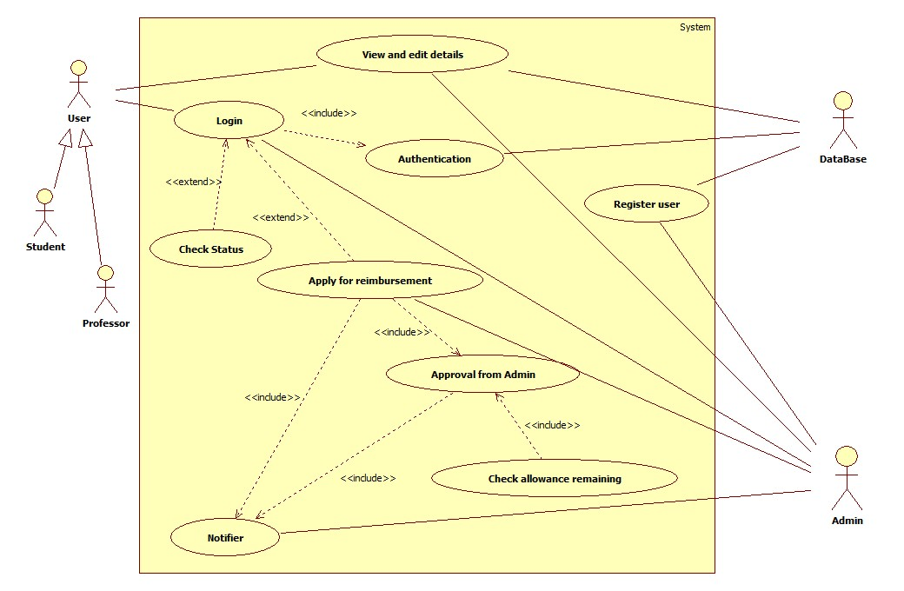

#### **2. Class Diagram :**

#### 

#### 

#### **3.Sequential Diagram :**

#### **1. Login**

#### 

#### **2 Register**

#### **3 Applying for reimbursement(Same for student, user and staff)**

#### **4. Activity Diagrams :**

**1 Validating credentials**

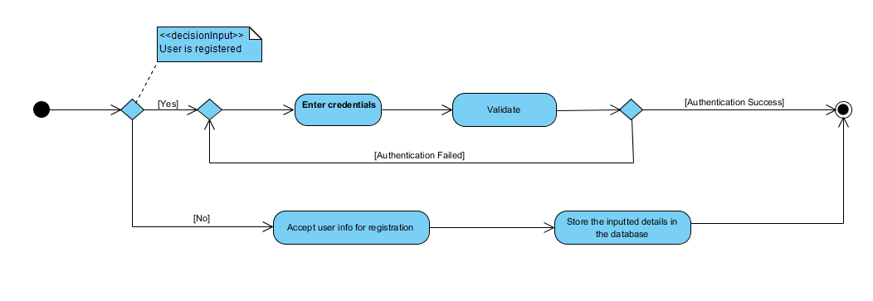

**2 Applying for reimbursement**

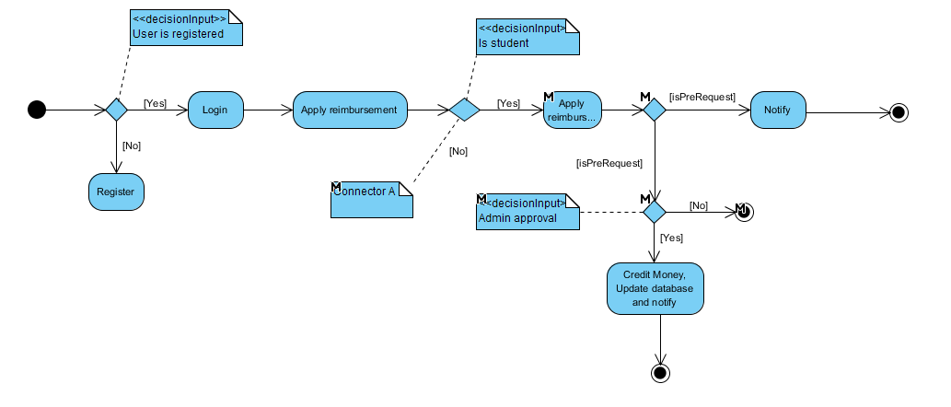

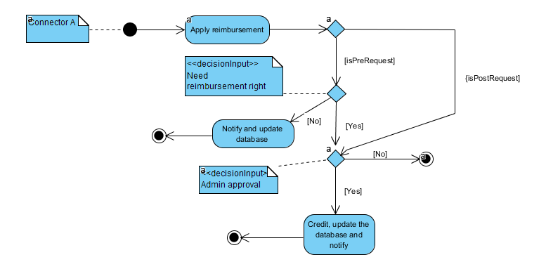

#### 

### **3. Non-Functional Requirements**

### **3.1 Performance Requirements :** The response time of the program depends on the connectivity with the database, (local host in this case). So response time is less than 1 second.

**3.2 Security Requirements :** User data is well secure in the database and can’t be accessed without successfully logging into the system.

**3.3 System Requirements :** The system must be able to run full -fledged C++ applications, with pre-installed GCC compiler.

**3.4 Software Requirements :** The system should be pre-installed with libraries such as windows.h and conio.h, to allow uninterrupted working.

### 

## 4.**User Characteristics**

To be precise there are 3 types of users who will interact with this software. Namely, Students (UG,PG) , Professors and Admin.

Students and Professors will have powers to register, change their details and apply for allowances . Request for allowance can be applied for, both before and after the trip. They can even access their previous allowances for which they have applied for in the past.

The Admin, will have the power to authorise or deny any allowance request. He/She will have a proper access to the database, in case he wants to review some past claim.

# 

## **Use case description**

|  |  |
| --- | --- |
| **Name** | **Login** |
| Short Description | The user or admin, would feed their valid user-id and password, to log into the software. |
| Precondition | Entered user-id and password are valid and exist in the database. |
| Postcondition | User is successfully logged into the software. |
| Error Situations | Invalid credentials or file not accessible. |
| System State in the state of error | Error is printed. |
| Actors | User ( including students and professors) and Admin |
| Trigger | After login option is invoked from the main interface page. |
| Standard Process | 1. User enters the credentials. 2. Details get authorised from the database. 3. In case of successful login, user is redirected to menu page else error message is printed and redirected to main interface page. |
| Alternative Process | User can get work done manually. |

|  |  |
| --- | --- |
| **Name** | **View and Edit Details** |
| Short Description | The user will be able to view and change his/her respective account details. Here, Admin will have the exclusive power to access and change details of any arbitrary user. |
| Precondition | User should be an existing member of this software and should be able to login using his credentials. |
| Postcondition | Information will be fetched from the database, and can be accessed by the user |
| Error Situations | In case of wrong inputs. |
| System State in the state of an error | Error message is shown. |
| Actors | User (student and professor) , Admin , Database. |
| Trigger | Once view and edit details option  is invoked from the main page |
| Standard Process | 1.In case user invokes the view details option:   * User details are fetched from the database and stored in a temporary user object. * Then details are displayed across the application interface.   2.In case user invokes edit details option :   * The software updates the details as edited by the user, in the database. |
| Alternative Process | As an alternate, the user may directly go the concerned authority’s office to view and edit details. |

|  |  |
| --- | --- |
| **Name** | **Register** |
| Short Description | A new student or professor, can register his/her details and become a user of the software. |
| Precondition | The new member must not be an existing user of the software. |
| Postcondition | Details of the new member are updated in the database and he/she becomes a user of the software and he/she will be redirected to the main menu page. |
| Error Situations | In case the new member is a pre-existing user, an error message will be displayed. Or in case a mismatching data is entered in some data field. |
| Actors | Data Verifier, Database and User |
| Trigger | Upon invoking the register option from the main interface menu. |
| Standard process | 1. User feeds his/her required details.  2.Program ensures, that the entered data type matches the required type.  3.After checking the error situations, database is updated and user is redirected to the main menu page. |
| Alternative Process | The new person may visit the concerned authority’s office and get registered. |

|  |  |
| --- | --- |
| **Name** | **Authentication** |
| Short Description | Matches the data entered by the user, with the database. If matched, redirects to the main menu page. Else, displays error message.  If user forgets password, then upon verification of the security question from database, new password may be created. |
| Precondition | User must have entered his/her credentials in the login page. |
| Postcondition | Data gets available for fetching from the database. |
| Error Situation | * If user does not exist, error message is displayed and asking to register. * If password does not match, error message is displayed. |
| Actors | Data Verifier |
| Trigger | After entering the user details, authentication is maneuvered. |
| Standard Process | * Verifies the entered data with the database. * If verified successfully, data becomes accessible. * Else error message is displayed. * If user forgets password, then upon verification of the security question from database, new password may be created. |
| Alternative Process | User can directly mail his/her problem to the concerned authority (Admin). |

|  |  |
| --- | --- |
| **Name** | **Apply for reimbursement** |
| Short Description | This maneuvers the whole process of applying for the reimbursement. Processes the request and sends it to the admin for final approval. |
| Precondition | The user must be having a proper trip detail proof, in order to claim the reimbursement. |
| Postcondition | If the claim gets approval from the admin, then the allowance is given and successful notification is sent to the user, else error notification is given. |
| Error Situation | In case balance allowance is not cleared, and still the user applies for yet another allowance. |
| System State in the state of an error | Error message is shown. |
| Actors | Admin |
| Triggers | After entering the trip details and then invoking, applying for reimbursement. |
| Standard Process | Applying for allowance before the trip:   * User must ensure that the previous unpaid allowances are completed. * Logged in professor, fills in the trip details and send the request for allowance to the admin. * The admin, processes the request and takes decision. * Upon approval allowance is given and concurrently database is updated. * After returning from the trip, it is required, by the user to submit proper proof of trip details and return the balance amount to the concerned authority   Applying for allowance after the trip :   * The user must ensure that the previous unpaid allowances are completed. * After this the user, enter the trip details, which are sent to the admin for approval, admin processes the request. * Upon approval from the admin, allowance is given and database is updated. |
| Alternative process | User may fill in the hardcopy of forms manually and submit it to the concerned authority. |

|  |  |
| --- | --- |
| **Name** | **Notifier** |
| Short Description | This use case sends notification in case a user applies for an allowance, gets approved or gets denied (in all three cases a separate notification is sent to the user and to the admin.) |
| Precondition | The user should have applied for an allowance. |
| Postcondition | Incase the user has just applied for the allowance, the Admin will get a notification regarding the same. Incase the allowance gets approved by the admin, a successful notification will be sent. And same for the denial case. |
| Error Situation | Wrong inputs given |
| System State in the state of an error | Error message is displayed. |
| Actors | Admin |
| Trigger | Applying for the allowance triggers the process of sending the notifications. |
| Standard Process | By checking the status of the approval, a notification is updated in the database for the users and admin. |
| Alternative process | User has to contact office personally in order to check status . |

### **Maintenance:**

The program is highly maintainable as, in the future if need arises to integrate our software with any other software, it can easily be done because of the diverse nature of the classes. All aspects are considered regarding maintainability. In future, if way of registration or login is modified, then it can easily be integrated, thus making it highly maintainable.

Design is language agnostic, so it can be implemented by ANY language.

**Supportabilty:**

Naming Convention :The code will be written as specified by the Hungarian Naming Convention.