*END RESULT*

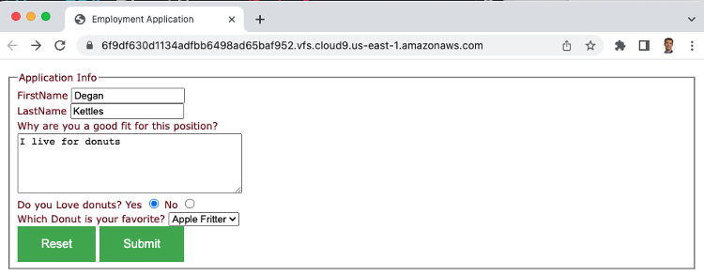

*FOLDER STRUCTURE*

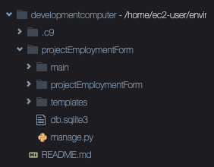

*templates/form.html*

<!DOCTYPE html>

<html lang="en">

<head>

<title>Employment Application</title>

<style>

body {

font-size: 10pt;

font-family: Verdana, Geneva, Arial, Helvetica, sans-serif;

color: #700707;

line-height: 14pt;

padding-left: 5pt;

padding-right: 5pt;

padding-top: 5pt;

}

button {

background-color: #4CAF50; /* Green */

border: none;

color: white;

padding: 15px 32px;

text-align: center;

text-decoration: none;

display: inline-block;

font-size: 16px;

}

</style>

</head>

<body>

<form

method="POST"

action="http://ec2-3-87-236-8.compute-1.amazonaws.com/phpinfo.php"

>

<fieldset>

<legend>Application Info</legend>

<label for="firstNameID">FirstName</label>

<input type="text" name="firstName" id="firstNameID" autofocus />

<br />

<label for="lastNameID">LastName</label>

<input type="text" name="lastName" id="lastNameID" />

<br />

<label for="specialInstructions">Why are you a good fit for this position?</label>

<br />

Do you Love donuts? Yes

<input type="radio" name="loveDonuts" value="Y" /> No

<input type="radio" name="loveDonuts" value="N" />

<br />

Which Donut is your favorite?

<select name="whichDonut">

<option>Apple Fritter</option>

<option>Chocolate</option>

<option>Glazed</option>

</select>

<br />

<button type="reset">Reset</button>

<button type="submit">Submit</button>

</fieldset>

</form>

</body>

</html>

*project settings.py*

"""

Django settings for projectEmploymentForm project.

Generated by 'django-admin startproject' using Django 4.1.7.

For more information on this file, see

https://docs.djangoproject.com/en/4.1/topics/settings/

For the full list of settings and their values, see

https://docs.djangoproject.com/en/4.1/ref/settings/

"""

from pathlib import Path

import os

# Build paths inside the project like this: BASE_DIR / 'subdir'.

BASE_DIR = Path(__file__).resolve().parent.parent

# Quick-start development settings - unsuitable for production

# See https://docs.djangoproject.com/en/4.1/howto/deployment/checklist/

# SECURITY WARNING: keep the secret key used in production secret!

SECRET_KEY = 'django-insecure-o#ix!62lr2il+sh7e@*#_tav5&2-ssi3luzhte#cgihf64!qs8'

# SECURITY WARNING: don't run with debug turned on in production!

DEBUG = True

ALLOWED_HOSTS = ['*']

# Application definition

INSTALLED_APPS = [

'django.contrib.admin',

'django.contrib.auth',

'django.contrib.contenttypes',

'django.contrib.sessions',

'django.contrib.messages',

'django.contrib.staticfiles',

'main.apps.MainConfig'

]

MIDDLEWARE = [

'django.middleware.security.SecurityMiddleware',

'django.contrib.sessions.middleware.SessionMiddleware',

'django.middleware.common.CommonMiddleware',

'django.middleware.csrf.CsrfViewMiddleware',

'django.contrib.auth.middleware.AuthenticationMiddleware',

'django.contrib.messages.middleware.MessageMiddleware',

'django.middleware.clickjacking.XFrameOptionsMiddleware',

]

ROOT_URLCONF = 'projectEmploymentForm.urls'

TEMPLATES = [

{

'BACKEND': 'django.template.backends.django.DjangoTemplates',

'DIRS': [os.path.join(BASE_DIR, 'templates')],

'APP_DIRS': True,

'OPTIONS': {

'context_processors': [

'django.template.context_processors.debug',

'django.template.context_processors.request',

'django.contrib.auth.context_processors.auth',

'django.contrib.messages.context_processors.messages',

],

},

},

]

WSGI_APPLICATION = 'projectEmploymentForm.wsgi.application'

# Database

# https://docs.djangoproject.com/en/4.1/ref/settings/#databases

DATABASES = {

'default': {

'ENGINE': 'django.db.backends.sqlite3',

'NAME': BASE_DIR / 'db.sqlite3',

}

}

# Password validation

# https://docs.djangoproject.com/en/4.1/ref/settings/#auth-password-validators

AUTH_PASSWORD_VALIDATORS = [

{

'NAME': 'django.contrib.auth.password_validation.UserAttributeSimilarityValidator',

},

{

'NAME': 'django.contrib.auth.password_validation.MinimumLengthValidator',

},

{

'NAME': 'django.contrib.auth.password_validation.CommonPasswordValidator',

},

{

'NAME': 'django.contrib.auth.password_validation.NumericPasswordValidator',

},

]

# Internationalization

# https://docs.djangoproject.com/en/4.1/topics/i18n/

LANGUAGE_CODE = 'en-us'

TIME_ZONE = 'UTC'

USE_I18N = True

USE_TZ = True

# Static files (CSS, JavaScript, Images)

# https://docs.djangoproject.com/en/4.1/howto/static-files/

STATIC_URL = 'static/'

# Default primary key field type

# https://docs.djangoproject.com/en/4.1/ref/settings/#default-auto-field

DEFAULT_AUTO_FIELD = 'django.db.models.BigAutoField'

*main/urls.py*

from django.urls import path

from .views import employmentFormPageView

urlpatterns = [

path("", employmentFormPageView, name="form")

]

*main/views.py*

from django.shortcuts import render

# Create your views here.

def employmentFormPageView(request) :

return render(request,"form.html")

*project urls.py*

from django.contrib import admin

from django.urls import path, include

urlpatterns = [

path('admin/', admin.site.urls),

path("", include('main.urls'))

]

Key commands:

docker run --rm -p 8080:8080 -v "`pwd`":"`pwd`" -w "`pwd`" -ti python bash

django-admin startproject projectEmploymentForm

chmod -R a+w .

python projectEmploymentForm/manage.py runserver 0.0.0.0:8080

python manage.py startapp main