End-to-End LLM Testing,
Benchmarking and Regression Analysis

Project Documentation
Document PROJECT_DOCUMENTATION.md / .docx
Scope Architecture, modules, APIs, database, design system, testing
Backend Python 3.11+ · FastAPI · SQLAlchemy 2.0 · SQLite
Frontend React 19 · TypeScript · Vite 8
Diagrams 12 Mermaid sources in docs/diagrams/

Contents
Word will populate this field on open. If it appears empty, right-click it and choose Update Field.

Project Documentation
End-to-End LLM Testing, Benchmarking and Regression Analysis
A self-hosted platform for running reproducible LLM benchmark suites, scoring each response with deterministic and model-graded evaluators, and detecting statistically significant regressions between two runs of the same dataset.

Table of contents
- Executive summary
- Problem statement and scope
- System architecture
- Technology stack
- Repository layout
- Backend modules
- Evaluation core
- Provider layer
- API reference
- Database schema
- Frontend architecture
- Design system
- Datasets
- Legacy Streamlit dashboard
- Configuration
- Setup and installation
- Running the application
- Testing
- Security model
- Known limitations and future work

1. Executive summary
This platform answers one question with statistical rigour: did this model get worse?
Most LLM evaluation tooling reports a score. A score alone cannot tell you whether a change is real or noise, and it cannot tell you whether a drop is large enough to act on. This project closes that gap by pairing a benchmark runner with a paired statistical comparison engine.
The system has three parts:
Part | Role | Entry point
Backend | Runs benchmarks, scores cases, performs regression analysis, persists everything | backend/main.py
Frontend | React SPA for launching runs, inspecting cases, and reading the regression matrix | frontend/src/App.tsx
Legacy dashboard | Streamlit UI over the same API, retained for parity | dashboard/app.py

The core design commitments are:
- Reproducibility. Every run records the dataset's SHA-256. Two runs can only be compared when their dataset hashes match, so a comparison can never silently mix different test suites.
- Fail-closed evaluation. An unrecognised evaluation method raises rather than passing. A case is never marked correct by accident.
- Honest statistics. Pass rate uses an exact McNemar test; every other metric uses a paired Wilcoxon signed-rank test. Confidence intervals come from a paired percentile bootstrap with a fixed, SHA-256-derived seed. Multiple comparisons are corrected with Holm-Bonferroni.
- No fabricated data. The UI renders only what the API returns. Where a value is unavailable, it says so rather than showing a placeholder number.

2. Problem statement and scope

The problem
A team changes a prompt template, swaps a model version, or adjusts a decoding parameter. The new configuration scores 84% where the old one scored 87%. Three questions follow immediately:
- Is a three-point drop larger than run-to-run noise?
- Which specific metrics moved, and by how much?
- Which test cases actually changed verdict?
Answering these by eye is unreliable. With 63 test cases, a three-point swing is two cases — well inside the range that random sampling produces. Acting on it wastes effort; ignoring it risks shipping a real regression.

What this project does
- Executes a benchmark suite against any OpenAI-compatible endpoint.
- Scores each case with a deterministic evaluator, and optionally with semantic similarity and an LLM judge.
- Stores every case result, including failures, with a sanitized error category.
- Compares two runs of the same dataset and reports, per metric, the mean delta, a bootstrap confidence interval, a raw p-value, a Holm-Bonferroni adjusted p-value, and a boolean regression verdict.
- Presents the result as a matrix where a regression is the visually dominant signal.

What this project deliberately does not do
- No automatic prompt optimisation. The platform measures; it does not tune.
- No hosted multi-tenant service. It is designed to run on one machine or one container, against your own API keys.
- No database migrations. Schema is created from the SQLAlchemy models at import. Changing a model requires recreating the database.
- No streaming responses. Providers are called with a single request/response cycle.

3. System architecture
Diagram — System architecture
flowchart TB
subgraph Client["Browser"]
UI["React 19 SPA<br/>Vite 8 + TypeScript"]
end

subgraph API["FastAPI application (backend/main.py)"]
MW["Middleware chain<br/>CORS → TrustedHost → protect_api"]
Routes["Route handlers"]
end

subgraph Core["Evaluation core (backend/evaluation)"]
DS["datasets.py<br/>load + SHA-256"]
RUN["runner.py<br/>execute_run"]
MET["metrics.py<br/>deterministic scoring"]
SEM["semantic.py<br/>sentence-transformers"]
JUD["judge.py<br/>LLM rubric scorecard"]
ANA["analysis.py<br/>compare_runs"]
end

subgraph Prov["Providers (backend/providers)"]
FAC["factory.py<br/>create_configured_providers"]
BASE["base.py<br/>retry + error mapping"]
IMPL["gemini · groq · minimax<br/>custom · mock"]
end

subgraph Store["Persistence"]
DB[("SQLite app.db<br/>SQLAlchemy 2.0")]
end

subgraph Ext["External services"]
LLM["LLM HTTP endpoints"]
ST["sentence-transformers<br/>model weights"]
end

UI -->|"HTTP /api/*"| MW
MW --> Routes
Routes --> DS
Routes --> RUN
Routes --> ANA
RUN --> MET
RUN --> SEM
RUN --> JUD
RUN --> FAC
FAC --> BASE
BASE --> IMPL
IMPL -->|"httpx"| LLM
SEM --> ST
DS --> DB
RUN --> DB
ANA --> DB
Routes --> DB

mermaid

The architecture is a straight line: the browser talks to FastAPI, FastAPI orchestrates the evaluation core, the evaluation core calls providers over HTTP, and everything durable lands in SQLite.
Request path. Every request passes a middleware chain before reaching a route handler:
- CORSMiddleware — origins from CORS_ORIGINS.
- TrustedHostMiddleware — applied only when ENVIRONMENT=production.
- protect_api — a custom HTTP middleware that enforces the x-api-key header when BACKEND_API_KEY is set, and rejects bodies larger than 1 MiB.
Orchestration. runner.execute_run() is the only place that drives a full benchmark. It loads the dataset, creates the run row, iterates cases, calls the provider, dispatches to the evaluators, and commits progress after each case. Committing per case means a crash mid-run leaves an inspectable, partially complete record rather than nothing.
Diagram — Benchmark run sequence
sequenceDiagram
autonumber
actor User
participant UI as React SPA
participant API as FastAPI
participant DS as datasets.py
participant RUN as runner.py
participant PROV as Provider
participant MET as metrics.py
participant SEM as semantic.py
participant JUD as judge.py
participant DB as SQLite

User->>UI: Select dataset, provider, model
UI->>API: POST /api/runs
API->>DS: load_dataset(dataset_file)
DS->>DS: compute SHA-256
DS-->>API: cases + sha256 + version
API->>DB: INSERT benchmark_runs (status=running)
API-->>UI: RunSummary (202-style acknowledgement)

loop For each test case
API->>PROV: generate(prompt)
alt Provider succeeds
PROV-->>API: candidate text + tokens + latency
API->>MET: evaluate_case(method, candidate, reference)
MET-->>API: deterministic result
opt Semantic scoring enabled
API->>SEM: similarity(candidate, reference)
SEM-->>API: cosine similarity
end
opt Judge enabled
API->>JUD: score(case, candidate)
JUD-->>API: 5-dimension scorecard
end
else Provider fails
PROV-->>API: ProviderError (sanitized)
API->>API: record error_category + message
end
API->>DB: INSERT benchmark_case_results
API->>DB: UPDATE run progress counters
end

API->>DB: UPDATE benchmark_runs (final status)
Note over API,DB: completed | partial_failure | failed
UI->>API: GET /api/runs (polled every 10s)
API-->>UI: RunSummary list

mermaid

Diagram — Run lifecycle
stateDiagram-v2
[*] --> running : POST /api/runs accepted

running --> completed : every case scored
running --> partial_failure : some cases errored
running --> failed : every case errored

completed --> [*]
partial_failure --> [*]
failed --> [*]

note right of running
Progress counters are committed
per case, so a crash mid-run leaves
a resumable, inspectable record.
end note

note right of partial_failure
passed_cases + errored_cases = total_cases
The run is still comparable, but the
regression verdict should be read with
the error rate in mind.
end note

note right of failed
error_message is set to a sanitized
summary such as "All provider requests
failed." No API keys or headers are
ever persisted.
end note

mermaid

Analysis. analysis.compare_runs() is pure with respect to the network: it reads two runs' case results from the database, pairs them by test_case_id, and computes the comparison. It never calls a provider.
Diagram — Regression analysis flow
flowchart TD
A["POST /api/analyses/compare<br/>baseline_run_id, candidate_run_id"] --> B{"Same dataset_sha256?"}
B -->|No| B1["400 — datasets differ"]
B -->|Yes| C{"Distinct run ids?"}
C -->|No| C1["400 — cannot compare a run with itself"]
C -->|Yes| D{"0 < alpha < 1 and<br/>minimum_regression_drop >= 0?"}
D -->|No| D1["422 — invalid parameters"]
D -->|Yes| E["Load case results for both runs"]

E --> F["_extract_metrics<br/>pair cases by test_case_id"]
F --> G["Metrics: deterministic_pass_rate,<br/>semantic_similarity, judge_overall,<br/>judge_relevance, judge_completeness,<br/>judge_instruction_following,<br/>judge_factual_alignment, judge_clarity"]

G --> H{"Metric is<br/>deterministic_pass_rate?"}
H -->|Yes| I["Exact McNemar test<br/>on discordant pairs"]
H -->|No| J["Paired Wilcoxon<br/>signed-rank test"]

I --> K["Paired percentile bootstrap CI<br/>10,000 resamples, SHA-256 seeded RNG"]
J --> K
K --> L["Holm-Bonferroni correction<br/>across all compared metrics"]
L --> M{"adjusted_p < alpha<br/>AND mean_delta < -minimum_regression_drop?"}
M -->|Yes| N["regression_detected = true"]
M -->|No| O["regression_detected = false"]
N --> P["Persist run_analyses row<br/>result JSON"]
O --> P
P --> Q["Return ComparisonResponse"]

mermaid

Persistence. SQLAlchemy 2.0 declarative models over SQLite. Four tables, described in section 10.
Diagram — Deployment topology
flowchart LR
subgraph Dev["Developer machine"]
ENV[".env<br/>API keys, ports, flags"]
VENV[".venv<br/>Python 3.11+"]
NODE["Node 20+<br/>npm"]
end

subgraph Backend["Backend process"]
UV["uvicorn backend.main:app<br/>port 8000"]
DBF[("app.db<br/>SQLite")]
end

subgraph Frontend["Frontend process"]
VITE["vite dev server<br/>port 5173"]
PROXY["/api, /health, /ready<br/>proxied to 127.0.0.1:8000"]
end

subgraph Optional["Optional"]
STREAMLIT["Streamlit dashboard<br/>dashboard/app.py"]
OLLAMA["Ollama / vLLM<br/>local OpenAI-compatible"]
end

ENV --> UV
ENV --> VITE
VENV --> UV
NODE --> VITE
UV --> DBF
VITE --> PROXY
PROXY --> UV
STREAMLIT --> UV
OLLAMA --> UV

style UV fill:#191b1f,color:#f2f3f5
style VITE fill:#191b1f,color:#f2f3f5

mermaid

4. Technology stack

Backend
Component | Version constraint | Purpose
Python | >=3.11 | Runtime
FastAPI | — | HTTP API and request validation
Uvicorn | — | ASGI server
SQLAlchemy | 2.0 style | ORM and schema definition
Pydantic | — | Request/response and judge scorecard validation
httpx | — | Async provider HTTP client
NumPy | — | Bootstrap resampling
SciPy | — | McNemar and Wilcoxon tests
scikit-learn | — | Cosine similarity
sentence-transformers | — | Semantic similarity embeddings
jsonschema | — | json_schema_validation evaluator
pandas | — | CSV dataset loading
python-dotenv | — | .env loading
Streamlit | — | Legacy dashboard
Plotly | — | Legacy dashboard charts

Dev extras: pytest, pytest-cov, ruff (line length 100, rules E, F, I).

Frontend
Component | Version | Purpose
React | 19 | UI
TypeScript | — | Type safety
Vite | 8 | Dev server and production bundler
oxlint | — | Linting
lucide-react | — | Icon set

The frontend has no state-management library, no CSS framework, and no component library. State lives in App.tsx and is passed down as props. Styling is a single hand-written stylesheet, index.css.

5. Repository layout
.
├── backend/
│ ├── main.py FastAPI app, middleware, all routes
│ ├── config.py Frozen Settings dataclass, production guards
│ ├── database.py Engine, session factory, Base
│ ├── models.py Four SQLAlchemy tables
│ ├── __main__.py `python -m backend` entry point
│ ├── evaluation/
│ │ ├── runner.py execute_run — the orchestration loop
│ │ ├── metrics.py evaluate_case — deterministic evaluators
│ │ ├── semantic.py SemanticScorer — embedding similarity
│ │ ├── judge.py LLM judge with a strict scorecard
│ │ ├── analysis.py compare_runs — the regression engine
│ │ ├── datasets.py load_dataset + SHA-256
│ │ ├── schemas.py Case-level result schemas
│ │ ├── run_schemas.py Run request/response schemas
│ │ └── analysis_schemas.py Comparison schemas
│ └── providers/
│ ├── base.py Provider protocol, retry policy, error mapping
│ ├── factory.py create_configured_providers
│ ├── gemini.py Google Gemini
│ ├── groq.py Groq Cloud
│ ├── minimax.py KiraAI MiniMax
│ ├── custom.py User-registered OpenAI-compatible endpoints
│ ├── mock.py Deterministic test provider
│ └── models.py Provider-side data models
├── frontend/
│ ├── src/
│ │ ├── App.tsx Shell, tab routing, polling, modal state
│ │ ├── api.ts All API types and fetch functions
│ │ ├── index.css Design tokens and every component class
│ │ ├── main.tsx React root
│ │ └── components/
│ │ ├── Header.tsx Brand, status row, navigation
│ │ ├── OverviewView.tsx Verdict, regression matrix, run ledger
│ │ ├── BenchmarkStudioView.tsx Launch a run
│ │ ├── DatasetExplorerView.tsx Browse and filter cases
│ │ ├── RegressionMatrixView.tsx Compare two runs
│ │ ├── ModelStudioView.tsx Register and test endpoints
│ │ └── RunDetailModal.tsx Per-case inspection dialog
│ ├── vite.config.ts Dev server and API proxy
│ └── package.json
├── dashboard/
│ └── app.py Legacy Streamlit dashboard
├── datasets/
│ ├── manifest.json SHA-256 and byte size for every dataset
│ ├── benchmark_dataset.csv 63 cases, 10 columns
│ ├── prompt_injection_tests.json 20 cases
│ ├── reference_grounding_tests.json 20 cases
│ └── structured_output_tests.json 20 cases
├── tests/ 8 test modules, 54 passing tests
├── docs/
│ ├── PROJECT_DOCUMENTATION.md This document
│ ├── PROJECT_DOCUMENTATION.docx Word version
│ ├── ARCHITECTURE.md Earlier architecture note
│ ├── DEPLOYMENT.md Deployment guide
│ ├── GITHUB_WORKFLOW.md CI notes
│ └── diagrams/ 12 Mermaid source files
├── pyproject.toml
├── compose.yaml
└── .env.example

6. Backend modules

`backend/config.py`
A frozen dataclass holding every setting, populated from environment variables via python-dotenv. Being frozen means configuration cannot drift at runtime.
Production guards raise at import time rather than failing later:
- BACKEND_API_KEY must be set when ENVIRONMENT=production.
- CORS_ORIGINS must not contain a wildcard in production.
- Debug affordances are disabled.

`backend/database.py`
Creates the SQLAlchemy engine, a sessionmaker, and the declarative Base. Base.metadata.create_all(bind=engine) runs at import, so the schema is created on first start. There is no migration system.

`backend/models.py`
Four tables: benchmark_runs, benchmark_case_results, run_analyses, custom_models. See section 10.

`backend/main.py`
The application. Responsibilities:
- Builds the FastAPI app with docs_url, redoc_url, and openapi_url all set to None in production, so the schema is not exposed.
- Installs the middleware chain described in section 3.
- Defines every route. Handlers are thin: they validate input, call into the evaluation core, and serialise the result.
- Owns the protect_api middleware, which uses hmac.compare_digest for the API-key comparison so the check is not timing-sensitive.

7. Evaluation core

`evaluation/datasets.py`
load_dataset() reads a CSV or JSON file from datasets/, normalises each row into a case dictionary, and computes the file's SHA-256. The hash is the reproducibility anchor: it is stored on the run and checked before any comparison.
Diagram — Dataset loading and scoring
flowchart TD
A["Dataset file in datasets/"] --> B{"Extension"}
B -->|".csv"| C["pandas.read_csv"]
B -->|".json"| D["json.load<br/>expects cases[] array"]

C --> E["Normalize each row to a case dict"]
D --> E

E --> F["Required: test_case_id,<br/>input_prompt, evaluation_method"]
F --> G{"evaluation_method"}
G -->|"exact_match"| H["Normalized string equality"]
G -->|"numeric_tolerance"| I["Parse float, compare within tolerance"]
G -->|"json_schema_validation"| J["jsonschema.validate against<br/>expected_output_schema"]
G -->|"anything else"| K["ValueError — fails closed"]

H --> L["DeterministicResult"]
I --> L
J --> L

L --> M["Optional: semantic similarity<br/>if reference_answer present"]
M --> N["Optional: LLM judge scorecard<br/>if judge_enabled"]

N --> O["Case verdict:<br/>passed | failed | error"]
O --> P["Aggregate into run counters"]

mermaid

`evaluation/metrics.py`
evaluate_case() implements exactly three deterministic methods:
Method | Behaviour
exact_match | Normalised string equality against reference_answer
numeric_tolerance | Parses both values as floats and compares within a tolerance
json_schema_validation | Validates the candidate against expected_output_schema with jsonschema

Any other method raises ValueError. This is deliberate: an unknown method must never be treated as a pass.

`evaluation/semantic.py`
SemanticScorer wraps sentence-transformers behind an lru_cache(2) so at most two models are resident. It returns cosine similarity between the candidate and the reference answer.
Two properties matter:
- Cosine similarity is not a correctness probability. It measures textual proximity. A confidently wrong answer that paraphrases the reference can score highly.
- When either text is missing, similarity is None rather than zero, so absence is distinguishable from dissimilarity.

`evaluation/judge.py`
An LLM-as-judge evaluator with a strict Pydantic scorecard. Five dimensions are scored on a 1–5 scale: relevance, completeness, instruction following, factual alignment, and clarity. factual_alignment is optional when the case supplies no reference context — scoring it without a ground truth would be fabrication.
The rubric is versioned as llm-judge-rubric-v1, and that version is recorded with the result so scores remain interpretable if the rubric later changes.

`evaluation/runner.py`
execute_run() is the orchestration loop:
- Load the dataset and compute its hash.
- Insert a benchmark_runs row with status='running'.
- For each case: call the provider, dispatch to the evaluators, insert a benchmark_case_results row, and update the run's progress counters — committing after each case.
- Set the final status.
Final status is derived from the error count:
Condition | Status
Every case errored | failed
Some cases errored | partial_failure
No cases errored | completed

`evaluation/analysis.py`
compare_runs() is the regression engine. It validates its inputs strictly:
- Both runs must share the same dataset_sha256.
- The run ids must differ.
- 0 < alpha < 1.
- minimum_regression_drop >= 0.
It then extracts eight metrics by pairing case results on test_case_id:
deterministic_pass_rate, semantic_similarity, judge_overall, judge_relevance, judge_completeness, judge_instruction_following, judge_factual_alignment, judge_clarity.
For each metric it computes:
- Mean delta between candidate and baseline.
- Test statistic and p-value. deterministic_pass_rate uses an exact McNemar test on discordant pairs, which is the correct test for paired binary outcomes. Every other metric uses a paired Wilcoxon signed-rank test.
- Bootstrap confidence interval. A paired percentile bootstrap with 10,000 resamples, seeded from a SHA-256 digest so the interval is reproducible.
- Holm-Bonferroni adjusted p-value, correcting across all metrics compared in the same call.
- Regression verdict: adjusted_p < alpha AND mean_delta < -minimum_regression_drop.
Both conditions are required. A statistically significant but tiny drop is not a regression; a large drop with too few samples to be significant is not a regression either.
Note on `higher_is_better`. The field exists on every MetricComparison and defaults to True. No code path currently sets it to False, because every metric the engine extracts is one where a higher value is better. The field is retained so a future cost or latency metric can be added without changing the comparison logic.

8. Provider layer

`providers/base.py`
Defines the Provider protocol with a single async generate() method, plus the shared HTTP machinery:
- `RetryPolicy` — exponential backoff computed as initial_delay_seconds * 2**attempt, capped at max_delay_seconds. A Retry-After header is honoured in both numeric-seconds and HTTP-date form.
- `BaseHttpProvider._send_with_retry` — retries on 408, 429, and 5xx responses, and on httpx.TimeoutException and httpx.TransportError.
- Error mapping — every failure is classified into one of: timeout, rate_limited, upstream_unavailable, authentication (401/403), request_rejected (other 4xx), invalid_response.
- Sanitisation — ProviderError messages never include request headers or API keys. This is what makes it safe to persist error_message on a case row and display it in the UI.
Diagram — Provider retry and error classification
flowchart TD
A["Provider request"] --> B{"HTTP status / exception"}
B -->|"200 OK"| C["Parse response body"]
B -->|"401 or 403"| D["authentication<br/>no retry"]
B -->|"408, 429, 5xx"| E["Retryable"]
B -->|"other 4xx"| F["request_rejected<br/>no retry"]
B -->|"TimeoutException"| E
B -->|"TransportError"| E

C --> G{"Body shape valid?"}
G -->|Yes| H["Return ProviderResponse"]
G -->|No| I["invalid_response<br/>no retry"]

E --> J{"Attempts remaining?"}
J -->|No| K["upstream_unavailable<br/>or rate_limited"]
J -->|Yes| L{"Retry-After header?"}
L -->|"numeric or HTTP-date"| M["Wait the stated delay"]
L -->|No| N["Exponential backoff<br/>initial * 2^attempt, capped"]
M --> O["Retry request"]
N --> O
O --> B

D --> P["ProviderError<br/>sanitized message"]
F --> P
I --> P
K --> P
P --> Q["Recorded on the case row as<br/>error_category + error_message"]

mermaid

`providers/factory.py`
create_configured_providers() instantiates only providers whose API key is non-blank. A provider with no key is reported as unconfigured by GET /api/config/providers and is never constructed.

Provider implementations
Module | Provider | Notes
gemini.py | Google Gemini | Native Gemini API shape
groq.py | Groq Cloud | OpenAI-compatible
minimax.py | KiraAI MiniMax | OpenAI-compatible
custom.py | User-registered | Any OpenAI-compatible base URL
mock.py | Test double | Deterministic, used by the test suite

9. API reference
All routes are under /api except the two health probes. When BACKEND_API_KEY is set, every /api route requires an x-api-key header.

Health
Method | Path | Returns
GET | /health | {status, app, environment}
GET | /ready | Readiness probe

Configuration
Method | Path | Returns
GET | /api/config/providers | {providers, custom_models, judge_enabled, judge_provider, environment}

Each entry in providers is keyed by provider id and carries {name, configured, default_model, available_models[]}.

Custom models
Method | Path | Purpose
GET | /api/custom-models | List registered endpoints
POST | /api/custom-models | Register an endpoint
DELETE | /api/custom-models/{id} | Remove an endpoint
POST | /api/custom-models/test | Send a probe request and report latency

The API never returns a stored api_key.

Datasets
Method | Path | Returns
GET | /api/datasets | [{dataset_file, dataset_name, dataset_version, case_count, sha256}]
GET | /api/datasets/{file}/cases | {dataset_file, dataset_name, dataset_version, cases[]}

Runs
Method | Path | Purpose
POST | /api/runs | Execute a benchmark synchronously and return the finished RunSummary
GET | /api/runs | List runs, newest first
GET | /api/runs/{id} | Run detail including every case result

POST /api/runs body:
{
"dataset_file": "benchmark_dataset.csv",
"provider": "minimax",
"model_id": "minimax-m3.1-flash-free",
"include_judge": false
}
json

Analyses
Method | Path | Purpose
POST | /api/analyses/compare | Compare two runs and return the metric matrix
GET | /api/analyses | List stored analyses
GET | /api/analyses/{id} | Retrieve a stored analysis

POST /api/analyses/compare body:
{
"baseline_run_id": "<uuid>",
"candidate_run_id": "<uuid>",
"alpha": 0.05,
"minimum_regression_drop": 0.02
}
json

Overview
Method | Path | Returns
GET | /api/overview | {project, status, metrics: {total_runs, models_evaluated, test_cases_executed}}

Important. /api/overview returns no regression data. The Overview page's verdict line and regression matrix are derived client-side by grouping GET /api/runs by provider::model_id and comparing each model's latest run against its previous run. This is a deliberate choice: the overview endpoint stays cheap, and the verdict is computed from the same run list the ledger displays, so the two can never disagree.

Diagram — Overview verdict derivation
flowchart TD
A["Overview tab loads"] --> B["Group runs by provider::model_id"]
B --> C["Sort each group by started_at desc"]
C --> D{"Group has 2+ runs?"}

D -->|No| E["Verdict: 'No model has two runs yet'<br/>Action: Run a benchmark"]
D -->|Yes| F["latest = runs[0]<br/>previous = runs[1]"]

F --> G["latestPassRate = passed/total * 100"]
G --> H["previousPassRate = passed/total * 100"]
H --> I["delta = latest - previous"]

I --> J{"delta < 0?"}
J -->|Yes| K["Row marked is-regressed<br/>delta rendered in rose"]
J -->|No| L["Row rendered neutral"]

K --> M["Verdict line names the regressed model<br/>and the size of the drop"]
L --> N["Verdict line reports the fleet is stable"]

M --> O["Matrix table: one row per model"]
N --> O
E --> O
O --> P["Ledger: dense rows, newest first"]
P --> Q{"User clicks a row or a matrix cell?"}
Q -->|Yes| R["onSelectRun → RunDetailModal"]
Q -->|No| S["Idle; polled every 10s"]

mermaid

10. Database schema
Diagram — Database schema
erDiagram
BENCHMARK_RUNS ||--o{ BENCHMARK_CASE_RESULTS : "has"
BENCHMARK_RUNS ||--o{ RUN_ANALYSES : "baseline of"
BENCHMARK_RUNS ||--o{ RUN_ANALYSES : "candidate of"

BENCHMARK_RUNS {
string id PK "uuid4 hex"
string dataset_file
string dataset_name
string dataset_version
string dataset_sha256 "comparison guard"
string provider
string model_id
string status "running|completed|partial_failure|failed"
boolean judge_enabled
datetime started_at "indexed"
datetime completed_at
int total_cases
int completed_cases
int passed_cases
int errored_cases
int total_input_tokens
int total_output_tokens
float total_latency_ms
float total_estimated_cost_usd
text error_message
}

BENCHMARK_CASE_RESULTS {
int id PK
string run_id FK "ON DELETE CASCADE"
int ordinal
string test_case_id "unique with run_id"
string evaluation_method
string status "passed|failed|error"
text candidate_text
string provider
string model_id
int input_tokens
int output_tokens
float latency_ms
float estimated_cost_usd
json deterministic_result
json semantic_result
json judge_result
text evaluation_error
string error_category
text error_message
}

RUN_ANALYSES {
int id PK
string baseline_run_id FK
string candidate_run_id FK
string method_version
float alpha
float minimum_regression_drop
datetime created_at "indexed"
json result
}

CUSTOM_MODELS {
int id PK
string name
string model_id
string base_url
string api_key "never returned by API"
text description
datetime created_at "indexed"
boolean is_active
}

mermaid

`benchmark_runs`
One row per benchmark execution.
Column | Type | Notes
id | string, PK | UUID4 hex
dataset_file | string | Filename within datasets/
dataset_name | string | Human-readable name
dataset_version | string | From the dataset
dataset_sha256 | string | Comparison guard
provider | string | Provider id
model_id | string | Model identifier
status | string | running, completed, partial_failure, failed
judge_enabled | boolean | Whether the LLM judge ran
started_at | datetime | Indexed
completed_at | datetime | Null while running
total_cases | int
completed_cases | int
passed_cases | int
errored_cases | int
total_input_tokens | int
total_output_tokens | int
total_latency_ms | float
total_estimated_cost_usd | float
error_message | text | Sanitized summary

`benchmark_case_results`
One row per case per run.
Column | Type | Notes
id | int, PK
run_id | string, FK | ON DELETE CASCADE
ordinal | int | Position in the dataset
test_case_id | string | Unique together with run_id
evaluation_method | string
status | string | passed, failed, error
candidate_text | text | Null when the provider failed
provider, model_id | string | Null when the provider failed
input_tokens, output_tokens | int
latency_ms | float
estimated_cost_usd | float
deterministic_result | JSON
semantic_result | JSON
judge_result | JSON
evaluation_error | text
error_category | string | One of the six provider error classes
error_message | text | Sanitized

A unique index on (run_id, test_case_id) prevents duplicate case rows.

`run_analyses`
One row per comparison.
Column | Type | Notes
id | int, PK
baseline_run_id | string, FK
candidate_run_id | string, FK
method_version | string
alpha | float
minimum_regression_drop | float
created_at | datetime | Indexed
result | JSON | The full metric matrix

`custom_models`
Column | Type | Notes
id | int, PK
name | string | Display name
model_id | string | Identifier sent to the endpoint
base_url | string | OpenAI-compatible root
api_key | string | Never returned by the API
description | text
created_at | datetime | Indexed
is_active | boolean

11. Frontend architecture
Diagram — Frontend component tree
flowchart LR
subgraph Shell["App shell (App.tsx)"]
H["Header<br/>brand · status · nav"]
M["main.app-main"]
F["footer"]
end

subgraph Tabs["Tab views"]
OV["OverviewView<br/>verdict + matrix + ledger"]
BS["BenchmarkStudioView<br/>dataset · provider · model · judge"]
DE["DatasetExplorerView<br/>filter · paginate · inspect"]
RM["RegressionMatrixView<br/>baseline vs candidate"]
MS["ModelStudioView<br/>register · test · delete"]
end

MOD["RunDetailModal<br/>dialog + focus trap"]

subgraph Data["Data layer (api.ts)"]
FETCH["fetchOverview · fetchProviders<br/>fetchDatasets · fetchDatasetCases<br/>fetchRuns · fetchRunDetail<br/>fetchCustomModels"]
MUT["createRun · compareRuns<br/>createCustomModel · deleteCustomModel<br/>testCustomModel"]
end

H --> M
M --> OV
M --> BS
M --> DE
M --> RM
M --> MS
OV -->|onSelectRun| MOD
RM -->|onSelectRun| MOD
BS -->|onInspectRun| MOD
OV -->|onNavigateToBenchmark| BS

OV --> FETCH
BS --> FETCH
BS --> MUT
DE --> FETCH
RM --> FETCH
RM --> MUT
MS --> FETCH
MS --> MUT
MOD --> FETCH

FETCH -->|"/api/* via Vite proxy"| BE["FastAPI backend"]
MUT -->|"/api/* via Vite proxy"| BE

mermaid

Interface
The screenshots below are captured from the running application against the live backend. No mock data is used.
Overview — the verdict line, the regression matrix, and the run ledger. The matrix is the first thing in the viewport; the ledger sits below it as dense rows rather than cards.
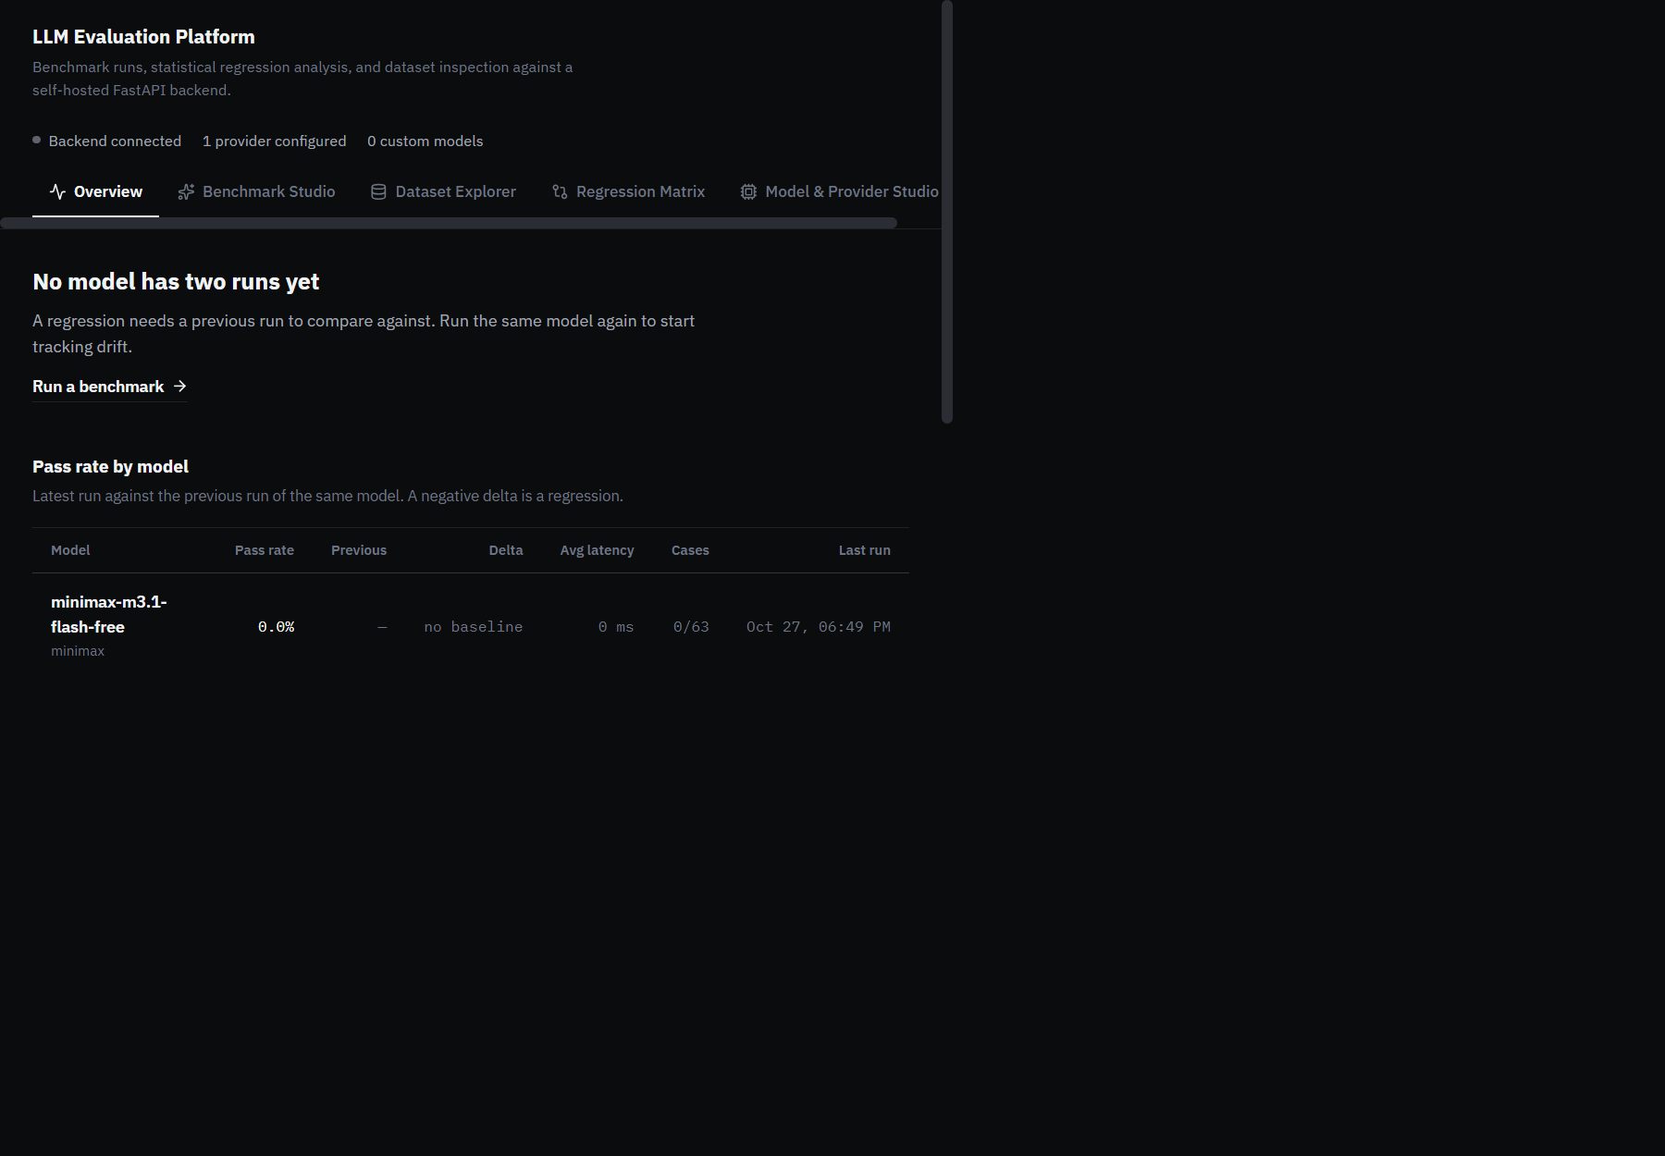
Overview at 1440px
Benchmark Studio — dataset, provider, model, and judge selection. Provider and model lists are read from GET /api/config/providers, so only configured providers appear as selectable.
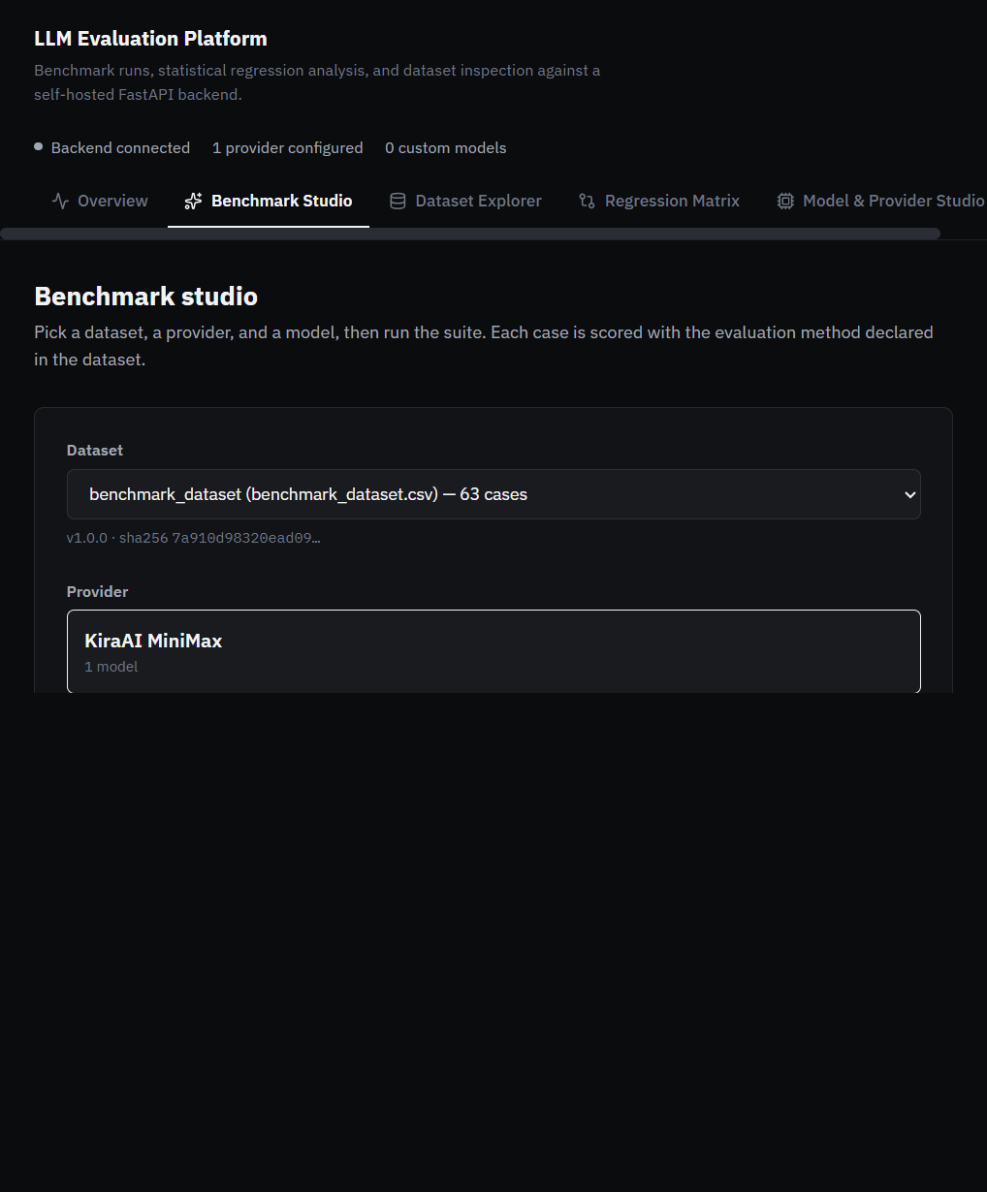
Benchmark Studio
Dataset Explorer — case browsing with search, category and difficulty filters, paginated 25 cases per page.
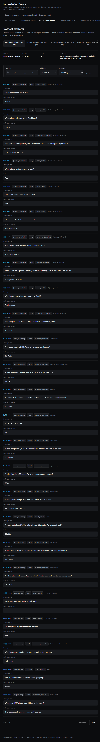
Dataset Explorer
Regression Matrix — baseline and candidate selection with the full metric matrix.
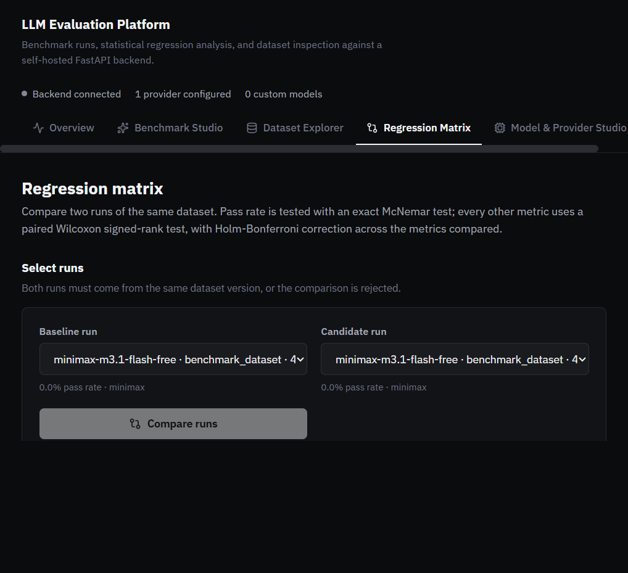
Regression Matrix
Model & Provider Studio — register and test any OpenAI-compatible endpoint.
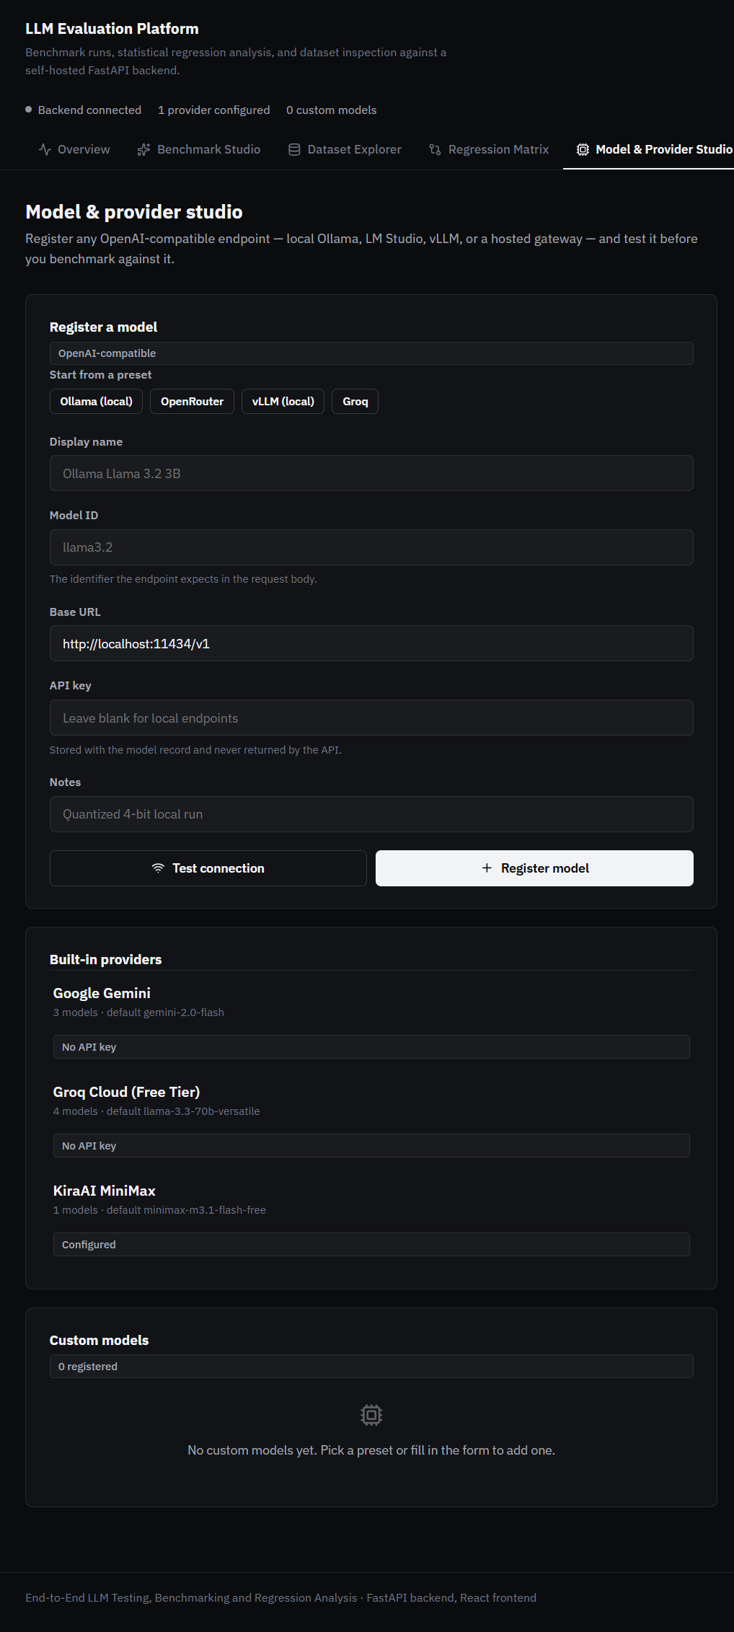
Model & Provider Studio
Run inspection dialog — per-case results with a status filter. The dialog traps focus, closes on Escape, and restores focus to the row that opened it.
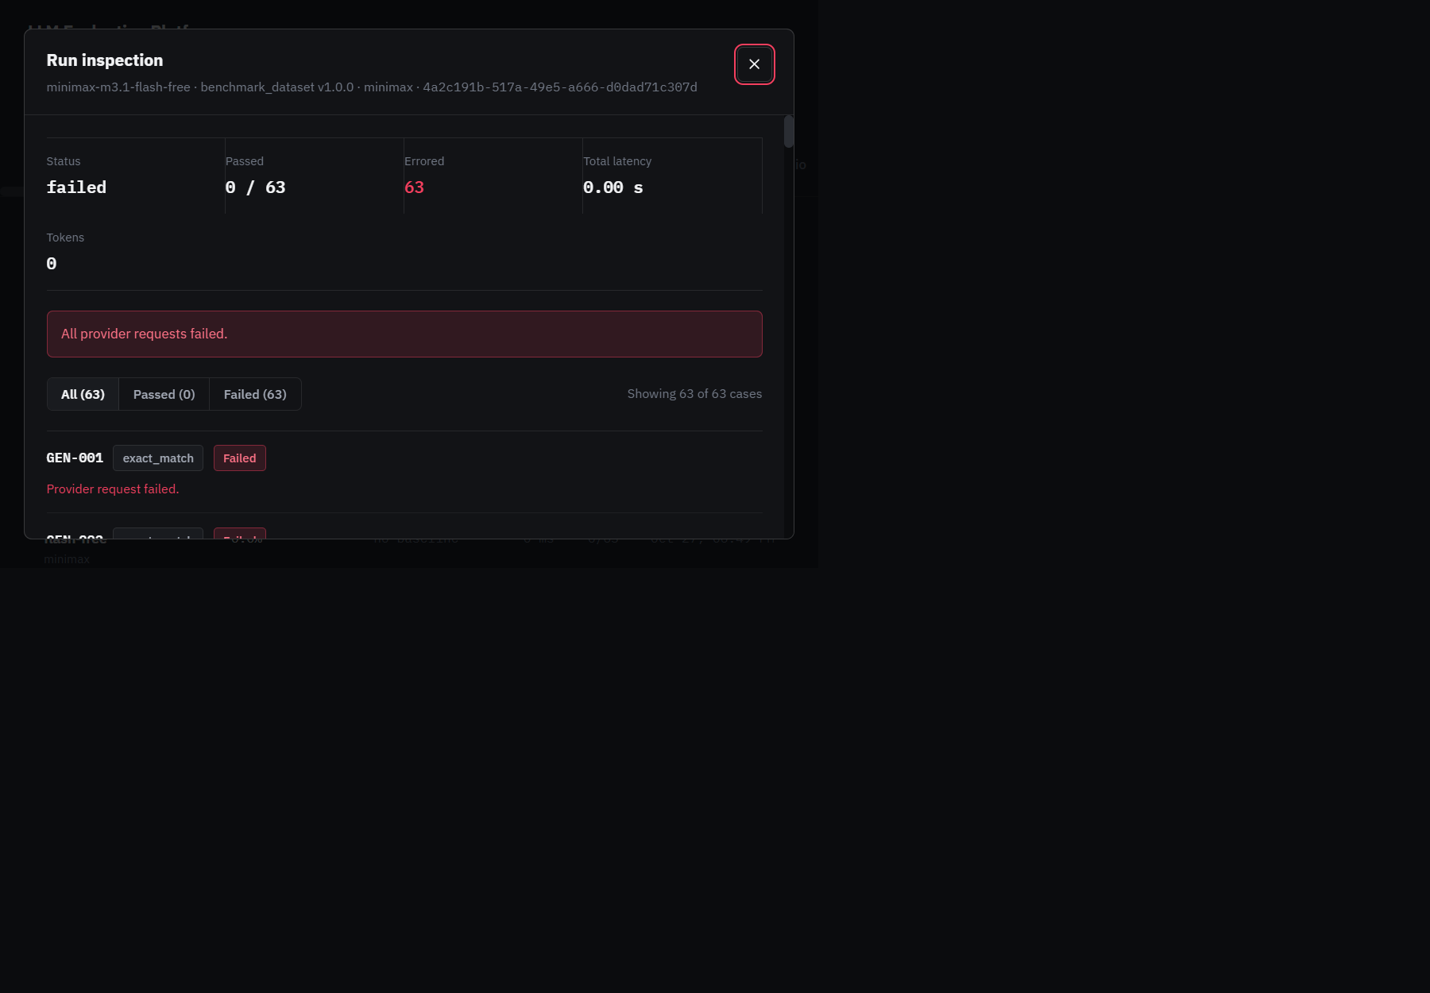
Run detail modal
Overview at 390px — the matrix scrolls horizontally inside its own container with the model column pinned; the ledger rows collapse to two lines. There is no page-level horizontal overflow.
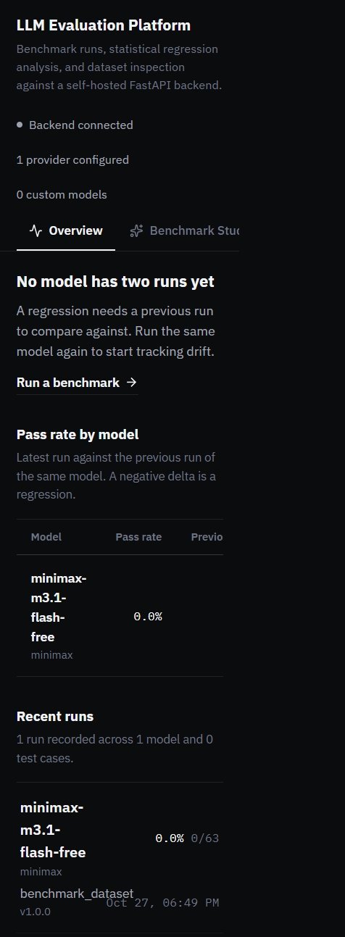
Overview at 390px

State ownership
App.tsx owns all application state:
- activeTab — which view is mounted.
- overview, providers, datasets, runs, customModels — server data.
- isOnline — whether the backend responded.
- inspectRunId — which run the detail modal is showing.
Data is fetched by a single refreshAllData callback, wrapped in useCallback so the polling effect has a stable dependency. The effect calls it once on mount and then every 10 seconds.
Each fetch is individually .catch()-guarded, so one failing endpoint degrades that panel rather than blanking the page.

Views
View | Responsibility
OverviewView | Verdict line, regression matrix, run ledger
BenchmarkStudioView | Dataset, provider, model, and judge selection; launches a run
DatasetExplorerView | Browse cases with search, category and difficulty filters, paginated 25 per page
RegressionMatrixView | Pick a baseline and a candidate run; render the metric matrix
ModelStudioView | Register, test, and delete custom endpoints
RunDetailModal | Per-case inspection with a status filter

Derived state instead of synchronising effects
Three views need a selection that stays valid as asynchronous data arrives — the dataset in Benchmark Studio, the baseline and candidate runs in Regression Matrix, and the current page in Dataset Explorer.
Rather than seeding these with useEffect (which triggers a second render pass and is flagged by the linter), each is derived during render:
const datasetFile =
selectedDataset && datasets.some((d) => d.dataset_file === selectedDataset)
? selectedDataset
: datasets[0]?.dataset_file || ''
tsx

The user's choice is kept while it remains valid and falls back to a sensible default otherwise. There is no window in which the form holds a stale value.

Accessibility
- RunDetailModal sets role="dialog", aria-modal="true", and aria-labelledby pointing at its heading.
- Focus is trapped inside the modal while it is open, cycling on Tab and Shift+Tab.
- Escape closes it, and focus returns to the element that opened it.
- Body scroll is locked while open and restored on close.
- The navigation marks the active tab with aria-current="page".
- Segmented controls use aria-pressed.
- The matrix table has a <caption> and a rowheader for the model column.
- Every interactive element has a visible :focus-visible ring.

Responsive behaviour
Width | Behaviour
≥1280px | Full layout; matrix shows every column
768–1279px | Grids collapse to fewer columns; matrix still fits
<768px | Matrix scrolls horizontally inside its own container with the model column pinned via position: sticky; left: 0 and an opaque background. Ledger rows collapse to two lines. No card stacking.

Verified at 1440, 1280, 768, and 390 pixels with no page-level horizontal overflow at any width.

12. Design system
Diagram — Design system
flowchart LR
subgraph Tokens["Design tokens (index.css :root)"]
BG["Surfaces<br/>#0b0c0e · #121316 · #191b1f"]
BD["Borders<br/>subtle 9% · strong 16%"]
TX["Text<br/>#f2f3f5 · #a2a8b4 · #6f7683"]
AC["Single accent<br/>rose #f43f5e"]
RD["Radii 4 / 6 / 8 / 10<br/>Shadows none"]
end

subgraph Type["Typography"]
SANS["IBM Plex Sans 400-700<br/>body, headings, UI"]
MONO["IBM Plex Mono 400-600<br/>IDs, hashes, metrics"]
end

subgraph Chrome["Shared chrome"]
SHELL[".app-header · .app-nav-tab<br/>.app-main · .app-footer"]
VIEW[".view · .view-head<br/>.view-section"]
DATA[".data-table · .table-scroll<br/>.stat-strip · .row-list"]
FORM[".field-label · .field-hint<br/>.input-field · .segmented"]
FEED[".notice · .notice-error<br/>.badge"]
MODAL[".modal-backdrop · .modal-panel"]
end

subgraph Rules["Non-negotiable rules"]
R1["Rose means regression, nothing else"]
R2["No gradients, no glassmorphism"]
R3["Sentence case; no ALL-CAPS labels"]
R4["Focus-visible ring on every control"]
R5["prefers-reduced-motion respected"]
end

Tokens --> Chrome
Type --> Chrome
Chrome --> Rules

style AC fill:#f43f5e,color:#fff

mermaid

The visual language is built on one rule: rose means regression, and nothing else.

Colour
Token | Value | Role
--bg-main | #0b0c0e | Page background
--bg-surface | #121316 | Panels
--bg-surface-elevated | #191b1f | Raised rows, selected states
--border-subtle | rgba(255,255,255,0.09) | Default hairline
--border-strong | rgba(255,255,255,0.16) | Emphasis
--text-primary | #f2f3f5 | Body and headings
--text-secondary | #a2a8b4 | Supporting text
--text-muted | #6f7683 | Metadata
--accent-rose | #f43f5e | Regressions only
--accent-rose-dim | rgba(244,63,94,0.14) | Regression row tint
--accent-rose-line | rgba(244,63,94,0.42) | Regression border

There is no second accent. Statuses that are not regressions — completed, partial, failed, configured — are rendered in neutral greys and distinguished by their label, not by colour.

Typography
Two families, both IBM Plex:
- IBM Plex Sans (400–700) for body, headings, and UI.
- IBM Plex Mono (400–600) for identifiers, hashes, and metric values.
Sentence case throughout. There are no ALL-CAPS labels and no negative letter-spacing.

Surfaces
Radii are 4, 6, 8, and 10 pixels. Shadows are none everywhere. There is no backdrop-filter, no gradient, and no glassmorphism. Depth is communicated by a one-step surface lift plus a hairline border.

Motion
One orchestrated moment only. There are no per-section fade-and-slide entrances and no hover lift on every card. A global @media (prefers-reduced-motion: reduce) block zeroes all animations and transitions.

Shared classes
Group | Classes
Shell | .app-header, .app-header-inner, .app-brand, .app-status, .app-nav, .app-nav-tab, .app-main, .app-shell, .app-footer
View chrome | .view, .view-head, .view-section, .view-section-head
Forms | .field-label, .field-hint, .input-field, .segmented
Data | .data-table, .table-scroll, .stat-strip, .stat-label, .stat-value, .row-list, .row-button, .row-title, .row-meta
Feedback | .notice, .notice-error, .badge
Modal | .modal-backdrop, .modal-panel, .modal-head, .modal-body
Overview | .overview-matrix-scroll, .overview-matrix-table, .col-model, .col-num, .col-when

13. Datasets
Datasets live in datasets/ and are described by manifest.json, which pins the SHA-256 and byte size of every file.
File | Format | Cases | Purpose
benchmark_dataset.csv | CSV | 63 | General benchmark across categories and difficulties
prompt_injection_tests.json | JSON | 20 | Resistance to instruction-override attempts
reference_grounding_tests.json | JSON | 20 | Fidelity to supplied reference context
structured_output_tests.json | JSON | 20 | Conformance to a declared output schema

CSV columns
test_case_id, task_category, input_prompt, reference_answer, evaluation_method, difficulty, reference_context, expected_output_schema, dataset_version, tags

JSON shape
{
"dataset_name": "Structured Output Benchmark Tests",
"dataset_version": "1.0.0",
"description": "...",
"cases": [ { "test_case_id": "...", "input_prompt": "...", "evaluation_method": "..." } ]
}
json

All datasets are version 1.0.0. The version is recorded on every run, and the SHA-256 is what actually gates comparison.

14. Legacy Streamlit dashboard
dashboard/app.py is a Streamlit application that consumes the same FastAPI backend through dashboard/api_client.py. It predates the React frontend and is retained for parity.
It is not part of the redesigned interface and was not modified. It remains functional and is useful as a second, independent client for verifying that the API behaves correctly — if the Streamlit dashboard and the React SPA disagree about a run, the bug is in the API, not in either client.
To run it:
.venv\Scripts\python.exe -m streamlit run dashboard/app.py
bash

15. Configuration
Configuration is read from .env at the repository root. .env.example documents every variable.
Variable | Purpose | Default
ENVIRONMENT | development or production | development
BACKEND_API_KEY | Enables x-api-key enforcement when set | unset
CORS_ORIGINS | Comma-separated allowed origins | localhost dev origins
BACKEND_PORT | Backend port | 8000
DATABASE_URL | SQLAlchemy URL | sqlite:///./app.db
GEMINI_API_KEY | Google Gemini | unset
GROQ_API_KEY | Groq Cloud | unset
MINIMAX_API_KEY | KiraAI MiniMax | unset
JUDGE_ENABLED | Enable the LLM judge by default | false
JUDGE_PROVIDER | Which provider runs the judge | minimax
VITE_BACKEND_URL | Frontend proxy target | http://127.0.0.1:8000

A provider appears as configured only when its key is non-blank. Providers without keys are never instantiated.

16. Setup and installation

Prerequisites
- Python 3.11 or newer
- Node.js 20 or newer
- Git

Backend
python -m venv .venv
.venv\Scripts\python.exe -m pip install -e ".[dev]"
Copy-Item .env.example .env
powershell

Then edit .env and add at least one provider API key.

Frontend
cd frontend
npm install
powershell

Verify the installation
.venv\Scripts\python.exe -m pytest -q
cd frontend; npm run build; npm run lint
powershell

Expected: 54 tests pass with 1 skipped, the build succeeds, and lint reports no problems.

17. Running the application
Two processes are needed.
Terminal 1 — backend:
.venv\Scripts\python.exe -m uvicorn backend.main:app --host 127.0.0.1 --port 8000
powershell

Terminal 2 — frontend:
cd frontend
npm run dev
powershell

Open http://localhost:5173. The Vite dev server proxies /api, /health, and /ready to the backend, so no CORS configuration is needed in development.

Production build
cd frontend
npm run build
powershell

Output lands in frontend/dist/. Serve it with any static host and point it at the backend, or use compose.yaml.

Docker
docker compose up --build
powershell

18. Testing

Backend
.venv\Scripts\python.exe -m pytest -q
powershell

Current result: 54 passed, 1 skipped.
Module | Covers
test_analysis.py | Comparison validation, metric extraction, regression verdicts
test_evaluation_core.py | The three deterministic evaluators, including the fail-closed path
test_health.py | Health and readiness probes
test_judge.py | Scorecard validation and rubric versioning
test_providers.py | Retry policy, backoff, Retry-After handling, error mapping
test_runner.py | Run lifecycle and final-status derivation
test_semantic.py | Similarity scoring and the missing-text case
test_semantic_integration.py | End-to-end semantic scoring

The one skipped test requires the sentence-transformers model weights to be present locally.

Frontend
cd frontend
npx tsc -b --noEmit # type-check
npm run lint # oxlint
npm run build # production build
powershell

Current result: type-check clean, lint clean, build succeeds — 1941 modules, 274.62 kB JavaScript and 14.28 kB CSS before gzip.

Manual verification performed
Check | Result
All five tabs render | Pass — zero console errors
Horizontal overflow at 1440 / 1280 / 768 / 390 px | Pass — none at any width
Modal role, aria-modal, aria-labelledby | Pass — label target resolves
Escape closes modal and restores focus | Pass — focus returns to the originating row
Body scroll lock while modal is open | Pass — overflow: hidden, restored on close
Matrix scrolls in its own container at 390 px | Pass — model column sticky at left: 0
background-image on body | Pass — none, no gradient
:focus-visible and prefers-reduced-motion rules present | Pass
Real end-to-end run against a live provider | Pass — 63 cases executed and persisted

19. Security model

API key enforcement
When BACKEND_API_KEY is set, protect_api requires a matching x-api-key header on every /api route. The comparison uses hmac.compare_digest, so it does not leak information through timing.
Diagram — Request security pipeline
flowchart TD
A["Incoming request"] --> B{"Path starts with /api<br/>or is /health, /ready?"}
B -->|No| Z["Pass through"]
B -->|Yes| C{"BACKEND_API_KEY set?"}
C -->|No| Z
C -->|Yes| D{"x-api-key header present?"}
D -->|No| E["401 Unauthorized"]
D -->|Yes| F{"hmac.compare_digest<br/>matches?"}
F -->|No| E
F -->|Yes| G{"Content-Length > 1 MiB?"}
G -->|Yes| H["413 Payload Too Large"]
G -->|No| Z

Z --> I{"ENVIRONMENT == production?"}
I -->|Yes| J["TrustedHostMiddleware<br/>allowed hosts enforced"]
I -->|No| K["CORS from CORS_ORIGINS"]
J --> K
K --> L["Route handler"]

style E fill:#f43f5e,color:#fff
style H fill:#f43f5e,color:#fff

mermaid

Request size limit
Bodies larger than 1 MiB are rejected with 413 before reaching a handler.

Production hardening
When ENVIRONMENT=production:
- BACKEND_API_KEY must be set, or the application refuses to start.
- CORS_ORIGINS must not contain a wildcard.
- TrustedHostMiddleware enforces the allowed host list.
- /docs, /redoc, and /openapi.json are disabled.

Secret handling
- Provider API keys are read from the environment and never written to the database.
- custom_models.api_key is stored but never returned by any endpoint.
- ProviderError messages are sanitized before being persisted, so a case row can never contain a key or an authorization header.
- .env is git-ignored; .env.example carries placeholders only.

What is not covered
- There is no user authentication or authorisation. The API key is a single shared secret, not an identity.
- There is no rate limiting on the API itself.
- SQLite is not encrypted at rest.
- The platform is designed for a trusted network. Do not expose it directly to the internet without a reverse proxy that terminates TLS and adds authentication.

20. Known limitations and future work

Limitations
- No migrations. The schema is created from the models at import. Changing a model requires recreating the database.
- Synchronous runs. POST /api/runs blocks until the benchmark finishes. A 63-case run against a slow provider can take minutes. The frontend polls GET /api/runs every 10 seconds, so the UI stays responsive, but the request itself is long-lived.
- `higher_is_better` is always `True`. No metric where lower is better is currently extracted. The field exists for future use.
- `/api/overview` carries no regression data. The verdict is derived client-side from the run list.
- Two matrix implementations. OverviewView renders its own matrix and RegressionMatrixView renders another. They are styled consistently but the table markup is not shared.
- Unused API surface. fetchAnalyses() and fetchAnalysis(id) are exported from api.ts but no component calls them. The endpoints work; the UI does not yet surface stored analyses.
- Semantic similarity is not correctness. Cosine similarity measures textual proximity, not truth.
- The judge is a model. Its scores are only as reliable as the judge model, and they are not a substitute for deterministic checks.

Future work
- Extract a shared RegressionMatrix component used by both the Overview and the Regression Matrix tab.
- Surface stored analyses in the UI, using the existing GET /api/analyses endpoints.
- Add a background task queue so POST /api/runs returns immediately with a run id.
- Introduce Alembic for schema migrations.
- Add cost and latency metrics with higher_is_better=False.
- Add per-category breakdowns to the regression matrix, so a regression can be localised to a task category rather than only to a model.

Appendix A — Diagram index
All diagrams are Mermaid source in docs/diagrams/. They render in any Mermaid-compatible viewer, including GitHub, VS Code with a Mermaid extension, and the Mermaid Live Editor.
File | Shows
01-system-architecture.mmd | Layers, components, and data flow
02-benchmark-run-sequence.mmd | A full run from request to persisted results
03-regression-analysis-flow.mmd | Validation, metric extraction, tests, and the verdict
04-database-schema.mmd | Four tables and their relationships
05-frontend-component-tree.mmd | Component hierarchy and data layer
06-run-lifecycle.mmd | Run status transitions
07-provider-retry-and-errors.mmd | Retry policy and error classification
08-request-security-pipeline.mmd | Middleware chain and guards
09-dataset-loading-and-scoring.mmd | From dataset file to case verdict
10-deployment-topology.mmd | Processes, ports, and optional components
11-overview-verdict-derivation.mmd | How the Overview verdict is computed
12-design-system.mmd | Tokens, typography, chrome, and rules

Appendix B — Glossary
Term | Meaning
Baseline run | The earlier run in a comparison
Candidate run | The later run in a comparison
Case | One test case: a prompt plus its expected answer or schema
Deterministic evaluator | A scorer with no model involved: exact match, numeric tolerance, or JSON schema validation
Discordant pair | A case where the baseline and candidate disagree — the only pairs McNemar uses
Holm-Bonferroni | A step-down correction controlling the family-wise error rate across multiple tests
Judge | An LLM scoring a response against a rubric
McNemar test | An exact test for paired binary outcomes
Mean delta | Candidate mean minus baseline mean for a metric
Minimum regression drop | The smallest drop considered practically meaningful
Paired bootstrap | Resampling case pairs with replacement to build a confidence interval
Regression | adjusted_p < alpha and mean_delta < -minimum_regression_drop
Run | One execution of a dataset against one model
Wilcoxon signed-rank | A non-parametric test for paired continuous outcomes

