INTERNSHIP TECHNICAL DOCUMENTATION
Task 4: Web Server Deployment Using Docker & Nginx
DevOps Internship Program | Containerization & Web Deployment
Document Type | Internship Task Report
Task Reference | Task 4 — Web Server Deployment Using Docker
Domain | DevOps / Containerization
Tools Used | Docker Desktop, Nginx, HTML, PowerShell, Windows
Status | Completed

1. OBJECTIVE

The objective of this task was to gain practical experience with Docker by containerizing and deploying a simple web application. Specific goals included:

- Understand the fundamentals of Docker — images, containers, and the Dockerfile.
- Create a custom Docker image using an official Nginx base image.
- Deploy a static HTML web page inside a Docker container served by Nginx.
- Map container ports to the host machine and verify the web application via a browser.
- Use Docker CLI commands and Docker Desktop to manage images and containers.

2. PROJECT OVERVIEW

A project folder named docker-web was created containing two core files: an index.html web page and a Dockerfile containing the build instructions. The Dockerfile uses the official Nginx image as a base and copies the HTML file into Nginx's default web root directory.

Once the image was built, a container was launched with port mapping configured to expose the web application on the host machine. The final result was a live, browser-accessible web page served entirely from within a Docker container — demonstrating a complete containerized deployment workflow.

3. TOOLS & TECHNOLOGIES USED

Docker Desktop | Graphical interface and daemon for building, running, and managing Docker containers on Windows.
Docker CLI | Command-line interface used to build images, run containers, and inspect container status.
Nginx | Lightweight, high-performance web server used as the base image to serve the HTML content.
HTML (index.html) | Static web page file representing the web application deployed inside the container.
Dockerfile | Text file containing step-by-step instructions to build the custom Docker image.
PowerShell | Windows terminal environment used to execute all Docker CLI commands.

4. PROJECT FOLDER STRUCTURE

The project directory was organized as follows:

docker-web/
index.html (Static HTML web page — the application content)
Dockerfile (Build instructions for the Docker image)

This minimal structure is sufficient for a containerized static web server deployment. The Dockerfile references the index.html file during the image build process.

5. FILE CONTENTS

5.1 index.html
The index.html file contains basic HTML markup to display a simple webpage. This file is copied into the Nginx web root inside the container so it can be served to any browser that connects to the container.

5.2 Dockerfile
The Dockerfile defines how the Docker image is constructed. The key instructions are:

FROM nginx:latest
COPY index.html /usr/share/nginx/html/index.html

- FROM nginx:latest — specifies the official Nginx image as the base layer.
- COPY index.html ... — copies the local HTML file into Nginx's default web directory inside the image.

6. PREREQUISITES

- Docker Desktop installed and running on the host machine (Windows).
- PowerShell or Command Prompt available to execute Docker CLI commands.
- Basic familiarity with HTML and command-line usage.
- Active internet connection for pulling the Nginx base image on first run.

7. STEPS PERFORMED

The following steps were carried out sequentially to containerize and deploy the web application:

Step 1 | Install Docker Desktop  Docker Desktop was installed on Windows. The application provides both the Docker daemon and a graphical interface for managing images and containers.

Step 2 | Create Project Folder & Files  A folder named docker-web was created. Inside it, two files were created: index.html (containing the webpage content) and Dockerfile (containing the image build instructions).

Step 3 | Build the Docker Image  docker build -t myweb .  This command built a Docker image named myweb using the Dockerfile in the current directory. The dot (.) specifies the build context as the current folder.

Step 4 | Run the Docker Container  docker run -d -p 8080:80 myweb  This command launched a container from the myweb image in detached mode (-d). Port 8080 on the host machine was mapped to port 80 inside the container (-p 8080:80).

Step 5 | Verify Running Containers  docker ps  This command listed all active containers, confirming that the myweb container was running successfully with the correct port mapping.

Step 6 | Access via Browser  http://localhost:8080  The web application was accessed through a browser using the mapped host port. The HTML page loaded successfully, confirming the container and Nginx were functioning correctly.

8. KEY FEATURES IMPLEMENTED

- Custom Docker image built from an official Nginx base image.
- Static HTML web application containerized and served via Nginx.
- Host-to-container port mapping configured for browser accessibility.
- Container run in detached mode for background operation.
- Container and image status verified using Docker CLI and Docker Desktop.
- End-to-end deployment confirmed via live browser output.

9. OUTPUT & SCREENSHOTS

The following screenshots document each stage of the task execution. All steps completed successfully without errors.

Figure 1 — Project Folder Structure

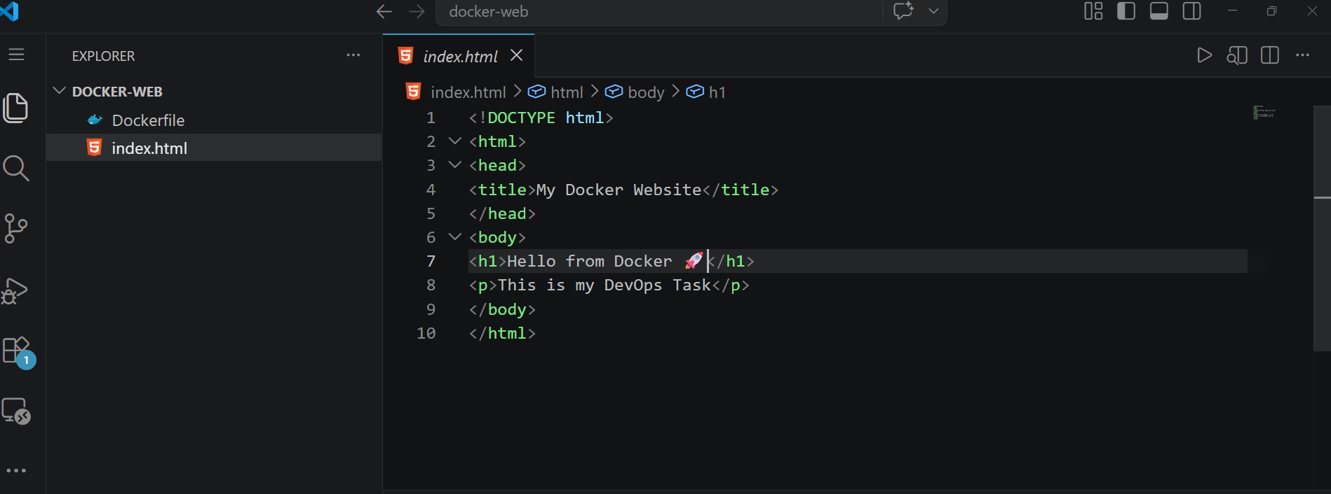
The docker-web project folder containing index.html and Dockerfile.

Figure 2 — HTML File (index.html)

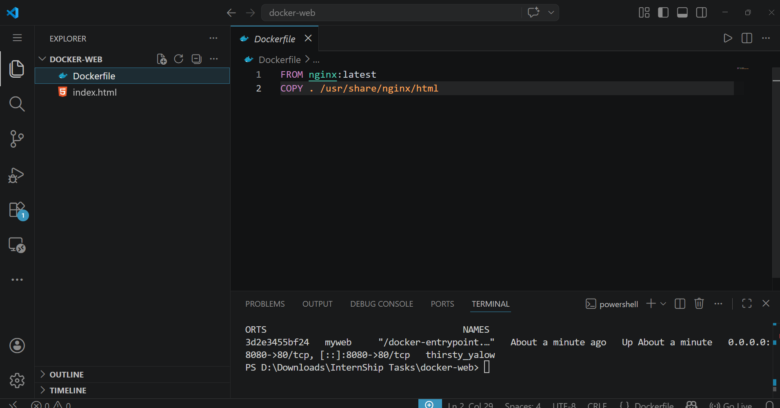
The index.html file containing the static HTML content to be served by Nginx.

Figure 3 — Dockerfile

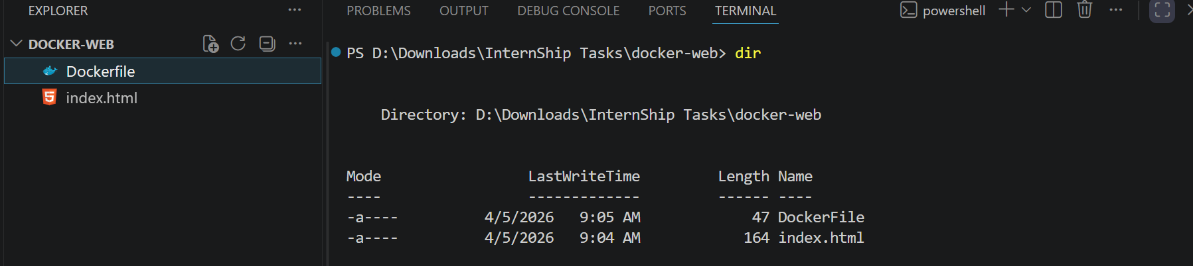
The Dockerfile defining the image build steps — using Nginx as base and copying the HTML file.

Figure 4 — Docker Build Command — Output

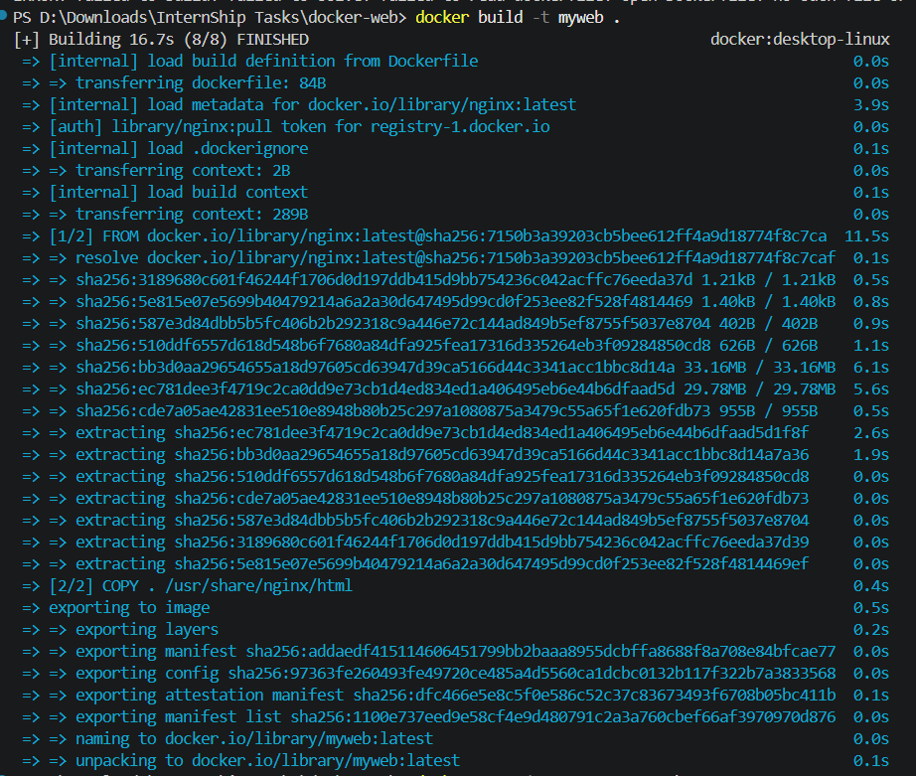
Output of 'docker build -t myweb .' showing the image built successfully.

Figure 5 — Docker Build — Success Confirmation

Final BUILD SUCCESSFUL confirmation line from the docker build command.

Figure 6 — Docker Run Command

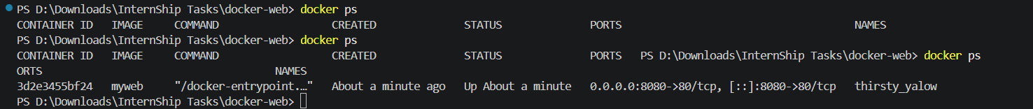
Output of 'docker run -d -p 8080:80 myweb' showing the container ID assigned upon startup.

Figure 7 — Running Containers — docker ps

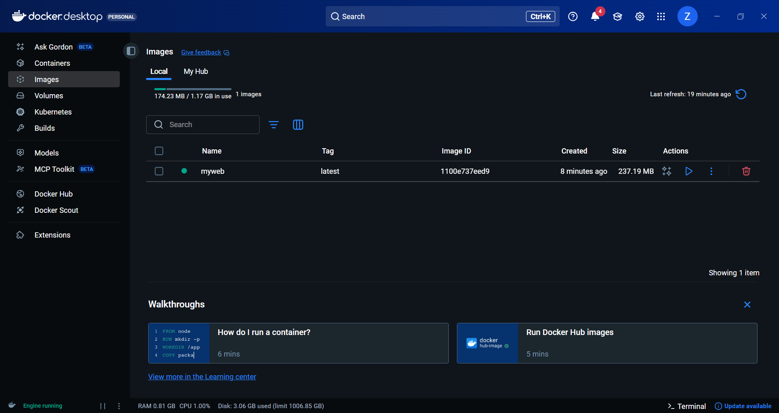
Output of 'docker ps' confirming the myweb container is active with port 8080:80 mapped.

Figure 8 — Docker Desktop — Image View

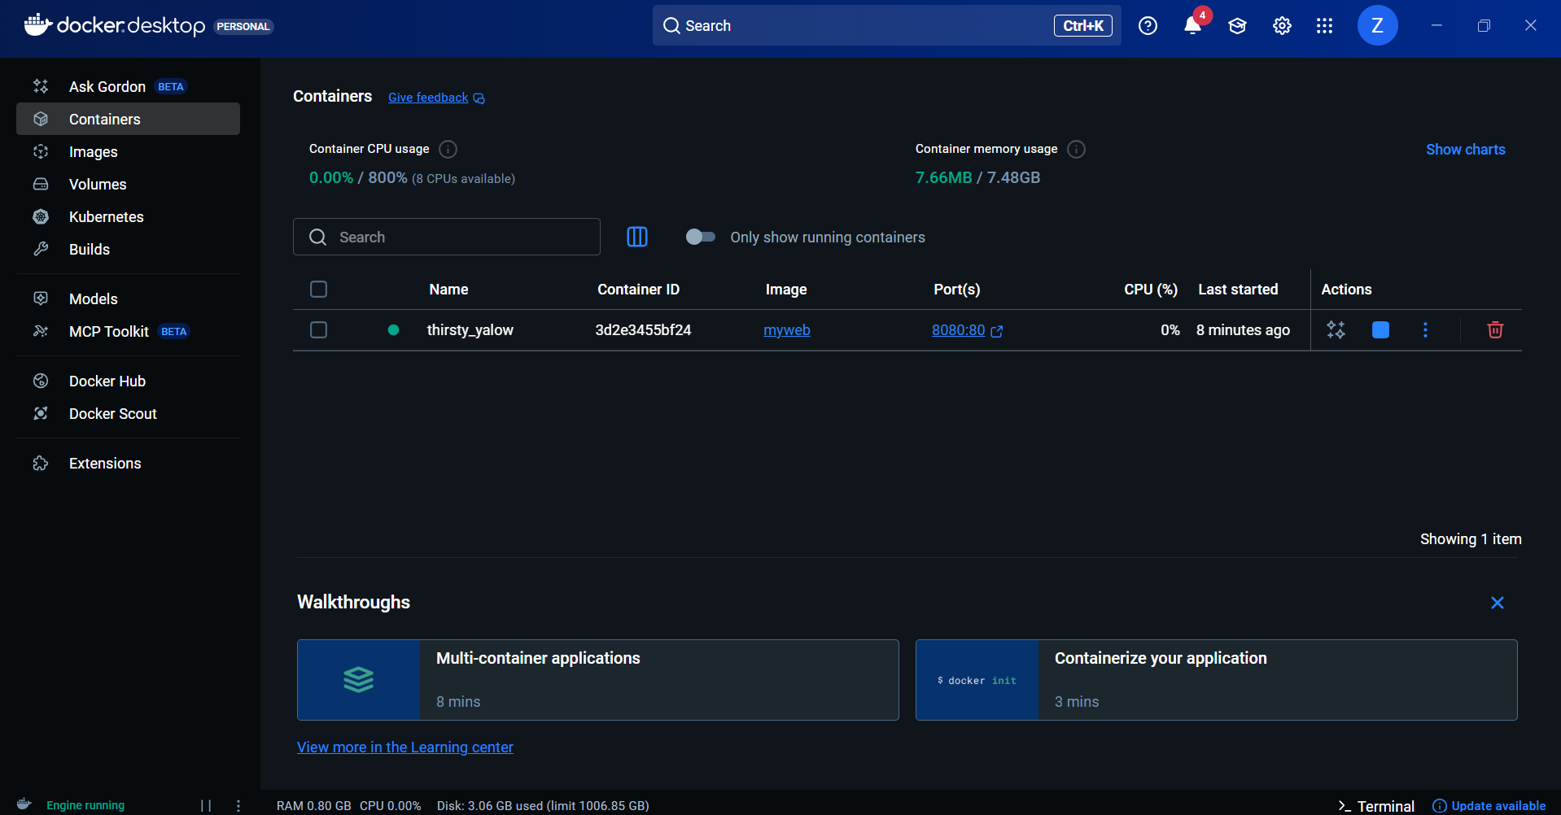
Docker Desktop showing the myweb image created and available for use.

Figure 9 — Browser Output — Web Application Live

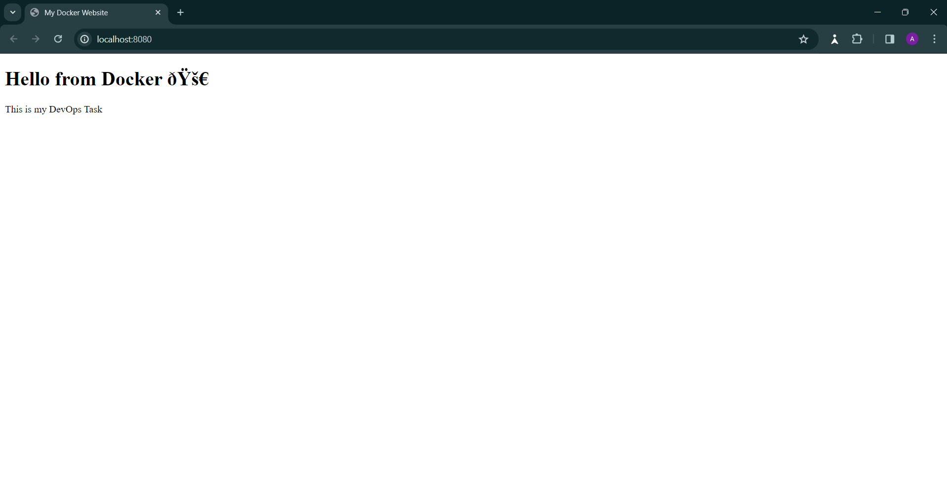
Browser accessing http://localhost:8080 — the HTML page served successfully from the Docker container via Nginx.

10. LEARNINGS & OBSERVATIONS

The following technical and conceptual insights were gained through the execution of this task:

- Docker allows applications to be packaged with all dependencies into portable, self-contained containers.
- The Dockerfile is the blueprint for an image — each instruction adds a layer to the final image.
- Port mapping (-p host:container) is essential for making containerized services accessible from the host machine.
- Detached mode (-d) allows containers to run in the background without blocking the terminal session.
- Docker Desktop provides a convenient GUI to monitor images and containers alongside the CLI.
- The task demonstrated a real-world deployment pattern: build an image, run a container, expose a service.

11. CONCLUSION

This task successfully demonstrated the end-to-end process of containerizing and deploying a static web application using Docker and Nginx. From writing the Dockerfile to accessing the live web page in a browser, every stage of the containerization workflow was completed and verified.

The hands-on experience gained in this task is directly applicable to real-world DevOps practices including microservices deployment, CI/CD pipeline integration, and cloud container orchestration using platforms such as Kubernetes and Docker Swarm. The fundamental skills of building Docker images, managing containers, and configuring port mappings form the foundation of modern containerized infrastructure.

12. DOCKER COMMANDS REFERENCE

The following Docker CLI commands were used during this task:

docker build -t myweb . # Build image named 'myweb' from current directory
docker run -d -p 8080:80 myweb # Run container in detached mode, map port 8080 -> 80
docker ps # List all currently running containers
docker images # List all locally available Docker images
docker stop <container-id> # Stop a running container
docker rm <container-id> # Remove a stopped container
docker rmi myweb # Remove the myweb image

— End of Document —

