Virtual Classroom - Database Project Documentation

1. Introduction:
The Virtual Classroom project is designed to simulate a digital academic environment where students, instructors, and administrators interact through a relational database. This system manages students, instructors, courses, enrollments, materials, attendance, and performance records. The project is implemented using SQL with robust normalization and relational integrity.

2. Database Schema Overview:
The following entities are part of the database schema for the Virtual Classroom system:

Students
- - student_id (Primary Key)
- - name
- - email (Unique)
- - batch_year

Instructors
- - instructor_id (Primary Key)
- - name
- - email (Unique)
- - department

Courses
- - course_id (Primary Key)
- - course_name
- - instructor_id (Foreign Key)

Enrollments
- - enrollment_id (Primary Key)
- - student_id (Foreign Key)
- - course_id (Foreign Key)

Materials
- - material_id (Primary Key)
- - course_id (Foreign Key)
- - title
- - file_link

Attendance
- - attendance_id (Primary Key)
- - student_id (Foreign Key)
- - course_id (Foreign Key)
- - attendance_date
- - status (ENUM: 'Present', 'Absent')

Performance
- - performance_id (Primary Key)
- - student_id (Foreign Key)
- - course_id (Foreign Key)
- - marks_obtained
- - total_marks

3. Entity Relationships:
The system includes the following relationships:
- Each student can enroll in multiple courses (many-to-many via Enrollments).
- Each instructor can teach multiple courses (one-to-many).
- Each course can have multiple materials and performance records.
- Attendance is tracked per student per course per date.
- Each course’s performance can be measured for every enrolled student.

4. SQL Features Demonstrated:
The SQL implementation includes the following features:
- - Table creation using DDL (CREATE TABLE with primary and foreign keys)
- - Data insertion using DML (INSERT INTO)
- - INNER JOIN, LEFT JOIN, RIGHT JOIN, and FULL OUTER JOIN (via UNION)
- - Aggregate functions like AVG, COUNT
- - Nested and correlated subqueries
- - GROUP BY for aggregation
- - Aliasing and derived column naming
5. ER Diagram:
The following diagram represents the Entity-Relationship model of the Virtual Classroom database. It includes all major entities, their attributes, and relationships with cardinality indications.
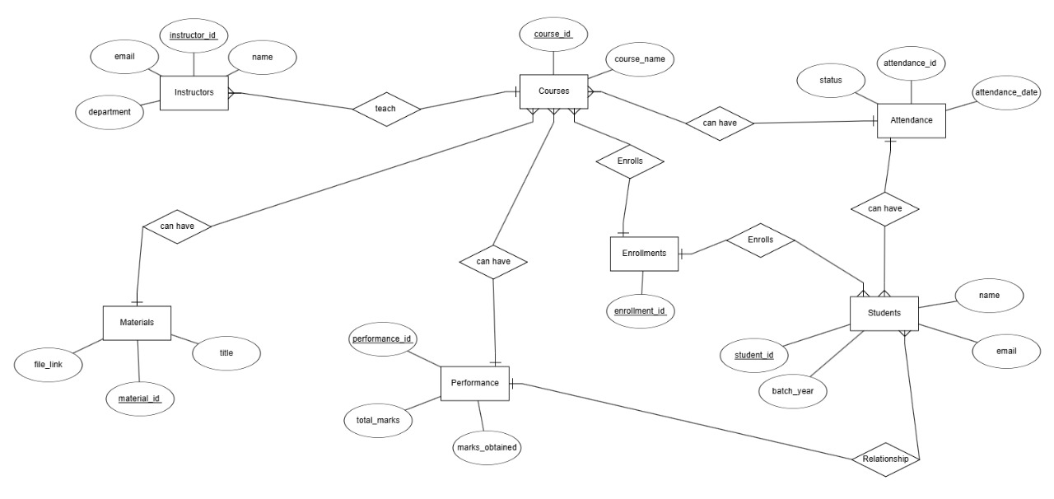

6. Schema Image View:
Below is the schema diagram in image format, showing the relational structure and foreign key dependencies clearly.
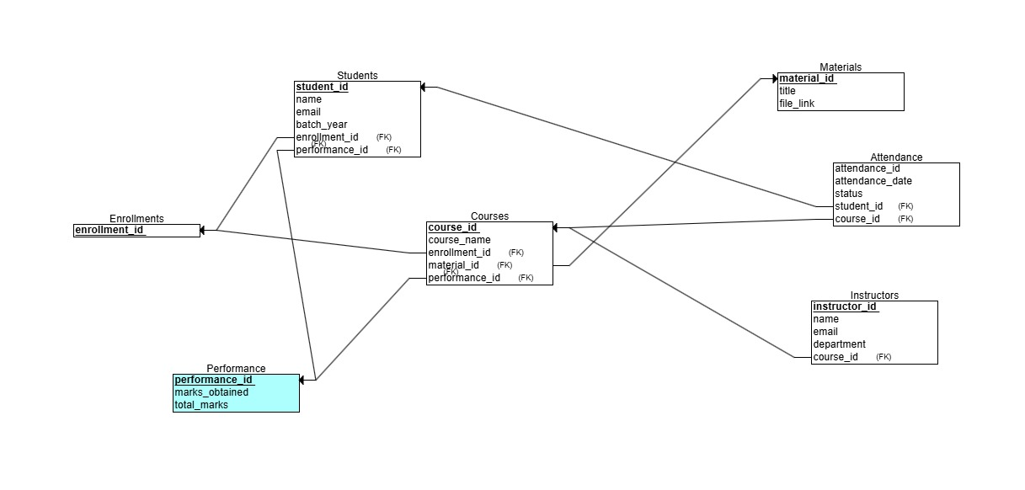

7. Conclusion:
This project effectively demonstrates the use of SQL for designing and managing a virtual classroom environment. With well-structured tables, relationships, and queries, the system ensures efficient data storage, retrieval, and integrity. It provides a solid foundation for academic management systems.

-------------------------------------------

