

Mid Lab Documentation

Your Name: Muhammad Zaid

Roll Number: FA23-BSE-032

Submitted to: Bilal Shabir Qaiser

Subject Name: SPM

Department of Computer Science
Software Engineering
COMSATS University Islamabad, Sahiwal Campus
1. Module 1: Project Initiation and Integration Management
This module establishes the executive governance foundation of the software system. It governs formal charter creation, stakeholder registers, subsidiary management plans, delivery milestones, and enforcement of pre-condition governance gates for project closure.
• Project Charter Management: Captures dynamic project objectives, SMART metrics, stakeholder register with influence/interest mapping, positive scope boundaries (In-Scope deliverables), negative scope boundaries (Out-of-Scope limits like physical server racks and biometric kiosks), approved baseline budget (PKR 5,000,000), project start date (2026-11-02), and hard deadline (2027-02-20). Accessible via the interactive 'Edit Charter' modal.
• Project Management Plan: Synthesizes four subsidiary plans: (1) Scope Management Plan defining requirement intake and WBS decomposition; (2) Schedule Management Plan defining working day calendars and CPM runs; (3) Cost Management Plan outlining BAC and contingency reserves; and (4) Quality Management Plan specifying ISO/IEC 25010 standards and zero-critical-defect release policy.
• Status, Milestones & Responsibility Matrix: Tracks five strategic milestones (M1 Charter Approval, M2 Core Architecture, M3 Clinical Lab Release, M4 Consortium UAT, M5 Final Commissioning). Compares target dates against CPM forecast dates and automatically flags delayed milestones. Assigns clear RACI responsibilities linking WBS deliverables to team roles.
• Project Closure Governance Gate: The system strictly prohibits closing a project while active blockers exist. The backend verifies that 100% of activities are complete, zero Critical/Major defects remain open, and quality checklist criteria are satisfied. Only then are sign-offs and lessons learned archived.
2. Module 2: Scope Management and Work Breakdown Structure (WBS) [04 Marks]
This module manages the requirements lifecycle, prevents scope creep, structures project work hierarchically, and enforces formal Change Control Board (CCB) impact evaluations.
• Requirements Management & MoSCoW Prioritization: Enables adding, updating, and reviewing project requirements. Each requirement is classified by Type (Functional vs Non-Functional), Priority (Must have, Should have, Could have, Won't have), and Lifecycle Status (Proposed -> Under Review -> Approved -> Implemented).
• Architectural Scope Gate (Enforced Rule): The server programmatically enforces that unapproved requirements ('Proposed', 'Under Review', 'Rejected') CANNOT be included in the approved project scope and CANNOT be assigned to WBS deliverables. If an unapproved requirement ID is submitted to POST /api/wbs, the API rejects the request with HTTP 422 Unprocessable Entity, guaranteeing zero unauthorized scope creep.
• Hierarchical Work Breakdown Structure (WBS): Generates a multi-tier tree hierarchy: Level 1 (Project Root 1.0) -> Level 2 (Major Deliverables 1.1 to 1.5) -> Level 3 (Work Packages 1.1.1, 1.1.2). Work packages establish 100% bidirectional traceability back to approved requirements.
• Change Request (CCB) Mechanism & Impact Simulation: Formal CCB workflow for proposed changes (e.g. CR-001 AI Symptom Checker & Mobile App). Before approval, the engine simulates the triple-constraint impact: Cost Delta (+PKR 800,000), Schedule Delta (+15 working days / 3 weeks), and Scope Promotion. Upon approval, the system promotes Proposed requirements to Approved and automatically creates immutable Baseline v2.
3. Module 3: Schedule and Resource Management [05 Marks]
This module delivers programmatic CPM scheduling, 5-day calendar date arithmetic, predecessor dependency linking, delay cascading algorithms, and interactive timeline visualization.
• Activity Definition & Resource Roster: Defines discrete tasks with working day durations, planned costs, and Finish-to-Start (FS) predecessor dependencies. Assigns dedicated team members with daily billing rates and daily capacities.
• Critical Path Method (CPM) & Cycle Detection: Uses Kahn's algorithm to detect circular loops. Performs Forward Pass calculating Early Start (ES) and Early Finish (EF), and Backward Pass calculating Late Finish (LF) and Late Start (LS). Computes Total Float (LS - ES). Activities with Total Float <= 0 are programmatically flagged as Critical Path tasks.
• Delay Identification & Cascading Impact: At status date (Week 9: 2026-12-28), compares actual percent complete against planned target. Incomplete critical path activities (ACT-005 at 40%) are flagged as Delayed. The cascading engine shifts downstream dependent activities (ACT-007, ACT-008, ACT-009, ACT-010) and recalculates the revised project completion date.
• Interactive Gantt-Style Timeline: Renders dynamic task bars across a 16-week calendar. Displays critical tasks in high-visibility red, non-critical in blue, internal progress shading, diamond milestone pins, and a vertical line indicating current status date.
4. Module 4: Cost Management and Earned Value Analysis (EVM) [05 Marks]
This module tracks project financial performance, records actual expenditures, computes standard EVM indicators, and triggers automatic warning messages when cost or schedule variances exceed safety thresholds.
• Cost Estimation & Expenditure Tracking: Calculates baseline Budget at Completion (BAC = PKR 5,000,000). Logs itemized actual expenditures (AC) categorized into Labour, Infrastructure, Licences, and Other with timestamps and notes.
• Programmatic EVM Indicators: Strictly implements standard formulas:
- Planned Value (PV): Baseline budgeted cost of scheduled work.
- Earned Value (EV): Budgeted cost of work actually performed (BAC × % Complete).
- Actual Cost (AC): Total cumulative expenditure incurred to status date.
- Cost Performance Index (CPI = EV / AC): Cost efficiency ratio.
- Schedule Performance Index (SPI = EV / PV): Schedule efficiency ratio.
- Estimate at Completion (EAC = BAC / CPI) & Variance at Completion (VAC = BAC - EAC).
• Automatic Variance Alerts & Thresholds: Monitors predefined thresholds (Warning < 0.95, Critical < 0.85). At Week 9, with CPI = 0.782 and SPI = 0.842, the system automatically raises RED Alert Banners indicating active cost overrun (projected EAC of PKR 6.41M) and schedule deviation.
5. Module 5: Quality Management and Risk Control [04 Marks]
This module ensures product quality and proactive risk mitigation through structured defect lifecycles, inspection checklists, 5x5 prioritization matrices, and Process Decision Program Charts (PDPC).
• Defect Tracking Module: Records defects with code, title, severity (Critical, Major, Minor, Trivial), testing phase, deliverable linkage, assigned personnel, and lifecycle states (Open -> In Progress -> Resolved -> Verified -> Closed). Open Critical defects block project closure.
• Quality Checklists & Inspections: Formal deliverable audit records featuring itemized criteria (code coverage >85%, security sanitization, race condition tests). Supports mandatory vs optional tags and pass/fail toggles, producing automated PASS/FAIL inspection determinations.
• 5x5 Risk Prioritization Matrix: Ranks risks based on Likelihood (1-5) × Impact (1-5), generating scores from 1 to 25. Assigns color bands: HIGH (Red, score >= 15), MEDIUM (Amber, 8-14), and LOW (Green, 1-7). Includes an interactive visual heatmap.
• Process Decision Program Chart (PDPC): Generates a multi-branch tree graph linking: High-Level Goal -> Potential Problem -> Dual Action Branches (Level 4A: Preventive Countermeasure to avoid failure; Level 4B: Corrective Contingency Action to minimize impact if failure occurs).
6. Module 6: System Integration, Validation, and Reporting [03 Marks]
This module unites all components into a production MERN application, guaranteeing cross-module data consistency, providing persistent database backup/restore facilities, and generating executive status reports.
• Full-Stack Database Integration: Seamless connectivity between React UI, Express REST gateway, and MongoDB database. Enforces referential integrity: Activities depend on WBS Work Packages, Expenditures link to Activities, Defects link to Deliverables, and Baseline v2 freezes approved changes.
• Meaningful Validation & Exception Handling: Centralized error handling middleware returning standardized error codes (HTTP 400 Bad Request, HTTP 422 Scope/Closure Gate violations, HTTP 409 Conflict). Complete automated Jest test suite with 15 passing test cases.
• Executive Performance Dashboard: Integrated control center showing overall RAG status (RED/AMBER/GREEN), EVM indicators, active threshold alerts, delayed activities list, pending CCB change requests, and open critical defects.
• Printable Status & Audit Report: Formatted executive report featuring formal narrative, earned value tables, milestone tracking, and signature sign-off blocks. Includes a one-click 'Print / Export PDF' button.
• Database Backup & Restore Manager (Examiner Feature): Allows 1-click export of the entire database to JSON (for GitHub upload), file-based restore for examiners, restore from official sample data, and clean-slate database wipe for testing manual user input without static data.
7. Database Schema & Attached Entity Relationship Diagram (ERD)
The PMIS database architecture is structured across 12 normalized MongoDB collections with cross-collection references. The primary entities and their relationships are illustrated in the attached Crow's Foot Entity Relationship Diagram below:
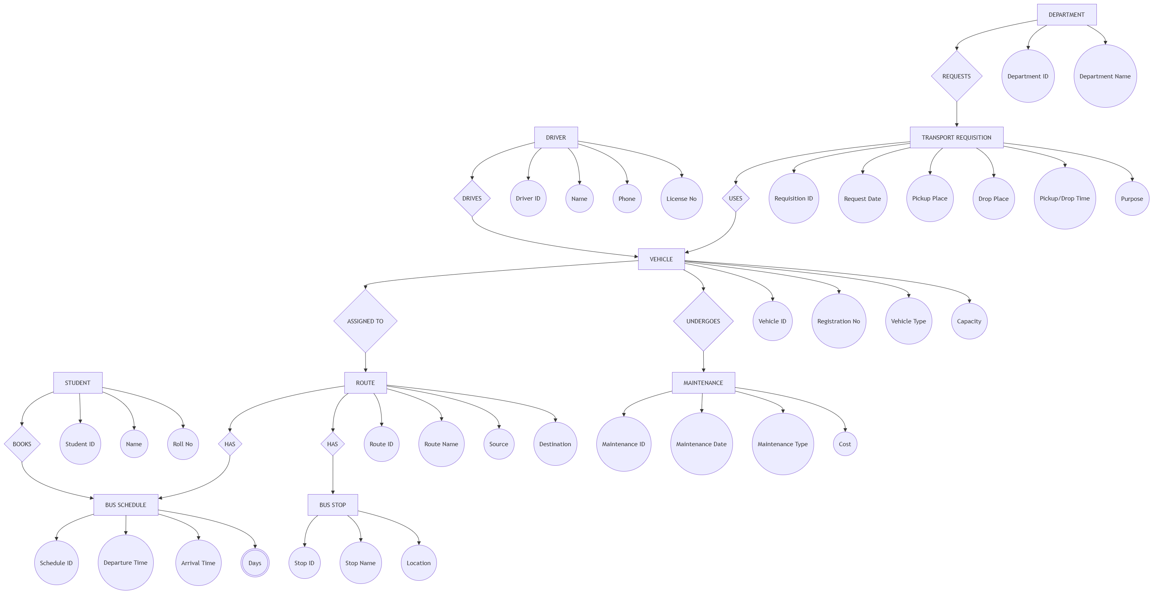
Figure 1: PMIS Enterprise Database Entity Relationship Diagram (ERD)
Table 1: MongoDB Database Collections Summary
Collection | Primary Key & Foreign Keys | Description & Key Attributes
projects | _id (PK) | Project charter, objectives, budget (5M), baselines (v1, v2), closure records
teammembers | _id (PK), projectId (FK) | Project team roster, roles (PM, Backend, QA), daily rates, daily capacity
milestones | _id (PK), projectId (FK) | Key delivery checkpoints (M1 to M5), target dates, forecast dates, status
requirements | _id (PK), projectId (FK) | Requirements register, code (REQ-xxx), MoSCoW priority, approval status
wbsnodes | _id (PK), projectId, parentId (FK) | WBS hierarchy tree (1.0, 1.1, 1.1.1), deliverable type, requirement references
activities | _id (PK), wbsNodeId, assigneeId (FK) | CPM tasks (ACT-xxx), durations, FS predecessors, ES/EF/LS/LF, float, critical flag
costentries | _id (PK), activityId (FK) | Itemized actual expenses (AC), amounts, dates, categories (Labour, Licences)
changerequests | _id (PK), projectId (FK) | Change proposals (CR-001), cost/schedule impact, CCB approval, snapshot
defects | _id (PK), deliverableId (FK) | Quality defect tracker (DEF-xxx), severity (Critical/Major), status workflow
qualityinspections | _id (PK), deliverableId (FK) | Formal deliverable audit reviews, checklist criteria, pass/fail result
risks | _id (PK), projectId (FK) | Risk register (RSK-xxx), Likelihood, Impact, Score (1-25), PDPC action branches
auditlogs | _id (PK), projectId (FK) | Audit trail records, user actions, system modifications, timestamps

Approved by Academic Steering & Examination Committee — COMSATS University Islamabad

