Wakalah (وكالة)
The Trust Layer for AI-Agent Transactions
MENA Ignite Hackathon — Idea Capture · Theme 4: Secure FinTech, Payments & Anti-Fraud Innovation
Submission date: 14 July 2026

Team Details
Team name | Wakalah
Team members | Zaid Takieddin — backend & AI agent layer  Yasser Al-Koudmany — frontend & demo experience
Contact | zaidtakieddin@gmail.com · +963 940 464 733

Integration Context
AI agents are beginning to book, purchase, and send money on people's behalf — and the payment industry is racing to authorize them. Every emerging agent-payment scheme authorizes the agent's credentials; none can answer the question the receiving institution actually cares about: is this agent still acting for a real, present, un-hijacked human, right now? Stolen credentials plus a cloned agent are indistinguishable at the protocol layer. The first place this will hurt is the MENA region's remittance corridors — the largest in the world — where account-takeover playbooks already begin with a SIM swap and will soon execute at machine speed, agent to agent, with no human in the loop to notice.
Wakalah uses CAMARA APIs available on the Nokia Network-as-Code platform as trusted, real-time signals that an AI agent layer orchestrates to bind every AI agent to its human principal. At mandate creation, Number Verification confirms network-level possession of the phone number and KYC Match confirms the claimed identity against the operator's registered owner, binding the agent to that principal; at transaction time, a risk-scoring agent fuses SIM Swap, Device Swap, Call Forwarding, Number Recycling, Tenure, Reachability, Roaming, and Location signals into a single allow / step-up / deny decision; and between transactions, a sentinel agent subscribes to SIM-swap events so a hijack after issuance revokes every outstanding trust token — mid-transaction if necessary. Banks, PSPs, and merchants verify one signed, expiring token with one API call before honoring anything an agent initiates.

Theme Relevance
Digital payments are accelerating across MENA while agentic commerce arrives on top of them: 2025–26 brought the first agent-payment protocols and card-network agent programs, and remittances — the region's financial lifeline and the world's largest corridors — will be among the first flows agents automate. Fraud infrastructure must precede that volume, not chase it. Wakalah is named for the classical Islamic agency contract (wakalah, وكالة), in which a principal (muwakkil) formally authorizes an agent (wakeel) to act on their behalf: this region has operated formalized agent-trust for fourteen centuries, and Wakalah digitizes exactly that structure for the newest kind of agent. The idea also reinforces Theme 1 (Trusted Digital Identity & Cross-Border Verification), but its home is secure payments and anti-fraud.
Project type  AI agent-orchestrated trust, mandate, and revocation layer for agent-initiated payments. | GSMA pillar  Connectivity for Good

How it supports this pillar: Wakalah turns mobile connectivity into the trust anchor of the agent economy. The network's own knowledge — whose SIM this is, whether it was swapped, whether calls are being silently forwarded, whether the subscriber behind the number even changed — becomes real-time consumer protection for people whose AI agents transact on their behalf, and a new recurring role and revenue line for the region's operators: every agent transaction anywhere becomes billable verification calls. Connectivity stops being a pipe under the agent economy and becomes its identity layer.

Solution Overview
Wakalah sits between AI agents and the institutions they transact with. (1) Mandate creation: a principal — Amina, in our demo — authorizes her AI agent “Rasheed” with a scope (“send up to 2,000 QAR per month to my mother”); the Mandate Agent runs the operator consent flow (Number Verification), matches the claimed identity against the SIM's registered owner (KYC Match), checks hijack recency (SIM Swap, Device Swap) and continuity (Number Recycling, Tenure), and mints a signed, expiring trust token carrying the scope, a risk score, and evidence references. (2) Transaction time: the merchant or PSP calls Wakalah's verify endpoint; the Risk Scorer re-checks the hot signals within the checkout's latency budget and returns allow, step-up, or deny with an explainable rationale. (3) Continuously: the Sentinel Agent watches SIM-swap and device-swap events and kills every outstanding token of a hijacked principal the moment the network reports it, notifying the principal and forcing re-verification. Throughout, a deterministic policy engine — not the LLM — holds final authority over every verdict, and every decision is logged with its evidence. Wakalah is API-first: institutions adopt it by calling the agent as a service, without replacing their existing fraud stacks.
How it helps solve the problem: It stops agent-mediated account takeover before authorization instead of after the money moves; it cuts false declines on legitimate customers (a genuinely traveling principal stays verified through roaming and location consistency); and it gives fraud and compliance teams a standing, auditable answer to a question they currently cannot ask at all — is this agent still authorized by a safe human?

Key Features & Benefits
- Standing, scoped, expiring trust tokens (signed JWTs) that bind an AI agent to a verified human principal — delegation governance, not point-in-time checks.
- Continuous revocation: a SIM-swap or device-swap event kills every outstanding token in seconds — mid-transaction if necessary.
- Five-dimension signal fusion across ten CAMARA signals: binding, hijack, identity, continuity, and context.
- Allow / step-up / deny verdicts with an explainable rationale, returned inside a checkout's latency budget.
- AI proposes, policy disposes: a deterministic, versioned rule engine holds final authority over every verdict — no LLM ever approves a payment alone.
- Complete audit trail per decision (signals, weights, rationale) for fraud and compliance teams.
- Graceful degradation by design: tested against Nokia NaC's own error-simulator devices, with a recorded-response replay fallback and a local Ollama fallback model so the demo never dies on a timeout. API-first integration for incremental adoption.

APIs & Technology
APIs used & how they help  - Number Verification — network-confirmed possession of the phone number at mandate creation (operator 3-legged consent flow).  - KYC Match — the claimed name/ID matches the SIM's registered owner: the wakeel acts for a named muwakkil, not just a number.  - SIM Swap (check + events) — recent swap blocks issuance; a swap event revokes outstanding tokens instantly.  - Device Swap — same SIM, suspicious new handset triggers step-up re-verification.  - Call Forwarding Signal — active unconditional forwarding = OTP/voice interception risk; voice-verified scopes are blocked.  - Number Recycling — detects a reassigned number, killing the inherited-account-takeover class before renewal.  - Tenure — subscription longevity as a trust prior: a decade-old subscriber is not a week-old burner SIM.  - Device Reachability Status — liveness context: a principal dark for days cannot anchor high-value scopes.  - Device Roaming Status — a genuinely traveling principal keeps transacting; false declines drop.  - Location Verification — optional geo-consistency check for high-value transactions. | Tech stack / frameworks  - Agent orchestration: LangGraph — stateful, auditable issuance / verification / revocation workflows.  - Typed decisioning: Pydantic AI — every verdict is a validated allow/step-up/deny structure.  - LLMs: Google AI Studio Gemini 2.5 Flash (reasoning, free tier) + Groq Llama (low-latency checkout-time checks, free tier) + Ollama local model as offline fallback.  - Backend: FastAPI (Python) with a WebSocket event stream feeding the live demo.  - Data & audit: Supabase Postgres (mandates, tokens, verifications, API-call log) + pgvector for agent memory.  - Frontend: Next.js on Vercel — split-screen demo with visible agent reasoning trace and live API-call panel.  - Data source: CAMARA APIs via the Nokia Network-as-Code sandbox and its official simulator personas, with a record/replay cache.

How the tech stack helps: LangGraph keeps the trust workflows stateful and auditable rather than a free-form chat loop; Pydantic AI forces typed verdicts a payments context can rely on; Gemini carries deliberate reasoning while Groq keeps per-transaction checks inside checkout latency, with a local Ollama model as an offline fallback so the demo survives rate limits or venue Wi-Fi; Supabase provides the compliance-grade audit trail. Every component is on the approved Resource & Tooling Guide list and pinned to a free tier — the full prototype can be built, demoed, and submitted with no credit card and no paid commitment.

Innovation Highlights
- First trust layer for the agents themselves: existing telecom anti-fraud (per-transaction SIM-swap checks, cross-border person trust scores) authenticates a human at a moment in time — Wakalah governs standing delegation, the case where the human is not present when the transaction happens.
- Event-driven revocation in seconds (mid-transaction), instead of periodic re-checks that discover the hijack after the payout.
- Orchestrates six Network-as-Code identity APIs beyond the commonly used trio — KYC Match, Device Swap, Call Forwarding Signal, Number Recycling, Tenure (and Age Verification on the roadmap) — an unusually deep, reasoned use of the Open Gateway catalog.
- Agentic AI squared: Wakalah's agents use network signals to police other AI agents — automation and decisioning at the exact center of the hackathon's mandatory AI-agent requirement.
- AI proposes, deterministic policy disposes — a safety architecture appropriate for payments, with the agent's visible reasoning trace shown on screen during the demo.
- Engineered for graceful degradation using NaC's own error-simulator devices (400/404/422/5xx personas), a recorded replay cache, and a local fallback model.
- Clear path from prototype to production: per-verification pricing that banks already pay today for SIM-swap checks, and alignment with emerging agent-payment mandate protocols.

Impact Metrics
- Fraud blocked: Wakalah denies the demonstrated SIM-swap-led takeover before authorization; because a hijack signal is re-checked on every verification, this class of attack is caught at the verify step (subject to operator signal availability — no system detects every fraud technique).
- Revocation speed: under 5 seconds (median) from SIM-swap event to every outstanding token revoked — design target, shown live in the prototype demo.
- False declines: 30–50% reduction (target) for genuinely traveling customers, via roaming- and location-aware verification instead of blanket geo-blocks.
- New operator revenue: 2–4 billable API calls per agent transaction — approximately $40–200 per 1,000 agent-initiated transactions, on flows operators currently monetize at zero.
- Decision latency: under 500 ms (p95 target) per verification — inside checkout latency budgets, using Groq's low-latency inference with signal-TTL caching.
- Adoption and auditability: a new bank or PSP goes live in under one week (single API-first verify endpoint), and 100% of decisions carry a complete, exportable evidence rationale — guaranteed by the deterministic policy engine.

Methodology & Architecture

How the agents communicate
- Principal → Mandate Agent: the principal authorizes her agent and completes the operator consent flow; Number Verification + KYC Match + swap/continuity checks mint a scoped, expiring trust token.
- Merchant / PSP → Risk Scorer: checkout calls verify(token, transaction); hot signals are re-checked within the latency budget; the deterministic policy engine issues allow / step-up / deny with a rationale.
- Network events → Sentinel Agent: SIM-swap / device-swap events revoke every outstanding token for the affected principal — mid-transaction if necessary — and trigger re-verification.
- Every layer → Audit & Dashboard: all API calls, agent proposals, and policy verdicts stream to the Supabase audit trail and the live dashboard (reasoning trace + API-call panel).

Architecture components
Input layer  Consumer AI agents + merchant/PSP checkout + the principal's consent flow (mobile). | Agent layer  LangGraph-orchestrated Mandate Agent, Sentinel Agent, and Risk Scorer with Pydantic-AI-typed outputs; Gemini/Groq brains, Ollama fallback.
Verification layer  NacClient — the single gateway invoking CAMARA APIs via Nokia Network-as-Code (REST + record/replay cache). | Policy & token engine  Deterministic, versioned rules; mints, verifies, and revokes signed JWT trust tokens; final authority on every verdict.
Data & audit  Supabase Postgres: mandates, tokens, verifications, and the full network-call log for compliance export. | Trust dashboard  Next.js split-screen demo: legitimate agent vs. cloned agent, agent reasoning trace, live API-call panel.

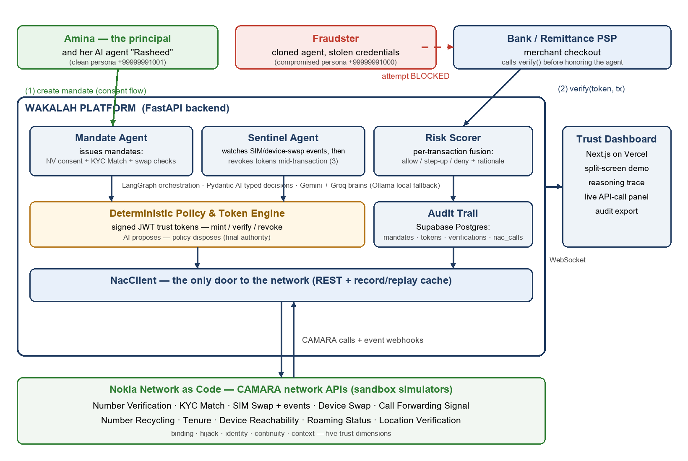
Wakalah architecture — actors, agent layer, deterministic policy engine, and the CAMARA signal layer.
Diagram link: diagram embedded above; editable source maintained in the team repository.

