
Play-by-Play AI

Introduction
Play-by-Play AI is a product for online games that enhances the gaming experience by providing real-time generated commentary. This commentary will be dynamic and context-specific, avoiding the repetitive nature of preset commentaries that many games currently use. You plan to utilize computer vision to analyze the game's visual data and generate relevant commentary on the fly, making the gameplay more engaging and exciting for the player.

Problem
The gaming industry has evolved remarkably, boasting stunning graphics, engaging gameplay, and sophisticated AI-based features such as face avatars and complex bots. However, a critical element is often overlooked: dynamic and varied commentary. Currently, many games rely on a limited set of preloaded commentary phrases, which quickly become repetitive and detract from the immersive experience. For instance, when a player hits a big six, the excitement is diminished by hearing the same commentary repeatedly. Addressing this issue with more diverse and adaptive commentary systems could significantly enhance the gaming experience, maintaining excitement and immersion for players.

Solution
Play-by-Play AI adds an innovative layer for online games, enhancing the gaming experience without changing the core functionality of the games themselves. Our product seamlessly integrates AI-driven commentary, providing dynamic and varied commentary that adapts to in-game events. This ensures that players hear something new and exciting every time a significant action occurs, such as hitting a big six. One of the standout features of Play-by-Play AI is its ability to learn and adapt to patterns. This continuous learning process not only improves the quality of the commentary but also keeps training costs low.

Technology Stack Overview

Frontend:
- Nodejs: For building web application. It will provide the UI for game creators/providers to view dashboards, active games, AI commentary costs, delays, etc.
- Web Sockets: For real-time updates on the dashboards, ensuring game creators receive live data.

AI & Machine Learning:
  - Large Language Models (LLMs): For generating dynamic and contextually relevant commentary. Models like GPT-4 can be fine-tuned for this purpose.
  - Computer Vision Models (e.g., OpenCV, YOLO): For analyzing visual data from the games, if necessary, to trigger appropriate commentary.
  - TensorFlow / PyTorch: For building and deploying machine learning models.

Data Storage and Processing:
- MongoDB / PostgreSQL: For storing game data, commentary logs, and other necessary information.
- Redis: For caching frequently accessed data and managing real-time data processing.

Product Overview
Our product, Play by Play AI, caters to game creators seeking to integrate advanced AI capabilities into their games to elevate user experiences. Beyond enhancing gameplay, we recognize the growing trend of competitive gaming tournaments where teams compete at large scales. Play by Play AI serves as a pivotal enhancement, offering AI-based commentary and insightful analysis. This feature not only enriches the gaming experience but also empowers gamers to improve their gameplay strategies.

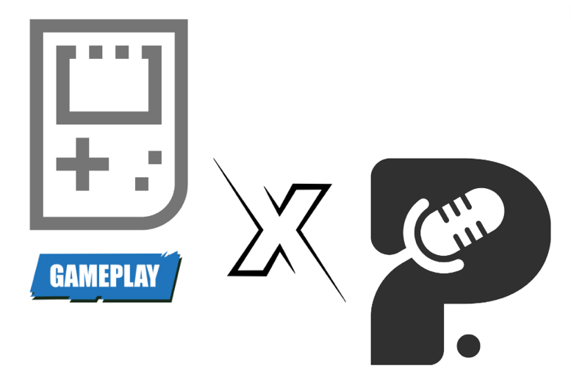
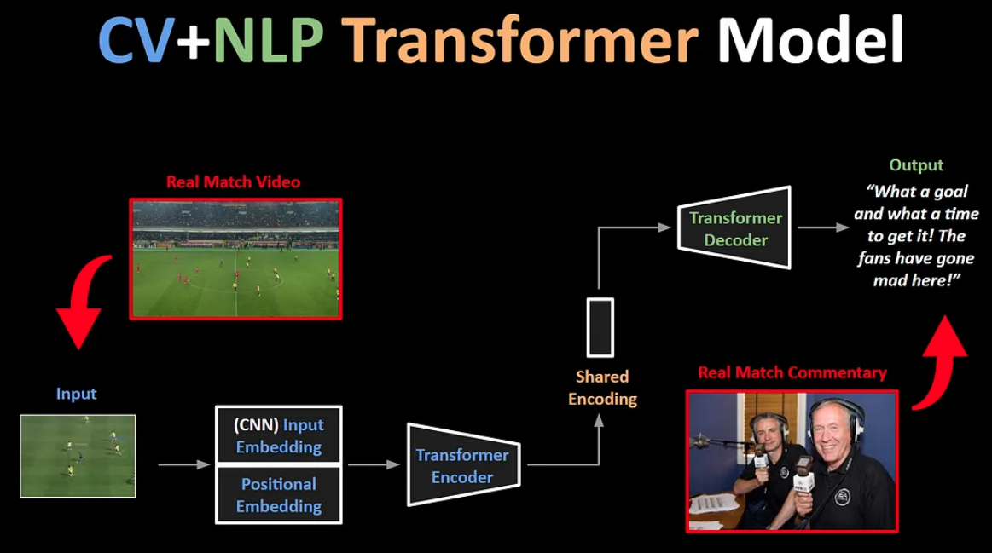

Reference
https://arxiv.org/pdf/2005.12872
https://arxiv.org/pdf/1907.11180
https://medium.com/deepgamingai/ai-based-video-game-commentary-with-end-to-end-transformers-a4729e34582c

