Final Year Project Progress Report

INCLUSIVE WEB PLATFORM

By:
Zaidan Mansour
Charbel Rizk

Supervisor(s):
Dr. Jean Yves Youssef
Dr. Roger Obeid
Dr. Rima Kilany

A report submitted in partial fulfillment of the requirements for the degree of
COMPUTER AND COMMUNICATIONS ENGINEERING

10-08-2026



Ecole Supérieure d’Ingénieurs de Beyrouth
Université Saint-Joseph de Beyrouth
Contents

List of figures 4
List of tables 5
Acronyms 5
1 Introduction 7
2 Background Research and Related work 9
2.1 Historical and Conceptual Background 9
2.2 Inclusive Recruitment and Existing Platforms 9
2.3 Phase I Limitations and Need for Dataset Expansion 10
2.4 Accessibility and Multimodal Digital Interfaces 11
2.5 Speech Recognition and NLP for Candidate Profile Creation 11
2.6 Human-in-the-Loop AI and Ethical Considerations 13
2.7 Critical Evaluation of Existing Approaches 13
2.8 Contribution of the Proposed Work 14
3 Requirements 15
3.1 Functional Requirements 15
3.2 Non-Functional Requirements: Encompassing measurable Quality Attributes, Constraints, Standards, and Regulations 19
3.3 Conceptual model 25
4 Solution Design 30
4.1 Propose multiple solutions: Design alternatives and comparison 30
Alternative 1: Fully Monolithic Web Application 31
Alternative 2: Full Microservices Architecture 31
Alternative 3: Layered Modular Architecture with External Service Integration— Chosen Approach 32
A. Authentication and Role Management 34
B. PwD Candidate Verification 35
D. AI-Assisted NLP Workflow 35
E. Matching Approach 36
4.2 H. Administrator-Controlled Catalogue Workbook Import 39
4.3 Solution modeling 41
5 Implementation Progress and Verification 43
5.1 Implemented System Baseline 43
5.2 Engineering Alternatives and Decision Rationale 43
5.3 AI-Assisted Profile-Building Workflow 45
5.4 Accessibility and Responsive Engineering 46
5.5 Security, Verification, and Privacy 47
5.6 Catalogue and Scoring Policy 48
5.7 Integration, E2E, and Performance Evidence 49
5.8 Requirements Traceability 50
5.9 Current Limitations 52
6 Conclusion and Future Work Planning 53
6.1 Remaining Work and Definition of Done 53
6.2 Risk Management 54
6.3 Project Management 54
7 References 55
8 Appendix A — System Architecture, Setup, and Operations 55
8.1 Implemented Runtime Architecture 55
8.2 Prerequisites and First-Time Setup 56
8.3 Daily Operation, Validation, and Troubleshooting 57
9 Appendix B — Authentication, Candidate Verification, Security, and Privacy 57
9.1 Authentication and Authorization Model 57
9.2 Candidate Eligibility Verification 58
9.3 Private Storage, Consent, and Candidate Rights 58
9.4 Security Verification and Deployment Duties 59
10 Appendix C — AI-Assisted Profile Building and Voice Navigation 60
10.1 Candidate Profile Assistant 60
10.2 Voice-Navigation Safety Architecture 60
10.3 Language, Privacy, Configuration, and Limitations 60
11 Appendix D — Deterministic Scoring Engine and Catalogue Policy 61
11.1 Authoritative Data Flow 61
11.2 Mathematical Model 61
11.3 Eligibility, Ranking, and Interpretation 62
11.4 Catalogue Baseline and Missing Assessments 62
11.5 Determinism, Testing, and Future Calibration 63
12 Appendix E — Responsive Design, Keyboard Access, and WCAG Evidence 63
12.1 Audit Scope and Implemented Corrections 63
12.2 Keyboard Acceptance Plan 65
12.3 ISO 9241-110 Interaction Principles 65
12.4 Conformance Boundary 65
13 Appendix F — Outcome Logging, Accessible Notifications, Testing, and Performance 66
13.1 Outcome and Notification Data 66
13.2 Recorded Automated Verification 66
13.3 Performance Measurements 67
13.4 Required Manual and Deployment Retests 67
14 Appendix G — Documentation and Evidence Traceability 67

List of figures
Figure 1: C4 notation legend 25
Figure 2: System context diagram (C4 Level 1) 26
Figure 3: Container diagram (C4 Level 2) 27
Figure 4: Conceptual class diagram 29
Figure 5: Matching-evaluation state diagram 29
Figure 6: Layered modular runtime service boundaries and health evidence 34
Figure 7: Candidate disability-card requirement and verification consent 35
Figure 8: Employer task-importance and assistance configuration 37
Figure 9: Candidate data-access, consent, retention, and erasure controls 38
Figure 10: Administrator catalogue upload control and accessible result feedback 39
Figure 11: Supported occupational-workbook columns and feasibility mapping 40
Figure 12: Component diagram 42
Figure 13: Candidate AI-assisted profile-building workflow 46
Figure 14: Keyboard/voice navigation and accessible notifications 47
Figure 15: Authorized candidate-verification dashboard 48
Figure 16: Responsive role dashboards 49
Figure 17: Integration, E2E, and performance evidence 50
Figure 18: Gantt chart 54

List of tables
Table 1: High-level architecture alternatives comparison 32
Table 2: Engineering design-decision matrix 43
Table 3: Requirements progress and verification matrix 50
Table 4: Runtime services and local endpoints 55
Table 5: Security and privacy control summary 58
Table 6: Deterministic scoring policy 61
Table 7: Accessibility verification coverage 63
Table 8: Recorded automated verification results 66
Table 9: Repository documentation incorporated into this report 67

Acronyms

AI | Artificial Intelligence
API | Application Programming Interface
ASR | Automatic Speech Recognition
C4 | Context, Containers, Components, and Code
CSS | Cascading Style Sheets
CV | Curriculum Vitae
DB | Database
ERD | Entity Relationship Diagram
FYP | Final Year Project
GDPR | General Data Protection Regulation
GUI | Graphical User Interface
HoReCa | Hotels, Restaurants, and Catering
HTML | HyperText Markup Language
HTTP | HyperText Transfer Protocol
HTTPS | HyperText Transfer Protocol Secure
JSON | JavaScript Object Notation
JWT | JSON Web Token
LLM | Large Language Model
ML | Machine Learning
NLP | Natural Language Processing
NFR | Non-Functional Requirement
PwD | Person with Disability / Persons with Disabilities
RBAC | Role-Based Access Control
REST | Representational State Transfer
SMTP | Simple Mail Transfer Protocol
SQL | Structured Query Language
UI | User Interface
UML | Unified Modeling Language
WCAG | Web Content Accessibility Guidelines

Introduction

Access to employment is not only an economic need, but also a major factor of dignity, autonomy, social participation, and personal identity. For persons with physical disabilities (PwD), however, access to the labor market remains difficult, especially when recruitment processes are still based on traditional profiles, subjective judgment, and a focus on limitations rather than abilities. In many cases, employers hesitate to hire PwD because disability is perceived as a source of complexity, cost, adaptation constraints, or uncertainty. On the other side, many PwD are not fully informed about their real professional potential, especially in fields such as hospitality and food service, where tasks are diverse and can often be adapted or reorganized.
The JoIn Hospitality initiative addresses this challenge by presenting inclusion not as an act of charity, but as a win-win opportunity for both the hospitality industry and persons with disabilities. Its objective is to break the ice between recruiters and PwD by transforming physical conditions into job-relevant remaining abilities, and by matching these abilities with real professional tasks in the HoReCa sector: hotels, restaurants, catering, and food service. The JoIn Hospitality pitch presents the software component as an “icebreaker” tool that facilitates the connection between recruiters and PwD, while the tailored framework matches professional tasks with remaining functional abilities in order to propose roles that genuinely fit each person’s capabilities.
Phase I of the Inclusive Web Platform delivered a functional proof of concept for this vision. The previous team developed a web-based recruitment platform using a Symfony backend, PostgreSQL database, React frontend, JWT authentication, role-based access control, and a separate Flask microservice for task-level ability matching. The prototype allowed candidates to define their remaining abilities, browse job opportunities, apply to suitable positions, and receive compatibility results based on the relationship between their abilities and the tasks required by each job. The Phase I report clearly identified the central idea of the platform: recruitment should begin with what a person can do, not with what the person cannot do.
However, while Phase I proved the technical feasibility of ability-to-task matching, the accessibility dimension of the platform remains a major challenge. Since the platform is designed for PwD, accessibility cannot be treated as a secondary feature. A recruitment system intended for persons with physical disabilities must be usable by people who may face motor difficulties, visual barriers, speech-related limitations, fatigue, or literacy-related difficulties. In its current form, the application process still depends mainly on reading, typing, and navigating a standard web interface. This creates a paradox: the platform promotes inclusion, but some of the users who most need it may still face barriers when trying to use it.
Phase II therefore focuses on transforming the existing platform into a genuinely accessible and multimodal recruitment experience. The objective is to extend the Inclusive Web Platform by allowing candidates to complete their account creation, profile building, ability declaration, and job application through different input and output channels, including text, voice, audio support, and accessible visual interfaces. In particular, the system will integrate an automatic speech recognition layer capable of transcribing spoken input in the target languages: Lebanese Arabic, French, and English. This transcription will then be processed by an NLP layer that proposes a structured profile of remaining abilities and skills mapped to the platform’s predefined vocabulary.
A key principle of this phase is that artificial intelligence will assist the user, not replace the user’s decision. Any ability, skill, or disability-related attribute proposed by the AI layer must be shown to the candidate for review, correction, confirmation, or rejection before it is stored or used in the matching engine. This human-in-the-loop approach is essential because disability and health-related information are sensitive, personal, and should never be inferred as fact without explicit confirmation. The confirmed structured profile will then feed the existing Phase I matching engine, allowing the project to improve accessibility and data entry without redesigning the whole matching logic.
In parallel, the user interface will be redesigned and evaluated according to WCAG 2.1 Level AA accessibility principles. This includes keyboard navigation, screen-reader compatibility, sufficient contrast, clear focus management, resizable text, captions or transcripts for audio and video content, and compatibility results that are not communicated by color alone. These improvements are necessary to make the platform accessible not only in its mission, but also in its actual daily use.
The scope of this project is therefore the continuation and engineering extension of the existing Inclusive Web Platform. It does not aim to replace medical assessment, rehabilitation professionals, recruiters, job coaches, or workplace adaptation policies. Instead, it aims to provide a technical bridge between PwD and recruiters by making the application process more accessible, by helping candidates express their abilities through voice or text, and by preserving a transparent ability-to-task matching process. The main beneficiaries are candidates with physical disabilities, recruiters and employers in the hospitality and food service sector, inclusion organizations, and future researchers who may use consent-based outcome data to improve the matching model.
This project constitutes a major design experience because it combines web engineering, software architecture, accessibility engineering, human-computer interaction, applied AI, multilingual speech recognition, NLP-based information extraction, security, privacy, and data-protection design. The expected deliverable is an improved platform prototype that extends the Phase I system with multimodal candidate input, AI-assisted profile extraction, human confirmation, accessibility-compliant interfaces, and integration with the existing task-level matching service. The project will also include updated documentation, functional and non-functional requirements, design diagrams, technical tests, accessibility checks, and, where feasible, feedback from representative users or stakeholders in the inclusion ecosystem.
Another expected contribution of Phase II is the preparation of a foundation for future data-driven improvement. With explicit user consent, the platform may record application outcomes and, when available, placement results. This would allow future teams to build a labelled dataset based on real-world use rather than only expert-defined assumptions. Such a dataset could later support the improvement of the matching model and provide evidence for how well the platform supports inclusive recruitment in practice.
The main challenges expected in this phase are the support of Lebanese Arabic speech recognition, the risk of incorrect AI extraction, the sensitivity of disability-related data, and the difficulty of meeting accessibility requirements in a realistic and measurable way. These challenges will be addressed through modular service design, model evaluation, editable transcriptions, confidence-based review prompts, explicit user confirmation before storing sensitive information, and accessibility validation using automated tools and assistive-technology testing.
This work is carried out in continuity with the previous FYP team’s prototype and in cooperation with the project supervisors and JoIn Hospitality stakeholders. It also builds on the broader vision of JoIn Hospitality, which combines software, adaptive work tools, and training to support inclusion in the hospitality industry. Through these improvements, Phase II aims to move the platform from a functional prototype toward a truly inclusive digital recruitment tool: one that does not only make opportunities visible, but also makes the application process usable, understandable, and empowering for the people it is meant to serve.
Progress update (10 August 2026): Phase II has now implemented the principal prototype workflows described above, including candidate eligibility verification, editable English/French/Arabic profile transcripts, consent-gated AI suggestions with candidate confirmation, deterministic task-level matching, private document handling, role-based security, responsive keyboard and optional voice navigation, accessible notifications, outcome logging, and repeatable integration/E2E/performance tests. Final rendered WCAG checks, representative-user evaluation, ten additional validated job roles, deployed capacity evidence, formal multilingual evaluation, and the planned cache layer remain in progress.

Background Research and Related work

Historical and Conceptual Background
The employment of persons with physical disabilities has evolved significantly over time. In the past, disability was mainly understood through a medical model, where the person was evaluated according to impairment, incapacity, or limitation. This view often led to dependency, protection, and separation from ordinary professional environments. Employment opportunities for persons with disabilities were therefore frequently limited or approached through charity-based and assistance-based models.
Over time, this perspective shifted toward a social and rights-based model. In this model, disability is not seen only as an individual medical condition, but also as the result of barriers created by society, workplaces, recruitment methods, tools, and communication systems. The JoIn Hospitality research material highlights this evolution by comparing the medical model and the social model of disability, and by showing that disability should also be understood through the way society and work environments are organized.
This shift is essential for the present project. If the barriers faced by persons with disabilities are not only physical or medical, but also organizational, digital, and communicational, then software can play an important role in reducing these barriers. A recruitment platform can either reproduce exclusion by forcing all users to interact in the same traditional way, or it can support inclusion by adapting the application process to the user’s abilities.
The hospitality and food service sector, also known as HoReCa, represents an important field for this approach. It includes hotels, restaurants, catering, food preparation, service, and related activities. This sector contains a wide variety of tasks and roles, which makes it suitable for task-level analysis. Many jobs in this field can be broken down into smaller tasks, and some tasks may be adapted, reorganized, or partially performed depending on a candidate’s remaining abilities. JoIn Hospitality presents the hospitality industry as a strong opportunity for inclusion because it faces labor shortages, high turnover, and a growing need for inclusive recruitment solutions.

Inclusive Recruitment and Existing Platforms
Most current recruitment platforms are based on traditional candidate profiles, CVs, qualifications, experience, and employer interpretation. Even when platforms aim to support inclusion, many of them mainly increase the visibility of candidates with disabilities without changing the structure of recruitment itself. In these systems, the employer still evaluates the candidate globally and subjectively, without necessarily understanding whether the candidate can perform the specific tasks required by the job.
Phase I of the Inclusive Web Platform addressed this limitation by introducing an ability-to-task matching approach. Instead of treating a job as a single role, the platform breaks it down into tasks and subtasks, then compares those requirements with the candidate’s remaining functional abilities. The Phase I report identified this as the central idea of the platform: recruitment should begin with what a person can do, not with what the person cannot do.
In Lebanon, ProAbled was studied as an existing inclusive recruitment platform. It plays an important role by connecting persons with disabilities, NGOs, rehabilitation centers, and employers. However, as explained in the Phase I report, its approach remains mainly profile-based and does not provide task-level matching between job requirements and remaining abilities. This shows that visibility alone is not enough. A candidate may be visible to employers, but still not properly understood if the platform does not explain what tasks the candidate can actually perform.
Human-centered inclusion models, such as the work observed through Arc-en-Ciel and JoIn Hospitality, provide another important reference. These approaches are grounded in real human abilities, practical observation, coaching, and adaptation. Their strength is that they respect the complexity of disability and avoid reducing the person to a simple profile or score. However, they are difficult to scale digitally if they depend only on manual evaluation, human experts, or case-by-case judgment.
Automated recruitment and AI-based matching systems provide another direction. They can improve speed, scalability, and consistency, but they also introduce risks. If the decision logic is not transparent, automated systems can become difficult to trust. They may also reinforce bias or make incorrect assumptions about a person’s abilities. For this reason, the present project does not use AI as a final decision-maker. Instead, AI is used as an assistive layer that helps structure information while keeping the candidate and recruiter in control.

Phase I Limitations and Need for Dataset Expansion
Phase I successfully demonstrated that task-level ability matching is technically possible. The previous prototype included a React frontend, a Symfony backend, a PostgreSQL database, JWT authentication, role-based access control, and a Flask microservice for the AI matching component. The AI microservice received candidate disability or ability information and returned compatibility results for the available job roles.
However, one important limitation of Phase I was the small size of the job-description dataset. The matching engine was trained and tested using only three HoReCA job roles: Glacerie, Boulangerie-Pâtisserie, and Chocolaterie. The Phase I report states that the training dataset was derived from Excel files containing these three job roles, with task-by-task feasibility ratings per disability type. This was sufficient to prove the concept, but it is not enough to represent the real diversity of the hospitality and food service sector.
In reality, HoReCa includes many different job families, tasks, work environments, physical constraints, and required abilities. A platform limited to three jobs cannot provide enough opportunities for candidates or enough flexibility for recruiters. It also limits the usefulness of the machine learning model, because the model can only predict compatibility for a very small set of roles.
For this reason, Phase II will expand the dataset by adding ten additional job descriptions, increasing the platform coverage from three to thirteen job roles. These new job descriptions will be structured into tasks and subtasks, then mapped to the required abilities and feasibility levels. This expansion will make the platform more realistic, more useful, and closer to real HoReCA recruitment needs.
The machine learning matching model is also affected by this expansion. In Phase I, the model predicted compatibility scores and remaining abilities based on the available dataset. The results were strong, but they were based on a limited number of job roles. In Phase II, the model must be updated, retrained, and evaluated using the expanded dataset so that it can generate compatibility results across thirteen jobs instead of only three. This will improve the coverage and practical value of the matching engine while preserving the original Phase I architecture.

Accessibility and Multimodal Digital Interfaces
Another important limitation of many digital recruitment systems is that they assume all users can read, type, click, scroll, and navigate a web interface in the same way. This assumption is problematic for persons with physical disabilities, who may experience motor difficulties, visual barriers, fatigue, limited hand use, or difficulty using a keyboard and mouse. Therefore, accessibility is not only a design improvement; it is a basic condition for the platform to achieve its purpose.
The Phase I platform promoted inclusive recruitment, but the interaction process still depended mainly on standard web navigation, reading, and typing. This creates a gap between the mission of the platform and the actual user experience. A platform designed for PwD must be accessible not only in its objective, but also in its interface and interaction methods.
The state of the art in accessible web design is strongly influenced by the Web Content Accessibility Guidelines, especially WCAG 2.1. These guidelines are organized around four major principles: content should be perceivable, operable, understandable, and robust. For this project, WCAG 2.1 Level AA is used as the target accessibility level. This includes keyboard navigation, screen-reader support, sufficient color contrast, visible focus indicators, resizable text, alternative text for meaningful visuals, captions or transcripts for audio and video content, and compatibility results that are not communicated by color alone.
Multimodal interaction is also important for this project. A multimodal interface allows users to interact with the system through more than one channel, such as text, speech, audio feedback, visual elements, keyboard navigation, or assistive technologies. In the context of the Inclusive Web Platform, this means that candidates should not be forced to complete their profile or application only by typing. They should be able to use voice input, text input, or a combination of both depending on their abilities and preferences.

Speech Recognition and NLP for Candidate Profile Creation
Automatic Speech Recognition, or ASR, is the technology that converts spoken language into written text. In this project, ASR is relevant because it allows candidates to describe their abilities, experience, limitations, preferences, and needs orally. This can reduce the dependency on typing and make the application process more accessible for users with upper-limb motor difficulties, fatigue, or low digital literacy.
However, ASR introduces technical challenges. French and English are widely supported by many speech-to-text systems, but Lebanese Arabic is more difficult because it is a dialect with variations in pronunciation, vocabulary, and code-switching. Many Lebanese users naturally mix Arabic, French, and English in the same sentence. This makes transcription more complex and may reduce accuracy. Therefore, the transcript must not be treated as final. The candidate must be able to review, correct, and confirm the transcription before it is used.
Several ASR solutions may be considered for this project, including open-source or API-based speech-to-text models such as Whisper. These models are relevant because they support multilingual transcription and can reduce the typing effort required from candidates. However, their accuracy must be evaluated in the project context, especially for Lebanese Arabic, mixed-language speech, background noise, and informal expressions. For this reason, the ASR output will always remain editable and subject to candidate confirmation before being processed further.
Natural Language Processing, or NLP, is the second important technology in this phase. Once the candidate’s speech or typed text is available, NLP can be used to extract structured information from a free narrative. For example, if a candidate says that they can stand for short periods, use one hand with precision, understand instructions, or prefer seated tasks, the NLP layer can propose corresponding abilities and skills from the platform’s predefined vocabulary.
In this project, the NLP component will not rely mainly on a traditional keyword-based or rule-based NLP pipeline. Traditional NLP approaches often depend on predefined keywords, manual rules, or classical text classification techniques. While these methods can be useful in controlled situations, they are less flexible when users express themselves in natural, informal, multilingual, or dialectal language. Since candidates may describe their abilities using Lebanese Arabic, French, English, or a mixture of these languages, a more flexible approach is required.
For this reason, Phase II will use an LLM-assisted NLP approach through the OpenAI API. The objective is to transform the candidate’s free narrative, obtained either from typed text or from ASR transcription, into a structured representation of abilities, skills, preferences, and possible constraints. This approach is suitable for the project because OpenAI’s API supports structured outputs, where model responses can be constrained to follow a supplied JSON schema, making it easier to integrate extracted information with backend services.
In addition, the LLM-assisted layer can be made context-aware by providing it with the current page or form context. This means that the system does not ask the model to extract every possible piece of information, but only the information relevant to the current step of the user journey, such as account creation, profile completion, ability declaration, or job application. This improves precision and reduces irrelevant extraction.
The extracted information will be mapped to the platform’s predefined vocabulary and returned in a structured format, such as JSON, so that it can be processed by the backend and later used by the matching engine. The extracted data can be organized into categories such as functional abilities, skills, limitations or constraints, preferences, assistance needs, and experience-related information, depending on the current form being completed. For example, during the ability declaration step, the system may focus on what the candidate can do, what they can do with assistance, and what should be avoided. During the job application step, it may focus more on preferences, availability, and specific needs related to the selected role. This makes the AI layer more controlled, more understandable, and better aligned with the platform workflow.
The advantage of this approach is that it reduces the burden on the candidate. Instead of manually filling many fields, the candidate can describe their situation naturally, and the system helps transform this narrative into structured data. This makes the application process more accessible and more user-friendly, especially for candidates who may have difficulty typing or navigating long forms.
However, LLM-assisted NLP also has limitations. The model may misunderstand the user, propose an incorrect ability, miss an important detail, or infer sensitive information that the candidate did not intend to declare. Structured output improves integration and format reliability, but it does not guarantee that every extracted value is semantically correct. OpenAI also notes that structured outputs do not prevent all model mistakes inside the generated values.
For this reason, the AI output must not be considered final. The system will use the LLM as an assistive tool, not as an automatic authority. Every proposed ability, skill, preference, or constraint must be displayed to the candidate for review, correction, confirmation, or rejection before it is stored or used by the matching engine.
This human-in-the-loop mechanism is essential for both ethical and technical reasons. It protects the candidate’s autonomy, reduces the risk of incorrect profile construction, and prevents sensitive disability-related information from being stored without explicit confirmation. In this way, the ASR and NLP layers support accessibility and efficiency while keeping the candidate in control of their own data.

Human-in-the-Loop AI and Ethical Considerations
Human-in-the-loop AI is a design approach where artificial intelligence supports the user but does not make final decisions without human review. This principle is essential in the present project because disability-related information is sensitive and personal. The system must not automatically decide that a candidate has a certain limitation, skill, disability attribute, or ability based only on an AI interpretation.
In the proposed Phase II system, the AI layer will propose a structured profile, but the candidate will remain responsible for confirming, editing, or rejecting each suggestion. Nothing sensitive should be stored or used by the matching engine before explicit user confirmation. This reduces the risk of harmful errors and keeps the candidate in control of their own profile.
This approach also supports explainability and trust. Instead of giving a hidden AI result, the system shows which abilities or skills were extracted and allows the user to understand and modify them. This is important because inclusive recruitment should not become another opaque scoring process. The goal is to make the system transparent, understandable, and respectful of the user’s autonomy.
Privacy is also a major concern. Disability and health-related information are sensitive data. Therefore, the system should apply data minimization, explicit consent, role-based access control, secure storage, and clear separation between temporary AI suggestions and confirmed user information. The platform should collect only what is necessary for job matching and should avoid storing inferred disability-related information without the candidate’s approval.

Critical Evaluation of Existing Approaches
The related work can be grouped into four main categories: traditional recruitment platforms, inclusive employment platforms, human-centered inclusion models, and AI-assisted digital systems.
Traditional recruitment platforms are scalable and familiar to employers, but they are not designed around disability inclusion. They usually focus on CVs, qualifications, and experience, which can disadvantage PwD if the recruitment process ignores remaining abilities or task adaptability.
Inclusive employment platforms improve visibility and create bridges between candidates, NGOs, and employers. Their main strength is that they focus on a population that is often excluded from ordinary recruitment channels. However, many of them remain profile-based and do not provide a structured ability-to-task matching mechanism.
Human-centered inclusion models are more respectful of individual complexity. They can consider real abilities, workplace context, adaptation, coaching, and human judgment. Their limitation is scalability. A fully manual process is difficult to apply to many candidates, many employers, and many job roles.
AI-assisted systems can process information quickly and support scalable matching. They can help extract skills, classify profiles, or recommend job opportunities. However, they may lack transparency, make incorrect inferences, or introduce bias if not carefully controlled. In the context of disability, this risk is especially serious because incorrect assumptions may affect dignity, opportunity, and trust.
The Phase II solution combines the strengths of these approaches while making implementation status explicit. It preserves the deterministic task-level scoring policy, introduces a controlled catalogue-import process, adds accessible multimodal interaction, uses AI only as an assistive profile-building layer, and requires human confirmation before suggested profile data is stored. Expansion from three to thirteen validated job roles remains a requirement pending ten additional authoritative workbooks.

Contribution of the Proposed Work
The contribution of Phase II is not to create a completely new recruitment platform, but to extend the existing Inclusive Web Platform into a more complete, accessible, and realistic system. Phase I proved that task-level matching can support more objective inclusive recruitment. Phase II builds on this foundation by improving both the coverage of the matching engine and the accessibility of the candidate journey.
The first data contribution is a controlled catalogue-import pipeline and a documented missing-assessment policy. The current validated baseline contains the three supplied HoReCa workbooks—chocolate/confectionery, ice-cream production, and bakery/pastry—with 362 normalized tasks and 5,477 recorded assessments. The planned expansion to thirteen roles remains pending because unsupported roles must not be invented or inferred.
The second contribution is the preservation and verification of the established mathematical scoring approach. The engine performs deterministic, explainable task-level compatibility calculations using confirmed candidate data, task weights, highlighted or mandatory status, feasibility assessments, education requirements, and assistance availability. AI-generated profile suggestions do not silently change its inputs.
The third contribution is the integration of a multimodal application process. Candidates will be able to use speech, text, or both to build their profile and apply for jobs. By combining ASR, NLP, and human-in-the-loop confirmation, the platform will help candidates express their abilities more naturally while keeping control over the final structured profile.
The fourth contribution is the alignment of the platform with accessibility standards, especially WCAG 2.1 Level AA. This transforms accessibility from a general intention into measurable interface requirements that can be tested and improved.
Finally, Phase II prepares the foundation for future data-driven improvement. With explicit user consent, the platform can record application outcomes and placement results, creating a labelled dataset for future improvement of the matching model. This means that the system can gradually evolve from expert-defined assumptions toward evidence-based matching supported by real-world results.
In summary, this phase contributes by connecting four dimensions that are often separated: inclusive employment, task-level job matching, accessible digital interaction, and AI-assisted profile structuring. The result is a platform that does not only help recruiters see candidates, but also helps candidates express themselves, confirm their data, and access opportunities through an interface adapted to their abilities.

Requirements
The Phase II requirements extend the Phase I Inclusive Web Platform. The current implementation covers role-based accounts, candidate eligibility verification, profiles, jobs, applications, task-level ability matching, accessible notifications, outcome logging, private document handling, privacy controls, responsive access, keyboard and optional voice navigation, and AI-assisted profile building. Dataset expansion, deployed capacity validation, representative-user evaluation, and final WCAG rendered verification remain tracked work.
The requirements in this section are structured according to the principles of requirements engineering described in ISO/IEC/IEEE 29148:2011. Functional requirements describe the observable services and behaviors that the system shall provide, while non-functional requirements define measurable quality attributes, technical constraints, and compliance obligations. These requirements will guide the design, implementation, testing, and validation of the platform.

Functional Requirements
FR1 — User Account, Authentication, and Role Management
The system shall allow users to register, sign in, and log in as candidates, employers, administrators, or authorized verifiers using email and password authentication. Each user account shall be assigned a unique internal identifier generated by the system. The system shall apply role-based access control so that each user can access only the functionalities allowed by their role.
FR2 — Candidate Profile Management
The system shall allow candidates to create, view, edit, and update their profiles. The profile shall include personal information, education level, previous experience, skills, preferences, confirmed remaining abilities, assistance needs, and relevant constraints.
FR3 — Official Disability Recognition Management
The system shall allow candidates, when applicable and with explicit consent, to provide information related to official disability recognition. This may include disability card status, issuing authority, recognition level, disability range, and verification status.
Candidate registration shall require one disability card or official recognition document, explicit consent to its verification use, and email verification. The document shall be accessible only to an authorized verifier or administrator and shall never be exposed to employers.
The platform shall not calculate or validate the official disability percentage by itself. It shall only store confirmed information provided by the candidate or authorized stakeholders.
FR4 — Ability Selection and Management
The system shall allow candidates to select, view, and update their remaining abilities from a predefined vocabulary. These abilities shall be used by the matching engine to compare the candidate profile with job task requirements.
FR5 — Multimodal Application Flow
The system shall allow candidates to complete the main candidate journey with keyboard and text input. Voice navigation is an optional additional control, and the profile-building workflow accepts either typed text or an editable voice transcript.
The same journey shall remain fully operable using keyboard navigation.
FR6 — Speech Capture and Transcription
The system shall capture spoken input from the candidate and transcribe it into editable text using an ASR service. The ASR component shall target Lebanese Arabic, French, and English.
The candidate shall be able to review, correct, and confirm the transcript before it is processed by the AI extraction layer.
FR7 — LLM-Assisted NLP Profile Extraction
The system shall use an LLM-assisted NLP component, through the OpenAI API, to analyze the candidate’s typed narrative or ASR transcript.
The AI component shall propose structured information such as functional abilities, skills, limitations or constraints, preferences, assistance needs, and experience-related information.
The extracted information shall be mapped to the platform’s predefined vocabulary and returned in a structured format such as JSON.
FR8 — Page-Aware AI Assistance
The system shall guide the LLM-assisted extraction according to the current page or form context.
The AI extraction layer shall be limited to the candidate profile schema and active controlled catalogues. Separately, voice-navigation commands shall use page-specific action allowlists so that spoken commands cannot execute arbitrary application behavior.
This requirement ensures that the AI component extracts only relevant information and avoids unrelated or unnecessary suggestions.
FR9 — Human-in-the-Loop Confirmation
The system shall present every AI-proposed ability, skill, limitation, preference, assistance need, or disability-related attribute to the candidate for review, correction, confirmation, or rejection.
No sensitive information shall be stored or used in matching before explicit user confirmation.
FR10 — Job, Task, and Subtask Management
The system shall allow administrators and authorized employers to create, view, edit, and manage job roles.
Each job role shall be divided into tasks and subtasks. Each task or subtask shall be associated with required abilities, feasibility conditions, and possible adaptation needs.
FR11 — Job Dataset Expansion
The system shall extend the existing job-description dataset from three HoReCa job roles to thirteen job roles by adding ten additional structured job descriptions.
Each new job description shall be decomposed into tasks and subtasks and mapped to the platform’s predefined ability vocabulary.
FR12 — Task Feasibility Classification
The system shall classify task feasibility using three main categories:
- feasible;
- feasible with adaptation or assistance;
- not suggested.
The system shall avoid negative or discriminatory wording such as “cannot”. Instead, it shall use professional and inclusive wording such as “not suggested” or “requires adaptation”.
FR13 — Task Weighting Configuration
The system shall support assigning weights to tasks and subtasks according to their importance in the job role.
Task weights may be based on essentiality, frequency, safety impact, hygiene or quality impact, delegability, and possibility of adaptation.
These weights shall be used to calculate more realistic compatibility scores.
FR14 — Ability-Task Compatibility Matching
The system shall compare the candidate’s confirmed remaining abilities with the task and subtask requirements of each job role.
The system shall calculate a compatibility score between the candidate and each job role.
FR15 — Scoring Engine Preservation and Validation
The system shall preserve and test the approved deterministic task-level mathematical scoring policy while importing additional validated job catalogues. Any future change to the scoring formula or its inputs shall require a separately documented version, validation, and stakeholder review.
The Python scoring service shall generate explainable compatibility scores across supported jobs and expose task-level feasibility, weights, mandatory-task effects, and assistance assumptions without using disability identity as an employment decision.
FR16 — Partial Compatibility Evaluation
The system shall evaluate compatibility at task level before calculating the overall job score.
For each task, the system shall indicate whether the task is feasible, feasible with adaptation or assistance, or not suggested for the candidate.
FR17 — Accessible Compatibility Result Visualization
The system shall present compatibility results in a clear and accessible way.
The result page shall show the overall compatibility score, task-level feasibility, suggested adaptations where applicable, and explanations that are understandable to candidates and recruiters.
The visualization shall not rely on color alone.
FR18 — Job Browsing and Application Handling
The system shall allow candidates to browse job opportunities, view job details, view task requirements, see compatibility results, and submit applications.
The system shall allow employers to view, review, and manage applications received for their posted jobs.
FR19 — Candidate Search and Filtering
The system shall allow employers to search and filter candidates using job-relevant criteria such as confirmed abilities, skills, location, availability, compatibility score, and adaptation needs.
Filtering based directly on disability identity or unsupported sensitive assumptions shall be avoided unless it is legally justified, consent-based, and approved by the project stakeholders.
FR20 — Application Status Tracking
The system shall allow employers to update the status of an application.
Application statuses may include pending, in review, interview requested, accepted, and rejected.
Candidates shall be able to view the current status of their applications.
FR21 — Accessible Notifications
The system shall notify users of important events, including application updates, interview requests, profile confirmation steps, and matching results.
Notifications shall be available through accessible in-app notifications and email notifications.
FR22 — Accessible Output and Feedback
The system shall provide accessible feedback through clear text messages, screen-reader-compatible status messages, and optional text-to-speech reading of key screens or results.
For any audio or video content used in the platform, the system shall provide captions or transcripts when applicable.
FR23 — Outcome Logging for Future Learning
With explicit user consent, the system shall record application outcomes and, when available, placement outcomes.
These records shall support the creation of a labelled dataset for future improvement of the matching model using real-world data.

Non-Functional Requirements: Encompassing measurable Quality Attributes, Constraints, Standards, and Regulations

Quality attributes and technical constraints
Non-functional requirements define the measurable qualities and constraints that determine whether the system is usable, secure, accessible, reliable, and maintainable. Functional requirements may be implemented correctly while the final product remains difficult or unsafe to use if these quality attributes are not respected. Therefore, the following requirements include measurable targets for performance, accessibility, security, privacy, reliability, compatibility, and maintainability.
NFR1 — Accessibility
The platform shall target WCAG 2.1 Level AA conformance.
This includes keyboard navigation, screen-reader compatibility, semantic HTML and ARIA where needed, visible focus indicators, sufficient color contrast, resizable text, alternative text for meaningful visuals, captions or transcripts for media, and result visualization not based on color alone.
Accessibility shall be validated using automated tools such as axe or Lighthouse. The target is to have no critical accessibility violations on the main candidate pages. At least one manual keyboard-only test and one screen-reader test shall be performed where feasible.
NFR2 — Performance
Under normal operating conditions, core pages such as login, dashboard, profile, job search, and application submission shall respond in under 3 seconds for at least 90% of user requests.
The system shall support at least 100 concurrent active users during prototype testing without major degradation of the main workflows.
Compatibility matching for a candidate and a job role shall complete in under 2 seconds for at least 90% of matching requests under normal workload.
AI-assisted profile extraction shall return suggestions within approximately 3 to 5 seconds for short candidate narratives under normal load.
ASR transcription of a short utterance shall return within a few seconds, depending on the selected ASR service and network conditions.
NFR3 — Privacy and Special-Category Data Protection
Disability-related and health-related information, including official disability cards or recognition documents, shall be treated as sensitive personal data.
The system shall collect only necessary information, request explicit consent before storing sensitive data, and avoid storing AI-inferred disability-related attributes without user confirmation.
Uploaded official disability documents shall be used only for verification purposes and shall not be exposed to employers by default.
NFR4 — Security
The system shall build on secure authentication and role-based access control. Passwords shall be stored using secure hashing, and protected API routes shall only be accessible to authorized users according to their role.
Access to uploaded official disability cards or recognition documents shall be restricted to authorized administrators or approved verification stakeholders only.
Communication between the frontend, backend, matching service, ASR service, LLM API, notification service, and storage components shall use secure channels where applicable and shall minimize unnecessary personal identifiers.
NFR5 — Explainability and User Control
The system shall not present AI-proposed abilities, skills, limitations, or disability-related attributes as facts before candidate confirmation.
All AI suggestions shall be transparent, editable, confirmable, and rejectable.
The candidate shall be able to understand what information was extracted and how it will be used by the platform.
NFR6 — Multilingual Support and Graceful Degradation
The system shall target Lebanese Arabic, French, and English for voice and text input.
When transcription or extraction confidence is low, the system shall ask the user to review, correct, repeat, or clarify the input instead of automatically committing uncertain information.
If the ASR or LLM service is unavailable, the user shall still be able to continue the workflow using manual text input.

NFR7 — Reliability and Availability
The system shall preserve confirmed user data in the event of unexpected failure.
Confirmed profile information, uploaded documents, applications, and matching results shall not be lost if an ASR, LLM, or matching service temporarily fails.
The platform shall aim for 99% availability during the prototype deployment period, excluding scheduled maintenance.
NFR8 — Maintainability and Modularity
ASR, LLM-assisted NLP, and deterministic task-level scoring shall remain separable modules or services so that providers and policies can be replaced or versioned without redesigning the whole platform.
This modular design shall allow models, APIs, or services to be replaced, updated, or retrained without redesigning the entire platform.
The project shall preserve the existing microservice-oriented pattern used in Phase I.
NFR9 — Compatibility and Responsive Access
The platform shall be usable on recent versions of modern web browsers.
The platform shall be responsive and usable on desktop and mobile browsers.
A native mobile application is outside the scope of this phase and may be considered future work.
NFR10 — Data Quality and Model Evaluation
Every imported job dataset shall follow the controlled catalogue schema. The current validated baseline contains three job roles, 362 tasks, 16 disability categories, and 5,477 recorded task/disability assessments; additional roles shall not be claimed until their source workbooks are supplied, reviewed, normalized, and regression-tested.
Each job shall be decomposed into tasks and subtasks with feasibility labels and, where applicable, task weights.
The deterministic scoring engine shall be evaluated against expected expert-defined compatibility outputs, policy invariants, catalogue integrity checks, and regression tests. Predictive-model metrics shall be used only if a future, separately approved learned model is introduced.
NFR11 — Notification Delivery
Email and in-app notifications shall be delivered within one minute of the triggering event under normal operating conditions, excluding delays caused by external email providers.
NFR12 — Ethical Use of AI
The system shall use AI to assist profile creation and matching, not to make final employment decisions.
Final recruitment decisions shall remain the responsibility of recruiters and stakeholders.
The platform shall avoid unsupported assumptions, discriminatory filtering, and hidden automated decisions.
NFR13 — Secure Document Handling
Uploaded official disability cards or recognition documents shall be stored securely and accessed only by authorized roles.
The system shall not display uploaded documents to employers by default. Employers may see only a verification status such as not provided, pending, verified, or rejected.
NFR14 — Scalability
The system architecture shall support future expansion beyond thirteen job roles without requiring a complete redesign.
The job, task, ability, and matching structures shall allow additional HoReCa roles and other sectors to be added later.
NFR15 — Usability
The user interface shall be simple, consistent, and understandable for candidates, employers, and administrators.
Candidates shall be able to complete the main application journey without requiring technical knowledge or training.
Error messages, confirmation messages, and AI suggestions shall be written in clear and user-friendly language.
NFR16 — Caching and Response Optimization
The system shall use a caching layer to improve response time and reduce repeated processing for frequently accessed or computationally expensive data.
The cache may store non-sensitive data such as job descriptions, task lists, ability vocabulary, accessibility metadata, and repeated compatibility results when appropriate.
Sensitive information such as official disability documents, raw transcripts, unconfirmed AI outputs, and private candidate data shall not be cached unless protected, justified, and compliant with privacy requirements.
Cached data shall have expiration and invalidation rules to ensure that users receive updated results when profiles, jobs, tasks, abilities, or matching models change.

Standards, laws and regulations

The project must consider standards and regulations related to accessibility, privacy, security, requirements engineering, software validation, usability, and system modeling. These standards ensure that the platform is not only functional, but also safe, accessible, maintainable, and ethically appropriate for a sensitive inclusion-related domain.

Name of standard / regulation | Part / Section | Part / Section title | Brief description of how the solution is compliant
WCAG 2.1 | Level AA | Web Content Accessibility Guidelines | The platform targets accessible navigation and interaction through keyboard operability, screen-reader support, sufficient contrast, visible focus, resizable text, alternative text, captions/transcripts, and compatibility results that are not based on color alone.
GDPR | Article 5 | Principles relating to processing of personal data | The system applies data minimization, purpose limitation, transparency, and storage limitation. Only necessary candidate, ability, document, and matching data are collected.
GDPR | Article 6 | Lawfulness of processing | Candidate data are processed only for explicit recruitment and matching purposes, based on consent or another applicable legal basis defined by the project stakeholders.
GDPR | Article 9 | Special categories of personal data | Disability and health-related information are treated as special-category data. AI-inferred information and uploaded official disability documents are not stored or used without explicit confirmation and consent.
GDPR | Article 25 | Data protection by design and by default | The system includes privacy safeguards in its design, such as human confirmation, limited data collection, role-based access, and separation between temporary AI suggestions and confirmed stored profile data.
GDPR | Article 32 | Security of processing | The platform uses authentication, role-based access control, password hashing, restricted document access, and secure handling of sensitive data.
ISO/IEC/IEEE 29148:2011 | Requirements engineering processes and products | Systems and software engineering — Life cycle processes — Requirements engineering | The project separates functional and non-functional requirements, phrases them as observable system behaviors and measurable constraints, and uses them as a basis for design, implementation, testing, and validation.
ISO/IEC 27001:2013 | A.9.1 | Access control policy | Role-based access control restricts functionalities and sensitive information to authorized candidates, employers, and administrators. Uploaded official disability documents are not visible to employers by default.
ISO/IEC 27001:2013 | A.12.4.1 | Event logging | Security-relevant and workflow-relevant actions, such as login, profile updates, job changes, matching requests, document verification, and application status updates, can be logged for audit and troubleshooting.
IEEE 12207 | 6.4.11 | Software validation process | The project includes validation through functional tests, accessibility tests, ASR/NLP tests, matching evaluation, and user feedback where feasible.
IEEE 12207 | 6.3.5 | Software configuration management | The project uses Git/GitHub for version control, change tracking, collaboration, and code management.
ISO 9241 | Part 110 | Dialogue principles | The interface follows principles of consistency, feedback, error tolerance, user control, and suitability for the task. This supports accessible and understandable candidate journeys.
ISO/IEC 25010 | Product quality model | Usability, accessibility, reliability, security, maintainability, compatibility | The solution addresses usability, accessibility, security, reliability, maintainability, compatibility, and performance through measurable non-functional requirements.
UML 2.5 | Modeling notation | Unified Modeling Language | UML diagrams may be used to describe system structure, workflows, components, classes, and interactions in a standardized way.
OWASP Web Security Guidelines | Web application security practices | Secure web application development | The platform considers secure authentication, authorization, input validation, protected API routes, restricted document access, and reduced exposure of sensitive data.
Local disability recognition and employment inclusion regulations | Country-specific | Official disability recognition and inclusion obligations | The platform may store official disability recognition information when voluntarily provided and confirmed by the candidate. The system does not calculate official disability percentage and does not replace legal or medical recognition processes.

Conceptual model
This section describes the conceptual model of the proposed Inclusive Web Platform for employment. Based on the gathered functional and non-functional requirements, the following section provides an overview of the primary entities that make the whole system, as well as of its processes and the actors involved. Diagrams are included to demonstrate how the system operates, what concepts the platform relies on, and how the components are related. That is why, being an intermediate step between requirement analysis and solution design outlined further in the report, the conceptual model plays a significant role in describing the proposed system.

Context Diagram (C4 - Level 1)

Before presenting the system context diagram, a short legend is provided to clarify the notation used in the C4 model. The person symbol represents an external actor who interacts with the platform, such as a candidate, employer, or administrator. The blue rectangle represents the software system under study, while the dashed arrow represents a relationship or interaction between an actor and the system.

Figure 1: C4 notation legend
The system context diagram gives a high-level view of the Phase II Inclusive Employment Platform, its main users, and its external notification service. It defines the system boundary without showing internal technical components, which are detailed later in the container diagram.
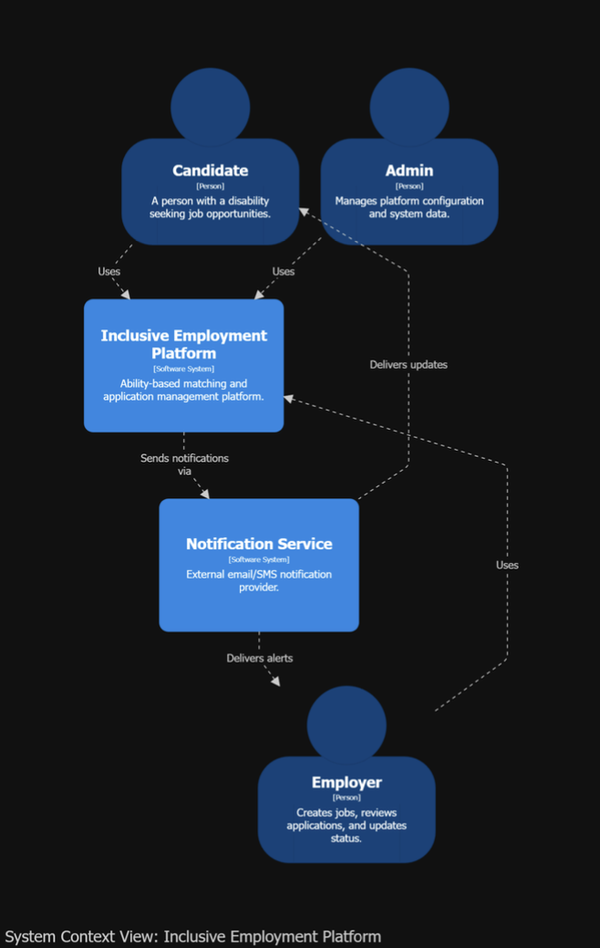
Figure 2: System context diagram (C4 Level 1)

The platform is used by candidates, employers, and administrators. Candidates create profiles, view compatible jobs, and apply. Employers post jobs, review applications, and update application status. Administrators manage platform data and configuration. The notification service delivers alerts and application updates to users.

Container Diagram (C4 - Level 2)

The container diagram shows the main technical blocks and their communication boundaries: the accessible React interface, authoritative Symfony API, PostgreSQL, deterministic Python scoring service, AI/voice service, private file storage, and notification delivery. The cache is a planned performance component and is not represented as already implemented.
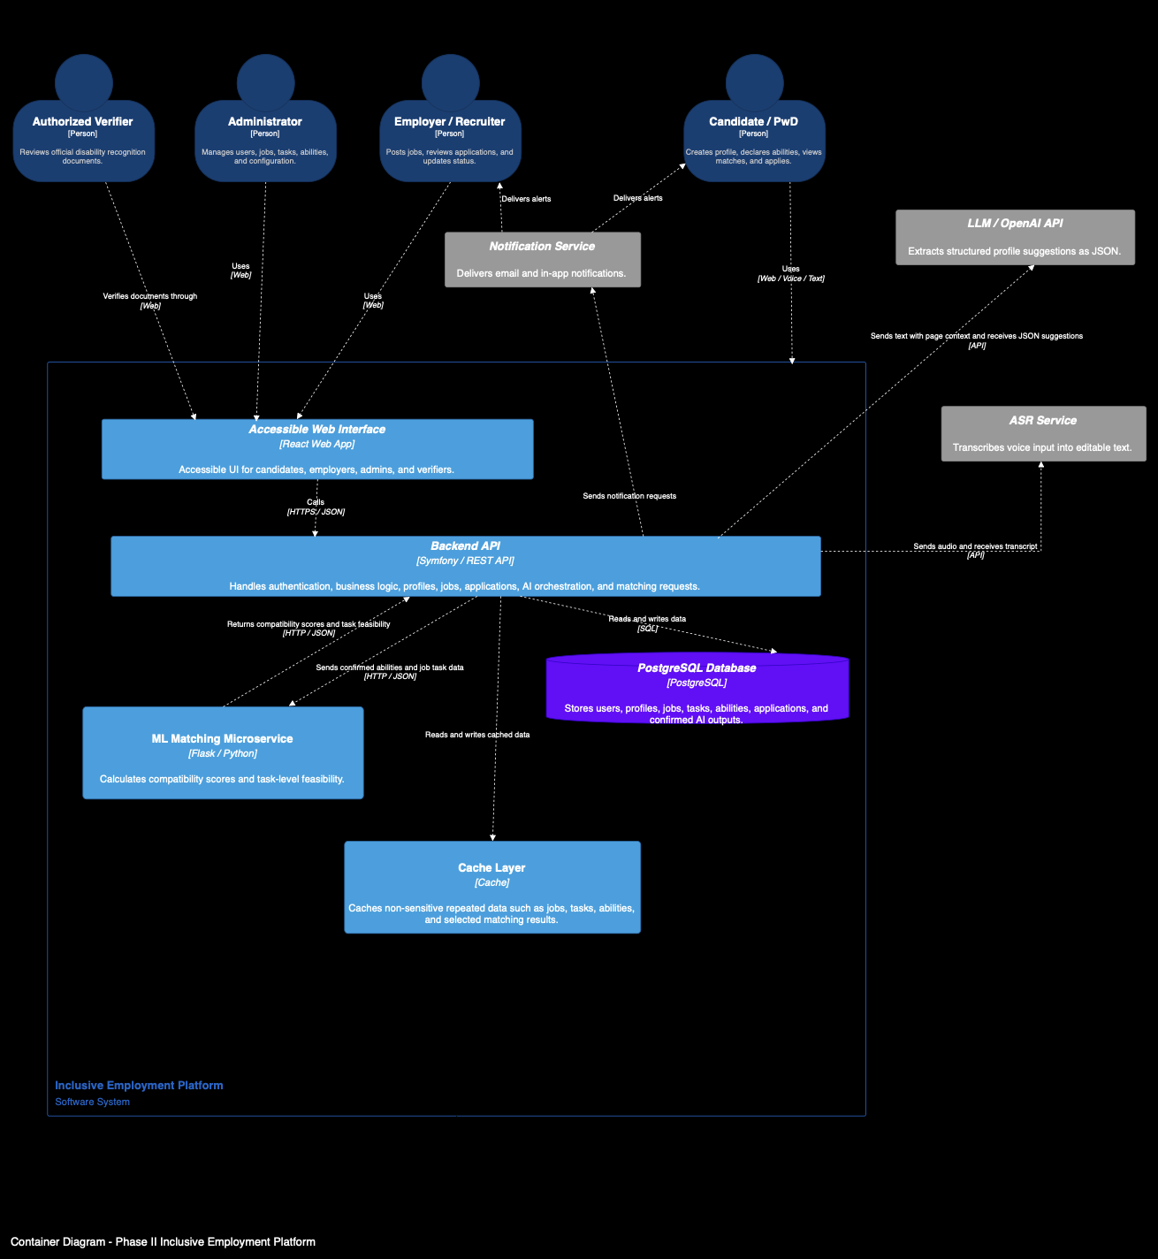
Figure 3: Container diagram (C4 Level 2)
The accessible web interface is used by PwD candidates, employers, administrators, and authorized verifiers. It communicates with the backend API through HTTPS/JSON requests. The backend API manages authentication, role-based access, profiles, jobs, applications, AI orchestration, matching requests, and verification workflows.
PostgreSQL stores confirmed records such as users, profiles, job definitions, tasks, assessments, applications, verification status, outcomes, consents, and audit metadata. The deterministic Python service receives authoritative candidate and offer data from Symfony and returns compatibility, eligibility, ranking, and task-level explanations. The planned cache will be limited to repeated non-sensitive catalogue data and will require explicit expiry and invalidation rules.
External services support the platform with additional features. The notification service delivers email and in-app alerts, the ASR service transcribes voice input into editable text, and the LLM/OpenAI API extracts structured profile suggestions from text using the current page context. These AI suggestions are not stored as final data before the candidate reviews and confirms them.
Conceptual Class Diagram

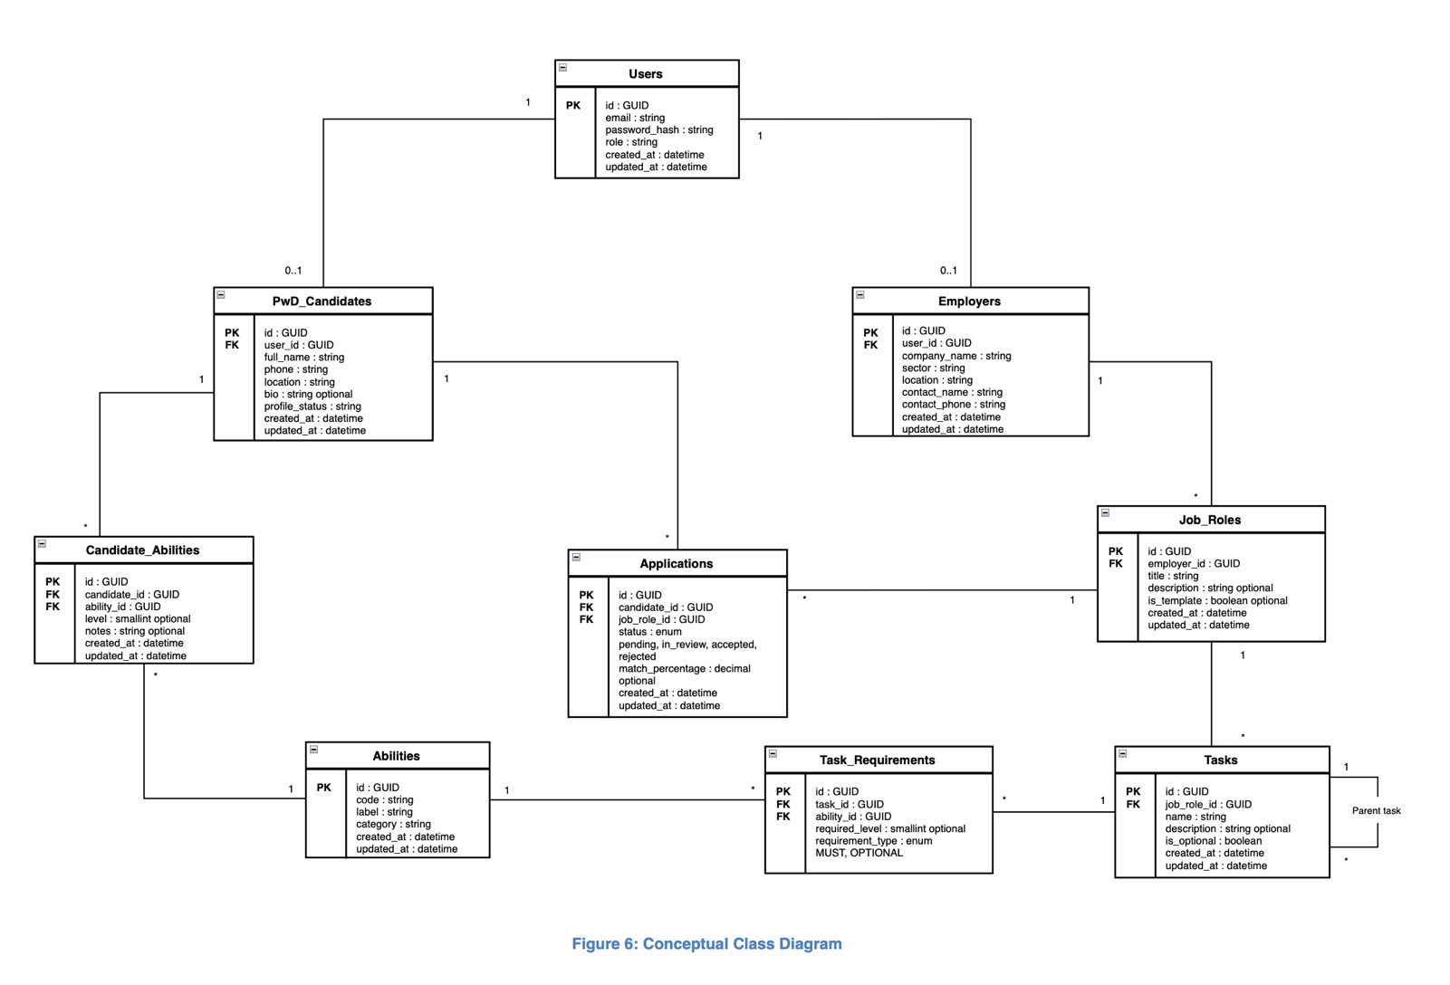
The conceptual class diagram presents the main entities used by the platform and the relationships between them. The Users entity stores account information and user roles. The PwD_Candidates and Employers entities store profile information for the two main public user types. PwD candidates can declare their abilities through Candidate_Abilities, apply to available Job_Roles, and receive a matching percentage for each application. Employers create job roles, and each job role is divided into tasks. Each task is connected to the abilities required to perform it through Task_Requirements. This structure supports the platform’s ability-based job matching process.

Figure 4: Conceptual class diagram

State Diagram
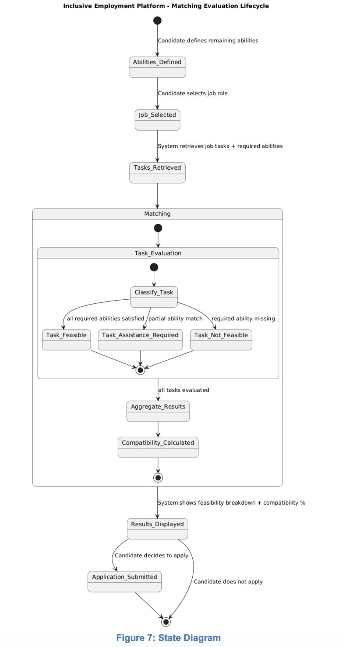
Figure 5: Matching-evaluation state diagram
The state diagram shows the lifecycle of the job matching evaluation process. After the PwD candidate defines their remaining abilities and selects a job role, the system retrieves the required tasks and abilities for that job. Each task is then evaluated and classified according to the candidate’s abilities. After all tasks are evaluated, the system aggregates the results, calculates the compatibility percentage, and displays the feasibility breakdown. Finally, the candidate can either submit an application or decide not to apply.

Solution Design
The previous section defined what the system should do through its functional and non-functional requirements, conceptual model, and behavioral diagrams. This section explains how the proposed Phase II Inclusive Employment Platform will satisfy these requirements through concrete design choices, architecture decisions, technologies, and processing workflows.
The solution is designed as an accessible, ability-based recruitment platform for PwD candidates and employers in the hospitality field. It supports candidate profile creation, disability recognition verification, multimodal input, AI-assisted profile extraction, ability-based job matching, application management, and notification delivery. The design follows a modular layered architecture in order to separate the user interface, backend logic, database, matching service, AI services, secure file handling, and external notifications.
The main design objective is to keep the platform simple enough to implement and maintain, while still supporting the new Phase II requirements such as accessibility, speech input, LLM-assisted NLP, human-in-the-loop confirmation, secure handling of sensitive files, and compatibility scoring.

Propose multiple solutions: Design alternatives and comparison
There is no single solution for designing the Phase II Inclusive Employment Platform. Several design alternatives were considered before selecting the final architecture. The comparison was done at both high level and low level in order to choose a solution that satisfies the functional requirements, respects the non-functional requirements, and remains realistic for implementation.
The platform must support several important features: user registration, role-based access, PwD candidate verification, candidate profile creation, ability declaration, job and task management, application tracking, multimodal input, AI-assisted extraction, matching calculation, notifications, and secure handling of sensitive data. At the same time, the solution must remain accessible, secure, maintainable, scalable, and easy to use for persons with disabilities.
The selected solution is a layered modular web architecture. It combines a React interface, Symfony API, PostgreSQL database, Python scoring service, private file storage, separate AI/voice processing, notifications, and a planned cache layer for repeated non-sensitive data.
This design was selected because it gives a balance between simplicity and modularity. The platform remains easier to implement than a full microservices architecture, but the most important components, such as the matching engine, ASR service, LLM-assisted extraction, and notification service, remain separated enough to be tested, replaced, or improved later.
A key design objective is to reduce digital barriers without making AI or voice mandatory. The complete manual profile form remains available. In the optional profile workflow, a candidate types or records English, French, or Arabic; recorded speech is transcribed into editable text; explicit consent is collected; and the AI service returns structured, reviewable profile suggestions. The workflow does not automatically populate registration or job-application fields.
However, the system does not save AI-generated information directly. The extracted content is first shown to the candidate as editable suggestions. The candidate must review, modify, confirm, or reject the information before submission. Only confirmed data is stored in the database. This supports the human-in-the-loop principle and prevents the system from storing incorrect or unconfirmed information.
Accessibility is a major design criterion. The interface supports keyboard operation, visible focus, persistent labels, responsive reflow, screen-reader-oriented semantics, error recovery, and status announcements across the principal workflows. These corrections target WCAG 2.1 Level AA, but the project does not claim conformance until the documented post-remediation browser, native 200% zoom, and assistive-technology tests are completed.
The service is designed to be simple and free for PwD candidates, making the platform easier to use and more inclusive. This design choice supports the project objective of helping persons with disabilities access employment opportunities without being blocked by complex digital forms or inaccessible recruitment procedures.

High level alternatives

At the global architecture level, three main alternatives were considered: a fully monolithic application, a full microservices architecture, and a layered modular architecture with external service integration.

Alternative 1: Fully Monolithic Web Application

In this approach, all functionalities would be implemented inside one single application. User management, candidate profiles, employer features, job management, matching logic, AI processing, notifications, and file handling would all be part of the same backend.
This solution would be simple to deploy and easier to understand at the beginning. It would also reduce communication overhead between components because everything would run in one application.
However, this approach is not flexible enough for Phase II. The deterministic scoring policy, speech transcription, AI extraction, notification delivery, and private-file lifecycle have different dependencies and change rates. If every concern were embedded in one backend, replacing the transcription provider or versioning the scoring policy would increase regression risk across unrelated workflows.
Therefore, a fully monolithic approach was not selected.

Alternative 2: Full Microservices Architecture

In this approach, the system would be divided into several independent services. For example, there could be a separate authentication service, profile service, job service, matching service, AI service, notification service, and file storage service.
This architecture provides strong modularity and scalability. Each service can be deployed and updated independently. It is useful for large-scale systems with many users and high traffic.
However, this option adds significant complexity. It requires service discovery, API gateways, monitoring, inter-service security, deployment orchestration, and more advanced infrastructure. For an FYP prototype, this complexity is not justified. The expected system size and workload do not require a full microservices architecture at this stage.
Therefore, this option was considered too complex for the current project scope.

Alternative 3: Layered Modular Architecture with External Service Integration— Chosen Approach
The selected approach is a layered modular architecture. The system is divided into clear layers and components:
Presentation Layer: React/Vite Web Interface
Application Layer: Symfony Backend API
Persistence Layer: PostgreSQL Database
Matching Layer: Python Deterministic Scoring Service
Support Layer: Private File Storage and Planned Cache
External Services: ASR, LLM API, Notification Service
The React frontend provides an accessible interface for PwD candidates, employers, administrators, and authorized verifiers. The Symfony backend API manages registration, authentication, role authorization, profiles, jobs, applications, verification, AI orchestration, and service integration. PostgreSQL stores confirmed persistent data, and the Python scoring service calculates deterministic compatibility results. Protected files use private storage. A cache will be added later for measured repeated non-sensitive reads, with expiry and invalidation rules.
External services are used only where they add clear value. ASR supports voice-to-text conversion, the LLM helps extract structured information from natural language, and the notification service sends alerts to users.
This architecture was selected because it is modular without being unnecessarily complex. It supports the Phase II requirements while remaining realistic for implementation.
Table 1: High-level architecture alternatives comparison
Criterion | Monolithic Application | Full Microservices | Chosen Layered Modular Architecture
Implementation complexity | Low | High | Medium
Maintainability | Medium | High | High
Scalability | Limited | Very high | Good
AI and scoring integration | Tightly coupled | Fully separated | Modular and manageable
Security management | Simple but centralized | Complex | Controlled and modular
Future extensibility | Limited | Very high | Good
Operational overhead | Low | Very high | Medium and proportionate to prototype scope
Component testability | Limited isolation | Strong isolation | Strong boundaries for scoring and AI/voice
Accessibility delivery fit | Shared interface possible | Shared interface may fragment across teams | One accessible React design system across all roles
Sensitive-data separation | Centralized in one application | Flexible but operationally complex | Explicit RBAC and private-storage boundary
FYP feasibility | Fast initially but difficult to extend safely | Low within the available time and infrastructure | High: implemented incrementally with clear future paths
The chosen architecture provides the best compromise between simplicity, modularity, accessibility, security, and future extensibility.

Applied architecture example
For example, replacing the speech-transcription provider affects the AI/voice adapter and configuration, while the Symfony authorization rules, PostgreSQL schema, and deterministic scoring formula remain unchanged. If the AI/voice service is unavailable, the candidate can continue with manual profile entry. The evaluation in Table 1 is illustrated by the independently running services in Figure 6.
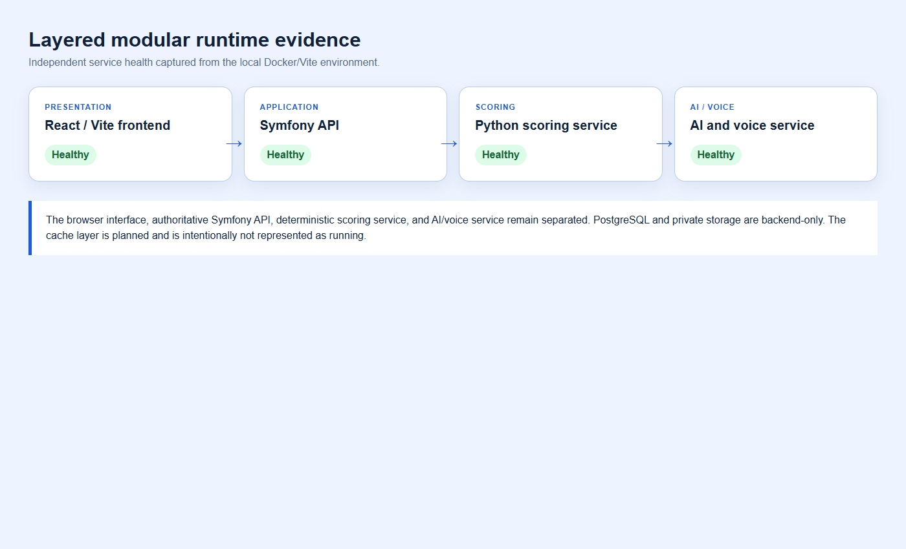
Figure 6: Layered modular runtime service boundaries and health evidence

Low level alternatives

At the component level, several design choices were also analyzed. These choices concern authentication, PwD candidate verification, multimodal input, AI-assisted NLP, matching logic, temporary storage, and caching.

A. Authentication and Role Management
The selected authentication approach is based on email and password authentication managed by the Symfony backend. Each user account is assigned a unique internal identifier, and the role field defines the type of account, such as PwD candidate, employer, administrator, or authorized verifier.
Public registration is limited to two roles: PwD candidates and employers. Administrator and authorized verifier accounts are not created through the public website; they are created and managed internally by the platform owner. This prevents unauthorized users from accessing sensitive administrative or verification functions.
Role-based access control is applied by the backend to protect platform features and data. For example, PwD candidates can complete their profile and apply to jobs, employers can manage job roles and applications, administrators can manage platform data, and authorized verifiers can update candidate verification status. This design keeps authentication simple, controlled, and aligned with the privacy and security requirements of the platform.

B. PwD Candidate Verification

Two alternatives were considered for verifying PwD candidates.
The first option was to store the uploaded disability card permanently in the system. This would allow the document to be reviewed later, but it would increase privacy and security risks because disability recognition documents are sensitive.
The chosen option is authorized human verification with private, time-limited document storage. The candidate uploads a required disability card with explicit consent. The request remains pending until an authorized verifier approves or rejects it, and sign-in remains blocked until both email verification and document approval pass. The source file is scheduled for deletion 30 days after the decision; the verification status, reviewer, note, and audit events remain.
This choice reduces privacy risks and follows the principle of data minimization.
Applied verification example: a candidate submits a valid PDF and verifies the email address, but the account still cannot sign in while the review status is pending. Approval by an authorized verifier opens access; rejection keeps access blocked and requires a reason. The required upload and purpose-specific consent are shown in Figure 7.
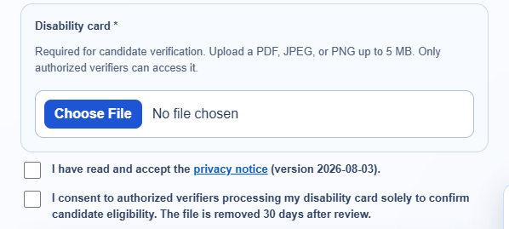
Figure 7: Candidate disability-card requirement and verification consent
C. Candidate Input Method
Three alternatives were considered for candidate profile completion.
The first option was manual form completion only. This is easy to implement but may create barriers for PwD candidates who have difficulty typing, navigating long forms, or using standard digital interfaces.
The second option was voice input only. This improves accessibility for some users, but it excludes users who prefer text or cannot use voice comfortably.
The chosen option is multimodal profile input with a complete manual fallback. The candidate can type directly or explicitly activate the microphone. The browser sends bounded audio to the AI/voice service, which returns an English, French, or Arabic transcript. The transcript remains editable and is not analysed until the candidate grants the required AI consent. This approach supports accessibility while keeping the user in control.

D. AI-Assisted NLP Workflow
Two alternatives were considered for extracting useful candidate information from text.
The first option was a rule-based NLP system. It would detect information using predefined keywords and patterns. This approach is easier to control, but it is limited when users speak naturally, use mixed languages, or describe their abilities in different ways.
The chosen option is LLM-assisted NLP within the candidate profile workflow. After voice input is transcribed—or after the candidate types directly—the editable English, Arabic, or French text is analysed only after explicit consent. The protected service returns suggestions mapped to the current profile schema and controlled catalogues; it does not populate registration or application fields automatically.
The LLM returns a structured JSON output, for example:
{ "personalInformation": { "location": "Beirut" }, "educationLevel": "...", "disabilities": [], "skills": [], "preferences": [], "assistanceNeeds": [], "taskSkills": [], "unmatchedStatements": [] }
The structured JSON is displayed as editable suggestions rather than being applied automatically. Every suggestion starts unselected. The candidate chooses which items to confirm, and Symfony validates selected values against field limits and active catalogues before persistence. This keeps AI advisory and prevents unconfirmed sensitive information from becoming profile fact.

E. Matching Approach
Three matching alternatives were considered.
The first option was keyword-based matching between candidate profiles and job descriptions. This would be simple but not accurate enough because it does not evaluate the real tasks required by each job.
The second option was a fully automated ML decision system that directly decides if a candidate is suitable for a job. This could be powerful, but it would be less transparent and harder to justify ethically.
The chosen option is deterministic task-level ability-based matching. Each job is decomposed into weighted tasks with explicit feasibility assessments. The service compares confirmed candidate inputs with these task requirements, applies the approved mathematical policy, and returns the overall score and explainable task-level breakdown. It does not make the final recruitment decision.
This approach is transparent because the candidate receives the eligibility result, compatibility percentage, absolute compatibility band, and task-level explanations. The score represents compatibility with the configured vacancy under the documented policy; it is not an official disability percentage, employment decision, or guarantee of suitability.
Applied matching example: Figure 8 shows an employer selecting Write, Read, and Count as important tasks, so each uses adjusted weight 1.5 instead of the default 1.0. The imported assessments then control feasibility: column F/feasible uses factor 1.00; column G/needs assistance uses factor 0.75 only when the employer offers task assistance, otherwise it becomes effective avoid and earns zero; column H/avoid uses factor 0.00 even when assistance is offered. A mandatory effective avoid excludes the offer, while an optional avoid remains in the denominator and earns zero. The source mapping is shown in Figure 11.
A blank or unchecked workbook cell is not an avoid value and is not imported as an assessment. If a genuine candidate-disability/task pair has no recorded assessment at runtime, the centralized inclusion-first policy treats it as feasible and flags the assumption for review. For multiple disabilities, assessments are not averaged: the most restrictive recorded result controls the task.
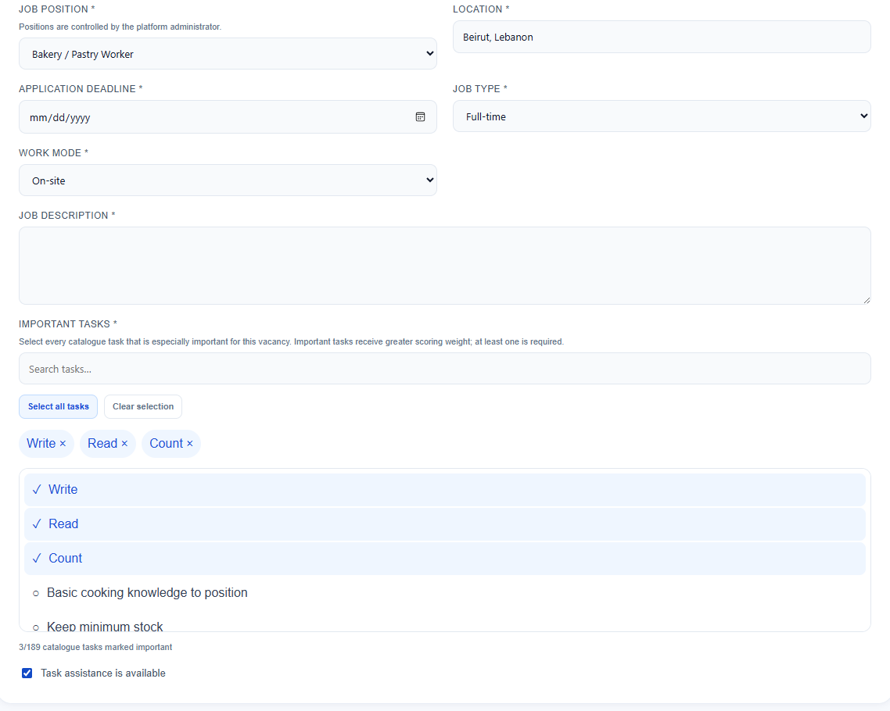
Figure 8: Employer task-importance and assistance configuration
F. Storage of Voice, AI Suggestions, and Uploaded Documents
Two alternatives were considered for temporary data.
The first option was to store raw voice recordings, transcripts, AI suggestions, and uploaded documents in the database. This would make tracking easier, but it would store unconfirmed and sensitive information, which creates privacy risks.
The chosen storage boundary separates structured records from private files and transient AI data. PostgreSQL stores confirmed structured records and audit metadata. Profile audio remains in browser memory only long enough for transcription; unconfirmed suggestions remain transient; and disability cards or optional application documents use authenticated private storage with MIME/size validation, no-store responses, auditing, retention, and deletion controls.
This design supports privacy, security, and the human-in-the-loop principle.
Applied privacy example: candidate export returns the structured account data rather than raw disability-card bytes. Withdrawing AI consent prevents future AI analysis without deleting already confirmed profile facts. Password-confirmed account deletion removes the account and associated private application/verification documents. These user controls are shown in Figure 9.
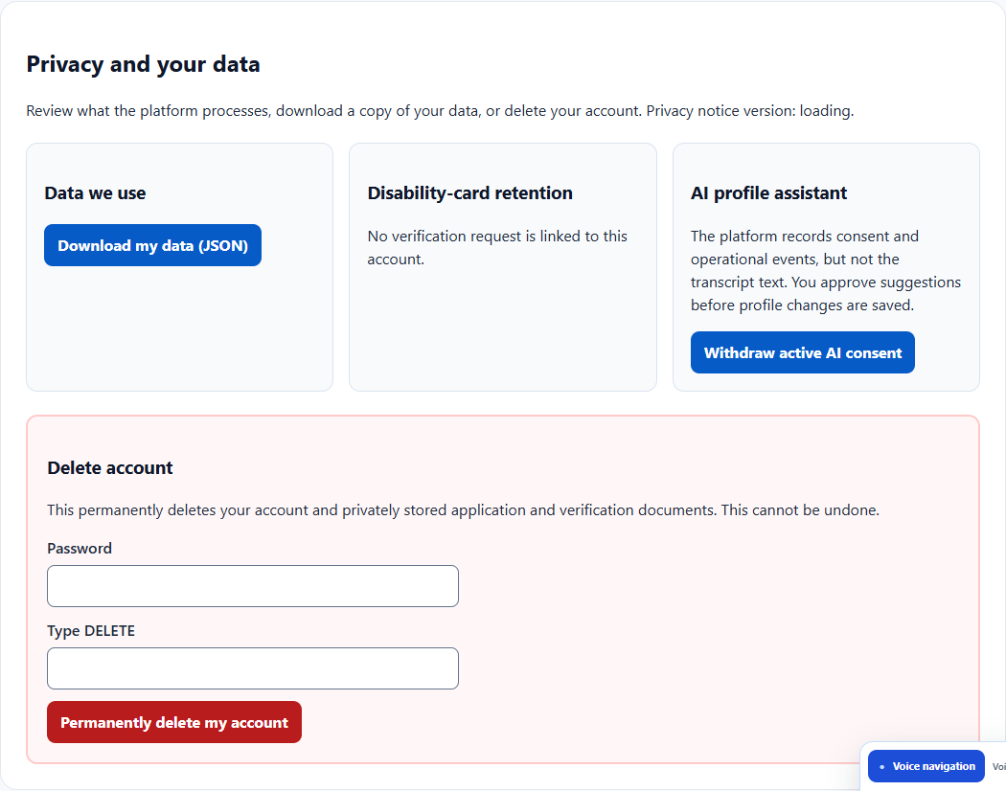
Figure 9: Candidate data-access, consent, retention, and erasure controls
G. Cache Layer
Two alternatives were considered for performance.
The first option was to avoid caching and always query the database or external services. This is simpler but less efficient when the same non-sensitive data is requested many times.
The selected future optimization is a cache layer for repeated non-sensitive data such as published jobs, tasks, and controlled vocabularies. It has not yet been implemented because the local performance baseline is within budget. The later implementation will be justified with deployed measurements and will define keys, expiry, invalidation, authorization boundaries, and failure fallback before caching is enabled.
This staged choice avoids premature complexity while retaining a clear path to improve deployed performance without caching disability documents, transcripts, unconfirmed AI output, tokens, or private candidate records.
Planned cache example: a key such as catalogue:job-definition:{id}:v{version} may store only published tasks and controlled vocabulary. An administrator catalogue import or job-definition update must invalidate the related version. Short TTL, cache-miss fallback to PostgreSQL, metrics, and failure isolation are required. Tokens, disability cards, transcripts, unconfirmed AI output, private candidate profiles, and authorization decisions must never use this cache.

H. Administrator-Controlled Catalogue Workbook Import
New occupational catalogues must be added without editing application code, rerunning fixtures, or deleting live users, profiles, vacancies, and applications. Three approaches were evaluated: developer-only fixture regeneration, an unrestricted generic spreadsheet importer, and a template-specific administrator workflow. Fixture regeneration is deterministic but unsuitable for normal operation. An unrestricted importer is flexible but cannot safely infer arbitrary workbook meaning. The selected boundary is therefore an administrator-only, validated .xlsx importer for the agreed occupational workbook structure.
1. Upload and access control. The Admin dashboard accepts one or more .xlsx files through Add data sheets. Symfony verifies the JWT and ROLE_ADMIN or ROLE_SUPER_ADMIN on the server, requires at least one workbook, enforces a 10 MB per-file limit, rejects duplicate filenames in the same request, copies uploads to a private 0700 temporary directory, and invokes the trusted Python extractor with a Process argument array and a 60-second timeout. Temporary copies are deleted in a finally block. The interface exposes progress and accessible success/error feedback. Figure 10 shows the control and a non-persistent test response used only to demonstrate the feedback state.
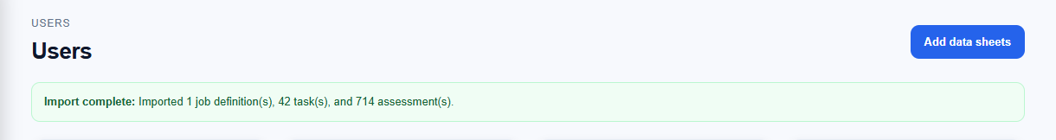
Figure 10: Administrator catalogue upload control and accessible result feedback
2. Workbook identification. The extractor opens the OOXML workbook with OpenPyXL in data-only mode. Worksheets after the first are treated as disability/task matrices only when their normalized title matches the controlled disability-sheet map; an unknown sheet produces a warning and is skipped. The three supplied filenames have reviewed job-name overrides. For a future supported filename, the extractor attempts to infer the English position name from column C around rows 19 to 35 and derives a normalized job slug.
3. Task and assessment extraction. For each recognized disability sheet, rows are scanned from row 19 to the last used row. The current canonical task name is the trimmed English value in column C. Column B contains French labels and column D contains Arabic labels in the supplied workbooks, but those two source-language labels are not yet persisted by the importer. A row becomes an assessment only when it contains both a task name and a marker: F means feasible, G means needs_assistance, and H means avoid. If markers overlap, the most restrictive precedence H, then G, then F is applied. Blank, title, duplicate-layout, and unmarked rows are skipped rather than converted to avoid. Figure 11 records the verified field mapping.
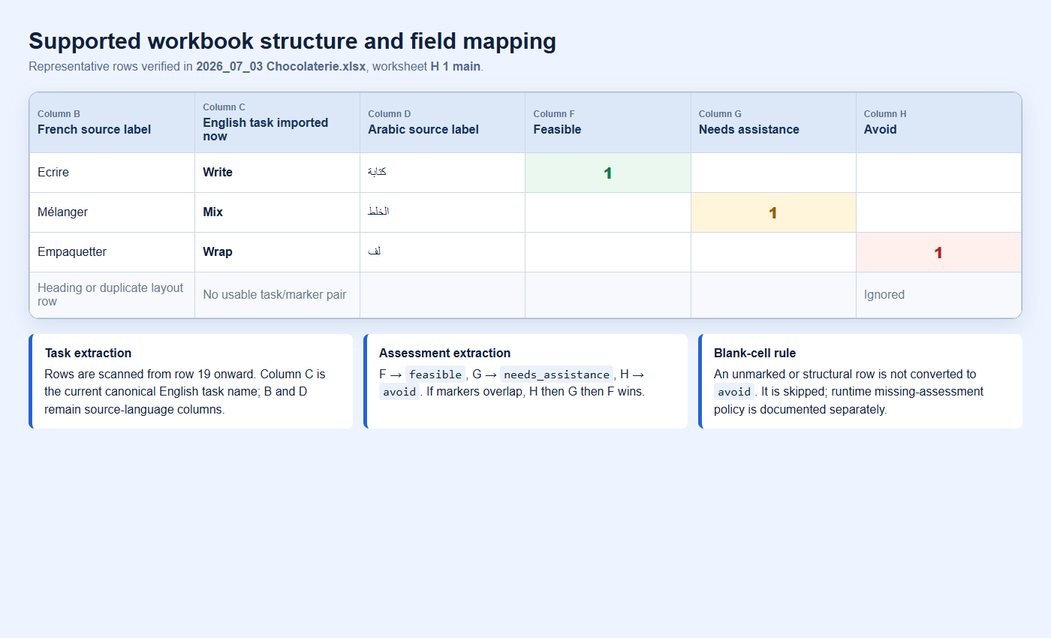
Figure 11: Supported occupational-workbook columns and feasibility mapping
4. Normalization and traceability. Whitespace is normalized and each task receives a stable slug-like key. Repeated wording is preserved with an occurrence suffix so legitimate duplicate task rows can remain aligned across disability sheets. Every assessment retains its source worksheet and source row. The extractor returns schema-versioned JSON containing disabilities, job definitions, ordered tasks, assessments, completeness metadata, and warnings. Unknown feasibility values never reach the entity because the domain model accepts only feasible, needs_assistance, or avoid.
5. Transactional database application. Before writing, Symfony rejects any job whose slug or name already exists. One Doctrine transaction then creates any mapped disabilities not already present, the active job definition, its tasks, and its disability/task assessments. Imported definitions currently default to minimum education none; tasks default to weight 1.0 and mandatory false so later policy changes are explicit. Any exception rolls back the batch. This workflow never invokes fixtures and never purges existing business data.
6. Runtime application and worked score example. After a successful commit, the new active job definition and task list are available to the employer posting form. The employer selects which imported tasks are important and declares whether task assistance is available. Symfony retrieves the same persisted tasks and disability assessments for candidate matching and passes normalized input to the deterministic Python engine. For an important task with base weight 1.0, adjusted weight is 1.5. A feasible task earns 1.5 points; a needs-assistance task earns 1.5 Ã— 0.75 = 1.125 points when assistance is offered and zero otherwise; an avoid task earns zero and cannot be rescued by the generic assistance flag. The final compatibility percentage is earned adjusted weight divided by maximum adjusted weight, provided all eligibility gates pass.
7. Current limitations and production hardening. The importer is intentionally template-specific: disability worksheet names must be mapped, column C is the current canonical language, and repeated task occurrences must remain structurally consistent across sheets. Imported definitions become active immediately; a preview, expert validation, and publish step remain desirable. Production hardening should add MIME/OOXML signature checks, compressed-archive and worksheet-size limits, malware scanning, importer integration tests with rollback evidence, and localized task-label persistence. These are recorded limitations, not completed controls.

Solution modeling
In this section, the modeling of the selected solution is presented. After comparing the possible design alternatives, the chosen solution is described in more detail in order to prepare for the implementation phase. The following diagrams and flowcharts explain how the main components of the Phase II Inclusive Employment Platform interact internally and how they support the functional and non-functional requirements defined previously.
The solution model reflects the implemented modular structure: accessible React interface, Symfony API and data-access layer, PostgreSQL, Python scoring service, AI/voice service, email notifications, and private file storage. Caching remains a deferred optimization and is not shown as completed implementation evidence.
The accessible web interface supports keyboard navigation throughout public, candidate, employer, verifier, and administrator workflows. It includes a skip link, visible focus, logical focus movement, responsive controls, accessible form labels, dialog focus trapping and restoration, Left/Right arrow navigation where safe, and screen-reader-compatible outcome messages.
The implementation remains iterative: accessibility retests, representative-user feedback, deployment measurements, and new validated datasets may require controlled refinements. Current limitations and pending evidence are explicitly recorded instead of being presented as completed compliance.

Component Diagram
The component diagram shows the internal structure of the Phase II Inclusive Employment Platform. The accessible React web interface communicates with the backend API, which contains the main components for authentication, profile management, job and task management, ability catalog management, matching, applications, notifications, AI input processing, and data access.
The AI profile assistant manages an optional text/voice workflow. Voice is converted into an editable transcript, explicit consent is collected, and the internal extraction service returns structured profile suggestions. Suggestions remain unsaved until the candidate selects and confirms them. Page-aware action allowlists are used by the separate voice-navigation control.
The matching service compares confirmed candidate information with published job-task requirements and returns an explainable compatibility result. PostgreSQL stores confirmed platform data. Disability cards and application documents use authenticated private storage outside the public web root; audio is kept in browser memory for transcription and is not retained by the application. A cache layer remains part of the planned architecture and will be implemented later for measured, repeated non-sensitive reads with explicit expiry and invalidation rules.
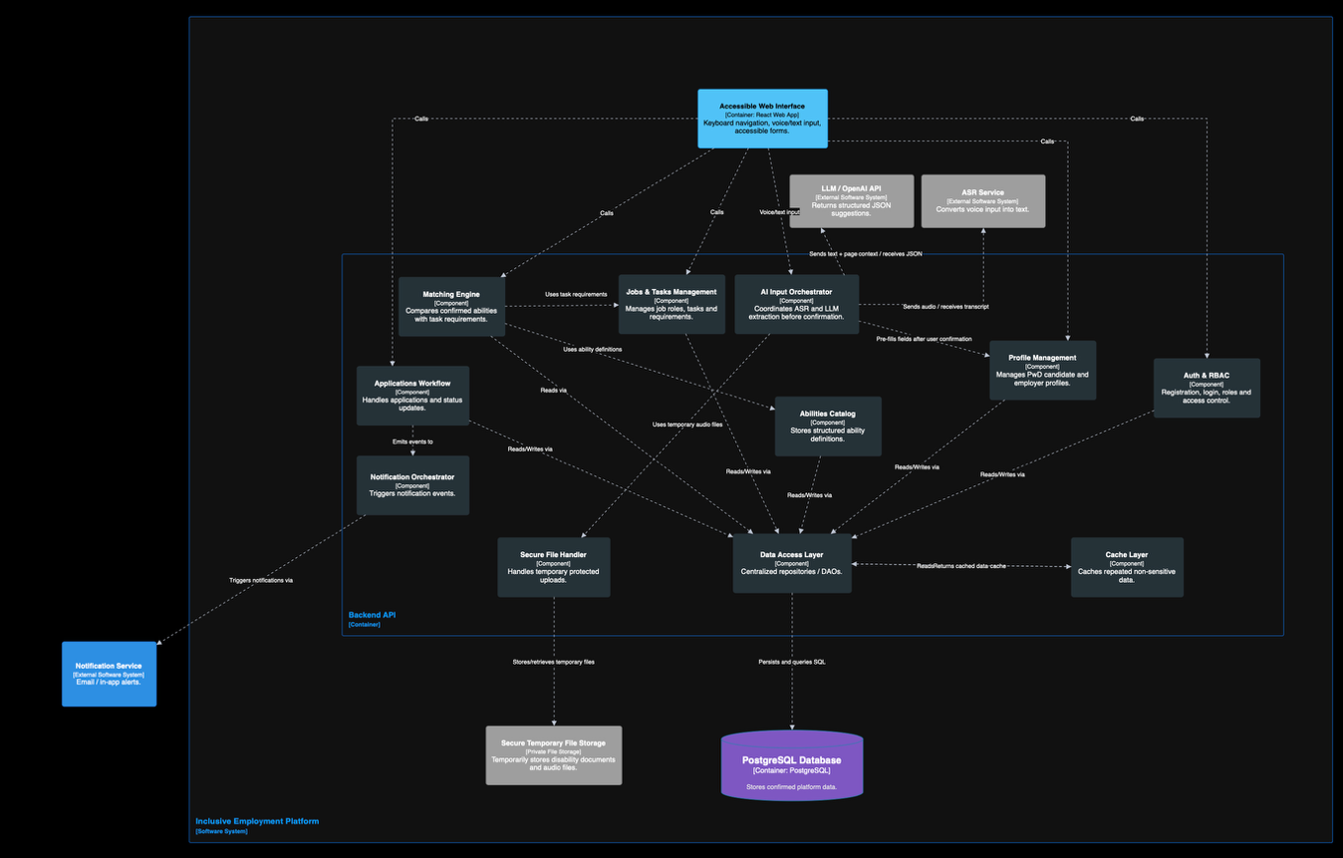
Figure 12: Component diagram

Required resources

Software Resources
The proposed solution is based on a web application stack composed of a React frontend, a Symfony/PHP backend API, a PostgreSQL relational database, and a Python/Flask matching microservice. The frontend communicates with the backend through HTTPS/JSON requests, while file uploads such as voice recordings or disability recognition documents are sent using secure multipart requests.
The backend exposes REST API endpoints and manages authentication, role-based access control, profile management, job and task management, applications, notifications, AI orchestration, and communication with the matching service. Stateless authentication can be implemented using JWT, while user roles are used to separate access between PwD candidates, employers, administrators, and authorized verifiers.
The frontend is responsible for the accessible user interface. It supports responsive pages, client-side validation, keyboard navigation, visible focus indicators, accessible forms, and role-based routing. It also supports multimodal input by allowing PwD candidates to complete certain forms using text or voice.
For AI-assisted input, an ASR service such as Whisper can be used to convert voice recordings into text. The transcribed text can then be sent to an LLM/OpenAI API to extract structured JSON suggestions. These suggestions are only saved after candidate confirmation.
For notifications, the platform can use in-app alerts and email notifications through Symfony Mailer, Mailtrap for testing, or SendGrid/SMTP for real-world delivery. A cache layer such as Symfony Cache or Redis can be used to store repeated non-sensitive data, such as job roles, tasks, abilities, and selected matching results.
Secure temporary file storage is required for protected uploads such as disability recognition documents and voice recordings during processing. These files should be stored outside public folders and deleted after verification or transcription when possible.

Hardware Resources
The core development can be carried out on standard laptops or PCs with at least 8 GB RAM, preferably 16 GB RAM when running Docker containers, the backend, frontend, PostgreSQL database, and matching service simultaneously.
Docker and Docker Compose provide the local development environment. Deployment and testing require a local or cloud host for the React production build, Symfony API, PostgreSQL database, Python scoring service, AI/voice service, notifications, and private file storage. The planned cache service can be added after deployed measurements establish its sizing, invalidation, and security requirements.

Implementation Progress and Verification
This progress report records the implemented Phase II baseline as of 10 August 2026. The work has advanced beyond preliminary analysis into an integrated prototype with executable backend, frontend, database, scoring, AI/voice, verification, privacy, accessibility, and testing workflows. Evidence is linked to the zm branch so that each claim can be reviewed against source code, technical documentation, and machine-readable results.

Implemented System Baseline
The platform uses a React/Vite frontend, Symfony API, PostgreSQL database, Python scoring service, and a separate AI/voice service. Docker Compose provides the local integration environment. The current codebase contains dedicated candidate, employer, verifier, and administrator experiences protected by server-validated role authorization.
Candidate registration now has two independent eligibility gates: email ownership verification and authorized review of a mandatory disability card. Sensitive files are stored privately outside the public web root, opened only through authenticated endpoints, audited on access, and scheduled for deletion after the documented retention period.

Engineering Alternatives and Decision Rationale
The project decisions were evaluated against accessibility, explainability, privacy, security, implementation effort, maintainability, testability, expected prototype load, and future extensibility. The selected design is not presented as universally best; it is the best fit for the current FYP scope and records the conditions under which it should evolve.

Table 2: Engineering design-decision matrix
Decision | Alternatives compared | Selected solution and rationale | Trade-off / follow-up
System architecture | Single monolith; full microservices; layered modular system | Layered modular system: simpler to deliver than full microservices while keeping scoring and AI/voice replaceable and independently testable. | Some services still share deployment; add operational separation only when scale justifies it.
Matching method | Keyword matching; opaque ML decision; deterministic task-level scoring | Deterministic task-level scoring: preserves the approved mathematics, exposes feasibility and weights, and is easier to audit ethically. | Future learned models require consented outcome data, versioning, evaluation, and stakeholder approval.
Candidate input | Manual only; voice only; multimodal | Manual form plus editable English, Arabic, or French typed/voice transcript: expands access without excluding users or making AI mandatory. | Formally evaluate Lebanese Arabic, code-switching, and assistive-technology interaction.
AI control | Automatic persistence; rule-based extraction; LLM suggestions with review | Consent-gated LLM suggestions with human confirmation: handles natural language while preventing unreviewed sensitive data from becoming fact. | External-service cost, latency, and extraction accuracy remain measurable risks; manual entry is the fallback.
Sensitive documents | Public uploads; database blobs; authenticated private storage | Private storage outside  the web root with MIME/size checks, random names, auditing, no-store responses, and retention deletion. | Production backups, encryption/key management, legal retention, and incident response require operational policy.
Caching | No cache; immediate cache; measurement-driven staged cache | Planned measurement-driven cache for repeated non-sensitive catalogue reads, preserving a simple and correct baseline first. | Implement later with Redis or an equivalent only after deployed profiling; define TTL, invalidation, authorization, privacy exclusions, and fallback.
Accessibility verification | Informal UI review; automated-only scan; automated plus manual evidence | WCAG 2.1 AA-targeted engineering with automated scans, keyboard/reflow tests, and a required manual screen-reader/zoom retest. | No conformance claim until all pending rendered and assistive-technology evidence passes.

AI-Assisted Profile-Building Workflow
Candidates may keep using the complete manual profile form or provide an editable typed or spoken description. Speech transcription supports English, French, and Arabic selection. Audio is transcribed and discarded by the application. The transcript can be corrected before the candidate gives explicit consent for AI analysis.
The assistant returns structured suggestions with evidence and confidence. Every suggestion starts unselected and remains editable. Only explicitly selected values are sent to a confirmation endpoint, revalidated against active database catalogues, and persisted. This human-in-the-loop boundary prevents automatic diagnosis and preserves the approved scoring input contract.
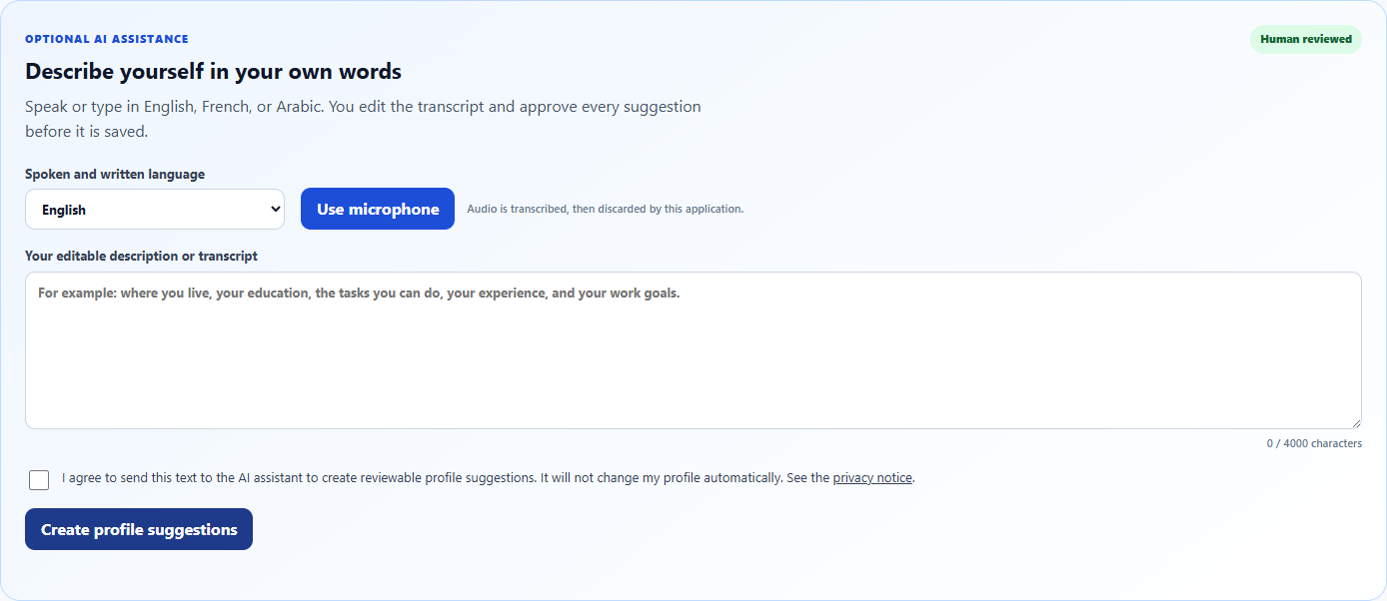
Figure 13: Candidate AI-assisted profile-building workflow
Evidence: AI profile workflow documentation

Accessibility and Responsive Engineering
The public pages and all four role experiences were reviewed for responsive reflow, keyboard operation, focus order, semantic structure, accessible names, validation, contrast, reduced motion, dialogs, tables, filters, tabs, file controls, and live status messages. Left and Right Arrow provide requested focus navigation where this does not interfere with text fields or native widgets; Tab and Shift+Tab remain standard controls.
The remediation is substantial, but it is not represented as proof of complete WCAG 2.1 Level AA conformance. The final audit still requires a live post-remediation axe run, native 200% zoom, representative mobile and landscape tests, and manual NVDA/browser checks across authenticated workflows.
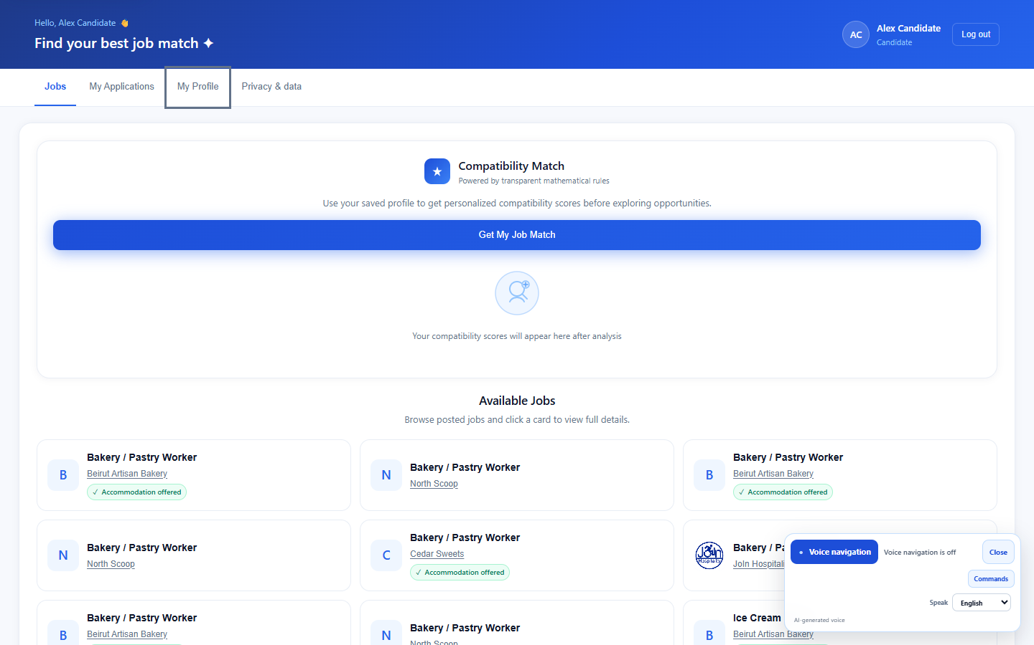
Figure 14: Keyboard/voice navigation and accessible notifications
Evidence: WCAG 2.1 AA audit report

Security, Verification, and Privacy
Backend firewalls protect role-prefixed APIs before controller execution, and the frontend confirms the active role through the protected session endpoint rather than trusting local token claims. Anonymous, forged-token, and cross-role access are rejected. Candidate verification decisions, document access, consent events, and application outcomes are auditable.
The candidate privacy dashboard explains stored data categories and consent history and supports structured export, AI-consent withdrawal, and password-confirmed account deletion. Technical safeguards support privacy principles but do not replace organizational legal review, incident response, backup-erasure rules, or production secret management.
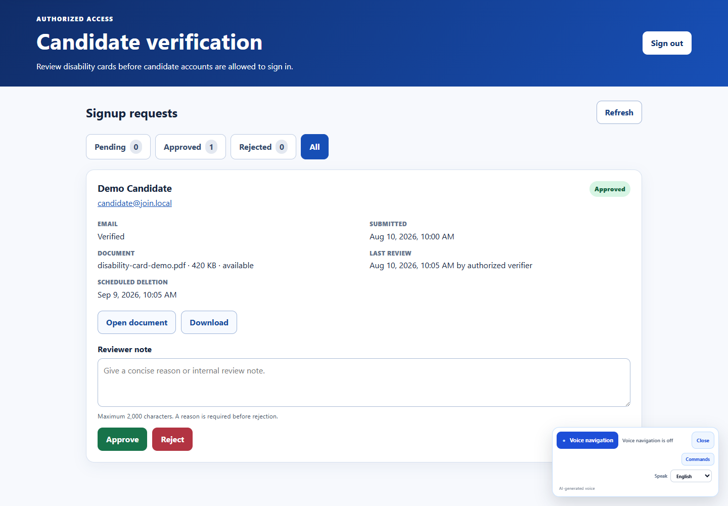
Figure 15: Authorized candidate-verification dashboard
Evidence: candidate verification documentation
Related evidence: authorization security documentation
Related evidence: privacy controls documentation

Catalogue and Scoring Policy
The current controlled catalogue contains three supplied job definitions: Chocolate/Confectionery Worker, Ice Cream Maker, and Bakery/Pastry Worker. Together they contain 362 tasks, 16 disability categories, and 5,477 recorded assessments. Unchecked source cells are treated as headings, duplicates, structural cells, or unassessed cells according to the documented source-cell policy; they are not fabricated as negative assessments.
The mathematical scoring engine was intentionally preserved. Matching uses confirmed education, confirmed disability selection, published job tasks and weights, mandatory/highlighted status, feasibility assessments, and assistance availability. AI profile task-skill suggestions are stored for profile enrichment but are not introduced into scoring without a separate reviewed scoring version.

Integration, E2E, and Performance Evidence
The repeatable verification suite passed 17 of 17 API integration checks and 19 of 19 browser E2E checks. The existing voice-navigation suite passed 49 of 49 tests and the scoring suite passed 11 of 11 tests. The production frontend build and ESLint completed without errors or warnings.
Local production-build performance measurements passed all configured budgets with zero violations. Recorded p95 API latency was 205.1 ms for public jobs, 163.2 ms for public job definitions, 86.7 ms for the candidate session, and 244.8 ms for the candidate profile. Recorded page load/FCP values were 102.6/448 ms for Welcome, 95.3/184 ms for Sign In, and 103/552 ms for Candidate. JavaScript and CSS gzip sizes were 130,428 and 13,579 bytes. These values are a development-machine regression baseline, not a production capacity claim.
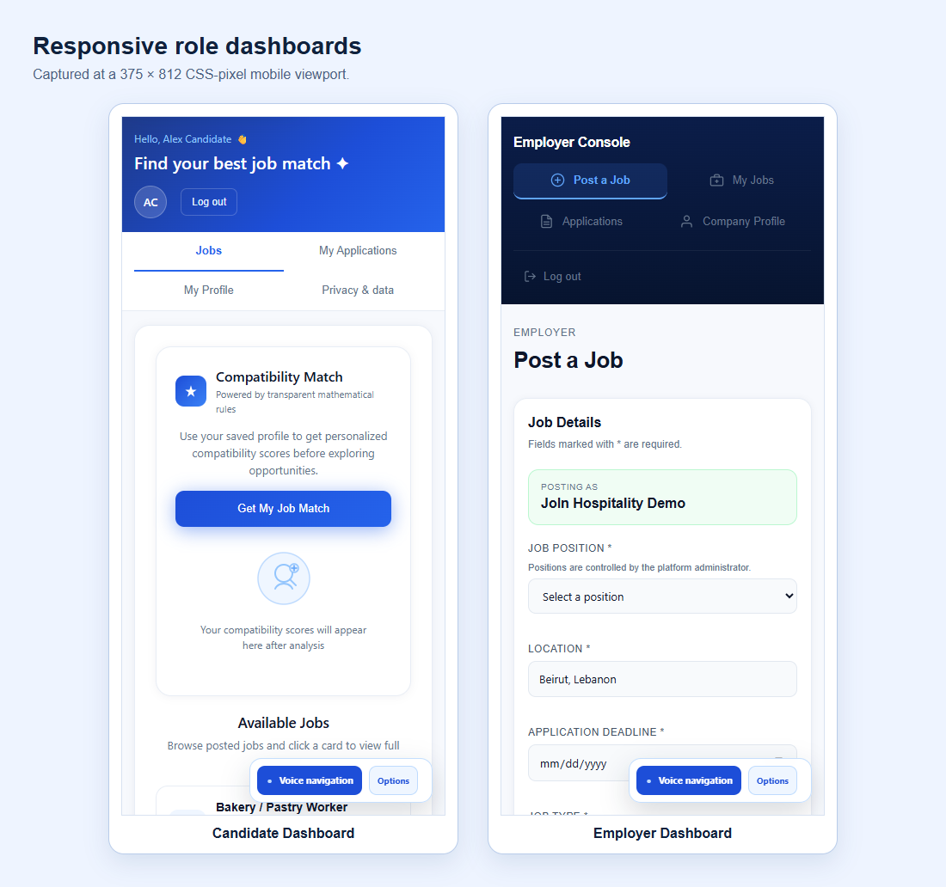
Figure 16: Responsive role dashboards
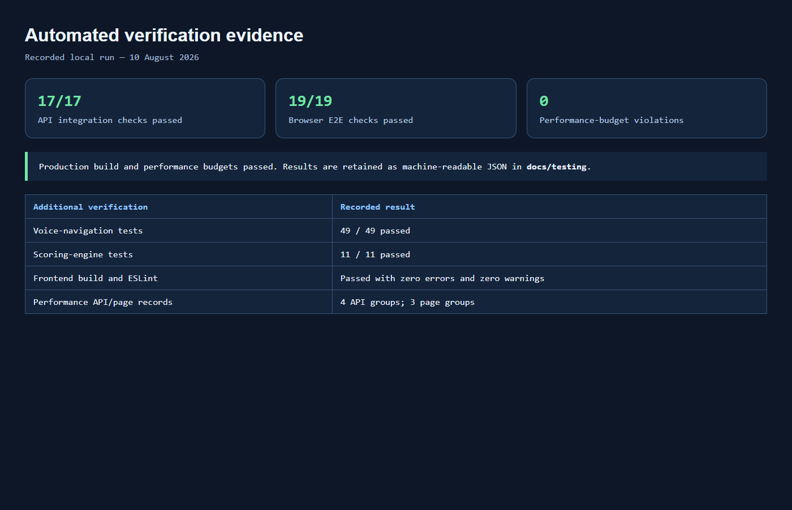
Figure 17: Integration, E2E, and performance evidence
Evidence: integration, E2E, and performance report
Machine-readable evidence: performance results

Requirements Traceability

Table 3: Requirements progress and verification matrix
Requirement area | Status | Implemented evidence | Remaining work
Authentication and RBAC | Implemented | Server-validated JWT sessions; explicit candidate, employer, verifier, and administrator route boundaries; anonymous, forged-token, and wrong-role checks. | Repeat security audit in the production deployment.
Candidate eligibility verification | Implemented | Mandatory disability-card upload and consent; email verification; authorized review; protected document access; approval/rejection audit. | Confirm institutional verifier policy and production retention schedule.
Candidate profile and AI assistance | Implemented | Manual form plus editable English/French/Arabic transcript; consent; reviewable unsaved suggestions; controlled-catalogue validation. | Evaluate Lebanese Arabic, mixed-language, and representative-user accuracy.
Task-level matching | Implemented | Approved deterministic scoring policy preserved; task weights, feasibility, mandatory status, assistance, and education remain explicit. | Validate future catalogue additions before import.
Jobs, applications and outcomes | Implemented | Candidate, employer, and administrator workflows; optional application documents; accessible statuses; consent-aware outcome logging. | Collect sufficient real-world outcome data before any predictive-model study.
Accessibility and responsive design | Remediated; final verification pending | Keyboard workflows, arrow navigation, focus management, semantics, contrast, reflow, reduced motion, errors, and status announcements. | Run documented NVDA, native 200% zoom, mobile-device, and post-remediation axe matrix.
Privacy and private storage | Implemented | Purpose-specific consent, MIME/size validation, private no-store downloads, audit events, export, consent withdrawal, deletion, and retention purge. | Complete jurisdiction-specific legal review, backup erasure, and incident-response procedures.
Integration and E2E testing | Implemented | API integration: 17/17 passed. Browser E2E: 19/19 passed. Voice-navigation tests: 49/49. Scoring tests: 11/11. | Run the same suites in CI and against the deployed environment.
Performance baseline | Implemented locally | Production-build budgets passed with zero violations; representative API p95 values below 245 ms and recorded page-load/FCP evidence. | Perform concurrency and deployed-origin measurements; the 100-user target is not yet proven.
Dataset expansion to 13 roles | Pending | Validated baseline: 3 jobs, 362 tasks, 16 disability categories, 5,477 recorded assessments. | Obtain, normalize, review, and regression-test ten additional authoritative workbooks.
Cache layer | Planned | Current non-cached baseline is measured and within local budgets; sensitive-data exclusions are defined. | Implement and test the planned cache for repeated non-sensitive data with TTL, invalidation, authorization, and failure fallback.

Current Limitations
The following items remain open and are not represented as completed: ten additional validated job workbooks; final rendered WCAG and assistive-technology evidence; representative stakeholder and PwD usability evaluation; production deployment, capacity, backup, monitoring, and incident-response evidence; and formal Lebanese Arabic/mixed-language evaluation. Redis or another cache is also deferred unless deployed measurements demonstrate a need.

Conclusion and Future Work Planning
Phase II has delivered an integrated engineering prototype that advances the Inclusive Web Platform from a basic ability-matching proof of concept toward a secure, accessible, and reviewable recruitment workflow. The principal implemented contributions are candidate eligibility verification, private document handling, server-enforced role authorization, editable multilingual transcription, consent-gated AI profile suggestions, deterministic explainable matching, responsive keyboard-accessible interfaces, privacy controls, outcome logging, and repeatable integration, E2E, unit, accessibility, and performance evidence.
The strongest project design decision is to keep people in control. AI output is advisory and editable, candidate confirmation is mandatory before persistence, disability documents are separated from employer views, and the matching score supports—not replaces—human recruitment decisions. The mathematical scoring contract has not been silently altered by the AI workflow.
The current result is not presented as finished regulatory compliance or production readiness. The evidence clearly distinguishes implemented controls from pending validation so that later reviewers can reproduce tests, challenge assumptions, and close the remaining gaps.

Remaining Work and Definition of Done
1. Complete the post-remediation WCAG matrix at 320, 375, 768, 1024, and 1440 pixels; native 200% zoom; text spacing; landscape orientation; keyboard-only operation; and at least one documented NVDA/browser pairing. Resolve failures and update the audit evidence before making any AA conformance claim.
2. Obtain ten additional authoritative job workbooks, normalize them through the existing catalogue schema, review them with domain stakeholders, and rerun catalogue and scoring regression tests. Until then, the supported validated catalogue remains three roles.
3. Conduct representative usability sessions with PwD candidates, employers, and authorized verifiers. Measure task completion, errors, recovery, comprehension, and satisfaction against ISO 9241-110 principles, and record resulting corrections.
4. Evaluate English, French, Arabic, Lebanese Arabic, and mixed-language transcription/extraction using consented test samples. Report accuracy and failure cases; retain manual entry as the operational fallback.
5. Deploy to a controlled environment and repeat integration, E2E, security, accessibility, and performance suites. Add concurrency measurements, monitoring, secret management, scheduled retention purge, backup/erasure procedures, incident response, and formal privacy/legal review.
6. Implement the planned cache layer for repeated non-sensitive catalogue data. Document the selected technology, cache keys, TTL values, invalidation triggers, authorization boundaries, privacy exclusions, monitoring, and database fallback; then rerun correctness and performance tests.
7. Review every embedded screenshot for readability and privacy, retain the linked technical evidence, update Word fields and page numbers after final edits, and complete supervisor review before submission.

Risk Management
Data quality remains the main scoring risk. The project mitigates it by importing only supplied, reviewable workbooks, preserving source references, ignoring unchecked structural cells according to policy, and refusing to invent the ten missing job roles. AI/ASR accuracy is controlled through editable transcripts, explicit consent, human confirmation, server validation, and a complete manual fallback.
Privacy and authorization risks are reduced through role-prefixed API rules, server-confirmed sessions, private storage, random filenames, server-side MIME validation, no-store responses, document access auditing, retention scheduling, data export, consent withdrawal, and account deletion. Production governance, backups, secrets, incident response, and legal validation remain organizational responsibilities.
Performance and schedule risk are managed through versioned source control, small testable increments, explicit automated budgets, machine-readable results, and documented limitations. A cache should be introduced only after deployed evidence identifies a bottleneck, since premature caching would add invalidation and privacy risk.

Project Management
Development is maintained on the zm Git branch with focused commits and technical evidence stored beside the code. Requirements, security decisions, privacy controls, accessibility remediation, keyboard tests, and automated test results are documented in the repository. The remaining work should continue as traceable issues with acceptance criteria and attached retest evidence.
Project repository and current branch: inclusive-web-platform — zm
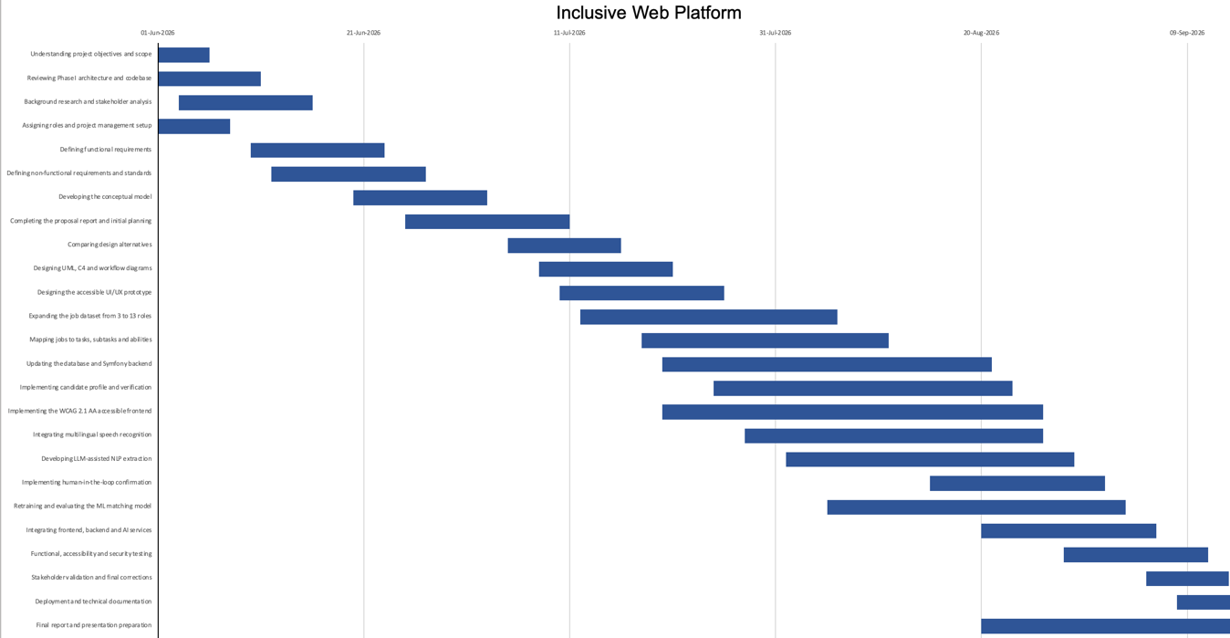
Figure 18: Gantt chart

References
[1] World Wide Web Consortium, “Web Content Accessibility Guidelines (WCAG) 2.1,” W3C Recommendation, 2025.
[2] W3C Web Accessibility Initiative, “WCAG 2 Overview,” W3C.
[3] European Parliament and Council of the European Union, “Regulation (EU) 2016/679, General Data Protection Regulation,” EUR-Lex, 2016.
[4] ISO/IEC/IEEE, “ISO/IEC/IEEE 29148:2011 — Systems and software engineering — Life cycle processes — Requirements engineering,” ISO, 2011.
[5] ISO/IEC, “ISO/IEC 25010:2011 — Systems and software engineering — Systems and software Quality Requirements and Evaluation (SQuaRE) — System and software quality models,” ISO, 2011.
[6] OWASP Foundation, “OWASP Web Security Testing Guide.”
[7] Symfony, “Security,” Symfony Documentation.
[8] Symfony, “Symfony Documentation.”
[9] React, “Accessibility,” React Documentation.
[10] OpenAI, “Structured model outputs,” OpenAI API Documentation.
[11] OpenAI, “Introducing Structured Outputs in the API,” OpenAI, 2024.
[12] Université Saint-Joseph, Moodle platform.
[13] International Organization for Standardization, ISO 9241-110:2020 — Ergonomics of human-system interaction — Part 110: Interaction principles, 2020.
[14] Z. Mansour and C. Rizk, Inclusive Web Platform source code and technical documentation, GitHub, branch zm, 2026.

Appendix A — System Architecture, Setup, and Operations

Implemented Runtime Architecture
The prototype follows the selected layered modular architecture. React renders user experiences; Symfony is the authoritative API and security boundary; PostgreSQL stores confirmed records; Python services isolate deterministic scoring and AI/voice functions; and private files remain outside the web root. Docker Compose starts the backend stack consistently. The planned cache is deliberately documented as future work rather than shown as an already running component.
Table 4: Runtime services and local endpoints
Component | Technology | Local endpoint | Responsibility
Frontend | React 19 and Vite | http://localhost:5173 | Accessible public pages and candidate, employer, verifier, and administrator interfaces.
Backend API | Symfony and PHP | http://localhost:8081/api | Authentication, authorization, persistence, business workflows, file access, mail, and service orchestration.
Database | PostgreSQL 16 | Docker internal service | Authoritative accounts, profiles, jobs, tasks, assessments, applications, outcomes, consents, and audits.
Scoring service | Python HTTP service | http://localhost:5001 | Deterministic task-level eligibility, compatibility, explanation, and ranking.
AI and voice service | Python/Flask and OpenAI adapters | http://localhost:5002 | Speech transcription, bounded voice interpretation, speech feedback, and protected profile extraction.
Private storage | Symfony var volume | Not publicly routed | Disability cards and optional application files with authenticated access and retention controls.
Planned cache | Redis or equivalent after measurement | To be defined | Repeated non-sensitive catalogue reads with TTL, invalidation, monitoring, and database fallback.

Prerequisites and First-Time Setup
Required development software is Git, Docker Desktop with Docker Compose, Node.js with npm, and a recent browser. The repository should be cloned, the backend environment files should be prepared from their examples, and strong local values should be supplied for JWT, database, profile-AI, mail, and OpenAI configuration. Real secrets must never be committed or exposed through Vite variables.
Backend startup command: cd backend; docker compose up -d --build. First initialization then runs composer install, JWT key generation, Doctrine migrations, and—only for controlled development—fixtures. Fixture loading purges and recreates demonstration data; it must never be used against valuable or production records.
Frontend startup command: cd frontend; npm.cmd install when dependencies are absent, followed by npm.cmd run dev -- --host 0.0.0.0. The host option allows testing from another device on the same trusted local network. Frontend API and voice base addresses must use the development computer LAN address rather than 127.0.0.1 when a phone is the client.

Daily Operation, Validation, and Troubleshooting
Daily startup uses docker compose up -d in backend and npm.cmd run dev in frontend. docker compose ps and service health endpoints confirm readiness. Logs are inspected with docker compose logs --tail 100 or docker compose logs -f followed by php, database, scoring-engine, or voice-navigation.
Database changes require a versioned Doctrine migration followed by docker compose exec php php bin/console doctrine:migrations:migrate --no-interaction and doctrine:schema:validate. Backend source is bind-mounted, but container rebuild or recreation is required after Dockerfile, dependency, or environment changes. PostgreSQL data persists in a named volume unless docker compose down -v is deliberately executed.
The standard verification sequence includes Symfony configuration/schema checks, scoring unit tests, voice unit tests, frontend build and ESLint, API integration, browser E2E, performance budgets, the security route audit, and the documented WCAG browser/manual matrix. Common failures are diagnosed by checking the current directory, container state, port mapping, CORS origin, migrations, dependencies, fixture credentials, service health, and environment configuration in that order.

Appendix B — Authentication, Candidate Verification, Security, and Privacy

Authentication and Authorization Model
Public registration creates candidate or employer accounts only. Administrator and verifier authority is assigned internally. Symfony authenticates protected API calls before controllers run. Route groups require ROLE_CANDIDATE, ROLE_EMPLOYER, ROLE_VERIFIER, or ROLE_ADMIN as appropriate; administrators inherit verifier API oversight but do not enter the verifier frontend route. Public exceptions are limited to registration, login, email verification, password recovery, published jobs, public job definitions, documentation, and CORS preflight.
Frontend route protection does not trust decoded browser claims. Before a dashboard renders, the application calls the protected session endpoint and compares the server-confirmed role with the requested route. Validation repeats periodically and when focus returns to the browser. Tokens use sessionStorage rather than persistent localStorage and are never placed in protected document URLs.

Candidate Eligibility Verification
Candidate access uses two independent gates: ownership of the registered email address and approval of an uploaded disability card by an authorized verifier. Candidate registration requires a PDF, JPEG, or PNG document up to 5 MB and explicit consent to verification processing. The two decisions may occur in either order, but a new candidate cannot sign in until both pass. Employer registration requires email verification but no disability document.
The verifier dashboard lists pending, approved, rejected, or all requests; presents email-verification status; opens or downloads the protected file through an authenticated request; records approval or rejection with reviewer identity, note, and timestamp; and requires a clear reason for rejection. Email notification failure does not roll back the saved decision and is reported separately.

Private Storage, Consent, and Candidate Rights
Disability cards and optional application documents use cryptographically random stored names below backend/var/private. Server-detected MIME type—not filename extension—controls acceptance. Empty or oversized files are rejected. Authorized responses use private, no-store caching and X-Content-Type-Options: nosniff. Every card view or download records actor, action, request, and timestamp.
A verification decision schedules the source card for deletion after 30 days while retaining the status and audit record. The purge command must run at least daily. Candidate account deletion removes associated private card and application files before database records are removed.
The candidate Privacy & data dashboard explains stored categories and consent history and provides JSON export, withdrawal of future AI analysis consent, and password-confirmed account deletion. These controls support data minimization, purpose limitation, transparency, retention, access control, portability, consent withdrawal, and erasure; they do not independently prove compliance with every privacy law.
Table 5: Security and privacy control summary
Control area | Implemented control | Evidence or behavior | Remaining operational requirement
Authentication | Email/password with secure hashing and JWT | Protected APIs require X-Auth-Token; query-string token extraction is disabled. | Production secret rotation, monitoring, and secure transport.
Authorization | Explicit route-prefix RBAC | Candidate, employer, verifier, and administrator roles cannot use protected APIs assigned to other roles. | Repeat route audit after every new endpoint and in deployment.
Candidate eligibility | Email verification plus authorized disability-card review | Both independent  gates must pass before a newly registered candidate can sign in. | Institutional verifier assignment and review policy.
Private uploads | Private path, random filename, MIME and size validation | Files are outside the public web root and returned only through authenticated no-store responses. | Backup encryption/erasure and production key management.
Retention | Card deletion scheduled 30 days after a decision | Status remains after the source file is purged; access and decisions are audited. | Run the purge command daily and approve jurisdiction-specific retention.
Candidate control | Consent history, export, withdrawal, deletion | Privacy dashboard supports JSON export, AI-consent withdrawal, and password-confirmed account deletion. | Formal legal review, controller contact, incident response, and backup erasure.
AI minimization | No automatic diagnosis or persistence | Audit metadata excludes transcript, narrative, raw audio, passwords, and private documents. | Provider agreement and deployment privacy notice for external AI processing.

Security Verification and Deployment Duties
The route regression audit checks anonymous calls, forged JWTs, cross-role attempts, valid-role access, and intentionally public catalogue endpoints. Every new protected endpoint must be placed under the correct prefix or explicit access rule and added to this audit. Production responsibilities still include HTTPS, secret rotation, rate limiting where appropriate, backup protection and erasure, monitoring, incident response, verifier governance, and jurisdiction-specific legal approval.

Appendix C — AI-Assisted Profile Building and Voice Navigation

Candidate Profile Assistant
The AI profile assistant is optional. The manual form remains fully usable if AI or speech services are unavailable. A candidate chooses English, French, or Arabic, types a narrative or records speech, edits the resulting transcript, reads the privacy notice, and explicitly consents before requesting suggestions. Audio is held in browser memory for transcription and discarded by this application.
The extraction service proposes structured personal information, education, active-catalogue disabilities, skills, preferences, assistance needs, and active task skills. Each item includes evidence and confidence where available. Every suggestion starts unselected; the candidate can edit, select, ignore, or reject it. Only selected values reach the confirmation endpoint, where Symfony revalidates field lengths and controlled-catalogue membership before persistence.
The assistant may suggest a disability only when it was stated explicitly and exactly matches the active catalogue. It does not diagnose or infer medical facts. Unmatched useful text is displayed for manual review and is not automatically stored. Audit events retain language, consent/outcome type, character count, and item counts—not audio, transcript, or narrative content.
Confirmed task skills enrich the profile but are not sent to the scoring engine. This invariant protects the approved mathematical input contract. Introducing AI-derived fields into scoring would require a separately versioned, reviewed, migrated, and regression-tested policy.

Voice-Navigation Safety Architecture
Voice navigation follows the principle: flexible understanding, restricted choices, deterministic execution. Speech transcription and language interpretation may be probabilistic, but model output is schema constrained and must pass a trusted registry. The model cannot generate routes, selectors, JavaScript, arbitrary clicks, or unregistered operations. React executes only a fixed authorized action returned by the registry.
The voice lifecycle covers off, permission request, listening, processing, speaking, paused, and error states. A bounded utterance is recorded, silence ends the turn, the selected language and current page context are supplied, and no more than six structured history turns are retained in browser memory. The registry returns authorized, clarification, or rejected. Clarification choices are revalidated, bare unanchored confirmation is rejected, and disabling voice clears history and releases microphone resources.
Registered actions include trusted route navigation, browser back, bounded scrolling, page-section reading, internal dashboard views, authentication-form fields and confirmation-gated submission, candidate profile and matching actions, employer/administrator operations, dynamic records already loaded by the application, and grounded questions about bounded readable content on the current page. Voice is always optional and every function retains a keyboard/mouse equivalent.

Language, Privacy, Configuration, and Limitations
The profile assistant exposes English, French, and Arabic. The voice-navigation command subsystem currently provides explicit English and Arabic selection; French command coverage is a remaining requirement even though French profile transcription is available. Formal accuracy evaluation is still required for French, Arabic, Lebanese Arabic, accents, code-switching, noise, and representative speech patterns.
Audio and transcript content are sent to the configured OpenAI services when the user activates the relevant function. API keys remain server-side and are excluded from Git and Docker build context. CORS, file sizes, transcript lengths, feedback lengths, history size, and schema fields are bounded. Website-question support may send bounded readable page content but does not collect input values; authenticated rendered text may nevertheless contain personal data and therefore requires a clear production privacy notice.
The principal internal endpoints are POST /api/profile/transcribe, POST /api/profile/extract, POST /api/voice/process, POST /api/voice/interpret, and POST /api/voice/speech. Symfony exposes authenticated POST /api/candidate/profile/ai-suggestions and /api/candidate/profile/ai-confirm. The internal extraction endpoint requires the shared PROFILE_AI_TOKEN.

Appendix D — Deterministic Scoring Engine and Catalogue Policy

Authoritative Data Flow
React requests matches but never calculates the official score. Symfony authenticates the candidate, loads authoritative PostgreSQL profile and offer data, constructs the scoring payload, and calls the Python service. Python validates the domain objects, applies eligibility and mathematical rules, returns explanations and ranking, and Symfony adds presentation metadata before React renders the result.

Mathematical Model
For task i, let w_i be its positive base weight, h_i its highlighted multiplier, a_i = w_i × h_i its adjusted weight, f_i its effective feasibility factor, and p_i = a_i × f_i its earned points. For an eligible offer, P_max = Σa_i, P_earned = Σp_i, and Score = round(100 × P_earned / P_max, 2). Valid jobs contain at least one positive-weight task, so division by zero is excluded by domain validation.

Table 6: Deterministic scoring policy
Policy element | Current value | Effect | Engineering rationale
Base task weight | 1.0 by default | Defines task importance before vacancy highlighting. | No importance is guessed from wording or spreadsheet order.
Highlighted multiplier | 1.5 | Employer-selected important tasks influence numerator and denominator. | Represents the real vacancy while keeping the numeric rule centralized.
Feasible factor | 1.00 | Earns the complete adjusted task weight. | Represents independent feasibility in the supplied assessment.
Needs-assistance factor | 0.75 when assistance exists; otherwise avoid | Earns partial points only when the offer provides assistance. | Explicit proof-of-concept policy, not a medical probability.
Avoid factor | 0.00 | Earns no points; mandatory avoid excludes the offer. | An explicit avoid assessment cannot be rescued by assistance.
Missing assessment | Feasible fallback plus assumption flag | Avoids treating unchecked structural cells as negative evidence. | The returned explanation identifies that the value was assumed.
Multiple disabilities | Most restrictive assessment wins | Uses the minimum effective feasibility across confirmed disabilities. | Conservative, deterministic, and explainable.
Score | 100 × earned adjusted weight / maximum adjusted weight | Rounded to two decimals for eligible offers. | A null score means a hard eligibility gate failed; zero has a different meaning.

Eligibility, Ranking, and Interpretation
Education and mandatory-task rules are hard gates. If a gate fails, eligible is false and score is null; null must not be confused with an eligible score of zero. For multiple confirmed disabilities, the most restrictive assessment for each task wins. Assistance can transform needs-assistance into the 0.75 factor but never overrides explicit avoid.
Eligible offers are sorted by descending score, followed by title for ties; excluded offers follow eligible ones. Highest-ranked is relative to the returned pool and does not mean strongly compatible. Presentation bands are strong 80–100, moderate 60–below 80, limited 40–below 60, and low below 40. These labels do not alter the formula or authorization to apply.

Catalogue Baseline and Missing Assessments
The validated catalogue is derived from the three supplied HoReCa workbooks: Chocolate/Confectionery Worker, Ice Cream Maker, and Bakery/Pastry Worker. It currently contains 362 tasks, 16 disability categories, and 5,477 recorded assessments. Only checked feasibility cells are recorded as assessments. Unchecked headings, duplicates, layout rows, and unassessed structural cells are ignored.
At runtime, absence of an assessment is treated as no recorded restriction, using the documented feasible fallback and returning an assumed-from-missing-data flag in the explanation. This policy follows the supplied source interpretation and prevents unchecked structural cells from being converted into invented negative evidence. Future stakeholder review may revise the policy through a versioned change, but the current mathematical approach is intentionally preserved.

Determinism, Testing, and Future Calibration
The score depends only on candidate education and confirmed disabilities; job education, assistance, tasks, weights, mandatory/highlighted status; assessment data; and central policy constants. There is no randomness, training, timestamp input, external web data, or browser-side official calculation. Company description, location, deadline, and prose cannot alter the score.
The eleven unit tests cover all-feasible scoring, assistance on/off behavior, explicit and mandatory avoid, optional avoid, missing-assessment fallback, multiple disabilities, education exclusion, and highlighted weighting. Future calibration must use expert-reviewed candidate/job examples and expected outcomes rather than cosmetically changing percentages. Any learned model would be a separately approved future system supported by sufficient consented outcome data.

Appendix E — Responsive Design, Keyboard Access, and WCAG Evidence

Audit Scope and Implemented Corrections
The accessibility scope includes Welcome, Employers, Privacy, Voice Help, Sign Up, Sign In, password recovery/reset, candidate setup and dashboard states, AI profile review, jobs and applications, privacy controls, employer workflows, verifier review, administrator management, file controls, dialogs, filters, tabs, notifications, and shared navigation. Responsive checks target 320, 375, 768, 1024, and 1440 CSS pixels, landscape orientation, text spacing, and 200% zoom.
Implemented corrections standardize containers, spacing, typography, controls, breakpoints, wrapping, table/card behavior, and dialog sizing. Shared accessibility work covers alternative text, headings and landmarks, accessible names/descriptions, focus visibility, focus management, error identification, live status announcements, contrast, reduced motion, semantic HTML, and valid ARIA. Candidate, employer, verifier, and administrator management operations remain keyboard reachable.

Table 7: Accessibility verification coverage
Area | Implemented evidence | Relevant criteria/principle | Final evidence still required
Keyboard and focus | Skip link, logical order, visible focus, route focus, dialog trap/restore, Escape, and safe Left/Right focus navigation. | WCAG 2.1.1, 2.1.2, 2.4.3, 2.4.7; ISO controllability. | Complete every workflow with keyboard and record tester/browser evidence.
Responsive reflow | Shared breakpoints, wrapping controls, table/card adaptation, mobile forms, and constrained dialogs. | WCAG 1.4.10 and 1.4.12. | Retest 320, 375, 768, 1024, 1440, landscape, text spacing, and native 200% zoom.
Forms and errors | Persistent labels, required state, aria-invalid, linked errors, first-invalid focus, and recovery instructions. | WCAG 3.3.1–3.3.3 and ISO error tolerance. | Manual announcement and recovery checks with NVDA.
Semantics | Headings, landmarks, named controls, tables/regions, tabs, dialog semantics, and alternative text. | WCAG 1.1.1, 1.3.1, 2.4.6, 4.1.2. | Verify reading order and meaningful names in rendered states.
Status feedback | Polite success status, assertive errors, atomic notices, and focus after consequential actions. | WCAG 4.1.3 and ISO self-descriptiveness. | NVDA checks for AI, applications, verification, privacy, and administration.
Visual presentation | Strengthened contrast, non-color status text, resizable layout, and reduced-motion behavior. | WCAG 1.4.3, 1.4.10; reduced motion advisory. | Post-remediation axe scans and manual visual checks.
User control | Manual alternatives to AI/voice, editable transcripts, confirmation, cancel/close behavior, and clear state feedback. | ISO 9241-110 controllability, conformity, individualization, and learning. | Representative PwD usability sessions.

Keyboard Acceptance Plan
Every user-facing workflow must be completable without mouse, touch, or voice. The first Tab exposes Skip to main content; focus follows reading order and remains visible; route changes focus the main region; Enter and Space activate controls; Escape closes dismissible overlays; and dialogs trap focus and restore it to their trigger. Tab and Shift+Tab retain their standard sequence.
The requested Right Arrow and Left Arrow navigation moves to the next or previous ordinary focusable control only when native behavior is not overridden. Text inputs and textareas keep caret movement until the relevant boundary. Selects, radio groups, sliders, date/time fields, editable content, media controls, and composite widgets retain their native arrow semantics. Within a dialog, focus navigation cannot leave the dialog.

ISO 9241-110 Interaction Principles
Suitability for the task is supported by role-specific dashboards and direct workflows. Self-descriptiveness is supported by labels, instructions, statuses, and explanations. Controllability is supported by manual alternatives, editable AI output, cancel/close behavior, and user-paced navigation. Conformity with expectations is supported by consistent controls and standard keyboard conventions. Error tolerance is supported by linked validation, focused recovery, confirmation, and non-destructive failure handling. Individualization is supported by text, keyboard, mouse, and optional voice modes with language choice and reduced motion. Suitability for learning is supported by Voice Help, clear commands, feedback, and predictable navigation.

Conformance Boundary
The report does not claim complete WCAG 2.1 Level AA conformance. Source remediation, build, lint, historical baseline scans, responsive screenshots, and automated E2E evidence are substantial but insufficient. A new live axe scan, native browser 200% zoom, manual text-spacing/reflow inspection, representative authenticated workflows, and NVDA with Edge must be recorded after remediation before a conformance decision.

Appendix F — Outcome Logging, Accessible Notifications, Testing, and Performance

Outcome and Notification Data
Application submission and employer status changes create chronological outcome events containing application and actor identifiers, previous/new status, mail-delivery result, and timestamp. Events exclude documents, filenames, disability information, profile narrative, reviewer notes, passwords, and email bodies. Repeating an unchanged status must not create a duplicate outcome or email.
Employer transitions to pending, in review, accepted, or rejected trigger a plain-text candidate email when mail is configured. Mail failure never rolls back the saved business decision; sent or failed is recorded and returned. Verifier approval/rejection actions are also audited. Candidate, employer, verifier, and administrator feedback uses the shared Accessible Notice: errors are assertive alerts, success is a polite status, both are atomic, and focus may move to the outcome after an action.

Recorded Automated Verification

Table 8: Recorded automated verification results
Verification suite | Recorded result | Scope | Interpretation
API integration | 17/17 passed | Public catalogues, valid role sessions, representative reads, anonymous rejection, and wrong-role rejection. | Read-only local integration baseline.
Browser E2E | 19/19 passed | Public routes, protected redirects, four dashboards, wrong-role redirect, validation focus, alert, and skip link. | Automated browser coverage; does not replace manual assistive-technology testing.
Voice navigation | 49/49 passed | Registry boundaries, roles, actions, clarification, dynamic records, and safety behavior. | Deterministic boundary tests; real accent and microphone evaluation remains pending.
Scoring engine | 11/11 passed | Feasibility, assistance, mandatory gate, missing assessment, multi-disability, education, and weighting. | Validates the mathematical policy, not real-world placement effectiveness.
Frontend quality | Build and ESLint passed | Production bundle creation and static source checks. | Browser and deployment behavior still require runtime tests.
Performance | Zero budget violations | API latency, page load/FCP, transfer size, resource timing, and gzip bundle size. | Development-machine baseline; concurrency and deployed-origin measurements remain pending.

Performance Measurements
Recorded local p95 API values were 205.1 ms for public jobs, 163.2 ms for public job definitions, 86.7 ms for candidate session, and 244.8 ms for candidate profile. Recorded page load/FCP values were 102.6/448 ms for Welcome, 95.3/184 ms for Sign In, and 103/552 ms for Candidate. JavaScript and CSS gzip sizes were 130,428 and 13,579 bytes.
The first performance run identified a synchronous external Google Fonts request capable of delaying rendering by approximately 6.2 seconds. The dependency was removed and system font fallbacks were used, after which repeated production-build measurements passed all budgets. These measurements are a regression baseline on the development computer—not evidence of production availability, 100 concurrent users, mobile hardware performance, or external-network behavior.

Required Manual and Deployment Retests
Manual retesting must confirm mail delivery/failure behavior, NVDA announcements, duplicate-outcome prevention, verifier decision audits, keyboard completion, dialog focus, AI suggestion review, privacy operations, mobile reflow, and native zoom. Deployment retesting must repeat integration, E2E, security, accessibility, and performance suites on the deployed origin and add concurrency, monitoring, backups, purge scheduling, and incident-response evidence.

Appendix G — Documentation and Evidence Traceability
The report contains the engineering content needed to understand the solution without opening GitHub. Repository links remain useful for verifying exact source code, commands, historical decisions, and machine-readable evidence; they are not substitutes for the written documentation.
Table 9: Repository documentation incorporated into this report
Repository document | Subject incorporated in report | Report location | Treatment
AI_PROFILE_WORKFLOW.md | Candidate journey, consent, validation, privacy boundaries, scoring invariant, and endpoints. | Appendix C | Written into the report; link retained only for source traceability.
AUTHORIZATION_SECURITY.md | JWT model, server-confirmed frontend route protection, role boundaries, and regression audit. | Appendix B | Written into the report.
CANDIDATE_VERIFICATION.md | Two-gate registration, verifier workflow, protected documents, audit, retention, and deployment. | Appendix B | Written into the report.
PRIVACY_CONTROLS.md | Consent, minimization, private storage, export, withdrawal, erasure, and operational limits. | Appendix B | Written into the report.
scoring-engine-technical-specification.md | Formula, gates, policy constants, ranking, data assumptions, determinism, tests, and limitations. | Appendix D | Core technical and mathematical content written into the report.
voice-navigation-technical-specification.md | Architecture, command safety boundary, languages, lifecycle, actions, privacy, configuration, and testing. | Appendix C | Core technical content written into the report.
frontend-revamp.md | Architecture evolution, candidate/employer/admin workflows, catalogue import, voice actions, and delivery history. | Main progress section and Appendices A–C | Consolidated by current feature rather than copying obsolete chronological notes.
keyboard-navigation-test-plan.md | Acceptance criteria, workflow matrix, dialogs, screen-reader checks, and arrow-key boundaries. | Appendix E | Written into the report with pending manual evidence identified.
wcag-audit/*.md | Baseline scope, responsive foundation, route reviews, management reviews, shared corrections, issue matrix, and final audit status. | Appendix E | Consolidated into an evidence and retest matrix; no unsupported conformance claim.
OUTCOME_LOGGING_AND_ACCESSIBLE_NOTIFICATIONS.md | Outcome-event minimization, mail status, shared accessible notices, and manual retest. | Appendix F | Written into the report.
INTEGRATION_E2E_PERFORMANCE.md | Executable suites, results, performance values, and limitations. | Appendix F | Written into the report and illustrated by Figure 17.
project-setup-and-docker-guide.md | Architecture, prerequisites, setup, persistence, database access, updates, and troubleshooting. | Appendix A | Operational essentials written into the report.
run-project-commands.md | Startup, shutdown, migrations, fixtures, tests, logs, inspection, and recovery commands. | Appendix A | Validated command set written into the report.
Machine-readable JSON evidence | WCAG scenarios, integration, E2E, and performance measurements. | Appendices E–F | Results summarized; raw JSON remains attached to source control to preserve machine readability.
Machine-generated JSON is intentionally summarized rather than printed line by line because raw output is not readable report prose. The original JSON files remain versioned evidence that can be rerun and compared. Chronological frontend notes are likewise consolidated into the current architecture and behavior so obsolete intermediate decisions are not presented as the final system.
Complete repository documentation: docs directory on branch zm
Current implementation source: inclusive-web-platform branch zm

