MODERN CLOUD COMPUTING

Common Capstone Infrastructure Guide
Gitea • Runner • Registry • Keycloak • PostgreSQL • k3d/k3s • Argo CD • Prometheus • Grafana • Trivy
Local-First Shared Baseline for the Cloud Computing Final Capstone
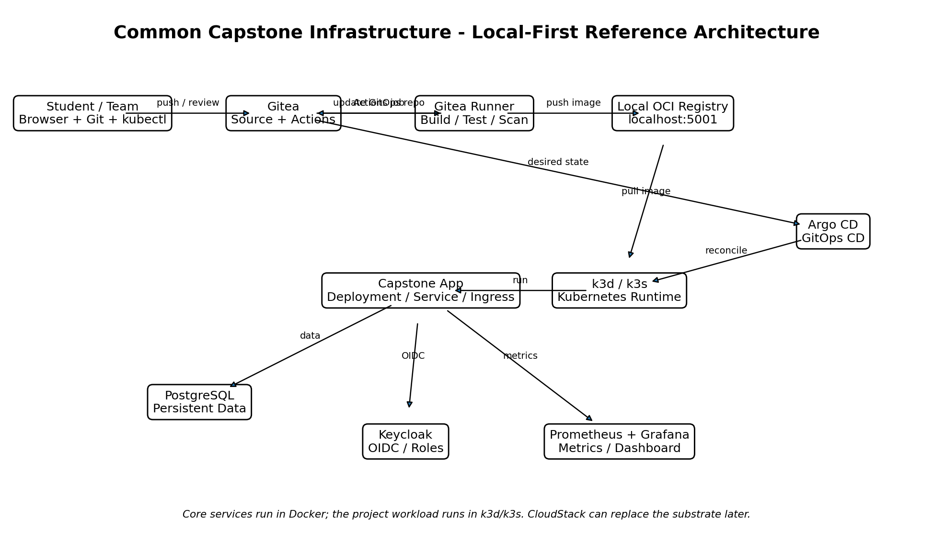
Design principle: All teams use the same infrastructure responsibility model. The organizational case and application domain may differ, but CI/CD, Kubernetes, IAM, observability, security scanning, and recovery evidence remain comparable.

1. Purpose and Relationship to the Capstone Guideline
This package supplies the common technical baseline for the Cloud Computing Final Capstone Project. It does not prescribe the business domain or application features. Instead, it reduces environmental differences between groups so assessment can focus on cloud architecture, delivery, operations, security, reliability, and cost evidence.
- Application teams own the case study, source code, data model, tests, configuration, and cloud decisions.
- The common package provides reproducible local services and reference templates.
- CI builds and verifies application artifacts; Argo CD owns Kubernetes deployment reconciliation.
- Real secrets are not stored in Git.
- The package remains local-first until real CloudStack infrastructure becomes available.
RPS alignment: The capstone is the integrative implementation evidence for the course outcome that students can create and implement Cloud Computing application solutions. The common infrastructure also supports the Sub-LOs on operating cloud infrastructure, maintaining cloud security, and building a cloud-computing project.

2. Architecture and Responsibility Boundaries
Component | Responsibility | Student evidence
Gitea | Source repository, pull/review history, Actions workflow definitions | repository URL, commits/PRs, workflow definition
Gitea Runner | Executes trusted local CI jobs | runner status, build/test/scan job evidence
Local Registry | Stores immutable container images | image tag/digest and successful pull/deploy
Keycloak | OIDC login and role baseline | issuer/client config and allow/deny tests
PostgreSQL | Persistent application data | migration/data evidence, backup and actual restore
k3d/k3s | Local Kubernetes orchestration | Deployment/Service/Ingress, probes, resources, scaling/failure test
Argo CD | GitOps continuous delivery and self-healing | Application sync, revision, drift/reconciliation evidence
Prometheus/Grafana | Metrics collection and operational dashboard | target state, selected metrics, service-oriented dashboard
Trivy | Container vulnerability evidence | scan output plus risk interpretation/remediation decision

Critical boundary: The reference CI workflow does not run `kubectl apply`. CI produces/tests/scans/publishes an artifact and updates the GitOps repository. Argo CD is the component that reconciles Kubernetes desired state.

3. Course Snapshot and Version Strategy
Component | Version / line | Reason
Gitea | 28.2.0 | Pinned server snapshot for consistent Actions/API behavior
Gitea Runner | 5.1.1 | Pinned runner; custom classroom image adds Java/Maven/Node/Docker CLI
Argo CD | 3.5.6 | Stable non-HA local GitOps controller snapshot
Keycloak | 26.8.1 | Recent patched classroom OIDC server
PostgreSQL | 17-alpine | Stable major line for application persistence
Prometheus | 3.15.1 | Metrics collection
Grafana | 13.2.4 | Dashboard UI
Trivy | 0.76.0 | Container vulnerability scanning
k3d | 5.9.0 recommended | Local k3s lifecycle on Docker

Students must record actual versions in their evidence. Upgrading a component during the project is allowed only when the team records the reason, compatibility impact, and validation result.

4. Laptop and Software Requirements
Requirement | Minimum / recommendation
Operating system | Windows 11 with WSL2/Docker Desktop, current Linux, or supported macOS
Memory | 8 GB minimum for staged use; 16 GB+ recommended for full stack
CPU | 4 logical cores minimum; 6-8 preferred
Disk | 20 GB free space recommended
Host tools | Docker + Compose, Git, curl, jq (Bash path), kubectl, k3d
Network | Required for first image pulls, Argo CD manifest install, and external Actions such as checkout

Resource strategy: Do not run everything continuously on an 8 GB laptop. Start core services first, enable the runner when doing CI work, and start Prometheus/Grafana only when collecting observability evidence.

5. Package Layout
Cloud_Computing_Common_Capstone_Infrastructure_Package/
├── guides/
├── infrastructure/
│ ├── docker-compose.yml
│ ├── .env.example
│ ├── keycloak/
│ ├── runner/
│ ├── prometheus/
│ ├── grafana/
│ └── k3d/
├── scripts/
├── templates/
│ ├── app-repo/
│ ├── gitops-repo/
│ ├── argocd/
│ └── evidence/
├── smoke-test/
├── SECURITY_NOTES.md
├── TROUBLESHOOTING.md
└── VERSION_MATRIX.md

6. Initial Setup and Environment Doctor
- Extract the package to a short local path, for example `C:\cloud-capstone` or `~/cloud-capstone`.
- Copy the environment template.
# Linux/macOS
cp infrastructure/.env.example infrastructure/.env
# Windows PowerShell
Copy-Item infrastructure\.env.example infrastructure\.env
- Review the classroom passwords in `.env`. They are intentionally simple and must remain local.
- Run the doctor.
# Linux/macOS
./scripts/doctor.sh
# Windows PowerShell
./scripts/doctor.ps1
☐ Docker engine is running.
☐ Git is available.
☐ kubectl is available.
☐ k3d is available.
☐ Required ports are not unexpectedly occupied.

7. Start the Core Services
# Linux/macOS
./scripts/up-core.sh
# Windows PowerShell
./scripts/up-core.ps1
Service | Endpoint / purpose
Gitea | http://127.0.0.1:3001 - Git and Actions
PostgreSQL | 127.0.0.1:5432 - application database
Keycloak | http://127.0.0.1:8081 - OIDC/IAM
OCI Registry | http://127.0.0.1:5001/v2/ - local image registry

docker compose --env-file infrastructure/.env -f infrastructure/docker-compose.yml ps
curl http://127.0.0.1:5001/v2/

8. Bootstrap Gitea and the CI Runner
- Create the local administrator/student accounts and runner registration token.
# Linux/macOS
./scripts/bootstrap-gitea.sh
# Windows PowerShell
./scripts/bootstrap-gitea.ps1
- Start the custom runner.
# Linux/macOS
./scripts/start-runner.sh
# Windows PowerShell
./scripts/start-runner.ps1
- Open Gitea and confirm that the runner is visible/online in the Actions runner settings.
Runner security: The local runner mounts the host Docker socket and offers the `capstone:host` label. This is a classroom compromise for trusted student repositories. Do not reuse this architecture as a shared multi-user production runner.

9. Create the k3d/k3s Cluster
# Linux/macOS
./scripts/create-cluster.sh
# Windows PowerShell
./scripts/create-cluster.ps1
The reference cluster uses one k3s server and one agent. It joins the Docker `capstone-net` network, maps HTTP/HTTPS ingress to the laptop, and trusts the local classroom registry at `registry:5000`.
kubectl get nodes -o wide
kubectl get pods -A
kubectl get ingressclass

10. Validate the Registry and Kubernetes Path with the Smoke Test
# Linux/macOS
./scripts/smoke-test.sh
The smoke test builds a tiny Nginx image, pushes it to `localhost:5001`, deploys it from the same registry inside k3d as `registry:5000`, and tests Traefik ingress at `http://smoke.localhost:8088/`.
Interpretation: A successful smoke test proves the basic host-Docker -> registry -> k3d pull -> Deployment -> Service -> Ingress path. It does not prove that the capstone application itself is healthy.

11. Bootstrap the Two Common Project Repositories
# Linux/macOS
./scripts/bootstrap-project.sh
# Windows PowerShell
./scripts/bootstrap-project.ps1
The script creates and populates:
student/capstone-app
student/capstone-gitops
- `capstone-app` contains the CI workflow and is replaced/extended with the team application source.
- `capstone-gitops` contains the Kubernetes desired state and must not contain application source or real secrets.
- The app repository receives the local `GITOPS_PASSWORD` Actions secret so CI can update the GitOps repository.

12. CI/CD and GitOps Flow
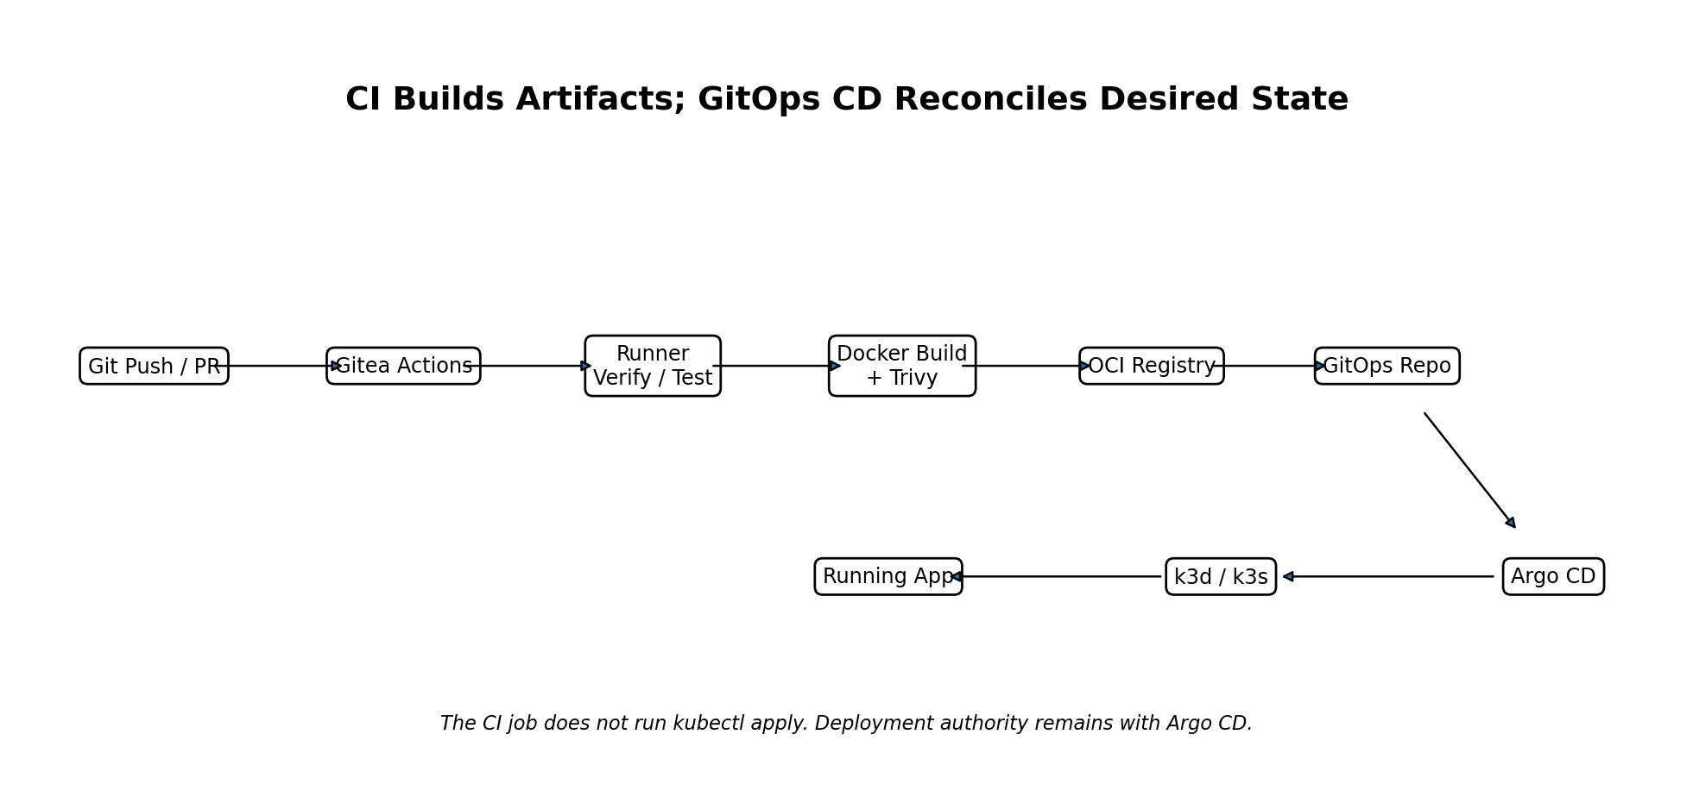
Stage | Owner | Expected behavior
Source change | Student/Gitea | Commit or pull request changes application source
Verify | Gitea Runner | Maven test/verify or approved equivalent
Build | Gitea Runner + Docker | Create immutable image tagged with short Git SHA
Scan | Trivy | Report HIGH/CRITICAL findings; team interprets risk
Publish | Local Registry | Push image to localhost:5001
Desired-state update | CI -> GitOps repo | Change image newTag in Kustomize overlay
Deploy | Argo CD | Observe Git revision and reconcile cluster
Runtime | k3d/k3s | Rolling update and health probes determine readiness

Security progression: The initial scan is a reporting gate (`--exit-code 0`) so students learn to interpret findings. A later DevSecOps improvement may convert selected severity/policy conditions into a blocking gate with a documented exception process.

13. Create the Runtime Secret Before the First Application Sync
The GitOps repository deliberately excludes the real database password. Create the local Secret directly in the cluster before the application is expected to become Ready:
kubectl create namespace capstone --dry-run=client -o yaml | kubectl apply -f -
kubectl -n capstone create secret generic capstone-app-secret \
--from-literal=DB_PASSWORD=capstone \
--dry-run=client -o yaml | kubectl apply -f -
Evidence: Do not submit the Secret YAML with its value. Evidence may show the Secret object name and successful application use, but redact sensitive values.

14. Install Argo CD and Connect the GitOps Repository
# Linux/macOS
./scripts/install-argocd.sh
# Windows PowerShell
./scripts/install-argocd.ps1
The baseline GitOps repository is intentionally public only inside the local Gitea instance, so Argo CD can read it without storing another credential. A team may harden this by making the repo private and configuring a read-only Argo CD credential as an advanced security improvement.
kubectl -n argocd get applications.argoproj.io
kubectl -n argocd describe application capstone-app
Optional UI port-forward:
./scripts/argocd-ui.sh
# PowerShell: ./scripts/argocd-ui.ps1

15. Adapt the Templates to the Team Application
Template field | Default | Team action
Container port | 8080 | Change if the approved runtime uses another port
Readiness | /q/health/ready | Keep for Quarkus or replace with an equivalent health endpoint
Liveness | /q/health/live | Keep for Quarkus or replace appropriately
DB URL | jdbc:postgresql://host.k3d.internal:5432/capstone | Adapt database/schema strategy if approved
OIDC issuer | http://host.k3d.internal:8081/realms/capstone | Configure application OIDC integration
Ingress host | capstone.localhost | May be changed, but record it consistently
Resources | 100m/192Mi request; 500m/512Mi limit | Treat as initial values to measure and rightsize

16. Identity Baseline with Keycloak
The imported `capstone` realm contains a public client `capstone-app`, realm roles `user`, `operator`, and `admin`, and simple local users for testing. Two sample groups (`tenant-a` and `tenant-b`) are included as raw material for teams that implement multitenancy.
Account | Password | Purpose
usera | usera | normal user / tenant-a sample
userb | userb | normal user / tenant-b sample
operator | operator | operations/approval role sample
appadmin | appadmin | application admin role sample

Assessment boundary: The common realm only provides a starting identity boundary. Each team must design its own authorization rules and demonstrate at least one allowed and one denied operation.

17. Enable Observability When the Project Reaches the Operations Milestone
# Linux/macOS
./scripts/up-observability.sh
# Windows PowerShell
./scripts/up-observability.ps1
Tool | URL | Default use
Prometheus | http://127.0.0.1:9090 | Scrapes Quarkus `/q/metrics` through host port 8088
Grafana | http://127.0.0.1:3000 | Students build a service-owner dashboard

If the application is not Quarkus or exposes metrics on another path, update `infrastructure/prometheus/prometheus.yml`, restart Prometheus, and record the reason.

18. Backup and Actual Restore Validation
The common package deliberately distinguishes a backup file from recovery evidence.
# Create backup
./scripts/backup-postgres.sh
# Restore the dump into a separate validation database
./scripts/restore-postgres-validation.sh backups/<file>.dump
- Record application row counts or business checks before backup.
- Create the backup and record timestamp/file size.
- Restore into `<database>_restore_validation` rather than overwriting the live development database.
- Validate tables and selected business records in the restored database.
- Record measured restore time, limitations, and whether the result meets the team RTO/RPO assumptions.
Recovery evidence: A `.dump` file alone is not restore proof. The capstone requires evidence that a usable dataset was actually restored and validated.

19. Recommended Evidence Checkpoints
Milestone | Common infrastructure evidence
M3 Platform | cluster nodes, Deployment/Service/Ingress, probes/resources, registry path
M4 Delivery | Gitea workflow, runner log, immutable image tag, scan result, GitOps commit, Argo sync
M5 Operations | Prometheus target, dashboard, health, log sample, initial SLI/SLO
M6 Security | Keycloak role tests, secret handling, Trivy interpretation, network/trust-boundary note
M7 Reliability | pod failure/recovery, backup, actual restore, recovery timing
M8 FinOps | requests/limits, observed usage, rightsizing/cost assumption

20. Common Security and Fairness Rules
- Do not expose local services to the LAN unless the instructor approves the change.
- Do not submit passwords, Keycloak tokens, Gitea runner tokens, runner registration files, or session cookies.
- Do not claim high availability because a single pod restarted.
- Do not claim disaster recovery because a backup file exists.
- Do not claim zero trust because Keycloak is installed.
- Do not claim multitenancy unless tenant identity and isolation are tested, or explicitly justify the approved single-tenant path.
- All teams must preserve the separation between the application repository and GitOps repository.

21. Health/Status Commands
./scripts/status.sh
# or PowerShell: ./scripts/status.ps1
docker compose --env-file infrastructure/.env -f infrastructure/docker-compose.yml ps
k3d cluster list
kubectl get nodes
kubectl get pods -A
kubectl -n capstone get all,ingress
kubectl -n argocd get applications.argoproj.io

22. Troubleshooting Order
- Host tool missing or wrong version
- Docker engine / port conflict
- Core Docker service unhealthy
- Gitea user/runner registration
- Registry push or pull
- k3d cluster / DNS / ingress
- Kubernetes Secret/configuration
- Argo CD repository/sync
- Application readiness/logs
- Prometheus target and dashboard
Method: Capture evidence before changing a configuration. Change one variable at a time, rerun the same validation command, then document what the change proved.

23. Cleanup and Destructive Reset
Normal stop preserves data:
docker compose --env-file infrastructure/.env -f infrastructure/docker-compose.yml --profile ci --profile observability stop
The provided reset script deletes the k3d cluster and all persistent Docker volumes. It requires an explicit confirmation phrase.
./scripts/reset-lab.sh
# PowerShell: ./scripts/reset-lab.ps1

24. Future Mapping to Real CloudStack
When CloudStack becomes available, the application and GitOps model should not need to be redesigned. Replace the local substrate while preserving higher-level responsibilities:
Current
Laptop Docker -> k3d/k3s -> application
Future
CloudStack -> Linux VM(s) -> k3s -> same GitOps application model
- CloudStack becomes the IaaS control plane for VM, virtual network, volume, security-group, and placement evidence.
- k3s remains the orchestration layer unless the course intentionally changes the platform.
- Gitea/Runner/Argo CD may remain local initially or move to shared services later.
- The team should then compare responsibility boundaries, availability, networking, capacity, and cost between local and IaaS-hosted execution.

25. Instructor / Team Acceptance Checklist
☐ Core Docker services start and remain localhost-bound.
☐ Gitea administrator/student accounts and runner registration work.
☐ Gitea Runner is online and accepts `capstone` jobs.
☐ Local registry accepts an image push.
☐ k3d nodes can pull the registry image.
☐ Ingress is reachable on the mapped host port.
☐ App and GitOps repositories are separate and initialized.
☐ Real Kubernetes Secret is not committed to Git.
☐ Argo CD reads the GitOps repository and reports sync state.
☐ Prometheus/Grafana can be started only when required.
☐ PostgreSQL backup and validation restore scripts are available.
☐ Students understand the runner Docker-socket limitation and local-lab trust assumption.

26. References and Current Snapshot Sources
- Gitea releases and documentation: https://github.com/go-gitea/gitea/releases and https://docs.gitea.com/
- Gitea Runner documentation: https://docs.gitea.com/runner/
- Argo CD releases/documentation: https://github.com/argoproj/argo-cd/releases and https://argo-cd.readthedocs.io/
- Keycloak releases/documentation: https://github.com/keycloak/keycloak/releases and https://www.keycloak.org/documentation
- k3d documentation: https://k3d.io/
- Prometheus/Grafana/Trivy official documentation.

