MODERN CLOUD COMPUTING

Final Capstone Project Guideline
Design, Implement, Deploy, Operate, Secure, Recover, and Justify a Cloud-Native Information System
Bachelor of Information Systems • Semester V • 3 Credits
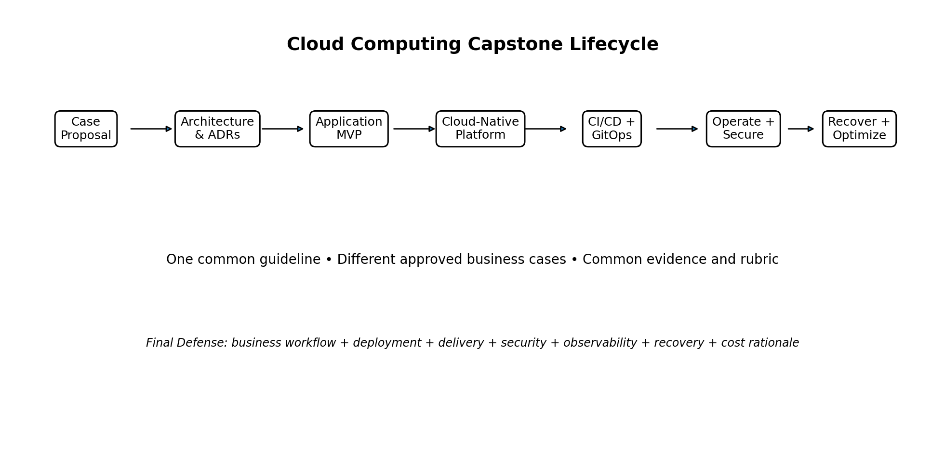
Project Registration Field | Team Entry
Team Name
Case Study / Proposed System
Member 1 / Student ID
Member 2 / Student ID
Member 3 / Student ID
Member 4 / Student ID (if approved)
Repository / Workspace

Core principle: All teams follow one common capstone guideline, one evidence model, one milestone scheme, and one rubric. Business cases may differ, but cloud engineering expectations remain comparable.

1. Purpose of the Capstone
The final capstone is the integrative assessment for the Cloud Computing course. It is not intended to reward the team that writes the largest application. It evaluates whether students can make defensible cloud decisions, implement a usable workload, operate it on a cloud-native platform, and produce evidence about security, reliability, operations, and cost.
The project question is:
Capstone challenge: Can your team design, implement, deploy, operate, secure, recover, and justify a cloud-native information system for a realistic organizational case?

2. Course and RPS Alignment
The Semester Learning Plan defines four course Learning Outcomes: explaining cloud-computing concepts, analyzing business/architecture models and cloud applications, evaluating cloud-technology applications, and creating/implementing cloud-computing application solutions. The capstone is primarily the integrative evidence for the fourth outcome while also requiring the earlier outcomes as justification and analysis.
RPS capability | Capstone interpretation
Explain cloud-computing architecture | Team can explain service models, architecture layers, responsibilities, and trade-offs.
Compile cloud architecture design documents | Team produces architecture views, quality scenarios, ADRs, and trust/failure boundaries.
Design virtualization according to needs | Team justifies container/Kubernetes abstraction and future IaaS mapping.
Create multitenancy software | Team implements tenant isolation or submits a justified single-tenant decision plus migration design.
Operate cloud facilities and infrastructure | Team can deploy, inspect, scale, troubleshoot, observe, and recover the workload.
Maintain security of the cloud environment | Team demonstrates IAM/authorization, secret handling, vulnerability evidence, and security controls.
Explain future cloud progress | Team evaluates at least one emerging or advanced capability in the improvement roadmap.
Create a project applying cloud computing technology | Team completes the end-to-end capstone and technical defense.

Assessment weight: The RPS assigns 50% of the course grade to Project Results. This guideline therefore treats the capstone as a substantial engineering portfolio rather than a final-week programming exercise.

The RPS also specifies Collaborative Learning, Product Oriented Learning, and Project Based Learning. The capstone uses these approaches through team delivery, staged artifacts, product demonstration, and evidence-based review.

3. Project Model: One Guideline, Multiple Approved Cases
All groups use the same engineering baseline. Variation comes from the organizational problem and domain, not from different grading rules.
What is common | What may vary
Learning outcomes and rubric | Business/domain problem
Mandatory cloud capabilities | Application entities and workflow
Evidence standard | Optional advanced capability
Milestone/checkpoint structure | Frontend style or business report
Final defense format | Technology substitution with justification
Submission structure | Additional domain-specific control

Fairness rule: A more complicated business domain does not receive extra credit by itself. Grades are based on the quality of cloud decisions, implementation, evidence, verification, and technical understanding.

4. Team Formation and Individual Accountability
Recommended team size: three students. A four-person team requires instructor approval and a correspondingly broader implementation or evidence scope.
Suggested responsibility area | Examples
Application & Data | domain model, API/workflow, persistence, test data
Platform & Delivery | container, Kubernetes, CI, artifact publication, GitOps
Security & Operations | IAM, secrets, scanning, observability, recovery, FinOps

Responsibilities are organizational aids, not knowledge silos. Every member must be able to explain the full system during the defense.
☐ Use version-control history or equivalent contribution evidence.
☐ Maintain an individual contribution log.
☐ Each student submits a short individual reflection.
☐ The instructor may ask any member to demonstrate or explain any mandatory capability.
☐ A team result may be adjusted individually when contribution or technical understanding is materially different.

5. Case-Study Selection
Teams may select one of the approved archetypes below or propose another case. The case is only the business context; it does not replace the common technical requirements.
Track | Example capstone case | Possible core workflow
Campus Services | Laboratory Reservation & Usage | request → approval → usage → report
Education | Training / Course Registration | catalog → registration → approval → attendance
SME / Commerce | Multi-Tenant Order & Inventory | order → stock allocation → fulfillment → summary
Foundation / NGO | Donation & Program Management | donation → allocation → activity → accountability
Public Service | Community Service Request | request → triage → assignment → closure
Research | Research Dataset & Experiment Management | dataset → experiment → result → publication status
Asset Management | Equipment & Maintenance | asset → fault → work order → completion
Event Management | Event, Registration & Attendance | event → registration → check-in → summary
Logistics | Shipment / Delivery Tracking | shipment → status events → delivery → exception
IT Service | Multi-Tenant Service Desk | ticket → assignment → resolution → SLA summary

5.1 Student-Proposed Case Approval
A proposed case should be approved before substantial implementation. The proposal must answer:
- Who are the users and stakeholders?
- What business process is being improved?
- What data must persist?
- What authentication/authorization decisions exist?
- Why does the workload benefit from cloud characteristics rather than simple hosting?
- What scaling, availability, security, or recovery concern makes the project technically meaningful?
- What part of the project can be demonstrated within the semester and available infrastructure?

6. Application Scope
The application should be intentionally small enough that cloud engineering remains the main learning objective.
Scope dimension | Recommended baseline
Domain entities | Approximately 4–6 meaningful entities
Roles | Approximately 3–5 roles or permission groups
Core business workflow | At least one complete end-to-end workflow
Persistent data | Required
API/UI | At least one usable interface; API-only is acceptable if justified and demonstrated
Reporting | At least one operational or business summary
Tenancy | Implement isolation or submit approved justified N/A + future design
Microservices | Not required; modular monolith is acceptable and often preferred for this course

Avoid over-engineering: The capstone is not a contest to build the most microservices, brokers, databases, or clusters. Additional components count only when they solve a stated requirement and are supported by evidence.

7. Mandatory Cloud Engineering Baseline
All projects must satisfy the following capability baseline. The future common-infrastructure package may provide reference implementations, but this guideline remains platform-neutral at the learning-outcome level.
Domain | Mandatory capability | Minimum evidence
Cloud adoption & business | Problem, users, cloud suitability, constraints, measurable success | adoption rationale + stakeholder/workload note
Architecture | Provider-neutral architecture, dependencies, trust/failure boundaries, quality attributes | architecture diagram + ADR + quality scenario
Application & data | Usable workflow with persistent data | working transaction + data proof
Containerization | Repeatable application image | Dockerfile/container build + version evidence
Kubernetes / orchestration | Declarative workload, service exposure, config, health, resources | manifests + running workload + service proof
Delivery | Automated validation/build and controlled deployment path | CI run + immutable artifact + deployment/GitOps evidence
Identity & access | Authentication and role/permission enforcement | positive + negative authorization tests
Secrets & config | No hard-coded production-like secrets; runtime config separated | secret/config decision + repository review
Security operations | Dependency/image/configuration scan with risk-based interpretation | scan + prioritized remediation note
Observability | Health plus meaningful operational telemetry | dashboard or equivalent + log/metric evidence
Service objective | At least one measurable SLI/SLO or operational acceptance target | definition + measurement evidence
Reliability | Controlled failure/restart/reconciliation test | failure test + recovery observation
Data protection | Backup and actual restore verification | backup artifact + restore proof
Capacity / FinOps | Resource/capacity and simple cost or unit-cost analysis | capacity worksheet + cost rationale
Roadmap | Residual risks and prioritized next steps | improvement backlog / roadmap

7.1 Multi-Tenancy Requirement
Because the RPS explicitly includes the ability to create multitenancy software, teams must address tenancy in one of two approved ways:
Option | Requirement
A — Implement tenancy | Tenant identity/context, tenant-aware queries, authorization, and a negative isolation test proving one tenant cannot read another tenant’s protected data.
B — Justified single-tenant design | Document why the workload is intentionally single-tenant, identify what would need to change to become multi-tenant, and provide a tenant-isolation design for a future version. Instructor approval is required.

8. Reference Technology Direction
The common infrastructure will be provided separately. The project guideline does not require one framework, but the course reference path is expected to support:
- a Java/cloud-native workload such as Quarkus or JHipster Quarkus;
- a relational database such as PostgreSQL;
- an identity provider such as Keycloak;
- containerization and a lightweight Kubernetes distribution such as k3s/k3d;
- a Git/CI platform and runner;
- a GitOps CD controller such as Argo CD;
- metrics/dashboard tooling;
- an image/dependency security scanner.
Technology substitution: Teams may propose alternatives, but substitutions require a short rationale explaining compatibility with the mandatory capabilities and the effect on evidence comparability.

9. Evidence Standard and Cumulative Portfolio
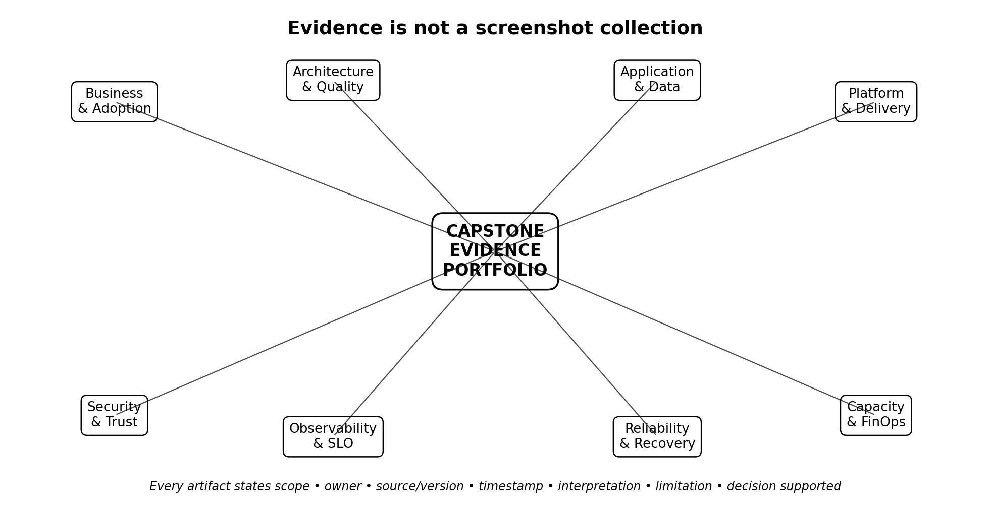
Tool output is raw evidence. It becomes assessment evidence only when the team explains what it means and what decision it supports.
Evidence field | Required meaning
Scope | What system/component/test is being evidenced?
Owner | Who produced/reviewed the artifact?
Source / version | Software, configuration, commit, image, manifest, or document version
Timestamp | When was the evidence captured?
Method | Command, scenario, workflow, or test method
Observation | What happened?
Interpretation | Why does the result matter?
Limitation | What does this evidence not prove?
Decision supported | Which design/operational decision is justified or changed?

9.1 Recommended Evidence Portfolio Structure
cloud-capstone-<team>/
├── README.md
├── 01-business/
├── 02-architecture/
├── 03-application-data/
├── 04-platform-kubernetes/
├── 05-ci-cd-gitops/
├── 06-security/
├── 07-observability-slo/
├── 08-reliability-recovery/
├── 09-capacity-finops/
├── 10-decisions-adr/
├── 11-demo-defense/
└── source/

10. Recommended Milestones and Checkpoints
The capstone should be started before the final weeks. The schedule below is a course-management recommendation layered on top of the RPS; exact dates may be set by the lecturer.
Milestone | Target outcome | Gate / review question
M0 — Case Proposal | problem, users, workflow, cloud rationale, team | Is the case feasible and genuinely cloud-relevant?
M1 — Architecture Baseline | architecture, quality attributes, ADRs, tenancy approach | Can the team explain boundaries and trade-offs?
M2 — Application MVP | core workflow + persistence + roles | Does the business process work before infrastructure complexity grows?
M3 — Cloud-Native Platform | container + Kubernetes + config/probes/resources | Can the workload be deployed repeatably and inspected?
M4 — Delivery Automation | CI + immutable artifact + controlled CD/GitOps path | Can change move from source to runtime with traceability?
M5 — Operations & SLO | health, metrics/logs, dashboard, SLI/SLO | Can the team explain service health for a defined audience?
M6 — Security | IAM tests, secrets, vulnerability evidence, threat/control notes | Are trust boundaries enforced and findings prioritized?
M7 — Reliability & Recovery | failure test, backup, restore, RTO/RPO or recovery targets | Can the team recover rather than merely claim recoverability?
M8 — Capacity & FinOps | requests/limits, capacity headroom, simple cost/unit-cost, roadmap | Can the team optimize without weakening reliability/security?
FINAL — Demo & Defense | end-to-end scenario, portfolio, technical defense | Can every member defend the implemented system and evidence?

11. Optional Advanced Capabilities
Advanced work is valuable only after the mandatory baseline is stable. Teams may select two or three capabilities with instructor approval.
Area | Advanced examples
Serverless / event-driven | Quarkus Funqy, event contract, broker, retry/idempotency/DLQ
Tenancy | PostgreSQL Row-Level Security, tenant quota/metering, tenant onboarding
Kubernetes | HPA, NetworkPolicy, PodDisruptionBudget, multi-environment overlays
Delivery | canary/blue-green experiment, supply-chain provenance, policy gate
Observability | OpenTelemetry traces, log-trace correlation, error-budget exercise
Security | MFA for privileged role, secret rotation, policy as code
Storage | object storage lifecycle, versioning, immutability, restore comparison
Reliability | chaos/failure injection, scheduled recovery drill, PITR design
FinOps | per-tenant showback, growth forecast, reliability-versus-cost ADR
Future cloud | CloudStack deployment mapping, sovereign/edge/multi-cloud decision

Bonus principle: Advanced capability does not compensate for missing mandatory evidence. A smaller, well-proven system scores higher than a complex system that cannot be operated, secured, or recovered.

12. Required Deliverables
Deliverable | Minimum content
A. Project Proposal | problem, stakeholders, case scope, cloud rationale, team roles, initial risks
B. Architecture Pack | provider-neutral architecture, trust/failure boundaries, quality scenarios, ADRs
C. Source & Configuration | application source, Dockerfile, manifests, automation definitions, configuration templates
D. Working Runtime | deployable application on approved course infrastructure
E. Evidence Portfolio | all mandatory domains using the evidence standard
F. Final Technical Report | concise integrated explanation of design, implementation, evidence, limitations, and roadmap
G. Demo Script | repeatable end-to-end demonstration sequence
H. Individual Reflection | contribution, technical learning, one design disagreement/decision, next improvement
I. Final Presentation / Defense | architecture, evidence, demo, Q&A

13. Final Demonstration and Technical Defense
The final assessment should prioritize a live, evidence-driven scenario over a slide-only presentation. Recommended duration: approximately 20–25 minutes per team, subject to class size.
- Explain the business problem and why cloud characteristics are relevant.
- Log in as an appropriate user and complete the core business transaction.
- Show that data persists.
- Show the running Kubernetes workload and service endpoint.
- Show an automated CI run and identify the immutable application artifact/version.
- Show the controlled deployment/GitOps state and rollout result.
- Demonstrate one denied/unauthorized action.
- Show a security scan and explain the highest-priority finding rather than reading the report.
- Show health/metrics/dashboard evidence and explain one SLI/SLO or operational target.
- Delete or fail a controlled component and demonstrate expected recovery/reconciliation.
- Show backup/restore proof for data protection.
- Explain resource/capacity and cost/FinOps assumptions.
- State two residual risks and the prioritized improvement roadmap.

13.1 Individual Defense Question Bank
- Why is this workload cloud-suitable rather than simply hosted?
- Which component is control plane versus data plane in your implementation?
- What happens if one application pod is deleted?
- What does your readiness probe protect against?
- Where is configuration stored and why?
- Which secret would be most damaging if leaked?
- How do you prove tenant or role isolation?
- What does your scan prove and what does it not prove?
- What is your most useful service signal and why?
- What is your recovery target and was it actually tested?
- Which resource is currently over- or under-provisioned?
- What would change when the workload moves from k3d to a real IaaS/private-cloud platform?

14. Common Project Rubric (100%)
The capstone component represents the Project Results assessment area. The rubric below grades the project itself on a 100-point scale; the lecturer can convert it to the RPS project weight.
Assessment domain | Weight | Excellent evidence
Business problem & cloud rationale | 10% | Clear stakeholder/workload need, measurable success, cloud fit and constraints; alternatives considered.
Architecture & quality attributes | 15% | Coherent provider-neutral architecture, boundaries, ADRs, quality scenarios, consequences and assumptions.
Working application & data | 15% | Complete core workflow, meaningful persistence, role-aware behavior, reproducible tests.
Cloud-native deployment / Kubernetes | 15% | Repeatable image/deployment, service/config/probes/resources, scaling/rollout/troubleshooting evidence.
CI/CD & GitOps / delivery control | 10% | Automated build/test, immutable artifact, controlled deployment, traceability and rollback/recovery evidence.
Security | 10% | IAM/least privilege, negative tests, secret handling, threat/control reasoning, prioritized scan findings.
Observability & operations | 10% | Operationally meaningful telemetry, dashboard/log evidence, defined SLI/SLO or acceptance target, runbook awareness.
Reliability & recovery | 7.5% | Controlled failure evidence, backup + actual restore verification, justified recovery objective/limitation.
Capacity & FinOps | 5% | Resource baseline/headroom, transparent cost/unit-cost assumptions, optimization without harming controls.
Documentation, evidence & technical defense | 2.5% | Traceable portfolio, clear limitations, reproducible demo, all members demonstrate understanding.

14.1 Performance Bands
Band | Typical characteristics
Excellent | Working, reproducible, evidence-rich, trade-offs understood, negative tests included, limitations explicit, team can defend decisions.
Good | Most capabilities work and are documented; evidence exists but some interpretations, negative tests, or decision links are shallow.
Adequate | Basic application/deployment works, but evidence is screenshot-heavy, automation/security/recovery are incomplete or weakly justified.
Insufficient | Primarily an application-development project; major mandatory cloud capabilities absent, unverified, or not understood.

14.2 Critical Quality Gates
Assessment gate: A team cannot receive an excellent overall score if the application cannot be demonstrated, mandatory security/recovery evidence is missing, or the team cannot explain its own architecture.

☐ No hard-coded real credentials or access tokens in the submitted repository.
☐ No fabricated screenshots, command outputs, metrics, or scan results.
☐ No claim of high availability, disaster recovery, zero trust, serverless, or multi-tenancy without evidence appropriate to that claim.
☐ Backup existence alone is not restore proof.
☐ A running Kubernetes pod alone is not evidence of CI/CD, security, observability, or reliability.
☐ AI-assisted code/documentation, if allowed by course policy, must still be understood and defended by the student team.

15. Final Submission Structure
cloud-capstone-<team-name>/
├── final-report.pdf
├── README.md
├── architecture/
├── source/
├── deployment/
├── automation/
├── evidence/
│ ├── business/
│ ├── architecture/
│ ├── application-data/
│ ├── platform/
│ ├── delivery/
│ ├── security/
│ ├── observability/
│ ├── reliability-recovery/
│ └── capacity-finops/
├── decisions/
├── demo/
└── individual-reflections/

15.1 Final Technical Report Outline
Section | What to include
1. Executive Summary | case, users, cloud goal, implemented scope, headline result
2. Problem & Cloud Rationale | business process, constraints, alternatives, success criteria
3. Architecture | components, data flow, boundaries, quality attributes, ADR summary
4. Application & Data | domain/workflow, roles, persistence, tenancy approach
5. Platform & Deployment | container, Kubernetes objects, configuration, resources, exposure
6. Delivery Automation | CI, artifact strategy, deployment/GitOps process, rollback
7. Security | IAM, secrets, trust boundaries, scanning, negative tests
8. Operations & Observability | health, logs/metrics/traces as applicable, dashboard, SLI/SLO
9. Reliability & Recovery | failure tests, backup, restore, RTO/RPO or recovery observations
10. Capacity & FinOps | resource demand, headroom, cost assumptions, optimization
11. Limitations & Residual Risk | what remains unproven or intentionally out of scope
12. Improvement Roadmap | prioritized next steps including future real cloud/private-cloud deployment

16. Final Acceptance Checklist
☐ Case proposal is approved.
☐ Core business workflow is usable.
☐ Persistent data survives application restart as designed.
☐ Container image is reproducible and versioned.
☐ Kubernetes manifests are declarative and stored with the project.
☐ Configuration and secret decisions are documented.
☐ CI evidence exists.
☐ Deployment/CD or GitOps evidence exists.
☐ Positive and negative authorization tests exist.
☐ Security scan is interpreted and prioritized.
☐ Operational telemetry is meaningful and not only a default dashboard screenshot.
☐ At least one service objective/acceptance target is stated.
☐ Controlled failure and recovery evidence exists.
☐ Backup has been restored and validated.
☐ Capacity/cost assumptions are transparent.
☐ Residual risks and limitations are explicit.
☐ Every member can explain the architecture and mandatory controls.
☐ Final report, source, evidence, and reflections are complete.

17. Relationship to the Future Common Infrastructure Package
A separate common-infrastructure package may later standardize repositories, identity, registry, Kubernetes, CI/CD, GitOps, observability, scanning, and helper scripts. That package is an implementation convenience, not the capstone learning objective. Teams are still responsible for understanding responsibility boundaries, configuration, evidence, failure behavior, and trade-offs.
The intended migration path for the laboratory is:
Current course environment:
Student/Team Laptop -> Docker -> k3d/k3s -> Capstone Workload
Future laboratory environment:
Private Cloud / CloudStack -> Linux VM(s) -> k3s/Kubernetes -> Same Capstone Workload

18. Instructor Use Notes
- Approve the business case early and reject cases that are too broad or have no meaningful cloud requirement.
- Use milestone gates to detect teams that postpone all infrastructure work until the end.
- Require negative tests, failure evidence, and restore evidence—not only success screenshots.
- Randomize defense questions among team members.
- Grade tool substitution by the same capability/evidence baseline.
- Treat optional advanced features as depth, not a substitute for missing mandatory controls.
- Keep the project repository and evidence accessible for moderation/review until course grades are finalized.

19. Course Basis
This capstone guideline is derived from the 2026/2027 Cloud Computing Semester Learning Plan and the Modern Cloud Computing course materials. The materials consistently frame cloud learning as an evidence-building and decision-making activity, with cumulative artifacts that include scope, source/version, timestamp, interpretation, limitation, and the decision supported.
- Semester Learning Plan: Cloud Computing (Specialization Courses Ad.3), Information Systems B.Sc., 2026/2027.
- Modern Cloud Computing Chapter 1: Cloud Computing as a Business and Operating Model.
- Chapters 2–8: virtualization/containers, architecture, IaaS, storage, PaaS/multi-tenancy, serverless/event-driven, Kubernetes/cloud-native.
- Chapter 9: Infrastructure as Code, Configuration Management, CI/CD, and GitOps.
- Chapters 10–12: operations/observability/SRE, security architecture, security operations.
- Chapter 13: Reliability, Disaster Recovery, and Business Continuity.
- Chapter 14: FinOps, Capacity, Sustainability, Sovereign/Edge Cloud, and Emerging Trends.

