West Bank Live Tracker MCP: Audit Report
Sep 24, 2026 · @zaid salem

Executive summary
The server is well designed and unusually honest about what it does not know, but it is not yet safe as the only source for a travel decision. Across five test rounds on 23 and 24 September 2026, about half of the logged issues were fixed. The largest remaining risks are the route verdict and where incidents get placed on the map.
Top risks today
- Route verdicts can read "likely open" while the exits are closed. At 16:24 on 24 Sep, Ramallah to Nablus read "likely open" while Ein Siniya, Beit El and Silwad were all closed about 2 to 2.6 km off the route. The first 26.8 km of that route had no tracked checkpoint at all.
- Incidents in named villages land on the city center. Beit Rima, Beit Ur, Abu Falah and al-Mazra'a are detected in the text but pinned to central Ramallah, which inflates Ramallah's counts.
- The incident classifier is below its own quality bar. It measures 72% precision against an 80% gate, and only 35% for deaths. Mislabelled events still appear, such as land bulldozing recorded as a demolition.
- English place names resolve to the governorate center. "Nablus" lands about 5 km east of the city, so nearby searches return different checkpoints than "نابلس".
- Coverage is thin at key hours. Only 37% of 250 checkpoints had a current reading at 09:00 on 24 Sep, and Jenin and Tubas have 2 tracked checkpoints each.
What improved during testing: cross-channel incident merging, route transparency (travel order, coverage, nearby closures), the wrong-checkpoint fuzzy match, several misleading headlines, English support in news, and a full licensing layer that grades all 28 tools.

Scope and method
The audit was a black-box test through the MCP interface, run in five rounds as fixes were deployed. All times are local (Asia/Hebron, UTC+3).
Round | When | Focus
5 | 24 Sep, 16:47 | Change check only
4 | 24 Sep, 16:24 to 16:35 | Full regression after fixes
3 | 24 Sep, 15:27 to 15:45 | New licence_tools, regression
2 | 24 Sep, 08:55 to 09:10 | New insights tool, regression, morning snapshot
1 | 23 Sep, 18:17 to 18:45 | Baseline: every tool, first bug list
How each tool was tested
- Real questions a user would ask, in both Arabic and English (for example Ramallah to Nablus, Huwara, Qalandiya).
- Cross-checks of the same fact across tools, such as checkpoint_status against can_i_travel, or crossings against the King Hussein Bridge checkpoint row.
- Edge cases: misspellings, unknown names, filters in both languages, small and large radii.
- Spot checks of classified incidents against the raw channel messages returned by latest_news and search.
Not covered: live subscription to the event stream (only stream_info was called), latency and load, databank reconstruction with as_of, and ground truth. Every answer here was checked against the same Telegram feeds the server reads, not against observers on the road.

What the server provides
The server exposes 28 tools in six groups, answering in Arabic with an English translation alongside.
Group | Tools | What you get
Live movement (6) | checkpoint_status, checkpoints_near, checkpoints_summary, can_i_travel, where_is, stream_info | Open, closed or congested per checkpoint and direction, who is present, reading age, route verdicts, place lookup, a live change stream
Security (4) | incidents_near, incidents_summary, latest_news, search | Located raids, settler attacks, closures, arrests and demolitions with source counts, plus the raw channel messages
Place history (5) | place_history, place_pattern, place_profile, area_history, insights | Daily report counts, the usual status by hour, governorate totals, and a one-call summary of an area
Context (4) | weather_now, connectivity_now, fuel_prices, crossings | Weather advisories, internet reachability from IODA, official fuel price ceilings, crossing status
Databank (5) | databank, trend, compare, correlate, what_correlates_with | 206,153 historical rows in 20 categories, baselines, side-by-side series, guarded correlation
About the system (4) | coverage, data_gaps, licenses, licence_tools | What is and is not measured, stale or failing pipelines, who owns each row, what each tool may be republished as
Live checkpoint data comes from Telegram road-condition channels. Incidents come from governorate news channels. Weather is from Open-Meteo, connectivity from IODA (Georgia Tech), and routing from Valhalla over OpenStreetMap.

Scorecard
As of round 5: 12 tools work as described, 12 work with caveats, and 4 give wrong or empty answers in tested cases.
Tool | Status | Main issue or strength
can_i_travel | Broken | "Likely open" while exit checkpoints 2 to 2.6 km off the route are closed; first 26.8 km unverified
place_profile | Broken | "Huwara" resolves to the town only: no checkpoint state, empty hourly pattern, incidents mostly from Nablus
crossings | Broken | Says no source exists while King Hussein Bridge is tracked as a checkpoint; Arabic area filter returns 0
what_correlates_with | Broken | Candidate pool fills with skipped series, so 0 tests run; still claims about 1 would look significant
incidents_near | Partial | Merging fixed; named villages still pinned to the governorate center; some events mislabelled
incidents_summary | Partial | Worst-affected list inflated by city-center fallbacks; a checkpoint name appears as a place
where_is | Partial | Town vs checkpoint handled well; English names resolve to governorate centers; Karmelo pinned about 60 km off
insights | Partial | Transitions and count notes fixed; English names shift the search center
place_history | Partial | Leaves out today; army and inspection sightings counted as status values
place_pattern | Partial | Headline fixed; presence still mixed into status counts
area_history | Partial | Useful totals; presence mixed into status counts
weather_now | Partial | Data correct; filtered answer still says "normal across the West Bank"
connectivity_now | Partial | Licence fixed; signals_agreeing always 1 even when all three signals agree
trend | Partial | Governorate series end in Dec 2021 with no age warning in the headline
compare | Partial | Correct series; same staleness; attribution repeated on every point
licenses | Partial | Source filter does not narrow the totals or the pending list
checkpoint_status | Works | Both languages, direction split, presence separate, match shown; score can exceed 1.0
checkpoints_near | Works | Clear known vs unknown counts; closures past the result limit are counted but not listed
checkpoints_summary | Works | Duplicate names now separated by ID; failed auth twice on 23 Sep before working
stream_info | Works | Stream running, 10 s poll, about 2,200 watched states
latest_news | Works | English areas fixed; 250-character excerpts disclosed
search | Works | Now covers the road channel; literal spelling match only
fuel_prices | Works | Two-outlet confirmation rule; headline effective date wrong for kerosene and LPG
databank | Works | 206,153 rows in 20 categories; tool description still says 186k and 19
correlate | Works | Refusals are sensible; every food price is labelled per kg, including eggs and water
coverage | Works | Honest about gaps; says cooking gas has no source while fuel prices lists LPG
data_gaps | Works | Honest radar; headline "27 fresh" hides 13 steps failing for a month
licence_tools | Works | All 28 tools graded; some boilerplate notes do not fit

Critical findings
These are the issues that can give someone deciding whether to drive a wrong answer. One is still open and serious; the others are fixed or lower risk.

1. Route verdicts miss closures at the exits (open)
The same trip, Ramallah to Nablus, was tested four times. Each time the verdict disagreed with checkpoint_status for the checkpoints a driver actually passes when leaving Ramallah.
When | Verdict given | What other tools showed at the same time
24 Sep, 16:47 | Likely open | Beit El closed (68 min, 2 sources), Ein Siniya closed (18 min, 2 sources), Silwad closed, Silwad-Yabroud congested. Route goes via Ofra and Yabrud; first 26.8 km have no tracked checkpoint (coverage 50%)
24 Sep, 16:24 | Likely open | Ein Siniya closed 3 min earlier; Beit El and Silwad closed; all 2 to 2.6 km off the route
24 Sep, 15:27 | Passable but congested | Ein Siniya closed (12 min, 2 sources, army present) and Atara congested; neither on either route
24 Sep, 09:00 | Blocked at Huwara | Huwara main checkpoint open (78 min); the block most likely came from the separate "Huwara Under Bridge" row, 5 hours old
The tool now shows its working: towns passed, coverage, and nearby closures. That makes the gap visible, but the headline verdict still reads as permission to travel. A closure 2 km off a corridor at the origin is usually the road you must take to reach that corridor.

2. Wrong checkpoint on a fuzzy English match (fixed in round 2)
On 23 Sep, "Zaatara" returned عطارة (Atara) as congested with the army present, while the real زعترة was open with only police. They are about 11 km apart. It now resolves correctly and shows a match score.

3. English names move the search center (open)
"Nablus" resolves to the governorate center (32.1831, 35.2981), about 5 km east of the city (32.2211, 35.2544). With a 2 km radius, insights for "Nablus" returned only Awarta and Beit Furik, not the city's own gates.

4. Crossings are blind to a checkpoint the system already tracks (open)
crossings says no source reports crossing status. At the same time checkpoint_status reported King Hussein Bridge open, 4 hours old. A traveller asking about the bridge gets two different answers.

5. Unknown is handled honestly, but it is common (by design)
Every tool treats "no recent report" as unknown, never as open. That is correct. But 63% of checkpoints were unknown at 09:00 on 24 Sep, so most answers in the morning rest on a minority of checkpoints.

Incident pipeline
Merging duplicate reports now works, but where incidents are placed and what they are called are still the weakest parts of the system. The server's own quality score puts the classifier below its 80% gate, and five of nine types sit under it.
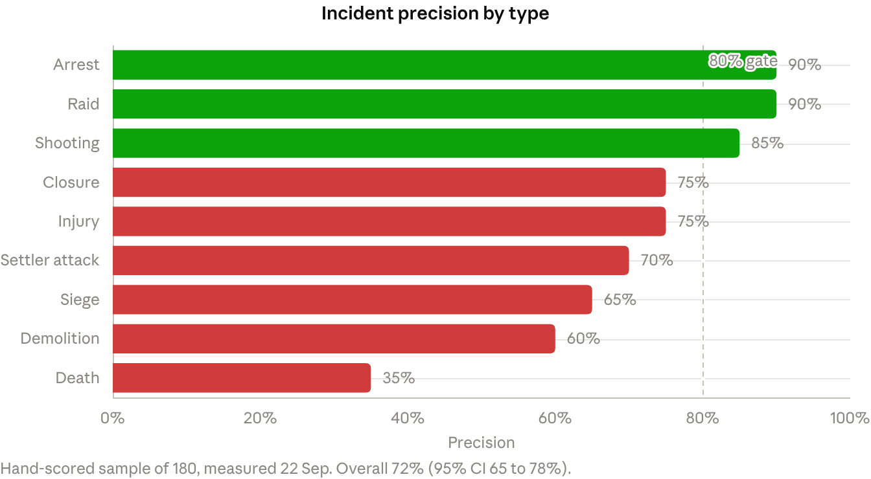
insights quality block, 24 Sep 2026 · 9 incident types
Death is the lowest type at 35%, yet the headline of insights still reports death counts with only the overall caveat attached.

Duplicate merging (fixed in round 4)
- Habla: 5 raid events from 4 channels became 1 event with 5 reports and 4 sources.
- Atara settler attack on 24 Sep: 2 events became 1 with 5 reports and 3 sources.
- Overnight Nablus raid on 23 Sep: now 1 event with 10 reports from 2 sources.
- Effect: insights for Nablus over 7 days fell from 84 to 67 incidents, and corroborated counts rose.

Placement (open)
Each incident now carries named_place and place_precision, which is a good change. But names the system already detects still fall back to the governorate center.
Named place detected | Placed at | Distance shown
Beit Rima (بيت ريما) | Central Ramallah | 0.0 km
Beit Ur (بيت عور) | Central Ramallah | 0.0 km
Abu Falah (ابو فلاح) | Central Ramallah | 0.0 km
al-Mazra'a (المزرعه) | Central Ramallah | 0.0 km
These fallbacks are counted as "Ramallah" in incidents_summary, which is why Ramallah tops the worst-affected list in most windows. A checkpoint name, كراميلو الطيبه, also appears there as an incident place.

Classification (open)
- 24 Sep, 15:15: army bulldozing land in al-Mazra'a al-Gharbiya was recorded as a demolition in Ramallah.
- 24 Sep, 15:14: the army installing an iron gate on the Jariot road near Beit Ur was recorded as a settler attack in al-Bireh.
- 23 Sep, 18:39: a political statement mentioning settlers was recorded as a settler attack in Ramallah (round 1).

Timing
Incident times are when a channel posted, precise to the hour, not when the event happened. The tools say this clearly.

Places and geography
Place resolution is solid in Arabic and for exact checkpoint names, but English names, a few mispinned rows and the town versus checkpoint split still cause wrong or empty answers.
Issue | Example | Status
English names resolve to the governorate center | "Nablus" to 32.1831, 35.2981 (governorate); "نابلس" to 32.2211, 35.2544 (city). On 23 Sep "Ramallah" sat 5.7 km from the city point | Open
Mispinned checkpoint | كراميلو الطيبه at 32.515, 35.186, near Jenin. The Ramallah road bulletin lists it on the Mu'arrajat road east of Ramallah, about 60 km south. English name empty | Open
Town vs checkpoint in place_profile | "Huwara" returns the town row only: no live checkpoint state, 24 empty hours, incidents mostly from Nablus city 6.9 km away | Open
Wrong English names on route checkpoints | "من عين سينا لزعترة" labelled "Za'tarah"; "شارع جنين نابلس" labelled "Nablus" | Open
Match score above 1.0 | 1.04 for Ein Siniya and Atara, 1.011 for Huwara | Open
Fuzzy match to a different checkpoint | "Zaatara" returned Atara, 11 km away | Fixed, round 2
Duplicate checkpoint names | Two "Kafr ad-Dik" rows now told apart by place ID | Fixed, round 2
English area filter in news | "Ramallah" returned 2 items, 3 days and 2 months old | Fixed, round 2
Arabic area filter in crossings | "اريحا" returns 0 crossings | Open
The explicit where_is warning that a town and its namesake checkpoint are different rows is good design. The tools that wrap it, place_profile in particular, do not yet act on it.

Analytics and databank
The analytics tools are careful by design: they refuse misleading correlations and label uncertainty. The remaining problems are stale series presented without their age, one tool that never runs, and presence data mixed into status counts.

insights (added round 2)
One call returns the checkpoint mix, what is closed now, busiest hours, incidents by type and the measured precision of each. Round 4 fixed its main flaws: "changing" now counts real status changes (Awarta 117 in 7 days, Huwara 24), and the checkpoint and direction counts are labelled and explained.
Still open:
- English place names shift the search center (see Places).
- The Arabic label "أزحم الساعات" (most congested hours) describes the hours with the most reports, not the most congestion.
- The headline repeats death counts without the 35% precision for that type.

Staleness in trend and compare
With a governorate filter, WFP food price series end in December 2021, while the national series runs to July 2026. The trend headline still says "last 3 readings flat" with no warning that those readings are nearly five years old.

what_correlates_with
With 20 candidates, 15 are skipped as the same concept and 5 for a different time grain, so 0 tests run. The response still says roughly 1 result would look significant by chance. Unchanged across all five rounds.

Data shape issues
- Presence mixed into status: place_history, place_pattern and area_history count "idf", "inspection" and "police" as values next to open and closed. For Ramallah on one day that was 79 of 871 readings.
- Food units: every food price is labelled ILS per kg, including eggs, milk, drinking water and tea.
- place_history leaves out today, because it reads a nightly rollup.
- compare repeats the attribution on every data point, which makes responses very large.
- The databank description is stale: it says 186k rows and 19 categories; the live count is 206,153 and 20.

Licensing layer
The licensing layer, added in round 3, is the most mature part of the server: all 28 tools are graded and every response now carries its own licence block. What remains is wording, not policy.
Partner tier | Tools | Meaning
Full | 20 | Derived observations the platform may hand on whole; share-alike tools state their ODbL obligation
Filtered | 5 | Databank tools; each row keeps its own licence
Excerpt | 2 | latest_news, search: channel text cut to 250 characters with source and time
Cited fact only | 1 | connectivity_now: IODA is all rights reserved and permission has not been requested yet
Fixed during testing
- IODA was labelled CC BY-NC 4.0 in connectivity_now while the registry said all rights reserved. Round 4 corrected the payload.
- place_profile's note claimed its payload had no coordinates; every incident in it has a latitude and longitude. Corrected in round 4.
- Share-alike tools now spell out that a derived database must carry the same licence.
- checkpoint_status carried an obligation about route geometry it does not return. Removed in round 5.
Still open
- Metadata tools (coverage, data_gaps, licenses, licence_tools) and crossings carry the note "computed from many reports", which does not describe them.
- Checkpoint coordinates are said to come from the platform's own registry, but checkpoint_status still prints "© OpenStreetMap contributors" as its source. One of the two should change.
- Excerpted items report full_text_chars as 500 every time, which looks like a storage cap rather than the true length.
- The licenses source filter does not narrow the headline totals or the pending-permissions list.
- The IODA permission letter is drafted but marked not sent.

Data health and coverage
About half of the 250 tracked checkpoints have a current reading at any moment, the north is barely covered, and 13 pipeline steps have been failing for about a month.
Live checkpoint coverage. 52% of checkpoints had a current reading at 18:17 on 23 Sep (119 of 250 unknown). At 09:00 on 24 Sep it was 37% (157 unknown). Coverage also varies sharply by governorate.
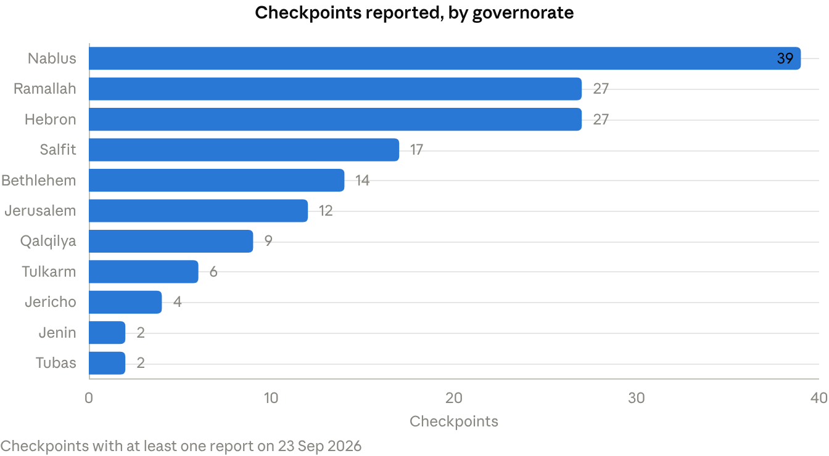
area_history, 1 day · 11 governorates
Jenin and Tubas together had 4 reporting checkpoints, so any answer about the northern West Bank rests on very little.
Failing pipeline steps (as measured 24 Sep, 06:54)
Step | Consecutive failures | Fill path noted by the server
ocha-casualties, ocha-demolitions | 31 | Scraper down; no open mirror exists
pcbs-indicators | 31 | Re-source from PCBS directly (CC BY)
hamoked-detention | 31 | Prisoner data still flows via Addameer
7 databank steps (btselem, gaza, incidents, martyrs, prisoners, structures, ucdp-actions) | 29 | Superseded by v2; fix or retire
learn-corrections, validate | 29 | v1 internal; superseded by v2
The data_gaps headline reads "27 fresh of 32", which is true of the datasets but hides these failures.
Nothing measured at all: crossing status, water, and cooking-gas availability. Upstream dead: UNRWA aid-truck data (stopped 16 Jan 2025) and the Tech for Palestine infrastructure series (ended 5 Oct 2025). Stale: fuel-station availability, last observed 07:31 on 23 Sep; HaMoked prisoner data, 115 days old against a 93-day allowance.
The server's own source scout lists 40 candidates to close gaps, led by the SHCC health-in-conflict dataset, UNRWA refugee data and World Bank infrastructure indicators.

Fix history
Fixes landed in every round after the baseline, with round 4 the largest. Newest first.
Round | Fixed or added
5, 24 Sep 16:47 | can_i_travel names the towns passed, reports route coverage and the longest unverified stretch, and mentions nearby closures in English. Arabic incident summary translates "fire_detection". Wrong geometry obligation removed from checkpoint_status
4, 24 Sep 16:24 | Cross-channel incident merging. can_i_travel lists checkpoints in travel order with ages, adds nearby closures and a "likely open" verdict. insights counts real transitions and explains its counts. Incidents carry named_place and place_precision. IODA licence corrected in the payload. place_profile licence note corrected. Share-alike obligations stated
3, 24 Sep 15:27 | New licence_tools grading all 28 tools. Licence block on every response. Channel text excerpted to 250 characters with disclosure. IODA graded as cited fact only
2, 24 Sep 08:55 | New insights tool. "Zaatara" no longer matches Atara, and a match score is shown. place_pattern headline matches its data. connectivity_now English answer correct. latest_news accepts English areas. search covers the road channel. "Noneh" typo gone. Duplicate closed names separated by ID. Staleness bands explained
1, 23 Sep 18:17 | Baseline. About 35 issues logged

Recommendations
Fix the four P0 items before anyone relies on the server for a travel decision; the rest improve trust and polish.

P0: before relying on it for travel
- ☐ can_i_travel: score the way out of the origin and the way into the destination. Snap the origin city's own exit checkpoints (Ein Siniya, Atara, Beit El, Jalazone for Ramallah) onto every route, or widen the corridor near both ends.
- ☐ can_i_travel: stop saying "likely open" on thin evidence. Return "unverified" when the longest unchecked stretch is over about 10 km, or when a closure sits within about 3 km of the first or last 10 km. Put nearby closures in the headline, not only in near_misses.
- ☐ Place named villages on the map. When named_place is set, geocode it instead of falling back to the governorate. Never count a fallback under the city in incidents_summary.
- ☐ Resolve English names to the locality, not the governorate. "Nablus" and "Ramallah" should land where "نابلس" and "رام الله" do.

P1: correctness
- ☐ Split land bulldozing from demolition, and route gate installation to closure. Re-score the classifier; show per-type precision next to any count below the gate, deaths first.
- ☐ Wire crossings to the King Hussein Bridge checkpoint row, and accept Arabic area names.
- ☐ Make place_profile return both the town and the checkpoint when both exist.
- ☐ Re-pin كراميلو الطيبه and give it an English name; audit other checkpoints for large offsets from their named road.
- ☐ Move army, police and inspection sightings out of status counts in history, pattern and area tools.
- ☐ Put the age of the latest reading into trend and compare headlines.
- ☐ Fix what_correlates_with candidate selection so it tests comparable series, and print the real expected false-positive count.
- ☐ Compute signals_agreeing from the signals; cap match scores at 1.0.
- ☐ Make the filtered weather_now headline speak about the filtered governorate.

P2: polish and data
- ☐ Correct fuel headline effective dates; fix food price units; update the databank description.
- ☐ Tidy licence boilerplate on metadata tools; reconcile the OpenStreetMap source line with the own-registry claim; report true full_text_chars; make the licenses filter narrow totals.
- ☐ Include today in place_history; stop repeating attribution on every compare point.
- ☐ Fix or retire the 13 failing v1 steps, starting with OCHA casualties and demolitions.
- ☐ Add a crossings source (the ingested @JerichoNews channel is a candidate) and more road channels for Jenin and Tubas.
- ☐ Send the IODA permission letter.

Appendix: evidence log
Key test cases behind the findings, newest first. Times are local.
When | Tool and input | Observed | Result
24 Sep 16:47 | can_i_travel رام الله to نابلس | Likely open; via Ofra, Yabrud, Mevo Shillo; coverage 50%, first 26.8 km unverified; Beit El and Ein Siniya closed as near misses | Fail
24 Sep 16:47 | insights "Nablus", 2 km, 1 day | Centered on governorate point; returned Awarta and Beit Furik only | Fail
24 Sep 16:24 | incidents_near حبلة, 1 km, 24 h | 1 raid, 5 reports, 4 sources (was 5 events) | Pass
24 Sep 16:24 | incidents_near رام الله, 8 h | Beit Rima, Beit Ur, Abu Falah, al-Mazra'a all at 0.0 km with governorate precision | Fail
24 Sep 15:27 | checkpoint_status عين سينيا vs can_i_travel | Checkpoint closed, 2 sources, army; route said passable and did not include it | Fail
24 Sep 15:27 | latest_news رام الله vs incidents_near | Land bulldozing became a demolition; gate installation became a settler attack in al-Bireh | Fail
24 Sep 15:27 | licence_tools | 28 of 28 graded; tiers 20 full, 5 filtered, 2 excerpt, 1 cited fact | Pass
24 Sep 09:05 | can_i_travel Ramallah to Nablus vs checkpoint_status حوارة | Route blocked at Huwara; Huwara open 78 min earlier | Fail
24 Sep 09:00 | checkpoint_status "Zaatara" | Resolved to زعتره, score 0.989 | Pass (fixed)
24 Sep 09:00 | place_pattern قلنديا, 30 days | Headline "usually congested, 14 of 19 hours" | Pass (fixed)
24 Sep 08:58 | insights رام الله, 30 days | 790 incidents; death precision 35% in quality block, headline reports 48 deaths | Partial
23 Sep 18:40 | checkpoint_status "Zaatara" | Returned عطارة (Atara): congested, army; real Za'tara open | Fail (fixed later)
23 Sep 18:35 | place_pattern قلنديا | Headline "usually open"; data showed congestion in 16 of 19 hours | Fail (fixed later)
23 Sep 18:30 | crossings vs checkpoints_summary | No source for Allenby; bridge row closed 104 min earlier | Fail
23 Sep 18:25 | what_correlates_with food.price.bread | 20 considered, 0 tested | Fail
23 Sep 18:20 | checkpoints_summary | Auth failed twice, then worked | Intermittent

