

Texas Tech University
Edward E. Whitacre Jr.
College of Engineering

ECE 3311: Electronics
Dr. John Mankowski

Electronics Fall 2025 – Project
Zaied Al Bayati

Submitted by
December 8, 2025

Contents

Abstract 3
Fig 0.1 4
Fig. 0.1 — Reference schematic provided by Dr. John Mankowski, illustrating the overall multi-stage amplifier architecture used as the foundation for this project. 4
Stage One – Common Emitter 4
Fig 1.1 6
Stage two – Common Emitter With $Re$ 7
Fig 2.1 8
Stage three – Class AB Push-Pull 9
Fig 3.1 10
Final multi-stage, linear BJT amplifier 11
Fig 4.1 11
Fig 4.2 12
Fig 4.3 13
Fig 4.4 14
Low pass and High pass filtering 15
Verification 15
Fig 5.1 16
Fig 5.2 16
Fig 5.3 17
Fig 5.4 17
Fig 5.5 17
Conclusion 18
Fig 6.1 19
Fig 6.2 19
Fig 6.3 20
Fig 6.4 20

Abstract
Our task in this project is to design and simulate a multi-stage linear BJT amplifier that can drive a 4 Ω speaker with at least 10 W of RMS power. The input signal is a 1 kHz sinusoidal waveform with a peak amplitude of 5 mV and a source resistance of 100 Ω. The overall design uses 2N5210 transistors for the voltage-gain stages and generic NPN and PNP BJTs for the Class AB push–pull output stage.

The complete circuit is designed and simulated in LTspice using a reference schematic provided by Dr. John Mankowski (see Fig. 0.1), which serves as the foundation for meeting the project requirements. The main design goal is to determine appropriate biasing component values for each stage. For the first stage, these include $R_{B1_1}$, $R_{B1_2}$, $R_{C_1}$, and $R_{E_1}$. For the second stage, the biasing and gain-shaping components are $R_{B2_1}$, $R_{B2_2}$, $R_{C2}$, $R_{e_2}$, and $R_{E}$. For the Class AB push–pull amplifier, $R_{1}$ and $R_{4}$ set the biasing of the output transistors. Finally, $C_{HPF}$ and $C_{LPF}$ are chosen to implement the required high-pass and low-pass filtering.

This report presents the bias calculations for each of the three amplifier stages, along with the resulting input resistance, output resistance, and voltage gain. It also includes transient simulations showing both the input signal $V_{sig}$ and the output signal $V_{out}$, as well as a detailed discussion and analysis of the amplifier’s performance relative to the project specifications.

Fig 0.1
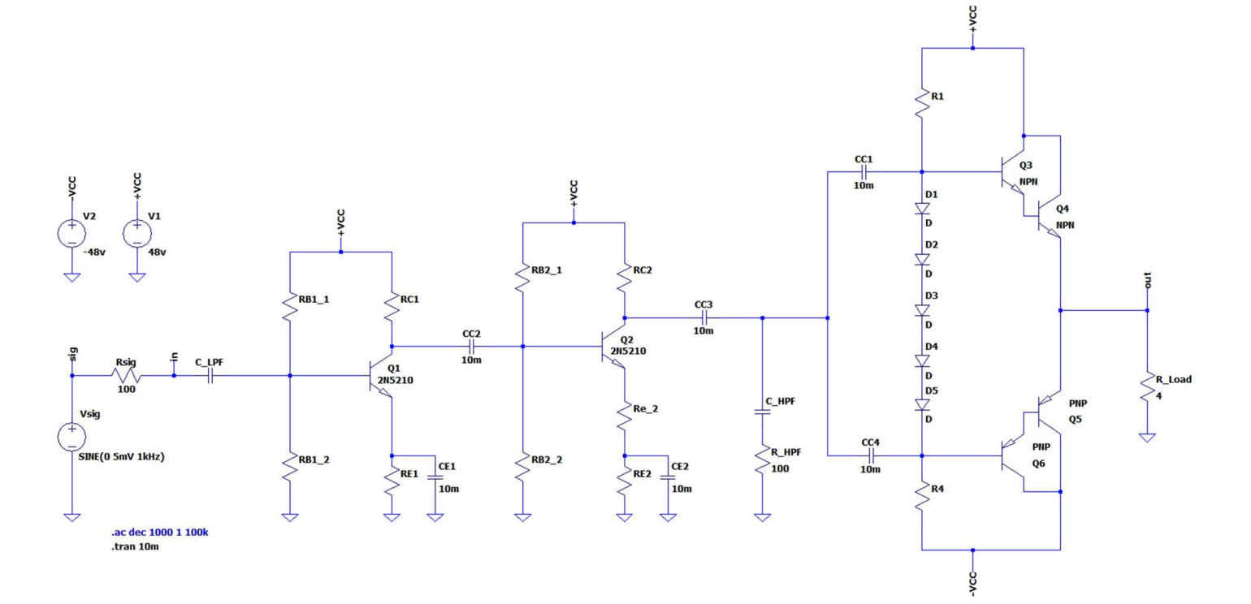

Fig. 0.1 — Reference schematic provided by Dr. John Mankowski, illustrating the overall multi-stage amplifier architecture used as the foundation for this project.

Stage One – Common Emitter
The common-emitter amplifier is our first stage (see Fig. 1.1). This stage does not include an emitter bypass capacitor, allowing it to contribute the majority of the overall voltage gain. To properly bias the transistor, we followed the standard guidelines discussed in class for designing a linear common-emitter amplifier.
The biasing rules used were:
- The DC base voltage should be approximately one-third of the supply voltage.
- The DC collector voltage should be approximately two-thirds of the supply voltage.
- The voltage drop across the collector resistor $R_{C}$should be roughly one-third of $V_{CC}$.
- The current flowing through $R_{1}$and $R_{2}$should be about ten times the emitter current to ensure bias stability.
To satisfy these conditions, we begin by selecting $R_{1}=200\text{ k}Ω$ and $R_{2}=100\text{ k}Ω$. Using the voltage-divider formula:
$$V_{BB}=\frac{R_{2}}{R_{1}+R_{2}} V_{CC}$$
Substituting $V_{CC}=48\text{ V}$, we obtain:
$$V_{BB}=\frac{100\text{ k}Ω}{300\text{ k}Ω}×48\text{ V}=16\text{ V}$$
This result satisfies our design goal of setting the base voltage to approximately one-third of the supply voltage.
Next, choosing a desired collector current of approximately $I_{C}≈10\text{ mA}$ and selecting $R_{C}=1.6\text{ k}Ω$, we find:
$$I_{C}R_{C}≈16\text{ V}≈\frac{1}{3}V_{CC}$$
which confirms that the drop across $R_{C}$ also meets the one-third rule.
Likewise, the collector-to-base voltage satisfies:
$$V_{CB}≈\frac{1}{3}V_{CC}$$
Finally, using $I_{E}≈10\text{ mA}$, the emitter resistor value is:
$$R_{E}=\frac{V_{E}}{I_{E}}$$
which gives:
$$R_{E}=\frac{15.3\text{ V}}{0.01\text{ A}}=1.53\text{ k}Ω$$
With these calculated values, the first-stage common-emitter amplifier is properly biased and provides the high gain required to begin amplifying the 5-mV input signal.

Fig 1.1
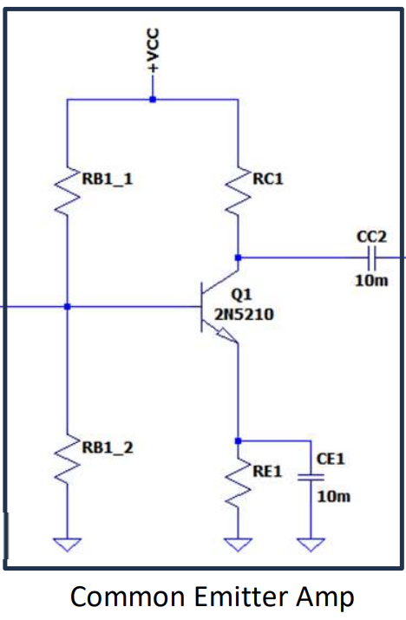
Fig. 1.1 — LTspice schematic of the first-stage common-emitter amplifier, which provides the primary voltage gain and establishes the initial biasing for the multi-stage amplifier.

Stage two – Common Emitter With $R_{e}$
The second stage is a common-emitter amplifier with an unbypassed emitter resistor, as shown in Fig. 2.1. Adding $R_{e}$ introduces local negative feedback, which reduces distortion and gives us fine control over the stage gain. This makes the second stage an important part of tuning the overall voltage gain before the signal reaches the Class AB output stage.
The biasing calculations follow the same rules used for Stage One. For this stage, we select:
- $R_{B2_1}=200\text{ k}Ω$
- $R_{B2_2}=100\text{ k}Ω$
- $R_{C}=1.6\text{ k}Ω$
- $R_{E}=1.45\text{ k}Ω$
- $R_{e}=165 Ω$
As before, the voltage-divider formed by $R_{B2_1}$ and $R_{B2_2}$ sets the base voltage to approximately one-third of the supply voltage, ensuring stable biasing at an emitter current of roughly 10 mA. The small unbypassed emitter resistor $R_{e}$ plays a key role in determining the stage gain:
$$A_{v}≈-\frac{R_{C}}{R_{e}}$$
which allows us to fine-tune the total gain of the cascaded system while managing power consumption and maintaining linearity.
The point of using a cascaded design is that the first stage delivers high gain, while the second stage adjusts and stabilizes that gain to ensure the system operates efficiently and remains within the linear region.

Fig 2.1
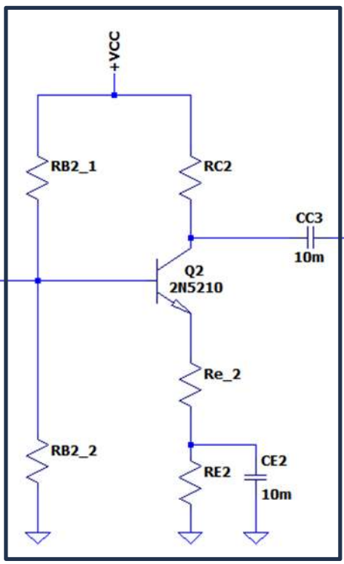
Fig. 2.1 — Common-emitter amplifier with emitter resistor $R_{e}$, used to stabilize biasing and control stage gain.

Stage three – Class AB Push-Pull
The final stage of the amplifier is a Class AB push–pull configuration (see Fig. 3.1). This stage is responsible for supplying the necessary current to drive the 4 Ω speaker while preserving the full voltage swing produced by the earlier stages. Because the load impedance is low, the voltage-gain stages alone cannot deliver sufficient current, making this stage essential for achieving the required 10 W RMS output power.
To reduce crossover distortion—an issue that occurs when the output transitions between the positive and negative halves of the waveform—we employ a diode biasing network. The five diodes in Fig. 3.1 each provide approximately one $V_{BE}$ drop, creating an appropriate forward-bias condition for the NPN and PNP Darlington pairs. This ensures that both transistors remain slightly on at the zero-crossing point, resulting in a smooth handoff between devices and minimizing distortion.
For this design, we set the biasing resistors to:
$$R_{1}=R_{4}=10\text{ k}Ω$$
These resistors help establish the quiescent operating point for the output stage and maintain stable conduction in the Darlington transistors.
The simulated output confirms that the Class AB stage delivers the required current and produces a clean, balanced output waveform when driving the 4 Ω speaker load.

Fig 3.1
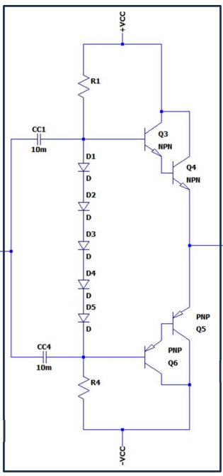
Fig. 3.1 — Class AB push–pull amplifier stage responsible for driving the 4 Ω speaker load.

Final multi-stage, linear BJT amplifier
With all three stages combined, we can begin testing the complete amplifier as it drives the 4 Ω speaker load (see Fig. 4.1). Our initial expectation is that the first stage will provide the majority of the voltage gain, while the second stage will contribute additional gain and offer fine tuning through its unbypassed emitter resistor. Finally, the Class AB push–pull output stage is responsible for delivering the necessary current to the speaker, ensuring that the full voltage swings generated by the earlier stages are preserved without distortion.

Fig 4.1
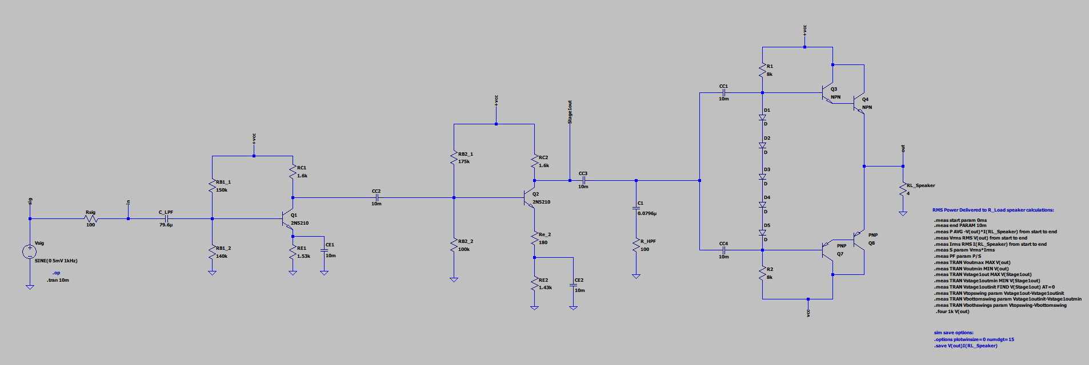
Fig. 4.1 — Complete LTspice schematic of the three-stage amplifier using the initial design parameters.

Fig 4.2
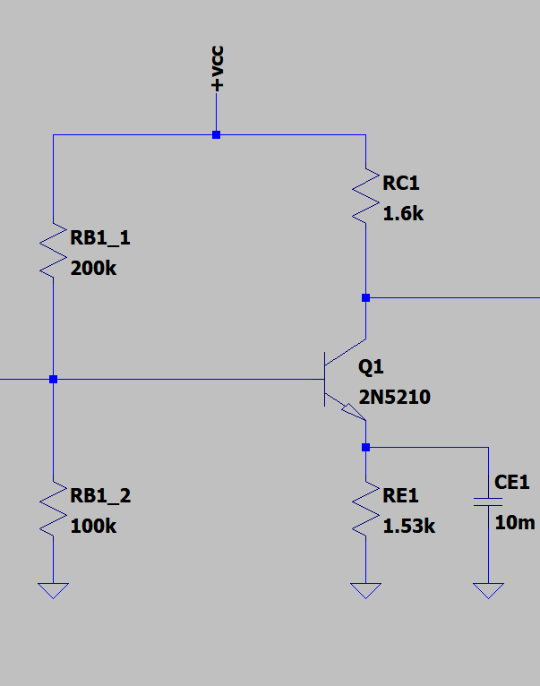
Fig. 4.2 — First-stage common-emitter amplifier modeled in LTspice, showing the implemented biasing and gain-setting resistor values.

Fig 4.3
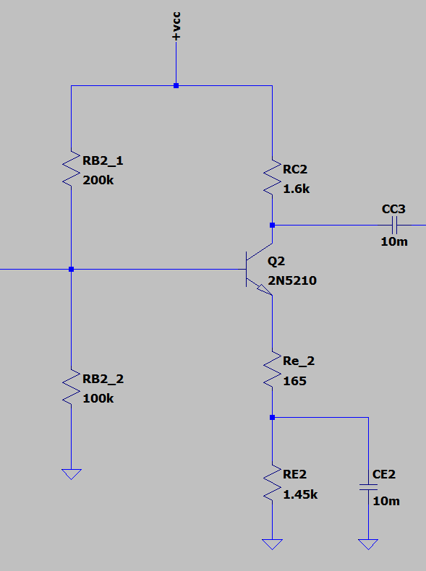
Fig. 4.3 — Second-stage common-emitter amplifier modeled in LTspice, including the unbypassed emitter resistor $R_{e}$used for gain control and stability.

Fig 4.4
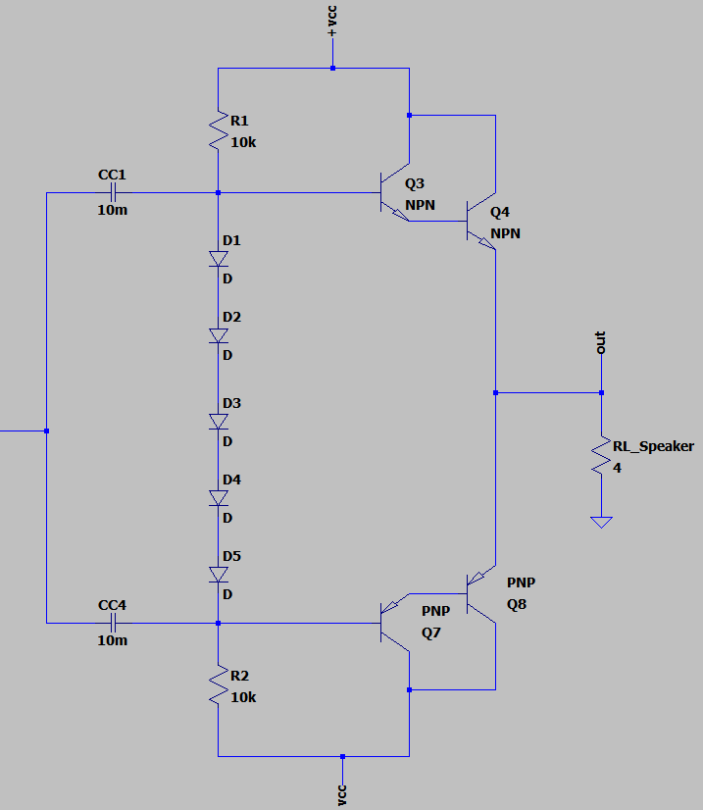
Fig. 4.4 — Class AB push–pull amplifier modeled in LTspice, showing the output stage driving a 4 Ω speaker resistor.

Low pass and High pass filtering
To remove unwanted frequency components and ensure that the amplifier operates within the desired audio range, we select capacitor values such that the lower cutoff frequency is approximately 20 Hz and the upper cutoff frequency is around 20 kHz. The cutoff frequency for a single-pole RC filter is given by:
$$C=\frac{1}{2πRf_{c}}$$
Using this expression and the appropriate resistance values in the circuit, we determine the required filter capacitors. For a target low-pass cutoff frequency near 20 Hz, the calculated value is:
$$C_{LPF}≈12 μ\text{F}$$
Similarly, for a high-pass cutoff frequency near 20 kHz, we obtain:
$$C_{HPF}≈0.008 μ\text{F}$$
These capacitor values place the mid-band gain well within the audio frequency range, filtering out both extremely low and extremely high-frequency components. The simulated filter behavior is shown in Fig. 6.3 and Fig. 6.4.

Verification
To verify the performance of our full amplifier design, we first performed a transient simulation over a 10 ms window, plotting both the input signal $V_{sig}$and the output signal $V_{out}$. These waveforms, shown in Fig. 5.1, Fig. 5.2, and Fig. 5.3, allow us to confirm that the amplifier produces a clean sinusoidal output with proper amplification.
Next, we evaluated whether the 4 Ω speaker load was receiving at least 10 W of RMS power. LTspice provides a built-in measurement function that computes average power across a component during a specified time interval. We used the following directive:
$$\text{.}\text{meas} \text{P }\text{AVG }\text{-V(out)*I(}\text{RL_Speaker}\text{) }\text{FROM }\text{start }\text{TO }\text{en}\text{d}$$
The resulting RMS power measurement is shown in Fig. 5.4.
To assess signal distortion, we performed a Fourier analysis on the output node using the LTspice directive:
$$\text{.four }\text{1k }\text{V(out)}$$
Since our fundamental frequency is 1 kHz, this command calculates harmonic content and allows us to determine total harmonic distortion (THD). Finally, to verify the symmetry and peak-to-peak value of the output waveform, we used additional LTspice measurement directives. The full list of commands used for these evaluations is provided in Fig. 5.5.

Fig 5.1
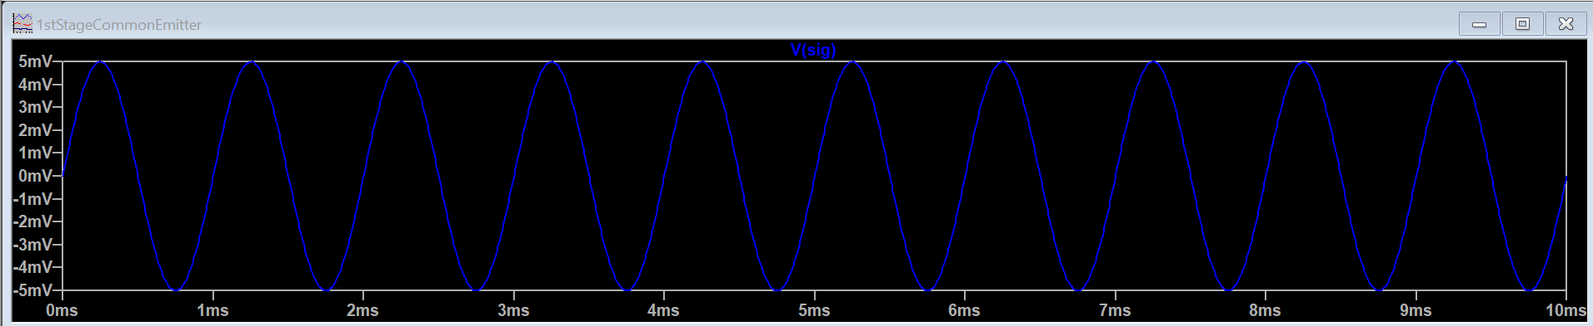

Fig 5.2
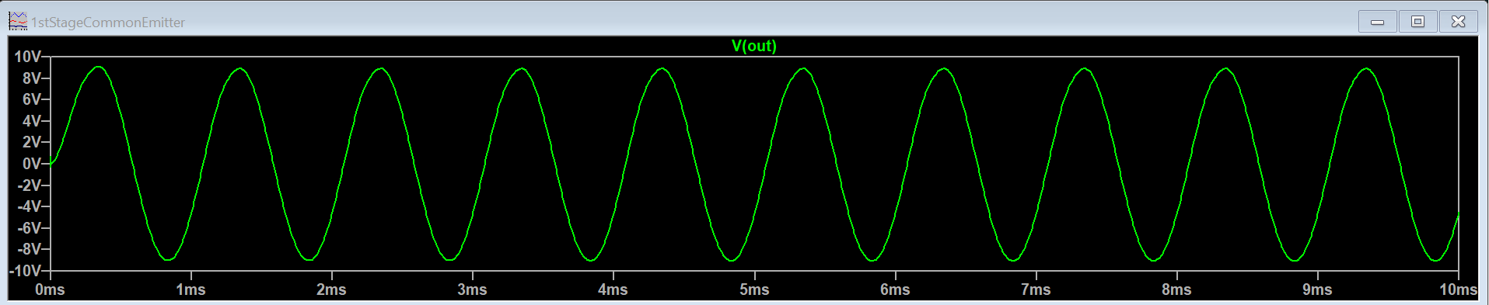

Fig 5.3
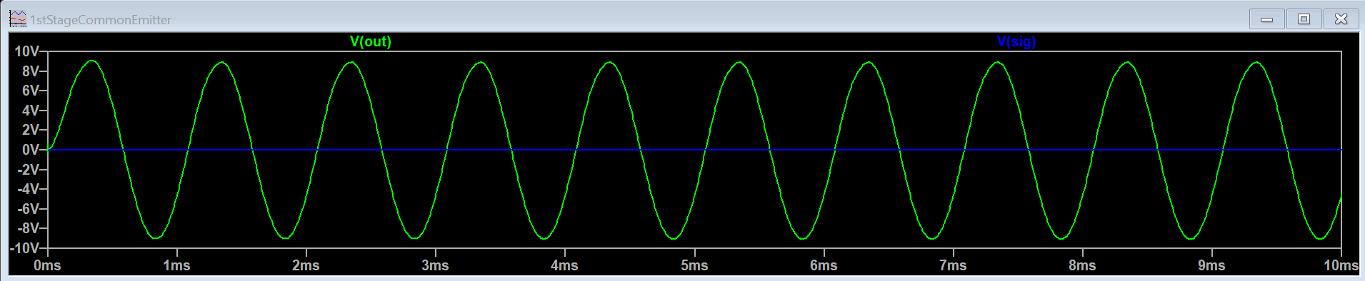

Fig 5.4
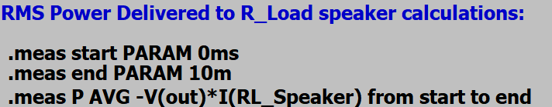

Fig 5.5
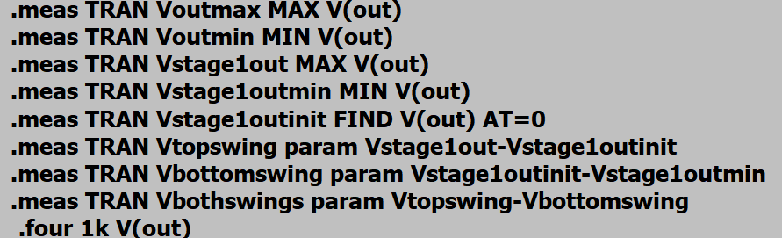

Conclusion
Our results confirm that the final amplifier design meets all project requirements, as shown in Fig. 6.1 through Fig. 6.4. The Fourier analysis indicates approximately 1% distortion relative to the 1 kHz fundamental, demonstrating that the output signal remains highly faithful to the original input. Additionally, the peak-to-peak values of the output waveform differ by only 0.04 V, showing that the positive and negative swings are nearly symmetrical and that crossover distortion has been effectively minimized.
To accurately model the behavior of the 2N5210 transistors in the gain stages, we used a common β value of approximately 250, which corresponds to the typical current gain listed in the device’s datasheet at collector currents near 10 mA. Incorporating this realistic β value into our calculations improved the accuracy of our predicted gains and biasing points before running simulations.
The differences observed between the calculated and simulated overall voltage gain arise mainly from real-device effects such as β variation, Early voltage behavior, and loading interactions between stages. These factors reduce the effective gain compared to ideal hand calculations but are expected in practical amplifier design.
A significant finding in this project was the influence of the emitter resistors $R_{e}$and $R_{E}$in the first two stages. Adjusting these resistors allowed us to control the amplifier’s linearity and greatly improved the symmetry of the output waveform. When $R_{e}$and $R_{E}$were tuned appropriately, the difference between the positive and negative peaks approached zero, giving us a much more balanced signal entering the output stage.
Similarly, we found that adjusting the biasing resistors in the Class AB push–pull amplifier directly affected the RMS power delivered to the 4 Ω speaker. Increasing these resistor values improved the quiescent operating point and allowed the amplifier to deliver higher RMS power without introducing distortion or compromising waveform integrity. This relationship played an essential role in meeting the target of at least 10 W of RMS output power.
The amplifier’s frequency response also aligns with expectations. With cutoff frequencies near 20 Hz and 20 kHz, the design maintains stable mid-band gain across the audible spectrum. The high-pass and low-pass filters perform as intended, ensuring proper attenuation outside the passband and maintaining stability.
Although achieving perfectly ideal behavior proved challenging, the final configuration delivers clean amplification, stable biasing, minimal distortion, and sufficient power to the 4 Ω load. The calculations supporting these results are shown in Fig. 6.1 and Fig. 6.2, and the simulation data confirms that the final design satisfies the project requirements.

Fig 6.1

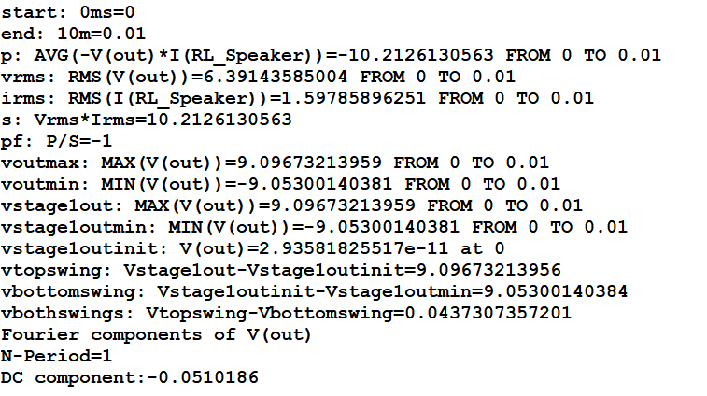

Fig 6.2
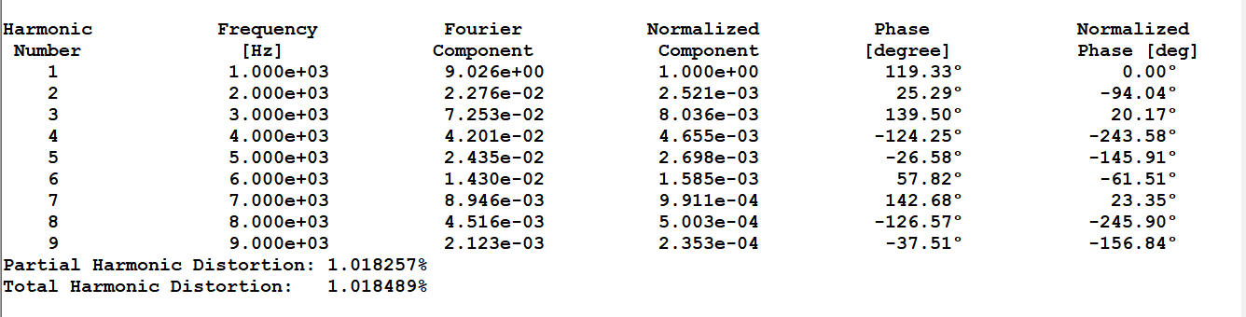

Fig 6.3
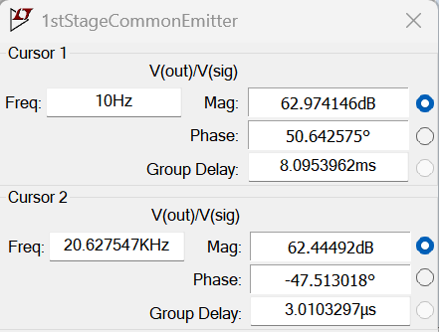

Fig 6.4
