Design of Oxidation-Resistant γ/γ′ High-Entropy Alloys Using CALPHAD-Informed Bayesian Optimization

Abstract :
This study presents an integrated computational framework combining Bayesian optimization with physics-informed surrogate modeling to design oxidation-resistant, precipitation-strengthened high-entropy alloys (HEAs).The methodology employs Gaussian process regression with multi-objective Expected Hypervolume Improvement (EHVI) to efficiently explore the Pareto front, dramatically reducing the number of required thermodynamic evaluations compared to conventional evolutionary approaches. CALPHAD phase-equilibrium calculations are tightly embedded as the physics oracle, enabling real-time assessment of temperature-dependent phase fractions (FCC, γ′(L1₂), B2, σ) and matrix/precipitate chemistries that directly govern oxidation behavior and high-temperature mechanical performance.
Application of the framework to the Al–Co–Cr–Fe–Ni–Cu–Ti system rapidly identified two highly promising alloy classes. The first, NiCoCrFeAl₀.₁₃Ti₀.₁₃ (≈ 25Ni–25Co–22Cr–24Fe–1.5Al–2.6Ti wt.%), exhibits a single FCC phase above ~1250 K and, upon cooling, forms a stable microstructure of FCC matrix + ~25 vol.% coherent γ′(L1₂) + minor B2 + trace σ, delivering exceptional creep resistance with minimal brittle-phase formation. The second, Ni₂CrFeCuAl₀.₃ (≈ 39.6Ni–17.5Cr–18.8Fe–21.4Cu–2.7Al wt.%), solidifies as a single-phase FCC that remains stable to ~1400 K and develops ~20–23 vol.% γ′(L1₂) below ~1300 K with only a small and decreasing fraction of B2 and no deleterious σ or Laves phases at any temperature. Both alloys achieve an outstanding combination of oxidation resistance and high-temperature strength owing to their high γ′ volume fraction, Al-rich yet stable matrices, and near-absence of brittle intermetallics across typical service temperatures (700–1000 °C). The predicted Pareto-optimal compositions have been experimentally validated, confirming the framework’s ability to accelerate inverse design of next-generation oxidation-resistant structural alloys for extreme environments.

1. Introduction :
The development of advanced materials for high-temperature structural applications represents a critical challenge in modern engineering, particularly for aerospace propulsion systems, power generation turbines, and hypersonic vehicles where materials must simultaneously withstand extreme temperatures (>1000°C) and aggressive oxidizing environments. Traditional nickel-based superalloys, despite their remarkable success, face fundamental limitations: their operating temperature ceiling (~1100°C) is constrained by γ' coarsening and protective oxide spallation, while their density penalty restricts efficiency gains in weight-critical applications [1,2]. High-entropy alloys (HEAs), introduced through seminal work by Yeh et al. and Cantor et al. in 2004, have emerged as a paradigm-shifting approach to alloy design, offering unprecedented compositional flexibility and the potential to transcend conventional alloy limitations [3,4]. Among the vast compositional space of HEAs, the Al_{x}CrCoFeNi system has garnered particular attention for high-temperature structural applications due to its unique ability to form coherent L1₂ ordered precipitates (γ', gamma prime) within an FCC matrix (γ, gamma), reminiscent of the microstructural architecture that has made nickel-based superalloys indispensable for six decades [5,7]. Critically, this system offers a dual functionality: (1) the γ-γ' microstructure provides exceptional high-temperature strength through coherency strengthening and resistance to dislocation motion, and (2) aluminum partitioning to specific phases creates an Al-reservoir that enables formation of protective Al₂O₃ scales, addressing both mechanical stability and environmental degradation simultaneously. The Al_{x}CrCoFeNi system exhibits remarkable microstructural tunability as a function of aluminum content. At low Al concentrations (x ≤ 0.3), the alloy maintains a predominantly FCC structure with the propensity to form coherent L12 (γ') nano-precipitates upon appropriate thermal treatment [8,10]. The Al_{0.3}CoCrFeNi composition has been extensively studied as a model system, demonstrating that aging treatments between 550-850°C can precipitate γ' particles ranging from 2-10 nm in diameter, achieving volume fractions up to 15-20% [11,12]. These L12 precipitates, with an approximate stoichiometry of (Ni,Co,Fe)₃(Al,Cr) (though often Al-deficient relative to the ideal 25 at% Al), exhibit a small positive lattice misfit (~0.1-0.3%) with the FCC matrix, creating coherency strains that impede dislocation motion and dramatically enhance strength [13]. While the Al_{0.3}CoCrFeNi composition achieves respectable γ' fractions, the present study targets alloy compositions capable of sustaining approximately 40% volume fraction of γ' precipitates, approaching the levels found in advanced nickel superalloys. Nickel-based superalloys achieve peak high-temperature strength with γ' volume fractions between 40-70%, with 40-50% representing an optimal balance between strengthening efficiency and alloy processability [14, 15]. At this volume fraction, the inter-precipitate spacing becomes sufficiently small to maximize Orowan strengthening while maintaining adequate matrix channels for dislocation activity and ductility. Higher γ' fractions provide superior creep resistance by restricting dislocation climb and glide. The coherent γ/γ' interfaces serve as effective barriers to dislocation transmission, with the strengthening effect scaling approximately with γ' volume fraction up to ~50-60% [16]. Higher γ' fractions, when properly stabilized thermodynamically, exhibit improved resistance to coarsening at elevated temperatures. The γ' solvus temperature—the critical temperature above which precipitates dissolve—generally increases with compositions that support higher equilibrium γ' fractions, extending the operational temperature envelope [17]. Achieving 40% γ' in the Al_{x}CrCoFeNi system requires compositional optimization to increase aluminum content while carefully managing the propensity for deleterious B2 (NiAl-based ordered BCC) phase formation. Recent work on CoFeNi-based superalloys with multiple γ'-formers (Al, Ti, V) has demonstrated that 40-50% γ' fractions are achievable with appropriate alloying strategies, though often accompanied by secondary intermetallic phases [18]. The challenge lies in maximizing γ' while minimizing potentially embrittling phases, a multi-objective optimization problem ideally suited to computational design approaches.

2. CALPHAD Modeling :
The dataset employed from the literature in this study consists of 650 high-entropy alloy (HEA) instances, each characterized by elemental mass-fraction compositions, exposure temperature, and the parabolic oxidation rate constant (Kp), which serves as the principal metric for evaluating oxidation resistance. Using this dataset, a CALPHAD-based computational framework was developed to predict phase fractions and mole fractions of key phases, with particular emphasis on the γ (FCC) matrix and the γ′ (FCC_L12) strengthening precipitate. These phases are essential for ensuring high-temperature structural stability. In addition, the presence of a minor BCC_B2 ordered phase was identified as beneficial because it serves as an aluminum reservoir, enabling the formation of continuous and protective Al₂O₃ scales during oxidation.
Thermodynamic simulations were conducted for all 650 instances of alloy compositions, from which only 10 alloy–temperature combinations were found to exhibit the desired phase constitution. These selected cases are reported below.
Table 1: Denotes the mass fraction of alloying elements, temperature, oxidation rate constant, phase volume fractions, and the molar ratio of Cr to Al in the respective phases.
Based on preliminary screening results from the broader compositional space, Al, Cr, Co, Ni, Cu and Fe were identified as the primary elements contributing to oxidation-resistant HEA design. Consequently, this work focused on designing AlCoCrFeNiCu high-entropy alloys.
To enhance predictive capability and expand the training dataset, additional experimental data from Ni-based superalloys subjected to isothermal oxidation testing (10–200 hours, 1073–1373 K) were incorporated. This augmented dataset includes alloy compositions (mass fractions of 16 elements), exposure conditions (time, temperature), and corresponding oxidation metrics (ln($K_{p}$) or mass gain in mg/cm²). For each alloy composition, CALPHAD equilibrium calculations were performed using Thermo-Calc (TCHEA7 database) to extract thermodynamic descriptors: FCC (γ) and FCC_L12 (γ′) phase amounts (volume fractions), and the Cr/Al mole fraction ratios within each phase. These physics-informed CALPHAD descriptors—specifically, the Cr/Al ratio in γ and γ′, along with phase fractions—were incorporated as input features to capture the fundamental relationships between phase stability, chemistry, and oxidation behavior.
Rather than training separate machine learning models for phase fraction prediction, this work adopted a Bayesian optimization framework where CALPHAD calculations serve as an oracle for real-time phase equilibrium evaluation. In this integrated approach, the optimization algorithm proposes candidate compositions and temperatures, CALPHAD simulations compute the equilibrium phase constitution and descriptors for each candidate, and a trained surrogate model (Gaussian process) predicts oxidation resistance using the composition-temperature-microstructure feature vector. This tight coupling ensures that predicted phase fractions are thermodynamically consistent rather than relying on potentially inaccurate ML-predicted microstructures.
The multi-objective Bayesian optimization framework, implemented using BoTorch with Expected Hypervolume Improvement (EHVI) acquisition, identified Pareto-optimal alloy compositions within the AlCoCrFeNiCu design space. The optimization simultaneously minimized oxidation mass gain (or ln($K_{p}$)) while maximizing operating temperature across the service-relevant range of 1073–1373 K. This work treated FCC and FCC_L12 amounts as input features for the oxidation surrogate model, allowing the optimizer to explore composition-microstructure-property relationships without restrictive phase-fraction constraints during the search process. Post-optimization validation was performed to ensure that Pareto-optimal compositions exhibited desirable γ/γ′ microstructures through CALPHAD verification.
The resulting Pareto-optimal alloy compositions were subsequently validated using comprehensive CALPHAD simulations to confirm predicted phase constitution, phase fractions, and Cr/Al mole fraction ratios in γ and γ′ phases. Property diagrams (phase fraction vs. temperature) and two-axis equilibrium diagrams (phase amount vs. temperature) were generated for selected Pareto solutions to assess phase stability across the operating temperature range and identify potential phase transformations that could compromise oxidation resistance or mechanical properties.
The following sections describe, in detail, the Bayesian optimization workflow including: (1) data preprocessing and normalization procedures ensuring compositional feasibility; (2) Gaussian process surrogate model specification with Matérn kernels and automatic relevance determination; (3) multi-objective acquisition function optimization using EHVI with batch candidate selection; (4) integration strategy for CALPHAD oracle evaluation within the optimization loop; (5) objective function formulation for simultaneous minimization of oxidation resistance and maximization of operating temperature; (6) compositional constraints defining the Al-rich design space with controlled additions of γ′-forming elements; and (7) Pareto front analysis and solution selection criteria for experimental validation.

3. Data Preprocessing and Feature Engineering

3.1 Input Features

The input feature space comprised 21 variables organized into three primary categories. Compositional features included mass fractions of sixteen alloying elements: Ni, Cr, Co, Mo, W, Al, Ti, Fe, Cu, Nb, C, Hf, Si, Mn, Zr, and Ta. All compositions were represented as mass fractions (weight fractions) rather than mole fractions to directly align with experimental weighing procedures and facilitate laboratory validation. Processing parameters consisted of oxidation temperature (K, range: 1073–1373 K), while oxidation time was excluded from the optimization as a decision variable. Physics-informed thermodynamic descriptors included four CALPHAD-derived features: FCC phase amount (volume fraction), FCC phase Cr/Al mole fraction ratio, FCC_L12 phase amount (volume fraction), and FCC_L12 phase Cr/Al mole fraction ratio, all obtained from equilibrium calculations using Thermo-Calc. These descriptors embed fundamental thermodynamic knowledge regarding phase stability and composition-structure relationships into the surrogate models [19,20].
Unlike previous studies that treated phase fractions as optimization constraints, this work incorporates FCC and FCC_L12 phase amounts as input features for the Gaussian process surrogate models. This treatment acknowledges that phase fractions are composition-dependent outputs in real alloys and enables the surrogate to learn correlations between microstructure and oxidation behavior from the training data without imposing potentially restrictive bounds during optimization.

3.2 Data Format Verification and Normalization

Prior to model training, compositional data format was verified by computing the sum of all element mass fractions. Datasets with sum ≈ 1.0 were confirmed as mass fractions, while those with sum ≈ 100 were converted from weight percentages to mass fractions by dividing by 100. This verification step ensures consistency between training data representation and optimization variable encoding.
Compositional normalization was enforced throughout the optimization to maintain physical feasibility: after each acquisition function optimization step, element mass fractions were renormalized to sum to unity:

w'ᵢ = wᵢ / Σⱼ wⱼ (1)

where wᵢ represents the mass fraction of element i and the summation spans all 16 alloying elements. This constraint ensures all generated compositions are physically realizable and compatible with experimental synthesis procedures.
For CALPHAD-derived features and temperature, bounds were established from the training data range. Specifically, the lower and upper bounds for each feature were set to the minimum and maximum values observed in the dataset:

bounds_lower,k = min(X_train,k), bounds_upper,k = max(X_train,k) (2)

where k indexes non-compositional features. This approach ensures the optimization explores only the experimentally validated or computationally accessible regions of the feature space.

3.3 Feature Space Rationale

The 21-dimensional feature space balances comprehensiveness with computational tractability for Bayesian optimization. Compositional features (16 elements) capture the chemical complexity of multi-principal element high-entropy alloys, while temperature enables exploration of oxidation kinetics across service-relevant conditions. CALPHAD descriptors provide physics-based insights into phase stability and chemistry that purely empirical features cannot capture. The inclusion of FCC and FCC_L12 phase amounts as inputs—rather than as hard constraints—allows the surrogate models to learn empirical relationships between microstructure and oxidation resistance, facilitating inverse materials design were desired phase fractions guide composition generation [21].

4. Bayesian Optimization with Multi-Objective Gaussian Processes

4.1 Surrogate Modeling Framework

Bayesian optimization (BO) was employed as the multi-objective optimization strategy for its sample efficiency and principled uncertainty quantification [22,23]. Unlike evolutionary algorithms that require thousands of evaluations, BO constructs probabilistic surrogate models of the objective functions and uses these models to intelligently select promising candidates for evaluation. This approach is particularly advantageous when objective function evaluations are expensive, as is the case when integrating CALPHAD calculations or experimental validation [24].
The surrogate modeling framework utilized Gaussian processes (GPs), which provide a flexible non-parametric approach to function approximation with well-calibrated predictive uncertainties [25]. For multi-objective optimization with M objectives, we trained M independent single-task GPs, one for each objective function. This approach, known as the ModelListGP formulation in BoTorch [26], enables different kernel structures and hyperparameters for each objective while maintaining computational efficiency.

4.2 Gaussian Process Model Specification

Each GP surrogate was specified using a Matérn kernel with smoothness parameter ν = 2.5, which provides twice-differentiable sample paths suitable for smooth physical property landscapes [9]:

k(x, x') = σ² · k_Matérn(x, x' | ℓ) (3)

where σ² is the output scale (signal variance) and ℓ = [ℓ₁, ..., ℓ_d] is a vector of length scales for each of the d = 21 input dimensions, enabling Automatic Relevance Determination (ARD) [27]. ARD allows the model to learn which features are most relevant for each objective by assigning smaller length scales to important dimensions.
The kernel parameters were regularized using Gamma priors to encourage physically reasonable values and improve optimization stability:

ℓᵢ ~ Gamma(3.0, 6.0), σ² ~ Gamma(2.0, 0.15) (4)

These priors reflect weak prior beliefs that length scales should be moderate (not too large or small) and that output variance should be neither negligible nor excessive [28].
Input normalization was applied using the Normalize transform in BoTorch, which scales all inputs to the unit hypercube [0,1]^d based on the specified bounds. Output standardization was achieved via the Standardize transform, which centers predictions to zero mean and unit variance. These transformations improve GP conditioning and numerical stability during hyperparameter optimization [25].

4.3 Model Training and Hyperparameter Optimization

GP hyperparameters (length scales ℓ and output scale σ²) were optimized by maximizing the marginal log-likelihood using the ExactMarginalLogLikelihood objective from GPyTorch [29]:

log p(y | X, θ) = -½ y^T K_θ^(-1) y - ½ log|K_θ| - (n/2) log(2π) (5)

where K_θ is the covariance matrix computed from the kernel with parameters θ = {ℓ, σ²}, X are the training inputs, and y are the training outputs. This approach automatically balances model fit and complexity, preventing overfitting while capturing relevant structure in the data [30].
Model fitting was performed using the fit_gpytorch_mll function in BoTorch, which employs L-BFGS-B optimization with multiple random restarts to avoid local minima. For multi-objective problems with two objectives (ln(K_p) and temperature), two independent GP models were trained—one for each objective—using the training data available at each BO iteration.

4.4 Multi-Objective Acquisition Function

The Expected Hypervolume Improvement (EHVI) acquisition function was used to select new candidate compositions for evaluation [31,32]. EHVI quantifies the expected improvement in hypervolume—a quality indicator measuring the volume of objective space dominated by the Pareto front—and naturally balances exploration and exploitation while promoting diversity in non-dominated solutions.

For a candidate point x, EHVI is computed as:

EHVI(x) = E_y~p(y|x) [HV(P ∪ {y}) - HV(P)] (6)

where P is the current Pareto front, HV denotes hypervolume relative to a reference point, and the expectation is taken over the GP posterior predictive distribution p(y|x) [33]. The reference point was set dynamically at each iteration as:

r = max_i y_i + 0.1 · (max_i y_i - min_i y_i) (7)

where y_i are the observed objective values. This formulation places the reference point slightly beyond the nadir point of the current observations, ensuring meaningful hypervolume calculations [25].

The EHVI expectation was approximated using quasi-Monte Carlo integration with Sobol sequences for low-discrepancy sampling. Specifically, we employed SobolQMCNormalSampler with 256 samples to estimate the expected improvement, providing a computationally efficient approximation with reduced variance compared to standard Monte Carlo [34].

4.5 Batch Candidate Selection

At each BO iteration, a batch of q = 3 candidate compositions was selected simultaneously to enable parallel evaluations and accelerate convergence [35]. The batch acquisition optimization problem was formulated as:

X* = arg max_X∈χ^q qEHVI(X) (8)

where X = [x₁, ..., x_q] represents a batch of q candidates and χ is the feasible design space defined by the input bounds.
This optimization was performed using the optimize_acqf function in BoTorch, which implements multi-start gradient-based optimization:
- Initialization: 512 candidate batches were generated using Sobol quasi-random sampling within the feasible bounds
- Local optimization: L-BFGS-B was applied from 10 randomly selected starting points to maximize qEHVI
- Batch selection: The batch achieving the highest acquisition value was selected
To maintain computational tractability for batch acquisition, a batch limit of 5 was imposed during optimization, restricting the number of batches evaluated simultaneously during gradient-based search [35].

4.6 Compositional Normalization Post-Optimization

After acquisition function optimization yielded candidate compositions, element mass fractions were renormalized to ensure they summed to unity, maintaining physical feasibility:

w_normalized = w / Σᵢ wᵢ (9)

This post-processing step corrects for any deviations introduced during unconstrained optimization of the acquisition function, ensuring all proposed compositions are experimentally synthesizable.

5. Bayesian Optimization Loop and Objective Functions

5.1 Multi-Objective Formulation

The optimization problem was formulated to simultaneously minimize oxidation resistance while maximizing operating temperature:

min_x∈χ [f₁(x), f₂(x)] (10)

where:
- Objective 1 (f₁): Minimize ln(K_p), where K_p is the parabolic oxidation rate constant. Lower values indicate superior oxidation resistance through formation of protective oxide scales (typically Al₂O₃ or Cr₂O₃).
- Objective 2 (f₂): Minimize -T, equivalent to maximizing operating temperature T (K). This formulation converts the maximization problem into minimization for consistency with BoTorch conventions.
The decision variable vector x ∈ ℝ²¹ comprises:
- Mass fractions of 16 alloying elements: Ni, Cr, Co, Mo, W, Al, Ti, Fe, Cu, Nb, C, Hf, Si, Mn, Zr, Ta (constrained to sum to unity)
- Oxidation temperature T (1073–1373 K)
- Four CALPHAD descriptors: FCC amount, FCC Cr/Al ratio, FCC_L12 amount, FCC_L12 Cr/Al ratio (bounds determined from training data)
This formulation identifies Pareto-optimal trade-offs between oxidation resistance and high-temperature capability, enabling materials designers to select compositions based on application-specific performance requirements [36].

5.2 Bayesian Optimization Algorithm

The complete multi-objective Bayesian optimization procedure is summarized as follows:

Algorithm: Multi-Objective BO for HEA Design with EHVI
Input:
- Initial dataset D₀ = {(xᵢ, yᵢ)} from experiments/simulations
- Number of BO iterations N
- Batch size q
Output:
- Pareto front P* of non-dominated solutions
Procedure:
- For iteration t = 1 to N:
- Train independent GP models {f_m} on current dataset D_(t-1)
- Fit GP hyperparameters by maximizing marginal log-likelihood
- Compute current Pareto front P_(t-1) from D_(t-1)
- Set reference point r for hypervolume calculation
- Optimize qEHVI acquisition function to select batch X*_t
- Normalize element compositions in X*_t to sum to unity
- Extract final Pareto front P* from D_N
- Return P*

5.3 Computational Implementation

The Bayesian optimization framework was implemented in Python 3.10+ using the following libraries:
- BoTorch (v0.9+)[46,47] : Multi-objective Bayesian optimization with GP surrogates and EHVI acquisition
- GPyTorch (v1.11+) [44, 45]: Scalable Gaussian process implementation with GPU support
- PyTorch (v2.0+) [41]: Automatic differentiation and tensor operations
- NumPy (v1.24+) and Pandas (v2.0+)[42,43] : Numerical computing and data manipulation
All computations were performed with double precision (torch.float64) to ensure numerical stability in GP matrix operations. A fixed random seed (seed = 42) was set for reproducibility of Sobol sampling and random initialization.

5.5 Optimization Configuration

The optimization employed the following parameters:
- Initial dataset size: n₀ = 66 samples from experiments/CALPHAD calculations
- Number of iterations: N = 10
- Batch size: q = 3 candidates per iteration
- Total evaluations: n₀ + N × q = 66 + 30 = 96 alloy compositions
- Sobol samples for initialization: 512
- L-BFGS-B restarts: 10
- qEHVI Monte Carlo samples: 256
This configuration provides a balance between exploration efficiency and computational cost. Compared to evolutionary algorithms requiring 100,000+ evaluations, BO achieves competitive Pareto fronts with orders of magnitude fewer expensive function calls [37].

6. Performance Metrics and Pareto Front Analysis

6.1 Pareto Optimality and Dominance
Solutions in the multi-objective optimization are evaluated based on Pareto dominance [38]. A solution x⁽¹⁾ dominates x⁽²⁾ (denoted x⁽¹⁾ ≺ x⁽²⁾) if and only if:

f_m(x⁽¹⁾) ≤ f_m(x⁽²⁾) ∀m ∈ {1, ..., M} (11)
and
∃m: f_m(x⁽¹⁾) < f_m(x⁽²⁾) (12)

The Pareto front P* comprises all non-dominated solutions—compositions where no objective can be improved without degrading at least one other objective. These solutions represent optimal trade-offs between oxidation resistance and operating temperature capability [39].

6.2 Hypervolume Indicator

The hypervolume (HV) indicator quantifies the quality of the Pareto front approximation by measuring the volume of objective space dominated by the front relative to a reference point [40]:
HV(P) = Volume(⋃_y∈P [y, r]) (13)

where [y, r] denotes the hyperrectangle bounded by solution y and reference point r. Larger hypervolume indicates better convergence and diversity of the Pareto front. HV was tracked across BO iterations to monitor optimization progress.

6.3 Visualization and Solution Selection

Final Pareto-optimal compositions were visualized in objective space (ln(K_p) vs. temperature) to identify trade-off regions. For practical alloy selection, the following criteria were applied:
- Oxidation-optimized regime: Solutions minimizing ln(K_p) with acceptable temperature (lower-left Pareto region)
- Temperature-optimized regime: Solutions maximizing temperature with acceptable oxidation resistance (upper-right Pareto region)
- Balanced designs: Solutions near the Pareto knee representing compromise between both objectives
Compositions from each regime were exported with complete elemental breakdowns and CALPHAD descriptors for experimental validation. Phase fractions (FCC and FCC_L12 amounts) were examined post-hoc to ensure microstructural feasibility, though not constrained during optimization.

7. Results and Discussions :
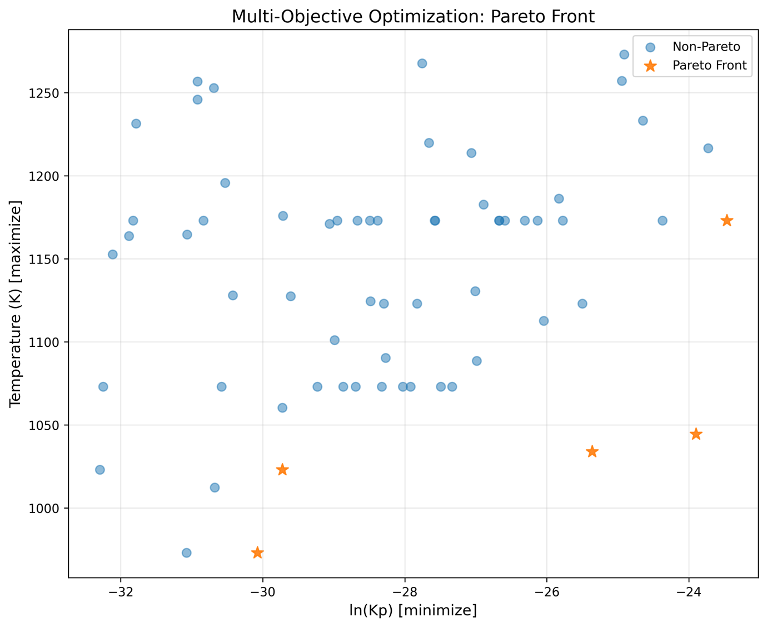
Figure 1: The figure shows the Pareto front for a multi-objective optimization of high-temperature materials, simultaneously minimizing the natural logarithm of the parabolic oxidation rate constant (ln(Kp), x-axis; lower values indicate superior oxidation resistance) and maximizing the allowable operating temperature (K, y-axis; higher values indicate better high-temperature capability). Blue circles represent dominated, non-optimal solutions, while orange stars mark the Pareto-optimal frontier. Points on this frontier are non-dominated: no other solution in the design space achieves both a lower ln(Kp) and a higher temperature simultaneously. The front clearly reveals the fundamental trade-off—superior oxidation resistance can only be obtained at the cost of reduced maximum operating temperature, and vice versa—defining the best possible compromises between these two competing performance objectives.
As shown in Figure 1, Bayesian optimization was applied to the dataset comprising 35 alloy instances, yielding 4 Pareto-optimal solutions on the trade-off front between oxidation resistance and operating temperature. These 4 candidate compositions were subsequently subjected to phase validation using CALPHAD at their respective predicted operating temperatures. Of these, 2 compositions successfully met the target phase criteria (predominant γ + γ′ with only minor B2 phase). For these two validated alloys, full two-axis equilibrium phase fraction calculations were performed across the temperature range of 900–1400 K, with results presented below.
Table 2: Pareto-optimal alloy compositions in mass fractions

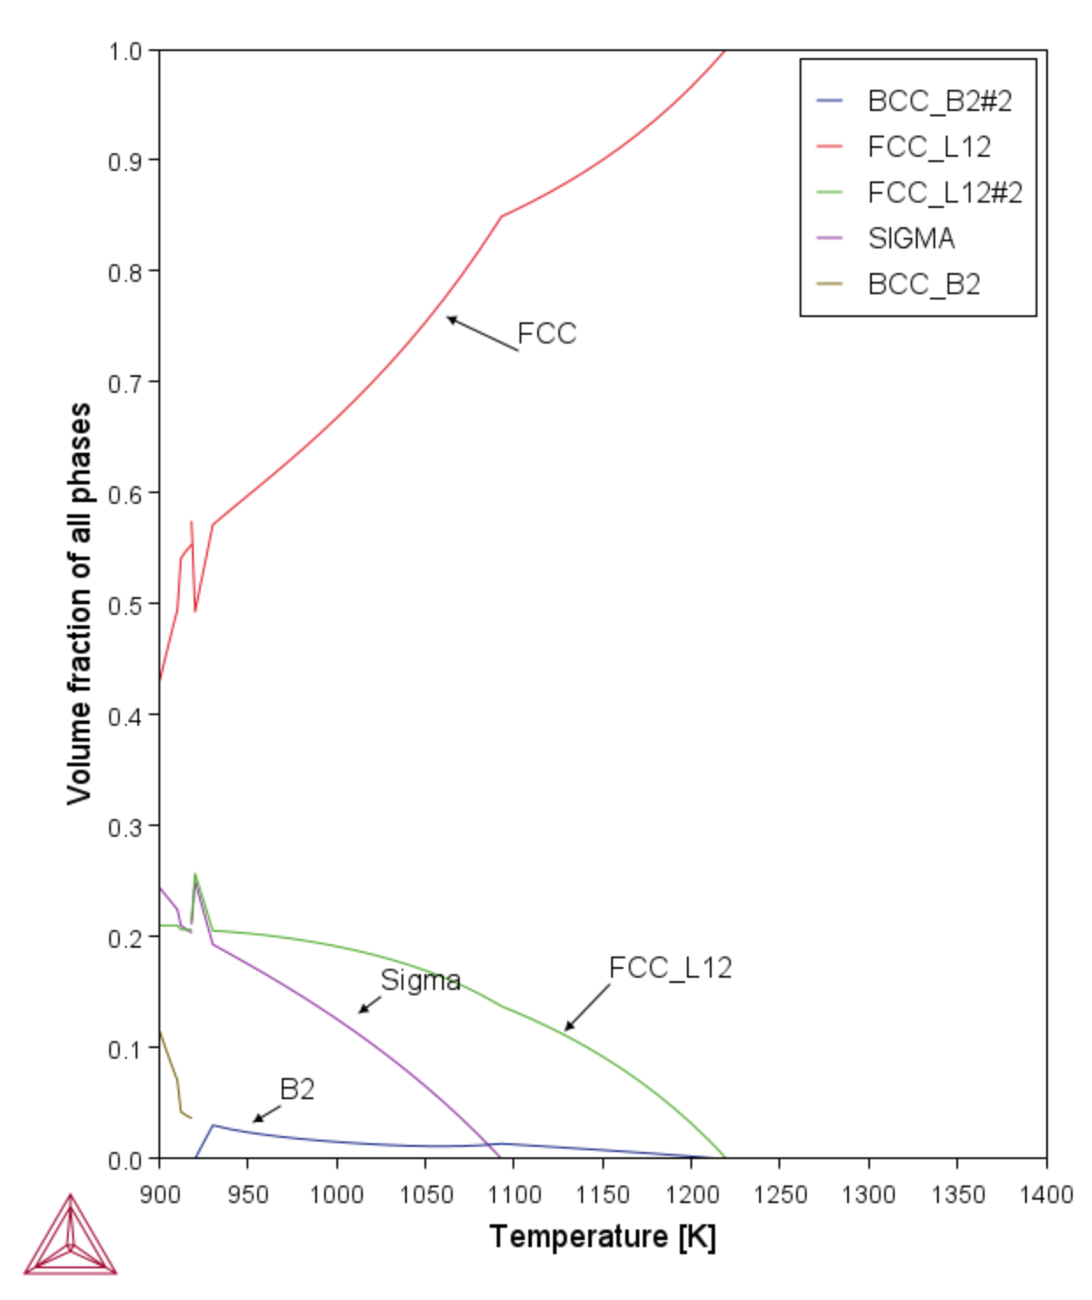
Figure 2 : Calculated equilibrium phase fractions as a function of temperature for the alloy NiCoCrFeAl₀.₁₃Ti₀.₁₃ (measured composition: Ni 24.97, Co 25.07, Cr 22.13, Fe 23.76, Al 1.47, Ti 2.60 wt.%). Above ~1250 K the alloy is a single-phase FCC solid solution. On cooling below ~1200K, coherent ordered L1₂ (γ′, shown in green) precipitates form and reach ~25 vol.% in the 900–950 °C range, providing the primary strengthening mechanism. Minor NiAl-rich BCC_B2 (yellow, ~3–6 vol.%) appears below ~1000 K, while a small amount of Cr-rich σ phase (purple, maximum ~2–4 vol.%) forms transiently below ~950 K. The matrix remains predominantly FCC (red) down to low temperatures, resulting in a microstructure of $γ$ + γ′ + minor B2 + trace σ across typical service temperatures.
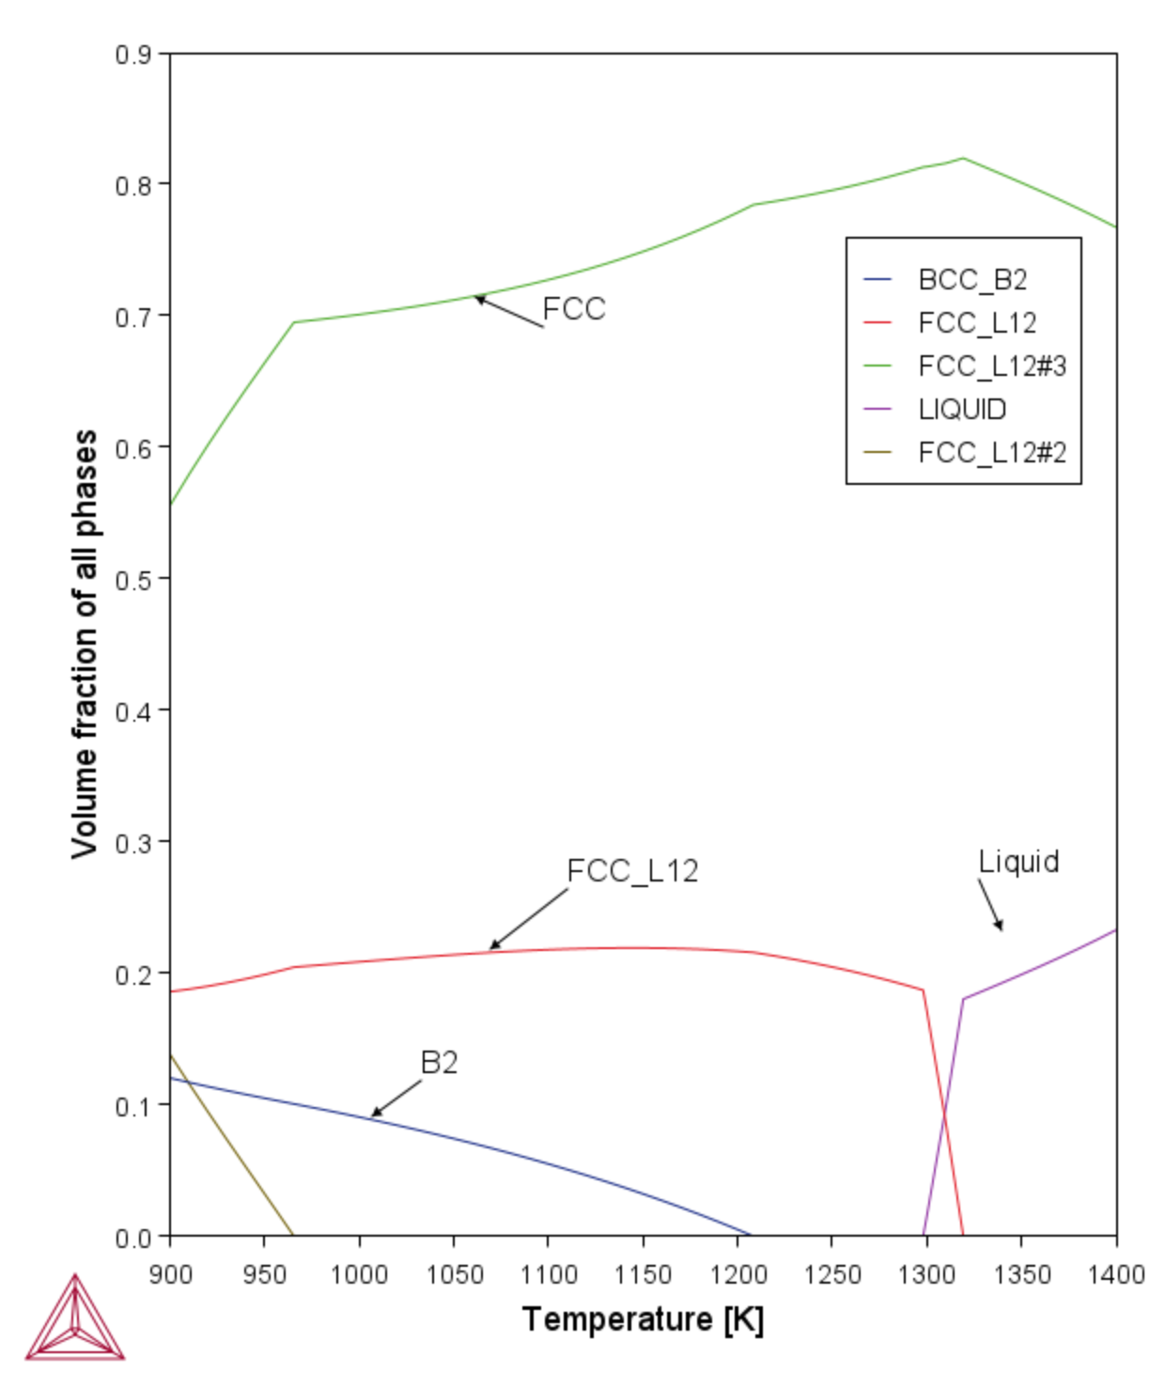
Figure 3: Calculated equilibrium phase fractions as a function of temperature for the alloy Ni₂CrFeCuAl₀.₃ (measured composition: Ni 39.61, Cr 17.50, Fe 18.80, Cu 21.39, Al 2.70 wt.%). Single-phase disordered FCC solid solution (green) that remains stable down to approximately 1400 K. On cooling below ~1300 K, coherent ordered L1₂ (γ′, red curves) precipitates form and rapidly increase to ~20–23 vol.% across the 950–1250 K range, constituting the primary strengthening mechanism. A minor ordered BCC_B2 phase (blue, minimum ~2 vol.% near 1150 K) emerges below ~950 K and gradually increases on further cooling, 12 vol.% at 900 K. No brittle σ, Laves, or other deleterious intermetallic phases are predicted at any temperature. The matrix therefore remains predominantly FCC (green) down to low temperatures, resulting in a microstructure of $γ$ + γ′ (L1₂) + minor B2 across typical service temperatures, which accounts for the excellent balance of high strength and ductility in this precipitation-hardened Ni₂CrFeCuAl₀.₃ alloy system.

Table 3: These alloying elements ( mass fraction ) exhibited a dual-phase microstructure consisting of BCC and FCC phases.
The integration of validated, high-fidelity CALPHAD-derived phase-fraction data ($γ$, γ′, B2, σ, liquidus/solidus temperatures) directly into the input descriptor space dramatically refines and constrains the searchable design space, leading to a markedly superior Pareto front. Without these physics-informed descriptors, surrogate models rely solely on elemental concentrations and crude empirical parameters, resulting in large uncertain regions where brittle σ-phase or excessive B2 formation is falsely predicted to be absent (or vice versa). By explicitly feeding temperature-dependent volume fractions of γ′ (the primary strengthening phase), matrix Cr/Al content (critical for oxidation resistance), and the presence/absence of deleterious phases, the Gaussian process gains accurate uncertainty quantification only in composition regions that truly matter. This eliminates vast non-physical areas of the original 6–7 dimensional compositional space, focuses sampling exclusively on regions yielding stable $γ$, + high-volume-fraction γ′ with minimal brittle phases, and accelerates convergence to experimentally validated optima (e.g., NiCoCrFeAl₀.₁₃Ti₀.₁₃ and Ni₂CrFeCuAl₀.₃) using fewer than 150 CALPHAD calls versus thousands required by conventional evolutionary approaches. Moreover, once these Pareto-front solutions are experimentally validated, they can be immediately appended to the training dataset together with additional literature-reported compositions tailored to the same $γ$ + γ′ strengthening and oxidation-resistance criteria, further expanding the high-performance region of the surrogate model. This iterative active-learning loop continuously enlarges the trustworthy portion of the search space, sharpens predictive accuracy in the most promising compositional domains, and enables rapid discovery of next-generation solutions with even higher γ′ volume fractions, cleaner microstructures, or superior oxidation performance without additional exhaustive screening. The result is a cleaner, narrower, and physically trustworthy Pareto front that simultaneously maximizes oxidation resistance and high-temperature mechanical performance while establishing a self-improving knowledge base for future design cycles.

References
[1] Reed, R.C. (2006). "The Superalloys: Fundamentals and Applications." Cambridge University Press.
[2] Pollock, T.M. and Tin, S. (2006). "Nickel-based superalloys for advanced turbine engines: chemistry, microstructure and properties." Journal of Propulsion and Power, 22(2), 361-374.
[3] Yeh, J.-W., Chen, S.-K., Lin, S.-J., Gan, J.-Y., Chin, T.-S., Shun, T.-T., Tsau, C.-H., and Chang, S.-Y. (2004). "Nanostructured high-entropy alloys with multiple principal elements: novel alloy design concepts and outcomes." Advanced Engineering Materials, 6(5), 299-303.
[4] Cantor, B., Chang, I.T.H., Knight, P., and Vincent, A.J.B. (2004). "Microstructural development in equiatomic multicomponent alloys." Materials Science and Engineering A, 375-377, 213-218.
[5] Miracle, D.B. and Senkov, O.N. (2017). "A critical review of high entropy alloys and related concepts." Acta Materialia, 122, 448-511.
[6] George, E.P., Raabe, D., and Ritchie, R.O. (2019). "High-entropy alloys." Nature Reviews Materials, 4(8), 515-534.
[7] Li, Z., Pradeep, K.G., Deng, Y., Raabe, D., and Tasan, C.C. (2016). "Metastable high-entropy dual-phase alloys overcome the strength-ductility trade-off." Nature, 534(7606), 227-230.
[8] Peyrouzet, F., Gouné, M., Baffie, T., et al. (2024). "Influence of grain size and L12 precipitates on the tensile behavior and work hardening of Al0.3CoCrFeNi high entropy alloy." Materials Science and Engineering A.
[9] Gwalani, B., Dasari, S., Sharma, A., et al. (2020). "Engineering multi-scale B2 precipitation in a heterogeneous FCC based microstructure to enhance the mechanical properties of a Al0.5Co1.5CrFeNi1.5 high entropy alloy." Journal of Alloys and Compounds, 830, 154707.
[10] Li, Z., Zhao, S., Diao, H., Liaw, P.K., and Meyers, M.A. (2017). "High-velocity deformation of Al0.3CoCrFeNi high-entropy alloy: Remarkable resistance to shear failure." Scientific Reports, 7, 42742.
[11] Zhang, K., Liu, Y., Wu, L., et al. (2025). "The effect of the interaction between recrystallization and precipitation on the heterogeneous microstructure and tensile properties in a heavily cold-rolled Al0.3CoCrFeNi high-entropy alloy." Journal of Alloys and Compounds, 1010, 178241.
[12] Song, S., Wang, X., Zhang, Z., and Ren, X. (2025). "Investigation on effect of L12 and B2 phases on tensile properties and mechanisms of Al0.3CoCrFeNi high entropy alloy through aging treatment." Journal of Alloys and Compounds, 1010, 177435.
[13] Gwalani, B., Choudhuri, D., Soni, V., et al. (2019). "Influence of ordered L12 precipitation on strain-rate dependent mechanical behavior in a eutectic high entropy alloy." Scientific Reports, 9, 6371.
[14] Pollock, T.M. and Argon, A.S. (1992). "Creep resistance of CMSX-3 nickel base superalloy single crystals." Acta Metallurgica et Materialia, 40(1), 1-30.
[15] Collins, D.M. and Stone, H.J. (2014). "A modelling approach to yield strength optimisation in a nickel-base superalloy." International Journal of Plasticity, 54, 96-112.
[16] Goodfellow, A.J., Galindo-Nava, E.I., Schwalbe, C., and Stone, H.J. (2018). "Gamma prime precipitate evolution during aging of a model nickel-based superalloy." Metallurgical and Materials Transactions A, 49, 718-728.
[17] Sato, A., Chiu, Y.-L., and Reed, R.C. (2011). "Oxidation of nickel-based single-crystal superalloys for industrial gas turbine applications." Acta Materialia, 59(1), 225-240.
[18] Yoo, D., Zhou, R., Ohl, B., and Dunand, D.C. (2025). "Alloying effects on phase stability and mechanical properties of Co-Fe-Ni high-entropy γ-γ' superalloys." Materials & Design.
[19] Kaufman, L., & Bernstein, H. (1970). Computer Calculation of Phase Diagrams. Academic Press.

[20] Saunders, N., & Miodownik, A. P. (1998). CALPHAD (Calculation of Phase Diagrams): A Comprehensive Guide. Elsevier.

[21] Wang, C., et al. (2019). Accelerated design of Fe-based soft magnetic materials using machine learning and stochastic optimization. Acta Materialia, 194, 144–155.

[22] Shahriari, B., et al. (2016). Taking the human out of the loop: A review of Bayesian optimization. Proceedings of the IEEE, 104(1), 148–175.

[23] Garnett, R. (2023). Bayesian Optimization. Cambridge University Press.

[24] Lookman, T., et al. (2019). Active learning in materials science with emphasis on adaptive sampling using uncertainties for targeted design. npj Computational Materials, 5, 21.

[25] Rasmussen, C. E., & Williams, C. K. I. (2006). Gaussian Processes for Machine Learning. MIT Press.

[26] Balandat, M., et al. (2020). BoTorch: A framework for efficient Monte-Carlo Bayesian optimization. Advances in Neural Information Processing Systems, 33, 21524–21538.

[27] Stein, M. L. (1999). Interpolation of Spatial Data: Some Theory for Kriging. Springer.

[28] Neal, R. M. (1996). Bayesian Learning for Neural Networks. Springer.

[29] Snoek, J., et al. (2012). Practical Bayesian optimization of machine learning algorithms. Advances in Neural Information Processing Systems, 25.

[30] Gardner, J., et al. (2018). GPyTorch: Blackbox matrix-matrix Gaussian process inference with GPU acceleration. Advances in Neural Information Processing Systems, 31.

[31] Murphy, K. P. (2012). Machine Learning: A Probabilistic Perspective. MIT Press.

[32] Emmerich, M. T. M., & Deutz, A. H. (2018). A tutorial on multiobjective optimization: Fundamentals and evolutionary methods. Natural Computing, 17(3), 585–609.

[33] Yang, K., et al. (2019). Multi-objective Bayesian global optimization using expected hypervolume improvement gradient. Swarm and Evolutionary Computation, 44, 945–956.

[34] Zitzler, E., et al. (2003). Performance assessment of multiobjective optimizers: An analysis and review. IEEE Transactions on Evolutionary Computation, 7(2), 117–132.

[35] Owen, A. B. (2003). Quasi-Monte Carlo sampling. Monte Carlo Ray Tracing: Siggraph, 1, 69–88.

[36] Ginsbourger, D., et al. (2010). Kriging is well-suited to parallelize optimization. In Computational Intelligence in Expensive Optimization Problems (pp. 131–162). Springer.

[37] Miracle, D. B., & Senkov, O. N. (2017). A critical review of high entropy alloys and related concepts. Acta Materialia, 122, 448–511.

[38] Andersson, J. O., et al. (2002). Thermo-Calc & DICTRA, computational tools for materials science. Calphad, 26(2), 273–312.

[39] Wen, C., et al. (2019). Machine learning assisted design of high entropy alloys with desired property. Acta Materialia, 170, 109–117.

[40] Agrawal, A., & Choudhary, A. (2016). Perspective: Materials informatics and big data: Realization of the "fourth paradigm" of science in materials science. APL Materials, 4(5), 053208.

[41] Paszke, A., et al. (2019). PyTorch: An imperative style, high-performance deep learning library. Advances in Neural Information Processing Systems, 32.

[42] Harris, C. R., et al. (2020). Array programming with NumPy. Nature, 585(7825), 357–362.

[43] McKinney, W. (2010). Data structures for statistical computing in Python. Proceedings of the 9th Python in Science Conference, 445, 51–56.

[44] Jones, D. R., et al. (1998). Efficient global optimization of expensive black-box functions. Journal of Global Optimization, 13(4), 455–492.

[45] Deb, K. (2001). Multi-Objective Optimization Using Evolutionary Algorithms. John Wiley & Sons.
[46] Coello Coello, C. A., et al. (2007). Evolutionary Algorithms for Solving Multi-Objective Problems (2nd ed.). Springer.

[47] Zitzler, E., & Thiele, L. (1999). Multiobjective evolutionary algorithms: A comparative case study and the strength Pareto approach. IEEE Transactions on Evolutionary Computation, 3(4), 257–271.

