

Object Oriented Programming Lab

Assignment 1

Submitted by: 241484_Huzaifa Basit

To: Sir Mahaz

Cyber Security Fall 2024-B

Question 1:

C++ Code:

#include<iostream>

using namespace std;

class Rectangle

{

    int length;

    int width;

    public:

    Rectangle(int l=0, int w=0)

    {

        length=l;

        width=w;

    }

    void setvalue(int l, int w)

    {

        length=l;

        width=w;

    }

    void getvalue(int l,int w)

    {

        int area=l*w;

        cout<<"The area of reactangle is "<<area<<endl;

        int perimeter=2*(l+w);

        cout<<"The perimeter of rectangle is "<<perimeter<<endl;

    }

};

int main()

{

    Rectangle r;

    int no1, no2;

    cout<<"Enter your length of rectangle: ";

    cin>>no1;

    cout<<"Enter your width of rectangle: ";

    cin>>no2;

    r.setvalue(no1,no2);

    r.getvalue(no1,no2);

}

Output:

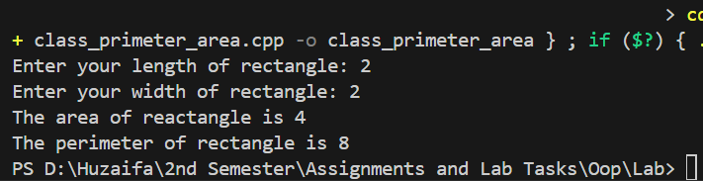

Question 2

C++ Code:

#include<iostream>

using namespace std;

class Student

{

    string employee_name;

    int employee_age;

    char employee_gender;

    public:

    Student(string en="Unknown", int ea=0, char eg='N')

    {

        employee_name=en;

        employee_age=ea;

        employee_gender=eg;

    }

    void setvalue(string en, int ea, char eg)

    {

        employee_name=en;

        employee_age=ea;

        employee_gender=eg;

    }

    void getvalue(string en, int ea, char eg)

    {

        cout<<"\tDisplaying The student Information\n";

        cout<<" Name of student 1: "<<en<<endl;

        cout<<"Age of student 1: "<<ea<<endl;

        cout<<"Gender of student 1: "<<eg<<endl;

        cout<<" Name of student 1: "<<en<<endl;

        cout<<"Age of student 1: "<<ea<<endl;

        cout<<"Gender of student 1: "<<eg<<endl;

    }

};

int main()

{

    Student s1,s2;

    string s1_name;

    int s1_age;

    char s1_gender;

    string s2_name;

    int s2_age;

    char s2_gender;

    cout<<"\tEntering values\n";

    cout<<"Enter your name: ";

    cin>>s1_name;

    cout<<"Enter your age: ";

    cin>>s1_age;

    cout<<"Enter your gender: ";

    cin>>s1_gender;

    s1.setvalue(s1_name,s1_age,s1_gender);

    s2.setvalue(s2_name,s2_age,s2_gender);

    cout<<"Enter your name: ";

    cin>>s2_name;

    cout<<"Enter your age: ";

    cin>>s2_age;

    cout<<"Enter your gender: ";

    cin>>s2_gender;

    s1.getvalue(s1_name,s1_age,s1_gender);

    s2.getvalue(s2_name,s2_age,s2_gender);

}

Output:

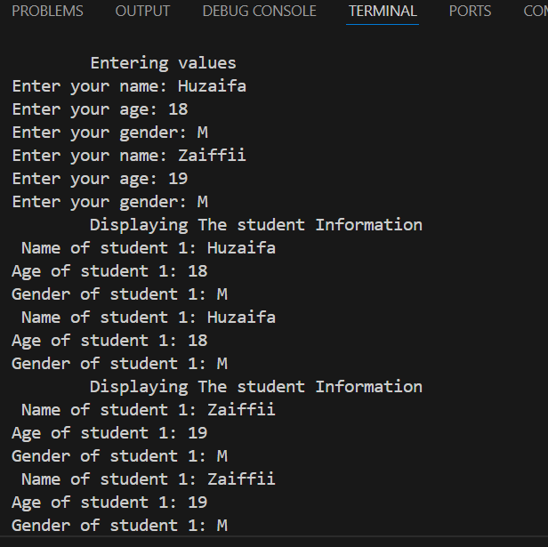

Question 3

C++ Code:

#include<iostream>

using namespace std;

class Bank

{

    string bank_name;

    int account_no;

    double balance;

    public:

    Bank(string bn="Unknown", int an=0, float b=0)

    {

        bank_name=bn;

        account_no=an;

        balance=b;

    }

    void opening_account();

    void show_account_info();

    void deposit();

    void withdrawal();

    void search();

};

int main()

{

    Bank p1;

    bool exit=false;

    do

    {

        int choice;

        cout<<"Press 1 to Open your account\n";

        cout<<"Press 2 to View your account info\n";

        cout<<"Presss 3 to deposit\n";

        cout<<"Press 4 to withdrawal\n";

        cout<<"Press 5 to search\n;";

        cout<<"Press 6 to exit\n";

        cout<<"Enter the operation you want to perform: ";

        cin>>choice;

        switch (choice)

        {

            case 1:

                p1.opening_account();

            break;

            case 2:

                p1.show_account_info();

            break;

            case 3:

                p1.deposit();

            break;

            case 4:

                p1.withdrawal();

            break;

            case 5:

                p1.search();

            break;

            case 6:

                cout<<"\tExiting\n";

                cout<<"Hope to see your soon\n";

                exit=true;

            break;

            default:

                cout<<"Enter a valid choice";

        }

    }while(exit==false);

}

void Bank::opening_account()

{

    cout<<"\tOpening account\n";

    cout<<"Enter your bank account name: ";

    cin>>bank_name;

    cout<<"Enter your bank account number: ";

    cin>>account_no;

    cout<<"Enter your opening balance: ";

    cin>>balance;

}

void Bank::show_account_info()

{

    cout<<"\tShowing account info\n";

    cout<<"Bank name: "<<bank_name<<endl;

    cout<<"Account number: "<<account_no<<endl;

    cout<<"Balance: "<<balance<<endl;

}

void Bank::deposit()

{

    cout<<"\tDepositing amount\n";

    double deposit;

    do

    {

        cout<<"Enter the amout you want to deposit in your bank account: ";

        cin>>deposit;

        if(deposit>0)

        {

            balance+=deposit;

            cout<<"New Balance: "<<balance<<endl;

        }

        else

            cout<<"Please enter a valid amout!\n";

    }while(deposit<0);

}

void Bank::withdrawal()

{

    cout<<"\tWithdrawing amount\n";

    double withdrawal;

    do

    {

        cout<<"Enter the amount you want to widthdrawal from your bank account: ";

        cin>>withdrawal;

        if(withdrawal>0 && withdrawal<balance)

        {

         balance-=withdrawal;

         cout<<"New balance: "<<balance<<endl;

        }

        else

            cout<<"Please enter a valid amount!\n";

    }while(withdrawal>0 && withdrawal<balance);

}

void Bank::search()

{

    cout<<"\tSearching for account\n";

    int search_account_no;

    do

    {

    cout<<"Enter the account number that you want to search: \n";

    cin>>search_account_no;

    if(search_account_no==account_no)

        show_account_info();

    else

        cout<<"Please enter a valid account number to search!\n";

    }while(search_account_no!=account_no);

}

Output:

