

Object Oriented Programming Lab

Lab Task 4

Submitted by: 241484_Huzaifa Basit

To: Sir Mahaz

Cyber Security Fall 2024-B

Student Management

C++ Code:

#include<iostream>

using namespace std;

class student

{

int rollno;

string firstname;

string lastname;

string classname;

double marks;

char grade;

public:

student(int rn=0,string fn="unknown", string ln="uknown", string cn="unknown", double m=0, char g='U')

{

rollno=rn;

firstname=fn;

lastname=ln;

classname=cn;

marks=m;

grade=g;

}

void setvalue(int rn,string fn, string ln, string cn, double m, char g)

{

rollno=rn;

firstname=fn;

lastname=ln;

classname=cn;

marks=m;

grade=g;

}

void getvalue()

{

cout<<"Your rollno is: "<<rollno<<endl;

cout<<"Your first name is: "<<firstname<<endl;

cout<<"Your lastname is: "<<lastname<<endl;

cout<<"Your classname is: "<<classname<<endl;

cout<<"Your marks are: "<<marks<<endl;

cout<<"Your grade is: "<<grade<<endl;

}

};

int main()

{

student s1;

int roll;

string first, last, classn;

double mar;

char gra;

cout<<"\tInputting Information\n";

cout<<"Enter your rollno: ";

cin>>roll;

cout<<"Enter your first name: ";

cin>>first;

cout<<"Enter your last name: ";

cin>>last;

cout<<"Enter your class name: ";

cin>>classn;

cout<<"Enter your marks: ";

cin>>mar;

cout<<"Enter your grade: ";

cin>>gra;

s1.setvalue(roll,first,last,classn,mar,gra);

cout<<"\tDisplaying Information\n";

s1.getvalue();

}

Output:

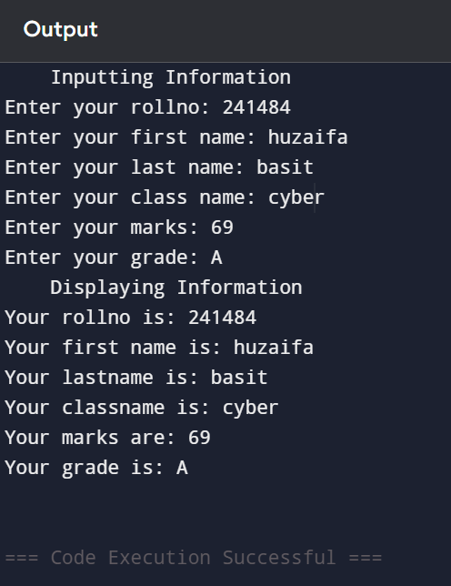

Constructor Overloading

C++Code:

#include<iostream>

using namespace std;

class Student

{

string name;

int age;

public:

Student()

{

name="Unknown";

age=0;

}

Student(string na, int ag)

{

name=na;

age=ag;

}

void setvalue(string n, int a)

{

name=n;

if(a>0 && a<150)

age=a;

else

cout<<"Your age is invalid";

}

void getvalue()

{

cout<<"Name: "<<name<<endl;

cout<<"Age: "<<age<<endl;

}

};

int main()

{

string s1name;

int s1age;

cout<<"\tInputting Details\n";

cout<<"Enter your name: ";

cin>>s1name;

cout<<"Enter your age: ";

cin>>s1age;

Student s1(s1name,s1age);

Student s2;

cout<<"\tDisplaying Details\n";

s1.getvalue();

s2.getvalue();

}

Output:

