**Title:**

**Vehicle to Grid Bidirectional Inverter design for Grid Stability**

**Abstract**

The price of fossil fuel is increasing day by day and the production of electricity is also getting a direct effect. Therefore, people are introducing the alternate technologies that should be cheaper, reliable and can fulfill our requirement of electricity. V2G is one of the important steps in this regard. We can fulfill our urgent electricity requirements by vehicles that are parked in a charging station for more than 6-7 hours. The major concern of our work is to work on the bidirectional inverter. That can give supply to the grid and also charge the vehicle when it is needed.

**Introduction:**

Vehicle-to-Grid (V2G) is determined by Amory Lovins in 1995 firstly, and William Kempton developed it. The primary concept of V2G is that EVs can provide energy to the power system when it parked, battery of EVs can charge during low demand times and discharge when power is needed [1]. People go to work and their vehicle keep parked in parking lot of company more than 6-7 hours and there is no use of them at that time. In our work, we will utilize those vehicles in combined form. As the number of electric vehicles will increase in the parking lot it will influence a good result on the electric grid utility. We will connect all the batteries of those vehicles and provide supply to the grid during peak hours [2]. We will also charge the batteries by the bidirectional converter. Bidirectional inverter will give supply to electric grid utility and will also charge the batteries. We can use that electricity for the black start, for the peak hours, for the backup of the electricity for the company. We can also get electricity from the vehicle for our home appliances instead of buying it from the grid [3]. It depends on the working criteria that for what purpose we will use that technology. Simple block diagram of v2g bidirectional system is shown below.

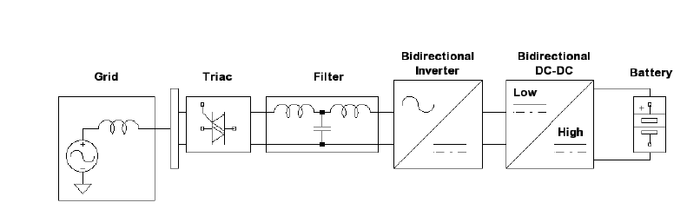

At present, with the development of V2G, the key issues are as follows:

* Intelligent dispatching from the grid view
* Smart charging management from the EV view
* Bi-directional charger
* Effect of V2G on battery

Our major concern will be the design of inverter (bi-directional charger) that can work in both directions from vehicle to grid and the grid to the vehicle when it will need to charge those batteries again at the end of office time. All the work will be done on the simulation at Matlab. The simulation will provide the graphical representation and lead us to the better and accurate results.

**Problem statement:**

The problem for the implementation of V2G is the designing of an inverter that can be reliable, efficient and can work with minimum variation. In the transfer of electrical energy from batteries to grid utility, harmonics and fluctuations take place. If it cannot be controlled in time then it can effect on batteries if the grid utility will give supply or charge the batteries. Harmonics in V2G system disturbs them a lot and if harmonics will keep interrupting in the transmission of the vehicle to grid and the grid to the vehicle then there can be the loss of energy and the purpose of the vehicle to the grid cannot be fulfilled. Therefore it is necessary to design as the inverter that works efficiently with minimum harmonics and should be reliable**.**

**Proposed method**

There are many types of inverters that have been used in the implementation of V2G. Some of them are given below[4].

* DC to DC inverter
* DC to AC inverter
* AC to DC inverter
* Active Rectifier
* Buck/Boost converter

Bi-directional inverter can be design with and without considering buck/boost converter but we will use mix scheme to increase the better efficiency, reliability in real time with minimum harmonics that will not interrupt our power transfer from vehicle to grid and then grid to the vehicle.

**Signification of research**

The purpose of this research is to make a backup of the vehicles in the parking lot with maximum efficiency, reliability, and minimum harmonics. So, we can produce electricity from the vehicles and provide it to the grid or the building itself during the peak hours.

**Aim and objective**

The basic aim and objective of research to design the charging inverter that can charge in both direction from vehicle to the grid and then again from grid to the vehicle. The inverter should be efficient reliable and produce minimum fluctuations.

**Literature review**

Nowadays, producing electrical energy from the fossil fuel is too much costly and it’s leading to run out the fossil fuel. Due to rapidly increasing price of fossil fuel and environmental pollution issues peoples are moving toward renewable energy. But the renewable energy is also not sometimes efficient and reliable. That’s why V2G technology is going popular these days very rapidly. It provides backup for the renewable technology. Electrical vehicles are replacing combustion engine gradually. In Pakistan, people go to work for 8 hours. Their vehicles are parked in parking lot and there is no use of them at that time. We will utilize those vehicles because parking vehicles in the parking lot will provide nothing of but use of those vehicles in that parking lot by the use of their batteries can provide some profit for the owner of the vehicles. It is very useful to sell energy rather than to purchase energy. It will be profitable for the owner of the vehicles. The batteries of those vehicles should be connected in series and then a big voltage source will create that will send to the electric grid utility, Where it can be used in peak hours. The vehicle to grid technology can provide the source of backup for the renewable technologies, black start or spinning reserve. It can also provide backup for the company or building of parking lot. It depends on you that why you are implementing the technology and where you want to use it. A diagram of v2g is shown below.

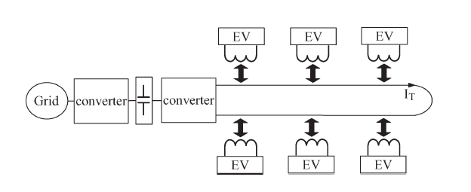

To understand the V2G concept and the project work, the following backgrounds are researched and presented [5].

**The Grid:**

The grid is an interconnected web of production and consumption centers and its basic function is to move power from where it is generated to where it is utilized. This “power system” must balance generation and load, or supply and demand while the energy flow is in the form of real and reactive power. The system frequency must be kept at, or very near to, its nominal frequency –60Hz in the United States, or 50Hz in many other countries. Any deviation from this requires action by the system operator. If the frequency is too high, that means there is too much power being generated in relation to load. Therefore, the load must be increased or the generation must be reduced to keep the system in balance. If the frequency is too low, then there is too much load in the system and the generation must be increased or the load reduced. V2G power will serve as an ancillary service in the electric power system. Ancillary services are necessary for maintaining grid reliability, balancing the supply and demand, and supporting the transmission of electric power from seller to purchaser.

**Battery:**

In nearly all applications involving battery storage, a charge controller is necessary and at the same time must be able to discontinue power flow when the battery is fully charged or has reached a prescribed state. The controller should also be adjustable to ensure optimal battery system performance under various charging, discharging, and temperature conditions.

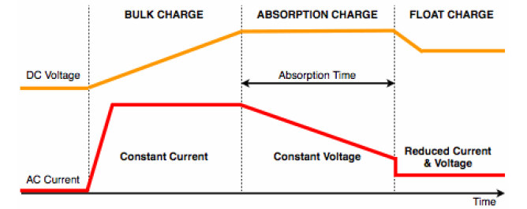

Figure shows a three-stage Battery control algorithm. Initially the charge controller acts as a Current source. If the charging mechanism is the grid, then full current will be used for charging. This is the bulk chargestage. When the charging voltage reaches a preset level, the bulk voltage*,* the charging mode is switched to constant voltage modeor absorption chargestage. After the absorption mode is continued to a preprogrammed time, the charging voltage is decreased to the float voltage. This float voltage is maintained by the charge controller and must be set to a level that will not damage the battery. During the discharge cycle, the charge controller, ideally, should stop the discharging of the batteries at exactly at the prescribed set point.

The vehicle modeled is the Chevrolet Volt that comes with a Lithium-ion battery. This battery is preferred over other batteries most other car use today which is the nickel metal hydride battery. The lithium-ion battery, built by General Motors, will be the preferred battery used in the Chevrolet Volt because of its performance and sizing package. The lithium-ion battery provides about two to three times the power of the nickel metal hydride battery in a smaller package.

Several advantages to the lithium-ion battery are its high efficiency, superior specific energy and power, long life, lower initial material cost and fewer replacements, high cell voltage which leads to fewer cells, higher energy-to-weight ratio, suffers little or no memory (lazy battery) effect which can occur when batteries lose their maximum energy capacity, and recharging the vehicle will take about eight hours using a 120V and less than three hours on 240V.

**Inverter:**

A power inverter or inverter is an electronic device or circuitry that changes direct current (DC) to alternating current (AC). The input voltage, output voltage and frequency, and overall power handling depend on the design of the specific device or circuitry.

A bidirectional inverter, in a DC-distribution system, is a device that is used to regulate and monitor the flow of power between a DC bus and an AC grid and to restrict the voltage expanse at the former to only a certain permissible range of voltages. In other words, a bi-directional inverter is the one that not only performs the DC to AC conversion, but also performs the conversion of AC power to DC.

The major advantage of using a bidirectional inverter is that their use provides users—typically homeowners and business owners—with additional flexibility in terms of the ability to decide when to buy power from an electrical grid and when to sell so as to make the maximum profit based on the price of electricity at a particular point in time

**LCL Filter:**

The importance of the filter is to filter out the sinusoidal currents delivered to the grid. Without the filter, non-sinusoidal currents, including higher-order harmonics are transferred to the grid which may cause non-sinusoidal voltage drop across the line impedance and increase the voltage distortion supplied to the load.

The LCL low-pass filter is used rather than L or LC filter because of the advantages it supplies to the user. A third-order LCL filter is connected the between the inverter and the grid so it may handle high switching frequency switches such as the IGBT and reduce the switching frequency ripple. It is consists of smaller inductance values in comparison to the L type filter, thus it is used in high-powered, low frequency current controlled grid-connected converters. With the small component values, the filter provides higher harmonic performances and good attenuation is achieved at a reasonable filter cost.

**Bidirectional power flow:**

For many power electronics applications, especially PV systems, the basic requirement for efficient control is that the circuit should be capable of handling bidirectional power flow, i.e., energy transfer should be possible from the grid to battery during charging mode and battery to grid in discharging mode. A bidirectional charger will need to function smoothly in both directions. While in discharge mode, the charger should return current in a similar sinusoidal form that complies with regulations [6]. Following the bidirectional block diagram in figure 2, an AC waveform is passed through the filter to remove unwanted harmonics. The AC waveform is then rectified into DC waveform as it passes through the bidirectional inverter. The bidirectional DC-DC converter then steps up the voltage to that of the battery to ensure a proper charging voltage.

In discharge mode, the charging mode is reversed. The bidirectional DC-DC converter steps down the voltage to that of the rectified grid. The DC waveform is then passed through the inverter back into a unipolar modulated signal and out through the filter producing an AC waveform acceptable to the grid

Due to its different power supply and functions of EVs some researcher shows that V2G can be divided into four categories [7].

* Centralized implementation: it suits for large scale charging place. Taking centralized control and having great impact on the grid.
* Autonomous implementation: the features are flexible, continent and free from time and place and so on. But it does not good to achieve unified management.
* Based on micro-grid implementation: EVs integrate into the micro-grid rather than directly exchange the power from the grid. The EV also can be regarded as the energy storage system to achieve self-sufficient in a certain area.
* Based on replacing battery implementation: in this model battery types need to be unified.

There are many benefits of using V2G technology but the most major problem that created by EV integrated into the grid are given below [8].

* Harmonics pollution
* Load fluctuation

If the numbers of the vehicles are not confirmed then it can also affect the grid. And create fluctuation and load variation while charging the vehicle [9]. A charger performs a better role to maintain the fluctuation and prevents from overcurrent to the batteries for lithium-ion batteries the charger warns the overcurrent charging [10]. The batteries of the vehicles connected together and converter are used to convert and then transmit the electrical energy to the micro grid. Where it can use in peak hour demands and then at off-peak hours it is charged again by bi-directional charging inverter supplied from the micro grid. It is used as back up energy and black start.

At first, the energy transfer was unidirectional but it was not much efficient. It creates harmonics and fluctuation. That’s why bidirectional charging and discharging have started to use and it’s much more efficient. But there are also some issues in the bi-directional charging system. Harmonics disturb it a lot that’s why it’s needed to design inverter with better performance. It’s better to charge to vehicles and also to give supply to the grid during peak hours. That’s why people moved toward the bidirectional system. When the vehicle gives supply to grid it adds in credit and when it get supply from the grid for charging itself then it reverses the meters that’s also called smart metering system in V2G. The benefit of the smart metering is we will not calculate the consumption of energy per unit. It will automatically deduct the difference between consumed and supplied unit.

**Our contribution**

Our contribution will be in inverter design with the mixing scheme. There are many inverters everyone has its positive and negative aspects. So, we will use mix scheme and then try to increase the efficiency and performance of the inverter which can charge the vehicle and grid with minimum harmonics and with maximum efficiency. All the work will be done on simulations in Matlab software.

**Reference**

1. Kempton, W. and J. Tomić, *Vehicle-to-grid power fundamentals: Calculating capacity and net revenue.* Journal of power sources, 2005. **144**(1): p. 268-279.

2. Shumei, C., et al. *The construction and simulation of V2G system in micro-grid*. in *Electrical Machines and Systems (ICEMS), 2011 International Conference on*. 2011: IEEE.

3. Zhou, X., et al. *Multi-function bi-directional battery charger for plug-in hybrid electric vehicle application*. in *Energy Conversion Congress and Exposition, 2009. ECCE 2009. IEEE*. 2009: IEEE.

4. Buja, G., M. Bertoluzzo, and C. Fontana, *Reactive power compensation capabilities of V2*

*G-enabled electric vehicles.* IEEE Transactions on Power Electronics, 2017. **32**(12): p. 9447-9459.

5. Agatep, A. and M. Ung, *Design and Simulation of V2G Bidirectional Inverter and DC-DC Converter.* 2011.

6. Kramer, B., S. Chakraborty, and B. Kroposki. *A review of plug-in vehicles and vehicle-to-grid capability*. in *Industrial Electronics, 2008. IECON 2008. 34th Annual Conference of IEEE*. 2008: IEEE.

7. Sun, Y., et al., *A unified modeling and control of a multi-functional current source-typed converter for V2G application.* Electric Power Systems Research, 2014. **106**: p. 12-20.

8. Ma, Y., et al. *An overview on V2G strategies to impacts from EV integration into power system*. in *Control and Decision Conference (CCDC), 2016 Chinese*. 2016: IEEE.

9. Venayagamoorthy, G.K., et al. *Real-time modeling of distributed plug-in vehicles for V2G transactions*. in *Energy Conversion Congress and Exposition, 2009. ECCE 2009. IEEE*. 2009: IEEE.

10. Voelcker, J., *Lithium batteries take to the road.* IEEE Spectrum, 2007. **44**(9): p. 26-31.