Dekeister Devoir TP Tpb
Clément Td1

Question 1)
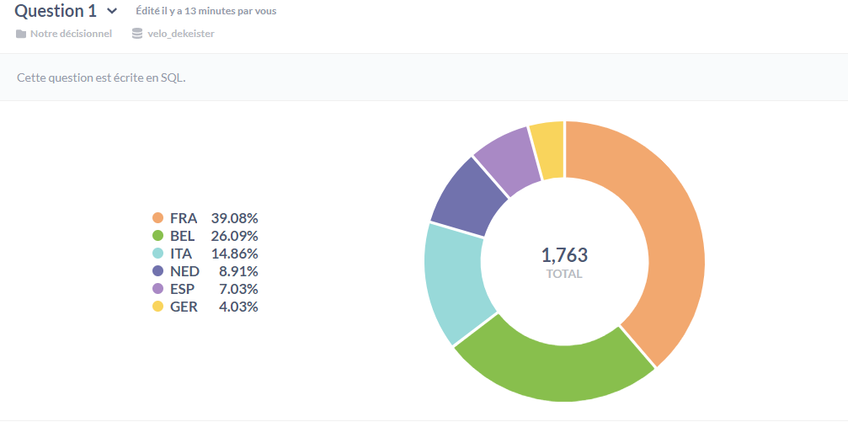

Question 2)
