**Feasibility Analysis**

Survey Questions

> Would you like to have an online complaint portal with the added feature of current status of your complaint?

No

Yes

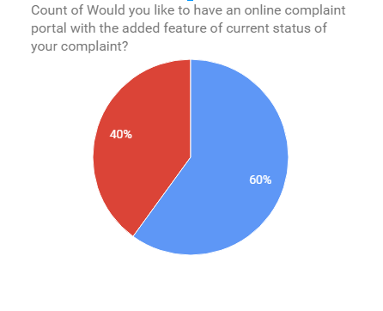

> Are you comfortable paying bills online?

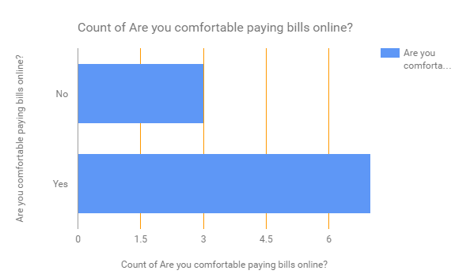

> Do you face difficulties when hiring an electrician, plumbers etc?

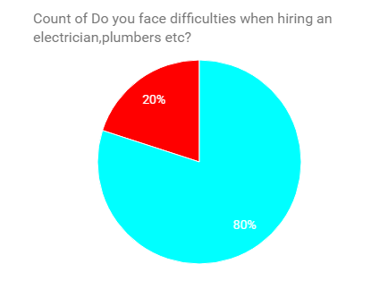

Yes

No

> Would you like a system which automatically updates you about all your society events?

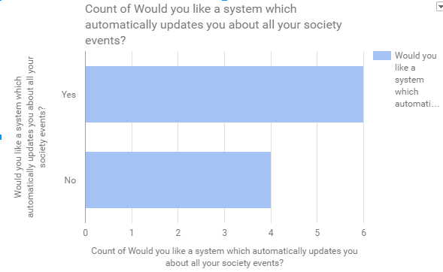

> Would you like to have an online system which will notify your security guard when you are expecting visitors?

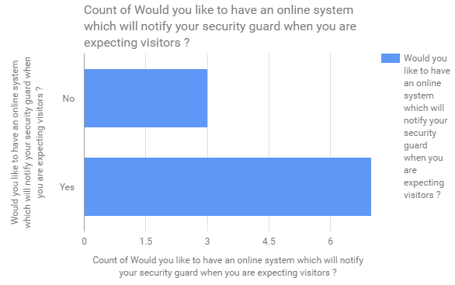

**Feasibility Analysis of the above survey:**

**>What if the system wasn’t implemented?**

* Problematic in having proper data.
* A lot of paper work and record.
* End-user (resident) have to spend a lot of time in queue to get purpose to be achieved.
* End-user (resident) might miss event such as Community meeting etc.
* Paying maintenance bill and other bills becomes a long process

**>What are the current process problems?**

* Paper logs are maintained for the visitors, staff entry and exit.
* Complaint Booking required the user to go admin office and issue a report.
* Residents are not aware of the in and around events occurring in the society
* Physical presence is required for the payment of all the maintenance, electricity bills etc. which consumes lot of time and efforts.
* Resident presence is required for paying the maintenance bill , electricity bill, which leads to spending of a lot of time.

**>How will the proposed system help?**

* The proposed system will make process automatic for the apartment/society and the management will have better production of work.
* It will automate all your monthly and annual bills and keep all the accounts online.
* It will help automatize all of the monthly and annual bills and keep all the records online, helpful for NRI owners of the apartments.
* Enables security and safety for the resident.
* Helps in communicating with neighbours
* The system will digitalize all records which will be legit and helpful.

**>What will be the integration problems?**

* For monetary transactions, third-party API’s are used, hence any bugs in the API may damage the usage of the portal and its working functionality.
* If environment such as no internet or unavailability of service or down time of cloud services could result in down time.
* Poor internet on the user phase or admin phase may lead to bad response time.

**> Is new technology needed? What skills?**

No new technology is needed as far as this project is concerned. Although, this project do requires a combination of many available software technologies.

No there is no requirement of new technology for this project. But the implementation of the system requires duplo type combination of main micro services.

**> What facilities must be supported by the proposed system?**

* The service is for home owners and apartment management people where people of same apartment can share and see happenings of society work.
* The service creates a platform for the user to :
  + Pay maintenance, electricity, house and water tax.
  + Communication with neighbors.
  + Service and complaint functionality enables the residents to book electrician etc. and complain about general society problems with tracking availability.
  + Visitor system to increase the sense of security.