**Feasibility Analysis**

Survey Questions

> Would you like to have an online complaint portal with the added feature of current status of your complaint?

No

Yes

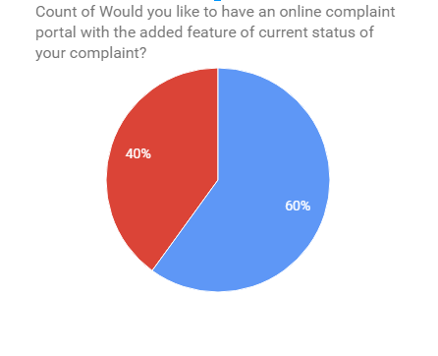

> Are you comfortable paying bills online?

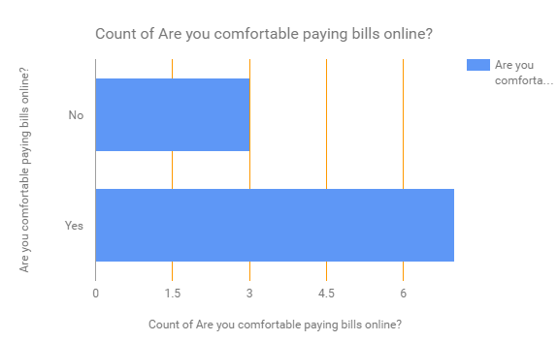

> Do you face difficulties when hiring an electrician, plumbers etc?

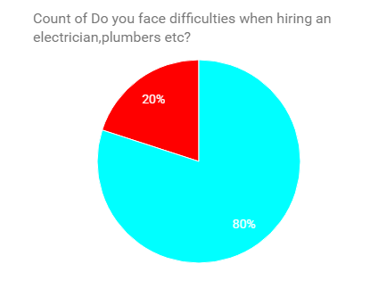

Yes

No

> Would you like a system which automatically updates you about all your society events?

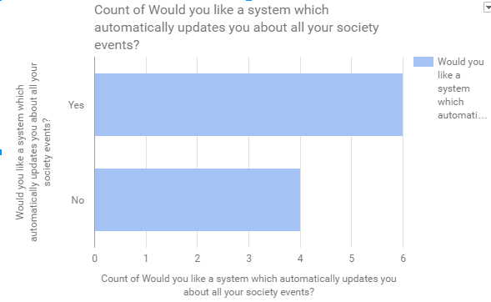

> Would you like to have an online system which will notify your security guard when you are expecting visitors?

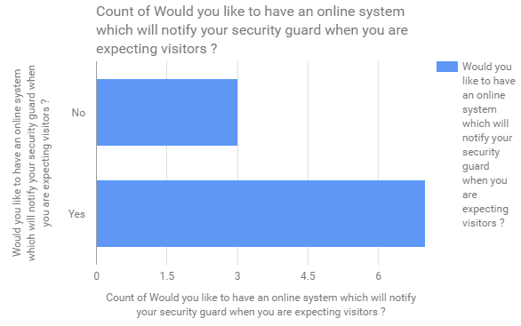

**Feasibility Analysis of the above survey:**

**>What if the system wasn’t implemented?**

* Inconsistency in data entry and there is always room for errors.
* It is time consuming and costly to produce reports.
* Residents are not aware about all the events around them and mostly face problems with their neighbours.
* Paying the maintenance and other bills is a strenuous task.

**>What are the current process problems?**

* Manual logs exist to keep a record of visitors or staff at the entry.
* Complaint system requires the tenant to go to the administrative office and complaint.
* Tenants are not updated about the events happening in the society.
* Physical presence is required for the payment of all the maintenance, electricity bills etc. which consumes lot of time and efforts.
* Determining the financial cycle of the management is a long process.

**>How will the proposed system help?**

* The proposed system will help you automatize the apartment/society/community management for better communication and make the apartment life easier.
* It will automate all your monthly and annual bills and keep all the accounts online.
* Ensure better safety and security in your apartment.
* Help you build better network with our neighbours.
* Update you on all the Events, news and services in and around your neighbourhood.
* Maintains an online record of all the visitors in the society as well as the domestic staff removing the manual regular register.
* The system will help us maintain a track of all the expenses and help in providing complete transparency.

**>What will be the integration problems?**

* For payment and access management it should be noted that third-party API's are used. Any bug in those API or any unstable update on those API's may damage the software and its working and may impair some of its functionality which could result in some down times.
* In some restricted environment there can be problems like slow internet or unavailability of service such as Azure on that network which could result in less optimal functioning to no functioning of the web app.
* Internet being the backbone for this project, availability of a good and decent internet is needed.
* Slow internet on the admin side may lead to slower load and response time which could make the process slow.

**> Is new technology needed? What skills?**

No new technology is needed as far as this project is concerned. Although, this project do requires a combination of many available software technologies.

**> What facilities must be supported by the proposed system?**

* This product is a self-contained project for the home owners and societies where people from same society can share and see what, when and where are all the things happening all around the neighborhood and be updated with their surroundings.
* The product creates platform for the user to:

a) Pay bills for entities such as maintenance, electricity, taxes (home, water).

1. Interact with neighbors
2. Service functionality allows you to book electrician, plumber etc. in a single click and track the progress of the same online.
3. Complaint functionality solves the issues in and around the apartment environment
4. Visitor system to improvise general security