**Feasibility Analysis**

Survey Questions

> Would you like to have an online complaint portal with the added feature of current status of your complaint?

No

Yes

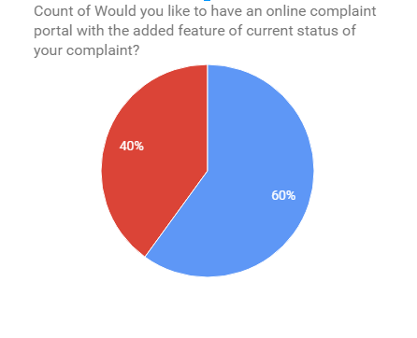

> Are you comfortable paying bills online?

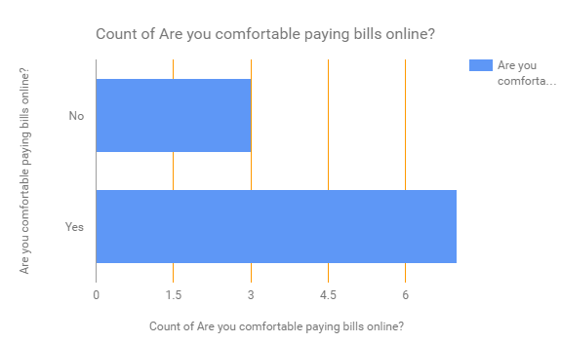

> Do you face difficulties when hiring an electrician, plumbers etc?

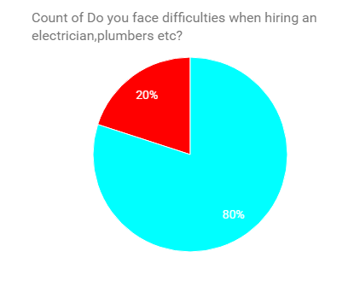

Yes

No

> Would you like a system which automatically updates you about all your society events?

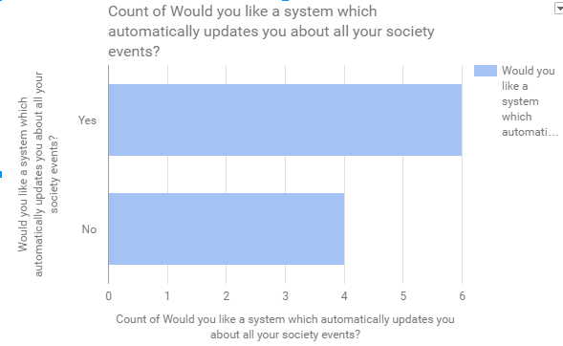

> Would you like to have an online system which will notify your security guard when you are expecting visitors?

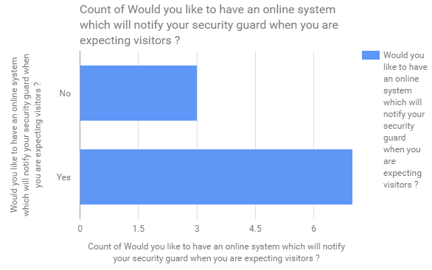

**Feasibility Analysis of the above survey:**

**>What if the system wasn’t implemented?**

* Too much time wasted between message passing of residents and building admin.
* It is expensive to have reports.
* Residents who are busy with job all day might find it difficult to be updated about the building events.

**>What are the current process problems?**

* Manual logs do exist but it is a waste of resource and time
* Complaint system process is too lengthy
* No updating process about the events

**>How will the proposed system help?**

* The proposed system will help you automatize the apartment/society/community management for better communication and make the apartment life easier.
* Keep improved safety and security in your apartment.
* Update you about the events happening in the neighbourhood
* Improve socialisation between different employees
* Removes the manual work of updating visitor log.

**>What will be the integration problems?**

* Any bug in those API or any unstable update on those API's may damage the software and its working and may impair some of its functionality which could result in some down times.
* Problems with Azure could lead to instability
* Internet is one of the most crucial part of this.
* Slow internet on the admin side may lead to slower load and response time which could make the process slow.

**> Is new technology needed? What skills?**

The technologies used is the combination of the existing

technologies

**> What facilities must be supported by the proposed system?**

* This product is a self-contained project for the home owners and societies where people from same society can share and see what, when and where are all the things happening all around the neighborhood and be updated with their surroundings.