**Feasibility Analysis**

Survey Questions

> Would you like to have an online complaint portal with the added feature of current status of your complaint?

No

Yes

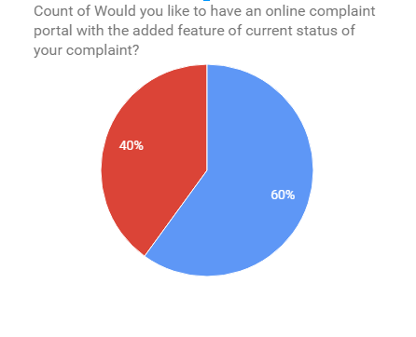

> Are you comfortable paying bills online?

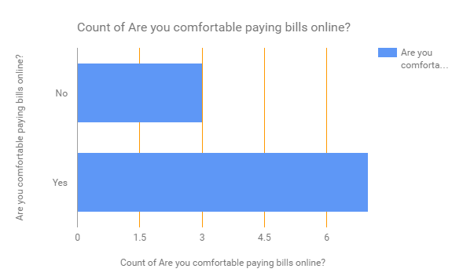

> Do you face difficulties when hiring an electrician, plumbers etc?

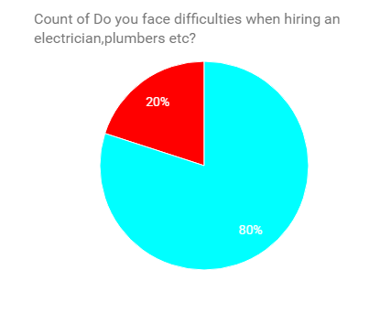

Yes

No

> Would you like a system which automatically updates you about all your society events?

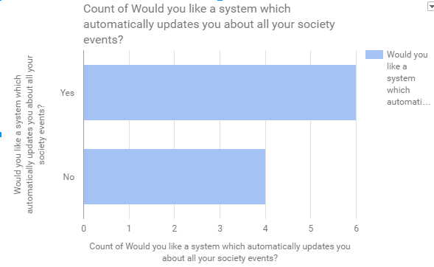

> Would you like to have an online system which will notify your security guard when you are expecting visitors?

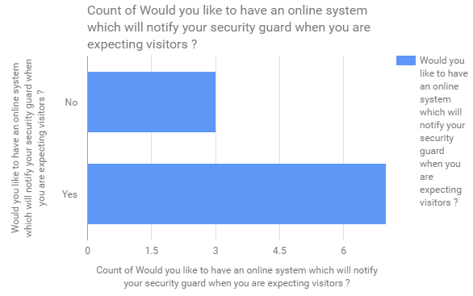

**Feasibility Analysis of the above survey:**

**>What if the system wasn’t implemented?**

* Manual entry of data always has room for errors and is tedious.
* It is time consuming and costly to produce reports.
* Tenants face problems with their neighbours and are not updated about the events going in and around their neighbourhood.
* Residents face problems to pay the maintenance and other bills.

**>What are the current process problems?**

* Complaint system requires the tenant to go to the administrative office and complaint.
* Tenants are not updated about the events happening in the society.
* Physical presence for payment of all bills consuming time.
* Residents have to deal with problems with neighbours
* It is not easy for the home owners to determine their financial cycle for efficient management of the incoming and outgoing finances.

**>How will the proposed system help?**

* The proposed system will help develop a digital environment for efficient management of the apartment/society.
* It will provide an easier platform to pay the bills and help maintain all the accounts online.
* Ensure better safety and security in your apartment.
* Help you build better network with our neighbours.
* Maintains an online record of all the visitors in the society as well as the domestic staff removing the manual regular register.

**>What will be the integration problems?**

* Third-party API's are used for the payment and access management. Any bug in those API or any unstable update on those API's may cause problems to the software.
* In some restricted environment there can be problems like slow internet or unavailability of service such as Azure on that network which could result in less optimal functioning to no functioning of the web app.
* As internet is the backbone to this project slow internet on the admin side may lead to slower load and response time which could make the process slow.

**> Is new technology needed? What skills?**

This project only uses a combination of the available software technologies and as of now no new technology is required.

**> What facilities must be supported by the proposed system?**

* This project provides a digital environment to the tenants and home owners helping them to share what are the things happening around them and update them with all the news in the neighborhood.
* Easier platform to pay bills for entities such as maintenance, electricity etc.
* Service functionality allows you to book electrician, plumber etc. in a single click and track the progress of the same online.
* Visitor system to improvise general security.