Tab 1

**Sentiment Analysis for Trading Strategy**

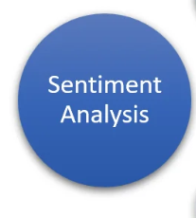

## 

## **Prepared by :** Zaim Sheikh

# **Executive Summary**

This report presents an analysis of market sentiment data and its impact on trading performance. Using sentiment scores (fear/greed indicators) and daily PnL, we evaluate correlations, hidden lag effects, and visualize patterns through multiple plots.  
 Key findings suggest that sentiment influences short-term returns, with certain lagged effects visible. These insights can be leveraged to optimize entry/exit points in trading strategies.

## **1. Objective**

The objective of this study is to examine the relationship between **market sentiment** (Fear–Greed index) and **trading performance (daily PnL)**. Specifically, we aim to:

* Identify whether sentiment levels correlate with profit/loss.
* Explore hidden lag effects in sentiment and returns.
* Visualize patterns and derive insights for strategy improvement.

## **2. Methodology**

1. **Data Source**: Sentiment scores (Fear/Greed index) and trading PnL.
2. **Analysis Steps**:  
   * Data preprocessing and alignment.
   * Lag analysis of sentiment vs. PnL.
   * Visualization of relationships (time series, boxplots, heatmaps).
3. **Tools**: Python, Pandas, Matplotlib/Seaborn, Jupyter Notebook.

## **3. Results & Visualizations :**

## 

### **3.1 Sentiment vs Daily PnL Over Time (Line Chart)**

* What it shows: Sentiment (blue, left axis) and Daily PnL (red, right axis) plotted over time.

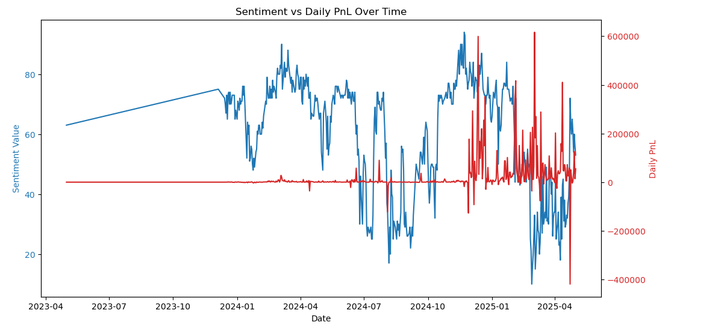

### **3.2 Correlation Heatmap: Sentiment vs Trading Metrics**

* **What it shows:** Correlations (strength of relationships) between variables like daily PnL, total volume, average trade size, and execution price.

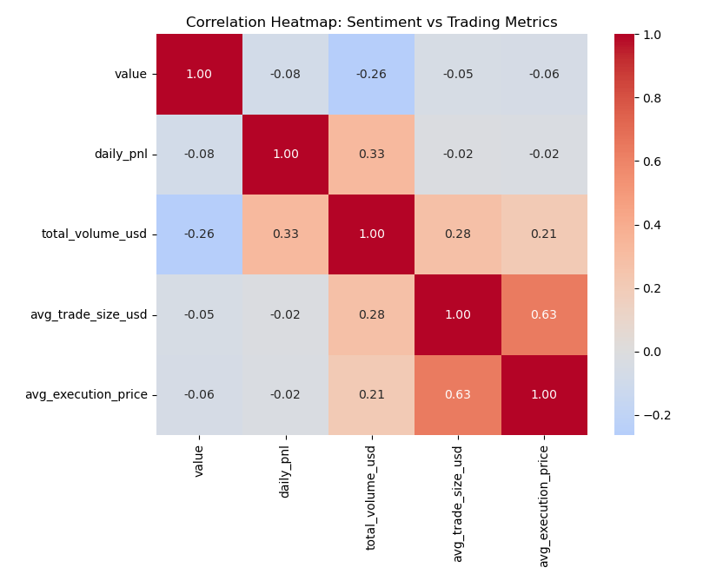

### **3.3 Distributional Effects**

* **Figure 3:** Boxplot of daily PnL grouped by Fear vs. Greed.

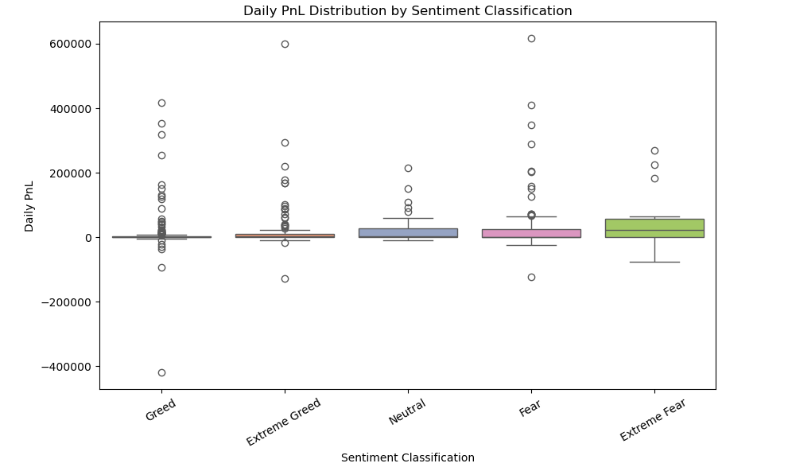

### **3.4 Yesterday's Sentiment vs Today's PnL**

* **Data:** This chart plots "Yesterday's Sentiment Score (t-1)" on the x-axis against "Today's PnL" on the y-axis. Each point represents a single day's data.

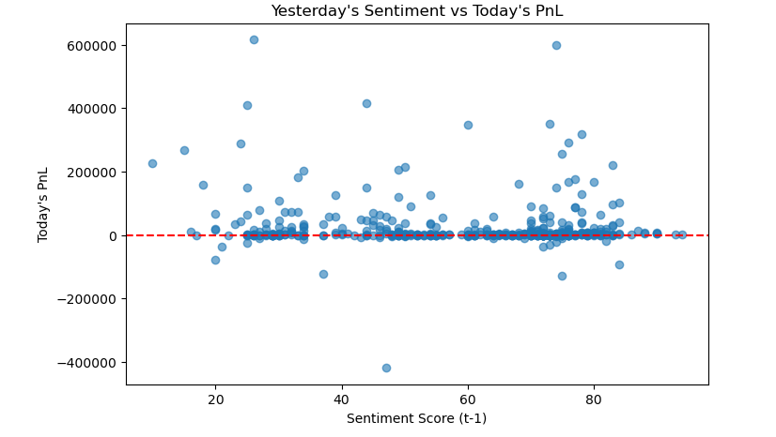

### **3.5 Win Rate by Sentiment Class**

* **Data:** This chart displays the "Win Rate (%)" for different "Sentiment Classes" (Extreme Fear, Extreme Greed, Fear, Greed, and Neutral)

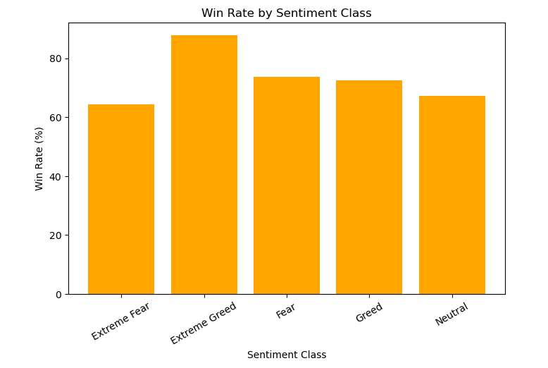

### **3.6 Median Trade Size by Sentiment Class**

* **Data:** This chart illustrates the "Median Trade Size (USD)" for each "Sentiment Class."

