**Comsats University Islamabad, Lahore**

**Campus**

**Assignment #2**

**OOP**

**Submitted To:**

**Sir Shahid Bhatti Submitted by:**

**Zain Yaqoob**

**Sp24-BSE-125**

**Section: A**

**//Package and imported classes//**

package com.example.demo;  
  
import java.io.File;  
import java.util.ArrayList;  
  
import javafx.application.Application;  
import javafx.event.ActionEvent;  
import javafx.geometry.Insets;  
import javafx.geometry.Pos;  
import javafx.scene.Scene;  
import javafx.scene.control.Button;  
import javafx.scene.control.Label;  
import javafx.scene.control.TextField;  
import javafx.scene.image.Image;  
import javafx.scene.image.ImageView;  
import javafx.scene.layout.GridPane;  
import javafx.scene.layout.HBox;  
import javafx.scene.layout.VBox;  
import javafx.scene.paint.Color;  
import javafx.scene.text.Font;  
import javafx.scene.text.FontWeight;  
import javafx.scene.text.Text;  
import javafx.stage.FileChooser;  
import javafx.stage.Stage;

public class App2 extends Application {

**//Declaring and initializing Fields//**  
 private String submittedName;  
 private String submittedFatherName;  
 private String submittedPhoneNumber;  
 private String submittedCity;  
 private String submittedImagePath;  
  
 private boolean formSubmitted = false;  
  
 **// ArrayList to store user information//**  
 private ArrayList<String> userInfo = new ArrayList<>();

**// Main to launch the code//**  
 public static void main(String[] args) {  
 *launch*(args);  
 }  
  **//Overriding abstract methods in application class//**  
 @Override  
 public void start(Stage primaryStage) {  
 primaryStage.setTitle("Stylish JavaFX Form");  
  
 **// Form GridPane//**  
 GridPane formGrid = createFormGrid(primaryStage);  
  
 **// Scene and Stage Setup//**  
 Scene formScene = new Scene(formGrid, 800, 600);  
  
 **// Apply custom styling directly in the code//** primaryStage.setScene(formScene);  
 primaryStage.show();  
 }  
  
 private GridPane createFormGrid(Stage primaryStage) {  
 GridPane grid = new GridPane();  
 grid.setAlignment(Pos.*CENTER*);  
 grid.setHgap(10);  
 grid.setVgap(15);  
 grid.setPadding(new Insets(25, 25, 25, 25));  
 grid.setStyle("-fx-background-color: linear-gradient(to bottom, #1e2a47, #4a4e69);"); // Gradient background  
  
 **// Title Box for "User Information Form"//** VBox headerBox = new VBox(10);  
 headerBox.setStyle("-fx-background-color: #333333; -fx-padding: 15px; -fx-border-radius: 10px;");  
 headerBox.setAlignment(Pos.*CENTER*);  
 Text scenetitle = new Text("User Information Form");  
 scenetitle.setFont(Font.*font*("Tahoma", FontWeight.*BOLD*, 24));  
 scenetitle.setFill(Color.*WHITE*);  
 headerBox.getChildren().add(scenetitle);  
 grid.add(headerBox, 0, 0, 2, 1);  
  
 **// Name field//** grid.add(createStyledLabel("Name:"), 0, 1);  
 TextField nameField = new TextField();  
 nameField.setStyle("-fx-font-size: 14px; -fx-background-color: #fff; -fx-border-color: #ccc; -fx-padding: 5px;");  
 grid.add(nameField, 1, 1);  
  
 **// Father Name field//** grid.add(createStyledLabel("Father Name:"), 0, 2);  
 TextField fatherNameField = new TextField();  
 fatherNameField.setStyle("-fx-font-size: 14px; -fx-background-color: #fff; -fx-border-color: #ccc; -fx-padding: 5px;");  
 grid.add(fatherNameField, 1, 2);  
  
 **// Phone Number field//** grid.add(createStyledLabel("Phone Number:"), 0, 3);  
 TextField phoneNumberField = new TextField();  
 phoneNumberField.setStyle("-fx-font-size: 14px; -fx-background-color: #fff; -fx-border-color: #ccc; -fx-padding: 5px;");  
 grid.add(phoneNumberField, 1, 3);  
  
 **// City field//**  
 grid.add(createStyledLabel("City Address:"), 0, 4);  
 TextField cityField = new TextField();  
 cityField.setStyle("-fx-font-size: 14px; -fx-background-color: #fff; -fx-border-color: #ccc; -fx-padding: 5px;");  
 grid.add(cityField, 1, 4);  
  
 **// Upload Image button//**  
 grid.add(createStyledLabel("Upload Image:"), 0, 5);  
 Button uploadImageButton = new Button("Browse");  
 uploadImageButton.setStyle("-fx-font-size: 14px; -fx-background-color: #007BFF; -fx-text-fill: white; -fx-padding: 10px; -fx-border-radius: 5px;");  
 grid.add(uploadImageButton, 1, 5);  
  
 **// To track uploaded image path//**  
 final Text imageStatus = new Text();  
 imageStatus.setFill(Color.*WHITE*);  
 grid.add(imageStatus, 1, 6);  
  
 **// Submit button//**  
 Button submitButton = new Button("Submit");  
 submitButton.setStyle("-fx-font-size: 14px; -fx-background-color: #4CAF50; -fx-text-fill: white; -fx-padding: 10px; -fx-border-radius: 5px;");  
 HBox hbBtnSubmit = new HBox(10);  
 hbBtnSubmit.setAlignment(Pos.*BOTTOM_RIGHT*);  
 hbBtnSubmit.getChildren().add(submitButton);  
 grid.add(hbBtnSubmit, 1, 7);  
  
 **// View Info button//**  
 Button viewInfoButton = new Button("View Info");  
 viewInfoButton.setDisable(true);  
 viewInfoButton.setStyle("-fx-font-size: 14px; -fx-background-color: #17A2B8; -fx-text-fill: white; -fx-padding: 10px; -fx-border-radius: 5px;");  
 HBox hbBtnView = new HBox(10);  
 hbBtnView.setAlignment(Pos.*BOTTOM_RIGHT*);  
 hbBtnView.getChildren().add(viewInfoButton);  
 grid.add(hbBtnView, 1, 8);  
  
 **// Status text//**  
 final Text actionTarget = new Text();  
 actionTarget.setFill(Color.*WHITE*);  
 grid.add(actionTarget, 1, 9);  
  
 **// File chooser for image upload//**  
 FileChooser fileChooser = new FileChooser();  
 fileChooser.getExtensionFilters().add(new FileChooser.ExtensionFilter("Image Files", "*.png", "*.jpg", "*.jpeg"));  
  
 uploadImageButton.setOnAction(event -> {  
 File file = fileChooser.showOpenDialog(primaryStage);  
 if (file != null) {  
 submittedImagePath = file.getAbsolutePath();  
 imageStatus.setFill(Color.*GREEN*);  
 imageStatus.setText("Image selected successfully!");  
 } else {  
 imageStatus.setFill(Color.*FIREBRICK*);  
 imageStatus.setText("No image selected.");  
 }  
 });  
  
 **// Handle Submit button click//**  
 submitButton.setOnAction((ActionEvent e) -> {  
 submittedName = nameField.getText();  
 submittedFatherName = fatherNameField.getText();  
 submittedPhoneNumber = phoneNumberField.getText();  
 submittedCity = cityField.getText();  
  
 if (submittedName.isEmpty() || submittedFatherName.isEmpty() || submittedPhoneNumber.isEmpty() || submittedCity.isEmpty() || submittedImagePath == null) {  
 actionTarget.setFill(Color.*FIREBRICK*);  
 actionTarget.setText("All fields are required!");  
 return;  
 }  
  
 actionTarget.setFill(Color.*GREEN*);  
 actionTarget.setText("Form submitted successfully!");  
 formSubmitted = true;  
 viewInfoButton.setDisable(false);  
  
 **// Add user info to ArrayList//**  
 userInfo.clear(); // Clear any existing info  
 userInfo.add("Name: " + submittedName);  
 userInfo.add("Father Name: " + submittedFatherName);  
 userInfo.add("Phone Number: " + submittedPhoneNumber);  
 userInfo.add("City: " + submittedCity);  
 userInfo.add("Image Path: " + submittedImagePath);  
  
 actionTarget.setFill(Color.*GREEN*);  
 actionTarget.setText("Form submitted successfully!");  
 formSubmitted = true;  
 viewInfoButton.setDisable(false);  
 });  
  
 **// Handle View Info button click//**  
 viewInfoButton.setOnAction((ActionEvent e) -> {  
 if (formSubmitted) {  
 // Switch to the information view  
 GridPane infoGrid = createInfoGrid(primaryStage);  
 Scene infoScene = new Scene(infoGrid, 800, 600);  
 primaryStage.setScene(infoScene);  
  
 // Print user information to console  
 System.*out*.println("User Information:");  
 for (String info : userInfo) {  
 System.*out*.println(info); // This will display in the console  
 }  
 }  
 });  
  
 return grid;  
 }  
  
 **// Helper method to create bold, white labels//**  
 private Label createStyledLabel(String text) {  
 Label label = new Label(text);  
 label.setStyle("-fx-font-size: 16px; -fx-font-weight: bold; -fx-text-fill: white;");  
 return label;  
 }  
  
 private GridPane createInfoGrid(Stage primaryStage) {  
 GridPane grid = new GridPane();  
 grid.setAlignment(Pos.*CENTER*);  
 grid.setHgap(10);  
 grid.setVgap(15);  
 grid.setPadding(new Insets(25, 25, 25, 25));  
 grid.setStyle("-fx-background-color: linear-gradient(to bottom, #6a4c93, #b497bd);"); // Gradient background for second screen

**Main scene of the Application**

**Scene to through error if not all fields are added**

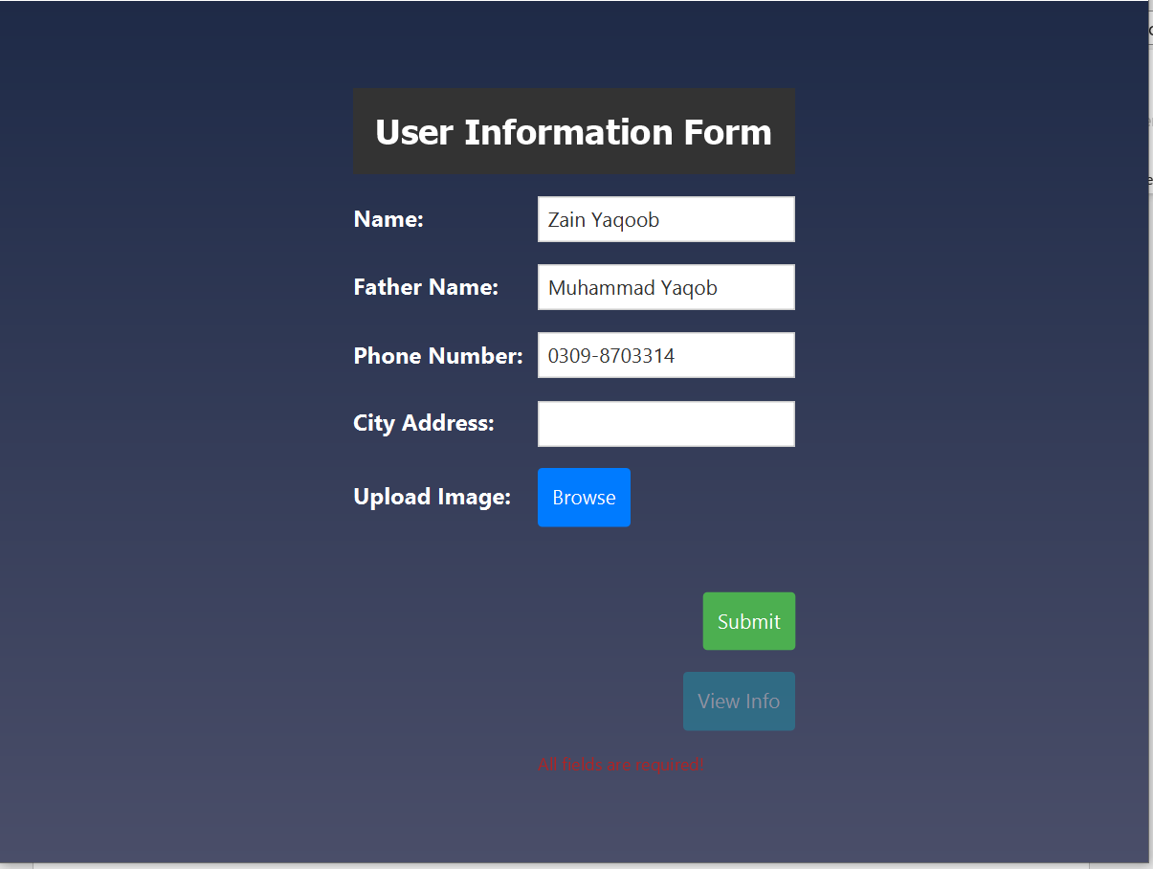

**Scene displaying successful Data entry**

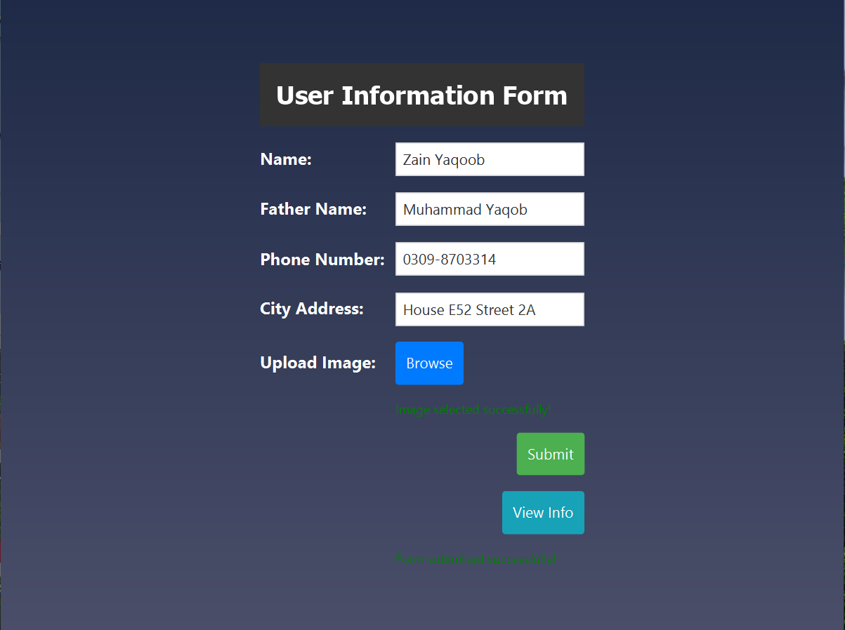

**// Title Box for "Submitted Information"//**  
 VBox headerBox = new VBox(10);  
 headerBox.setStyle("-fx-background-color: #333333; -fx-padding: 15px; -fx-border-radius: 10px;");  
 headerBox.setAlignment(Pos.*CENTER*);  
 Text scenetitle = new Text("Submitted Information");  
 scenetitle.setFont(Font.*font*("Tahoma", FontWeight.*BOLD*, 24));  
 scenetitle.setFill(Color.*WHITE*);  
 headerBox.getChildren().add(scenetitle);  
 grid.add(headerBox, 0, 0, 2, 1);  
  
 grid.add(createStyledLabel("Name:"), 0, 1);  
 Label nameLabel = new Label(submittedName);  
 nameLabel.setStyle("-fx-font-size: 16px; -fx-font-weight: bold; -fx-text-fill: white;");  
 grid.add(nameLabel, 1, 1);  
  
 grid.add(createStyledLabel("Father Name:"), 0, 2);  
 Label fatherNameLabel = new Label(submittedFatherName);  
 fatherNameLabel.setStyle("-fx-font-size: 16px; -fx-font-weight: bold; -fx-text-fill: white;");  
 grid.add(fatherNameLabel, 1, 2);  
  
 grid.add(createStyledLabel("Phone Number:"), 0, 3);  
 Label phoneNumberLabel = new Label(submittedPhoneNumber);  
 phoneNumberLabel.setStyle("-fx-font-size: 16px; -fx-font-weight: bold; -fx-text-fill: white;");  
 grid.add(phoneNumberLabel, 1, 3);  
  
 grid.add(createStyledLabel("City Address:"), 0, 4);  
 Label cityLabel = new Label(submittedCity);  
 cityLabel.setStyle("-fx-font-size: 16px; -fx-font-weight: bold; -fx-text-fill: white;");  
 grid.add(cityLabel, 1, 4);  
  
 **// Display the selected image//**  
 grid.add(createStyledLabel("Uploaded Image:"), 0, 5);  
 if (submittedImagePath != null) {  
 Image image = new Image("file:///" + submittedImagePath);  
 ImageView imageView = new ImageView(image);  
 imageView.setFitHeight(100);  
 imageView.setFitWidth(100);  
 grid.add(imageView, 1, 5);  
 }  
  
 **// Back Button to return to the form//**  
 Button backButton = new Button("Back");  
 backButton.setStyle("-fx-font-size: 14px; -fx-background-color: #FFC107; -fx-text-fill: white; -fx-padding: 10px; -fx-border-radius: 5px;");  
 backButton.setOnAction(event -> {  
 GridPane formGrid = createFormGrid(primaryStage);  
 Scene formScene = new Scene(formGrid, 800, 600);  
 primaryStage.setScene(formScene);  
 });  
  
 HBox hbBtnBack = new HBox(10);  
 hbBtnBack.setAlignment(Pos.*BOTTOM_RIGHT*);  
 hbBtnBack.getChildren().add(backButton);  
 grid.add(hbBtnBack, 1, 7);  
  
 return grid; }  
}

**Second screen to Display Submitted Information**

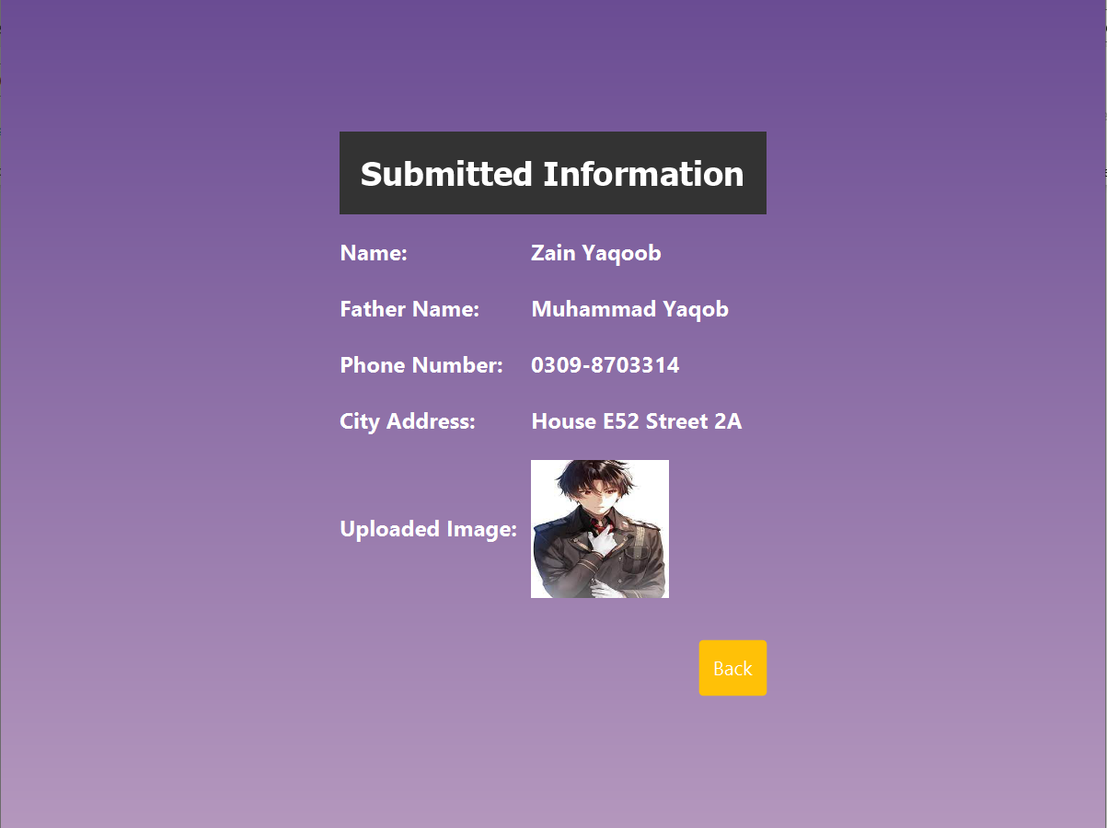

**Displaying data on Console as well stored in ArrayList**

