Assignment 1: Finite Element Analysis of Structures

By

**HAIDER ALI (104323332)**

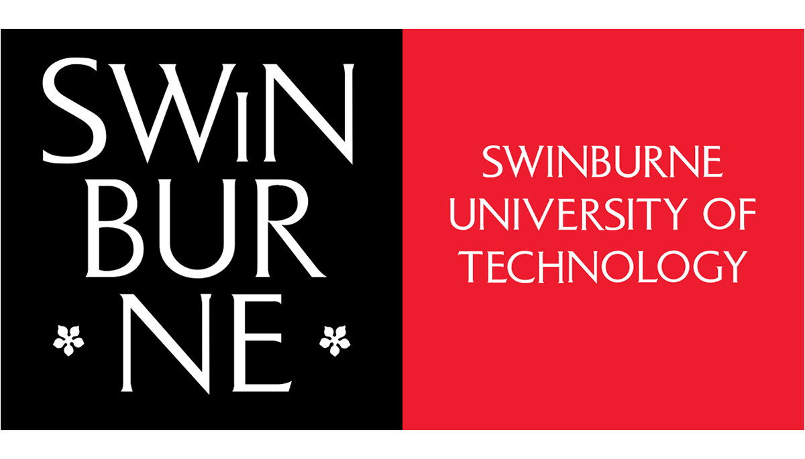

Submitted to

Dr. Hendrik Wijaya

Master of Professional Engineering

SWINBURNE UNIVERSITY OF TECHNOLOGY, AUSTRALI

**Question 1:**

Elon Musk is renowned for his revolutionary leadership style, innovative thinking, and tireless pursuit of innovation. His abilities as a leader might be useful in an engineering project.

**Visionary Thinking:** Musk has a distinct and adventurous outlook on the future. He establishes ambitious objectives that motivate his colleagues to break through barriers and pursue excellence in their work.

**Hands-On Approach:** He actively participates in all facets of his initiatives, from tactical choices to technical specifics. This practical approach creates a thorough comprehension of the project's difficulties and solutions.

**Effective Communication:** He promotes a culture of cooperation and shared goals with his open and direct communication approach, which guarantees transparency and alignment among team members.

Musk has proven to be resilient in the face of obstacles and failures. His teams are inspired to continue and come up with innovative solutions by his will to conquer challenges. Musk is not hesitant to take calculated risks in order to make advancements. This quality can spur creativity and motivate team members to consider novel concepts.

**Question 2:**

Reinforcement of Culture Quote, saying, or conviction: "Diversity breeds strength and innovation." The importance of varied viewpoints, experiences, and backgrounds is emphasized in this remark as it relates to current project management techniques. Accepting cultural variety may result in more insightful ideas, more creativity, and better project outcomes.

**Question 3:**

Here are some important suggestions based on a project-based organization viewpoint and taking Hofstede's model's cultural components into account:

Establish an inclusive atmosphere where team members from high-PDI cultures may freely express their thoughts and opinions in order to acknowledge and overcome power distance (PDI). Encourage open discussion and make sure that decision-making is inclusive and transparent. Recognize the inclination for individualism or collectivism within the two civilizations.

**Individualism vs. Collectivism (IDV):** Promote cooperation and teamwork in collectivist cultures while granting autonomy and acknowledging individual contributions in individualistic cultures to maintain a healthy balance in team dynamics.

Adjust leadership philosophies to account for differing degrees of aggressiveness and collaboration when discussing masculinity vs. femininity (MAS). While focusing on work-life balance and encouraging leadership in high-femininity cultures, provide clear goals and a structured framework in high-MAS cultures.

Adapt communication and planning tactics to varied degrees of comfort with ambiguity to practice uncertainty avoidance (UAI). To reduce uncertainty in cultures with high UAI, give thorough project plans and regular updates. Encourage a more adaptable and flexible attitude towards change in low-UAI cultures.

Recognize many perspectives on long-term planning and flexibility (Long-Term Orientation, or LTO). In high-LTO cultures, provide a defined project plan with attainable milestones; in low-LTO cultures, show flexibility and response to changing conditions.