Name | Zainab Hilal Abo-Alhamad sayed (mern stack)

Lab1_Testing
True or False
Why is Testing necessary?

- because software is likely to have faults ( T )
- To learn about the reliability of the software ( T )
- To fill the time between the delivery of the software and the release date ( F )
- To prove that the software has no faults ( F )
- Because testing is included in the project plan ( F )
- Because failures can be very expensive ( T )
- To avoid being sued by customers ( T )
- To stay in business ( T )
compare between :
functional testing | non-functional
Tests what the system does (functions & Requirements) | Tests how well the system works
Validates system behavior | Validates performance, quality, reliability
Unit, Integration, System, Acceptance | Performance, Load, Stress, Security, Usability

black box |  | White Box | Gray Box
no code knowledge |  | full code knowledge | partial code knowledge
Testers / End Users |  | developers | Testers / Developers

What is the SDLC?
Software / system Development Life Cycle
consists of 5 key phases
- Analysis (Requirement Gathering)
- Design
- Implementation (Coding)
- Testing
- Evolution
What are the Testing levels?
- Unit Testing
- Integration Testing
- System Testing
- Acceptance Testing (UAT)

What are the Testing Types? 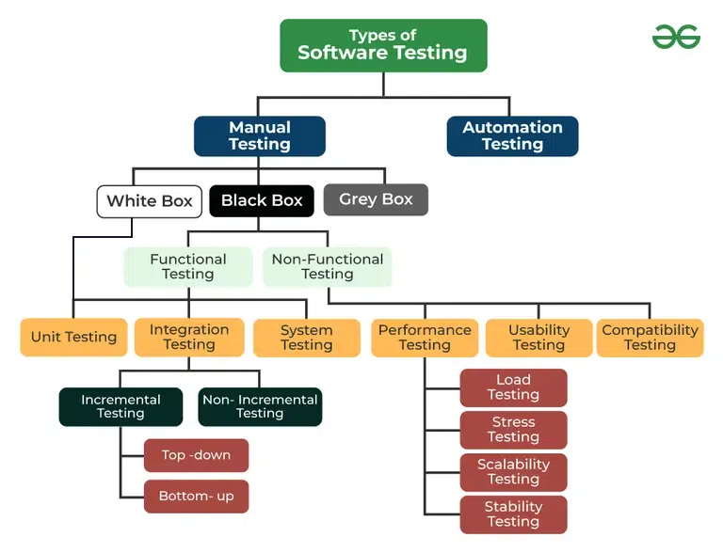

[Bouns] search for the difference between TDD and DDD and BDD
Test-Driven Development (TDD)
TDD is a development methodology where tests are written before the code that needs to be tested
Pros of TDD
- Higher code quality
- Early bug detection
- Cleaner interfaces
Cons of TDD
- Steeper learning curve
- Initial productivity slowdown
- Maintenance overhead
Behavior-Driven Development (BDD)
BDD evolved from TDD but focuses on business value and user behavior rather than implementation details.
Pros of BDD
- Improved communication
- Better requirement alignment
- Living documentation
Cons of BDD
- Tool complexity
- Slower test execution
- Maintenance challenges

Domain-Driven Design (DDD)
DDD is a design approach that focuses on modeling software to match the business domain. It emphasizes collaboration between technical and domain experts to create a shared understanding and language around business concepts.
Pros of DDD
- Strategic design tools
- More maintainable codebase
- Better alignment with business needs
Cons of DDD
- Not suitable for all applications
- Steep learning curve
- High initial investment

Who does Testing?
- Software testing
- Software Developer
- Project lead /Manger
- End user

