Deep Learning-based Anomaly Detection for Oil and Gas Pipeline Defect Detection and Integrity Management

Sibtain Mehdi Razvi Syed

Abstract—Detecting pipeline defects such as corrosion is difficult because there are usually far fewer confirmed and reliably labelled defect cases than normal cases. This makes traditional supervised classification methods less suitable. This study examines whether deep learning-based anomaly detection methods, trained mainly or only on normal data, can perform better than traditional anomaly detection methods when labelled defect data are limited. It also investigates whether combining deep learning and classical anomaly scores can improve detection. Three types of anomaly detection methods were compared: reconstruction-based deep learning, boundary-based deep learning, and classical statistical methods. The methods were tested on two public pipeline datasets: one containing pipeline surface images and another containing pipeline incident records. Multiple experimental runs were carried out using different random seeds, and Wilcoxon signed-rank tests with Bonferroni correction were used where the complete repeated-run procedure was available. The results show that deep learning does not always perform better than classical methods. On the tabular incident dataset, the classical Isolation Forest performed better than the deep learning autoencoder. However, on the image dataset, the boundary-based Deep SVDD model performed better than both the classical methods and the convolutional autoencoder. Three different methods of combining model scores were also tested, but none produced a statistically significant improvement over the best individual model. Overall, the findings suggest that the effectiveness of deep learning-based anomaly detection depends on the type of pipeline data being analysed. Combining different anomaly detection methods is also not automatically better than using the best individual model. This study provides a reproducible comparison of different anomaly detection approaches for pipeline defect detection when labelled defect data are scarce. It also reports false positive rates alongside standard detection metrics to reflect the practical trade-off between missed defects and unnecessary pipeline inspections.

Index Terms—anomaly detection, deep learning, pipeline defect detection, corrosion, integrity management, Deep SVDD, autoencoder, Isolation Forest.

I. Introduction
Oil and gas pipelines can develop corrosion overtime during operation, and corrosion is one of the most common and also the serious causes of pipeline failure. It can develop into leaks or ruptures if the corrosion is not detected early, which potentially causing environmental damage, financial losses, and also loss of life. For this reason, the most important part of pipeline integrity management is reliable defect detection. Traditional inspection often depends on experts examining visual or sensor data manually. Although this approach can be effective, but it is time-consuming, expensive when applied to large amounts of data, and influenced by the experience of the inspector.
Machine learning provides an opportunity to automate parts of the defect detection process. but the most straightforward approach is supervised classification using labelled examples of both normal and defective conditions where it is difficult to apply in this setting. As compared with normal conditions Confirmed pipeline defects are relatively rare, and obtaining reliable defect labels often requires specialized inspection like non-destructive techniques, such as magnetic flux leakage or eddy current testing, as discussed in Section II. As a result, there may not enough genuine defect examples for a supervised model to learn a reliable distinction between normal and defective conditions. With only a small number of defect examples, for available data the model may be overfit. Anomaly detection provides an alternative approach because it can learn what normal conditions look like and identify cases that differ from this pattern, It does not require a large number of labelled defects during training.
Previous studies, as discussed in Section II, for anomaly detection in pipeline and other industrial applications have used both classical statistical methods and deep learning. These studies show that both types of methods can detect patterns associated with defects. However, there is still limited evidence showing which approach is more effective and reliable for pipeline defect detection when labelled defect data are scarce. In particular, there is limited reproducible and statistically validated evidence comparing reconstruction-based deep learning, boundary-based deep learning, and classical statistical anomaly detection methods under the same experimental conditions. Existing pipeline studies also often use proprietary or manually collected datasets, making their results difficult for other researchers to reproduce. In addition, repeated experimental runs and formal statistical tests are not commonly reported, making it difficult to determine whether differences between models represent genuine performance differences or simply variation caused by the experimental setup.
This study addresses this gap by comparing three types of anomaly detection methods: reconstruction-based deep learning, boundary-based deep learning, and classical statistical methods. The methods are tested on two public pipeline datasets, using formal statistical testing and repeated experimental runs. There the complete experimental protocol was available. The study also examines whether combining deep learning anomaly and classical scores in a hybrid framework provides any improvement over the best individual method. The main research question and two sub-questions guiding the study are there in Section III-A.
The objectives of this study are:
To compare reconstruction-based deep learning, boundary-based deep learning, and classical statistical anomaly detection methods using a public pipeline image dataset and a public pipeline incident dataset, with statistical analysis and repeated experimental runs
To define the tabular anomaly class using an official PHMSA cause category, rather than selecting the class based solely on frequency of occurrence.
To investigate whether combining classical and deep learning anomaly scores in a hybrid framework improves performance compared with the best individual method.
To report false positive rate alongside standard detection metrics to show the practical trade-off between missed defects and unnecessary inspections in pipeline integrity management.
The definition of the tabular anomaly class was refined after the original research proposal was reviewed. Instead of using the broader incident-based definition proposed initially, this study uses the corrosion-specific definition which is described in Section III-C. This change was made to bring the tabular analysis more closely in line with the corrosion-focused image analysis, where the same definition is used consistently throughout the Methodology and Results sections.
The main contributions of this study are as follows. First, the study provides a statistically validated comparison of reconstruction-based, boundary-based, and classical anomaly detection methods using two independent and publicly available pipeline datasets. Rather than relying on the results of a single run experiments were repeated using predetermined random seeds, and the results were compared using the Wilcoxon signed-rank test with Bonferroni correction.
Second, the tabular anomaly class is based on an official PHMSA cause category rather than an arbitrary threshold based on how frequently a particular class occurs. The study also reports the false positive rate alongside the standard detection metrics. This provides a clearer view of the practical balance between detecting defects that might otherwise be missed and generating unnecessary inspections.
Third, the study investigates a hybrid anomaly detection framework that combines anomaly scores from classical and deep learning models. The aim is to determine whether combining the scores can improve performance compared with the strongest individual model. The results are reported regardless of whether the outcome supports the proposed approach. In this case, none of the fusion strategies produced a statistically significant improvement over the best individual model on either dataset.
Finally, both datasets used in the study are publicly available, and the implementation, experimental notebooks, and supporting protocols are provided in the project’s GitHub repository. This is intended to make the experiments easier to independently verify and reproduce. The repository is available at: https://github.com/Zain8045/pipeline-defect-anomaly-detection.
The remainder of this paper is organised as follows. Section II reviews related work on anomaly detection, deep learning approaches, pipeline defect detection, and statistical validation. Section III describes the datasets, anomaly definitions, preprocessing steps, models, training and evaluation procedures, and the hybrid framework. Section IV presents the experimental results. Section V discusses the findings in relation to the research questions and outlines the limitations of the study. Section VI concludes the paper.

II. Literature Review

A. Anomaly Detection: Concepts and Approaches
Anomaly detection aims to identify the patterns in data that differ from expected or normal behaviour. This is particularly important in safety-critical systems, such as nuclear power stations and jet engines, where abnormal events can have serious consequences and examples of new or unknown failure conditions may not be available in advance [1]. This makes a one-class approach useful, where the model is trained mainly on normal behaviour and then identifies observations that differ from what it has learned, rather than requiring labelled examples of both normal and abnormal cases.
Several established classical methods approach anomaly detection in different ways, although each has its own limitations. Local Outlier Factor (LOF) measures how isolated a data point is compared with its local neighbourhood. Instead of simply just classifying a point as normal or abnormal, it assigns an outlier score based on local density and can identify anomalies that global methods may miss [9]. However, its performance depends on the selected neighbourhood size, the density calculations can becomes less reliable if the number of features increases.
One-Class Support Vector Machine (One-Class SVM) takes a different approaches, it learn a boundary around the region that contain most of the normal data [8]. This allows it to identify observations that fall outside the learned boundary. but, based on the choices it performance depends such as the kernel type and associated parameters, which can make the method more difficult to configure.
Isolation Forest uses a different principle. It identifies anomalies by repeatedly and randomly partitioning the data rather than measuring distance or local density. Anomalies are generally easier to isolate because they are different from most observations and therefore require fewer partitions [7]. which makes Isolation Forest useful for datasets with many features, where distance-based methods can become less effective because observations tend to appear similarly distant from one another. However, the method still requires an estimate of the expected proportion of anomalies, known as the contamination parameter.
Boundary-based approaches have also been developed for one-class classification outside traditional statistical methods. For example, level-set methods can learn a nonlinear boundary around normal training data while controlling the expected proportion of normal observations rejected as anomalies [1]. These methods can represent more complex boundaries than simple hyperspheres or hyperplanes. However, their computational requirements can increase substantially as the dimensionality of the input data grows, particularly when the boundary is represented directly. Techniques such as sparse grids and narrow-band methods can be used to reduce these computational demands.

B. Deep Learning for Anomaly Detection
Deep learning allows models to learn more complex patterns from data which has improved anomaly detection. Where autoencoder is the one of the most widely used approaches. An autoencoder is a neural network that learns to reproduce its input and the reconstruction error can then be used to identify unusual data. When the model is trained mainly on normal data, it should reconstruct normal examples accurately, while anomalous examples are expected to produce larger reconstruction errors [10]. but this approach has a limitation. Autoencoders can sometimes learn features that are general enough to reconstruct anomalous inputs reasonably well particularly when the anomalies share similar characteristics with the normal data used during training [12]. In such cases, the reconstruction errors for normal and anomalous samples may be quite similar, making it harder to distinguish between them reliably.
Deep SVDD uses a different approach and does not depend on reconstruction. It is based on the idea of Support Vector Data Description, but uses a deep neural network to learn a representation in which normal data points are grouped closely within a compact hypersphere [2]. Anomalies are then identified based on their distance from the centre of this hypersphere. This is different from an autoencoder, where the anomaly score comes from the reconstruction error. Because Deep SVDD does not attempt to reconstruct the input, it avoids the specific issue of autoencoders sometimes reconstructing anomalous samples too accurately.

C. Pipeline Defect Detection
Within pipeline research, deep learning has been used with different types of data. For visual inspection, convolutional neural networks (CNNs) have been used to detect pitting corrosion from images of pipeline surfaces, with one study reporting a classification accuracy of 98.44% [3]. However, the authors also explain that there were no publicly available datasets for pitting corrosion image classification at the time. They therefore collected their own images during visits to oil and gas facilities. This makes the study more difficult for other researchers to reproduce or independently verify using the same data. More recently, another dataset has attempted to address this lack of public data by generating synthetic images of pipeline corrosion for classification purposes [6].
Deep learning has also been used with operational data rather than images. For example, a long short-term memory (LSTM) network was developed to detect anomalies in natural gas pipeline operational data collected over a one-year period [4]. Magnetic flux leakage (MFL) testing is another important area of pipeline inspection. It is one of the most widely used non-destructive testing methods, and deep learning has been increasingly used to analyse MFL signals for detecting and assessing defects. This is particularly useful because the interpretation of these signals has traditionally depended heavily on expert knowledge [5]. Other in-line inspection methods also use different types of instruments and data, including eddy current testing and robotic inspection systems [11].
More broadly, collecting enough labelled data to train deep learning models remains a challenge in industrial applications. Industrial environments can change over time, while the abnormal events that researchers want to detect are usually much less common than normal operating conditions [13]. The same problem is relevant to pipeline defect detection. Confirmed defects are relatively rare, and obtaining reliable labels often requires specialised inspection methods such as those described above. As a result, approaches that can learn mainly from normal operating data are particularly relevant when labelled defect examples are limited.

D. Statistical Validation and Class Imbalance
Another issue is the lack of consistency in how previous studies have validated their results. A review of deep learning methods for imbalanced data found that only a limited number of studies clearly stated how many times their experiments were repeated. In some cases, experiments were carried out only once, while other studies did not make it clear whether repeated trials were used at all. This makes it harder to know whether the differences reported between methods are reliable or simply the result of variation between individual runs [14]. This is particularly relevant in pipeline research, where the availability of suitable data is already limited [3], [6]. Together, these issues raise questions about the reproducibility and statistical reliability of existing findings. In this study, repeated experimental runs and formal statistical tests are therefore used to provide a more consistent basis for comparing the different models under the same experimental conditions.
Taken together, the previous studies show that both classical and deep learning approaches can be useful for anomaly detection. However, they do not all work in the same way. Reconstruction-based deep learning methods rely on the assumption that normal data can be reconstructed well, while methods based on decision boundaries aim to separate normal observations from potential outliers. Classical approaches are also important because they provide simpler reference points. Comparing them with deep learning models makes it possible to see whether the extra complexity of the latter actually results in better detection performance.
Despite the progress made so far, research on pipeline defect detection remains somewhat fragmented. Studies have used different datasets, defect types, evaluation procedures, and experimental settings, making direct comparisons difficult. There is therefore still a lack of a consistent statistical comparison between classical and deep learning anomaly detection methods when labelled defect data is limited. This study addresses this gap by evaluating the different approaches using the same experimental protocol and repeated runs.

III. Methodology

A. Overview
This study investigates whether deep learning-based anomaly detection methods can effectively identify defects in oil and gas pipelines when labelled defect data is limited. In this study, defect data are considered scarce because no labelled defect examples are used during model training. For the label-assisted conditions described in Section III-G, only a small proportion of the available labelled defect examples, either 5% or 10%, is used for threshold calibration. This definition refers to the amount of labelled defect information available during model development rather than the actual proportion of defects in the test data. The test-set class proportions differ between the two datasets, with defects accounting for 21.2% of the tabular dataset and 50% of the balanced image test set. The main research question is whether deep learning-based anomaly detection methods can reliably identify corrosion-related pipeline defects when labelled defect data is scarce, and whether they provide any advantage over classical anomaly detection methods. This is explored through two sub-questions. RQ1 examines whether deep learning-based anomaly detection models achieve significantly different corrosion detection performance from classical anomaly detection baselines when only limited labelled defect data is available. RQ2 examines whether a hybrid anomaly detection framework can improve defect detection performance compared with individual deep learning and classical methods under the same conditions.
Two datasets are used to investigate these questions, covering pipeline surface images and pipeline incident records. Following a one-class anomaly detection approach, the models are trained using only data from the designated normal or reference class. This reflects the practical situation in which confirmed and reliably labelled defect examples are difficult to obtain. Model performance is assessed over ten repeated runs, with formal statistical testing applied where the complete experimental protocol was completed. Repeating the experiments in this way provides a more reliable basis for determining whether differences between the methods are consistent or could simply be due to variation between individual runs.

B. Datasets
Two datasets were selected for this study. The K-Pipelines dataset [6] is an image-based dataset containing synthetically generated pipeline corrosion images created using Stable Diffusion. It was developed to address the limited availability of publicly accessible pipeline corrosion images. The Augmented split was used in this study, with 434 normal images for training and a balanced test set of 108 images. The test set contains 54 images showing visible corrosion and 54 without corrosion.
The second dataset is the US DOT Oil Pipeline Accidents dataset, a large public tabular dataset containing records of real pipeline incidents. It includes cause classification codes assigned by the Pipeline and Hazardous Materials Safety Administration (PHMSA). This dataset was selected because, among the public datasets considered during the study, it was the only one that allowed the anomaly class to be defined using an established domain-based classification rather than simply identifying the least frequent class as anomalous.
Using these two datasets provides an opportunity to examine the same research question using two independently sourced types of pipeline data. This is useful because a finding observed in only one dataset may be influenced by the particular characteristics of that dataset. If the deep learning methods show similar behaviour across both datasets, this provides stronger support for the results. If their performance differs, that is also useful because it may indicate situations in which the benefits of deep learning over classical anomaly detection methods are less consistent.

C. Anomaly Definition
For the image dataset, the anomaly definition is based directly on the dataset labels. Images showing visible corrosion are treated as anomalous, while images without visible corrosion are treated as normal.
The incident records do not provide a single label indicating which cases should be considered anomalous that is the reason tabular dataset requires a more careful definition. There are several cause categories, such as material, weld, or equipment failure, could also be consider as physical pipeline defects. To avoid using an overly broad definition and keep the two datasets focused on the same type of defect and , this study focuses specifically on corrosion detection. In the tabular dataset, records with a PHMSA cause code indicating corrosion are therefore treated as anomalous, while all other reported incident records are treated as the reference class.
It is important to clarify that the US DOT dataset contains reported pipeline incidents rather than defect-free pipeline operation, observations of normal,. Therefore, the term "normal" in the tabular experiments refers to the reference incident class rather than to normal pipeline operating conditions. Where else this class includes non-corrosion causes such as excavation damage, equipment failure, incorrect operation, and other reported causes. Based on this definition, out of 2,795 records 592 are classified as anomalous, representing 21.2% of the dataset.
This definition was preferred to a frequency-based approach because it is based on an established PHMSA cause category rather than an arbitrary statistical cutoff. As considered in the image dataset More importantly, it allows the tabular experiments to focus on the same corrosion-related defect. This provides a clearer basis for comparing the anomaly detection methods across the two datasets.

D. Preprocessing
The columns that would leak the label directly for the tabular dataset, such as the cause category fields themselves, along with identifier columns and injury or fatality counts, were removed before modelling. Remaining categorical fields were one hot encoded, and missing numeric values were imputed using the median. Features were scaled using a standard scaler fitted only on the normal portion of the training data, to avoid any information from anomalous records influencing the scaling.
For the image dataset, images were resized to 128 by 128 pixels and converted to tensors without further augmentation, as the K-Pipelines dataset is already provided in an augmented form.

E. Models
Three groups of models were used in this study.
The first group consists of reconstruction-based deep learning models. This includes a Feedforward Autoencoder for the tabular dataset and a Convolutional Autoencoder for the image dataset. Both models are trained using normal data and learn to reconstruct the input as accurately as possible. The reconstruction error is then used as the anomaly score. Autoencoders are one of the most commonly used deep learning approaches for anomaly detection [10].
The second group consists of boundary-based deep learning, represented by Deep SVDD [2], which was applied only to the image dataset. It was included because, unlike autoencoders, it does not depend on reconstruction error. This is important because reconstruction-based models can sometimes reconstruct anomalous samples reasonably well when they share similar low-level features with normal data [12]. Deep SVDD takes a different approach by learning a compact representation of normal samples and defining a boundary around them in the learned feature space. During the initial development of the model, a hypersphere collapse was observed, where the learned embeddings became almost identical for different inputs. The problem was identified and recorded in the project log. It was addressed by removing the bias terms from all network layers and using a two-stage training process. The encoder was first pretrained as part of an autoencoder for 30 epochs, followed by 50 epochs of training using the Deep SVDD objective.
The third group consists of classical anomaly detection methods. This group includes Isolation Forest [7], One-Class SVM [8], Local Outlier Factor [9], and PCA based on reconstruction error, all of which were applied to the tabular dataset. For the image dataset, Isolation Forest and One-Class SVM were applied to features extracted from the trained Convolutional Autoencoder rather than directly to the raw pixel values. This provides a more practical representation for these models while still allowing a comparison with the deep learning approaches. Including classical methods also makes it possible to assess whether the additional complexity of deep learning provides a meaningful advantage for this problem, rather than assuming that more complex models will perform better.

F. Training Protocol
All models in this study were trained exclusively on data from the designated reference class or normal, consistent with the one class anomaly detection setting. This is appropriate for this problem because confirmed defect examples are inherently scarce, and conventional supervised classification requires a reasonably large number of labelled examples from both classes to learn the reliable decision boundary, a requirement that is difficult to satisfy here is Deep learning models were trained using the, a popular algorithm used to train deep learning models is called as Adam optimizer, with a learning rate of 0.001 for the Feedforward Autoencoder and 0.0001 for the Deep SVDD and Convolutional Autoencoder models, for 100 epochs and 50 epochs respectively, with a batch size of 32 throughout.

G. Evaluation Protocol
Each model was run ten times using the same ten predetermined random seeds. And the repeated runs were used because the results can change slightly with different random seeds. Using multiple runs also made it possible to compare the models statistically rather than drawing conclusions from a single result. The only exceptions were the One-Class SVM and the Convolutional Autoencoder on the image dataset. These two models were based on one confirmed run, as explained in Section IV-B.
There had been three threshold settings were planned for the experiments. The first was based on the expected proportion of anomalies in each dataset. The other two settings used a limited number of labelled defect samples to set the threshold. In these cases, 5% or 10% of the available defect samples were used for threshold calibration using a separate validation set. The results reported in Section IV, however, use only the prevalence-informed threshold. The 5% and 10% label-assisted experiments were included in the original plan but were not completed within the available timeframe. This is therefore treated as a limitation and discussed in Section V.
For the prevalence-informed setting, the anomaly proportion was set to 21% for the tabular dataset and 50% for the image dataset. These values were decided before the final evaluation and came from the class proportions identified during dataset construction, as described in Section III-C. They were kept fixed throughout the evaluation and were not adjusted based on the model predictions. The test labels were used only after the threshold had been applied, in order to calculate the performance measures. For this reason, the approach is referred to as prevalence-informed rather than fully unsupervised, since the assumed anomaly proportion was obtained from the labelled dataset.
The models were tested using ROC-AUC, PR-AUC, F1-score, precision, recall, and false positive rate. False positive rate was included because of its relevance to pipeline inspection. If the engineers spend time inspecting sections of pipeline that are actually normal could consider as high false positive rate, which may result in unnecessary inspection work and additional costs. On the other hand, failing to detect a real defect can be more serious. Recall was therefore considered alongside false positive rate, as low recall means that some genuine defects are being missed. Both measures were considered together when assessing the practical performance of the models.
The Wilcoxon signed-rank test was used to compare model results across the repeated runs. Since several pairwise comparisons were made, the Bonferroni correction was applied to reduce the risk of obtaining statistically significant results simply because multiple tests were performed.

H. Sensitivity and Hyperparameter Analysis
The threshold ratios used in the main experiments were 21% for the tabular dataset and 50% for the image dataset. These values were decided beforehand from the known class distribution of the datasets and were not selected using test-set results. To see whether the choice of threshold had a noticeable effect on the results, a sensitivity analysis was carried out. F1 score and false positive rate were recalculated using several different threshold ratios. Because changing the threshold does not affect these measures ROC-AUC and PR-AUC were not recalculated. They are based on the ranking of the samples rather than on a specific cutoff.
A full grid search or random search was not carried out because the available time and computing resources were limited. Instead, a smaller comparison was made using two hyperparameters that could have a direct effect on the results: the number of neighbours in Local Outlier Factor and the learning rate of the Feedforward Autoencoder. The purpose was simply to check whether the settings used in the main experiments gave reasonably consistent results and were not just selected arbitrarily.

I. Hybrid Framework
After comparing the individual models, the hybrid approach was also tested to determine whether combining the best classical and deep learning models could improve anomaly detection performance. For the tabular data, Isolation Forest was combined with the Feedforward Autoencoder. For the image data, Deep SVDD was combined with Isolation Forest, using the features extracted by the encoder.
Three methods were used to combine the anomaly scores. The first method calculated the average of the two scores, while the second used the higher of the two scores. Both methods were fully label-free because no labelled data was used to combine the model outputs. The third method used a weighted average and therefore required labelled data. For this method, the weight was selected using the labelled validation set, with the value giving the highest PR-AUC being chosen. This weight was then fixed and applied to the test data.
Before combining the scores, the outputs from both models were normalised using the minimum and maximum values calculated from the normal training data. This ensured that the two scores were on a comparable scale and that one model did not dominate the combination simply because of differences in score magnitude.
The hybrid approaches were evaluated using the same repeated-run procedure used for the individual models. Results from the ten runs were compared using the Wilcoxon signed-rank test, with a Bonferroni correction applied to account for multiple comparisons.

J. Rejected Alternatives
Two choices made earlier in the project which is necessary to mention. The 3W dataset was looked at initially, but it was not used because it is mainly contains offshore oil well operating events rather than defects in pipeline structures. Using it would not have matched the main focus of this study. The Standard split of the K-Pipelines dataset was also considered, but it has only 60 test images. This was seen as too small for the repeated experiments and statistical tests used in the study. For this reasons, the Augmented split was selected and used for the experiments.

K. Ethical Considerations
As secondary data used in this study only that are publicly available. No human participants were involved, and neither dataset contains personal or individually identifiable information. The image dataset contains synthetically generated pipeline images, while the tabular dataset contains incident records related to pipeline operators and infrastructure rather than individual people. The project was therefore approved through Northumbria University’s module-level ethics approval process. the study did not raise the physical or personal risks normally associated with human-subject research Since there was no primary data collection or face-to-face involvement with participants. Both datasets were used in line with the licence conditions under which they were published.
There were also several other professional and practical issues to consider. From a security perspective, the data and code were stored and version-controlled within the project’s working environment and the public GitHub repository referred to in Section I. No credentials, passwords, proprietary industrial data, or sensitive infrastructure information were included in the shared material. Research transparency was also treated as important. The limitations of the experimental work, including the incomplete ten-run evaluation for two of the image models and the label-assisted threshold conditions that were not reported, are stated in Sections IV and V rather than being left out or presented as completed experiments.
Another consideration was computational cost of the experiments. Training the deep learning models repeatedly over ten runs required additional processing time and energy. This was kept under control by using relatively small model architectures and limiting the number of runs to what was necessary for the statistical analysis. More complex models and larger hyperparameter searches were not used where they would not have contributed directly to answering the research questions.
IV. Results

A. Tabular Dataset Results
Table I gives the mean and standard deviation from the ten runs carried out using different predetermined seeds under the prevalence-informed threshold condition. Isolation Forest gave the best results overall. It had the highest ROC-AUC, PR-AUC and F1-score, and it also produced the lowest false positive rate.
The false positive rate alone does not tell the whole story, however. A model can have a low false positive rate while still missing some actual defects. The recall results in Table I therefore need to be considered alongside the false positive rate when comparing the models.
LOF, One-Class SVM and PCA produced exactly the same results in all ten runs, which is why their standard deviation is zero. These methods are deterministic when the training data stay the same, so changing the seed does not change their results. They were still run under the same ten-seed setup as the other models so that the evaluation procedure remained consistent.
There was some variation in the results from Isolation Forest and the Feedforward Autoencoder. This is expected because both involve random elements. Isolation Forest uses random sampling, while the Autoencoder starts with randomly initialised weights.
The Feedforward Autoencoder was the only deep learning model tested using the tabular data. Its results were below those of the four classical models across the metrics reported in Table I. In this case, the deep learning model did not improve the results compared with the simpler classical approaches.
Model | ROC-AUC | PR-AUC | F1 | FPR
Isolation Forest | 0.556±0.02 | 0.241±0.02 | 0.261±0.04 | 0.198±0.01
LOF | 0.513±0.00 | 0.223±0.00 | 0.203±0.00 | 0.213±0.00
Feedforward AE | 0.474±0.03 | 0.198±0.01 | 0.150±0.03 | 0.227±0.01
PCA | 0.474±0.00 | 0.197±0.00 | 0.136±0.00 | 0.231±0.00
One-Class SVM | 0.451±0.00 | 0.197±0.00 | 0.170±0.00 | 0.222±0.00
TABLE I
Tabular Dataset Results, Mean±SD Across 10 Runs (Prevalence-Informed Threshold)

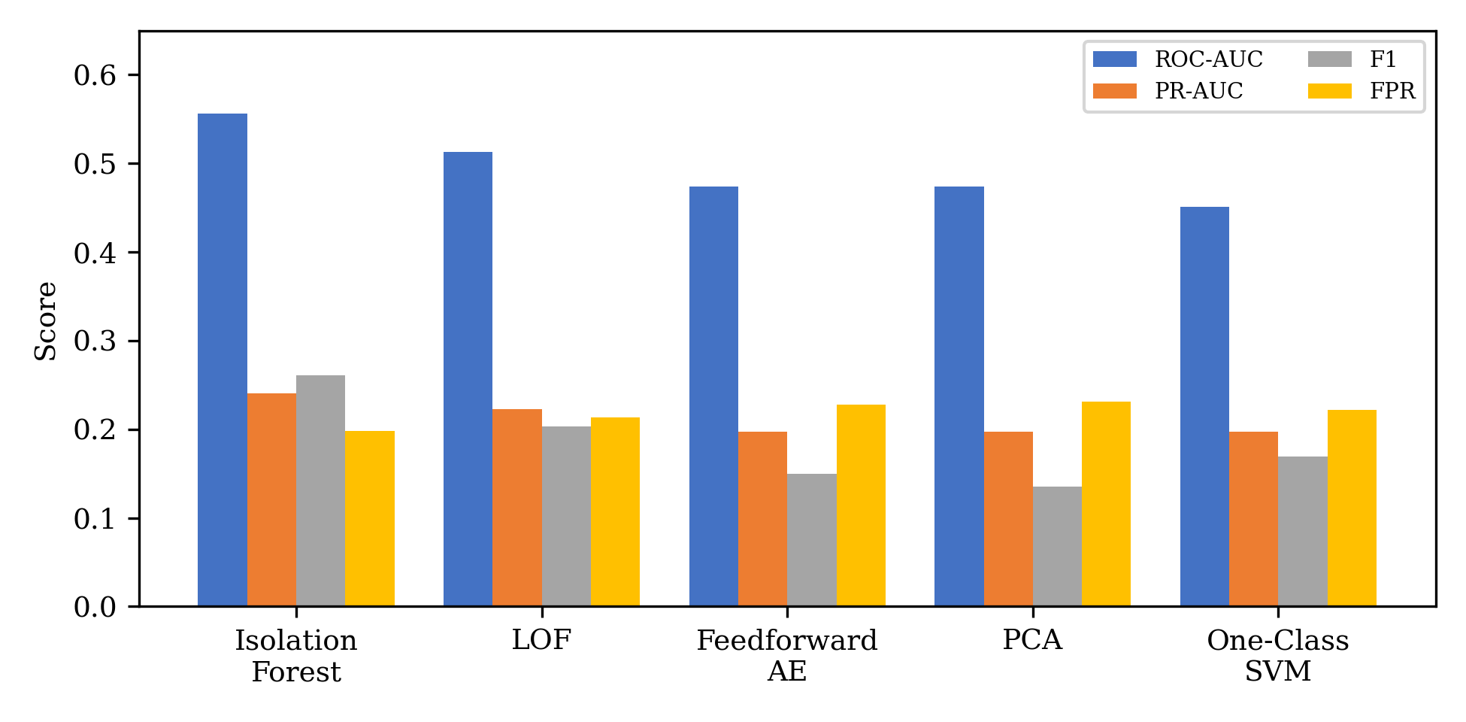
Fig. 1. Comparison of tabular anomaly detection models across four metrics.

B. Image Dataset Results
Table II reports the same four metrics as Table I, ROC-AUC, PR-AUC, F1-score, and false positive rate, for the image dataset. Deep SVDD and Isolation Forest are reported as the mean across ten repeated runs, while One-Class SVM and the Convolutional Autoencoder are reported from a single run, for the reasons discussed in Section III-G. Deep SVDD achieved the best result on every metric and also had the lowest false positive rate, but as with the tabular results, this should be read together with its recall value in the table rather than on its own. The Convolutional Autoencoder was the weakest of the four models tested.
Model | ROC-AUC | PR-AUC | F1 | FPR
Deep SVDD (10-run) | 0.682±0.04 | 0.738±0.04 | 0.628±0.04 | 0.372±0.04
Iso. Forest (Enc, 10-run) | 0.568±0.03 | 0.612±0.02 | 0.556±0.03 | 0.444±0.03
OC-SVM (Enc, 1 run) | 0.540 | 0.534 | 0.519 | 0.482
Conv AE (1 run) | 0.432 | 0.449 | 0.463 | 0.537
TABLE II
Image Dataset Results (10-Run Mean±SD Where Available, Else Single Run)
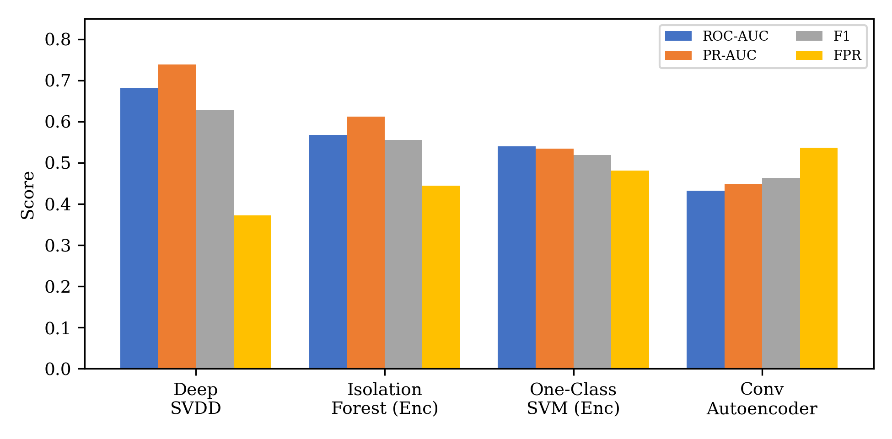
Fig. 2. Comparison of image anomaly detection models across four metrics.

C. Hybrid Framework Results
Table III reports the outcome of the hybrid framework investigation for both datasets, including the effect size (r) for each comparison alongside the Wilcoxon p-value. All p-values are compared against a Bonferroni-corrected significance threshold of 0.0167 (0.05 divided by three comparisons per dataset), rather than the conventional 0.05, to account for testing three fusion variants against the same baseline.
On the tabular dataset, naive, fully label-free fusion strategies (simple average and maximum) significantly degraded performance relative to Isolation Forest alone, while the label-assisted, validation-tuned weighted fusion consistently converged to assigning full weight to Isolation Forest across all ten runs, making it numerically identical to the individual baseline rather than a genuine fusion outcome.
On the image dataset, none of the three fusion strategies differed significantly from Deep SVDD alone at the corrected threshold. Notably, the validation-selected weight for Deep SVDD varied considerably across runs (ranging from 0.00 to 0.85, mean 0.53), in contrast to the tabular dataset where the weight was 1.00 in every run. This suggests the Isolation Forest features do carry some information not captured by Deep SVDD in certain runs, but not consistently or strongly enough to produce a statistically significant improvement across ten runs.
Dataset | Model | PR-AUC | p-value | Effect r
Tabular | Isolation Forest (baseline) | 0.2407 | — | —
Tabular | Hybrid - Average (label-free) | 0.2326 | 0.0020 | 0.886
Tabular | Hybrid - Weighted (label-assisted) | 0.2407 | 1.0000 | —
Tabular | Hybrid - Max (label-free) | 0.2387 | 0.0020 | 0.886
Image | Deep SVDD (baseline) | 0.7384 | — | —
Image | Hybrid - Average (label-free) | 0.7396 | 0.7695 | 0.113
Image | Hybrid - Weighted (label-assisted) | 0.7278 | 0.8457 | 0.081
Image | Hybrid - Max (label-free) | 0.7296 | 0.2754 | 0.371
TABLE III
Hybrid Framework Results vs. Best Individual Model (Bonferroni alpha = 0.0167)
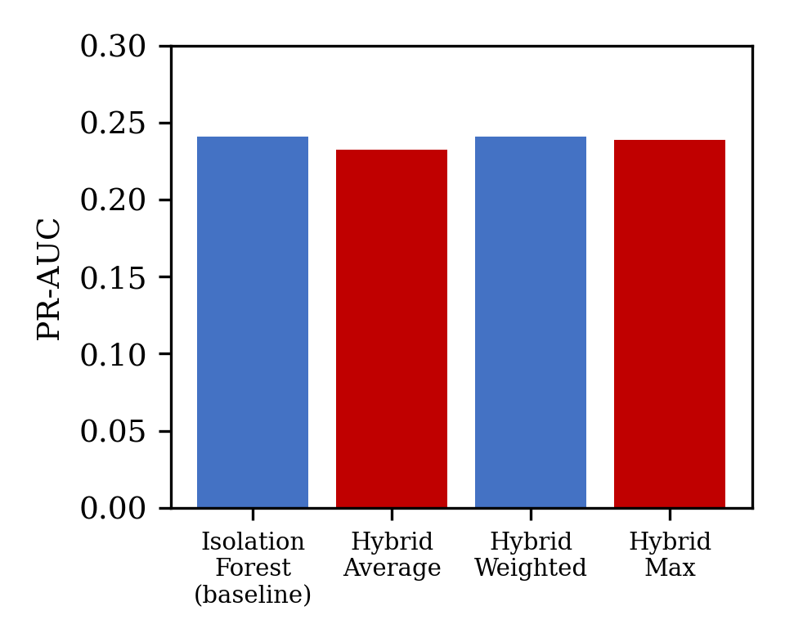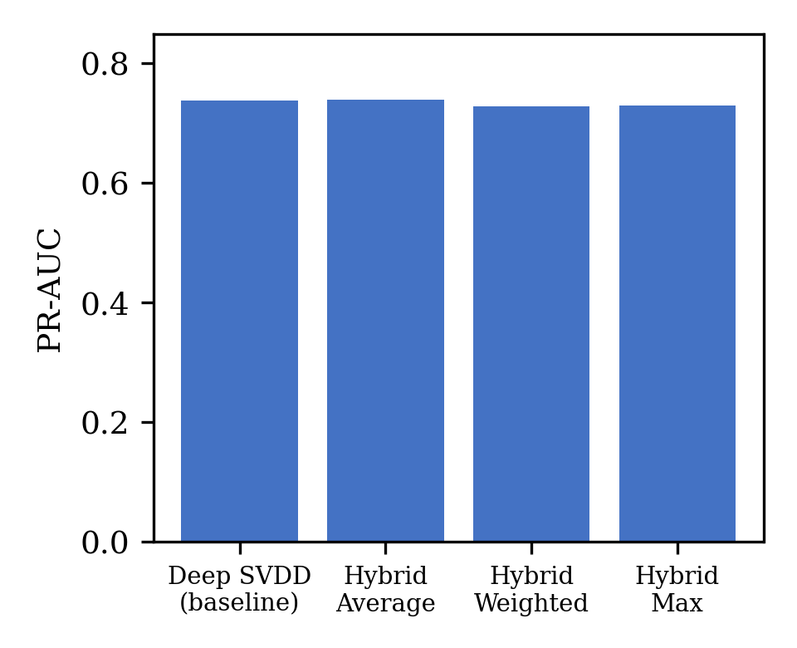
Fig. 3. Hybrid framework PR-AUC vs. best individual model, tabular (top) and image (bottom).

V. Discussion

A. Answering RQ1: Deep Learning vs. Classical Methods
RQ1 looked at whether deep learning-based anomaly detection models could detect pipeline defects better than classical methods when only a small number of defect samples were available. The results were different for the two datasets, so there is no single answer that applies to both. For the tabular dataset, Isolation Forest performed better than the Feedforward Autoencoder on all of the evaluation metrics. However, the opposite pattern was seen with the image dataset. Here, Deep SVDD performed better than both classical methods and the Convolutional Autoencoder across all metrics. This means that deep learning did not consistently perform better than the classical approaches. In this study, its performance depended on the type of data being used. It worked better for the image data, but this was not the case for the tabular data. Therefore, the results do not support a general statement that deep learning is superior to classical anomaly detection methods.
Looking at the actual scores is also important. On the tabular dataset, Isolation Forest achieved a ROC-AUC of 0.5561. Although this was the best result among the models tested, it is only slightly above 0.5, which would indicate performance close to random ranking. The Feedforward Autoencoder had a ROC-AUC of 0.4740, which was actually below this level. The PR-AUC results also need to be considered in relation to the class distribution. The positive class made up 21.2% of the tabular dataset, so a PR-AUC of 0.2407 is only a little higher than the baseline expected from that prevalence. This suggests that the models were finding only a limited amount of useful signal in the tabular data.
The results from the image dataset were more promising. In this case, the positive class represented 50% of the data, giving a no-skill PR-AUC baseline of 0.5. Deep SVDD achieved a PR-AUC of 0.7384, which is clearly above that baseline and indicates that the model was able to distinguish the two classes more effectively. The PR-AUC values from the two datasets should not, however, be directly compared because the class distributions are different. The comparison in this study is therefore focused on how the models performed within each dataset rather than trying to rank the two datasets against each other.
Overall, the tabular results were relatively weak across all five models. This may indicate that the PHMSA incident records contain limited information for distinguishing the pipeline defect class from the normal class as defined in this study. The image data gave a clearer result, particularly with Deep SVDD, which showed a more useful level of discrimination. Therefore, the answer to RQ1 is not simply that deep learning performs better than classical methods. Instead, the results show that its effectiveness depends on the dataset. Deep learning provided an advantage for the image data, while Isolation Forest was more effective for the tabular data.

B. Answering RQ2: The Hybrid Framework
RQ2 looked at whether combining the classical and deep learning anomaly scores could improve defect detection compared with using the best individual model. The results did not show any clear benefit from doing this in either dataset.
For the tabular data, the label-free fusion methods performed worse than Isolation Forest on its own. The label-assisted weighted fusion gave Isolation Forest a weight of 1.0 in all ten runs. This meant that the Feedforward Autoencoder had no effect on the final prediction. Rather than showing that the two models worked well together, this result suggests that the validation process simply found Isolation Forest to be the more reliable of the two.
The image dataset gave a slightly different result. None of the fusion methods improved significantly on Deep SVDD. The weights chosen by the label-assisted fusion did vary across the ten runs, which suggests that the Isolation Forest features were useful in some cases. However, this did not result in a consistent improvement in performance.
Overall, the results suggest that combining these particular classical and deep learning models did not improve pipeline defect detection compared with the strongest individual model. This was true for both the label-free and label-assisted fusion methods.

C. Statistical Interpretation and Limitations
Several parts of the experimental design need to be explained clearly rather than being left unstated. First, the ten repeated runs used in this study were based on different random seeds. These seeds affected model initialisation and, for the stochastic classical methods, the internal randomisation. However, the ten runs did not use ten different test sets. Therefore, the Wilcoxon signed-rank tests show whether the performance differences remained consistent across repeated runs on the same test set. They do not show whether the results would remain the same when the models are tested on completely new pipeline data collected independently. This is an important difference. If a model gives similar results across different runs, it gives more confidence that the result is not simply due to one particularly good or bad run. However, this alone does not prove that the model will generalise well to other pipeline populations.
Second, the deterministic classical models used on the tabular dataset, namely Local Outlier Factor, One-Class SVM, and PCA, produced exactly the same results in all ten runs. This is because, with the same training data, their implementations do not depend on a random seed. As a result, statistical comparisons involving these models should be understood as comparing the stochastic model against a fixed result rather than comparing two models whose results change across the ten runs.
The image test set also needs to be considered when interpreting the results. It contains 108 samples, which is larger than the 60-image Standard split that was rejected earlier in the study. However, 108 images is still a relatively small test set. Therefore, the results obtained from the image experiments should be interpreted with some caution.
There is also an inconsistency in the number of runs reported for the image models. The Deep SVDD and Isolation Forest results in Table II are based on the complete ten-run procedure. In contrast, the One-Class SVM and Convolutional Autoencoder results are based on only one run. The full ten-run procedure was not completed for these two models within the available time. Because of this, the four models in Table II were not evaluated under exactly the same run protocol. The single-run results for One-Class SVM and the Convolutional Autoencoder should therefore be considered as indicative results rather than results supported by the same level of statistical evidence as Deep SVDD and Isolation Forest.
Another point that should be considered is the interpretation of the false positive rate. A low false positive rate does not necessarily mean that a model is performing well overall. For example, a model may produce very few false alarms but still miss a large number of actual defects. In a pipeline inspection setting, these missed defects can be more serious than unnecessary inspections. For this reason, the false positive rate reported in this study should be considered together with the recall values presented in Tables I and II rather than being judged on its own.
Similarly, the use of ROC-AUC, PR-AUC, F1-score, and false positive rate in this study is intended to measure model performance under the experimental conditions described in Section III. These metrics should not be taken as direct evidence that a model is safe for use in an operational pipeline environment. Before deployment, the detection thresholds would need to be selected according to the actual cost of missed defects and false alarms. The models would also need to be validated against confirmed field inspection results. Such operational validation is outside the scope of this study.
The study also used two publicly available datasets. Using two independently obtained datasets was intended to provide evidence from different sources and reduce the risk of drawing conclusions from a single dataset. However, two datasets are still not enough to establish that the findings will remain valid across all types of pipeline data found in real-world applications. Therefore, the results should be understood as evidence from two complementary public datasets rather than as a general conclusion that applies to every pipeline defect detection problem.
There are also some dataset-specific limitations. The K-Pipelines dataset used in this study contains only synthetically generated images. This was a deliberate choice because of the limited availability of suitable public images showing pipeline corrosion, as discussed in Section II. However, synthetic images may not fully represent the variation, noise, lighting conditions, surface appearance, and other characteristics found in real inspection photographs. As a result, the performance of the models on real pipeline images may be different from the results obtained in this study.
A complete grid search or random search for hyperparameter optimisation was also not carried out. The available computational resources and project timeframe did not allow an extensive search across all possible parameter combinations. Instead, a bounded comparison of hyperparameters was carried out as described in Section III-H. This provides some evidence that the selected values were reasonable, but it cannot rule out the possibility that different settings could have produced better results.
Finally, this study did not include an explainability analysis of the model predictions. Understanding why a model identifies a particular pipeline sample as anomalous would be useful, particularly in a practical engineering environment where engineers need to have confidence in the system's decisions. However, explainability was outside the research questions and scope of the present study. It would therefore be a useful area to consider in future work.

VI. Conclusion
This study was carried out to understand how well deep learning-based anomaly detection methods can identify oil and gas pipeline defects when defect samples are limited, and whether they provide a clear advantage over classical anomaly detection methods. The results from the two public datasets used in this study show that the advantage of deep learning is not the same for every type of data. On the tabular dataset, Isolation Forest performed better than the Feedforward Autoencoder. On the image dataset, however, Deep SVDD performed better than both the classical methods and the Convolutional Autoencoder. These results answer RQ1 and show that the choice of anomaly detection method can depend strongly on the dataset being used.
The second research question, RQ2, looked at whether combining classical and deep learning anomaly scores could provide better results than using the best individual model. Three different fusion methods were tested across the two datasets. None of the hybrid approaches gave a statistically significant improvement over the best individual model. On the tabular dataset, the validation-tuned fusion method effectively ended up giving all the weight to Isolation Forest. This suggests that combining two models does not automatically lead to better performance. In this case, the individual model was already strong enough that adding the second model did not provide any clear benefit. This is an important finding because it shows that a hybrid approach should be evaluated based on actual results rather than assuming that combining models will always improve detection.
The study also provides a comparison of different anomaly detection approaches using pipeline defect data linked to an official PHMSA cause category. Where the complete repeated-run procedure was completed, statistical testing was used to check the consistency of the results. False positive rate was also included alongside the other performance measures because, in a pipeline inspection context, false alarms can lead to unnecessary inspections and additional costs. At the same time, these results should be considered within the experimental conditions of this study and should not be taken as evidence that the models are ready for direct use in real pipeline operations.
There are several limitations that should be considered when interpreting the findings. The image experiments were based on synthetically generated images rather than real inspection photographs. The full ten-run evaluation was also not completed for all of the image models, and an exhaustive hyperparameter search was not possible within the available time and computational resources. In addition, only two public datasets were used, so the findings cannot be assumed to represent all types of pipeline data.
Future work could address these limitations by completing the full repeated-run evaluation for the remaining image models and testing the methods on real pipeline corrosion images. It would also be useful to evaluate the models on additional pipeline datasets and carry out a more extensive hyperparameter search. Another important direction would be to include explainability methods so that engineers can better understand why a particular sample has been classified as anomalous. This could help assess whether anomaly detection models are suitable for supporting practical pipeline integrity management.

References
[1] X. Ding, Y. Li, A. Belatreche, and L. P. Maguire, "Novelty Detection Using Level Set Methods," IEEE Trans. Neural Netw. Learn. Syst., vol. 26, no. 3, pp. 576-588, 2015.
[2] L. Ruff et al., "Deep One-Class Classification," in Proc. 35th Int. Conf. Mach. Learn. (ICML), 2018.
[3] I. Malashin, V. Tynchenko, V. Nelyub, et al., "Deep Learning Approach for Pitting Corrosion Detection in Gas Pipelines," Sensors, vol. 24, no. 11, art. no. 3563, 2024.
[4] M. R. Fachrezi, A. F. Ihsan, and W. Astuti, "Anomaly Detection Using LSTM-Based Deep Learning on Natural Gas Pipeline Operational Data," in Proc. IEEE Int. Conf. Inf. Commun. Technol. (ICoICT), 2024.
[5] S. Huang, L. Peng, H. Sun, and S. Li, "Deep Learning for Magnetic Flux Leakage Detection and Evaluation of Oil and Gas Pipelines: A Review," Energies, vol. 16, no. 3, art. no. 1372, 2023.
[6] L. T. Ramos, E. Casas, and F. Rivas-Echeverria, "Synthetic generated data for intelligent corrosion classification in oil and gas pipelines," Intell. Syst. Appl., vol. 25, art. no. 200463, 2025.
[7] F. T. Liu, K. M. Ting, and Z.-H. Zhou, "Isolation Forest," in Proc. IEEE Int. Conf. Data Min. (ICDM), 2008.
[8] B. Scholkopf, J. C. Platt, J. Shawe-Taylor, A. J. Smola, and R. C. Williamson, "Estimating the Support of a High-Dimensional Distribution," Neural Computation, vol. 13, no. 7, pp. 1443-1471, 2001.
[9] M. M. Breunig, H.-P. Kriegel, R. T. Ng, and J. Sander, "LOF: Identifying Density-Based Local Outliers," in Proc. ACM SIGMOD, 2000.
[10] A. B. Nassif, M. Abu Talib, Q. Nasir, and F. M. Dakalbab, "Machine Learning for Anomaly Detection: A Systematic Review," IEEE Access, vol. 9, pp. 78658-78700, 2021.
[11] Q. Ma, G. Tian, Y. Zeng, et al., "Pipeline In-Line Inspection Method, Instrumentation and Data Management," Sensors, vol. 21, no. 11, art. no. 3862, 2021.
[12] D. Gong, L. Liu, V. Le, et al., "Memorizing Normality to Detect Anomaly: Memory-Augmented Deep Autoencoder for Unsupervised Anomaly Detection," in Proc. IEEE/CVF Int. Conf. Comput. Vis. (ICCV), 2019.
[13] P. Yan, A. Abdulkadir, P.-P. Luley, et al., "A Comprehensive Survey of Deep Transfer Learning for Anomaly Detection in Industrial Time Series: Methods, Applications, and Directions," IEEE Access, vol. 12, pp. 3038-3061, 2024.
[14] J. M. Johnson and T. M. Khoshgoftaar, "Survey on deep learning with class imbalance," J. Big Data, vol. 6, art. no. 27, 2019.

