|  |  |
| --- | --- |
| Name: Zain Akhtar | EE-272L Digital Systems Design |
| Reg. No.: 2023-EE-063 | Marks Obtained: ____________ |

Lab Manual

Experiment 3: Combinational Circuits Design Using Vivado

# DSD Lab Manual Evaluation Rubrics

|  |  |  |  |  |  |
| --- | --- | --- | --- | --- | --- |
| Assessment | Total  Marks | Marks Obtained | 0-30% | 30-60% | 70-100% |
| Code  Organization  (CLO1) | 3 |  | No Proper Indentation and descriptive naming, no code organization.    Zero to Some understanding but not working | Proper  Indentation or descriptive naming or code organization.    Mild to Complete understanding but not working | Proper  Indentation and descriptive naming, code organization.    Complete understanding, and proper working |
| Simulation  (CLO2) | 5 |  | Simulation not done or incorrect, without any understanding of waveforms | Working simulation with errors, don't cares's(x) and high impedance(z), partial understanding of waveforms | Working simulation without any  errors, etc and complete understanding of waveforms |
| FPGA  (CLO2) | 2 |  | Not implemented on FPGA and  questions related to synthesis and implementation not answered. | Correctly  Implemented on FPGA or  questions related to synthesis and implementation answered. | Correctly  Implemented on FPGA and  questions related to synthesis and implementation answered. |

# (a) Truth Table

|  |  |  |  |  |  |  |  |  |
| --- | --- | --- | --- | --- | --- | --- | --- | --- |
| a | b | c | !c | a|b | !(a&b) | !(a&b)^(a|b) | x=(!c)^(a|b) | y=(a|b)&(!(a&b))^(a|b) |
| 0 | 0 | 0 | 1 | 0 | 1 | 1 | 1 | 0 |
| 0 | 0 | 1 | 0 | 0 | 1 | 1 | 0 | 0 |
| 0 | 1 | 0 | 1 | 1 | 1 | 0 | 0 | 0 |
| 0 | 1 | 1 | 0 | 1 | 1 | 0 | 1 | 0 |
| 1 | 0 | 0 | 1 | 1 | 1 | 0 | 0 | 0 |
| 1 | 0 | 1 | 0 | 1 | 1 | 0 | 1 | 0 |
| 1 | 1 | 0 | 1 | 1 | 0 | 1 | 0 | 1 |
| 1 | 1 | 1 | 0 | 1 | 0 | 1 | 1 | 1 |

# (b) Combinational Delay

The maximum combinational delay is a to y that is 6.769 ns.

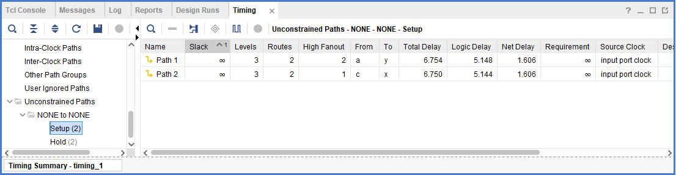

# (c) Resource Utilization

One LUT and five I/O pins are utilized.