**Experiment 4**

**K-Maps:**

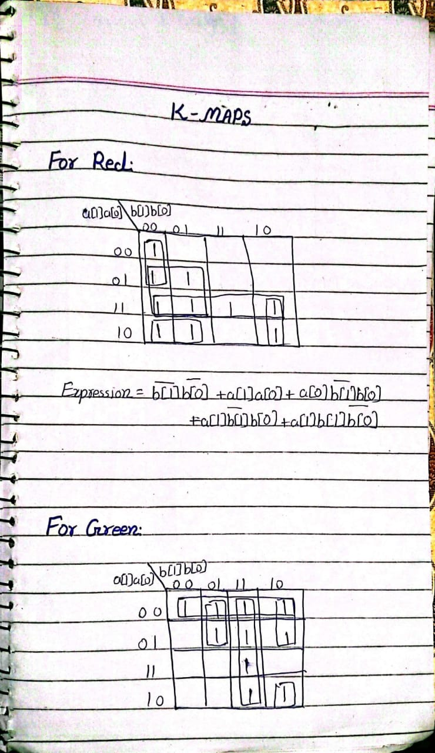

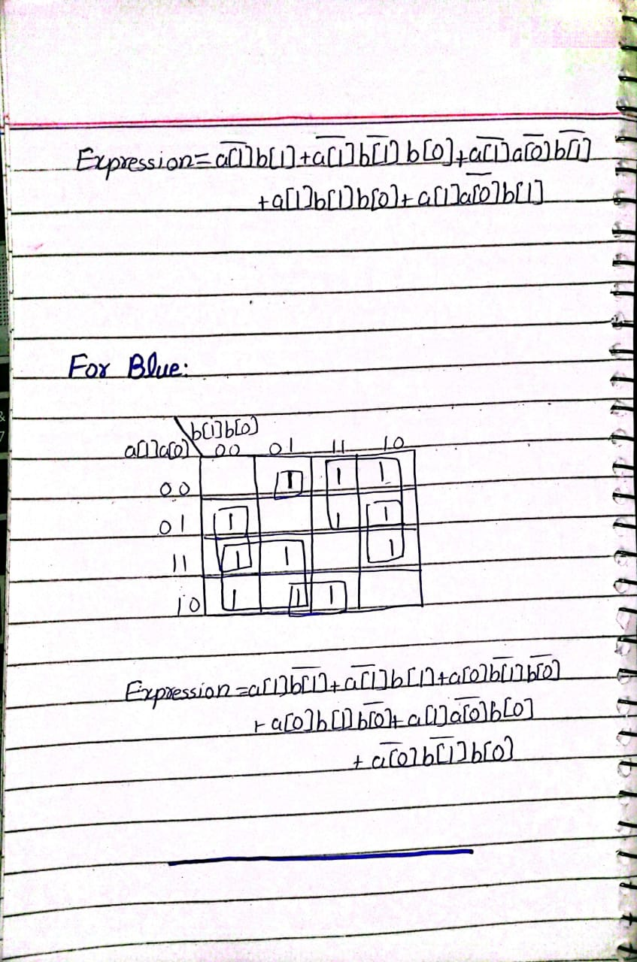

**Schematic:**

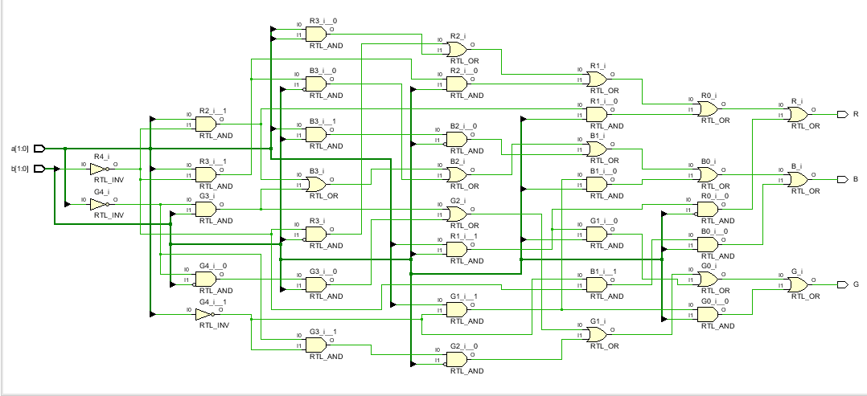

**Circuit Diagram(draw io):**

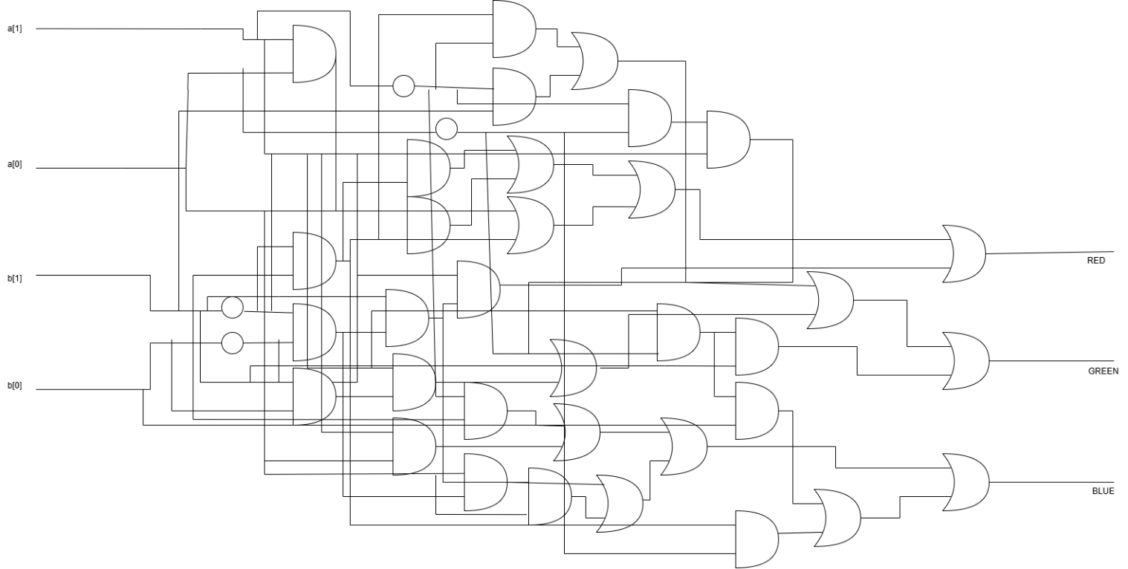

Maximum Combinational Delay:

